Human Resource Management 2
Student name: Carla Pires dos Santos
Student ID: 2115128

Module name: Human Resource Management
Module code: LCMB7000
Lecturer name: Gladius Kulothungan

Table of Contents
Introduction 3
1. Human management resource strategies developed and deploy in three areas in HRM to choose from: 4
1.1 Change management Strategy: 4
1.2 Employee retention Strategy 5
1.3 Learning & Development Strategy 7
2. Illustration of the selected strategies that build employees' value, appreciation, and develop a sense of Apple Inc. 9
Change management strategy that builds employees value, appreciated and develop a sense of Apple Inc. 9
Employee retention strategy make team members valued, appreciated and develop a sense of the Apple 10
Learning and development strategy which make team members valued, appreciated and develop a sense of the Apple 10
3. Critical Evaluation of model and principle of the running IHRM & HRM 12
Conclusion 13
Reference 13

Introduction
Human Management strategy is an organization's aggregate plan for maintaining its human resource to acquire the organization's targets. All rector of Homan resource, with employee recruiting, performance analysis, improvement, and award, is managed by the HR strategy. I chose Apple Inc. is a global technology business that manufactures consumer electronics, personal computers, computer software, and is a digital merchandiser of media content as a multination organization. The Apple Store is the chain of the retail store of this multinational organization and the core product line of this organization include; smartphone, Macintosh computer, and iPad tablet computer. The disclosed interpretations of senior management from the Apple of the adjustments in strategy undertaken following a big shift in the organization were exposed using numerous publications from the technological industry (Idris, 2017). This report demonstrated a short overview of three appropriate Human resource strategies and illustrated the strategies how it build Apple Inc. team members valued, developed, and appreciated along with a significant analysis of the model, principle as well as the concept of running HRM and IHRM theories.

1. Human management resource strategies developed and deploy in three areas in HRM to choose from:
1.1 Change management Strategy: Change management indicates an organization's strategies and systems for evaluating and implementing change in both internal and external operations. Individuals are maintained and supported, crucial change schemes are planned, and pre, as well as post-change operations, are maintained to confirm proper execution (Fee, 2017). Making Apple changes is challenging. Several stages of plane transition with small trouble. Change management has some stages in this regard and they are described in below:
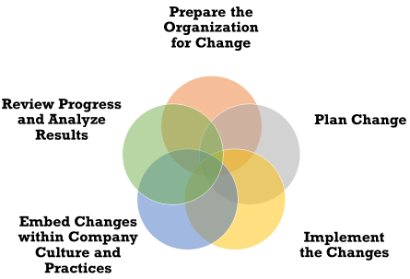
Figure: Steps in the change management process (Mohedo, 2018)
Make the Apple Change-Ready: A viable alternative does not come without thought, and any plan developed must be tailored to each company's specific needs. Depending on the company, change initiatives may be sustained in a variety of ways. Some change management systems are quite strict, whilst others are more adaptable and flexible (Ferri, 2019).
Plan Change: A lucrative alternative does not come without thought, and any approach developed must be tailored to the specific needs of each organization. Depending on the company, change initiatives may be sustained in a variety of ways (Guest, 2017). Some change management systems are quite strict, whilst others are more adaptable and flexible.
Changes Implementation: Once the strategy has been created, all that remains is to implement the actions outlined in the plan to accomplish the intended transformation. Depending on the program's characteristics, changes to the organization's structure, strategy, employee behavior, or other factors may be required. During the implementation phase, change managers must focus on allowing their employees to take the necessary steps to achieve the primary objectives. They should also strive to predict bottlenecks and, if detected, erase, remove, or lessen them. During the implementation stage, it's critical to convey the Apple goal to team members, as well as why change is required (Miller, 2015).
Changes in organizational culture and practices should be embedded: According to (Coleman, 2018), Change managers must defend reverting to the previous state or status quo once the change project is completed. This is especially true when the structure, method, culture, or strategy of an organization is altered. Employees may resort to the "old way" of doing things if a strategy isn't in place, especially during the transition time. Backsliding is more difficult to achieve if the organization's culture and processes have improved. Change management alternatives include new Apple structures, controls, and incentive systems.
Analyze the Results and Evaluate the Progress: Change activities may be carried out in a variety of ways depending on the firm. Some change management strategies are rigid, whilst others are malleable and flexible.

1.2 Employee retention Strategy
The capacity of an organization to retain its staff is indicated as employee retention. Employer’s primary motive in a commercial context is to maintain employee turnover low, which minimizes training expenses, recruiting costs, and the loss of talent and Apple expertise.
Benefits of Employee Retention: According to (Dyer, 2019), as companies compete for top talent, employee retention is crucial. While some experts advise aiming for a 90 percent retention rate, the reality is that this differs by Apple and sector. On the other hand, employee retention is advantageous for a multitude of reasons. Here are nine of the most significant advantages:
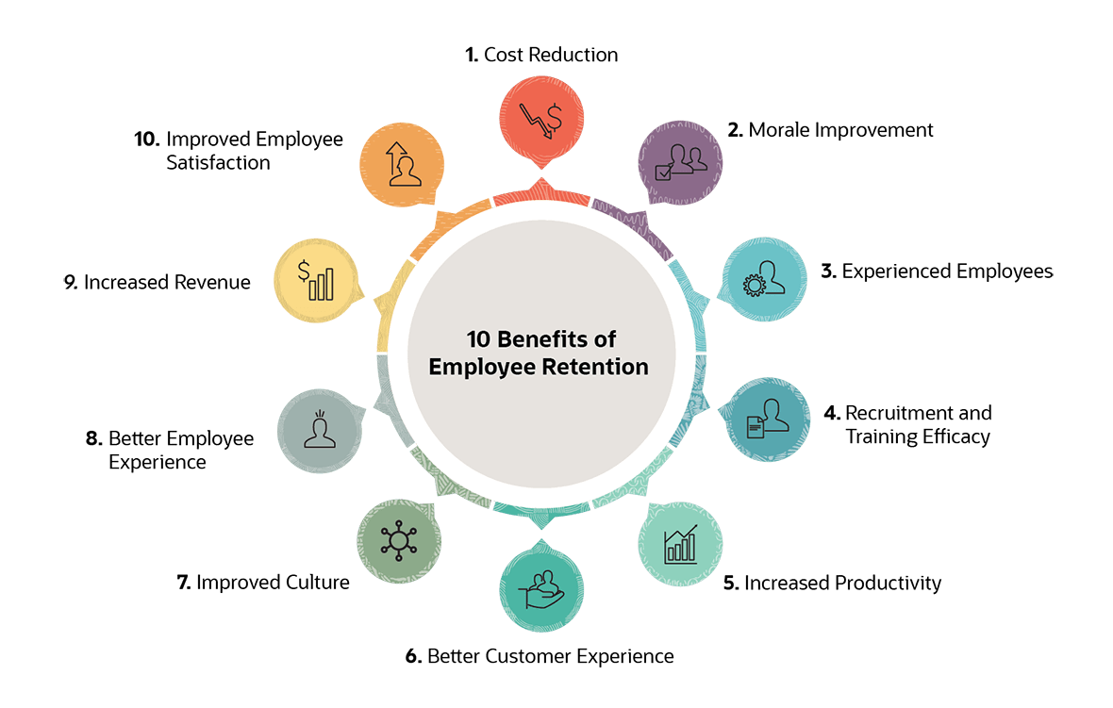
Figure: Employee retention and its benefits (Dyer, 2018)
Cost reduction. Recruiting and training new personnel costs businesses in the United Kingdom hundreds of millions of pounds every year. Such expenses are squandered if an employee leaves early. Production, teamwork, and morale all suffer, as a result, leading to financial losses. Total employee replacement costs can range from 90% of an entry-level employee's salary to 200 percent or more for senior executives and experts (Dyer, 2019).
Effectiveness of recruitment and training: By focusing on employee retention, businesses may accumulate money on recruiting and achieve more out of jobholders' training. Recruiting expenses include marketing the position, interview concern travel, or maybe signing incentives.
Productive Increased: Employee turnover affects productivity since it needs a period for a new employee to ascend to speed and perform at the same level as their ancestor (Ferri, 2019). It also has various negative impacts on surviving employees, who are obliged to count on more tasks and, as a result, may manufacture fewer quality products.
Employee morale Improvement: Successful employee retention programs generate a sense of connection and involvement among employees, raising morale and, as a result, increasing retention. A steady stream of departures, on the other hand, has a dismal effect on workplace morale, resulting in poor job quality and more workers departing.
Employees Experienced: Employees that have spent a long period with Apple are more devoted, informed, and talented. They've developed strong bonds with both consumers and staff.
Better customer experience: Recruits that are inexperienced and incompetent are more likely to make mistakes that have a negative influence on a customer's experience with Apple (Fee, 2017). Longer-term workers who are happy in their jobs are more likely to be good communicators and build strong ties with their customers.
Improved employee satisfaction and experience: Inexperienced and inept new hires are more prone to make blunders that negatively impact a customer's experience with Apple. Longer-term employees who are satisfied with their positions are more likely to be effective communicators and develop solid customer relationships.
Stronger corporate culture: Over time, the attributes and interactions of workers combine to establish a business culture. The organization's ethos is reinforced when engaged workers who are devoted to the organization's culture stay (Idris, 2017).
Increased revenue: According to anecdotal evidence, employee retention isn't only about saving money; it may also improve income. Customers and staff have a better experience when they have a greater retention rate.

1.3 Learning & Development Strategy
According to (Kavanagh, 2018), Learning and development is a popular human resources operation that entails providing the employees with a special ability to develop corporate operations. Learning and development have various advantages, including staff retention, future-proofing one Apple, and enhanced employee experience. Learning and development are frequently seen as an important component of an organization's entire people management strategy, with learning being used to attract, develop, maximize, and retain personnel (Belias, 2017).
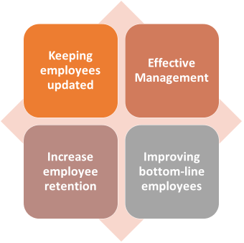
Figure: Motives of learning and development (Belias, 2017)
Maintaining employees updated: Employee learning and development at work allows them to stay current on the latest skills and information, allowing them to take on new responsibilities, increase productivity and efficiency, and reduce job completion time.
Effective Management: Employers may benefit from learning and development by building a more effective management team that can cope with challenging situations and make swift judgments. Employees may handle complicated decisions and break down jobs into smaller parts using the information obtained from the activity (Stewart, 2018).
Increase employee retention: Hiring is more costly than learning, but it increases employee motivation and develops trust between the business and the employee since the person feels like they belong.
Improving bottom-line employees: When learning and development are focused on bridging the skill gap of the employee, management can gain from an increase in profit (Chiboiwa, 2017). Employees that have been properly trained perform better, and the manager must help them achieve their full potential.

2. Illustration of the selected strategies that build employees' value, appreciation, and develop a sense of Apple Inc.

Change management strategy that builds employees value, appreciated and develop a sense of Apple Inc.
People maintain successful change, when avail is repeatedly the outcome of human behavior as well as a negativity is adjusted. By fostering speedier acceptance, broadening eventual usage, and boosting expertise, change management improves ROI (Dyer, 2019). The efficacy of change management and the chance of implementing targets are intricately linked In Apple Inc., according to data from a variety of sources. Respected managers & frontline employees are little responsive to Apple changes which immediately impact them and are more receptive to them. Apple Employees who believe they are devalued are more likely to respond adversely to suggested changes to defend themselves against their boss's abuse.
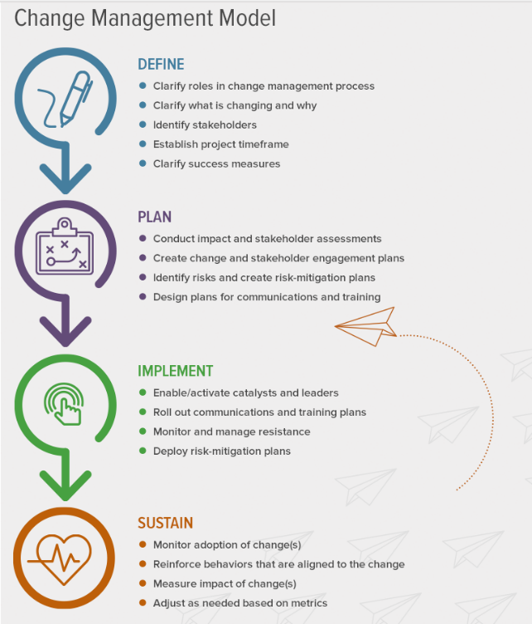
Figure: Change Management Model (Chiboiwa, 2017)

Employee retention strategy make team members valued, appreciated and develop a sense of the Apple
According to (Guest, 2017), Apple can retain employees can assist it in avoiding losing productivity. Employees at high-retention Apple like Apple are more engaged, which leads to more work being completed. More involved employees are more likely to form customer relationships, and teams with more time to get to know one another are more productive.
Appreciation Makes Them Feel Valued: Recognizing workers' contributions regularly might help to promote workplace morale and engagement. Apple Employees, particularly millennials, believe that timely job appreciation and thankfulness is the yardstick by which they assess their performance in today's market (Chiboiwa, 2017). Employee loyalty will be encouraged, as well as a sense of job satisfaction. As a consequence, they will be much more driven to work.
Timely Appreciation Increases Trust Levels: Learning and development opportunities have a big impact on employee retention. Boosting employee retention saves businesses money. Hiring a new employee in Apple is five times more expensive than maintaining a current one.

Learning and development strategy which make team members valued, appreciated and develop a sense of the Apple
Free food and beanbags aren't the only ways to express gratitude to one employee. It's not as complicated as it appears. Apple Employers will not be obligated to provide lavish bonuses. They just want, among other things, regular verbal help. In an era where maintaining talent is difficult, employee appreciation has become the standard (Belias, 2017). Consider several ways to express one gratitude for one dedicated staff. Nobody wants to be treated like a machine that may be thrown away. There are several terms in learning and development strategy which make apple employees values, appreciated and develop a sense and they are described in the below:
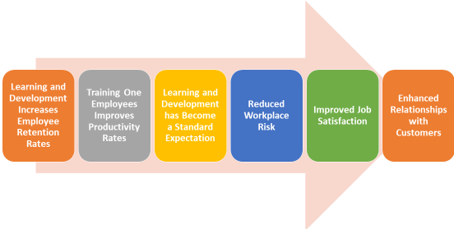
Figure: Learning and development strategy phases (Coleman, 2018)
Learning and Development Increase Apple Employee Retention Rates: Apple Employee retention is heavily influenced by learning and development opportunities. Employees would stay at Apple longer if it invested in their professional growth. Furthermore, increasing staff retention saves money for Apple.
Training Apple Employees Improves Productivity Rates: Because trained employees are considerably more productive than untrained employees, providing learning and development opportunities for one employee may have a direct impact on the bottom line of Apple. According to an IBM study, training teams create 10% more revenue than unskilled teams. (Mohammed, 2017) Employees are provided the skills and information they need to always follow best practices, resulting in increased output.
Reduced Apple Workplace Risk: If employees are not adequately trained to handle equipment and conduct themselves, one might expect a rise in the number of workplace accidents. Apple HR departments must design a clear, detailed compliance training program to ensure that workers understand how to be safe in the workplace (Wallis, 2017).
Improved Job Satisfaction: Apple Employee retention is heavily influenced by learning and development opportunities. Employees would stay at an Apple longer if it invested in their professional growth. Furthermore, increasing staff retention saves money for Apples
Enhanced Relationships with Customers: One personnel will be more suited to communicate with clients after receiving training. If one employee of Apple can effectively answer all of a client's queries, one may deliver excellent customer service. Customers will benefit from positive interactions with one customer service staff since learning and progress lead to higher work satisfaction (Ahmed, 2019). Customers will pick up on this upbeat tone since engaged employees are more productive.

3. Critical Evaluation of model and principle of the running IHRM & HRM
The Change Management Model of Lewin's is a three-stage change management model which he developed in the 1950s. Unfreezing, modifying, and freezing are the three stages listed (Chiboiwa, 2017). This model provides a thorough overview of the subject, but it leaves out several key elements that are crucial to the planning and execution of change in any company. High responsiveness and urgency, leadership and human resources, vision and structure, communication, empowerment, short-term wins through challenging but attainable targets, continuous improvement in systems, processes, and practices, and people planning and development are the eight steps in Kotter's Change Model. The capacity of an organization to retain personnel can help it avoid losing productivity (Thorne, 2019). Employees in companies with a high retention rate are more engaged, resulting in more work being implemented. Employees who are more involved are more likely to build customer relationships, and teams that spend more time getting to know one another are more productive. A good degree of employee turnover may be beneficial to an organization since it leads to new ideas and practices. Ignoring high levels of staff turnover may be costly; it can lower employee morale and damage an organization's external reputation, resulting in revenue loss (Coleman, 2018). Because of Apple Inc.'s continuous expansion both inside and outside of the area, training and development have always been cornerstones of the company's strategy. Apple spends a lot of money on training and development because it competes in a highly competitive retail business.

Conclusion
To fulfill long-term goals, Apple Inc. aims to maintain a talent pipeline. To achieve these, Apple has designed a variety of creative training and development initiatives. There are programs for on-the-job and off-the-job training and development. Apple Inc. was the first business to use the phrase "lead to succeed primary," for example. It is founded on the organization's basic principles and is inextricably linked to the goal of developing capabilities that will enable the company to thrive in the future (Caldwell et al. 2017). The training will be beneficial to senior executives. Since its establishment, the program has graduated over 302 outstanding CEOs. Apple has launched a slew of professional development initiatives targeted at luring and retaining top talent. The group comes up with a compensation structure that serves both the corporation and the individual. Apple also assesses personnel and creates succession plans for important positions inside the company. Apple Inc.'s management seeks to provide opportunities for recognition, promotion, and professional growth based on Maslow's hierarchy of expectations (Peetz et al. 2018). As a consequence, employees' self-actualization has improved.

Reference
Idris, A., 2014. Flexible working as an employee retention strategy in developing countries. Journal of Management Research, 14(2), pp.71-86.James, L. and Mathew, L., 2012. Employee retention strategies: IT industry. SCMS Journal of Indian Management, 9(3), p.79.
Fee, K., 2017. Delivering e-learning. A complete strategy for design, application and assessment. Development and Learning in Organizations: An International Journal.
Mohedo, M.T.D. and Bújez, A.V., 2018. Project based teaching as a didactic strategy for the learning and development of Basic competences in future teachers. Procedia-Social and Behavioral Sciences, 141, pp.232-236.
O'ReSujansky, J. and Ferri-Reed, J., 2019. Keeping the Millennials: Why companies are losing billions in turnover to this generation-and what to do about it. John Wiley & Sons.
Guest, D.E., 2018. Human resource management and performance: a review and research agenda. International journal of human resource management, 8(3), pp.263-276.
Miller, A.L., Wyman, S.E., Huppert, J.D., Glassman, S.L. and Rathus, J.H., 2017. Analysis of behavioral skills utilized by suicidal adolescents receiving dialectical behavior therapy. Cognitive and Behavioral Practice, 7(2), pp.183-187.
Coleman, J., 2017. Economic factors and achieving competitive advantage in a business environment. Harlow: Pearson. British Journal of Business and Economics, Vol 7, No.5. pp.45-74.
Dyer, L. and Reeves, T.,2019. Human resource strategies and firm performance: what do we know and where do we need to go?. International Journal of human resource management, 6(3), pp.656-670.
Kraatz, M.S. and Zajac, E.J., 2017. How organizational resources affect strategic change and performance in turbulent environments: Theory and evidence. Organization science, 12(5), pp.632-657.
Kavanagh, M.H. and Ashkanasy, N.M., 2020. The impact of leadership and change management strategy on organizational culture and individual acceptance of change during a merger. British journal of management, 17(S1), pp.S81-S103.
Belias, D. and Koustelios, A., 2017. The impact of leadership and change management strategy on organizational culture. European Scientific Journal, 10(7).
Stewart, J. and Kringas, P., 2019. Change management—strategy and values in six agencies from the Australian Public Service. Public Administration Review, 63(6), pp.675-688.
Chiboiwa, M.W., Samuel, M.O. and Chipunza, C., 2017. An examination of employee retention strategy in a private organisation in Zimbabwe. African journal of business management, 4(10), pp.2103-2109.
Mohammed, A., 2015. The impact of talent management on employee engagement, retention and value addition in achieving organizational performance. International journal of core Engineering & Management, 1(12), pp.142-152.
Wallis, A. and Kennedy, K.I., 2017. Leadership training to improve nurse retention. Journal of Nursing Management, 21(4), pp.624-632.
Ahmed, P.K., 2019. Culture and climate for innovation. European journal of innovation management.
Thorne, K. and Pellant, A., 2019. The essential guide to managing talent: How top companies recruit, train, & retain the best employees. Kogan Page Publishers.

