
UNIVERSITY OF WALES
Program Name: BSc Health and Social Care
Module Code- BMHP5023
Module Title -Introduction to Physiology
Assignment Title-Component 1: Written
Assignment (Case Study Report)

Student Name: Davia Jordan
Student ID: 2411484
Lecturer Name: Dr Soban Sadiq

Contents
Introduction 3
Maintenance of blood sugar levels according to the needs of the body 3
Glycolysis and cell metabolism 5
Management of Type 2 diabetes 7
Evidence Based Recommendations for Improvement in diabetes with lifestyle changes 8
Conclusion 10
References 11

Introduction
The chosen case study is 1. Diabetes is a chronic illness that can only be managed, but not treated completely. Being a metabolic disorder, it is caused by environmental stress and changes and also can be genetic, which is inherited from previous generations. Diabetes, if not managed, can be life-threatening and causes an increase in mortality rates overall. Diabetes mellitus is described as an inadequate amount of blood sugar in the body that happens due to defects in insulin production and action (Sarkar et al., 2019). A condition of high blood sugar, that is hyperglycaemia, that is high blood sugar and hypoglycaemia, that is low blood sugar, can be present. The imbalance of insulin levels and pancreatic cells can lead to this condition, which in turn is associated with defects in other organs and body functions.
This condition directly affects the immune system and causes obesity, walking disorders, inflammation, and internal stress on organs like the heart and kidneys. Type 1 diabetes is generally an autoimmune response from T and B cells, and defects in their functioning cause defects in sugar levels. This type is more common in children but can occur in any age group. The effect of this can be either fast or slow. On the other hand, type 2 diabetes affects adults and older people and only occurs in individuals carrying the genes of diabetes at a younger age. The risk factors associated with Diabetes Mellitus can be either irreversible or reversible. Reversible factors include weight gain, inactivity, infections and inflammations in the body, and dietary factors causing or increasing the blood sugar levels. While the irreversible factors are race, gender, genetics and age of an individual, these may increase or decrease the chances of suffering from this condition.

Maintenance of blood sugar levels according to the needs of the body
Maintenance of blood sugar levels or blood glucose levels requires the monitoring of fluctuations in sugar levels in the body according to the specific needs of an individual's body. These responses can be associated with diet, physical activities or other chronic diseases that together affect blood sugar levels (Mathew et al., 2023). This said, the blood glucose level keeps changing throughout the day, depending on the body's activity. An unhealthy and inactive lifestyle can lead to high glucose levels in the blood, which is hyperglycaemia. These sugar levels need to be monitored and diagnosed through tests at different times of day, that is, fasting sugar level test, non-fasting tests or HbA1c tests, which give a report of the last 2-3 months of blood sugar levels in an individual (Sharma et al., 2026).
An early diagnosis of diabetes can prevent deaths from this disease, due to poor eating habits and lifestyle choices; now, every other adult or child suffers from this condition. Two main methods can be followed for the maintenance and monitoring of glucose levels in diabetic or pre-diabetic patients. HbA1c test, which is glycosylated haemoglobin or an oral glucose tolerance test. For the oral glucose tolerance test, if plasma glucose is found to be more than 11.1 mmol/L, then the individual is considered diabetic. Patients suffering from diabetes generally have a fasting glucose level of more than 7 mmol/L (Alam et al., 2021). According to these tests and patients' requirements medications in some severe cases, insulin can be provided to control and manage the symptoms of diabetes.
Some lifestyle changes, such as diet, weight and physical activity, can also help in managing these conditions and blood sugar levels. Regular health checkups and blood tests can help in monitoring the sugar levels. Some other symptoms that signify the sudden changes in blood sugar level are frequent urination, infection, feeling thirsty, poor appetite, abnormal heart rate, and slow response of clotting factors. The effect can be shown on other organs of the body, such as kidney failure, stroke, cardiac arrest, or arthritis (Kumar et al.,2022)
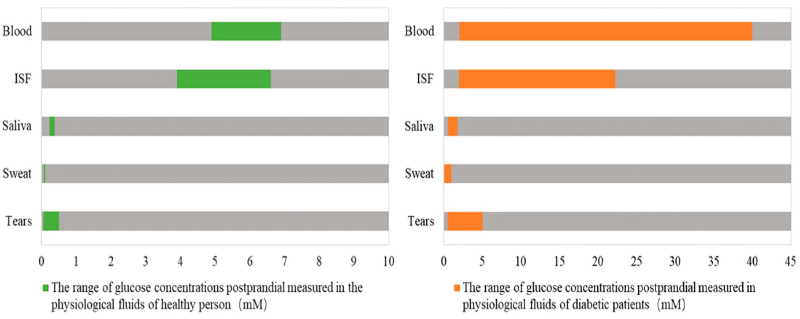
(Source: Moses et al., 2024)
The difference in glucose concentration when measured in a healthy person as compared to the concentration of glucose in different fluids of a diabetic person.

Glycolysis and cell metabolism
Glucose is the most important compound that produces energy in the form of ATP in the body. Blood glucose needs to be regulated strictly for the proper functioning of the body. It is utilised in the body according to proper needs and the availability of the regulatory system. The process through which glucose and oxygen molecules make energy, or ATP, is known as glycolysis (Hantzidiamantis et al., 2024). This process involves the breakdown of a glucose molecule into two molecules of pyruvate. After the completion of this process, two molecules of ATP are released. This process takes place in the cytosol and consists of 10 steps. This is an exergonic process with the reaction as follows:
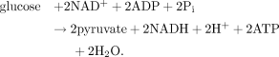
(Source: Chandel, 2021)
(Reaction of glycolysis with net ATP that is 2 ATP generated)
In the absence of oxygen, this pyruvate is converted into lactate and enters the cytosol for further reactions, but this is the only process that can generate ATP in an anaerobic condition. On the other hand, in the presence of oxygen, this pyruvate enters the mitochondria for the TCA cycle and produces ATP. The 10 steps of this reaction can be divided into two parts: the first 5 steps utilise ATP, while the next 5 steps release ATP. The net ATP production in the cycle can be shown by: 4 ATP in the payoff phase, which is in the last five steps, – 2 ATP in the investment phase, which is in the first five steps of glycolysis, = 2 net ATP produced. In erythrocytes, where there are no mitochondria or few mitochondria in the cells, the flux from the glycolysis cycle is so high that it can still generate ATP, and other pathways can be followed.
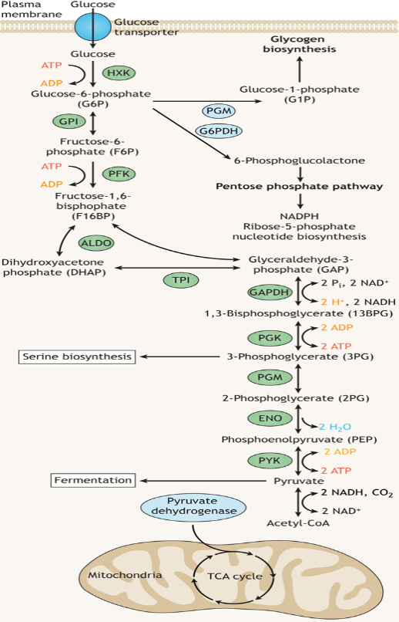
(Source: Fuller and Kim, 2021)
The process of glycolysis is completed in 10 steps, and with all the molecules present in the reaction.
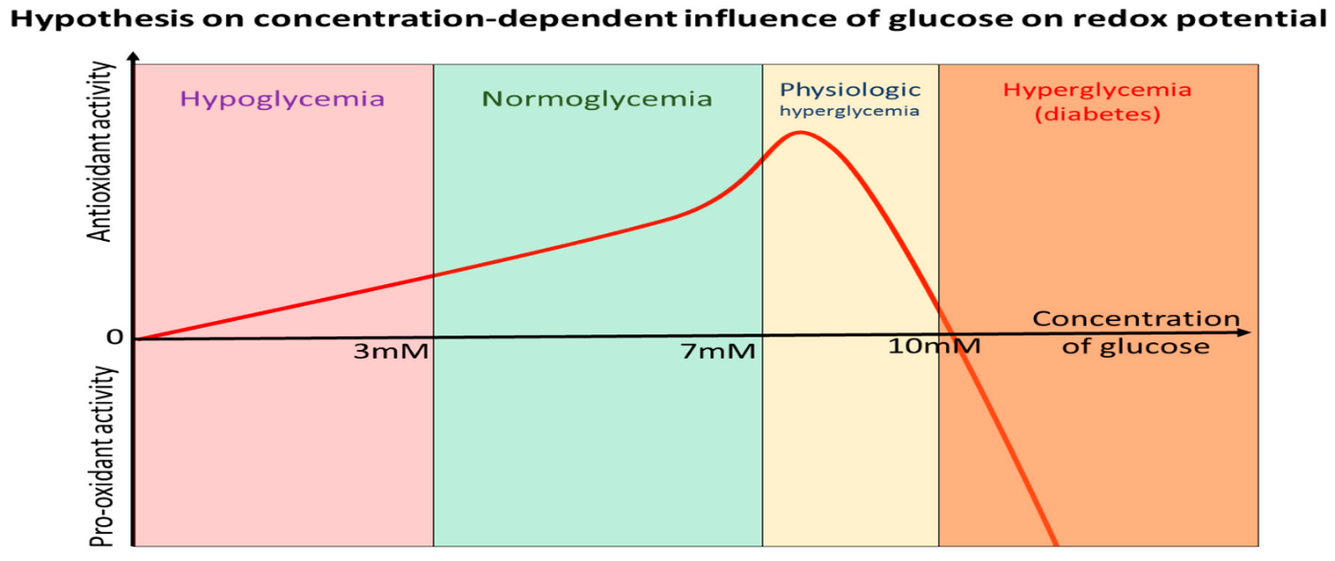
(Source: Cherkas et al., 2021).
The above graph shows the hypothesis on concentration-dependent activity and the influence of glucose on redox potential. The X-axis shows the concentration of glucose at different phases, that is, hypoglycaemia, normal glycemia, physiologic hyperglycaemia and hyperglycaemia, which is a diabetic blood glucose level. The Y-axis shows the oxygen activity, which is the pro-oxidant and anti-oxidant activity of the blood sample taken. A high concentration of glucose is observed in anti-oxidant activity with a pre-diabetic or physiological hyperglycaemia blood sample, basically showing a normal situation.

Management of Type 2 diabetes
Type 2 diabetes is more serious than type 1, causing chronic conditions of the heart and kidneys. Inflammation, infections and amputations are common in people with type 2 diabetes. They are at greater risk for all the other diseases and disorders of the body. Tracking and recording the blood sugar level regularly is more effective than taking glycosylated haemoglobin readings every 4-5 months, which is HbA1c. These readings, though, show the blood sugar levels of the past months, and in normal patients, it is enough to effectively manage and control the symptoms of this disease with medications (Mayeda et al.,2020). But in patients with other chronic illnesses and severe symptoms of diabetes, like ulcers and infections, continuous glucose monitoring is more efficient.
Anything can trigger the symptoms of type 2 diabetes, from weight gain or loss, lack of activity or any changes in diet. Once the disease takes its adverse course, it can even lead to death; continuous blood glucose level management is a better approach towards a good quality of life. Also, taking random blood glucose tests can help check if any change in diet or daily activity is causing a negative effect or a positive one, ensuring proper treatment. The regular checkups for all patients can help make unique treatment plans for them (Proboningsih et al.,2020). The requirements and needs of every human are different depending on their biochemistry and genetics, and the level of disorder in the pancreas. The action and secretion of insulin need to be precise for these patients, either by insulin injections or medications, which need to be administered at the proper time and the exact amount as specified.

Evidence-Based Recommendations for Improvement in diabetes with lifestyle changes
A new pandemic is said to be rising among adults and children in the post-COVID era that is associated with diabetes. After the pandemic, the issues and conditions regarding health and wellness have become serious issues. After COVID, diseases that are chronic in nature are even found in newborns and adults. Diabetes already affects a major part of our immune system, and due to lazy and sedentary lifestyles can become the new pandemic with no cure as of now. Diabetes is a leading cause of death even in children. A very important way to control and manage the symptoms of diabetes is to make a few lifestyle changes. A healthy lifestyle that includes eating healthy, exercising, doing lots of physical activities like playing outdoor games, going on walks, giving up unhealthy habits like smoking and alcohol consumption, and eating lots of fruits and vegetables. For patients suffering from diabetes, walking and looking at their diet can be beneficial to manage the symptoms along with medications like metformin (Galicia-Garcia et al., 2020). Oxidative stress and environmental conditions can also affect patients who are pre-diabetic or have the gene for diabetes.
Type 1 diabetes can easily be controlled with insulin therapy and regular blood checkups. Type 2 diabetes can be managed through oral medications. In the early stages, a few lifestyle changes and moving towards healthy choices can be helpful to avoid the condition overall. An overweight person who is obese is more prone to diabetes and heart conditions along the way. Overall, a physical and active lifestyle, a doctor-advised eating plan and routine, medications and surgical treatment of obesity if required can improve the conditions and symptoms of diabetes. Diabetes is not just a physiological disease but rather a condition triggered by stressful environmental factors; genes do play a major role. But in some people, these genes remain submissive throughout their adult life without triggering any kind of symptoms related to hyperglycaemia. This said, diabetes is a condition that can be managed and controlled on our own without major treatments necessary in acute conditions.
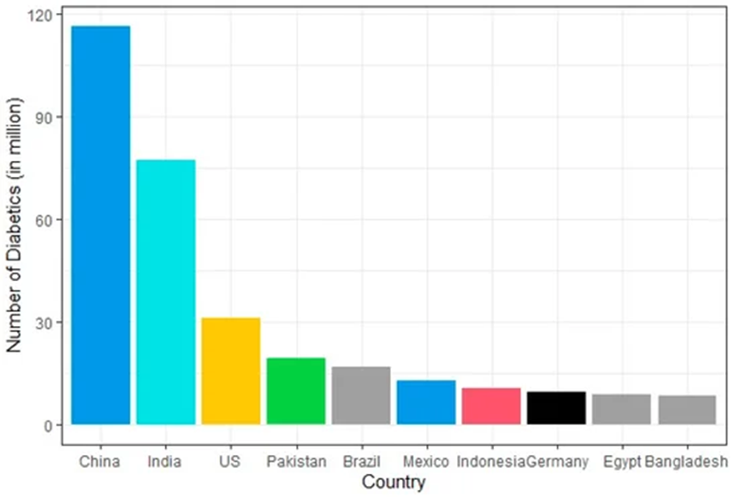
(Source: Alam et al.,2021)
Countries with the highest number of diabetic patients worldwide in 2019, China is in the lead, while Bangladesh showed the lowest number of diabetic patients.

Conclusion
Diabetes is a serious and chronic condition associated with the failure of the body to secrete or make insulin, causing high or low blood sugar levels. In the above assignment, the risk factors like cardiac arrest, kidney failures, inflammation and ulcers were discussed in detail. Also, as type 2 diabetes is more severe than any other type, its management and control with regular checkups need to be considered. Anything can trigger the symptoms of type 2 diabetes, from weight gain or loss, lack of activity or any changes in diet. Once the disease takes its adverse course, it can even lead to death. Regular health checkups and blood tests can help in monitoring the sugar levels. Some other symptoms that signify the sudden changes in blood sugar level are frequent urination, infection, feeling thirsty, poor appetite, abnormal heart rate, and slow response of clotting factors.
The effect can be shown on other organs of the body, such as kidney failure, stroke, cardiac arrest, or arthritis. The importance of glucose and the presence of oxygen in the generation of energy in the form of ATP is discussed, which is the glycolysis cycle. The net production of ATP from these cycles is 2 molecules. A new pandemic is said to be rising among adults and children in the post-COVID era that is associated with diabetes. Diabetes is a leading cause of death even in children. Overall, a physical and active lifestyle, a doctor-advised eating plan and routine, medications and surgical treatment of obesity if required can improve the conditions and symptoms of diabetes. Type 1 diabetes can easily be controlled with insulin therapy and regular blood checkups. Type 2 diabetes can be managed through oral medications. In the early stages, a few lifestyle changes and moving towards healthy choices can be helpful to avoid the condition overall.

References
Alam, S., Hasan, M.K., Neaz, S., Hussain, N., Hossain, M.F. and Rahman, T., 2021. Diabetes mellitus: insights from epidemiology, biochemistry, risk factors, diagnosis, complications and comprehensive management. Diabetology, 2(2), pp.36-50.https://www.mdpi.com/2673-4540/2/2/4
Chandel, N.S., 2021. Glycolysis. Cold Spring Harbour Perspectives in Biology, 13(5), p.a040535. https://cshperspectives.cshlp.org/content/13/5/a040535.full
Cherkas, A., Holota, S., Mdzinarashvili, T., Gabbianelli, R. and Zarkovic, N., 2020. Glucose as a major antioxidant: when, what for and why it fails?. Antioxidants, 9(2), p.140. https://www.mdpi.com/2076-3921/9/2/140
Fuller, G.G. and Kim, J.K., 2021. Compartmentalisation and metabolic regulation of glycolysis. Journal of Cell Science, 134(20), p.jcs258469. https://journals.biologists.com/jcs/article/134/20/jcs258469/272535/Compartmentalization-and-metabolic-regulation-of
Galicia-Garcia, U., Benito-Vicente, A., Jebari, S., Larrea-Sebal, A., Siddiqi, H., Uribe, K.B., Ostolaza, H. and Martín, C., 2020. Pathophysiology of type 2 diabetes mellitus. International journal of molecular sciences, 21(17), p.6275. https://www.mdpi.com/1422-0067/21/17/6275
Jwad, S.M. and Al-Fatlawi, H.Y., 2022. Types of diabetes and their effect on the immune system. J Adv Pharm Pract, 4(1), pp.21-30.https://www.researchgate.net/profile/Drsaher-Jawd-2/publication/361379433_Types_of_Diabetes_and_their_Effect_on_the_Immune_System/links/62acf4d923f3283e3af0849d/Types-of-Diabetes-and-their-Effect-on-the-Immune-System.pdf
Hantzidiamantis, P.J., Awosika, A.O. and Lappin, S.L., 2024. Physiology, glucose. In StatPearls [Internet]. StatPearls Publishing. https://europepmc.org/article/NBK/nbk560599
Kumar, R., Itumalla, R., Perera, B., Elabbasy, M.T. and Singh, M., 2022. Patient knowledge about diabetes: Illness symptoms, complications and preventive personal lifestyle factors. Health Psychology Research, 10(3), p.37520. https://pmc.ncbi.nlm.nih.gov/articles/PMC9392845/
Mathew, T.K., Zubair, M. and Tadi, P., 2023. Blood glucose monitoring.https://europepmc.org/article/nbk/nbk555976
Mayeda, L., Katz, R., Ahmad, I., Bansal, N., Batacchi, Z., Hirsch, I.B., Robinson, N., Trence, D.L., Zelnick, L. and De Boer, I.H., 2020. Glucose time in range and peripheral neuropathy in type 2 diabetes mellitus and chronic kidney disease. BMJ open diabetes research & care, 8(1). https://drc.bmj.com/content/8/1/e000991
Moses, J.C., Adibi, S., Wickramasinghe, N., Nguyen, L., Angelova, M. and Islam, S.M.S., 2024. Non-invasive blood glucose monitoring technology in diabetes management. Mhealth, 10, p.9. https://pdfs.semanticscholar.org/8644/4508c5b158b5d6b8a511d846f277c3f92218.pdf
Proboningsih, J., Joeliantina, A., Novitasari, A. and Purnamawati, D., 2020. Complementary treatment to reduce blood sugar levels of type 2 diabetes mellitus patients. International Journal of Public Health Science (IJPHS), 9(3), p.267. https://www.academia.edu/91922904/Complementary_treatment_to_reduce_blood_sugar_levels_of_type_2_diabetes_mellitus_patients
Sarkar, B.K., Akter, R., Das, J., Das, A., Modak, P., Halder, S., Sarkar, A.P. and Kundu, S.K., 2019. Diabetes mellitus: A comprehensive review. Journal of Pharmacognosy and Phytochemistry, 8(6), pp.2362-2371. https://www.academia.edu/download/104032269/8-6-233-163.pdf
Sharma, M., Bains, A. and Chawla, P., 2026. Why and when does one have high blood sugar?. In Diabetes and Neurodegeneration (pp. 3-12). Academic Press. https://www.sciencedirect.com/science/chapter/edited-volume/abs/pii/B9780443333552000025

