

Student name: Ahmed Ahmed
Student number: 2436755
Module name: Digital Skills for Personal Development and Business Growth
Module code: BMSW4008
Lecture name: Dr. Gareth Hughes

AI Acknowledgement
I confirm that I have not presented any AI generated materials as my own work.
I confirm that I have copies of my drafts, notes, and other resources I used, which I may be asked to provide in evidence.

Task 1:

Data Analysis Report

1. Executive Summary
This report looks at poll data from possible buyers in Swansea to come up with a launch plan for Trusted Wheels, a new used car shop that just opened. The results show a mature market group that trusts and values the state of vehicles more than anything else (Ennew, Waite, & Waite, 2017). For example, Prabhala and Bose (2025) found that confidence is linked to both searching for information online and buying a car. While there is a desire for standard fuels, demand for hybrids is important, suggesting a market in change (SMMT, 2026). The data suggests that a business model built on transparency, quality assurance, and a strong digital presence—specifically local SEO—will be most effective in attracting consumers who are increasingly seeking trustworthy information and making informed purchasing decisions in the evolving car market (Localise, 2026).
2. Introduction
According to ICDP (2025), the used car market is changing because people are choosing different types of fuel. Trusted Wheels is a new business in Swansea that needs to base its plan on what people in the area know. Kotler and Keller (2016) stress that knowing the customer is the first step to effective marketing. This study looks at poll data to help Trusted Wheels come up with a plan that is based on data.
3. Key Findings and Analysis
3.1 Market Maturity: The "Experienced Buyer"
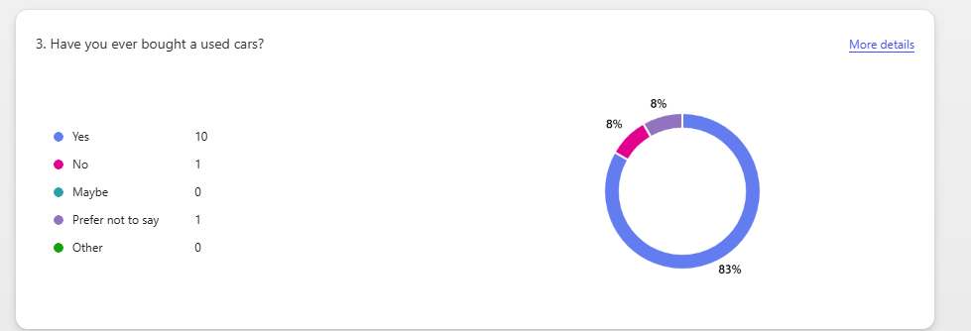
Survey Question 3: "Have you ever bought a used car?"
Data: 10 respondents answered "Yes," 1 answered "No," and 1 chose "Prefer not to say." The result translates to 83% having prior experience.
Analysis: The Swansea group is mostly made up of experienced, return buyers, which is different from larger trends where younger people enter the market for the first time (Capgemini, 2025).
Significance to Trusted Wheels: High-pressure methods are unlikely to sway this smart crowd. What they decide is based on faith, worth, and state (Chaffey and Ellis-Chadwick, 2019). To gain the trust of this picky group, Trusted Wheels needs to present itself as an improvement by providing a better, more open service that focuses on dependability and customer happiness. Research shows that how active customers are online has a big effect on their decisions to buy cars in person (Zhao, Liu, and Zhu, 2025).
3.2 The Dominance of "Condition" and Trust
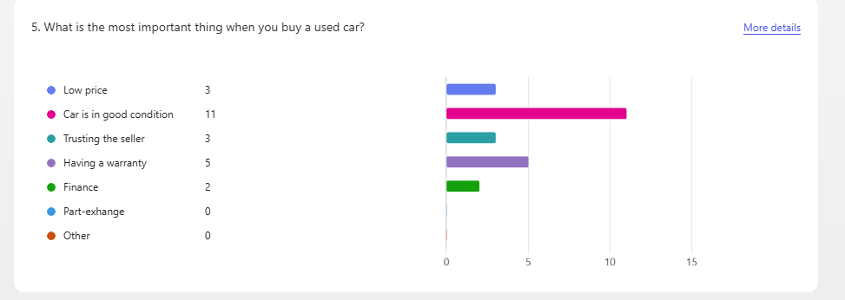
Survey Question 5: "What is the most important thing when you buy a used car?"
Data: Good condition (11), Warranty (5), Low Price (3), Trusting the seller (3), and Finance (2).
Analysis: Buyers value dependability, as shown by data from What Car? (2025), so "good condition" is the most important thing. Along with "trusting the seller" and "warranty," 18 of the 24 people who answered the survey put "risk reduction" first. This disparity is like the information gap that Akerlof studied in 1970, where the seller knows more about the quality of the car than the buyer. Consumers really value inspection services, and they have a big impact on their decisions about what to buy (Fu et al., 2025).
Significance to Trusted Wheels: It's not enough for the business to offer low prices. To become a "Trusted Dealer" in Swansea must be the goal (Ennew, Waite, and Waite, 2017). These standard backs up the name Trusted Wheels, which means that "good condition" must be proven through thorough checks and a guarantee.
3.3 Price Point Reality
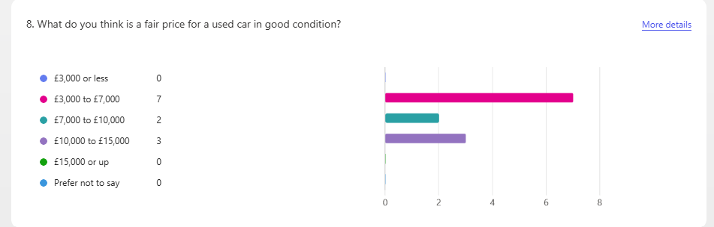
Survey Question 8: "What is a fair price for a used car in good condition?"
Data: £3,000-£7,000 (7), £10,000-£15,000 (3), £7,000-£10,000 (2).
Analysis: Reports show that there is a market for cars priced under £10,000. However, the Swansea data indicates that the largest group of cars falls within the price range of £3,000 to £7,000, while the second largest group is priced between £10,000 and £15,000. This number shows that the market is split in two.
Significance to Trusted Wheels: The initial stock must have many items priced between £3000 and £7000. A smaller, carefully chosen group of more expensive cars can be used to test the premium market without putting too much money at risk (Kotler and Keller, 2016).
3.4 Fuel Type Preferences
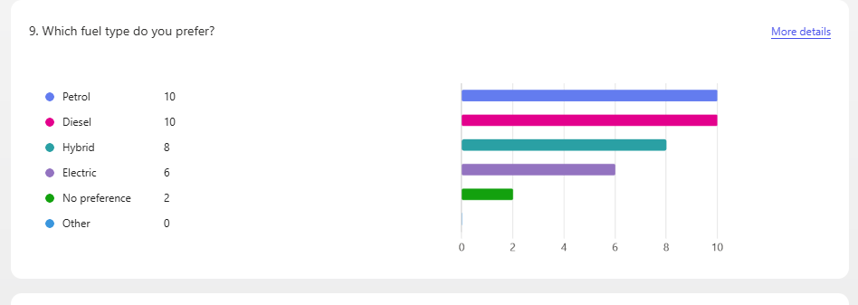
Survey Question 9: "Which fuel type do you prefer?"
Data: Petrol (10), Diesel (10), Hybrid (8), Electric (6), No preference (2).
Analysis: The most noticeable trend is the high desire for blends (8). Electric and hybrid options total 14, the same as petrol. Iogansen et al.'s (2026) research shows that people who buy electric cars often have different sociodemographic profiles and face different usage obstacles.
Significance to Trusted Wheels: It is important to have a large selection of hybrid cars. Because people are worried about how reliable batteries are (Auto Trader, 2026), the promise of "good condition" must include guarantees on the health of hybrid and electric batteries.
4. Audience Segmentation:
There are two main groups of customers:
1. The Value-Seeking Pragmatist (Primary): budgeted £3,000 to £7,000 and likes petrol or diesel. The guarantee and "good condition" are crucial.
2. The Eco-Friendly Early Adopter (Growing): budgets between £10,000 and £15,000 and chooses hybrid or electric cars. Low pollution and excellent petrol mileage are the main things that drive this market area. People also need to be sure that their batteries are healthy. Le (2025) says that digital brands and real messages about sustainability are becoming more important for reaching this group.
5. Influence on Business Concept and Marketing
The results have a direct effect on the Trusted Wheels idea, which is in line with their slogans "Drive Your Dream", "Quality Pre-Owned Vehicles", and "12-MONTH WARRANTY".
Business Concept: Set up as "The Trusted Choice in Swansea." You can get "Quality Pre-Owned Vehicles" with a "12-MONTH WARRANTY" and "FINANCE AVAILABLE" as the main deal. This idea immediately fights the "lemon problem" (Akerlof, 1970).
Marketing Strategy:
Local SEO: The main plan of action. Autocorp.ai (2026) says that the Google Business Profile will be tweaked so that it ranks "Trusted Wheels Swansea" and "used car dealer Swansea." According to LocatiQ (2025), having the same information in all local ads builds ties and improves an online image.
6. Conclusion
The poll results provide Trusted Wheels a clear road plan. The market puts trust and the state of the car first (Akerlof, 1970). A brand name, slogan, and list of services that say, "Drive Your Dream", "12-Month Warranty", and "Finance Available" all perfectly match these goals. Trusted Wheels can become the company people in Swansea trust by focusing on Local SEO (Chaffey and Ellis-Chadwick, 2019) and building a model on openness.

References
Akerlof, G.A. (1970) 'The Market for "Lemons": Quality Uncertainty and the Market Mechanism', *The Quarterly Journal of Economics*, 84(3), pp. 488-500. doi: 10.2307/1879431.

Auto Trader (2026) *2026 Used Car Market Report*. Manchester: Auto Trader Limited.

Autocorp.ai (2026) 'How to Rank for "Used Cars Near Me"'. Available at: https://autocorp.ai/blog/how-to-rank-for-used-cars-near-me (Accessed: 11 March 2026).

Capgemini (2025) *Automotive Digital Transformation Report 2025*. Paris: Capgemini Research Institute.

Chaffey, D. and Ellis-Chadwick, F. (2019) *Digital Marketing: Strategy, Implementation and Practice*. 7th edn. Harlow: Pearson.

Ennew, C., Waite, N. and Waite, R. (2017) *Financial Services Marketing: An International Guide to Principles and Practice*. 2nd edn. Abingdon: Routledge.

Fu, X., Kang, W., Wang, H. and Han, X. (2025) 'Eliciting consumer preferences for used vehicle e-commerce platforms: A discrete choice experiment approach', *Research in Transportation Economics*, 113. doi: 10.1016/j.retrec.2025.101246.

ICDP (2025) *European Used Car Market Trends 2025-2030*. London: ICDP.

Iogansen, X., Gore, C., Kneifel, J., Lakshmipuram Ranganath, S. and Helveston, J. (2026) 'Consumers' perceptions, knowledge, and adoption patterns of battery electric vehicles', *Transportation Research Part D: Transport and Environment*, 148. doi: 10.1016/j.trd.2025.105194.

Kotler, P. and Keller, K.L. (2016) *Marketing Management*. 15th edn. Harlow: Pearson Education.

Le, N.T. (2025) *Digital Branding and Sustainable Business Models: The Case of the Automotive Sector*. Master's thesis. Università degli Studi di Padova. Available at: https://hdl.handle.net/20.500.12608/94391 (Accessed: 11 March 2026).

LocaliQ (2025) 'How Local Listings Can Improve Your Dealership's SEO'. Available at: https://localiq.com/blog/listings-management/how-local-listings-can-boost-your-dealerships-seo/ (Accessed: 11 March 2026).

Localise (2026) 'How UK Car Dealerships Can Win Local Search in 2026'. Available at: https://localise.co.uk/how-uk-car-dealerships-win-local-search-2026/ (Accessed: 11 March 2026).

Prabhala, M. and Bose, I. (2025) 'Look Before you Leap! The Impact of Trust, Uncertainty, and Topics of Reviews on Search and Sales of Cars', *Information Systems Frontiers*, 27(4), pp. 1739-1757. doi: 10.1007/s10796-024-10552-4.

SMMT (2026) *UK New Car and Light Commercial Vehicle Registrations - February 2026*. London: The Society of Motor Manufacturers and Traders.

What Car? (2025) *What Car? Reliability Survey 2025*. London: Haymarket Automotive.

Zhao, L., Liu, C. and Zhu, Y. (2025) 'The impact of online marketing communication on offline sales: Evidence from a new energy vehicle brand', *Journal of Business Research*, 189. doi: 10.1016/j.jbusres.2025.115173.
Appendix


(Canva,2026)
Appendix

(Canva,2026)
Appendix

(Copilot,2026)

Appendix
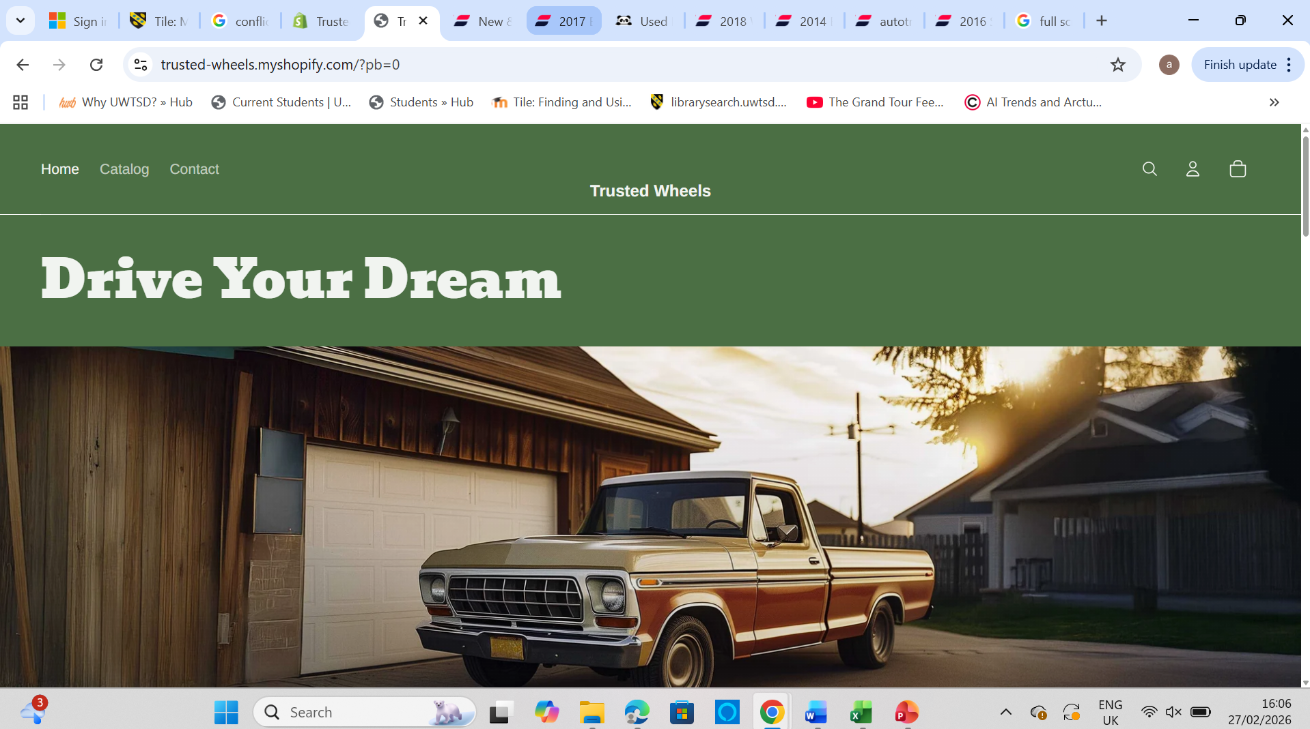
(Shopify,2026)
Appendix
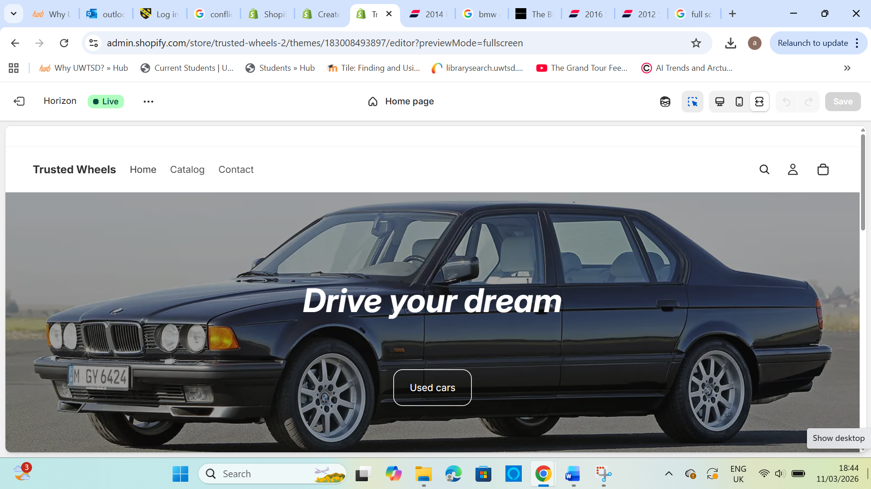
(Shopify,2026)

Task 2:

Student name: Ahmed Ahmed
Student number: 2436755
Module name: Digital Skills for Personal Development and Business Growth
Module code: BMSW4008
Lecture name: Dr. Gareth Hughes

AI Acknowledgement
I confirm that I have not presented any AI generated materials as my own work.
I confirm that I have copies of my drafts, notes, and other resources I used, which I may be asked to provide in evidence.

Importance of Excel in the Digital Era.

Currently of huge amounts of data, AI, and advanced cloud-based platforms, the PC spreadsheet might seem like something that no one needs anymore. Even so, Microsoft Excel, a program that is more than 40 years old, has survived and changed a lot, making it an even more important tool in the digital age. Excel is important for a lot more than just keeping the books. It's a flexible way to access data analysis, an important teaching tool for getting students ready for work, and a surprisingly powerful platform for advanced analytics. The fact that it is still useful shows how flexible, easy to access, and deeply ingrained it is in modern business and schooling.
Excel is brilliant because it can be both an easy-to-use tool for people and a complicated engine for analysing data for businesses. It makes data accessible to everyone, letting people at all levels of an organization do more than just receive information; they can also change it and get new insights. Kumiega (2024) says that Excel has quietly changed from a "simple ledger automation tool" to what is more correctly called an Integrated Development Environment (IDE) for analytics. Because of this change, Excel now has a fully working database, an OLAP engine, and access to several statistical computer languages and third-party tools inside its familiar grid. This simple framework, which started out as a digital record (Kumiega, 2025), now lets users do complex financial studies and even make predictive models using machine learning ideas. Many people don't see Excel as the powerful finance or analytics tool it has become because of how smoothly it has changed over time.
In the business world, this feature is most useful and notable for its usefulness. A Microsoft representative said that the number of people using Excel every month has steadily increased over the past six years (BBC News, 2026) and that it is still the standard tool for data analysis, planning, and reports across all fields. Small and medium-sized businesses (SMEs) need it more than anyone else. Elva (2025) talks about how Excel can be used strategically to make businesses more efficient. This fact is especially true in areas like financial planning, operational control, and human resource management, where being accessible and flexible are key to the flexibility of an organisation. Business intelligence tools are becoming more popular in high-stakes situations like mergers and acquisitions due diligence. However, Excel is still "indispensable" because it can do flexible, quick, and custom analyses that pre-packaged software can't easily copy (Jylhä, 2025). Many people use Excel all the time; in fact, tests indicate that two-thirds of office workers use it at least once an hour (BBC News, 2026).
In addition to the business world, Excel is also essential for schooling and building up the workforce. These days, knowing how to use data is an important skill, and Excel is the best way to teach kids how to handle and analyse data. Solehah et al.'s research from 2025 shows that it works well in schools for jobs like keeping track of student attendance and grades, which makes administration more efficient and data more accurate. More importantly, being able to use Excel well is a big part of how ready a student is for work. According to Kirsten, van Hoepen, and du Toit (2025), an Excel workshop focused on finance significantly improved students' skills and their perception of those skills. Most of them saw it as an important skill in today's competitive job market. As Kirsten et al. (2025) say, employers are always saying that grads don't have enough maths skills. To bridge the gap between school and work, Excel must be added to the curriculum. Through automating repeated numbers (Cory & Pruske, 2012; Kirsten et al., 2025), it goes beyond memory and helps students solve difficult problems and focus on figuring out what the results mean.
The tool is also useful for the most advanced college study. Chien's latest study (2025) presented "10 Steps in Excel for WoS", a new system that uses Visual Basic for Applications (VBA) in Excel to make difficult bibliometric analysis easier. Researchers can now use this new feature to organise data, make performance reports, and make complex visualisations from Web of Science data right in Excel. Usually, they would need to use more specific software to do these things. This project shows how Excel's ability to be programmed and adaptable lets it handle the complex needs of modern research. It also provides a clear and repeatable process that improves the quality of academic study.
In conclusion, Microsoft Excel is essential in this modern world for many reasons. It is used as a school lesson, a business tool, and a study site all at the same time. Excel is vital for digital literacy and navigating a data-driven world. This case shows that true adaptability is always important, no matter the time.

Reference List
BBC News (2026) 'Excel: The software that's hard to quit', BBC News, 9 January. Available at: https://www.bbc.com/news/articles/cwyxkzjpp87o (Accessed: 27 February 2026).
Chien, S.-Y. (2025) '10StepsinExcelforWoS: Streamlining bibliometric analysis in web of science using Microsoft excel', SoftwareX, 32, p. 102403. doi: 10.1016/j.softx.2025.102403.
Cory, S.N. and Pruske, K.A. (2012) 'Necessary skills for accounting graduates: An exploratory study to determine what employers seek', cited in Kirsten, E., van Hoepen, R. and du Toit, E. (2025) 'Can MS Excel help finance students to excel? A study in student work readiness', South African Journal of Higher Education, 39(3).
Elva, A.A. da S. (2025) 'Technology in Business Management: leveraging tools like Microsoft Excel to enhance corporate efficiency', Brazilian Journal of Development, 11(5). doi: 10.34117/bjdv11n5-081.
Jylhä, J. (2025) Transforming M&A Due Diligence: Evaluating the Role of Business Intelligence Tools in Replacing Excel-Based Analysis. Master's thesis. Aalto University. Available at: https://aaltodoc.aalto.fi/items/1e532b72-898a-4700-803f-4cc048cde0cd/full (Accessed: 27 February 2026).
Kirsten, E., van Hoepen, R. and du Toit, E. (2025) 'Can MS Excel help finance students to excel? A study in student work readiness', South African Journal of Higher Education, 39(3). doi: 10.20853/39-3-6383.
Kumiega, A. (2024) 'Excel: Automated Ledger or Analytics IDE?', arXiv preprint, arXiv:2409.12976. Available at: https://ui.adsabs.harvard.edu/abs/2024arXiv240912976K/abstract (Accessed: February 2026).
Kumiega, A. (2025) 'Automated Ledger or Fintech Analytics Platform?', FinTech, 4(2), p. 14. doi: 10.3390/fintech4020014.
Solehah, N. et al. (2025) 'Use of Microsoft Excel as Student Value and Data Management at SDIT Al Uswah Pamekasan', Widyagogik: Jurnal Pendidikan dan Pembelajaran Sekolah Dasar, 13(1). doi: 10.21107/widyagogik.v13i1.30184.

Appendix

Task 3:
Video link
https://www.canva.com/design/DAHDwcPtLDo/UEPOz3tLHppyGgGUZ9G2Qw/watch?utm_content=DAHDwcPtLDo&utm_campaign=designshare&utm_medium=link2&utm_source=uniquelinks&utlId=h282b1e8bb7

