

LOCATION: Swansea | LLEOLIAD: abertawe
LEVEL 6 | LEFEL 6
EXAMINATION PERIOD | CYFNOD ARHOLIADAU
JAN 2019 | Ionawr 2019

MODULE CODE: m6x01084
ADVANCED ROUTING
TIME: 2 HOURS
answer ALL quESTIONs IN SECTION A

answer TWO quESTIONs out of THREE in SECTION B

Equipment or materials required – None
Adnoddau neu ddefnyddiau sydd eu hangen - Dim

SECTION A: ANSWER ALL QUESTIONS

- What is the term that is used for the area of a network that is affected when a device or network service experiences problems?
- Failure domain
- Collision domain
- Broadcast domain
- User domain

- What is the function of STP in a scalable network?
- It decreases the size of the failure domain to contain the impact of failures.
- It protects the edge of the enterprise network from malicious activity.
- It disables redundant paths to eliminate Layer 2 loops.
- It combines multiple switch trunk links to act as one logical link for increased bandwidth.

- What are two requirements when using out-of-band configuration of a Cisco IOS network device? (Choose two.)
  - HTTP access to the device
  - a terminal emulation client
  - Telnet or SSH access to the device
  - a direct connection to the console or AUX port
  - a connection to an operational network interface on the device

- What are three characteristics of VTP? (Choose three.)
  - In the default VTP mode, VLANs can be created and modified on a switch.
  - Switches in VTP server mode store VLANs in the vlan.dat database.
  - VTP-enabled switches exchange three types of advertisements: summary routes, subnet advertisements, and advertisement requests from transparent bridges.
  - The switch configuration must be saved and the switch reloaded to reset a configuration revision number.
  - VTP updates are exchanged across trunk links only.
  - Switches in different VTP domains can exchange updates if revision numbers are the same.

- What is the purpose of the vlan.dat file on a switch?
  - It holds the running configuration.
  - It holds the saved configuration.
  - It holds the VLAN database.
  - It holds the operating system.

- A network administrator is planning to add a new switch to the network. What should the network administrator do to ensure the new switch exchanges VTP information with the other switches in the VTP domain?
  - Configure the correct VTP domain name and password on the new switch.
  - Associate all ports of the new switch to a VLAN that is not VLAN 1.
  - Configure the VLANs on the new switch.
  - Configure all ports on the new switch to access mode.

- What eliminates switching loops?
  - hold-down timers
  - poison reverse
  - Spanning Tree Protocol
  - Time to Live
  - VTP

- What is the value used to determine which port on a non-root bridge will become a root port in a STP network?
  - the highest MAC address of all the ports in the switch
  - the lowest MAC address of all the ports in the switch
  - the VTP revision number
  - the path cost

- Which three STP states were replaced with the RSTP discarding state? (Choose three.)
  - Listening
  - Learning
  - Blocking
  - Disabled
  - forwarding

- A network administrator enters the spanning-tree portfast bpduguard default command. What is the result of this command being issued on a Cisco switch?
  - Any switch port will be error-disabled if it receives a BPDU.
  - Any trunk ports will be allowed to connect to the network immediately, rather than waiting to converge.
  - Any switch port that has been configured with PortFast will be error-disabled if it receives a BPDU.
  - Any switch port that receives a BPDU will ignore the BPDU message.

- Which command will start the process to bundle two physical interfaces to create an EtherChannel group via LACP?
  - channel-group 2 mode auto
  - interface port-channel 2
  - channel-group 1 mode desirable
  - interface range GigabitEthernet 0/4 – 5

- Refer to the exhibit. A network administrator is reviewing the configuration of switch S1. Which protocol has been implemented to group multiple physical ports into one logical link?
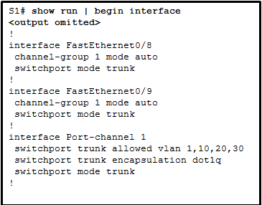
  - PAgP
  - DTP
  - LACP
  - STP

- When EtherChannel is configured, which mode will force an interface into a port channel without exchanging aggregation protocol packets?
  - active
  - auto
  - on
  - desirable

- A network administrator is analyzing the features that are supported by different first-hop router redundancy protocols. Which statement describes a feature that is associated with HSRP?
  - HSRP uses active and standby routers.
  - It uses ICMP messages in order to assign the default gateway to hosts.
  - It allows load balancing between a group of redundant routers.
  - HSRP is nonproprietary.

- What type of packets are sent when there is a change in the EIGRP topology?
  - Hello
  - Triggered bounded update
  - Acknowledge
  - Reply

- Refer to the exhibit. A network administrator has configured OFPF in the topology as shown. What is the preferred path to get from the LAN network that is connected to R1 to the LAN network that is connected to R7?
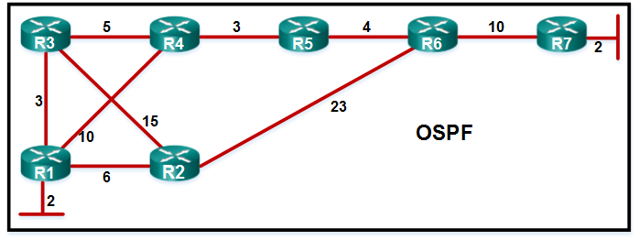
  - R1-R3-R4-R5-R6-R7
  - R1-R3-R2-R6-R7
  - R1-R2-R6-R7
  - R1-R4-R5-R6-R7

- What does the SPF algorithm consider to be the best path to a network?
  - The path with the least number of hops.
  - The path with the smallest delays.
  - The path that includes the fastest cumulative bandwidth links.
  - The path that includes the fastest single bandwidth link.

- What indicates to a link-state router that a neighbor is unreachable?
  - if the router no longer receives routing updates
  - if the router no longer receives hello packets
  - if the router receives an update with a hop count of 16
  - if the router receives an LSP with previously learned information

- What capability do protocol-dependent modules provide to the EIGRP routing protocol?
  - route different Layer 3 protocols
  - exchange summary routes between areas
  - combine routes learned from different protocols into a single routing table
  - load balance between routing protocols
- Which statement describes the autonomous system number used in EIGRP configuration on a Cisco router?
  - It carries the geographical information of the organization.
  - It functions as a process ID in the operation of the router.
  - It is a globally unique autonomous system number that is assigned by IANA.
  - It identifies the ISP that provides the connection to network of the organization.

- An EIGRP router loses the route to a network. Its topology table contains two feasible successors to the same network. What action will the router take?

  - The DUAL algorithm is recomputed to find an alternate route.
  - The router uses the default route.
  - The best alternative backup route is immediately inserted into the routing table.
  - The router will query neighbors for an alternate route.

- Which command will configure an IPv6 default static route?
  - router(config)# ipv6 ::/64 s0/0/0
  - router(config-rtr)# redistribute static
  - router(config)# ipv6 route ::/0 s0/0/0
  - router(config)# ipv6 unicast-routing

- What routing protocol can be configured to load balance across paths with unequal metrics through the use of the variance command?
  - EIGRP
  - OSPF
  - OSPFv3
  - RIPng

- In an OSPFv2 configuration, what is the effect of entering the command network 192.168.1.1 0.0.0.0 area 0?
  - It changes the router ID of the router to 192.168.1.1
  - It enables OSPF on all interfaces on the router.
  - It tells the router which interface to turn on for the OSPF routing process.
  - It allows all 192.168.1.0 networks to be advertised.

- What information is contained in OSPF type 3 LSAs?
  - networks reachable in other areas
  - networks learned from other routing protocols
  - the router ID of the DR to all routers in the area
  - the router ID of an ASBR and the route to reach it

SECTION B: ANSWER TWO QUESTIONS OUT OF THREE

  - In reference to EIGRP routing protocol, briefly explain the following:
    - Neighbor table
    - Topology table
    - Routing table
    - Advertised distance
    - Feasible distance
(10 Marks)

  - Explain the operation of HSRP in brief. (4 marks)

  - Explain convergence by describing operation of a dynamic routing protocol. (5 marks)

  - Refer to figure 1 below, EIGRP protocol has been configured on all routers. Router R1 is sending an update about 10.0.0.0/8 to R2. What issue will be caused by this update? How would you solve it? (6 marks)

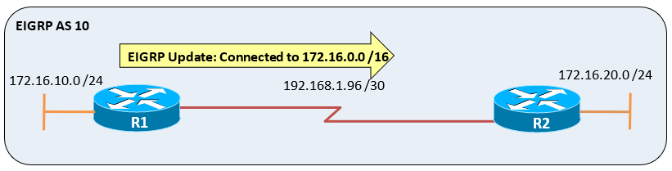
Figure 1

  - Extensive LSAs consume lots of bandwidth and create chaotic traffic. What solution does OSPF offer to solve this problem? Explain the function of DR and BDR?
(10 marks)
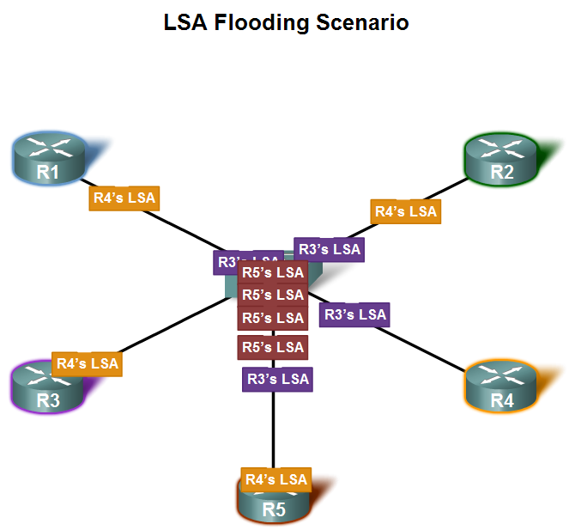
Figure 2
  - Write the commands to configure EIGRP for IPv6 before linking the process to the interfaces. (4 marks)

  - With the use of network shown below in figure 3; explain floating static route and write down the commands to create floating static route on R1 and R2 that floats above the EIGRP learned routes. (11 marks)
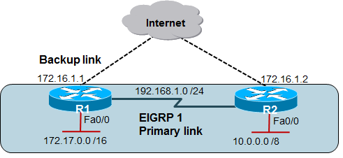
Figure 3

  - You have been asked to advise on a consultancy project for a company that is growing its network. The company has 7 sites and multiple sub-networks are operational in each site. They are looking to choose between EIGRP and OSPF as their dynamic routing protocol. Which would you recommend? Justify your choice by comparing the two mentioned routing protocols.
(10 marks)

  - Name and briefly discuss the OSPF operational states briefly. (14 marks)

  - What is the purpose of configuring passive interfaces? (1 mark)

Diwedd/End

