April 1, 2024
Cheng Chen (2305261)
University of Wales Trinity Saint David
BSc Applied Computing
Analyse the networks and discuss its security postures
L4 - Network and Cybersecurity Essentials (ACCA4024)
Contents
Abstract: 2
Introduction: 2
Part 1: 3
a) The Vital Role of the NIST Cybersecurity Framework in Safeguarding Digital Assets and Personal Data. 3
b) As stated in the introduction, Reconnaissance is the first stage in the “cyber kill chain” used by cybercriminals to gather pertinent information about their target. 4
c) Cyber – Attacks and Mitigations strategies 7
i) WannaCry and TeleRAT Malware: Operation and Mitigation 7
ii) Whaling and Pharming Phishing Attacks: Implementation and Mitigation 8
Part 2: 10
a) Using a network diagram (topology) or illustrations, create a secure network design 10
b) The software and hardware technologies can be implemented to enhance network security during its operation 12
Complete “Introduction to Packet Tracer” 13
Complete all the 5 Module Exams and Final Exam for Palo Alto Network Security Fundamentals 13
Conclusion: 15
Recommendations: 15
Future Work: 16
References 17

Abstract:
This paper delves into the realm of cybersecurity, zeroing in on the basic undertaking of protecting advanced resources and individual information today. It begins by outlining the ever-evolving issues and opportunities in the field and stresses the importance of having the necessary skills and knowledge. The National Institute of Standards and Technology (NIST) Online protection System arises as a vital device in accomplishing the general goal of defending computerized resources and individual information. Further, the paper explores the reconnaissance stage of cyber-attacks, highlighting the utilization of tools such as Nmap and Wireshark to gather pertinent information about targets. Additionally, it examines prevalent cyber-attacks like WannaCry and TeleRAT, elucidating their operational mechanisms and proposing effective mitigation strategies. Furthermore, the execution of phishing assaults known as Whaling and Pharming is talked about close by relief procedures. In the last option section, a safe organization configuration is introduced, consolidating plan standards zeroed in on accomplishing high accessibility. Finally, software and hardware technologies aimed at enhancing network security during operation are detailed, ensuring comprehensive protection against cyber threats.

Introduction:
Safeguarding digital assets and personal data has become paramount in contemporary society. With the proliferation of cyber threats, understanding cybersecurity and its multifaceted challenges is crucial. This paper aims to explore various aspects of cybersecurity, from the utilization of the NIST Cybersecurity Framework to the implementation of reconnaissance tools like Nmap and Wireshark. Additionally, it delves into prevalent cyber-attacks such as WannaCry and TeleRAT, elucidating mitigation strategies. Furthermore, phishing attacks, including Whaling and Pharming, are examined alongside effective countermeasures. The paper also presents a secure network design, putting an emphasis on high availability by eliminating single points of failure and providing dependable crossover. At last, it talks about programming and equipment advances pointed toward reinforcing network security during activity.

Part 1:

a) The Vital Role of the NIST Cybersecurity Framework in Safeguarding Digital Assets and Personal Data.
The NIST cybersecurity framework is a powerful tool to organize and improve your cybersecurity program. [1] The National Institute of Standards and Technology (NIST) The modern landscape of cybersecurity relies heavily on the Cybersecurity Framework, particularly for the protection of digital assets and personal data. The NIST framework is a comprehensive guide and road map for businesses to effectively improve their cybersecurity posture in a time of evolving cyber threats and rapid technological advancements.

The NIST Cybersecurity Framework provides a standardized approach to cybersecurity risk management. It offers a common language and set of best practices that enable organizations, regardless of size or industry, to assess and mitigate cyber risks systematically. By following the framework's guidelines, organizations can identify and prioritize their cybersecurity needs, thus facilitating the development of tailored strategies to safeguard their digital assets and personal data.
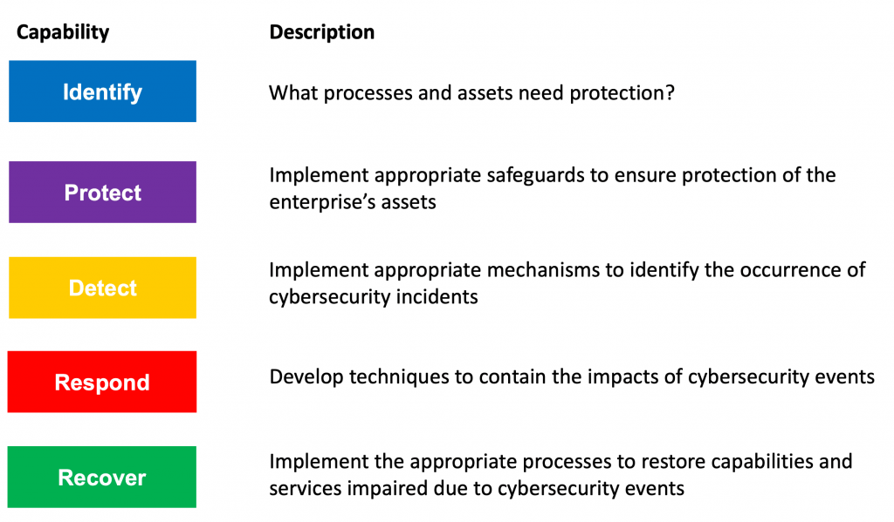
NIST Cybersecurity Framework [2]
The NIST framework emphasizes the importance of risk-based decision-making. In the present powerful danger scene, where digital dangers are continually developing and turning out to be more complex, associations should take on a proactive way to deal with network safety. The system urges associations to direct standard gamble evaluations, recognize likely weaknesses, and execute fitting controls to really alleviate chances. The NIST framework enables organizations to make informed decisions about resource allocation and risk prioritization, thereby enhancing their capacity to safeguard digital assets and personal data, by aligning cybersecurity efforts with the organization's overall risk management strategy.

One more key part of the NIST Network safety System is its accentuation on joint effort and data sharing. In today's interconnected world, cyber threats often transcend organizational boundaries, necessitating collaboration among various stakeholders, including government agencies, industry partners, and cybersecurity professionals. The framework promotes collaboration by providing a common set of cybersecurity principles and guidelines that facilitate communication and information sharing among stakeholders. By fostering collaboration, the NIST framework enables organizations to leverage collective expertise and resources to address cybersecurity challenges more effectively, thereby enhancing the overall security posture of the ecosystem.

The NIST framework promotes continuous improvement and adaptation to evolving threats and challenges. Cybersecurity is a constantly evolving field, with new threats emerging regularly and existing threats evolving in sophistication. The framework emphasizes the importance of ongoing monitoring, evaluation, and adjustment of cybersecurity strategies and controls to address emerging threats effectively. By adopting a continuous improvement mindset, organizations can stay ahead of cyber threats and adapt their cybersecurity measures to mitigate new risks effectively.

By establishing a standard approach to cybersecurity risk management and encouraging risk-based decision-making, the NIST Cybersecurity Framework contributes significantly to the current dominant goal of protecting digital assets and personal data. fostering collaboration and information sharing, and emphasizing continuous improvement and adaptation to evolving threats. By following the guidelines outlined in the framework, organizations can enhance their cybersecurity posture and effectively mitigate cyber risks, thereby safeguarding their digital assets and personal data against potential threats.

b) As stated in the introduction, Reconnaissance is the first stage in the “cyber kill chain” used by cybercriminals to gather pertinent information about their target.
During the reconnaissance phase of a cyberattack, cybercriminals frequently use powerful tools like Nmap and Wireshark to gather crucial information about their target.

Nmap is a network scanning tool—an open-source Linux command-line tool—used for network exploration, host discovery, and security auditing. [3] Nmap, short for Organization Mapper, empowers cybercriminals to find has and benefits on a PC organization, in this manner giving important bits of knowledge into the organization geography and likely weaknesses. One example of how Nmap can contribute to reconnaissance is by conducting a port scan. Cybercriminals can use Nmap to scan a target network for open ports, which can indicate the presence of running services and potentially vulnerable entry points.

- Example: 1
TCP SYN scanning is a network scanning technique used to determine open ports on a target host.
sudo nmap -sS <<Target_computer_ip_address>>
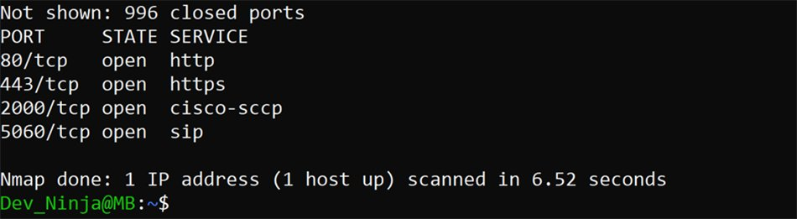
A TCP SYN scan shows results about the port, state and services. [4]

- Example 2
Version detection scanning is a network scanning technique designed to determine the specific version information of network services running on a target host.
sudo nmap -sV <<Target_computer_ip address>>
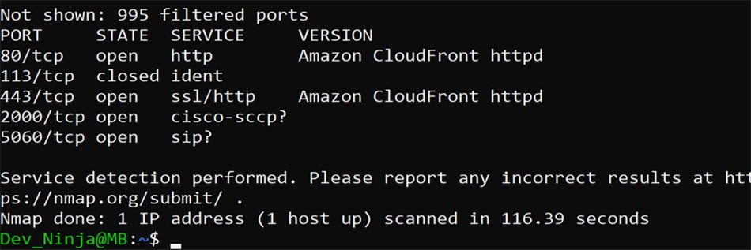
A version detection scan shows results about services running on open ports. [4]

Wireshark will help you capture network packets and display them at a granular level. [5] Then again, is an organization convention analyser that permits cybercriminals to catch and examine the traffic coursing through an organization continuously. By snooping on and examining network packets, Wireshark enables cybercriminals to gather detailed information about network communications, including the types of protocols being used, the source and destination addresses of packets, and even the contents of unencrypted data. Cybercriminals can use Wireshark to capture network traffic during a reconnaissance phase, allowing them to identify patterns of communication between devices and potentially uncover sensitive information such as usernames, passwords, or system configurations.

- Example
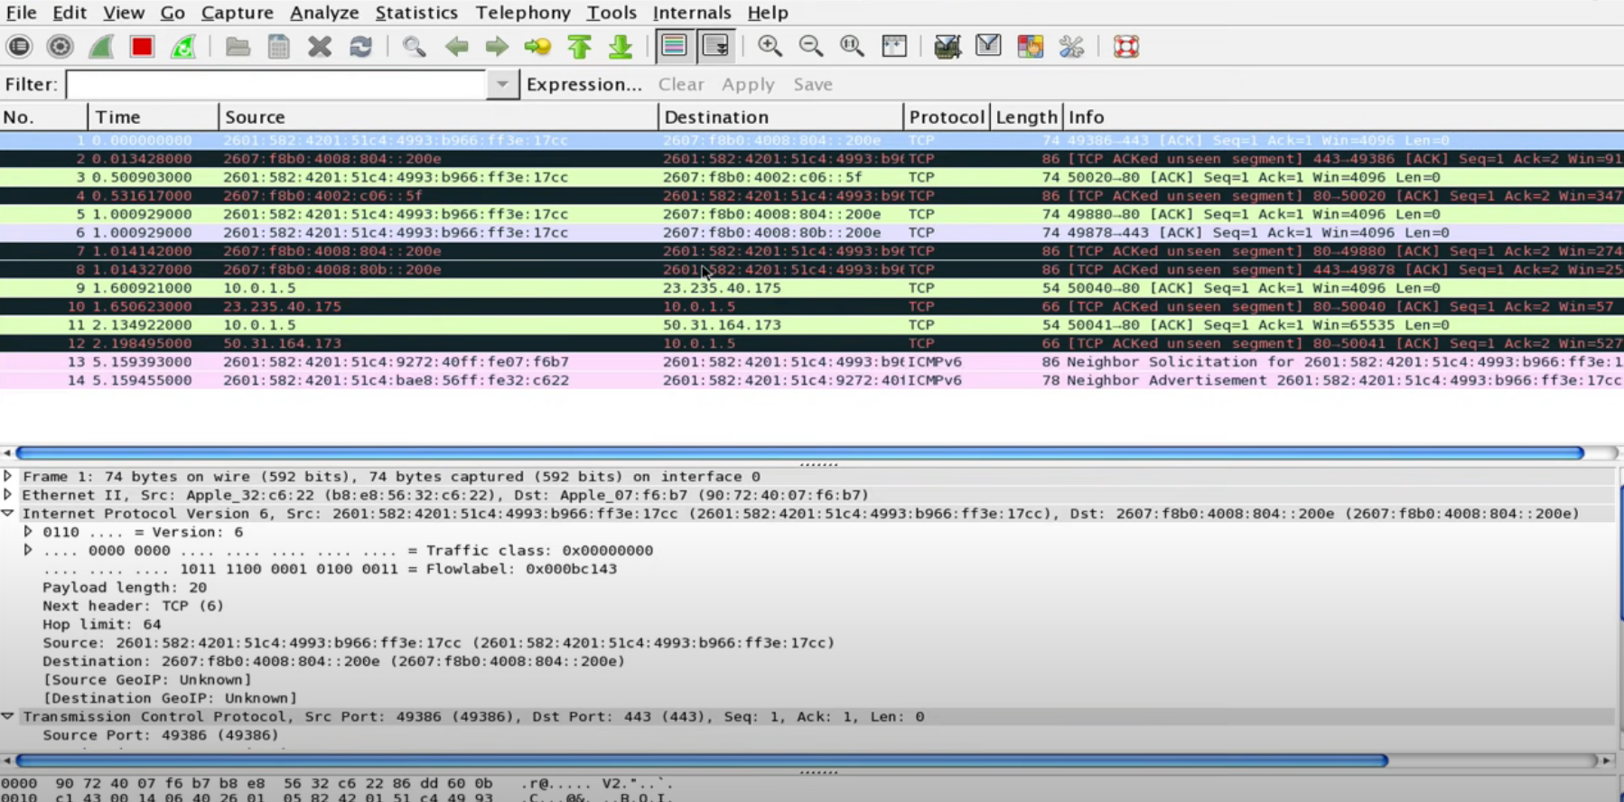
Viewing Packet Captures in Wireshark

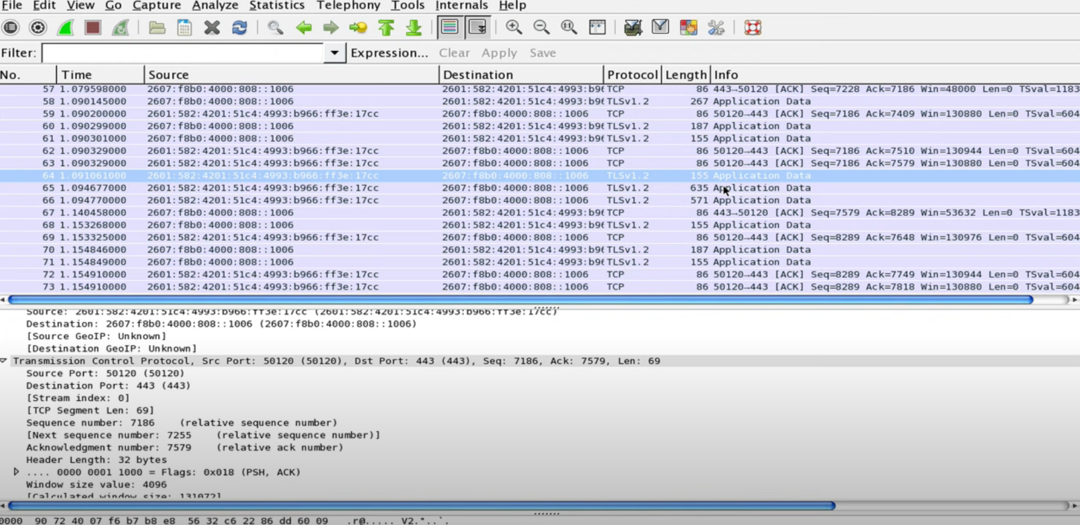
Finding what application / process is sending packets:

Nmap is for scouting and knowing the landscape, while Wireshark is for stealthily collecting what could be interesting data and bringing them back to camp for analysis. [6] During the reconnaissance phase of a cyberattack, Nmap and Wireshark are essential tools that enable cybercriminals to gather relevant information about their target network and potential vulnerabilities. Nmap works with the revelation of hosts and administrations by directing port outputs, while Wireshark empowers the catch and examination of organization traffic to uncover important bits of knowledge into network interchanges and potential security shortcomings.

c) Cyber – Attacks and Mitigations strategies

i) WannaCry and TeleRAT Malware: Operation and Mitigation
- WannaCry:
WannaCry, a notorious ransomware, Ransomware does this by either encrypting valuable files, so you are unable to read them, or by locking you out of your computer, so you are not able to use it. [7] spread rapidly in May 2017, infecting countless computers worldwide. It did this by taking advantage of a flaw in the Windows operating system, specifically the Server Message Block (SMB) protocol. WannaCry encrypted files on compromised computers and demanded Bitcoin ransom for decryption. It spread laterally through networks using the EternalBlue exploit leaked from the NSA.

Mitigation Strategies:
1. Patch Management: Prioritize patching systems to address known vulnerabilities, especially the one exploited by WannaCry. Regularly applying security patches prevents vulnerability exploitation and mitigates infection risks.

2. Network Segmentation: Implement network segmentation to restrict WannaCry spread within the organization. Isolate critical systems from less secure areas to contain ransomware impact and prevent lateral movement.

3. Backup and Recovery: Maintain regular backups of essential data to mitigate WannaCry impact. Ensure backup integrity to restore encrypted files, minimizing data loss, and reducing ransom payment incentives.

- TeleRAT:
TeleRAT, a remote access trojan (RAT), Telegram's Bot API was already being employed by attackers to steal information ranging from SMS and call history to file listings from infected Android devices. [8] Grants cybercriminals unauthorized access to compromised systems. It commonly spreads via phishing emails or malicious downloads, disguising as legitimate software or documents. TeleRAT enables remote control over infected devices, data exfiltration, and various malicious activities without user awareness.
Mitigation Strategies:
1. Employee Training: Educate employees on phishing email risks and the importance of cautious behaviour regarding attachments or links. By raising awareness about phishing tactics, employees can recognize and report suspicious emails, mitigating TeleRAT threats.

2. Endpoint Security Solutions: Deploy endpoint security solutions like antivirus and intrusion detection to detect and block TeleRAT infections. These solutions identify and isolate malicious files or processes, preventing endpoint compromise and data access.

3. Network Monitoring: Implement robust network monitoring tools and intrusion detection systems to detect unauthorized access and suspicious activity associated with TeleRAT. By monitoring traffic and analysing logs, organizations can identify and respond to security breaches promptly.

These mitigation strategies aim to reduce the impact of WannaCry and TeleRAT attacks, safeguarding organizations against data loss, financial damage, and reputational harm.

ii) Whaling and Pharming Phishing Attacks: Implementation and Mitigation
- Whaling:
Whaling attacks, targeting high-level executives to gain access to sensitive financial information or execute fraudulent transactions. With the aim of stealing money or sensitive information or gaining access to their computer systems for criminal purposes. [9]

Mitigation strategies:
1. Employee Awareness Training: Regular and comprehensive training programs should educate all employees, especially those in leadership positions, about the risks associated with whaling attacks. Training sessions should cover common phishing tactics, including email spoofing and social engineering techniques. Employees must be encouraged to verify the authenticity of email requests, especially those involving sensitive data or financial transactions, with caution and scepticism.

2. Multi-Factor Authentication (MFA): Critical accounts and transactions benefit from an additional layer of security when MFA solutions are implemented. Even if an attacker obtains login credentials through a whaling attack, MFA reduces the risk of unauthorized access by requiring multiple forms of authentication, such as passwords, biometrics, or one-time passcodes.

3. Email Separating and Verification: Send progressed email sifting advancements and validation components to distinguish and hinder ridiculed, or false messages related with whaling assaults. Use Shipper Strategy Structure (SPF), DomainKeys Recognized Mail (DKIM), and Space based Message Confirmation, Detailing, and Conformance (DMARC) to check email realness. Arrange email channels to hail dubious messages for survey by IT security staff, keeping them from arriving at workers' inboxes.

- Pharming:
Pharming attacks manipulate DNS records to redirect users to fraudulent websites, posing significant security risks. Is an online scam similar to phishing, where a website's traffic is manipulated, and confidential information is stolen. [10]

Mitigation strategies:
1. Secure DNS Configuration: Maintain up-to-date DNS software and patches to address vulnerabilities and enhance DNS security. Implement strong encryption protocols and enable DNSSEC to protect against DNS hijacking and manipulation, reducing the risk of unauthorized redirection to malicious websites.

2. Website Authentication: Employ advanced website authentication mechanisms such as Extended Validation (EV) SSL/TLS certificates and HTTP Strict Transport Security (HSTS) to validate website authenticity. EV SSL/TLS certificates provide visual cues, indicating a website's legitimacy, while HSTS ensures secure connections. These measures make it challenging for cybercriminals to impersonate legitimate sites and conduct pharming attacks.

3. Network Monitoring and Analysis: Deploy comprehensive network monitoring and analysis tools to detect anomalous DNS traffic patterns indicative of pharming attacks. Continuously monitor DNS requests and analyse network traffic for signs of unauthorized redirection or manipulation, enabling prompt identification and mitigation of suspicious activities.

Organizations can effectively mitigate the risks of whaling and pharming attacks by putting these proactive measures into action, protecting their assets, data, and reputation from cyber threats.

Part 2:

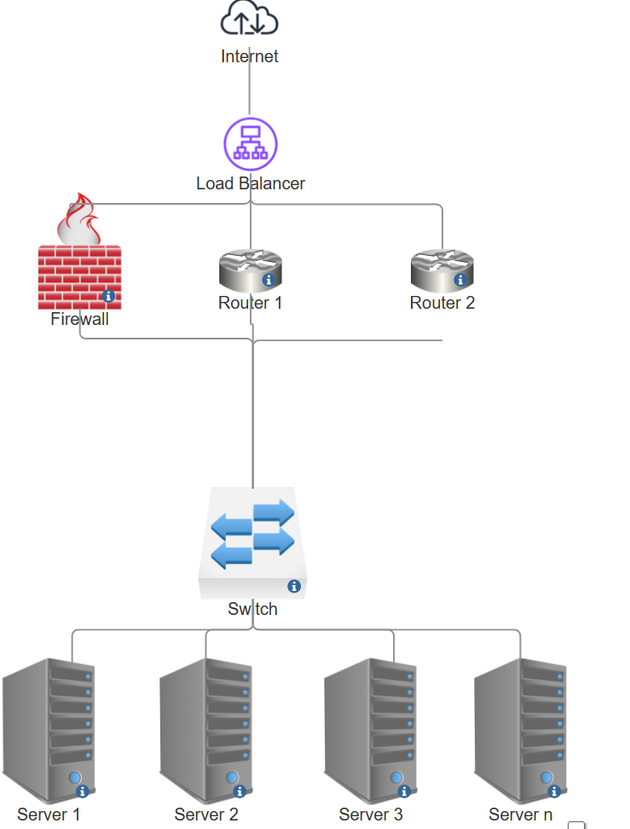
Using a network diagram (topology) or illustrations, create a secure network design.
In this design we have the following components:
- Internet: represents the external Internet.
- Load Balancer: responsible for distributing incoming traffic to multiple backend servers to improve performance and availability. Load balancers also monitor the health of servers and divert traffic from failed servers to healthy servers when necessary.
- Firewall: Used to protect the network from malicious traffic and attacks.
- Routers (Router 1 and Router 2): are responsible for forwarding traffic from the internal network to the external network (Internet) and back. Utilizing dynamic routing protocols like BGP (Border Gateway Protocol) or OSPF (Open Shortest Path First), it is possible to ensure that traffic can be forwarded between different paths for reliable crossover.
- Switch Layer: Provides LAN connectivity between devices in the internal network.
- Servers (Server 1 to Server n): host network services and applications, such as Web servers, database servers, and so on.

High Availability Explained
Elimination of a Single Point of Failure Through the use of a load balancer, we have eliminated a single point of failure in this design. multiple routers, and firewalls. If one of these components fails, the others can take over their functions, thus ensuring network connectivity and service availability.
Provides reliable crossover: By using multiple routers and dynamic routing protocols, we can achieve reliable crossover. If a router fails or a link goes down, the dynamic routing protocol will automatically select an alternate path to ensure that traffic can continue to be forwarded normally, thus ensuring network connectivity and availability.

Packet Tracer Topology and Basic Configuration
In this network topology, we can use packet tracer to simulate the path of traffic and verify the dynamic routing protocols between routers. We can also configure basic rules for load balancers and firewalls to ensure that traffic is transmitted securely and efficiently.
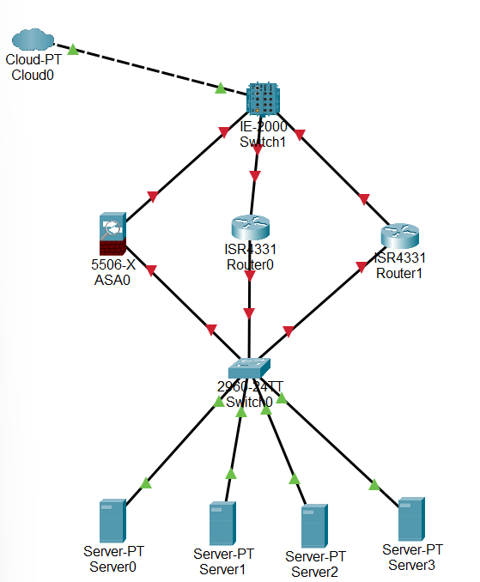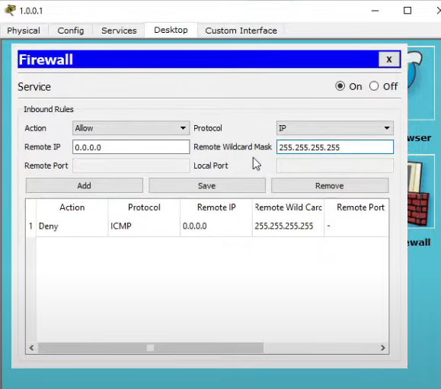

The software and hardware technologies can be implemented to enhance network security during its operation.
To improve network security during its activity, a few programming and equipment innovations can be executed:
1. Next-Generation Firewalls (NGFW): NGFW is a security appliance that processes network traffic and applies rules to block potentially dangerous traffic. [11] In order to enforce granular security policies based on application, user, and content, NGFWs offer advanced features like deep packet inspection and intrusion prevention. They enhance network security by preventing malicious traffic and recognizing threats immediately.

2. Intrusion Detection and Prevention Systems (IDPS): An intrusion detection and prevention system (IDPS) is a solution that monitors a network for threats and then takes action to stop any threats that are detected. [12] IDPS automatically block or reduce threats by monitoring network traffic for known attack patterns and suspicious activity. They protect against unauthorized access and data breaches by detecting and responding to potential security incidents.

3. Endpoint Security Solutions: These protect devices from malware and cyber threats. They include antivirus software, anti-malware tools, and endpoint detection and response capabilities, ensuring the security of individual devices and sensitive data.

4. Network Access Control (NAC) Systems: NAC guarantees just approved gadgets and clients access the organization by surveying gadget security act prior to allowing access. This reduces the likelihood of insider threats and prevents unauthorized access.

5. Virtual Private Networks (VPNs): Which stands for virtual private network, establishes a digital connection between your computer and a remote server owned by a VPN provider. [13] VPNs create encrypted tunnels for remote users to securely access the network. They protect data transmitted over untrusted networks, ensuring confidentiality and integrity.

Implementing NGFWs, IDPS, endpoint security, NAC systems, and VPNs enhances network security by enforcing policies, detecting threats, and securing access, ensuring data confidentiality and integrity.

Complete “Introduction to Packet Tracer”
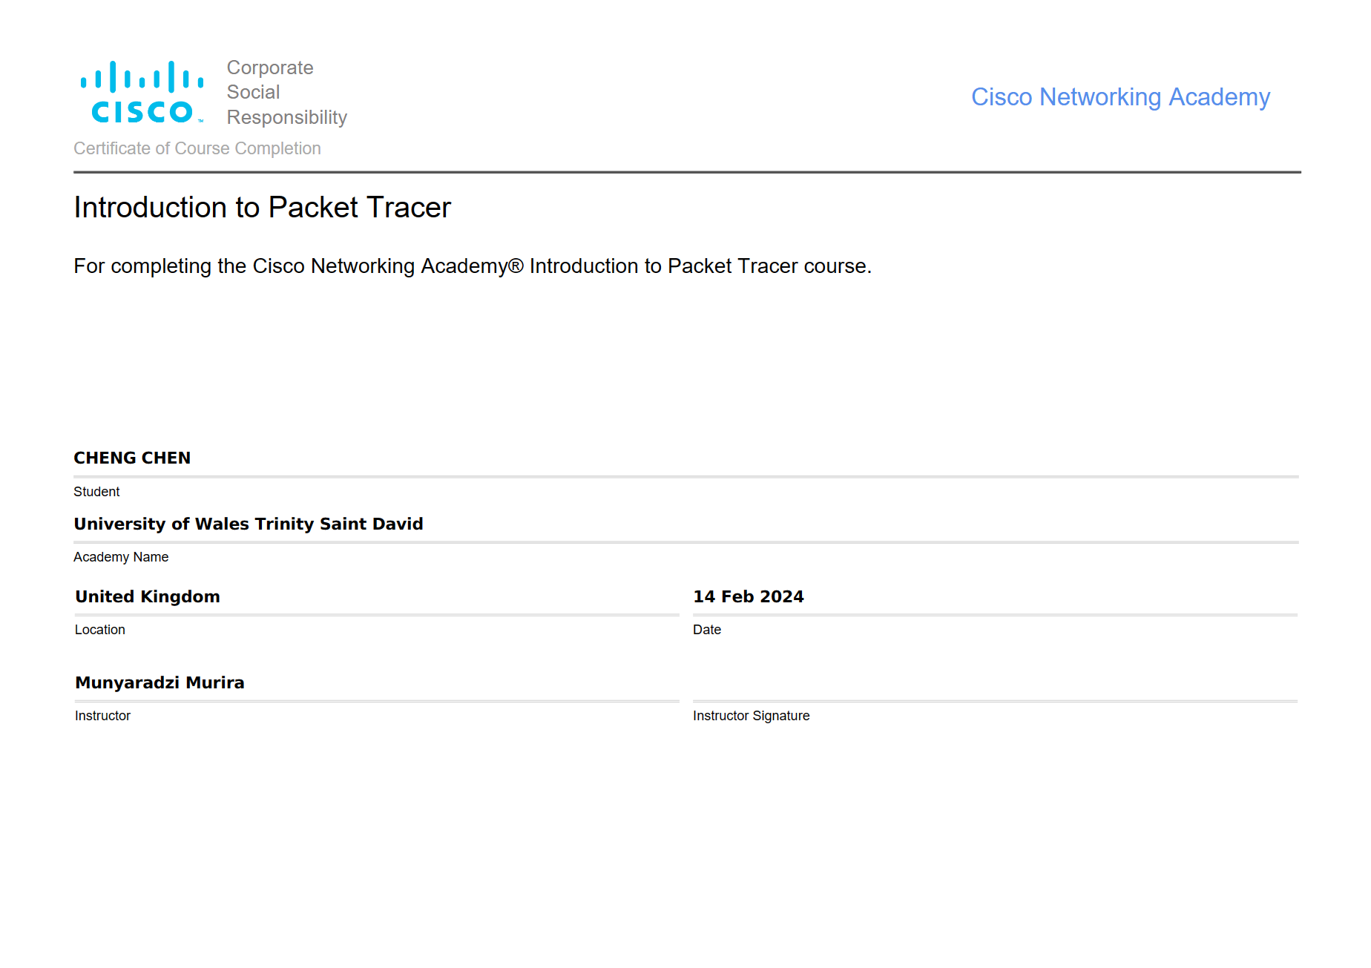

Complete all the 5 Module Exams and Final Exam for Palo Alto Network Security Fundamentals
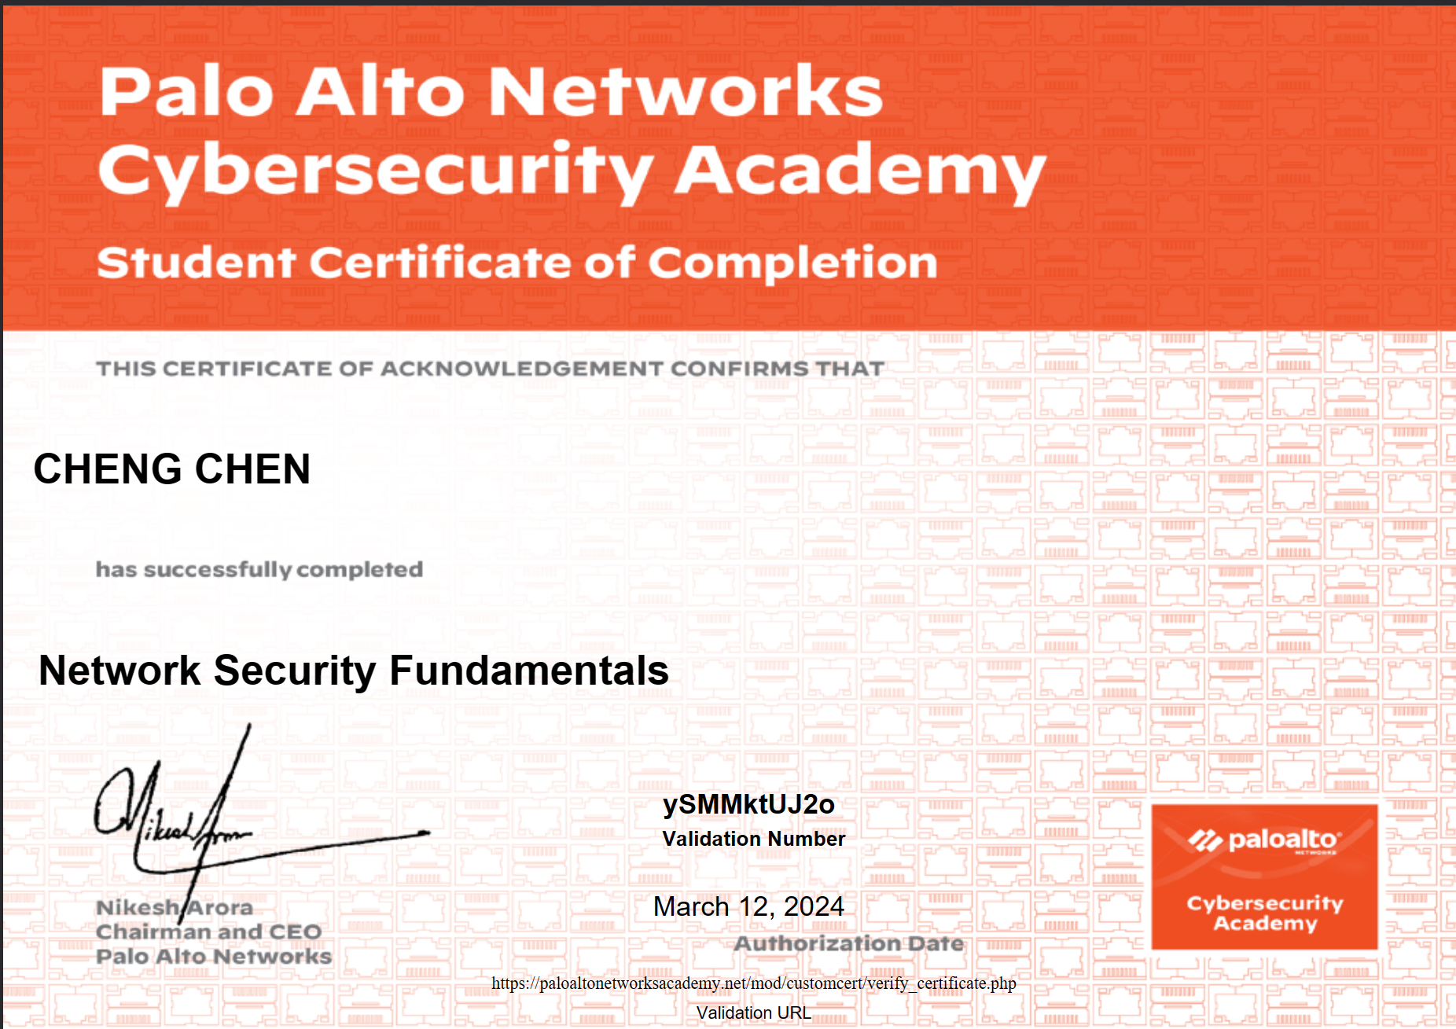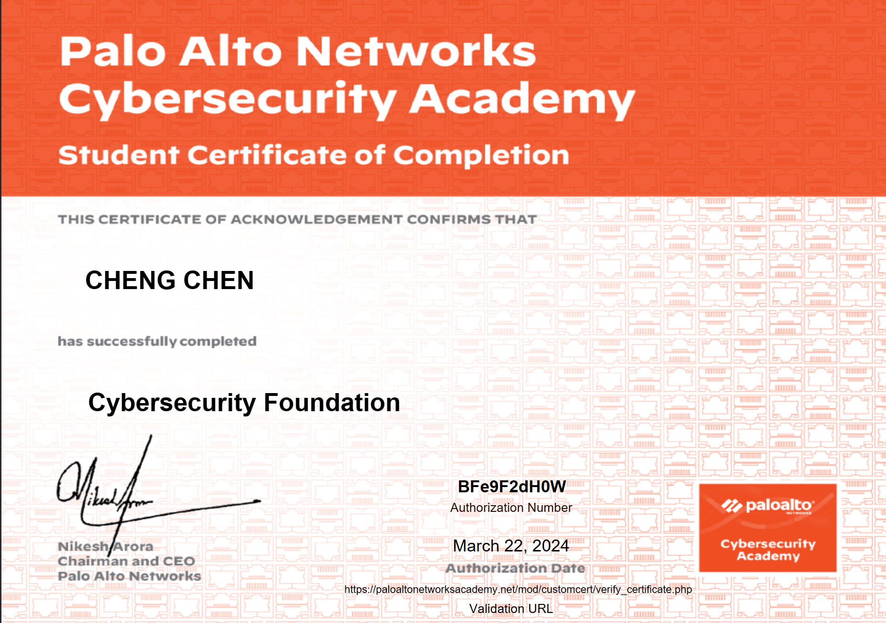

Conclusion:
In conclusion, the analysis of Whaling, Pharming, WannaCry, and TeleRAT underscores the critical importance of robust cybersecurity measures in safeguarding organizations against evolving cyber threats. Whaling and Pharming attacks exploit human vulnerabilities and weaknesses in DNS infrastructure, posing significant risks to data integrity and financial security. Meanwhile, WannaCry and TeleRAT represent formidable threats with their capabilities to infiltrate and compromise systems, leading to data encryption, unauthorized access, and potential financial losses.

Recommendations:
Based on the findings, several recommendations emerge:
1. Investment in Cybersecurity Training: Organizations should prioritize cybersecurity awareness training for employees, particularly focusing on phishing email recognition, safe browsing practices, and adherence to security protocols.

2. Implementation of Multi-Layered Defence: Deploying a multi-layered defence approach, including advanced endpoint security solutions, network monitoring tools, and robust access controls, can effectively mitigate the risk of cyber-attacks like Whaling, Pharming, WannaCry, and TeleRAT.

3. Regular Patch Management and Vulnerability Assessments: Organizations must maintain up-to-date patch management practices and conduct regular vulnerability assessments to address known vulnerabilities promptly and prevent exploitation by ransomware and remote access trojans.

4. Enhanced Backup and Recovery Strategies: Strengthening backup and recovery strategies, including regular backups of critical data and rigorous testing of recovery processes, is essential for minimizing the impact of ransomware attacks and ensuring business continuity.

Future Work:
For future work, further research and development efforts could focus on:
1. Advanced Threat Detection Technologies: Seeking advanced threat detection and response capabilities from emerging technologies like artificial intelligence and machine learning in order to effectively combat evolving cyber threats.

2. Conduct Examination and Abnormality Identification: Exploring social investigation procedures and oddity discovery calculations to distinguish dubious exercises and malevolent ways of behaving related with modern digital assaults like Whaling, Pharming, and TeleRAT.

3. Collaborative Defence Strategies: Encouraging collaboration among organizations, industry stakeholders, and government agencies to share threat intelligence, best practices, and cybersecurity resources for collective defence against cyber threats on a broader scale.

4. Regulatory Compliance and Cybersecurity Standards: Adhering to regulatory compliance requirements and industry cybersecurity standards to ensure robust security posture and resilience against cyber-attacks, while also promoting a culture of cybersecurity awareness and accountability within organizations.

Organizations can improve their cybersecurity posture, effectively mitigate cyber risks, and better safeguard their digital assets and sensitive information from evolving threats in the dynamic cyber landscape by implementing these recommendations and concentrating on future work areas.

References
[1] “What is the NIST Cybersecurity Framework?,” 2020. https://www.balbix.com/insights/nist-cybersecurity-framework/ (accessed Apr. 25, 2024).
[2] “What is the NIST Cybersecurity Framework?,” 2020. NIST-cybersecurity-framework-1024x599.png (1024×599) (balbix.com) (accessed Apr. 25, 2024).
[3] “How to Use Nmap | UpGuard.” https://www.upguard.com/blog/how-to-use-nmap (accessed Apr. 25, 2024).
[4] “Types of Nmap scans and best practices | TechTarget.” https://www.techtarget.com/searchnetworking/tip/Types-of-Nmap-scans-and-best-practices (accessed Apr. 16, 2024).
[5] “What Is Wireshark and How to Use It | Cybersecurity.” https://www.comptia.org/content/articles/what-is-wireshark-and-how-to-use-it (accessed Apr. 25, 2024).
[6] “Nmap vs Wireshark: 2024 Comparison,” 2023. https://www.stationx.net/nmap-vs-wireshark/ (accessed Apr. 25, 2024).
[7] “What is WannaCry ransomware?,” 2024. https://www.kaspersky.com/resource-center/threats/ransomware-wannacry (accessed Apr. 25, 2024).
[8] W. Kyle Ruchna Nigam, “TeleRAT: Another Android Trojan Leveraging Telegram’s Bot API to Target Iranian Users,” 2018. https://unit42.paloaltonetworks.com/unit42-telerat-another-android-trojan-leveraging-telegrams-bot-api-to-target-iranian-users/ (accessed Apr. 25, 2024).
[9] “What is a Whaling Attack?,” 2023. https://www.kaspersky.com/resource-center/definitions/what-is-a-whaling-attack (accessed Apr. 25, 2024).
[10] “What Is Pharming and How to Protect Yourself,” 2023. https://www.kaspersky.com/resource-center/definitions/pharming (accessed Apr. 25, 2024).
[11] “What is a next-generation firewall (NGFW)?” https://www.cloudflare.com/learning/security/what-is-next-generation-firewall-ngfw/ (accessed Apr. 25, 2024).
[12] “What is an intrusion detection and prevention system (IDPS)?” https://www.redhat.com/en/topics/security/what-is-an-IDPS
[13]“What is a VPN? Why Should I Use a VPN? | Microsoft Azure.” https://azure.microsoft.com/en-us/resources/cloud-computing-dictionary/what-is-vpn (accessed Apr. 25, 2024).

