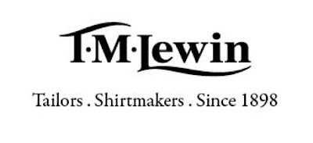  T.M. LEWIN REport  Rebecca Travers, Student Number 2128316 BMSW4004- Problem Solving and Decision Making Lecturer: Muhammad Islam | Abstract  [Draw your reader in with an engaging abstract. It is typically a short summary of the document. When you’re ready to add your content, just click here and start typing.]  Rebecca  [Course title]

Introduction 2
Problems 3
Pestel 4
Fishbone 6
Solution 7
Conclusion 8
References 9

Introduction
The retail sector has faced some tough battles in recent years, with the Guardian reporting that in September 2021, "1400 firms went bust" Inman (2021). When examining the situations faced by the U.K. over the past years, it is no surprise that so many companies have had to close. Lockdown restrictions affected consumer buying habits as all non-essential businesses had to work from home. In addition, inflation is at an all-time high. T.M. Lewin is a reputable company that has been established for over 120 years now. However, the company has been affected by these circumstances and has now gone into administration for the second time. This report examines possible problems within T.M. Lewin by using methods such as SWOT analysis, PESTEL, and the fishbone diagram to find solutions to the firm's current issues with loss within the business. Decision making is also discussed along with PMI charts to help weigh up the plusses and minuses within the business.

Problems

Companies within the U.K have struggled continuously for many years. After the pandemic, a lot of companies had to sies trading and close their doors for good due to debt levels increasing during the lockdown. The retail sector has faced many struggles recently due to many different factors, such as:
- supply chain issues,
- pandemics,
- lockdown restrictions,
- Inflation at 30 years high​
- Cost of living impact on customer spending
The united kingdom's economy seems to be struggling considerably, inflation continues to rise quicker than benefits and wages. Leaving many of the population struggling with essential items such as mortgages/rent and utility bills such as gas and electricity.
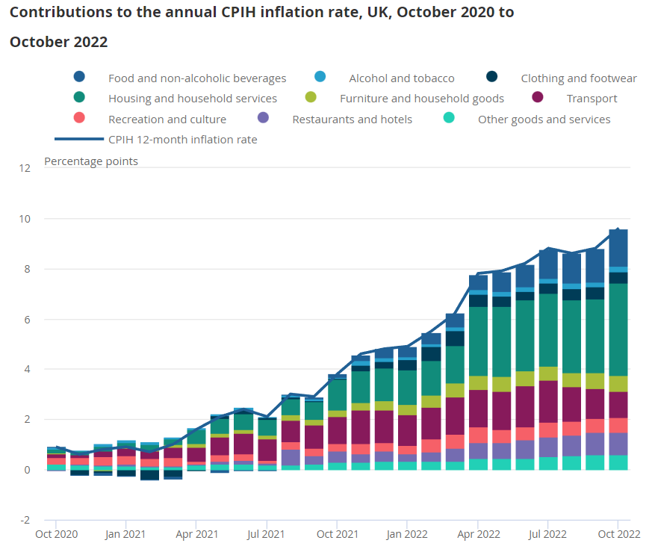

Source: King (2022) Office for National Statistics – Consumer price inflation

This impact on consumers has hit the retail sector hardest, with retailers working hard to mitigate the impact of numerous challenges. T.M. Lewin is a company that has been affected substantially by the circumstances above. On 30 June 2020, they went into administration after feeling the strain of the covid related lockdown. All non-essential retailers had to close during the pandemic due to the lockdown. They were leaving retailers to work online or not at all. The need for men's formal attire decreased due to working from home, cancellations of weddings and limitations on funerals. Soon after the first administration, T.M. Lewin faced hardship again and went into administration for the second time.

Pestel:
Pestel is a framework most often used by strategists at a corporate level to identify external factors that could impact the organisation from the outside. In research gathered by Kolter (1967), Francis J. Aguilar used a framework called 'ETPS' (Economic, Technical, Political, and Social) within 'scanning the business environment.' Kolter (1967) suggests that Aguilar wanted to investigate "the information styles of top management with information about the outside world." Pestel uses the same framework adding environmental and legal. Below are all outside influences affecting T.M. Lewin from outside the company itself.
Political | - Pandemic​ - 61% of businesses reported a decrease in turnover outside of normal range in England between 20 April and 3 May 2020. (Gough, 2020)​  - Working from home​​  - Business closures​  - 7,961 covid related deaths between9 March and 28 December 2020, (5,128 deaths were men) (Dr Windsor-Shellard and Nasir, 2021).
Economic | - Cost of living increasing (Tax, Energy, Wages)​  - Inflation has gone up by 11.01%
Social | - Consumer buying habits ​  - Demographics​  - Work life balance
Technological | - Product quality​  - Online advertising ​  - LinkedIn
Environmental | - Climate change, ​  - Carbon Footprint
Legal | - Government regulation

Alongside, pestel SWOT is commonly used and credited to Albert Humphrey, who tested the approach in the 1960s/1970s. T.M. Lewin has many strengths; the business was established in 1989. Throughout all their years as a trading company, they built goodwill with their customers, becoming a well-known company with 150 stores worldwide. The company was based initially in the U.K. (until 1980, when production moved overseas). Butler (2021) reported that the firm supplied the British army and RAF uniforms during the first world war. The company had a unique customer selling point: tailor-made, high-quality clothing.
However, the company has many weaknesses. They downsized from 150 shops to 50 due to the lockdown and fell into administration for the second time within two years.​ Due to the pandemic and businesses working from home, a decline in profits.​ T.M. Lewin also closed shops, operated solely online, and kept services expensive. ​They also had many supply chain issues leaving customers unsatisfied. Identifying the weaknesses helps to identify opportunities.
One significant opportunity is to reopen some shops; they cannot fulfil their central selling point of a personalised experience if customers cannot attend in person. Also, they have opportunities through social media platforms to create a loyal fanbase. This would keep consumers up to date with the business and create business through sharing the T.M. Lewin page. LinkedIn is also a credible platform that has 850 million subscribers world-wide. The LinkedIn business is used for supporting businesses in many different areas to boost the successfulness of the business.
However, a threat that the company needs to keep in mind is that inflation is continuing to rise. King (2022) quoted that inflation is at 8.8%, and living costs continue to squeeze the economy. Patrick and Pybus (2022) state that people "do not have anywhere, or anything left to cut". A contributing factor is that wages and benefits have not increased as quickly as inflation in goods.

Fishbone
The fishbone/Ishikawa diagram is an analysis technique for identifying problems and all root causes of the problem. It is commonly used to identify all problems and causes instead of targeting one and ignoring other problems. Prof. Kaoru Ishikawa created the model to show relation to the causes of the problem in a detailed and systematic approach. Below is a fishbone diagram detailing the problems T.M. Lewin is facing and its possible causes. Using a fishbone diagram is useful to stimulate thinking, provide a structure and to visually understand and communicate with others. After the problems and roots are identified, decision-making can begin, followed by solutions to the problems.
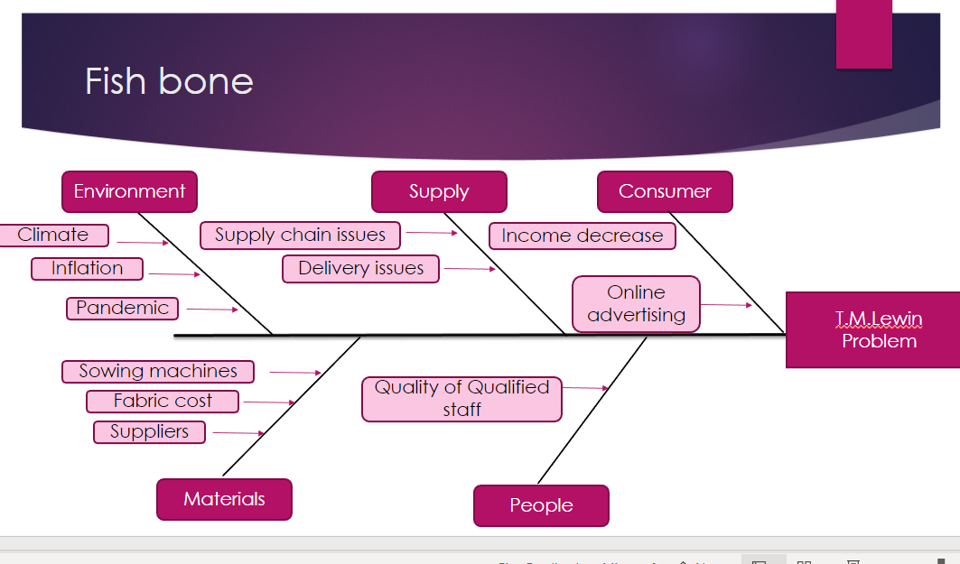

Decision making
Decision-making is a process that takes place when solutions are considered. Decision-making can occur at an individual level or as part of a team or organisational level. When decision-making, it is essential to consider alternative outcomes and choose the most appropriate for the best outcome. The process is shown below.

Problem identification is looking for anything that affects the organisation with the hope of rectification. It is impossible to solve a problem if it is unclear what the problem is. Criteria definition is identifying the critical factors of the problem. This step looks at factors such as quality, price and reputation connection with the problem and how the problem affects the business. Alternative generation & evaluation is when multiple courses of action are planned and evaluated based on the effectiveness towards the problem and the criteria. This should investigate the link between the problem and how it affects the organisation. It is good to weigh advantages and disadvantages and to consider any consequences that might affect the business with evaluating the courses of action. Rational decision-making should be imperative and based on facts. The implementing stage is acting on the given solution to fix the problem. At this stage, more problems could become evident, for example, factors such as not carrying out the course of action sufficiently. The last stage is monitoring/seeking feedback. It is all about reviewing the problem-solving over some time. The purpose is to check if the chosen solution was successful by requesting feedback.

When investigating the problems T.M. Lewin is facing; it is a good idea to use a chart containing Pros, Cons and interests, commonly referred to as a PMI chart.
Plus | Minus | Interesting / Implications
- Good Will (5)  - Well known throughout the world (4)  - High quality made to measure clothing. (2) | 1. Administration for the second time.(5)  2. Closed all shops and operated online. (3)  3. Expensive (5)  - Competitive prices within the market (4)  - Inflation affecting consumer buying habits (5)  - No use of LinkedIn (5) | - Loyalty schemes for loyal customers (4)  - Room for online sales as well as in shops (5)  - Chance to resource and mitigate some costing. (3)  - Difficulty attracting customers (-5)
11 | -27 | 8

The total from the PMI chart is minus 8. There are areas for improvement within T.M. Lewin that should be focused on to rectify going into administration for the second time.

Solution
In respect of all the outlined problems within T.M. Lewin, the company should focus on re-building rapport with its customers. With the lockdown forcing stores to close and operate online, T.M. Lewin lost their unique selling point of tailor-made fitting and measuring in-store. Reopening stores and offering instore measurements and the services they did previously would be beneficial. According to Panigrahi et al. (2018), "In the retail industry, the ability of capitalising demand is crucial that can boost profitability and satisfy retail consumers." This should be monitored closely by asking customers to leave feedback on the satisfaction of service.
Another area for improvement is their outreach on social networking platforms. Using LinkedIn could benefit the company greatly. According to Blue (no date) Linkedin is used to make companies more ‘productive and successful.’ It is the worlds largest network with over 850 million people subscribed. The Linkedin business is designed to help companies with sale solutions, marketing solutions as well as many more. The subscription does cost money however the benefits outweigh the money spent.
To move forward as the reputable company they once were, T.M. Lewin needs to consider outsourcing factors such as materials for cheaper alternatives to help mitigate inflation costs for the consumer. According to Lou et al. (2020), “dominant retailer’s outsourcing strategy has been overlooked.” When outsourcing materials, it is essential to research how other companies manage to do so effectively. To monitor this, the profits and losses the company makes should be studied periodically. T.M. Lewin should constantly look for cheaper resources and spend less on the result.
Offering customer loyalty schemes and special offers in line with the competition may help to attract new customers. Offers such as £10 off next spends can help to entice customers into spending in the store to receive the rewards. Khalil, Ullah & Khalil (2021) state, “Effective loyalty programs help convert a “delighted” client to a “loyal” one.” Customers are looking for better value for money during this unprecedented time of uncertainty for the U.K. The relation to customer spending and loyalty programs has proved a successful way of drawing in customers. T.M. Lewin should compare statistical information based on purchases to monitor if this is successful for the business.

Conclusion

To conclude, T.M. Lewin has some clear improvements that need to be resolved to become a functioning and profitable company. Using a literature-based approach may be beneficial to see where other companies have triumphed through the same problems. Sales could increase by making the brand sustainable and cheaper for the consumer, as many people are looking for better value for money. Using pestel and swot analysis regularly will also help identify any weaknesses that arise from any solutions. It is essential to monitor changes closely. The good and the bad! It is equally as essential to keep written logs on the solutions chosen, the solutions suggested and whether they worked. Keeping records of previous strategies is beneficial in the future if the same or similar problems occur. Previous attempts at resolving situations give helpful insight into how to deal with them again. The PMI chat is also extremely useful at finding out how big a problem is as well as the things that are working well within the company.

References

- Blue, A(no date) LinkedIn | linkedin. Available at: https://www.linkedin.com/company/linkedin (Accessed: November 26, 2022).
- Butler, S. (2022) TM lewin calls in administrators for second time in two years, The Guardian. Guardian News and Media. Available at: https://www.theguardian.com/business/2022/mar/17/tm-lewin-calls-in-administrators-for-second-time-in-two-years (Accessed: November 24, 2022).
- Dr. Windsor-Shellard, B . and Nasir, R. (2021) Coronavirus (COVID-19) related deaths by occupation, England and Wales: Deaths registered between 9 March and 28 December 2020, Coronavirus (COVID-19) related deaths by occupation, England and Wales - Office for National Statistics. Office for National Statistics. Available at: https://www.ons.gov.uk/peoplepopulationandcommunity/healthandsocialcare/causesofdeath/bulletins/coronaviruscovid19relateddeathsbyoccupationenglandandwales/deathsregisteredbetween9marchand28december2020 (Accessed: October 28, 2022).
- Gough, J. (2020) Coronavirus and the economic impacts on the UK: 21 May 2020, Coronavirus and the economic impacts on the UK - Office for National Statistics. Office for National Statistics. Available at: https://www.ons.gov.uk/businessindustryandtrade/business/businessservices/bulletins/coronavirusandtheeconomicimpactsontheuk/21may2020 (Accessed: October 28, 2022).
- Inman, P. (2021) The Guardian, More than 1,400 firms went bust last month in England and Wales, figures show. Guardian News and Media. Available at: https://www.theguardian.com/business/2021/oct/15/more-than-1400-firms-went-bust-last-month-in-england-and-wales-figures-show (Accessed: October 28, 2022).
- KHALIL, ULLAH and DR. KHALIL (2021) ‘The Effect of Customer Loyalty Programs on Customer Retention in Pakistan’, Journal of business & tourism (Mardān, Pakistan), 4(2), pp. 211–225. Available at: https://doi.org/10.34260/jbt.v4i2.173.
- King, A. (2022) Consumer price inflation, UK: September 2022, Consumer price inflation, UK - Office for National Statistics. Office for National Statistics. Available at: https://www.ons.gov.uk/economy/inflationandpriceindices/bulletins/consumerpriceinflation/latest (Accessed: October 29, 2022).
- Kotler, P. (1967) ‘AGUILAR, FRANCIS JOSEPH. Scanning the Business Environment (Book Review)’, The Journal of Business. Chicago, Ill: University of Chicago Press, p. 537–.
- Lou, Y. et al. (2020) ‘Logistics service outsourcing choices in a retailer-led supply chain’, Transportation research. Part E, Logistics and transportation review, 141, p. 101944–. Available at: https://doi.org/10.1016/j.tre.2020.101944.
- Patrick, R. and Pybus, K. (2022) ‘Cost of living crisis: we cannot ignore the human cost of living in poverty’, BMJ (Online), 377, p. o925–. Available at: https://doi.org/10.1136/bmj.o925.

- Panigrahi, S.K. et al. (2018) ‘A Strategic Initiative for Successful Reverse Logistics Management in Retail Industry’, Global business review, 19(3_suppl), pp. S151–S175. Available at: https://doi.org/10.1177/0972150918758096.

