Lecturer name : Babar Syed
Student name : Adriana Mihaela Petcu
Student number : 2126831
Programme : Master of Business Administration
Module : International Business Concepts
Module code : LCMB7034

Executive Summary
This report has discussed the impact of OLI factors on the market entry of Apple in India. The study showcased the use of the country comparison tool for identifying the difference between the USA and India for the business development of Apple. Moreover, Apple's accurate investment into its retail outlets globally is directed to achieve its sales via a price skimming strategy with third-party distributors and the execution of vertical integration. In terms of financial resources, Apple has the scale to absorb the high fixed costs of retail infrastructure and compliance with Indian regulations. Further, there is a financial position found for allowing and making a substantial investment, which is required to establish the owned operation with more capital-intensive than the export and licensing. Furthermore, the retail expansion and its ability to capitalise has been on the evolving regulatory and infrastructural landscape. Apple prioritises control over its retail experience. Additionally, the American culture values the customer's experience, thus Apple can foster this to enhance its connection and engagement with customers.
Table of Contents
Introduction 4
Benefits and challenges of international operations 6
Reason for Apple to be an MNC/TNC 6
Nature of Apple’s global operations 8
Different entry modes by Appleand the benefits 9
OLI factors (Ownership, Location and Internalisation) impact the international market entry mode 12
Impact of the OLI factors 12
Cultural differences 15
Impact of the cultural differences factor on the market entry strategy 16
Hofstede’s Cultural Framework 16
Recommendation 19
Conclusion 22
Reference List 23

Introduction
International business management (IBM) is a form of practice that designates business activities across cross-border transactions through global operational control of marketing, supply chain, finance, and human resources. As stated by Shenkar, Luo and Chi (2021, p. 33), IBM involves global market analysis, cross-cultural management, global supply chain management (SCM), international finance, trade and law.
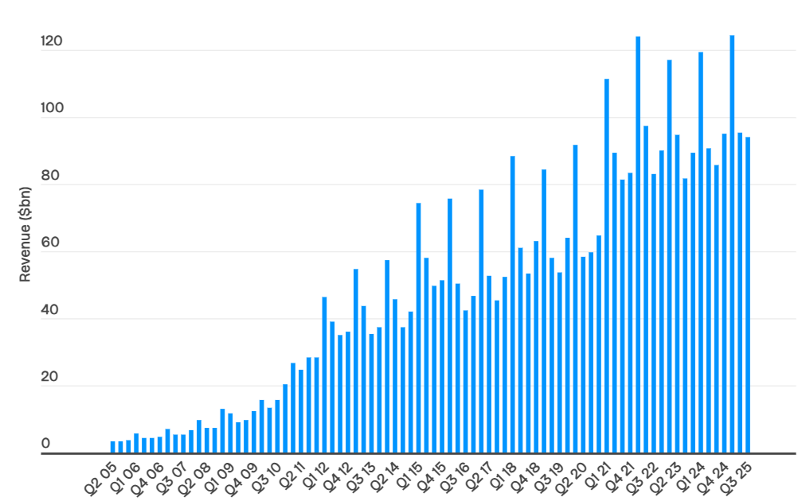
Figure 1: Apple’s revenue statistics
(Source: Curry, 2025)
For instance, in 2024, Apple generated 390.8 billion dollars in revenue, 51% from iPhone sales, 52 million iPads, 232 million iPhones, and 22 million MacBook and Mac units (Curry, 2025). The reason for the increased commercial success of the company is its selection of internationalisation of business strategy, with its chosen geographical demographic segmentation to gain potential markets and a significant customer base. The report is going to discuss the benefits and challenges of international operations of Apple, OLI (ownership, location and internalisation) factors in the international market entry mode and major adjustments in their SOPs (standard operating procedures).

Benefits and challenges of international operations

Reason for Apple to be an MNC/TNC
Apple is an MNC (multinational corporation) or a TNC (transnational corporation)that fits its globalised business operations, such as global sourcing, designing, manufacturing, and selling in diverse countries.
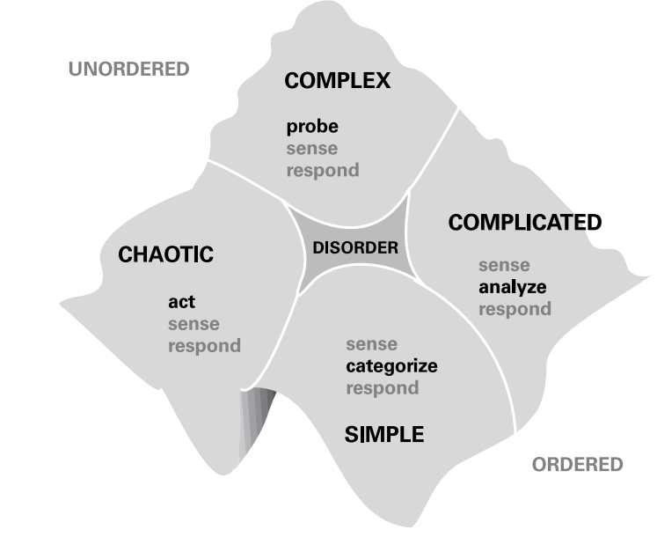
Figure 2: Cynefin framework
(Source: Snowden and Boone, 2007)
As stated by Snowden and Boone(2007),the Cynefin framework by Dave Snowden draws on a complex adaptive system theory with anthropological, cognitive science,e volutionary psychology and narrative patterns. The framework is capable of exploring Apple’s business internationalisation contextualisation in areas of communication, policy-making, decision-making, and knowledge management within the complex social environments. The reason for the company to transform into a proper MNC/TNC helped towards reduced cost business operations, expanded market reach, and gaining capitalised labour and resources in diverse markets. For instance, in 2025, Apple had 520 retail locations with 272 physical stores in the USA, 39 in the UK, 45 in China, 22 in Australia, 28 in Canada, and 20 in France(Upadhyay, 2023). In parallel, in 2025, Apple's revenues were 408.625 billion dollars, which was 391.035 billion dollarsin 2024 and a 5.97% upsurge (Macrotrends, 2025). From the empirical data, it is observed that geographicallytargeted segmentation and internationalisation of Apple's business helped the company to gain significant market share within the electronics segment and improve its brand reach globally. On the other hand, applying the Cynefin framework, Apple has adopted its product diversification strategy with knowledge-intensive product development for understanding complex environments, trends and likelihood of transforming its products as per customer preferences and market variables. However, a drawback of the Cynefin framework can be misclassification by incorrectly categorising the internationalisation problem, hence leading to poor internalisation decision-making processes.
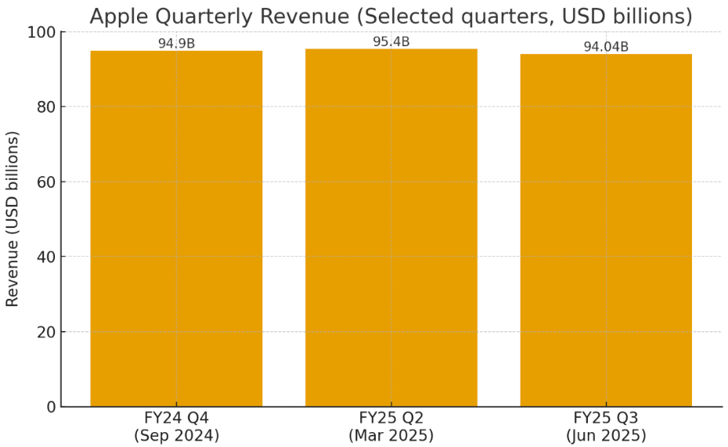
Figure 3: Apple commercial growth statistics
(Source: Namase, 2025)
Empirical data shows that in 2025, Apple had 2.35 billion active devices withiPhone salesof44.6 billion dollars, increasing 29% of its revenues, 0.26 per share dollars dividend to shareholders (Namase, 2025). From the rise in commercial improvement with its core strategic implications in product strategy, the company has made a wholly owned subsidiary mode of entry strategy, with 100% of the stocks supplied by the company itself. As researched by Collinson, Narulaand Rugman(2020, p. 43), the benefits of a wholly owned subsidiary include gaining full access to global strategic implications and operations by isolating excessive market entry experimentation and liabilities. Apple's investment in its wholly owned retail outlets led to managing its price skimming strategy with 3rdparty distributors within its vertical integration. Apple gained its own stores, online store and direct channels to 29% of net sales from direct channels, and 71% of indirect channels such as 3rdparty retailers, wholesalers, network carriers, and resellers (Maarten and Parisa, 2021).Apple’s wholly owned mode of entry strategy has enabled it to generate enormous sales through its direct and indirect distribution channels globally. However, the wholly owned strategy drawbacks include financial burden during high operational cost setup, and increased complex tax and trade regulations.

Nature of Apple’s global operations
From the financing capabilities of Apple, the company have revamped its investment to more than 18 gigawatts of clean energy for support, and 76 billion gallons in water savings as per Environment, Policy, and social actions (Apple, 2024). In this context, Apple has exaggerated its greenfield investment capabilities within its green investment environmental project. As explored by Daniels et al. (2022, p. 90), greenfield investment helps an organisation to exert its optimum control over globalised operations, significantly leading to integrated business designs and processes. For instance, Apple has made a 4.7 billion dollar greenfield investment, making green bonds that support innovative green technology and revamp low-carbon aluminium as commercial-purity from ELYSIS within iPhone SE(Apple, 2022). The strategic target for the greenfield investment showcases the ways the investments can help to reduce global emissions by bringing clean power to the global community. However, greenfield investment can sometimes be unpredictable and difficult for companies to gain significant data on research and investment decisions.
In this aspect, Apple will be committed towards driving environmental efforts and elevating global community environmental commitment. Statistics display in total; Apple had issued 4.7 billion dollars to fast-track the progress toward the corporation’s goal and become carbon neutral across its global supply chain by the end of 2030(Apple, 2022). In its core greenfield investment operations, Apple's green bond will support a total of 50 projects, which mainly include the low-carbon aluminium sourcing operations(Apple, 2022). The50 low-carbon aluminium sourcing operations are eligible to mitigate 2,883,000 metric tons of CO2e by the installation of approximately 700 megawatts of renewable energy capacity globally, whilst promoting its new recycling research and development (R&D)(Apple, 2022).However, the drawbacks of greenfield investments include extremely high-risk investments with potentially high market entry costs and governmental regulations that canhinder Apple’s risk-taking capabilities.
From production and sales operations, in 2025, Apple had made 2.35 billion devices with sales of iPhone categories of about 44.6 billion dollars, by growing29% of its revenues, andmaking0.26 per share dollars of its shareholder revenues (Namase, 2025). From the intensification in sale able enhancement with its fundamental strategic consequences in product diversification strategy, Apple has made a strategic alliance mode of entry strategy with the regeneration of 100% of the internal device stock production. As investigated by Wild and Wild(2023, p. 22), the advantages of the strategic alliance mode of entry strategy include acquisition of global strategic consequence-based admittance and operations by insulating unnecessary market entry research and accountabilities.
Empirical data shows Apple augmented its own physical stores, e-commerce store and direct channels to 29% of disposable sales from direct channels, 71% of physical stores, and e-commerce, such as 3rdparty retailers, wholesalers, and resellers (Maarten and Parisa, 2021). Apple's strategic alliance mode of entry strategy has enabled it to make mammoth sales through its physical stores, e-commerce store and direct distribution channels internationally. However, the strategic alliance mode of entry strategy has downsides such as fiscal burden due to highly volatile markets, complexity and fluctuations in tax and trade regulations.

Different entry modes by Apple and the benefits
The eclectic theory of international production is based on the selection and combination of business ideas from diverse internationalisation sources to create an internationalised new system, rather than obeying strictly to single internalisation frameworks. As discussed by Li et al. (2025, p 18), John Dunning’s eclectic paradigm in economics utilises an OLI (Ownership, Location and Internalisation) framework to elucidate foreign direct investment (FDI) decisions, and the eclectic paradigm in psychology, where global therapists join in numerous procedures to have a discourse within the exclusive client requirements. According to the theory, diverse entry modes adopted by Apple include foreign direct investment (FDI), wholly owned subsidiary, green investment, and strategic alliance mode of entry strategy.
Apple had announced to make foreign direct investment (FDI) mode of entry operations spend within its European suppliers and increased by over 50%, which totals €85 billion and in 2022, over €20 billion alone (Apple, 2023). The FDI investments had reached over 4,000 European suppliers and had supported cutting-edge innovation. The FDI strategy had led the company towards increased production and sales of Apple, from sensors within Apple Watch, lasers within iPhone, to microcontrollers within Mac. The FDI investments by the company had also helped in advance with the green changeover of the European industry. The reason behind sustainable business operation within the company is that Apple is committed to attaining carbon neutrality across its global supply chain, and through the investments in iOS app investment, production and economy, Apple has supported over 2.6 million European jobs(Apple, 2023). The benefits of the FDI mode of entry strategy by Apple from its global operations lie in incredible talent generation and increasing the spirit of innovation through breakthrough technologies with the global suppliers across Europe, and decarbonising the whole global supply chain.
On the other hand, Apple has leveraged a wholly owned subsidiary mode of entry strategy within diverse geographically segmented retail outlets, utilising a price skimming strategy in its core vertically integrated supply chain operations. Through a wholly owned subsidiary mode of entry strategy, Apple has become commercially successful with 29% of net sales from its direct e-commerce channels and 71% from wholesalers, third-party retailers, and resellers (Maarten and Parisa, 2021). Apple’s mode of entry strategy has allowed it to produce vast sales through its e-commerce, wholesalers, third-party retailers, and reseller distribution channels worldwide.
On a contradictory note, Apple exaggerated the green investment mode of entry strategy by investing in 18 gigawatts of clean energy and 76 billion gallons in water conservation within its green bond project (Apple, 2024). The strategic investment by the company has benefited in decreasing GHG emissions by transporting clean power to the worldwide community. In this context, Apple has integrated a strategic alliance mode of entry strategy and, in 2025, Apple generated 2.35 billion in production and iPhone sales, generating 44.6 billion dollars, a 29% revenue growth (Namase, 2025). The mode of entry strategy benefited the company with increased international strategic operations and alliances, thereby grabbing potential markets and customer base.

OLI factors (Ownership, Location and Internalisation) impact the international market entry mode

Impact of the OLI factors
According to Rana and Allen (2024, p.3), the market entry in India is shaped by their strong Ownership advantages with the brand, technology and supply chain for driving the choice of a subsidiary model and to maintain control with this. It can influence the internationalisation of the operation, which leads to a direct-owned retail approach rather than licensing.
Ownership
According to Batschauer da Cruz et al. (2022, p.3), the ownership advantages like Brand Equity and Technology: Apple’s strongest ownership advantages are its global brand prestige, proprietary hardware–software integration and R&D (Research and Development) intensity. These help Apple differentiate itself in a highly competitive Indian smartphone market dominated by price-sensitive consumers.
The weakness of the business is that it is difficult to identify the advantages of Apple's brand positioning as a premium product, which limits its market share in India, where affordability is key. Its ownership advantages don't fully translate into competitive pricing power in emerging economies. In proprietary technology, there is a huge control over the ecosystem found, which makes the licensing unattractive.
As proposed by Teece (2025, p.13), the ownership advantages create an impact on Apple towards high-control modes like wholly owned stores or subsidiaries. However, these strengths can be undermined by a price-sensitive market in India. The competitors of the brand, like Xiaomi and Samsung, use cost advantages to focus on the premium positioning of Apple (Globaldata, 2025).
Location
There is a huge impact on the entry mode of the business found, by which Apple relies on owned subsidiaries and direct control to safeguard intellectual property and brand identity. According to Lu et al. (2022, p.450), Apple initially avoided licensing or joint ventures, despite the regulatory pressures. They also prefer direct ownership of Apple Stores at the time of single-brand retail. The location and advantages are market potential, by which India is the world's second-largest smartphone market by volume, with rising middle-class income and aspirational consumer demand to make it strategically important despite the current low penetration of premium devices (Cleartax, 2025). India has a massive, young, and growing middle class with rising disposable incomes, which is a long-term attraction for Apple. In the policy environment, India has historically imposed restrictions on foreign retailers, which require single-brand retail FDI. As stated by Buckley et al. (2022, p.5), it has been effective for Apple to create an indirect entry through the resellers instead of wholly-owned Apple Stores. India offers cost advantages for manufacturing with lower wages and government incentives like “Make in India” (Timesofindia.indiatimes, 2025). It made a strategic hub for both domestic sales and global exports. The challenges in the local business will be weak infrastructure, bureaucratic hurdles, and diverse consumer segments, which can be impactful for managing and conducting the operations in Apple. The Import tariffs on devices have incentivised the local assembly to influence the decision and to invest in FDI rather than rely on imports.
As identified by Witek-Hajduk (2025, p. 51), there is a large and dynamic market for premium technology products, which is a key location in a specific factor. There is a high growth found for justifying investment in a direct market entry strategy. The Indian government has been increasing its openness to foreign retail, which has created an environment with direct foreign investment. India also presents logistical challenges for increasing the ability to develop the local supply chain, which is crucial for the retail expansion.
Internationalisation
Jaworek et al. (2021, p.440) have identified that, in the regulatory environment, India mandates local sourcing for single-brand retail FDI. This prompted Apple to set up manufacturing under the "Make in India" initiative and to gain location advantages and regulatory approval for the Apple Stores. India offers relatively low-cost labour for assembly, enhancing Apple's global supply chain diversification away from overdependence on China. There is a huge impact on the entry mode with location advantages, which are helpful for Apple toward local production via contract manufacturing to circumvent tariffs and meet sourcing rules. It also strengthens the case for wholly owned retail stores, since regulatory barriers were tied to local sourcing. Apple avoids franchising in India to maintain quality control, protect proprietary designs and prevent brand dilution. As opined by Qinand Meckechnie(2025), there is a strategic importance found in the potential benefits for external entry modes and to gain internal control on the retail network.
The reach of Apple is compared to its competitors in terms of the use of a wide local distribution network. According to Batschauer da Cruzet al. (2022, p.146), the OLI-driven strategy of Apple exposes the weaknesses of its high-control, premium model, which limits market penetration in a price-sensitive economy. Competitors can adapt more flexibly to local conditions, like Samsung and Xiaomi, to capture a larger market share. It can encourage FDI with the institutional constraints and price sensitivity forcing Apple to adapt slowly, blending resellers, online channels, with the owned stores and manufacturing hubs. As identified by Benabed (2024, p.138),in the supply chain and ecosystem control, Apple internalises their relationships with suppliers. There is an outsourcing found in the Indian firms for ensuring efficiency and secrecy.

Figure 4: OLI Factors
(Source: Created by Learner)

Cultural differences
As stated by Darkwah et al. (2024, p.123), cultural differences between the individualistic, premium-focused US, and the collective, price-sensitive and diverse Indian market have been significant for creating impact on the strategy of Apple. It is also necessary to adapt and offer adaptable and finance-based products to the localised market. To adapt the premium experience for resonating with the aspirational and to leverage the expansion of the middle class and government support for the local manufacturing. It helps boost the potential and long-term success. According to the Hofstede dimension model, in the Power Distance, India scores 77, which indicates an appreciation for the hierarchy with the top-down structure in the society and organisation (The Culture Factor, 2025).
Indian attitude could use the power holder for direction, with the acceptance of unequal rights between the power privileged, who are less privileged, to gain immediate superior access to gain loyalty from the employees. Real Power is centralised for the managers to enforce the obedience of the team members. As proposed by Domínguez Romeroet al. (2024, p.3363), employees are expected to be directed in their function to get psychological security and a positive attitude towards the managers. On the other side, the USA has a low score on the dimension, which underscores the American premise of liberty and justice for all. The score of Individualism is 24 for India and 60 for the US. As per the Individualistic aspect of Indian society, there is a dominant religion found in Hinduism. The focus on individualism interacts with the collectivism of Indian society, which leads to the intermediate score. A score of 60 indicates that the US is an individualistic culture. In the factor of motivation towards achievement and success, India scores 56, and the US scores 62 (The Culture Factor, 2025). India is a spiritual country with different religions and philosophies. On the other side, the British have the same culture in this respect, which is important for identifying conflict and understanding the consequences for the endangered democracy.
In the factor of uncertainty avoidance, India scores 40 with a medium to low preference. In the acceptance and imperfection, there is a unique and inventive solution found for empowering the aspect of the country. On the other side, the US scored 46 with their new ideas, innovative products and willingness, which is helpful for the growth and expansion of the business. In the factor of Long-Term Orientation, India got a 51 score in the dimension of religious and philosophical thought. On the other hand, the US scores 50 for analysing new information and measuring business performance on a short-term basis, and to get the profit and loss statements for all individuals. In the factor of Indulgence, India scores 26, and the US scores 68, which is reflected in the contradictory attitude and behaviour (The Culture Factor, 2025).

Impact of the cultural differences factor on the market entry strategy
Cultural differences between the US and India helped to ensure the entry of Apple and its success. The US-centric model of Apple, of premium pricing, individualistic branding, and controlled retail experience, cannot be transplanted into the collectivist, price-conscious, relationship-driven market of India without adaptation. The cultural alignment with India's hierarchical, aspirational society aids Apple's prestige; cultural barriers around the affordability, trust, and service constraints created a mass-market success. Long-term success helps to navigate Apple to fulfil these cultural gaps, and it is required to balance with the global brand consistency and with local cultural resonance. As stated by Arregle et al. (2021, p.1160), in India, buying decisions are influenced by family members, sales agents, and physical product experience in local stores. It can be impactful for increasing the sales growth, profit and revenue of Apple's business.

Hofstede’s Cultural Framework
According to Orak (2024), Hofstede’s Cultural Framework was introduced by Geert Hofstede, which considers six factors to compare the culture and values among different areas.
Power Distance Index
According to The Culture Factor (2025), India scores high in this factor, which is 77, indicating the acceptance of unequal distribution and centralised decision-making of high authorities. The United States scores low in this factor, which is 40, indicating decentralised decision-making and challenging the decisions taken by authorities.
Individualism
In this dimension, India's score is 24, which indicates strong group orientation and fulfils shared responsibilities. However, the United States' score is about 60 in individualism, indicating that the people prioritise their personal achievements over social responsibilities. This results in a competitive environment and weakening of interpersonal connections.
Motivation towards Achievement and Success
India scores 56 in this factor, while the United States scores 62, indicating better work-life balance for people of India and high competitiveness and ambition for the people of the United States. Thus, Apple can benefit more in the United States based on this dimension, as it can have higher productivity and efficiency, and lower turnover.
Uncertainty Avoidance
Both India and the United States have a low Uncertainty, Avoidance Index, which is 40 and 46, respectively. This indicates that the people are comfortable with uncertainty and ambiguity and are less stressed by unpredictable or unsuitable situations. Based on this factor, Apple can have flexibility, adaptability, and may be more receptive to new ideas and technologies in both countries.
Long Term Orientation
The score of this dimension is nearly the same for India and the United States, that is, 51 and 50, respectively. This infers the balanced approach in a country promoting the enhancement of the future while adapting to tradition and economic outcomes.
Indulgence
India scores low in this factor, that is, 26, indicating more restraint, abiding by strict social norms, and people are more pessimistic about the future. The United States scores quite high, 68, in this dimension, indicating an enhancement in entrepreneurship and an increase in optimism and creativity. Thus, Apple can be more profitable in the United States according to the indulgence factor.
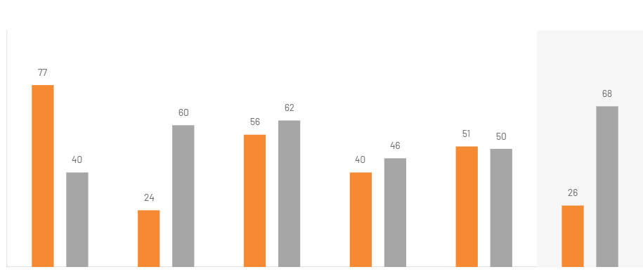
Figure 5: Hofstede Comparison
(Source: The Culture Factor, 2025)
According to Herlein (2025), a positive and effective culture can have a significant impact on the organisation's success and can motivate and encourage employees to work there. Thus, this can be beneficial for all the stakeholders and shareholders of the organisation. Culture is a real business that pays off and ensures the enhancement of performance and people. As per the reports of The Global Economy (2025), the United States has an innovation index of 62.4 and secures a global rank of third position across the world. Thus, an enhanced innovation index rate results in an increase in innovation and creativity in the design and technological advancement that perfectly aligns with the requirements of the customers. According to Apple (2025), it creates a culture that involves different backgrounds and experiences and opportunities for everyone. Additionally, it ensures equity for each stakeholder and shareholder of the organisation. Thus, it can enhance its customer loyalty and reduce turnover, resulting in an increase in productivity and annual revenue for the company.
As stated by Cassis (2022), the risk tolerance in the United States is much higher. Thus, it leads to more entrepreneurs and startups in the USA. Additionally, investors enter the deals with pre-determined desires, thus making it easier to access capital in the U.S. Thus, Apple can have a better brand reputation and investors in the United States. Apart from these, the company can maintain a high standard for innovation and design within the American market, associated with a high value.

Recommendation
Apple can improve its financial solutions and reduce costs to ensure success in India. McLaren (2024) demonstrated that a financial system can be referred to as the procedure that helps an organisation to manage, keep a record, and optimise the inflow and outflow of money in the business. An effective financial system provides clarity and visibility to customers. Without a proper finance system, an organisation can lose track of its investments and production costs. It includes real-time dashboards to keep the organisation up-to-date on its financial health. Apart from that, it helps to manage the cash flow efficiently. Additionally, strategy and realistic budgeting also assist an organisation to align with its target. Most successful businesses have a strong financial system in place. Thus, a sustainable and profitable business needs to prioritise its financial system and set a realistic budget for its product.
As stated by Apple (2025) on its official page, it provides products that last long and have a high residual value. Thus, the company believes investing in its product is smart and worth it. Its financial services are developed to enhance future value and build strong financial structures. Thus, the audience can get the required technology they need with a friendly and flexible experience. Apple's financial services provide flexibility in its services and products. According to Apple (2025), it reserves its right to change and moderate the price of its product at any time according to its policy. Kelly (2023) stated that the demand for Apple products remained strong and firm even though its products have seen a steep rise in their prices. Although Apple's premium pricing strategy has a negligible impact on its sales, it can still provide a realistic budget to make it affordable to numerous people.
Apple can enhance its customer service and provide after-sales support to improve its customer engagement and earn its customers ' loyalty. According to Podolsky (2024), poor and ineffective customer service results in customer dissatisfaction and frustration, while efficient customer service leads to customers' loyalty, trust, and builds a positive connection with the organisation. Research has shown that 91% of customers' purchase decisions are based on the online reviews of the product provided by other consumers. Thus, it enhances the organisation's brand reputation, and it can be achieved by a strong, rooted service that will be different from other competitors. Additionally, he mentioned that the customer service must be proactive rather than reactive. Apart from these, a company must take responsibility for its errors and address them professionally. Hence, a simplified and comprehensive customer journey is one of the steps to achieve the success of an organisation.
Apple (2025) offers various after-sales support, such as assisting in restoring the password if the user has forgotten their old password. It offers the best solution to users according to their needs and the details provided by them. Additionally, it provides Apple-certified repairs that are executed by its trusted experts who use genuine and original Apple parts. Its network of Apple Authorised Service Providers also provides convenient locations for Apple repairs to its customers. Apart from these, Apple offers services to customers for viewing their purchase history or managing their payment information. It also provides unlimited repairs for any accidental damage according to its protection policy and offers access to an Apple consultant for any information and advice regarding any product or service. The company also provides support and help for all products in one place. Thus, this effective and genuine customer support can enhance its brand reputation and attract more customers. Hence, in this process, Apple can improve its Standard Operating Procedures (SOPs) to ensure success in India.
Apple can modify its Supply chain and distribution system for better results in its development and growth in India. As Anand (2024) stated, an efficient supply chain plays a crucial role in the success of a business. However, an insufficient supply chain slows down the growth rate of a company and hinders its success. A practical and operational supply chain provides enhanced visibility to track real-time forecasting in the supply chain industry. It also boosts efficiency by shifting from manual labour to automation. Additionally, it ensures continuous and ideal communication and centralised data sharing among collaborators. Apart from these, it helps in adapting to market changes and adds flexibility to its system to operate efficiently. It also determines any disruptions or issues and addresses them effectively to maintain standards.
As per the official website of Apple (2025), the products are manufactured and designed in California by people all over the world. It maintains its standard in providing high-quality products and services in each place where it operates. Additionally, it supports the people and communities across its entire supply chain and contributes to a positive impact on the environment. Apple ensures that its suppliers fulfil the strict standards of the Apple Supplier Code of Conduct while operating or providing services to its customers. The code of conduct adheres to the labour and human rights, health and safety, and ethical, environmental, and management practices. The company believes in maintaining itself and its suppliers to high standards of accountability. Apple takes swift and spontaneous action if any regulation is being violated by its supply chain and addresses it professionally to prevent it from recurring.
Moreover, as per Apple (2025), the company has reduced carbon emissions by 60% and aims to neutralise its carbon footprint by 2030. It adopts measures to recycle and use renewable materials to reduce its carbon footprint. About 24% of the material that is used in Apple products comes from recyclable and renewable sources. Additionally, suppliers are shifting to generate electricity from solar, wind, and other renewable sources to cut carbon emissions. Apple has avoided around 22 million tonnes of greenhouse gas emissions in 2024. Apart from these, it uses paper packaging that comes from 100% fibre and is recyclable. Thus, this may enhance the brand value for the company and can ensure success in the countries where it is operating.

Conclusion
It can be concluded that Apple's accurate investment into its retail outlets globally is directed to achieve its sales via a price skimming strategy with third-party distributors and execution of vertical integration. In terms of financial resources, Apple has the scale to absorb the high fixed costs of retail infrastructure and compliance with Indian regulations. There is a financial position found for allowing and making a substantial investment, which is required to establish the owned operation with more capital-intensive than the export and licensing. The retail expansion of Apple and its ability to capitalise on the evolving regulatory and infrastructural landscape. Apple prioritises control over its retail experience. It makes internalisation through outlets and with e-commerce preferable. Internalisation has been fragmented in a price-sensitive market. The strong ownership advantages of Apple and desire can push toward high-control entry modes, to get location advantages in India.
There is a huge impact on the market entry strategy for considering the offering of iPhone models, and to get affordable options with price sensitivity in the Indian market. Apple has adapted and opened online and physical stores to ramp up local manufacturing and to offer financing schemes. US customers are comfortable with online direct sales. Thus, Apple can have a better hierarchical structure and formal communication in India compared to the United States. Hence, Apple can enhance innovation and increase its productivity by individualistic dimension, which is better in the United States. Apple can foster sustainability and responsibility in both countries, as they have almost the same score. Additionally, the American culture values the customer’s experience, thus Apple can foster this to enhance its connection and engagement with customers.

Reference List
Anand, K. (2024) The Importance Of Implementing End-to-End Supply Chain Technology. Available at: https://www.forbes.com/councils/forbestechcouncil/2024/08/12/the-importance-of-implementing-end-to-end-supply-chain-technology/ (Accessed: 28 October 2025).
Apple (2022) Apple’s $4.7B in Green Bonds support innovative green technology. Available at: https://www.apple.com/in/newsroom/2022/03/apples-four-point-seven-billion-in-green-bonds-support-innovative-green-technology/ (Accessed: 28 October2025).
Apple (2023) Apple investments with European suppliers top €20 billion in 2022. Available at: https://www.apple.com/mz/newsroom/2023/05/apple-investments-with-european-suppliers-top-20-billion-in-2022/ (Accessed: 28 October2025).
Apple (2024) Apple ramps up investment in clean energy and water around the world. Available at: https://www.apple.com/in/newsroom/2024/04/apple-ramps-up-investment-in-clean-energy-and-water-around-the-world/#:~:text=Apple%20is%20making%20new%20investments,a%20cleaner%20future%20for%20all.%E2%80%9D (Accessed: 28 October2025).
Apple (2025) All. Together. Available at: https://www.apple.com/diversity/ (Accessed: 28 October2025).
Apple (2025) Apple 2030. Available at: https://www.apple.com/in/environment/ (Accessed: 28 October2025).
Apple (2025) Apple Retail India Sales Policy. Available at: https://www.apple.com/in/legal/sales-support/sales-policies/retail_in.html (Accessed: 28 October2025).
Apple (2025) Apple Support. Available at: https://support.apple.com/en-in#:~:text=AppleCare%2B,to%20Apple%20experts%2C%20and%20more. (Accessed: 28 October2025).
Apple (2025) Innovation for all. Available at: https://www.apple.com/in/supply-chain/ (Accessed: 28 October2025).
Apple (2025) The best tools for work and school, now with flexible financing. Available at: https://www.apple.com/in/financing/ (Accessed: 28 October2025).
Arregle, J.L., Chirico, F., Kano, L., Kundu, S.K., Majocchi, A. and Schulze, W.S. (2021). Family firm internationalisation: Past research and an agenda for the future. Journal of International Business Studies, 52(6), pp.1159-1198.
Batschauer da Cruz, C.B., Eliete Floriani, D. and Amal, M. (2022) ‘The OLI Paradigm as a comprehensive model of FDI determinants: a sub-national approach’. International Journal of Emerging Markets, 17(1), pp.145-176.
Benabed, A. (2024) 'Multinational companies for business internationalisation through foreign direct investment (FDI) in globalisation: trends for values', Eastern European Journal for Regional Studies (EEJRS), 10(1), pp.137-155. Available at: DOI: https://doi.org/10.53486/2537-6179.10-1.08
Buckley, P.J., Enderwick, P. and Voss, H. eds. (2022) International business. Oxford University Press.
Cassis, R. (2022) Cultural Differences Explain The Business Chasm Between The U.S. And Europe. Available at: https://www.forbes.com/councils/forbesbusinesscouncil/2022/04/13/cultural-differences-explain-the-business-chasm-between-the-us-and-europe/ (Accessed: 28 October2025).
Cleartax (2025) Average salary. Available at: https://cleartax.in/s/average-salary-in-india (Accessed: 25 September 2025).
Collinson, S., Narula, R., and Rugman, A. M. (2020) International Business. 8th ed. Essex: Pearson Education Limited.
Curry, D. (2025) Apple Statistics (2025). Available at: https://www.businessofapps.com/data/apple-statistics/#:~:text=ends%20in%20September.-,Apple%20Key%20Statistics,increased%20by%201.9%25%20in%202024. (Accessed: 28 October2025).
Daniels, J. D., Radebaugh, L. H., Sullivan, D. P., and Click, R. W. (2022) International Business: Environments and Operations. 17 ed. Essex: Pearson Education Limited.
Darkwah, J.A., Boohene, D., Maxwell, A., Agbokah, E.T. and Oyekunle, D.O. (2024) ‘Historic Account and Underlying Factors of FDI Inflows to Sub-Saharan Africa: An OLI Theory Approach’. International Journal of Research in Business Studies, 9(1), pp.111-146
Domínguez Romero, E., Durst, S. and Navarro Garcia, A. (2024) 'Rethinking internationalisation processes: toward a circular framework'. Review of Managerial Science, 18(11), pp.3363-3394. Available at: https://doi.org/10.1007/s11846-023-00719-9
Globaldata (2025) Company Profile. Available at: https://www.globaldata.com/company-profile/apple-inc/competitors/ (Accessed: 28 October2025).
Herlein, M. (2025) The Power Of Culture: It’s Good Business! Available at: https://www.forbes.com/sites/forbesbooksauthors/2025/07/09/the-power-of-culture-its-good-business/ (Accessed: 28 October2025).
Hill, C. W. L. (2023) International Business: Competing in the global marketplace. 14 ed. New York: McGraw-Hill.
Jaworek, M., Karaszewski, W. and Szałucka, M. (2021) ‘Ownership-based entry mode strategies and limiting factors of foreign direct investment undertaken by Polish enterprises’, Journal of East European Management Studies, 26(3), pp.440-468. DOI: Available at:10.5771/0949-6181-2021-3-440
Kelly, G. (2023) Apple iPhones, iPads and MacBooks Are Getting More Expensive. Available at: https://www.forbes.com/sites/gordonkelly/2023/01/25/iphone-ipad-macbook-pricing-apple-prices-worldwide-2023/ (Accessed: 28 October2025).
Li, H., Hilletofth, P., Eriksson, D. and Tate, W. (2025) ‘Understanding the manufacturing reshoring decision-making content through the lens of the Eclectic Paradigm: a systematic literature review’, European Business Review, 37(1), pp.16-48. Available at: http://dx.doi.org/10.1108/EBR-10-2023-0300
Lu, J.W., Ma, H. and Xie, X. (2022) ‘Foreignness research in international business: Major streams and future directions’, Journal of International Business Studies, 53(3), pp.449-480.
Maarten and Parisa (2021) Apple’s Global Distribution Channels. Available at: https://globalmarketingprofessor.com/apples-global-distribution-channels/#:~:text=However%2C%20even%20though%20Apple%20puts,product%20through%20third%2Dparty%20companies. (Accessed: 28 October2025).
Macrotrends (2025) Apple Revenue 2010-2025 | AAPL. Available at: https://macrotrends.net/stocks/charts/AAPL/apple/revenue#:~:text=Apple%20revenue%20for%20the%20quarter,a%202.02%25%20increase%20from%202023. (Accessed: 28 October2025).
McLaren, K.W. (2024) Long-Term Financial Management for Business Stability. Available at: https://www.forbes.com/sites/forbesbooksauthors/2024/09/30/long-term-financial-management-for-business-stability/ (Accessed: 28 October2025).
Namase, C. (2025) Apple Stats 2025: Revenue, iPhone Sales, Tech Growth. Available at: https://techtrendbytes.com/apple-stats/ (Accessed: 28 October2025).
Orak, S. D. (2024) ‘Comparison of individual differences and Hofstede’s culture layers in the SLA process’. Focus on ELT Journal, 6(3), 105-123 pp. 112
Qin, F. and Meckechnie, I. (2025) 'Strategic Adaptation and Globalisation of Lenovo: A Case Study of Dynamic Capabilities in an Emerging Market Multinational'. INTERNATIONAL JOURNAL, 9(6).
Rana, M.B. and Allen, M.M. (2024) ‘How institutions influence firms’ climate change strategies: extending the perspectives of international business and global value chains with business systems’, In Walking the Talk? MNEs Transitioning Towards a Sustainable World: Tribute Volume to Alain Verbeke (pp. 265-294). Emerald Publishing Limited. Available at: 10.1108/S1745-886220240000018018
Shenkar, O., Luo, Y. and Chi, T. (2021) International business. Routledge.
Snowden, D.J. and Boone, M.E. (2007) ‘A leader's framework for decision making’, Harvard business review, 85(11), p.68.Available at: https://research-ebsco-com.ezproxy.uwtsd.ac.uk/linkprocessor/plink?id=10ce7bb9-cb9c-3503-9739-c38e8e910396
Teece, D.J. (2025) 'The multinational enterprise, capabilities, and digitalisation: governance and growth with world disorder'. Journal of International Business Studies, 56(1), pp.7-22. Available at: https://doi.org/10.1057/s41267-024-00767-7
The Culture Factor (2025) Country Comparison tool. Available at: https://www.theculturefactor.com/country-comparison-tool?countries=india%2Cunited+states (Accessed: 28 October2025).
The Global Economy (2025) Innovation Index - Country rankings. Available at: https://www.theglobaleconomy.com/rankings/gii_index/ (Accessed: 28 October2025).
Timesofindia.indiatimes (2025) India Business. Available at: https://timesofindia.indiatimes.com/business/india-business/why-apple-may-choose-to-stay-for-make-in-india-iphones-even-after-trumps-25-tariff-slap/articleshow/121376920.cms (Accessed: 28 October2025).
Upadhyay, B. (2023) Apple Store Count Worldwide: 272 In the US, 45 In China and More. Available at: https://www.news18.com/tech/apple-store-count-worldwide-272-in-us-45-in-china-and-more-7583191.html (Accessed: 28 October2025).
Wild, J. J. and Wild, K. L. (2023) International Business: The Challenges of Globalisation. 10 ed. Essex: Pearson Education Limited.
Witek-Hajduk, M.K. (2025) ‘Digital internationalisation of Internet-based firms: Processes, modes, and strategies’, In Digital Internationalisation of Firms (pp. 50-72). Routledge.

