

Name – Ashish. H. Khubchandani

Student Id – 2220290

Subject Name – Human Resource Management (LCMB 7000)

Assignment Name – Assignment 1

Professor Name – Mohamed Asim

Index
1 Introduction 3
2 AIMS and Objectives of Samsung 3
3 Background Samsung 4
4 Policies and procedures of Samsung 4
5 Labor Market 5
6 Developing Countries Current Labor market 5
7 Developed Countries Current Labor Market 6
8 UK labor Market 7
9 Tools and Theories 8
9.1 SWOT Analysis 8
9.2 PESTEL Analysis 10
10 HRM Strategic Theories 11
11 References 12

Introduction
South Korea is the home of the global conglomerate Samsung. Lee Byung-chul established the business as a trade firm in 1938. Since then, it has expanded to become one of the largest electronics firms in the world, operating in a variety of sectors including semiconductors, smartphones, TVs, home appliances, and more. The goals and objectives of Samsung, its history, policies, and practices, the labor market, and an analysis of the labor markets in developing and established nations, as well as the UK labor market, will all be covered in this introduction. We'll also conduct a SWOT analysis, a PESTEL study, and talk about strategic HRM theories.

AIMS and Objectives of Samsung
Consumer electronics, semiconductors, and telecommunications are just a few of Samsung's many areas of expertise. Depending on the particular business unit and product line, the organization has different goals and objectives. However, the following are some of Samsung's major goals and objectives:
- Samsung consistently creates new goods and enhances current ones in an effort to be a leader in innovation and technology. To accomplish this goal, the corporation makes significant investments in research and development.
- In the many areas in which it competes, Samsung wants to continue to be the market leader. In order to draw in new business and keep existing clients, the company works to provide premium goods at affordable pricing.
- Samsung is dedicated to offering top-notch customer service and attending to its clients' demands. By providing items that satisfy the requirements and expectations of its clients, the business hopes to forge long-lasting relationships with them.
- Financial Performance: Samsung aspires to generate sustained profits and returns for its shareholders in order to maintain a sound financial position. By controlling expenses and increasing efficiencies, the company works to improve its profitability and financial performance on a constant basis.
All things considered, Samsung's goals and objectives show its dedication to leadership in the market, innovation, customer satisfaction, environmental sustainability, and financial performance.

Background Samsung
Lee Byung-chul created Samsung, a South Korean transnational business, in 1938. The business began as a little trading business in Seoul that dealt in groceries and dried seafood. However, Samsung started to expand its operations in the late 1960s and entered the electronics, shipbuilding, and construction industries.
Samsung has developed into a major worldwide player throughout time, and its electronics business is among the biggest and most successful in the world. The corporation makes a variety of other goods as well, including household appliances, semiconductors, and medical devices. It is best known for its smartphones, tablets, and televisions.
Samsung has continued to grow and innovate despite occasional setbacks, such as the Galaxy Note 7 cellphones exploding. The business makes significant investments in R&D and has submitted thousands of patent applications, which have allowed it to keep one step ahead of its rivals. Samsung is one of the biggest technology businesses in the world today, operating in over 80 nations and employing over 300,000 people globally.


Policies and procedures of Samsung
As a multinational organization, Samsung is governed by a complex system of rules and regulations that apply to all of its operations. The following are some of the major guidelines and practices that Samsung follows to:
Code of Conduct: Samsung has a thorough code of conduct that outlines moral requirements and guidelines that all workers must abide by. Fair competition, anti-corruption, human rights, environmental sustainability, and social responsibility are some of the topics covered by the code.
Environmental Policy: Samsung has a distinct Environmental Policy that details its objectives for environmental sustainability and demonstrates its commitment to minimizing its environmental impact. The strategy addresses issues including waste minimization, pollution prevention, and the conservation of energy and resources.
Human Resource Policies: At Samsung, we have a variety of HR policies and procedures that address issues like hiring, development and training, performance evaluation, pay and benefits, and employee relations. These regulations guarantee that the business attracts, keeps, and develops top personnel while fostering a happy and encouraging workplace.
Policies for health and safety: Samsung is firmly committed to safeguarding the well-being of all parties involved, including its staff, clients, and shareholders. The business has specialized policies and processes that address things like risk management, emergency response, and occupational health and safety.
Policies pertaining to Product Quality and Safety: Samsung has strong policies and procedures in place to guarantee that its goods are of the highest caliber and are safe to use. All products are tested and certified by the company's specialized quality control department before being made available to the public.
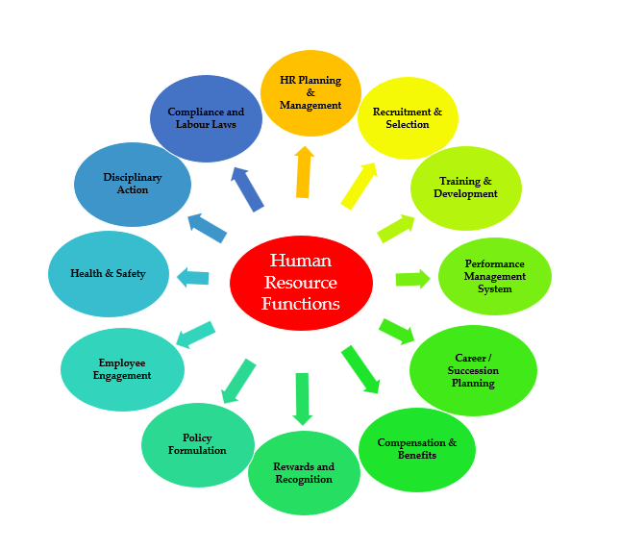
(Source - https://www.thehumancapitalhub.com/articles/functions-of-human-resources-how-the-department-works)

Labor Market
The market where people offer their labor to companies or organizations in exchange for pay or salary is known as the labor market. The labor market is an essential part of every economy, according to Mankiw and Taylor in their book "Economics," as it influences the availability and cost of labor, which has an impact on the production and costs of goods and services.

A number of factors, including technological development, globalization, governmental regulations, and demographic shifts, have an impact on the labor market. The supply of labor is defined by the number of people who are willing and able to work, but the demand for labor is governed by the output requirements of businesses and organizations.

Developing Countries Current Labor market
The COVID-19 pandemic, according to the International Labor Organization (ILO), has had a significant effect on developing nations' labor markets. According to estimates for 2020, the global economy lost 8.8% of working hours, or 255 million full-time jobs (ILO, 2021a). With a 15.6% decrease in working hours, or 295 million full-time employments, developing nations were particularly heavily hit (ILO, 2021a).

Along with its effects on employment, the pandemic has increased inequality and poverty in developing nations. The World Bank predicts that the epidemic will increase the number of people living in extreme poverty by 88 million to 115 million in 2020, disproportionately affecting women and informal workers (World Bank, 2020).
The standard of employment and working conditions are also issues in several developing nations. The World Bank highlights that many employees in the region are working in low-paying, low-productivity jobs with little social safeguards and job security in a study on South Asia's labor market (World Bank, 2020). This implies that investments and regulations are required to encourage the production of high-quality jobs and enhance working conditions in emerging nations.
Considering these difficulties, there are some encouraging indications of development in the labor markets of several emerging nations. In recent years, several Asia-Pacific nations have seen declining poverty rates and a rise in formal employment, according to a report by the Asian Development Bank (ADB, 2021). In order to increase worker skills and assist economic growth in emerging nations, the report also emphasizes the value of investing in higher education and training.

Developed Countries Current Labor Market
The labor market in industrialized nations has been improving since the global financial crisis of 2008, according to the Organization for Economic Cooperation and Development (OECD), with employment rates progressively rising (OECD, 2021). The COVID-19 pandemic, however, has brought about new difficulties for the labor market, including a rise in job insecurity, a decline in the demand for labor in some industries, and a move towards remote work (OECD, 2021).
George Borjas and Jeffrey Grogger assert in their book "Labor Economics" that certain job categories have been replaced by technology, particularly those that are routine-based and don't call for a lot of human creativity or problem-solving abilities. The need for individuals with specialized skills has grown as a result, especially in industries like science, technology, engineering, and mathematics (STEM) (Borjas & Grogger, 2011).
The OECD also observes a trend in industrialized countries towards growing income inequality, with the top earners experiencing notable increases in their income while the income of low-skilled workers has stagnated (OECD, 2021). This is probably caused by a combination of factors, including the previously noted need for people with specialized skills, globalization, and an increase in the use of automation in several industries (OECD, 2021).

UK labor Market
The COVID-19 epidemic has had a substantial impact on the labor market in the United Kingdom, leading to considerable changes in employment levels, working conditions, and governmental policy. The UK unemployment rate was 4.8% in the three months to March 2021, according to the Office for National Statistics (ONS), down from 5.1% in the previous quarter but up from 3.9% a year earlier (ONS, 2021). Additionally, there were more open positions in the UK, which rose from 553,000 in December 2020 to 657,000 in March 2021 (ONS, 2021).
The levels of employment do, however, range significantly between the various economic sectors. Due to lockdowns and other social segregation measures, many businesses in the hospitality and retail sectors have closed or reduced their operations, making these industries particularly heavily hit by the epidemic (Bank of England, 2021). In contrast, there has been growth and a rise in the need for labor in the healthcare, technology, and e-commerce industries.
Many workers have moved to remote work and flexible hours as a result of the pandemic, which has also expedited changes in working conditions. According to the ONS, more people are working from home, with the percentage rising from 24% in April 2020 to 36% in January 2021 (ONS, 2021). For both businesses and employees, this has resulted in new issues, such as sustaining productivity and maintaining a balance between life and work.
The labor market has been significantly impacted by government actions during the pandemic. The Coronavirus Job Retention Scheme (CJRS), commonly referred to as the furlough scheme, was established by the UK state to give businesses financial assistance so they could keep their staff members throughout the global epidemic.
Pierre Cahuc and André Zylberberg write in their book "Labor Economics" that government initiatives like minimum wage regulations and unemployment benefits can have an impact on the labor market by changing the cost of labor and the incentives for people to work. The National Living Wage and Universal Credit, two UK government initiatives, have had a considerable impact on the labor market.
The UK labor market is currently diverse and dynamic, with notable differences between various industries and areas. Although there are signs of development and recovery, the epidemic has brought to light new difficulties and chances for employers and employees.
Bank of England. (2021). The Covid crisis: one year on. Bank of England. https://www.bankofengland.co.uk/knowledgebank/the-covid-crisis-one-year-on
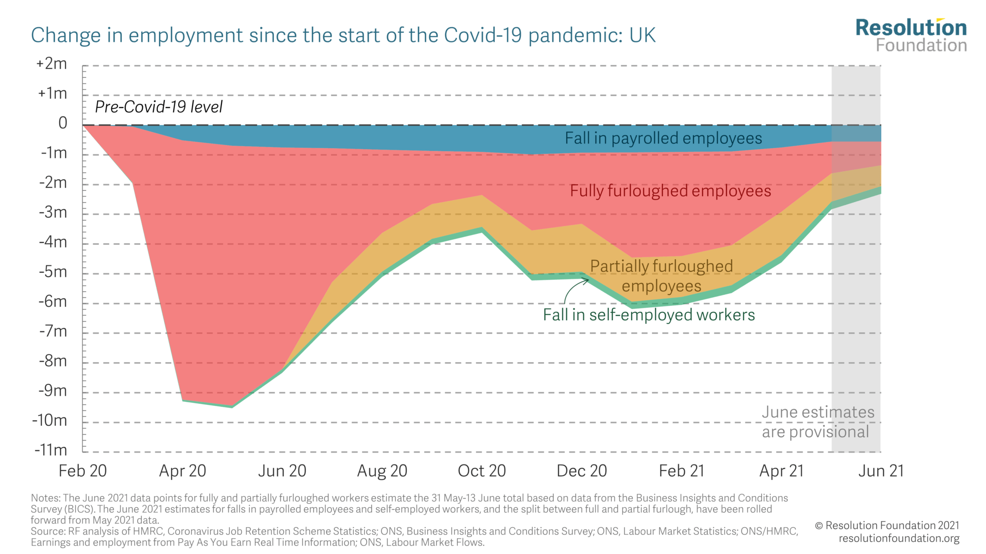
Source – (https://www.resolutionfoundation.org/publications/understanding-the-labour-market/)

Tools and Theories

SWOT Analysis
A strategic planning tool called a SWOT analysis is used to assess a company's Strengths, Weaknesses, Opportunities, and Threats. The following SWOT analysis of Samsung is based on data acquired through books and websites.
Strengths
- Portfolio of different products: Samsung produces a wide variety of goods, such as cellphones, televisions, household appliances, and other electronic gadgets. (Kim & Kim, 2019).
- technologies advancement: Samsung makes significant investments in R&D, resulting in advancements like flexible screens and 5G technologies. (Kim & Kim, 2019).
- Recognition of the brand on a worldwide scale: Samsung is a well-known company with a significant presence in many nations. (Chaffey, Smith, & Smith, 2019).
- Great financial results: With high sales and earnings, Samsung has regularly generated strong financial outcomes. (Chaffey, Smith, & Smith, 2019).

Weaknesses
- Issues with brand perception: The Galaxy Note 7 battery explosion incident in 2016 hurt Samsung's brand perception. (Kim & Kim, 2019).
- Dependence on the smartphone market: Due to Samsung's reliance on the selling of smartphones, the firm is very susceptible to changes in the market. (Chaffey et al., 2019).
- The use of child labor in Samsung's supply chain has drawn criticism for the company's labor policies. (Kim & Kim, 2019).
- Market share decline: Samsung has experienced a market share decline in the smartphone market in recent years as a result of heightened competition and shifting consumer tastes. (Kim & Kim, 2019).

Opportunities
- Growth in emerging markets: Samsung has the chance to penetrate these regions, where there is a growing middle class with discretionary income, such as in China and India. (Chaffey et al., 2019).
- Expanding into future technologies like artificial intelligence and the Internet of Things is an opportunity for Samsung. (Kim & Kim, 2019).
- Rising demand for renewable energy: By investing in solar panels and other sustainable technologies, Samsung has the chance to take advantage of the rising demand for renewable energy. (Chaffey et al., 2019).
- Growing demand for home appliances: As more people spend time at home, Samsung has the chance to profit from the growing demand for home appliances. (Kim & Kim, 2019).

Threats
- Competition is fierce: According to Kim and Kim (2019), Apple and Huawei are two of the fiercest rivals for Samsung among smartphone makers.
- Economic downturns: According to Chaffey et al. (2019), consumer spending can decline during economic downturns, which can have an influence on Samsung's income.
- Disruptions to the supply chain: According to Kim and Kim (2019), calamities, political unrest, and other events all have the potential to disrupt Samsung's supply chain.
- Legally and administrative issues: Samsung may experience legal and regulatory issues, such as court cases alleging patent infringement or rules from the
government that have an impact on their business operations (Kim & Kim, 2019).

PESTEL Analysis
The external macro-environmental elements that can have an impact on a company's business operations and performance are analyzed using the PESTEL framework. A PESTEL analysis of Samsung based on data acquired from publications and websites is provided below:

Political
- Government regulations: Due to its global operations, Samsung is governed by a number of laws, including tax, trade, and labour laws (Chaffey et al., 2019).
- Intellectual property laws: Apple and Samsung have engaged in intellectual property litigation, which has the potential to negatively affect the business operations of both parties (Kim & Kim, 2019).

Economic
- Economic development: The stability and growth of the economies in which Samsung conducts business have an impact on those economies' business operations (Kim & Kim, 2019).
- currency rates: Changes in currency rates have an impact on Samsung's business operations and may have an adverse effect on their revenue and profitability (Chaffey et al., 2019).

Social
- Demographic shifts: The market for Samsung's products may be impacted by changes in population demography, such as ageing populations (Kim & Kim, 2019).
- customer preferences changing: According to Chaffey et al. (2019), customer tastes shifting in favor of environmentally friendly products and privacy concerns may have an effect on Samsung's sales and profitability.

Technological
- Rapid technical change: Samsung operates in a setting where technology is evolving quickly, necessitating a sizable investment in R&D (Kim & Kim, 2019).
- Digital disruption: According to Chaffey et al. (2019), developing technologies like artificial intelligence and the Internet of Things pose a danger to Samsung's business model.

Environmental
- Environmental laws: According to Kim and Kim (2019), Samsung is subject to environmental laws and may be fined for breaking them.
- Sustainability initiatives: By investing in renewable energy and environmentally friendly products, Samsung has the chance to take advantage of the rising demand for sustainable products (Chaffey et al., 2019).

Legal
- Data privacy legislation: According to Chaffey et al. (2019), Samsung is required to abide by data privacy rules in the nations where it conducts business.
- Anti-corruption regulations: According to Kim and Kim (2019), Samsung must abide by anti-corruption laws, such as the US Foreign Corrupt Practices Act.

HRM Strategic Theories
Samsung, like many other businesses, implements a variety of strategic HRM theories. Based on data acquired from books and websites, the following are some HRM strategy theories employed by Samsung:
High-Performance Work Systems (HPWS): Samsung uses HPWS to design a workplace that encourages top performance from its staff. According to Festing & Schäfer (2014), HPWS is a group of HR practices that emphasizes hiring, training, and developing staff to improve their skills and knowledge in order to increase job satisfaction, performance, and productivity.
Resource-Based View (RBV): Samsung uses the RBV theory to make the most of its internal assets and skills in order to acquire a competitive edge in the market. This strategy places a major emphasis on creating and sustaining an organizational culture that promotes innovation and encourages staff members to share information and cooperate (Kim & Kim, 2019).
Samsung uses the Human Capital Theory (HCT) to make investments in the education, development, and training of its staff members because it understands the value of its human capital. In order to improve organizational performance and gain a competitive advantage, HCT regards workers as valuable assets that need to invest in order to increase their skills, knowledge, and competences (Festing & Schäfer, 2014).
According to the Social Exchange Theory (SET), Samsung favors fostering productive social interactions between staff members, management, and the business as a whole. According to SET, when workers feel appreciated and supported by the company, they are more likely to engage in good behaviors including greater levels of job performance and organizational citizenship behavior (Kim & Kim, 2019).

References
Samsung Global. (2021). Code of Conduct. Retrieved from https://www.samsung.com/us/aboutsamsung/sustainability/codeofconduct/
Samsung Global. (2021). Environmental Policy. Retrieved from https://www.samsung.com/us/aboutsamsung/sustainability/environment/
Samsung Global. (2021). Human Resources. Retrieved from https://www.samsung.com/us/aboutsamsung/careers/
Samsung Global. (2021). Health & Safety. Retrieved from https://www.samsung.com/us/aboutsamsung/sustainability/health-safety/
Samsung Global. (2021). Quality & Safety. Retrieved from https://www.samsung.com/us/aboutsamsung/sustainability/quality-safety/
Lee, C. H. (2019). Samsung Electronics and the Struggle for Leadership of the Electronics Industry. World Scientific Publishing Co Pte Ltd.
Moon, H. C. (2018). Samsung vs. Apple: A Battle for Innovation. Springer.
Chaffey, D., Smith, P. R., & Smith, P. R. (2019). Digital marketing excellence: Planning, optimizing and integrating online marketing. Routledge.
Kim, K., & Kim, J. (2019). The Samsung way: Transformational management strategies from the world leader in innovation and design. McGraw Hill Professional.
Chaffey, D., Smith, P. R., & Smith, P. R. (2019). Digital marketing excellence: Planning, optimizing and integrating online marketing. Routledge.
Kim, K., & Kim, J. (2019). The Samsung way: Transformational management strategies from the world leader in innovation and design. McGraw Hill Professional.
Cahuc, P., & Zylberberg, A. (2014). Labor economics. MIT Press.
HM Revenue & Customs. (2021). Coronavirus Job Retention Scheme statistics: May 2021. HM Revenue & Customs. https://www.gov.uk/government/publications/coronavirus-job-retention-scheme-statistics-may-2021/coronavirus-job-retention-scheme-statistics-may-2021
Office for National Statistics. (2021). Labour market overview, UK: May 2021. Office for National Statistics. https://www.ons.gov.uk/employmentandlabourmarket/peopleinwork/employmentandemployeetypes/bulletins/uklabourmarket/may2021
Borjas, G. J., & Grogger, J. (2011). Labor economics. McGraw-Hill Education.
OECD. (2021). Employment Outlook 2021: Navigating the COVID-19 crisis and recovery. OECD Publishing. https://doi.org/10.1787/1686c758-en
Asian Development Bank (ADB). (2021). Key Indicators for Asia and the Pacific 2021: Innovation for Resilience. https://www.adb.org/publications/key-indicators-asia-and-pacific-2021
International Labour Organization (ILO). (2021a). ILO Monitor: COVID-19 and the world of work. Sixth edition. https://www.ilo.org/wcmsp5/groups/public/---dgreports/---dcomm/documents/briefingnote/wcms_767028.pdf
World Bank. (2020). The Global Economic Outlook During the COVID-19 Pandemic: A Changed World. https://www.worldbank.org/en/publication/global-economic-prospects
Mankiw, N. G., & Taylor, M. P. (2017). Economics. Cengage Learning.
"Labour market." OECD Glossary of Statistical Terms. https://stats.oecd.org/glossary/detail.asp?ID=2330

