UWTSD
Data Analysis
Cameron Rees
1900641
09th January 2022
Research Methods (M5X01282)

Table of contents

- Introduction
- Primary data collection and / or secondary data selection techniques and procedures
- Design a survey / questionnaire and/or interviews for collecting primary data
- Critically discuss data analysis techniques
- Present the application of data analysis to achieve the outcomes
- Anticipated findings
- Conclusion
- References

Introduction
This report will consist of selected research problems and issues that have been identified and presented in the ‘5S’ research proposal report previously. For a bit of background on myself, I work for a logistics company called VALE which is a nickel refinery where we are producers of finished goods. We receive raw materials called TINOS and FMW from Canada and Japan that we then process into nickel powder and nickel pellets. The nickel we make is then used for aeroplane batteries and also car batteries as well as many other things. In the refinery I am located in the shipping warehouse and the shipping department have recently come up with a new research project proposal called 5S. 5S is a method of working that helps to create a self-sustaining culture of an organised, clean, safe, and efficient workplace that identifies and eliminates waste. It is more than housekeeping; it is a specific work culture that also helps to promote process improvements by helping to clearly identify abnormal conditions allowing quick fault finding and problem solving. In this report I will focus on the data collection and analysis techniques and strategies. In addition, this report will include the uses of primary and secondary data collection techniques and procedures, additionally, it will show a well-designed survey/questionnaire. Next this report will crucially discuss some data analysis techniques such as, (Regression analysis, Monte Carlo simulation, Factor analysis, Cohort analysis, Cluster analysis, Time series analysis and sentiment analysis.) Furthermore, it will illustrate the application of data analysis to achieve the goals set and finally this report will show what the predicted or anticipated findings of the research proposal are. Overall, this report on data analysis will show how crucial and beneficial all types of data analysis is in order to make any research proposal a successful research proposal.
Primary data collection and / or secondary data selection techniques and procedures
When collecting data there are two kinds, these are called “primary and secondary data”(Wagh, 2021). Firstly, Primary data is first-hand data that is gathered by the researcher themselves. The process is very interactive, and sources of primary data would include the likes of surveys, experiments, questionnaires and also interviews carried out by the researcher. However, when a sourcing for primary data the use of interviews or questionnaires can be expensive. Primary data is seen to be the most beneficial as it is more accurate and reliable and also it is always specific to the researchers use. Moreover, secondary data is less reliable and accurate as secondary data is data that is collected by somebody else during the past. Secondary data can be found in the form of government publications, websites, articles, and books. Even though secondary data is seen to be less reliable as the researcher hasn’t collected this data themselves, it is a far cheaper method of obtaining information as most secondary data is free of charge and also the process of which gathering this information is a very quick and easy one.
When constructing this report as a follow up to the research proposal, when discussing data analysis, it is imperative that the correct methods and techniques are used even if the use of primary or secondary data is being used. As stated earlier primary data consists of the usage of questionnaires, surveys, or interviews. In this research proposal it was best thought that the use of a survey would be the best and most efficient sort of primary data to gather as everyone who is involved in the ‘5S’ project can contribute to the research proposal and make the project a very successful one.
“Surveys”(SmartSurvey, 2021) are often completed online and allow this form of research to be helpful and a cost-effective way when a large audience is participating in the survey. The appropriate procedure that is necessary in order to carry out a well worked survey is as follow. Firstly, once the project proposal was decided questions must be formed. It is crucial that the survey has a precise balance as if the survey is far too long, people carrying out the survey will get bored and leave the survey not finished. Nonetheless, if the survey is too short yes, it will be completed but the amount of data gathered will be limited and possibly this will not be enough to see the whole picture. The format choice of questions is key also because if a survey has multiple choice types of answers it is easier for participant to answer, it is not time consuming as they do not need to think about a written answer and also it provides quantitative data (Quantitative research is commonly known with the positivist/postpositivist paradigm. This type of research requires data to be collected and converted into numerical form in order for statistical calculations to be made and also to help make conclusions) to be gathered and analysed by the researcher. If multiple choice is used also, it can be enhanced with the use of open-ended questions to gather even more data and allow “thematic analysis”(Delve, 2021) which Is a qualitative data analysis method that involves reading through a data set (such as transcripts from in depth interviews or focus groups) and identifying patterns in meaning across the data to be undertaken.
The usage of secondary data in this research proposal was also used and played a key part in this proposal. Secondary data can be found in the form of government publications, websites, articles, and books. With all these sources to choose from the research proposal would benefit greatly due to the use of the internet it is possible to look and gather information from different companies who have also conducted similar types of projects such as 5S. This would be a big advantage for the research proposal as it will give a good understanding how successful other companies were, and it will also show areas where they can improve from when overlooking other companies in order to make sure their research proposal is the best it can be. An example that consisted of a company using 5S is from the actual company who originated 5S which are known as Toyota in Japan. Toyota in Japan was the very first to implement a scheme called 5S in the hope to manage and sustain an efficient workstation. 5S consists of “5 Pillars” (Store, 2016) that are implemented in the standardisation process. The pillars that are involved with 5S form of Sort, straighten, shine, standardise and sustain. The whole aim that Toyota planned when inventing this method was to take their company to new heights and become more successful in an efficient way also. Another company that took inspiration like Vale was Harley Davidson Motor company in Milwaukee Wisconsin. Harley Davidson motor company have “1400 branches” reaching out to more than “100 countries” (Harley Davidson, 2022) Numerous branches out of the 1400 are slowly implementing to the use of 5S and lean production to pursue to streamline and boost their whole levels of efficiency. In Particular the branch located in Kansas city Missouri started to apply the 5S system due to the branch being threatened with dissolution. Employees who worked there were given instruction that they would be moved to another branch in the York in Pennsylvania if concessions in construction weren’t made. Conclusively, due to the application of 5S in the Kansas city branch it helped them stay open and this resulted in all the employees keep their jobs and not be located to another branch. Harley Davidson has the implementation of 5S will save the organisation as a whole “insurmountable costs in time and in safety measures”.
Design a survey / questionnaire and/or interviews for collecting primary data
For this research proposal as stated earlier the use of primary research is critical. For that reason, I have designed a survey that allows all participants who are involved with the implementation of the 5S system to take part in this survey and this will allow me to gather all the data and see what results are collected from this survey. Below is my survey and as stated earlier it is not too short or too long, it has very easy answerable questions, and it is nice and simple to follow. All 3 of these key factors have helped me generate a well-designed survey that will get every participant involved and allow me to gather a 100% results rate which will only be an advantage when constructing my results and how the 5S system should be implemented in the future.
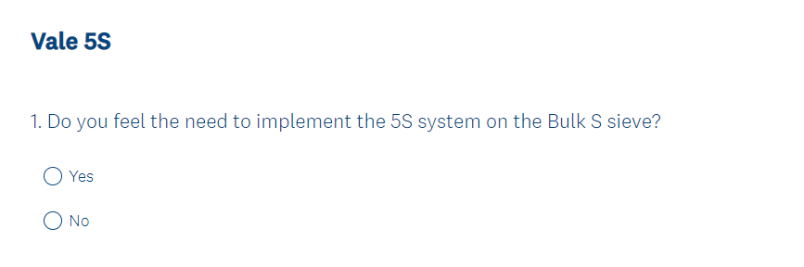

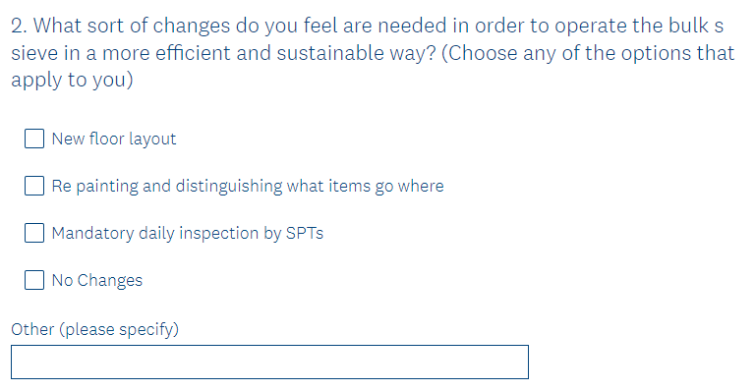
Figure 1.

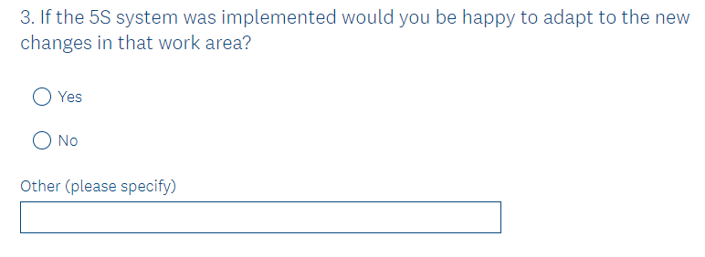
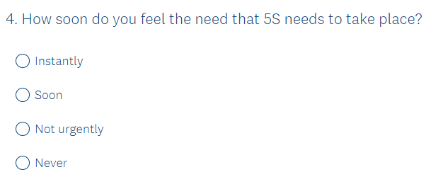
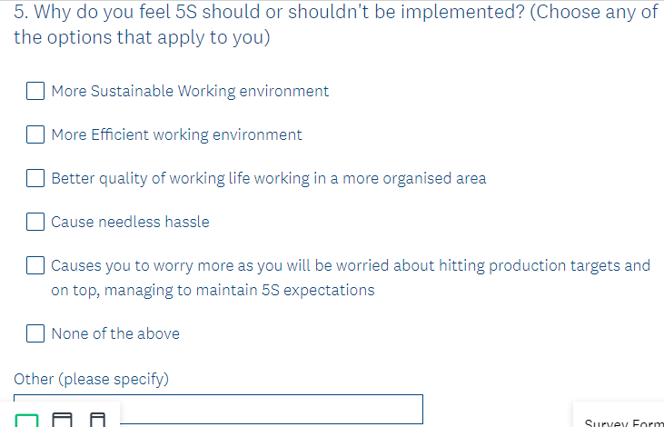

Critically discuss data analysis techniques
Data analysis involves various activities that involves its techniques such as collecting, cleaning, and organising the data. You would normally find these processes which include data analysis software for business purposes as it is necessary to prepare the data. Insights in data such as, metrics, figures and facts can be found by data analysis methods and techniques. There are two primary methods that have been mention in the previous report on this research proposal for data analysis which are “data analysis techniques and quantitative data analysis techniques.”(Maryville University, 2021) Both data analysis techniques can be used individually or together in order to benefit decision makers business insights from contrasting data types. When a researcher is thoroughly analysing data, they have the options to use a vast number of analytical techniques as stated above however when it involves very detailed statistical analysis more often than not most researchers believe SPSS the best solution. SPSS stands for “Statistical Package for the Social Sciences”(Alchemer, 2021) SPSS is used by different kinds of researchers for any difficult data analysis. Examples of what types of researchers use SSPS include, market researchers, health researchers, government entities, education researchers, marketing research and survey organisations. The list is endless, all these types of researchers process and analyse survey data with the use of SPSS. SPSS is used on a global scale by nearly most of the biggest research companies to mine text data and analyse survey data. Thy use SPSS as they know thy can get the best results for their research and survey projects.
Present the application of data analysis to achieve the outcomes
Throughout this research proposal the job of the researcher is to find solutions that can help the bulk s sieve find its most efficient and sustainable self. With the knowledge that the researcher has, it was decided that the introduction of the 5S system was going to be implemented. However, before making a final decision if they were 100% going to carry out the 5S system, the researcher adapted a critical data analysis technique by using SPSS which is used by nearly all the top research in the survey organisations world. This use of this technique allows the researcher to create a very good survey that can paint an image to the researcher when he finds out the results from the survey they created. As see above in figure 1 it clearly shows the 5 questions from survey created by the researcher. After distributing the surveys to employees who work on the bulk s sieve the results from the survey have been collected and are shown as followed:
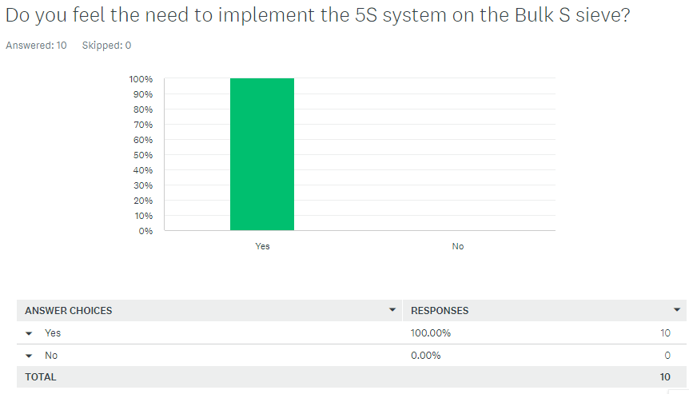
From question 1, as you can see from the results out of 10 employees who use the bulk s sieve on a daily basis have all felt that the implementation of the 5S system is necessary as the bar graph shows a resounding result of 100% in favour of Yes to the implementation of the 5S system.

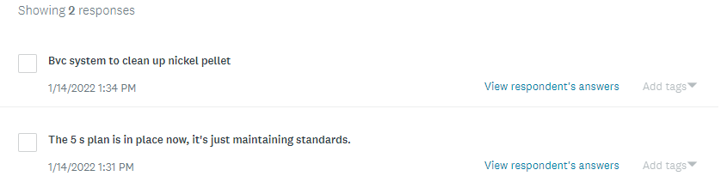
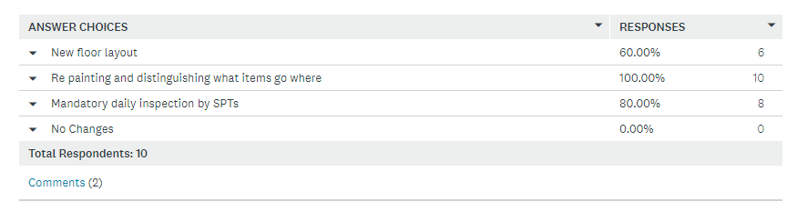
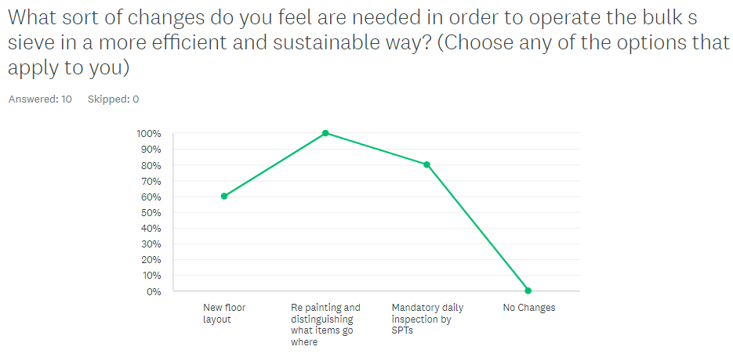
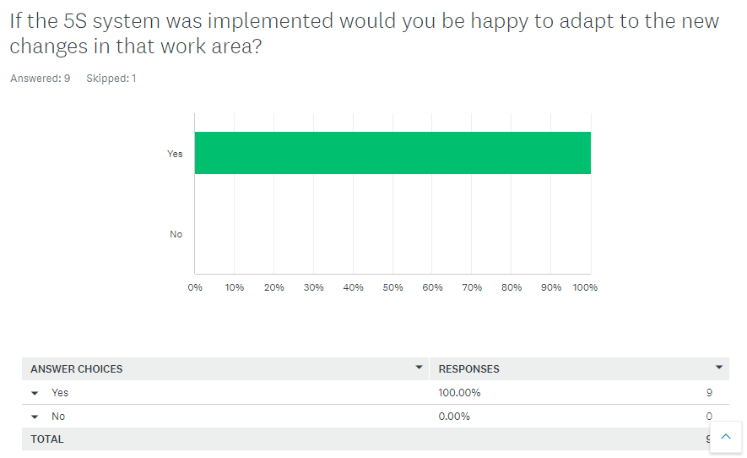
From the second question asked in the survey its can be seen that from all 10 participants feel the need for changes to constructed in order for the bulk s sieve to be more efficient and sustainable as nobody (0%) chose the answer that said no changes. The fact that no participants chose the no changes answer shows the researcher clearly by the line graph used that the participants feel that new changes are needed such as Re painting and distinguishing what items go whereas 100% of the participants chose this idea. Moreover, with the option of adding their own comments one participant added an idea of their own. The opportunity of adding a comment of their own is a great advantage to the researcher and whole research proposal as it gives new information and idea to make this research proposal the best it can be.
Question 3 focuses on whether an employee will be willing to adapt to changes made to the bulk s sieve job if it is decided to use the 5S system. From the results shown from the bar graph 100% of all participants show willingness to be able to adapt to changes made by the 5S system. This shows the researcher that not only everybody is willing to change normal daily routines around this jib but also what great employees there are that are situated with job due to the adaptation everyone is willing to tackle.

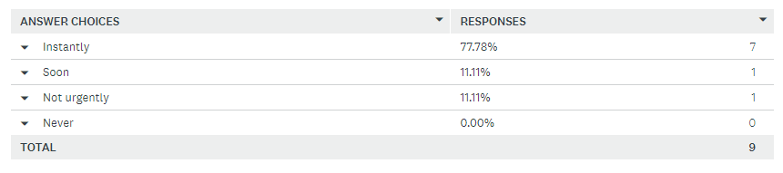
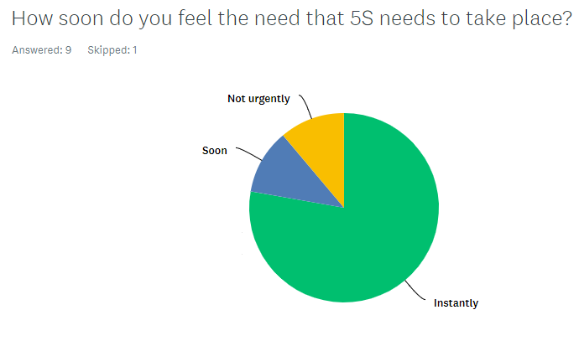
In the survey question 4 concentrates on how soon the employees feel that the new 5S system need to be implemented. From the Pie chart shown the researcher can see clearly that 77.78% which is 7/9 participants that involved themselves with this question feel that the 5S system needs to be introduces instantly. 1 participant felt that it is not as important for it to be introduced instantly as they selected it for it to be introduced soon and finally one participant felt that the 5S system does not need to be introduced any time soon as they selected the not urgently option. This question shows the researcher how important the 5S system means to the employees and also it shows him how much the employees want to implement it due the majority selecting in favour of an instant implementation.
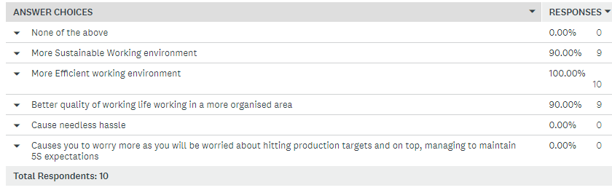
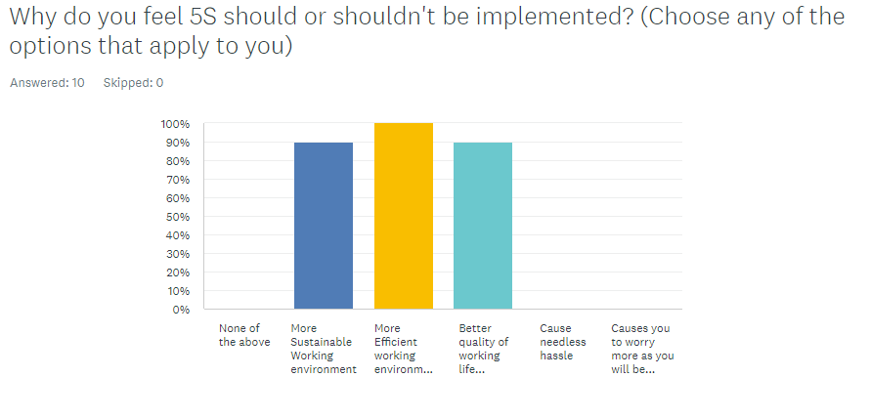
Finally, the last question concentrates on the factors of if the 5S system should or shouldn’t be implanted. From the bar chat from the 6 options listed only 3 options were chosen from all 10 participants. Out of the 6 options 3 of them are options that are in favour of the 5S system and 3 that are against it. As stated only 3 options were selected and the 3 options were all in favour of the 5S system. The bar chart shows that 100% of the participants feel that the 5S system would cause a more efficient working environment and also 90% of participants are in favour for feeling that the 5S system would cause a more sustainable working environment and also it would cause a better quality of working life. This shows the researcher a great positive towards the research proposal as 100% of the participants share the opinion that the 5S system would only bring a positive aspect to the bulk S sieve.

Anticipated findings
From studying and managing this research proposal the researcher will always predict and have anticipated findings. Throughout this proposal the researcher will endeavour to figure out as many solutions to the aims and objectives in both the previous paper and this paper. Furthermore, the researchers’ anticipations should also be the expectation to find that the introduction to the 5S system will not only help the overall improvement of the job but also provide sustainability and efficiency whilst doing so.
Conclusion
To conclude, this report has conducted a detailed account of various types of data analysis techniques and methods such as the software SPSS. Furthermore, it has highlighted in depth the crucial importance of different types of data needed in order to carry out a successful research proposal such as primary and secondary data. Moreover, this report shows why the researcher has used both types of data for example as stated earlier the use of primary data which involved the making of a survey and the secondary data which involved the use of the internet and how Toyota implemented the 5S system to make their company the success it is today. Once the report described what types of data the researcher will be using it then discusses why the researcher uses these types of data as both data types provide huge benefits to this research proposal. Also, In this research proposal it can be seen in the form of various types of graphs that the results of the primary data show concrete evidence to the researcher that employees who are involved with the bulk s sieve are in favour for the 5S system. This type of survey and results makes the researchers job a lot easier as he can see clearly what the results are, and he can then compare these results to his own predictions to see if he anticipated these findings. Overall, in my opinion in order to carry out a successful research proposal it is crucial you take the time to research what type of data you will be using, ask yourself how this will type of data benefit the proposal and finally use software’s such as SPSS to benefit your findings. If all are applied, then the outcome for the research proposal will only be a positive outcome.

References
Alchemer (2021) What is SPSS and How Does it Benefit Survey Data Analysis?, Alchemer. Available at: https://www.alchemer.com/resources/blog/what-is-spss/ (Accessed: 14 January 2022).
Delve (2021) How to do thematic analysis, Delve. Available at: https://delvetool.com/blog/thematicanalysis (Accessed: 13 January 2022).
Harley Davidson (2022) Locations | Harley-Davidson United Kingdom. Available at: https://www.harley-davidson.com/gb/en/about-us/careers/locations.html (Accessed: 13 January 2022).
Maryville University (2021) ‘Top 4 Data Analysis Techniques’, Maryville Online, 15 March. Available at: https://online.maryville.edu/blog/data-analysis-techniques/ (Accessed: 14 January 2022).
SmartSurvey (2021) Primary Research Methods Explained, SmartSurvey. Available at: https://www.smartsurvey.co.uk/articles/primary-research-methods (Accessed: 13 January 2022).
Store, T.F.T. (2016) Successful Companies Using 5S Today, The Floor Tape Store. Available at: https://www.floortapestore.com/blogs/news/successful-companies-using-5s-today (Accessed: 13 January 2022).
Wagh, S. (2021) Research Guides: Public Health Research Guide: Primary & Secondary Data Definitions. Available at: https://researchguides.ben.edu/c.php?g=282050&p=4036581 (Accessed: 20 October 2021).

