

customer Relationship management emerging themes
Understanding and Engaging in the Customer Experience BMSW5103

sabrina Reid 1920873
lecturers: Dr eric osei & Dr Richmond lamptey
4 APRIL 2022

Table of Contents
Introduction 3
Report 3
Customer Touchpoints 3
The Importance of Customer Touchpoints 5
The Customer Experience 5
The Importance of The Customer Experience 6
The Customer Brand Experience 7
The Importance of The Customer Brand Experience 9
CONCLUSION 9
Critical Analysis of Quality Models 9
Deming’s 9
Create a constant purpose toward improvement 10
Adopt a new philosophy. 10
Stop depending on inspections. 10
Use a single supplier for any one item. 10
Improve constantly and forever. 10
Use training on the job. 11
Implement leadership. 11
Eliminate fear. 11
Break down barriers between departments. 11
Get rid of unclear slogans. 11
Eliminate management by objectives 12
Crosby 12
REFERENCES 12
BIBLIOGRAPHY 13

Introduction

This report will explore emerging themes in the customer experiences, brand experience as well as customer touch points within the South Korean mobile phone company Samsung. Since 1988 Samsung have been producing mobile phones and Android operating systems, endured a slow yet steady climb within the mobile industry throughout the 1990s to early 2000s.
Samsung continued to grow and became the second largest mobile phone manufacturer in 2007. In June 2010, Samsung designed a new operating system and introduced their Galaxy S phone devouring the market share. The new and improve phone accounted for 24% of the market by the end of 2011, giving Samsung the perspicacity to drive forward with Android-based smartphones.
Samsung are continually devoted to growing and fortifying their customer relationships significantly and meaningfully through multi channels of high-quality customer services.
Samsung is dedicated to following local laws and regulations and enforcing a strong worldwide code of conduct for all workers. (“5 Leading Kiosk Companies - Verified Market Research”) It considers that ethical management is not just essentially a way for adapting to rapid changes in the global corporate environment, but also a vehicle for establishing trust with customers, shareholders, workers, company associates, and community organizations.
Samsung continues to teach its employees and maintain monitoring systems, all while exercising fair and transparent company management, in order to become one of the world's most ethical corporations. They have seen a rise in their sales and customer retention which has led Samsung to becoming leading giants and the world’s largest mobile phone manufacturers in 2012 to present day (Samsung, 2022).

Report

Customer Touchpoints
Customer touchpoints consist of a myriad of interactions through various channels which result in complex customer experiences and encounters throughout the customer journey. Customers' awareness, impressions of a company, brand, product, or service are formed during these points of contact, irrespective of a brand's preconceptions of control (Yaveroglu and Donthu 2008).This can be physical or indirect contact with products, services, or a representation of the company. The digital touchpoints can include website, digital billboards, and online advertisements (Neslin, et al. 2014).

Figure 1, Illustrates Various Customer Touchpoints
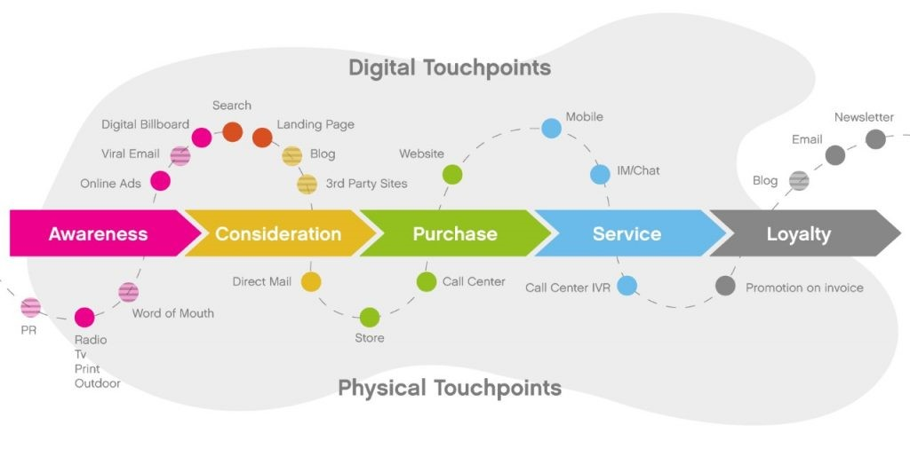
(Grohawk, 2020)

Omni-channel management is customary, and brands need to acclimatize to rapid media and channel fragmentation. (Brynjolfsson, Hu, and Rahman, 2013), (Brynjolfsson, Hu, and Rahman, 2013), (Verhoef, Kannan, Inman, 2015).

Figure 2, Illustrates the 360 degrees of Retail Omni-Channel Commerce
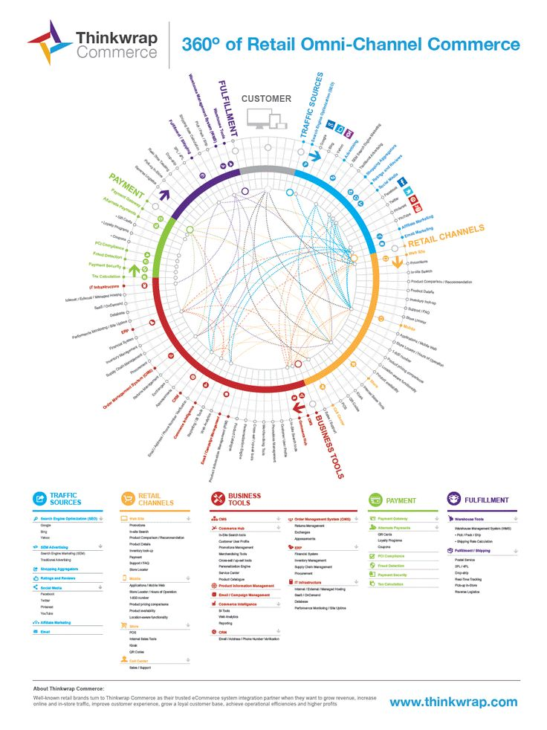
(Shift4shops, 2021)
A Samsung Galaxy S22 Ultra (S22 Ultra) was advertised on YouTube, disrupting the intended video by broadcasting a commercial at the start of a video. The spectator is forced to see this advertising, whereas they can change the channel on the television. Drawing their attention to the new phone becoming engrossed in it. As the advertisement is unavoidable, as a touchpoint its objective is to provide opportunities for engagement. So, by interrupting the viewer's experience, it has engaged a potential customer, who will retain and recollect the advertisement later.
These potential customers may share the information with their families and friends, via social media platforms or conversations. People enjoy interacting with one another and learning new things. Therefore, customer reviews/peer referrals are valuable touchpoint to Samsung. People value their peers’ opinions and share similar interests. hedonic and utilitarian rewards, consumers attain a variety of goals (Chernev, 2004). Consequently, these customers become brand ambassadors/advocates.
This can also encourage and attract a current consumer to continue with the brand, or even acquire The S22 Ultra for oneself, a loved one, or a family member, or even purchase the connected products such as watches and other products, assisting Samsung with brand retention. While customer-to-customer engagements via social media pose significant obstacles, they also present businesses with favourable prospects. (Leeflang et al., 2013), (Libia et al., 2010).
Using the phone as touchpoint, Samsung know how to pull on the heart strings of their customers, conveying sentiments of having the ‘ Epic ’ photo with captions of “Nightography is more than just video its photos ”, and slogans of “ With the power of Nightography to make nights epic & a note-worthy new look, The Galaxy S 22 Ultra, breaks all the rules of what a smart phone can do.” (Samsung, 2022). Holt (1997) states Very few products are brought to satisfy basic needs, most purchases reflect social objectives and values.
Irrespective of Samsung sentiments, the older generation are not hip to social media or understand it, therefore traditional means of advertising, such as newspaper adverts, billboards, radio & Television advertisements would be more suitable. For younger audiences this is great, as generation X is all about uploading their lifestyles on social media.
Brynjolfsson, Hu, and Rahman (2013), Rapp et al. (2015), Homburg et al. (2015), and Schmitt (2003) describe the customer experiences and customer journey eventuating through multi-channels of touchpoints with a company, brands service or product.

The Importance of Customer Touchpoints
Customers connect with companies or brands through touchpoints, which may be used to identify areas that need to be developed or improved. Customers' experiences and perceptions of a company or brand are significantly influenced by these interactions, which are segmented, refined, and evaluated on the positive and negative consequences of their customers' journey. According to (Holt, 1997), very few products are purchased to fulfil fundamental needs, and most purchases symbolise societal goals and values.
Touchpoints can assist companies to visually ensure that none of their customers slip through the cracks, this is merely within a company or brands influence and control. By delineating defined key touch points, companies can exploit excellent opportunities to enhance and maximize the experience of their customer’s journey. (Pine and Gilmore, 1998), explicitly conveyed the importance of experiences in today’s society and the opportunities for firms to benefit from creating strong and enduring customer experiences.

The Customer Experience
The customer experience refers to all aspects of the company that influence or affect a customer's perception and emotions in relation to that company. It is one of the most critical influences, of whether a customer chooses to spend their money, what they are willing to spend, or whether they will return to spend with Samsung, stay with Samsung, or leave, obstructing the customer experience's progress. The customer experience revolves around the company's relationship with its customers in all areas of interaction, whether it is a purchase or a brief encounter. Customer experiences are becoming more social, according to (Brynjolfsson, Hu, and Rahman, 2013), and peer customers are having an effect on them.

Figure 3, Illustrates the Strategy Process for The Customer Experience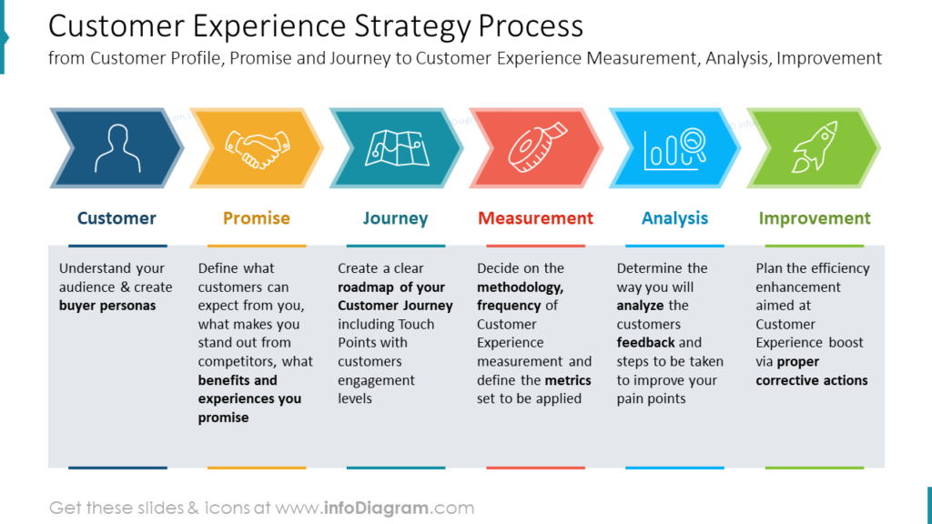
(Acquire, 2021)

The Importance of The Customer Experience

Customer satisfaction boosts a company's performance, according to (Fornell et al. 1996). and is imperative for companies or brands to implement consistent, relevant, and fresh innovative customer experiences within every interaction they have with their customers. Ensuring delivery on their customers’ expectations and the alignment of this delivery between the company or brand, in guaranteeing their customers are top priority in providing them with high-quality experiences. Furthermore, it is a collaborative responsibility of every department within Samsung to work closely together, diligently, and effectively, contributing to positively affecting each customer with an overall efficacious experience. According to (Cutlip et al. 2006), Marketing communication is the managing vocation that starts and sustains mutually beneficial relationships between the organisation and the public. Samsung recognizes the power of brand loyalty and customer retention. Samsung has become adept at identifying and understanding their customers' tendencies as a result of their customer experience channels, and they have begun to connect their clients with their smartphone devices (Cutlip et al. 2006).
Customers prefer Samsung products because of their operating system, features like Bixby, Samsung's version of a virtual assistant, wristwatch, headphones, and earbuds, as well as other products that can link to their mobile phones, according to Samsung. On the other hand, when certain big mobile phone brands release a new phone, their older phones often experience issues, prompting people to upgrade. Samsung, on the other hand, makes phones for a wide range of clients.

Figure 4, Illustrates the Journey of The Customer Experience
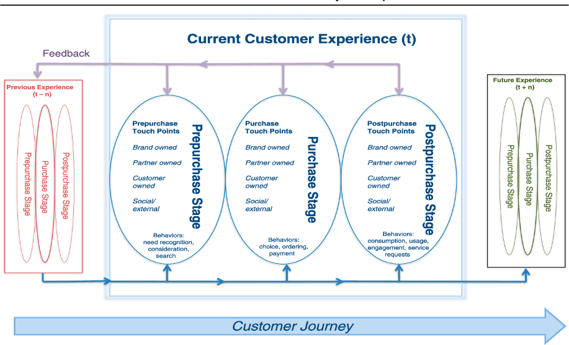
(Lemon, K & Verhoef, P, 2016)

The Customer Brand Experience

According to (Schmitt,1999), a customer's cognitive, behavioural, social, emotional, sensory, and spiritual responses to aesthetically appealing experiences customers have across all encounters with every component of the brand are a multidimensional construct. This is the manner of how the customers experience of company’s brand uniqueness from a holistic level is vital, especially in this digital era. What consumers actually want are enjoyable experiences, not things, (Abbott,1955).

Figure 5, Illustrates the Steps to Improve Customer Brand Experience
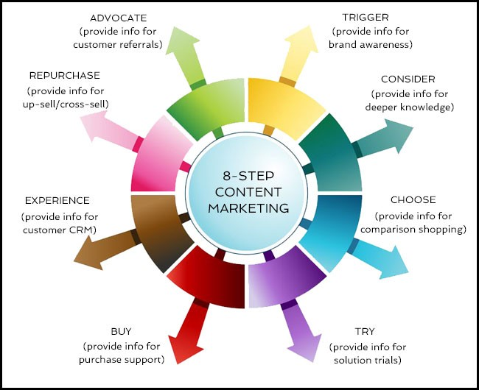
(Business finance, 2020)
The consumers that find the interruption of the S22 Ultra advertisement an annoyance, will avoid this brand as they do not find it relatable or befitting. On the other hand, the consumers that assent to the adverts will continue through to the website and may procced on to purchase a mobile phone9 from Samsung. Social chat bots (chatbots) are handy tools companies and brands utilize during this online stage of their customer’s experience and are implemented throughout all stages of purchase to post purchase. (Xu et al., 2017). The customer can learn how to use the phone's functions and verify that they have chosen the best smartphone for them. Chatbots are there for people to use and ask for queries at all stages. Samsung is able to identify and respond to these customer replies instantaneously, providing the opportunity to make changes in response to their customers' preferences and needs.
Samsung introduced a mobile customer service truck in New York City in 2018, where customers can step on board and repair their phone screens, receive help setting up a new phone, or simply re-charge their phones and devices, giving their customers an innovative brand experience of a food truck-oriented style of service.

The Importance of The Customer Brand Experience

Customers can connect and convey their experiences with a company or brand in real-time, whether it is online, via social media platforms like Twitter and Instagram, or in person. Thus, amplifying company’s and brands exposure to both positivity and negativity. People can use these platforms to engage with the company throughout and after the purchasing process, as well as communicate with other customers concerning their new phone and share real-time feedback. This will either facilitate or hinder the product's sales. Brand is a strategic asset and a potent source of distinction that plays a crucial role in market strategy, (Lim and O'Cass, 2001).
Companies are increasingly using it to engage with customers and announce new products. Samsung recognizes that most people own multiple phones and devices which they carry with them everywhere they go. Samsung has taken advantage of this by placing advertising information right in the palms of their customers' hands, where connection it is easily. This has benefited Samsung because it allows them to communicate with customers in real-time, resulting in immediate reactions. (Hanzaee and Farsani, 2011) discovered that the impact of brand image and perceived public relations on customer loyalty and that attracting new customers remains a crucial concern. Businesses should focus on keeping current consumers and structuring profitable yet long-term relationships with them, they go on to suggest.

Conclusion
Therefore, when a company fail to deliver on their promise, it is vital to recognise these flaws and inadequacies, by rectifying these issues for their customers. Maintaining these indispensable ethics and principles throughout the customer experience, over time Samsung have maintained these principles throughout the customer experience which has optimal impact on their sales, growth, and customer retention. Implementing principles of loyalty- simplicity, honesty, fairness, respect, and responsibility, results in financial magic in all companies of all sizes and in all industries (Reichheld, 2001).

Critical Analysis of Quality Models

Deming’s
Quality refers to a product or service that not only meets, but also exceeds, the company's and customers' expectations, as well as complying with medical and legal regulations (Indeed editorial team, 2020).
Deming's quality model focuses on improving a company's production and processes, as well as transforming management methods to develop a work environment that increases instead of decreases productivity. A strategic analysis implemented in the reconstruction of Japan’s economy in the 1930’s (The University of Tennessee, 2021).
PDCA is a great method for implementing changes in a sustainable and conscientious manner. Instead of replacing standard processes with a spontaneous method, take tiny steps and constantly keep a careful eye on the situation. However, one of the major drawbacks of the Deming cycle is that firms must budget enough time to implement the concept. Rapid issue resolution is not possible using PDCA (Ionos, 2022)

Figure 6, Illustrates the advantages and disadvantages of PDCA
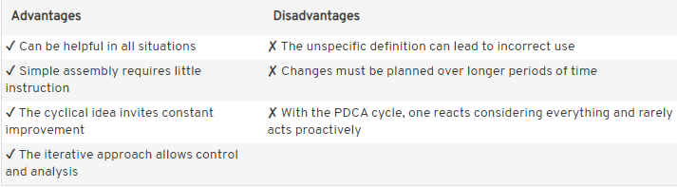
(Ionos, 2022)

Figure 7, illustrates the PDCA cycle
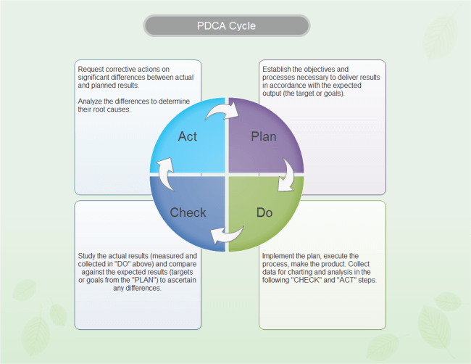
(Edraw, 2022).

Deming theory flows around fourteen points as illustrated in figure 6 below.

Figure 6, illustrates Deming’s 14 points
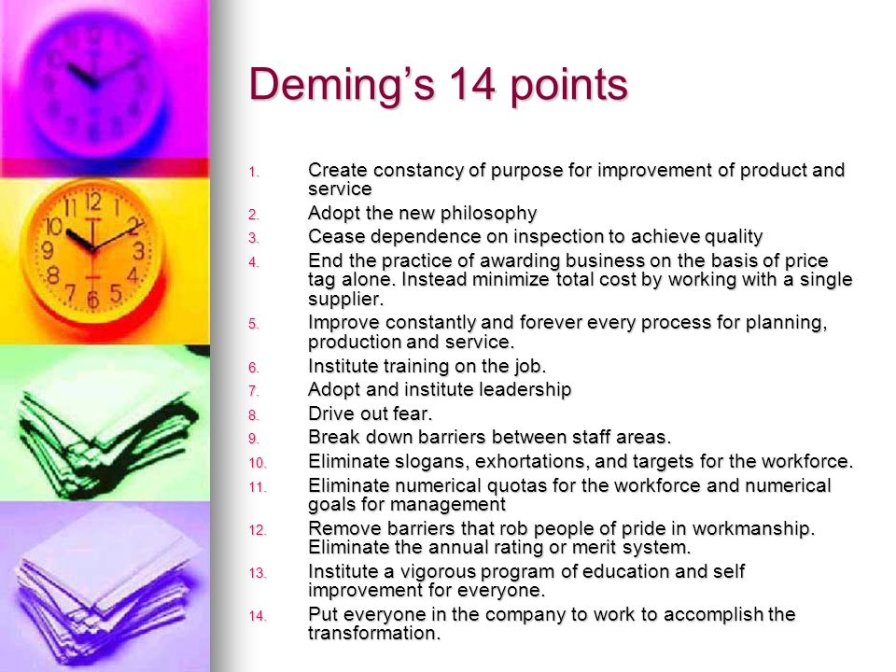
(Slideplayer. 2022).
Deming’s highlighted the need to focus on quality not quantity. Deming believed to break down barriers between employees and create a sense of responsibility for the company overall (Deming,1986) Samsung has recently launched their new company slogan ‘together for tomorrow.’ This entails everyone within the company works for the main goals of the company.(Samsung, 2022)

On the other hand, Deming mentions companies should eliminate slogans, targets, exhortation for the workforce. This is not a clear slogan has it could mean loyalty, building for tomorrow, shaping tomorrow, until it is explained it is unclear to say to remove slogans who is to say what is clear and what is unclear. It is hard to determine clear and unclear slogans because everyone has a different viewpoint. This could be viewed has a hinderance and contradict his quality over quantity. Targets allow the company to maintain a standard (Deming,1986), (Manor, 1988).

The slogans remind the workforce of who the company is and its aims. This helps with CRM as the customer will remain loyal to the brand identity especially if the quality is consistent.
Deming mentions the elimination of inspections as they are expensive and unpredictable and exposes the lack of quality.

This contradicts the quality over quantity theory as inspections are useful in exposing where work is needed. To get rid of inspections totally could affect CRM as quality may not be consistent. This could be found when customers are not happy with the battery life on a mobile phone. If there are targets, it is difficult to prove how quality is improving. It is not measurable therefore CRM could be affected as quality is not guaranteed.
The Eliminations of slogans and targets removes a standard to work towards. This could affect CRM has standards can vary. Furthermore, slogans like “ With the power of Nightography to make nights epic & a note-worthy new look, The Galaxy S 22 Ultra, breaks all the rules of what a smart phone can do.” (Samsung, 2022). Is something which customers remember the company for. It is a form of advertising.

Crosby’s Model
Philip Crosby felt that establishing effective quality management principles in companies would result in greater cost reductions than the expense of the quality system overall (Shmula, 2019). Crosby states that because "quality is free," ( Crosby,1979). doing things properly the first time is less expensive than the cost for repairs and reworks. He based his model on this philosophy (Nishant, 2020). (Talib et al., 2013) (Psomas and Jaca, 2016).

Figure 7 This Illustrates the main principles of Crosby’s TQM
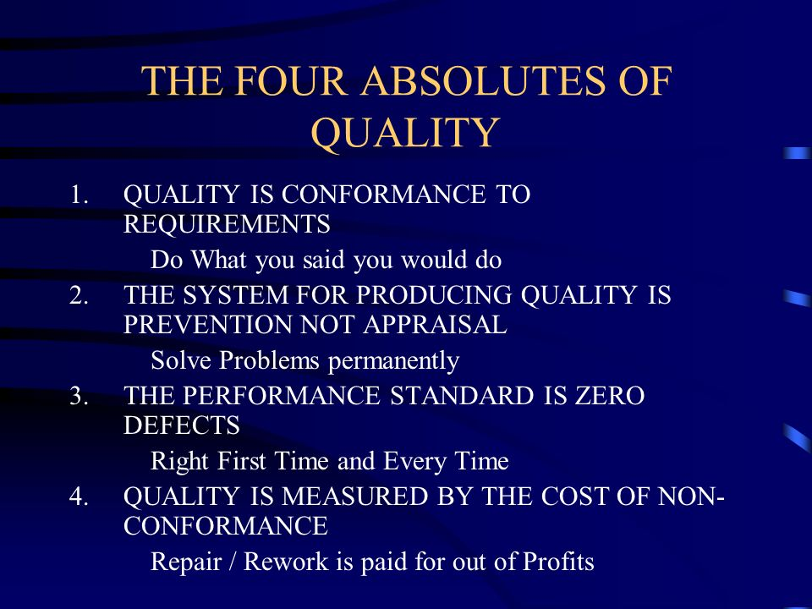
(Slideplayer, 2022)

Crosby’s theory focuses on maintaining an elevated level of quality. This helps Samsung to reduce cost in the long term due to no unnecessary fixing of defects. Furthermore, it assists with customer retention management positively has it builds loyalty and increases new customers as it is a brand customers can rely on (Crosby, 1984).
Crosby has four absolute which set the tone for the fourteen points. Crosby highlights the need for zero defects, which entails making sure there are no defects, and all employees are responsible for spotting them (Crosby, 1984), ( Bendell et al., 1995).
This is great has it ensures a high standard of quality. Moreover, encourages Samsung to consider every employee opinion and make changes where necessary. This relates to the slogan Samsung released as it could imply, we are all to work for the better of the company. On the other hand, this could become problematic as too many opinions on what a defect is could slow down progress in the company. This could affect CRM as customers cannot see the company growth. The Zero Defects Theory claims there is no waste in a project. Waste is everything that is not really productive, such as procedures, materials, and workers (Shmula, 2019), (Crosby, 1984), ( Bendell et al., 1995).
Crosby states quality is measured by conformance. This means the quality is measured by how much a product must meet its intended specification. This absolute is vital has it sets an unwritten target for all products Samsung develops. It makes it easy for all employees to understand what is required, therefore being able to address customers’ needs and helping CRM. Quality conformance is essential to all companies, the lack of it will become very costly (Crosby, 1984),
Crosby’s theory is focused around establishing goals for employees and communicating amongst all levels of business. Communication creates a sense of community and makes everyone feel valued therefore invoking pride in their work. This helps increase quality. The increased in quality is down to the individuals graft within the company, this is reinforced by Crosby’s theory who states employees should be rewarded for their work (Nishant, 2020), (Piltan and Sowlati, 2016)
Crosby’s theory flows around fourteen points as illustrated in figure 8 below

Figure 8 illustrates Crosby’s 14 points
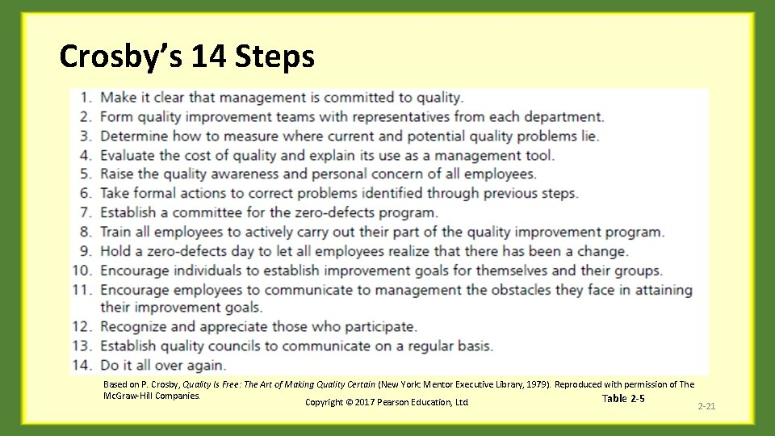
Slidetodoc. 2017.

Conclusion
Even though TQM is well regarded, its application so far has not yielded accurate results. This demonstrates the importance of management regularly evaluating results in order to indicate the requirements for adjusting at the appropriate moment. The introduction of the concepts and theories in Crosby’s and Deming's 14 points, whilst using effective change management philosophies (The University of Tennessee, 2021). Along with Samsung implementing new innovated philosophies within their company, has overall enhances their customer’s experience. Samsung’s employees understand the value of quality and works as a team, with each department collaborating closely in order to efficiently contribute to the company's success.

References

Acquire. 2021. Digital customer engagement starts here. [Online]. [26 March 2022]. Available from: https://acquire.io/blog/customer-experience-strategy/
Baxendale et al. 2020. The Impact of Different Touchpoints on Brand Consideration. Journal of Retailing; Greenwich. [Online]. 91(2), 235-253. [11 April 2022]. Available from: https://www.proquest.com/docview/1680399889?accountid=130472&parentSessionId=jAqLl%2F8f2mdo7uXWsua7N2lJ%2F62b5I2SexMLDjyGzZg%3D&pq-origsite=primo
Bendell et al. 1995. A framework for Crosby’s quality principles using ISM and MICMAC approaches. TQM Journal; Bingley. [Online]. 32(2), 305-330. [10 April 2022]. Available from: https://www.proquest.com/docview/2532612051?accountid=130472&parentSessionId=gf4UgXQ7fWyzBItEhJ6N9GsF3w9I8PCSomN5bX84VEs%3D&pq-origsite=primo

Brynjolfsson, Hu, and Rahman, 2013. Understanding Customer Experience Throughout the Customer Journey. Journal of Marketing. [Online]. 80(6), 69-96. [21 March 2022]. Available from: https://journals.sagepub.com/doi/10.1509/jm.15.0420
Business finance. 2020. How to Build a Remarkable Brand Experience for Knowledge Commerce. [Online]. [26 March 2022]. Available from: https://www.business2community.com/strategy/how-to-build-a-remarkable-brand-experience-for-knowledge-commerce-02299500
Crosby. 1984. A framework for Crosby’s quality principles using ISM and MICMAC approaches. TQM Journal; Bingley. [Online]. 32(2), 305-330. [10 April 2022]. Available from: https://www.proquest.com/docview/2532612051?accountid=130472&parentSessionId=gf4UgXQ7fWyzBItEhJ6N9GsF3w9I8PCSomN5bX84VEs%3D&pq-origsite=primo
Crosby. 1979. A framework for Crosby’s quality principles using ISM and MICMAC approaches. TQM Journal; Bingley. [Online]. 32(2), 305-330. [10 April 2022]. Available from: https://www.proquest.com/docview/2532612051?accountid=130472&parentSessionId=gf4UgXQ7fWyzBItEhJ6N9GsF3w9I8PCSomN5bX84VEs%3D&pq-origsite=primo

Cutlip et al. 2006. Impact of Public Relation and Brand Image on Customer’s Loyalty in Mobile Phone Industry of Pakistan. Kuwait Chapter of the Arabian Journal of Business and Management Review; Kuwait City. [Online]. 6(12), 44-51. [2 April 2022]. Available from: https://www.proquest.com/docview/1978205064?accountid=130472&parentSessionId=ONi4gkFXpWg3zBiLKhzhzzs1%2B1mTRrrlwiYPv7w5hiY%3D&pq-origsite=primo
Deming. 1986. Book Reviews: The Deming theory of management. Academy of Management the Academy of Management Review; Briarcliff Manor. [Online]. 13(1), 138. [11 April 2022]. Available from: https://www.proquest.com/docview/210961197?OpenUrlRefId=info:xri/sid:primo&accountid=130472
Dong-Hee, S. 2015. Effect of the customer experience on satisfaction with smartphones: Assessing smart satisfaction index with partial least squares. Telecommunications Policy. [Online]. 39(8), 627-641. [2 April 2022]. Available from: https://www-sciencedirect-com.ezproxy.uwtsd.ac.uk/science/article/pii/S0308596114001530
Edraw content team. 2022. Edraw. [Online]. [10 April 2022]. Available from: https://www.edrawsoft.com/business-diagram/deming-cycle.html
Grohawk. 2020. What are Customer Touchpoints. [illus.]. Available from: https://www.grohawk.com/what-are-customer-touch-points/(Accessed:26 March 2022)
Holt.1997. Mobile phone choice: technology versus marketing the brand effect in the Italian market. European Journal of Marketing; Bradford. [Online]. 44(5), 610-634. [4 April 2022]. Available from: https://www.proquest.com/docview/2439022861?accountid=130472&parentSessionId=8lCoyXqA1Z7LHXv%2B%2BYaZj8nVJRZ5HeouwkdCZ%2BTobAc%3D&pq-origsite=primo
Indeed Editorial Team. 2020. What Is Quality in a Business. [Online]. [8 April 2022]. Available from: https://www.indeed.com/career-advice/career-development/what-is-quality-in-a-business#:~:text=Quality%20means%20that%20the%20products,for%20legal%20or%20medical%20reasons.
Ionos. 2022. Ionos. [Online]. [10 April 2022]. Available from: https://www.ionos.ca/startupguide/productivity/pdca-cycle/
Lemon, K & Verhoef, P. et al, 2016. Understanding Customer Experience Throughout the Customer Journey. Journal of Marketing. [Online]. 80(6), 69-96. [21 March 2022]. Available from: https://journals.sagepub.com/doi/10.1509/jm.15.0420
Lim & O'Cass. 2001. Mobile phone choice: technology versus marketing the brand effect in the Italian market. European Journal of Marketing; Bradford. [Online]. 44(5), 610-634. [4 April 2022]. Available from: https://www.proquest.com/docview/2439022861?accountid=130472&parentSessionId=8lCoyXqA1Z7LHXv%2B%2BYaZj8nVJRZ5HeouwkdCZ%2BTobAc%3D&pq-origsite=primo
Manor, B. 1988. Book Reviews: The Deming theory of management. Academy of Management the Academy of Management Review; Briarcliff Manor. [Online]. 13(1), 138. [11 April 2022]. Available from: https://www.proquest.com/docview/210961197?OpenUrlRefId=info:xri/sid:primo&accountid=130472
Naki, , G.H. 2017. Impact of Public Relation and Brand Image on Customer’s Loyalty in Mobile Phone Industry of Pakistan. Kuwait Chapter of the Arabian Journal of Business and Management Review; Kuwait City. [Online]. 6(12), 44-51. [2 April 2022]. Available from: https://www.proquest.com/docview/1978205064?accountid=130472&parentSessionId=ONi4gkFXpWg3zBiLKhzhzzs1%2B1mTRrrlwiYPv7w5hiY%3D&pq-origsite=primo

Neslin et al. 2014.The Impact of Different Touchpoints on Brand Consideration. Journal of Retailing; Greenwich. [Online]. 91(2), 235-253. [11 April 2022]. Available from: https://www.proquest.com/docview/1680399889?accountid=130472&parentSessionId=jAqLl%2F8f2mdo7uXWsua7N2lJ%2F62b5I2SexMLDjyGzZg%3D&pq-origsite=primo

(Yaveroglu and Donthu 2008). The Impact of Different Touchpoints on Brand Consideration. Journal of Retailing; Greenwich. [Online]. 91(2), 235-253. [11 April 2022]. Available from: https://www.proquest.com/docview/1680399889?accountid=130472&parentSessionId=jAqLl%2F8f2mdo7uXWsua7N2lJ%2F62b5I2SexMLDjyGzZg%3D&pq-origsite=primo

Nishant, A. 2020. A framework for Crosby’s quality principles using ISM and MICMAC approaches. TQM Journal; Bingley. [Online]. 32(2), 305-330. [10 April 2022]. Available from: https://www.proquest.com/docview/2532612051?accountid=130472&parentSessionId=gf4UgXQ7fWyzBItEhJ6N9GsF3w9I8PCSomN5bX84VEs%3D&pq-origsite=primo
Petruzzellis, L. 2010. Mobile phone choice: technology versus marketing the brand effect in the Italian market. European Journal of Marketing; Bradford. [Online]. 44(5), 610-634. [4 April 2022]. Available from: https://www.proquest.com/docview/2439022861?accountid=130472&parentSessionId=8lCoyXqA1Z7LHXv%2B%2BYaZj8nVJRZ5HeouwkdCZ%2BTobAc%3D&pq-origsite=primo
Piltan and Sowlati, 2016. A framework for Crosby’s quality principles using ISM and MICMAC approaches. TQM Journal; Bingley. [Online]. 32(2), 305-330. [10 April 2022]. Available from: https://www.proquest.com/docview/2532612051?accountid=130472&parentSessionId=gf4UgXQ7fWyzBItEhJ6N9GsF3w9I8PCSomN5bX84VEs%3D&pq-origsite=primo

Psomas and Jaca. 2016. A framework for Crosby’s quality principles using ISM and MICMAC approaches. TQM Journal; Bingley. [Online]. 32(2), 305-330. [10 April 2022]. Available from: https://www.proquest.com/docview/2532612051?accountid=130472&parentSessionId=gf4UgXQ7fWyzBItEhJ6N9GsF3w9I8PCSomN5bX84VEs%3D&pq-origsite=primo
Reichheld, E.F. 2001. Loyalty Rules! How Today's Leaders Build Lasting Relationships. The Canadian Manager. [Online]. 26(4), 29. [2 April 2022]. Available from: https://www-proquest-com.ezproxy.uwtsd.ac.uk/docview/213664544/fulltextPDF/A5E1BFA66ACE44CAPQ/1?accountid=130472
Samsung. 2022. About us Samsung. [Online]. [10 April 2022]. Available from: https://www.samsung.com/uk/about-us/company-info/
Samsung. 2022. Samsung Electronics Unveils ‘Together for Tomorrow’ Vision at CES 2022. [Online]. [11 April 2022]. Available from: https://news.samsung.com/global/samsung-electronics-unveils-together-for-tomorrow-vision-at-ces-2022#:~:text=Samsung%20Electronics%20today%20unveiled%20its,keynote%20event%20at%20CES%202022
Scott brown, C. 2021. Samsung phones buyer's guide: Everything you need to know. [Online]. [10 April 2022]. Available from: https://www.androidauthority.com/samsung-phones-computers-more-1156543/
Shift4shops. 2021. How to Drive Recovery and Growth Post-Pandemic with Social Commerce and Marketplaces. [illus.]. Available from: https://blog.shift4shop.com/how-to-drive-recovery-and-growth-post-pandemic-with-social-commerce-and-marketplaces/(Accessed: 10 April 2022)
Shmula . 2019. Shmula. [Online]. [10 April 2022]. Available from: https://www.shmula.com/philip-crosby-contributions-to-the-theory-of-process-improvement-and-six-sigma/27873/
Slideplayer. 2022. Deming's 14 points. [Online]. [10 April 2022]. Available from: https://slideplayer.com/slide/8331272/
Slideplayer. 2022. Four absolutes of quality. [Online]. [10 April 2022]. Available from: https://slideplayer.com/slide/737024/
Slidetodoc. 2017. Chapter 2 Quality Theory Chapter Objectives 1 Integrate. [illus.]. Available from: https://slidetodoc.com/chapter-2-quality-theory-chapter-objectives-1-integrate/ (Accessed: 11 April 2022)
Talib et al. 2013. A framework for Crosby’s quality principles using ISM and MICMAC approaches. TQM Journal; Bingley. [Online]. 32(2), 305-330. [10 April 2022]. Available from: https://www.proquest.com/docview/2532612051?accountid=130472&parentSessionId=gf4UgXQ7fWyzBItEhJ6N9GsF3w9I8PCSomN5bX84VEs%3D&pq-origsite=primo
The University of Tennessee. 2021. Deming's 14 Points. [Online]. [9 April 2022]. Available from: https://www.uthsc.edu/its/business-productivity-solutions/lean-uthsc/deming.php
Wilson-Nash, C, Goode, A & Currie, A. 2020. Introducing the Social Bot: a novel touchpoint along the young adult customer journey. European Journal of Marketing; Bradford. [Online]. 54(10), 2621-2643. [25 February 2022]. Available from: https://www.proquest.com/docview/2457218591?accountid=130472&parentSessionId=tbW%2FxT%2FcZ9A7a%2BAe1tUGPgCp38Aiacn6z9WY57ipDv8%3D&p`q-origsite=primo

Xu et al., 2017. Introducing the Social Bot: a novel touchpoint along the young adult customer journey. European Journal of Marketing; Bradford. [Online]. 54(10), 2621-2643. [25 February 2022]. Available from: https://www.proquest.com/docview/2457218591?accountid=130472&parentSessionId=tbW%2FxT%2FcZ9A7a%2BAe1tUGPgCp38Aiacn6z9WY57ipDv8%3D&p`q-origsite=primo

