

Methods and Search Strategy Academic Poster

Student name: Samina Nazir
Student ID: 2215433
Module name: Independent Project
Module code: BMHP6020
Lecturer: Chloe Harries

Telemedicine and Digital Health as Tools for Advancing SDG in Rural Communities

Introduction and Research Aim  A methods chapter explains how a study was conducted so the process is transparent, credible, and repeatable. This poster summarises the dissertation’s desk-based (secondary research) approach, including the search process, selection decisions, quality checks, and how evidence was analysed into themes.  Aim: To examine how telemedicine and wider digital-health interventions support SDG 3 (Health and well-being), SDG 9 (Infrastructure and innovation), and SDG 10 (Reduced inequalities) in rural communities, and to produce equity-focused recommendations for practice and policy. | Search Strategy  A search strategy is a structured plan for finding relevant literature using agreed keywords, Boolean operators, and filters. In this study, the search was organised around three concepts: (1) telemedicine/digital health, (2) rural communities, (3) SDG-linked outcomes (access, infrastructure, equity). Keywords were expanded using synonyms (e.g., telehealth, virtual care, eHealth, mHealth). Boolean operators were applied to manage precision: OR broadened synonyms, AND linked concepts, and NOT removed irrelevant results. Searches prioritised evidence from the last 10 years, with selective inclusion of foundational sources where needed.
Searching for Information  A step-by-step process was used: (1) searching PubMed, Scopus, and Web of Science; (2) building combined strings such as telemedicine AND rural AND (access OR inequality OR SDG); (3) applying filters (English language, peer-reviewed, rural/remote context); (4) screening titles/abstracts for relevance; (5) reading shortlisted full texts; and (6) using selected UK/NHS and global policy sources to interpret governance, infrastructure, and inclusion. Twelve studies were finalised for thematic analysis. | 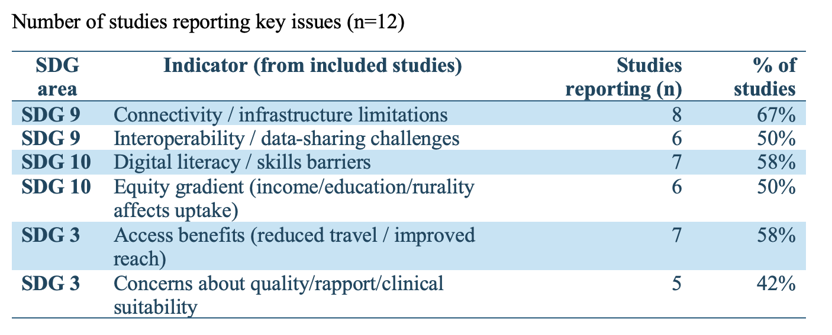

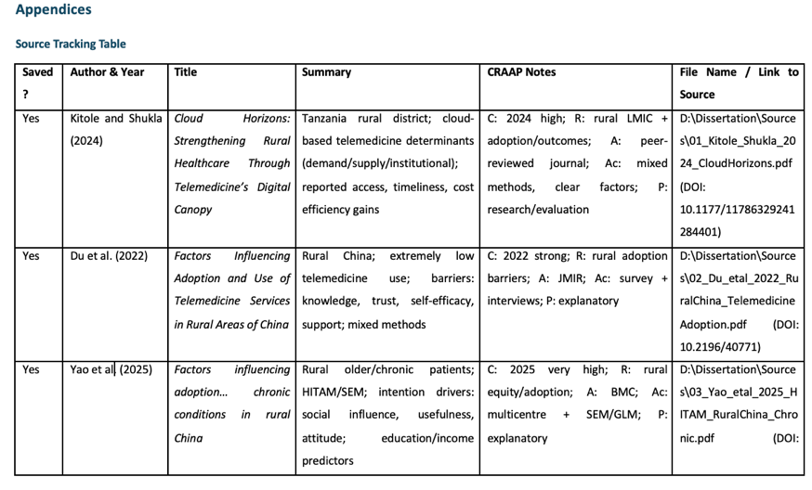
Research Validation and Analysis
Validation in secondary research means checking that evidence is credible, accurate, and relevant, reducing the risk of overclaiming from pilots or context-specific studies. Quality was assessed using the CRAAP framework (Currency, Relevance, Authority, Accuracy, Purpose). Evidence was then analysed using inductive thematic analysis, generating three themes: (1) infrastructure and interoperability shape sustainability, (2) literacy/trust shape uptake, and (3) socioeconomic position and policy design shape who benefits.

Inclusion: Rural telehealth/digital health studies, SDG-relevant outcomes, peer-reviewed evidence, mostly last 10 years, English/full text. | Exclusion: Urban-only studies, purely technical papers, low-credibility sources, outdated/irrelevant systems, non-English.
Ethical Considerations

References
Braun, V. and Clarke, V. (2006) ‘Using Thematic Analysis in Psychology’, Qualitative Research in Psychology, 3(2), pp. 77–101. doi:https://doi.org/10.1191/1478088706qp063oa.
Jol, G. and Stommel, W. (2016) ‘Ethical considerations of secondary data use’, Dutch Journal of Applied Linguistics, 5(2), pp. 180–195. doi:https://doi.org/10.1075/dujal.5.2.06jol.
Muis, K.R., Denton, C. and Dubé, A. (2022) ‘Identifying CRAAP on the Internet: a Source Evaluation Intervention’, Advances in Social Sciences Research Journal, 9(7), pp. 239–265.
United Nations (2015) The 17 sustainable development goals, United Nations. Available at: https://sdgs.un.org/goals (Accessed: 1 December 2025).

