
Master of Business Administration

International Business pathway

Contemporary employability skills
Assessment 1: Individual report. Weight: 100%
Module name: International Marketing: Principles and Practices
Module code: LCMB7026_LON
Lecturer name: Dr Amir Homayountard
Student name: Sadhana Kumari
Student Id: 2413773
Submission date: 13/08/2026

AI use acknowledgement

I acknowledge the use of “Quill bot” (https://quillbot.com/plagiarism-checker) on 11-08-2026 to check the plagiarism.
I confirm that I have not presented any AI generated text as my own work. I confirm I have copies of my drafts, notes, and other resources I used before, and after the use of AI tools which I may be asked to provide in evidence.

Table of Contents
Contemporary employability skills 2
Section 1: Comparative Report 7
1. Introduction 7
2. Comparative Analysis of the Two Markets 7
2.1 Macro environmental comparison using PESTEL 7
2.2 What PESTEL does not show 9
2.3 Cultural comparison using Hofstede 10
3. Comparative Analysis of Segmentation, Targeting and Positioning 11
3.1 Segmentation and targeting 11
3.2 Positioning 12
4. Comparative Analysis of the International Marketing Mix 13
4.1 Product, price and place 14
4.2 Promotion 15
4.3 People, process and physical evidence 15
4.4 How well the seven Ps travel 15
5. Market Entry Strategy in China 16
5.1 How Adidas actually entered 16
5.2 Explaining the choice 16
5.3 Evaluating the mode 17
6. Ethical Evaluation of the Marketing Mix in China 17
6.1 The issue 17
6.2 Effect on the marketing mix 18
6.3 Was there an ethical failure? 19
6.4 My judgement 19
7. Recommendations 20
8. Conclusion 21
Section 2: Reflective Account 22
9. Reflection on the Research and Writing Process 22
9.1 Description 22
9.2 Feelings 23
9.3 Evaluation 23
9.4 Analysis 23
9.5 Conclusion 24
9.6 Action plan 24
Reference List 26

List of Figures:
Figure 1: Hofstede’s cultural dimension scores for Germany and China (data from Hofstede Insights, 2026) 11
Figure 2: Perceptual map of sportswear positioning in Germany and China (constructed by the author from Chen, 2023; Guo, 2025; Li, 2023) 13
Figure 3: Evolution of Adidas’s entry and operating mode in China (Daxue Consulting, 2025) 17
Figure 4: Adidas Greater China net sales, 2020 to 2025 (data from adidas AG, 2022; adidas AG, 2026) 19
Figure 5: Gibbs’ reflective cycle as applied to this project (adapted from Ocampo et al., 2025) 23

List of Tables:
Table 1: PESTEL comparison of Germany and China as operating environments for Adidas 8
Table 2: Comparison of the seven Ps for Adidas in Germany and China 14
Table 3: Recommendations for Adidas’s international marketing strategy 21

Section 1: Comparative Report

1. Introduction
Adidas started in a small Bavarian town and now sells in more than a hundred countries, so the distance between where the brand comes from and where it earns its money is unusually wide. In 2025 the group reported record revenues of 24.8 billion euros, of which Europe accounted for 8,136 million euros and Greater China for 3,623 million euros (adidas AG, 2026). I have compared Adidas in Germany, its home market, with China, which is its largest host market in Asia and the one where it has run into the most public difficulty.
The pairing is deliberate rather than convenient. Germany and China sit at opposite ends of several of Hofstede’s cultural dimensions, they regulate business in very different ways, and Adidas has faced a serious ethical and reputational problem in one of them but not the other. That contrast makes it possible to test how much of an international marketing strategy genuinely travels between markets, and how much has to be rebuilt locally.

2. Comparative Analysis of the Two Markets

2.1 Macro environmental comparison using PESTEL
Table 1: PESTEL comparison of Germany and China as operating environments for Adidas
Factor | Germany | China
Political | Stable, predictable, EU policy framework. Political risk arrives through regulation. | State influence over media and consumer sentiment. Political risk arrives through the consumer.
Economic | High income, mature and slow growing sportswear market, price transparent. | Large and still expanding middle class, but growth slower than in the 2010s.
Social | Ageing population, strong interest in sustainability and product durability. | Young urban consumers, rise of guochao and preference for domestic cultural styling.
Technological | Established omnichannel retail, e-commerce through own platform and wholesale partners. | Social commerce, livestreaming and platform ecosystems such as Tmall and Douyin.
Environmental | EU and national pressure on recycled materials and circular product design. | Tightening environmental regulation on manufacturing, less consumer led.
Legal | Supply Chain Due Diligence Act obliges human rights checks across the whole chain. | Data and advertising rules, plus reputational exposure to sourcing statements.

Table 1 sets out the comparison, but three differences do most of the work in this report. The first is legal. Germany’s Supply Chain Due Diligence Act came into force in January 2023 and applied at first to companies with 3,000 or more employees, widening to those with more than 1,000 from 2024 (Federal Ministry of Labour and Social Affairs, no date). Adidas sits comfortably within scope. The act requires it to identify and act on human rights risks not only in its own operations but along its supply chain, and it carries fines of up to two per cent of global turnover. What matters here is that the obligation is imposed by the home country and applies to conduct in host countries. Adidas cannot satisfy German law by staying quiet about sourcing conditions abroad, which is exactly what would have been commercially convenient in China after 2021.
The second difference is political, and it is easy to misread. In Germany, politics reaches Adidas mainly through regulation and taxation, and it does so slowly enough to plan for. In China, Chan (2025) shows that political boycotts of foreign brands between 2016 and 2021 were not spontaneous consumer events but were amplified by state linked media and official commentary. Political risk therefore arrives through the customer rather than through the statute book, which is a different kind of exposure and one that a conventional PESTEL cell captures poorly.
The third difference is social and competitive at the same time. The German market is mature and price transparent, and Adidas competes there mainly against Nike and its neighbour Puma on product and heritage. The Chinese market has been reshaped by guochao, the preference for domestic brands with national cultural styling, which has moved Anta and Li-Ning from budget alternatives to serious rivals. Yu (2022) argues that domestic brands used the 2021 cotton dispute deliberately, converting public attention into brand value, and Han (2025) finds that repeated public opinion events shift consumer attitudes towards domestic brands in a way that does not fully reverse once the news cycle ends. If that is right, Adidas is not waiting out a temporary mood in China. It is competing against a change in preference that has settled.

2.2 What PESTEL does not show
PESTEL is good for getting the ground rules of a market onto one page, but it has two weaknesses that matter here. It presents factors as separate when they interact, and it says nothing about how fast a factor can move. Rashid (2023) applies it to a supermarket in a stable domestic setting, where that limitation does little harm. In China the political, social and legal factors are tangled together, and the Xinjiang issue moved from a compliance matter to a commercial crisis within days. I have therefore used PESTEL to organise the comparison rather than to explain it, and relied on the cultural analysis below to explain why one event produced such different reactions in the two countries.

2.3 Cultural comparison using Hofstede
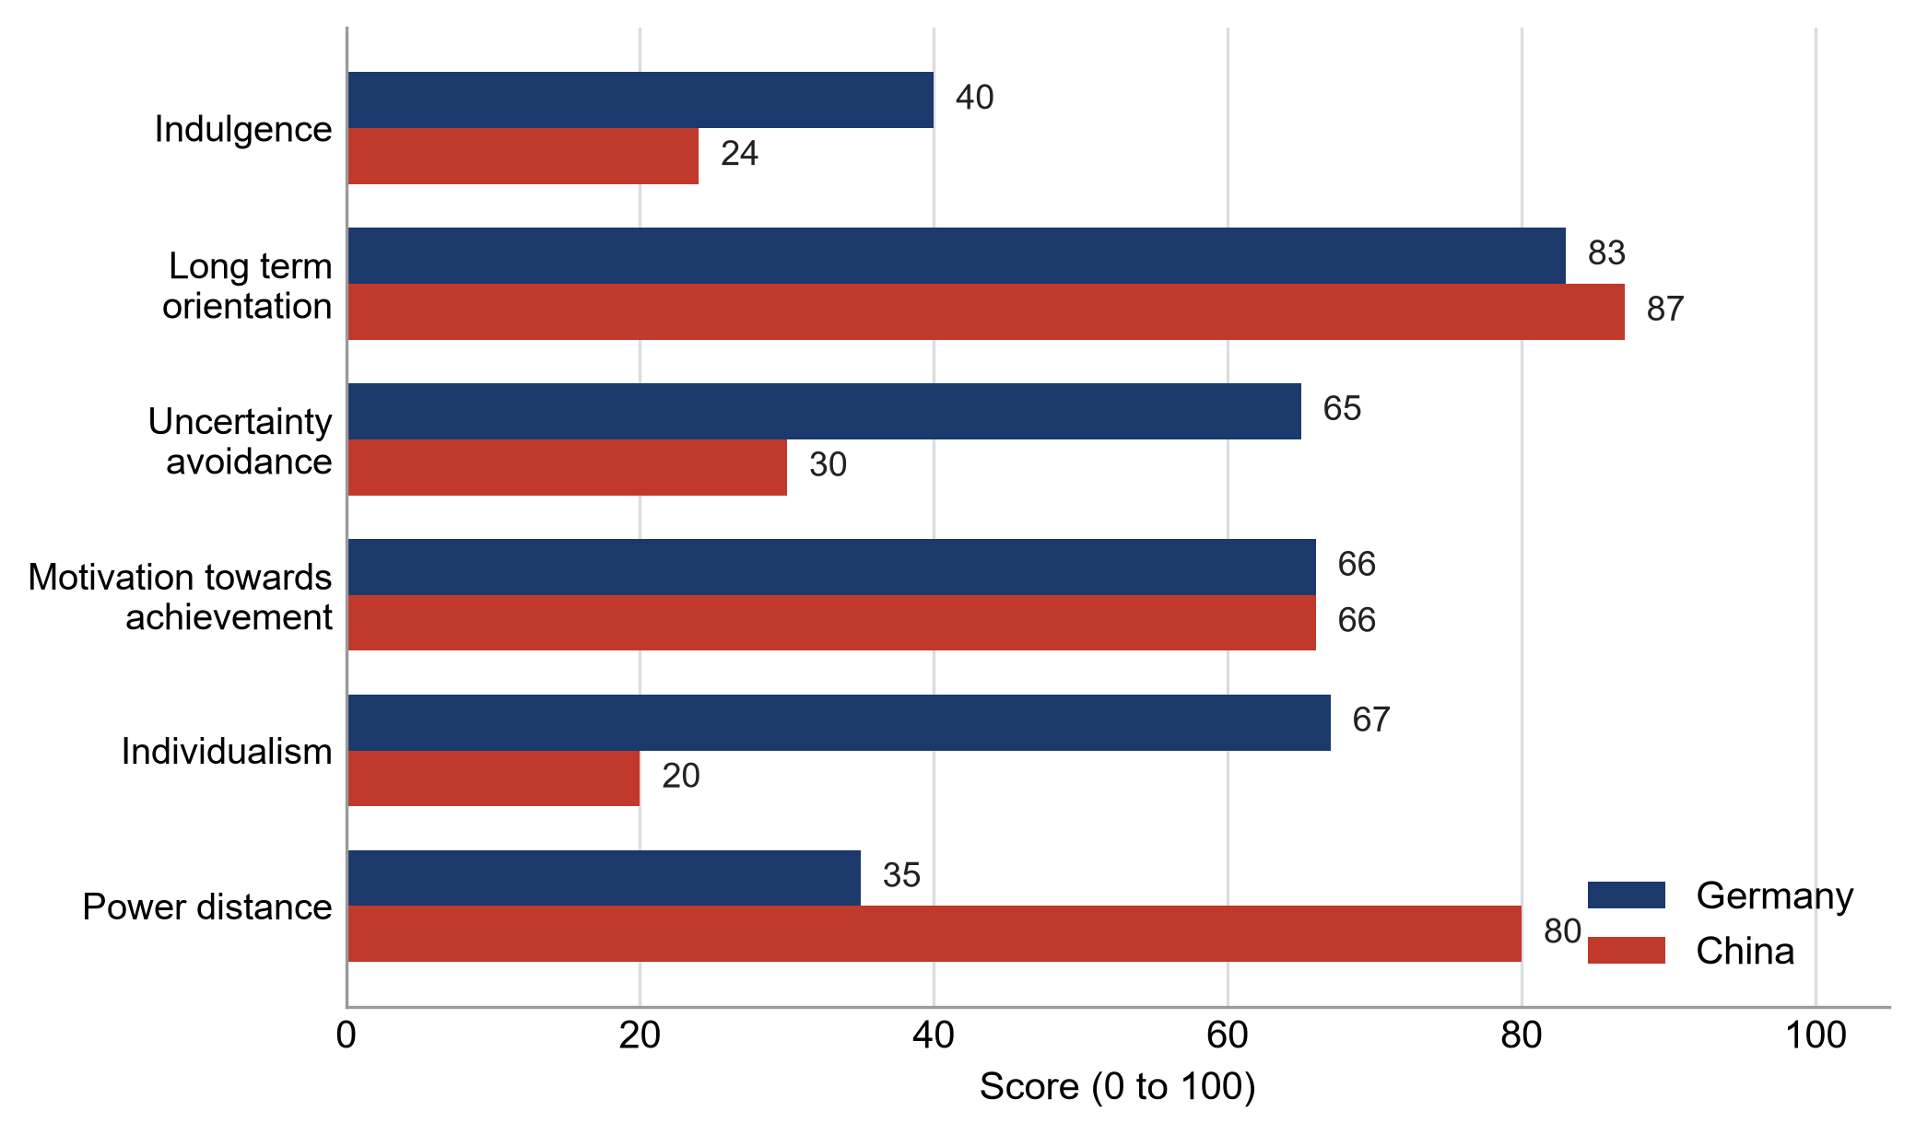
Figure 1: Hofstede’s cultural dimension scores for Germany and China (data from Hofstede Insights, 2026)
Hofstede’s (1980) model is still the most widely used way of comparing national cultures in marketing research, and Soares, Farhangmehr and Shoham (2007) show how routinely it is applied to explain differences in consumer response across countries. Figure 1 compares the two markets on the six dimensions.
The two largest gaps are individualism and power distance. Germany scores 67 for individualism against China’s 20, and 35 for power distance against China’s 80. That changes what an advertisement has to do. German campaigns can address the individual athlete and treat personal achievement as the motivating idea, which is close to Adidas’s global creative platform. In a collectivist market with high power distance, the group and its endorsed figures carry more weight, which helps explain why celebrity and athlete endorsement is so much more central to Adidas’s Chinese communication than to its German communication. Ma, Abdeljelil and Hu (2019) add something useful here. Using neuroscience methods, they find that Chinese consumers show measurable ethnocentric bias in brand preference and that cultural familiarity affects response below the level of conscious deliberation. That is a stronger claim than a survey can make, and it suggests localisation in China is a response to how consumers actually process foreign brands rather than a matter of marketing taste.
Uncertainty avoidance separates the markets as well, at 65 for Germany against 30 for China. A German buyer is more likely to want technical substantiation, evidence of durability and clear sustainability claims. A Chinese buyer is, on this measure, more tolerant of novelty and of fast product cycles, which fits the speed at which Adidas’s Shanghai design operation now works.
I want to be careful with these numbers. Yoo, Donthu and Lenartowicz (2011) point out that Hofstede’s dimensions were derived at national level from the employees of a single organisation and do not necessarily hold for individuals, which is why they built an individual level scale instead. Treating 1.4 billion people as one cultural unit hides the distance between Shanghai and a third tier city. I have used the scores to explain differences in marketing approach, not to predict how any particular consumer will behave.

3. Comparative Analysis of Segmentation, Targeting and Positioning

3.1 Segmentation and targeting
Dibb and Simkin (1991) make the point that targeting and positioning only work if segmentation has been done properly first, and that firms often run the sequence backwards. Adidas segments both markets on a similar logic, combining sport category with lifestyle usage, but the resulting segments are not equivalent.
In Germany the market is mature and the useful divisions are behavioural. Football is the anchor category, supported by the national team relationship and club sponsorship, and there is a large lifestyle segment buying Originals for style rather than for sport. Growth in Germany comes from taking share and from raising average selling prices, not from new customers entering the category at all.
In China the segmentation is more demographic and geographic. Growth still comes from the expanding urban middle class, from lower tier cities where sportswear ownership is lower, and from younger consumers. Long et al. (2022) studied what drives young Chinese consumers to intend to buy Western brands and found that perceived quality and social image still matter, which suggests the segment Adidas targets has not disappeared. Guo (2025) describes how Nike, Adidas and Lululemon each adjust the mix to reach it. The complication is that this same segment is the most exposed to nationalist sentiment online, so the consumers with the highest propensity to buy are also the ones most easily pulled away by a boycott.

3.2 Positioning
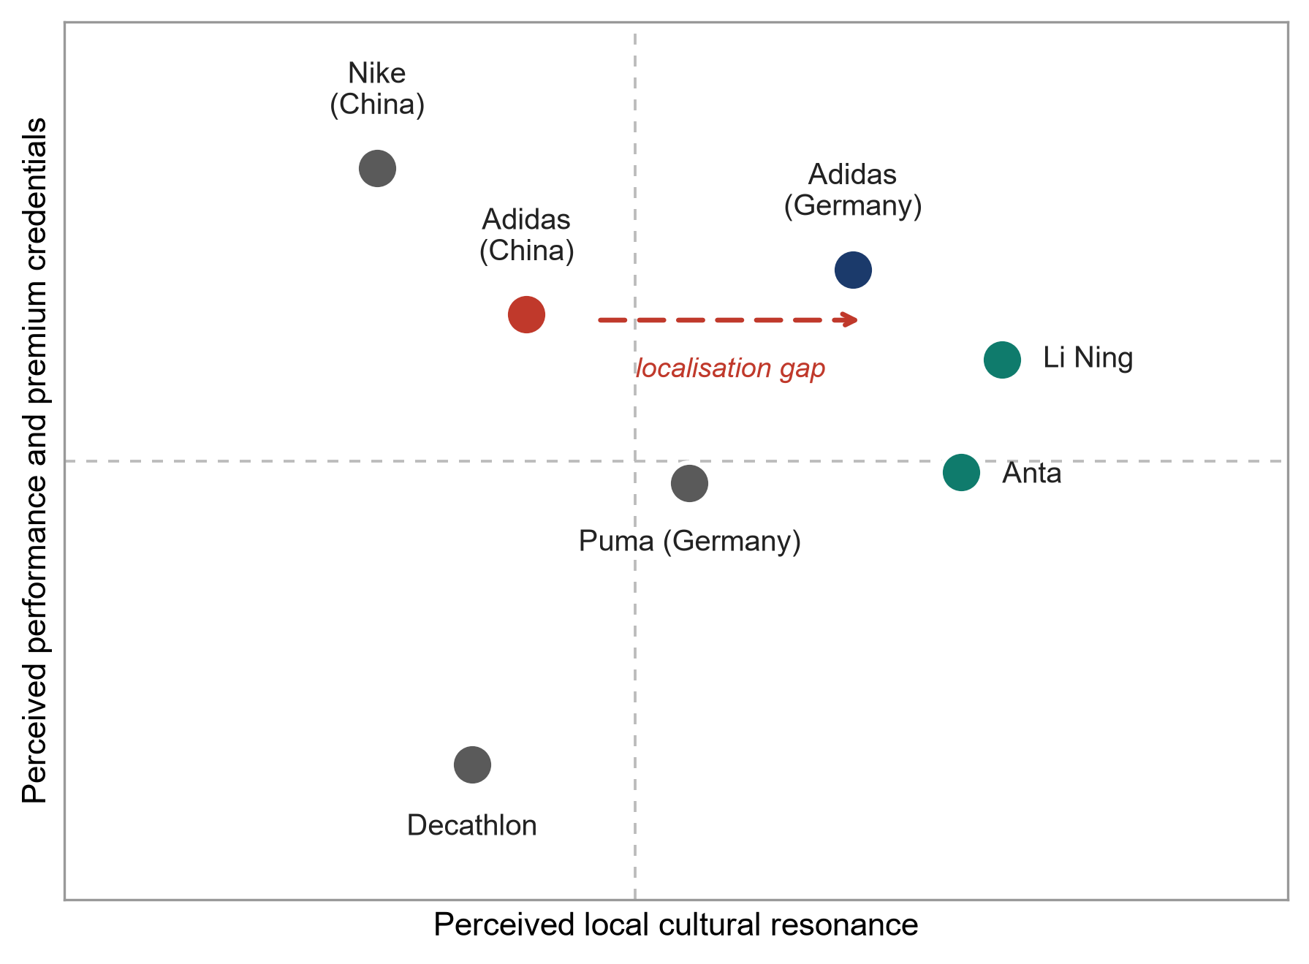
Figure 2: Perceptual map of sportswear positioning in Germany and China (constructed by the author from Chen, 2023; Guo, 2025; Li, 2023)

Figure 2 is my own reading of how the brands sit in each market, built from the literature rather than from survey data, so it should be treated as an argument rather than as a measurement. In Germany, Adidas holds a position that is premium, credible on performance and culturally native all at once. The heritage is real and local, which Iglesias, Ind and Schultz (2020) identify as a genuine strategic asset when a company uses its founding history deliberately rather than decoratively.
In China the third element is missing. Adidas can claim performance and premium, but local cultural resonance now belongs to Li-Ning and Anta. Chen (2023) compares Adidas directly with those two and concludes that their advantage rests on cultural proximity and speed rather than on better product. That is the gap the arrow in Figure 2 marks, and it explains the direction of Adidas’s recent strategy in China better than any statement of intent does.
There is an unavoidable tension in this. The more Adidas localises its Chinese positioning, the more it risks weakening the global consistency that makes the brand valuable in the first place. Li (2023) argues that Adidas’s marketing strength has come from a coherent global platform built around innovation and sustainability, and repositioning market by market chips away at that. My judgement is that the tension is real but manageable, because what Adidas is localising in China is design and cultural reference rather than the underlying performance promise.

4. Comparative Analysis of the International Marketing Mix
Booms and Bitner (1981) extended the original four Ps to seven in order to deal with services, and the extension matters for Adidas because so much of what the brand sells in both countries is now a retail and digital experience rather than a product handed over at a counter. Table 2 compares the seven elements across the two markets.
Table 2: Comparison of the seven Ps for Adidas in Germany and China
Element | Germany | China
Product | Close to the global range, sustainability and performance claims to the front. | About 60 per cent of products sold are designed locally, with cultural collections.
Price | Premium but constrained by price comparison and heavy online discounting. | Premium intent, undercut by domestic rivals and by platform promotional events.
Place | Own stores, wholesale partners and mature direct e-commerce. | Franchised store network plus Tmall, JD and Douyin as primary retail channels.
Promotion | Football sponsorship and brand heritage, moving to grassroots after 2026. | Celebrity and key opinion leader endorsement, livestreaming, festival campaigns.
People | Trained employees in owned stores, strong labour protection. | Large share of customer contact staff sit with franchise partners.
Process | Predictable fulfilment and returns, high service expectations. | Fast fulfilment, demand spikes driven by livestream and platform sales events.
Physical evidence | Store design signals heritage and technical credibility. | Flagship stores use local design cues and cultural references.

4.1 Product, price and place
The clearest product difference is who designs the range. In Germany the assortment is close to the global line, and the arguments made for it are technical and environmental. In China, Adidas has pushed design authority down to the Creation Center Shanghai under its In China, for China strategy, to the point where around 60 per cent of products sold in the market are locally designed and about 95 per cent are locally produced (Daxue Consulting, 2025). That is not a cosmetic change. It shortens the distance between a local trend and a finished product, which is the specific advantage Chen (2023) credits to Li-Ning and Anta.
On price, both markets push Adidas towards discounting but for different reasons. Germany has price comparison and a large wholesale channel that clears stock at a markdown. China has platform promotional events that make deep discounting close to compulsory, and domestic rivals that can undercut at similar quality. Li (2023) identifies pricing and product competitiveness as the weakest parts of Adidas’s marketing strategy, and the Chinese market is where that weakness bites hardest.
Place differs in structure rather than in ambition. Germany runs a conventional omnichannel model. China depends far more on third party platforms and on franchise partners for physical reach into lower tier cities, so Adidas controls less of the customer interaction than it does at home. Jiang (2023) argues that Adidas’s digital marketing has not kept pace with its e-commerce ambitions, and the Chinese channel structure is where that gap shows.

4.2 Promotion
Promotion is where the two markets diverge most. In Germany, Adidas has leaned on football heritage for seventy years, and that pillar is about to move. The German Football Association announced in March 2024 that Nike would supply the national teams from 2027, ending a partnership that began in 1954 (CNN Business, 2024). Losing the shirt in the home market is not a small commercial loss so much as the removal of the most visible piece of evidence for the heritage claim, and it lands just as the brand is trying to rebuild elsewhere.
In China the model is different in kind. Endorsement by celebrities and key opinion leaders carries the message, distribution runs through livestreaming, and campaigns are pinned to cultural moments such as Chinese New Year. That model is efficient and it is also fragile, because the same endorsers who amplify a brand can withdraw from it publicly, which is precisely what happened in 2021.

4.3 People, process and physical evidence
The three service elements are where the German and Chinese operations look least alike. In Germany most customer contact happens with directly employed staff under strong labour protection, which makes service quality easier to control. In China a large share of contact sits with franchise partners, so consistency depends on training and incentives rather than on direct management. Process follows the same logic. German fulfilment is predictable, while Chinese fulfilment has to absorb the demand spikes that livestream selling and platform festivals create. Physical evidence has moved furthest of the three: German stores still signal heritage and technical credibility, whereas Chinese flagship stores now use local design cues, which is the retail expression of the same localisation argument made in section 3.

4.4 How well the seven Ps travel
Akroush (2011) tested whether the seven Ps classification holds outside Western service settings and found that the structure survives but that the weight attached to each element shifts with context. Oflac et al. (2015) reach a similar conclusion in their application to a global logistics brand. My own reading of the Adidas comparison agrees. All seven elements exist in both markets, but promotion and physical evidence carry much more of the strategic load in China, while product and price carry more of it in Germany. Used as a checklist the framework flattens that difference, which is why I have weighted the discussion rather than giving each element equal space.

5. Market Entry Strategy in China

5.1 How Adidas actually entered
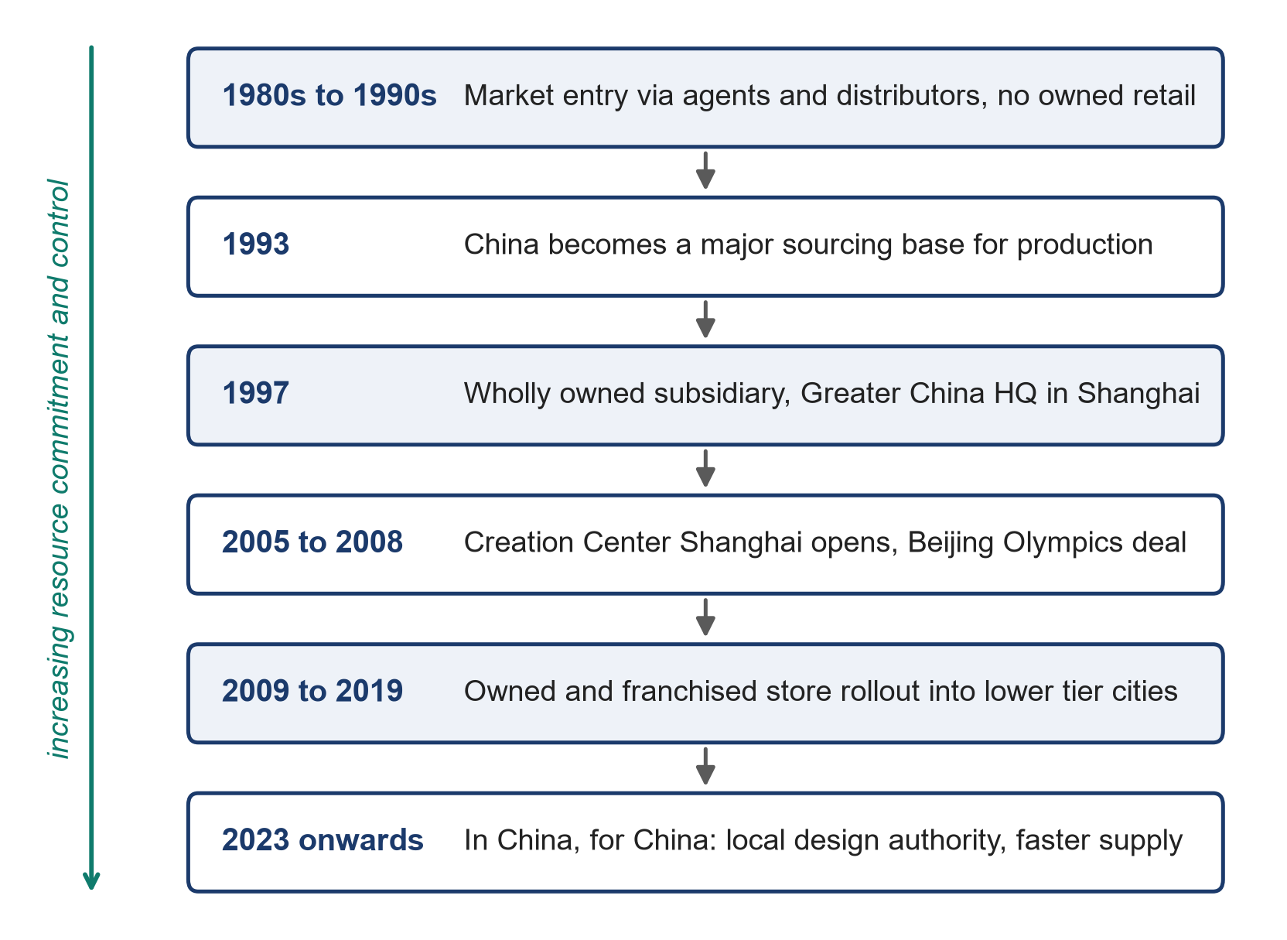
Figure 3: Evolution of Adidas’s entry and operating mode in China (Daxue Consulting, 2025)
Adidas reached China first through agents and distributors, made the country a major sourcing base by 1993, and formed an official wholly owned subsidiary in 1997 with its Greater China headquarters in Shanghai (Daxue Consulting, 2025). The Creation Center Shanghai followed in 2005, the Beijing Olympics gave the brand a step change in visibility in 2008, and a long period of store expansion into lower tier cities carried growth through to 2019. Figure 3 shows the sequence.

5.2 Explaining the choice
Dunning’s (2001) eclectic paradigm explains the outcome well. Adidas held ownership advantages in brand, design capability and product technology. China offered location advantages in market size, growth and an established manufacturing base. And there were clear internalisation advantages, because licensing the brand to a local partner would have meant giving up control over positioning and exposing the trademark in a market where enforcement was uncertain. When all three conditions hold, the paradigm predicts direct investment, and that is what Adidas chose.

5.3 Evaluating the mode
Schellenberg, Harker and Jafari (2017) note in their systematic review that the entry mode literature concentrates on the initial decision and pays much less attention to how modes evolve afterwards. Adidas illustrates the point. The interesting decisions came after 1997, not in it. Laufs and Schwens (2014) frame the choice as a trade off between control and risk exposure, and the Chinese case shows both sides of that trade in the same company. Owning the operation meant Adidas absorbed the full commercial force of the 2021 boycott directly, where a licensee would have taken part of it. The same ownership is what later allowed the company to hand real design authority to Shanghai, which no licensing arrangement would have delivered. The entry mode that deepened the damage in 2021 is also the one that made the recovery possible, and I read that as a genuine trade off rather than a mistake.

6. Ethical Evaluation of the Marketing Mix in China

6.1 The issue
In March 2021 Adidas, along with Nike, H&M and others, faced a sudden and organised backlash in China over earlier corporate statements expressing concern about forced labour and cotton sourcing in Xinjiang. Chinese celebrities ended endorsement deals within days, products were delisted from domestic e-commerce platforms and store traffic fell (BBC News, 2021; CNN Business, 2021). The trigger was not a new statement but the resurfacing of an old one, which is part of what made it difficult to manage.

6.2 Effect on the marketing mix
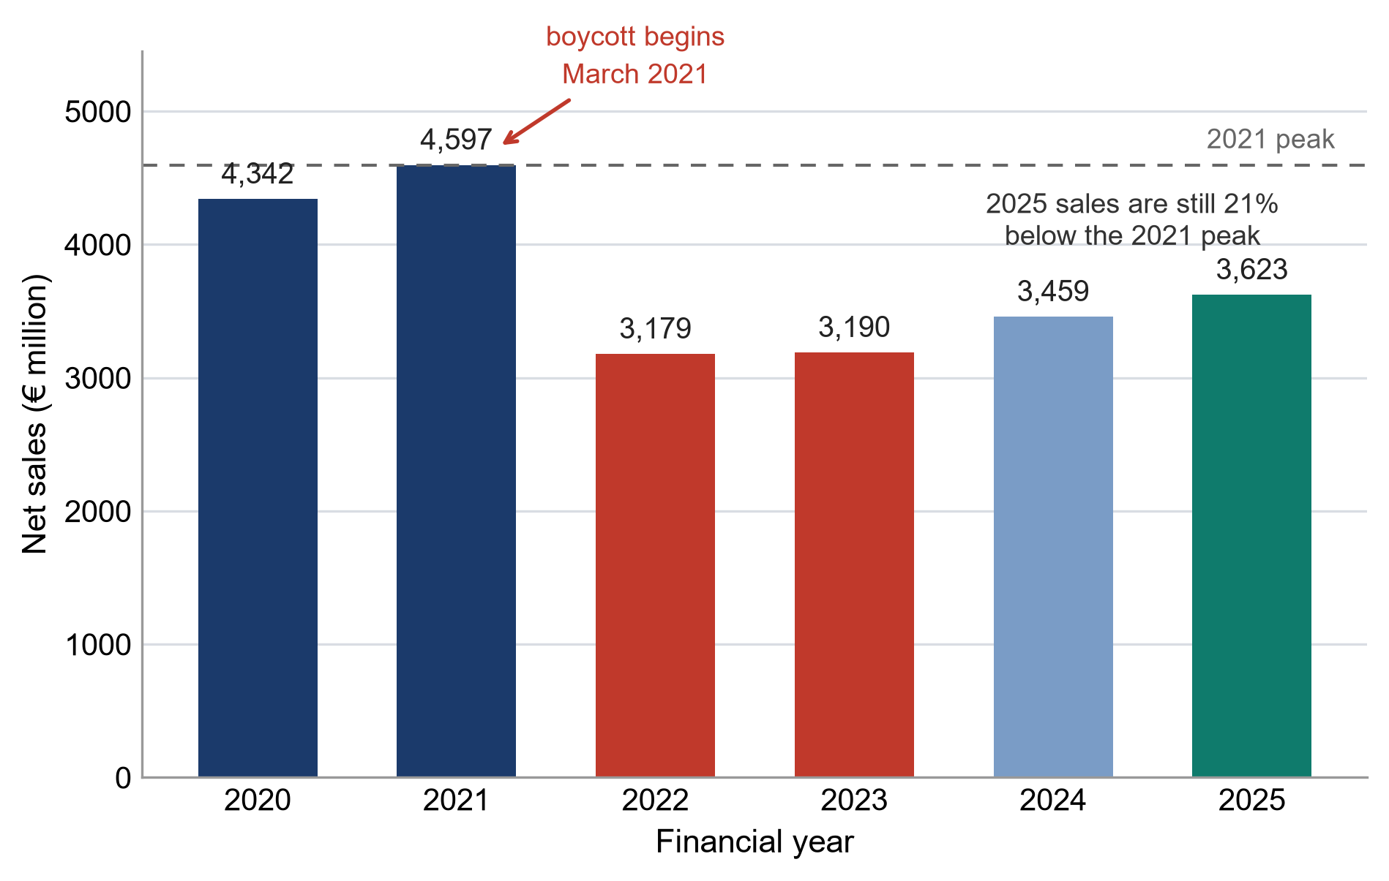
Figure 4: Adidas Greater China net sales, 2020 to 2025 (data from adidas AG, 2022; adidas AG, 2026)

Figure 4 shows what followed. Greater China net sales peaked at 4,597 million euros in 2021, fell to 3,179 million in 2022, and had only reached 3,623 million by 2025, still about 21 per cent below the peak. Over the same period Europe grew to 8,136 million euros in 2025 from 7,551 million a year earlier (adidas AG, 2026).
I have to be honest about what this evidence can and cannot show. The 2022 collapse coincided with severe pandemic lockdowns in Chinese cities, so the fall cannot be attributed to the boycott alone, and any account that does so is overreaching. What is harder to explain away is the shape of the recovery. Lockdowns ended, European sales grew strongly, and Chinese sales still sat a fifth below their pre-dispute level four years later. Han (2025) offers the most plausible reading, that repeated public opinion events move consumer attitudes towards domestic brands in a way that persists after the event itself has passed.
One further observation seems relevant. Adidas’s own annual report for 2021 discusses Greater China performance in terms of category mix, currency and sourcing costs, and makes no reference to the boycott at all (adidas AG, 2022). For an event that removed roughly a quarter of regional revenue over the following year, that silence is itself a marketing communications decision, and not an obviously good one.

6.3 Was there an ethical failure?
Two readings are available and both have support. On the first, Adidas acted properly. It held a stated position on human rights in its supply chain, that position is now reinforced by German law, and abandoning it under commercial pressure would have been the real failure. On the second, the company made a values claim in Western markets and then went quiet in the market where the claim was expensive, which makes the commitment look instrumental. Choi, Feng and Li (2023) model exactly this problem, showing that ethical commitments in fashion supply chains are fragile when compliance is costly and hard for outsiders to verify. Chan et al. (2020) find similar variation in how seriously CSR commitments are held across sportswear, fast fashion and luxury.
The picture is more complicated than a straightforward story of a Western brand raising standards. Yang and Ha-Brookshire (2021) show that Chinese apparel manufacturers hold their own view of what sustainability duties they owe and to whom, which means an imported standard is not automatically the more legitimate one.

6.4 My judgement
My view is that the ethical failure was not the original statement but the inconsistency around it. Making a public commitment in one market, saying nothing in another and omitting the episode entirely from the annual report is the behaviour that damages trust, because it invites both audiences to conclude the position is negotiable. Fong et al. (2022) find that consumer animosity towards Western brands plays out differently in online and physical retail, which matters here because the online channel is where Chinese criticism was expressed and where silence was most visible. There is a route back. Yu (2026) traces how boycott justifications evolved between the 2021 and 2024 waves, moving from moral stance taking towards more pragmatic judgements about availability and local embeddedness. That shift favours a brand that behaves consistently over one that is seen to be managing sentiment.

7. Recommendations
Table 3: Recommendations for Adidas’s international marketing strategy
Recommendation | Rationale and evidence | Timeframe
State one human rights position in identical terms in every market, including in the annual report. | The damage came from perceived inconsistency, and German law makes silence untenable (Choi, Feng and Li, 2023). | Immediate
Keep and extend local design authority in China while holding the performance promise global. | Local design answers the cultural proximity advantage of rivals without fragmenting the brand (Chen, 2023; Li, 2023). | Ongoing
Rebuild Chinese credibility through sport categories rather than cultural signalling. | Justifications have shifted towards pragmatic criteria, so opportunistic patriotism reads badly (Yu, 2026). | One to three years
Build a grassroots and club football presence in Germany before the 2027 kit change. | Heritage claims need visible evidence once the national team shirt is gone (CNN Business, 2024). | By 2027
Move more Chinese promotional spend into livestream and key opinion leader formats under local governance. | Digital execution is the identified weak point in the Chinese mix (Jiang, 2023; Guo, 2025). | One to two years

The first two recommendations carry most of the weight. A single, consistent human rights position is uncomfortable because it guarantees friction in China, but the alternative has already been tested and it produced the worst of both outcomes, reputational cost in Europe and lost revenue in China. Consistency at least makes the brand predictable, and predictability is what Yu (2026) suggests Chinese consumers are increasingly willing to reward once the initial anger has passed.
The second recommendation is about restraint. Adidas has already shown that it can localise design quickly, and the temptation now will be to localise everything, including the brand promise. I would not do that. The evidence in Long et al. (2022) is that young Chinese consumers still value Western brands for perceived quality and social image, so the performance promise is an asset worth protecting. Localise the product and the cultural reference, keep the promise global.
None of this is free. Local design authority raises cost and complexity, grassroots football investment in Germany buys far less visibility per euro than a national team shirt, and a consistent human rights position accepts a revenue ceiling in China. These are the trade offs the recommendations are actually asking Adidas to make.

8. Conclusion
Comparing Adidas in Germany and China shows that the parts of a marketing strategy that travel well are narrower than the frameworks suggest. The performance promise and the product technology cross the border almost unchanged. Positioning, promotion and physical evidence do not, because they depend on cultural meanings that are made locally. The entry mode Adidas chose in 1997 gave it the control it needed to adapt eventually, but the same control meant it absorbed the full force of the 2021 dispute when it came. The ethical episode is the sharpest lesson. A brand operating across markets with genuinely different values cannot hold a position in one place and stay silent in another, and the financial record since 2021 suggests the cost of trying is measured in years rather than quarters.

Section 2: Reflective Account

9. Reflection on the Research and Writing Process
I have used Gibbs’ reflective cycle to structure this account. Dennison (2012) argues that Kolb’s experiential learning theory remains the most cited source in reflective practice while attracting fair criticism about its usefulness for formal, intentional learning, and that criticism matched my situation. Kolb’s cycle assumes learning follows from experience. Gibbs separates out an evaluation stage and a feelings stage, which forced me to be specific about what went wrong rather than moving straight to a tidy conclusion. Ocampo et al. (2025) use the same cycle to structure a reflection on a research internship and found the staged format did similar work.
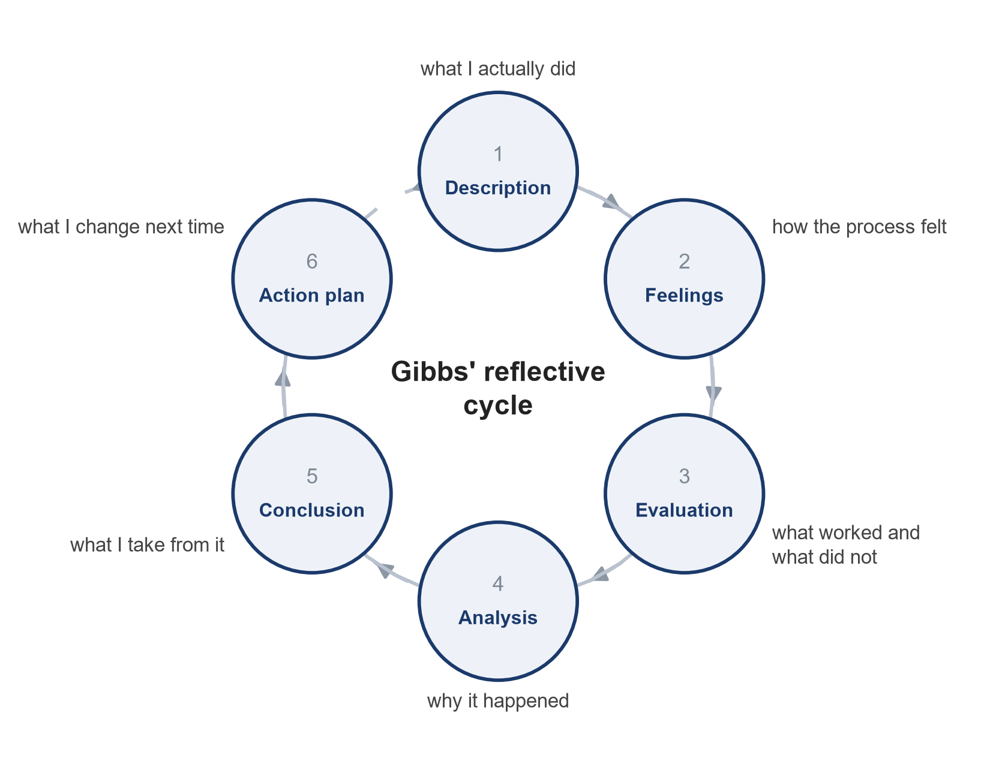
Figure 5: Gibbs’ reflective cycle as applied to this project (adapted from Ocampo et al., 2025)

9.1 Description
I was asked to compare one brand’s international market entry strategy and marketing mix across two countries. I chose Adidas, Germany and China. I began by reading the brief closely, then spent the first stretch of the work gathering literature through ScienceDirect, Emerald, Taylor and Francis, SAGE and Atlantis Press, and assembled a reference list of a little over thirty sources before writing anything. I drafted the comparative sections in order, taking PESTEL and Hofstede first, then segmentation and positioning, then the seven Ps, then entry mode and the ethical issue. The last thing I did was go back through every financial claim and check it against Adidas’s annual reports instead of the news coverage I had first taken it from.

9.2 Feelings
The early stage felt productive and was not. I had a long reference list and almost no argument, and I remember a fairly uncomfortable point about a third of the way in when I realised I could describe six frameworks and still had nothing to say. Writing about Xinjiang made me uneasy for a different reason. I was worried about producing something one-sided in either direction, and I spent longer on that section than on any other. The part I enjoyed most was finding that the 2021 annual report says nothing at all about the boycott. That was something I noticed myself rather than read in a paper, and it changed how I wrote the whole ethics section.

9.3 Evaluation
Three things worked. Checking every reference against a live source before using it meant I never had to defend a citation I was unsure about. Going to the annual reports for figures rather than to secondary summaries caught a discrepancy between a reported growth rate and the company’s own wording, which I would otherwise have repeated. And using the frameworks as an organising structure rather than as the content itself kept the analysis from turning into a list.
Three things did not. I collected literature before I had a question, so a good deal of early reading was wasted. My first draft of the seven Ps section was descriptive and had to be rewritten around the differences that mattered. And I very nearly attributed the entire 2022 sales collapse in China to the boycott before remembering that the same year included prolonged city lockdowns.

9.4 Analysis
The reason the early reading was wasted is that I was treating literature gathering as a stage to complete rather than as a response to a question. Dennison (2012) describes the risk of running through an experiential cycle without genuine reflective observation, and that is close to what I did. I had the concrete experience of reading and the abstract stage of applying frameworks, but nothing in between to test whether the reading was answering anything.
The near miss over the 2022 figures taught me more than anything else in the project. The number was real, the boycott was real, and the causal story was still not safe, because a second explanation sat on top of the first. Once I noticed it, I started looking for the same problem elsewhere and found that my confidence in the Hofstede scores had the same weakness. They explained the differences I had already decided were important. Yoo, Donthu and Lenartowicz (2011) made me treat those scores as a starting point rather than as evidence, which weakened one of my arguments and improved the section.
Underneath both problems is the same habit. I was looking for support for a reading I had already formed instead of looking for the reading that best fitted the evidence. That is a specific thing I can watch for, rather than a general resolution to be more critical.

9.5 Conclusion
What I take from this is fairly concrete. A research question has to come before the reading, or the reading has no way of being relevant. Numbers that carry an argument have to come from primary documents, because secondary sources compress and reframe them. Frameworks organise an analysis, they do not produce one, and the most useful part of applying PESTEL and Hofstede here was noticing where they failed to explain what had happened. Most of all, a causal claim needs a deliberate search for the rival explanation before it is written down, not after a marker has found it.

9.6 Action plan
For the next piece of work I will write a one page statement of the argument before collecting any sources, and use it to decide what to read. I will keep the rule that any figure appearing in my text is traced back to a primary document, and I will note the source next to the number while drafting rather than reconstructing it afterwards. I will set a word budget for each section at the outset, because the seven Ps section overran badly and the rewriting cost me time I needed elsewhere. And whenever I make a causal claim I will write the strongest competing explanation next to it in the draft and delete it only once I can say why it does not hold. That last habit is the one I expect to make the most difference.

Reference List
- Akroush, M.N. (2011) ‘The 7Ps classification of the services marketing mix revisited: Evidence from Jordan’, Jordan Journal of Business Administration, 7(1), pp. 116 to 146.
- adidas AG (2022) Annual Report 2021. Herzogenaurach: adidas AG. Available at: https://report.adidas-group.com/2021/en/ (Accessed: 10 August 2026).
- adidas AG (2026) Annual Report 2025. Herzogenaurach: adidas AG. Available at: https://report.adidas-group.com/2025/en/ (Accessed: 10 August 2026).
- BBC News (2021) ‘Nike, H&M face China fury over Xinjiang cotton concerns’, BBC News, 25 March. Available at: https://www.bbc.com/news/world-asia-china-56533560 (Accessed: 10 August 2026).
- Booms, B.H. and Bitner, M.J. (1981) ‘Marketing strategies and organization structures for service firms’, in Donnelly, J.H. and George, W.R. (eds.) Marketing of Services. Chicago: American Marketing Association, pp. 47 to 51.
- Chan, D.S.W. (2025) ‘International norms clash with China’s consumer nationalism’, The Pacific Review, 38(5), pp. 937 to 962.
- Chan, H.L., Wei, X., Guo, S. and Leung, W.H. (2020) ‘Corporate social responsibility (CSR) in fashion supply chains: A multi-methodological study’, Transportation Research Part E: Logistics and Transportation Review, 142.
- Chen, J. (2023) ‘An in-depth comparative analysis of Adidas’ marketing strategies and market comparison in the Chinese market’, in Proceedings of the 2023 International Conference on Management Innovation and Economy Development (MIED 2023). Dordrecht: Atlantis Press, pp. 344 to 351.
- Choi, T.M., Feng, L. and Li, Y. (2023) ‘Ethical fashion supply chain operations: product development and moral hazards’, International Journal of Production Research, 61(4), pp. 1058 to 1075.
- CNN Business (2021) ‘H&M and Nike are facing a boycott in China over Uyghur forced labor statements’, CNN, 25 March. Available at: https://www.cnn.com/2021/03/25/business/hm-nike-china-xinjiang-cotton-intl-hnk (Accessed: 10 August 2026).
- CNN Business (2024) ‘Nike inflicts huge home defeat on Adidas by stealing German soccer team kit deal’, CNN, 22 March. Available at: https://www.cnn.com/2024/03/22/business/nike-germany-soccer-adidas/index.html (Accessed: 10 August 2026).
- Daxue Consulting (2025) Adidas wins back consumers through ‘In China, For China’ strategy. Available at: https://daxueconsulting.com/market-research-on-adidas-in-china/ (Accessed: 10 August 2026).
- Dennison, P. (2012) ‘Reflective practice: The enduring influence of Kolb’s Experiential Learning Theory’, Compass: Journal of Learning and Teaching in Higher Education, 1(1).
- Dibb, S. and Simkin, L. (1991) ‘Targeting, segments and positioning’, International Journal of Retail and Distribution Management, 19(3), pp. 4 to 10.
- Dunning, J.H. (2001) ‘The eclectic (OLI) paradigm of international production: past, present and future’, International Journal of the Economics of Business, 8(2), pp. 173 to 190.
- Federal Ministry of Labour and Social Affairs (no date) The German Supply Chain Act. Available at: https://www.csr-in-deutschland.de/EN/Legislation/German-Supply-Chain-Act/german-supply-chain-act.html (Accessed: 10 August 2026).
- Fong, C.M., Chang, H.H.S., Lin, M.C. and Chen, I.H. (2022) ‘Reexamining emerging market animosity toward western developed countries: A study of physical and online retailing’, Journal of Retailing and Consumer Services.
- Guo, M. (2025) ‘Analysis of marketing strategy of international sports brands entering the Chinese market’, Advances in Economics, Management and Political Sciences, 174, pp. 46 to 51.
- Han, Z. (2025) ‘The change of consumer-domestic brand attitude under the influence of multi-period public opinion events: evidence from Chinese fast-fashion clothing brands’, Asia Pacific Journal of Marketing and Logistics, 37(8), pp. 2164 to 2181.
- Hofstede, G. (1980) Culture’s Consequences: International Differences in Work Related Values. Beverly Hills: Sage Publications.
- Hofstede Insights (2026) Country comparison tool: Germany and China. Available at: https://www.hofstede-insights.com/country-comparison-tool (Accessed: 10 August 2026).
- Iglesias, O., Ind, N. and Schultz, M. (2020) ‘History matters: The role of history in corporate brand strategy’, Business Horizons, 63(1), pp. 51 to 60.
- Jiang, R.X. (2023) ‘Research on the digital marketing strategy of Adidas’, Advances in Economics, Management and Political Sciences, 54, pp. 306 to 312.
- Laufs, K. and Schwens, C. (2014) ‘Foreign market entry mode choice of small and medium-sized enterprises: A systematic review and future research agenda’, International Business Review, 23(6), pp. 1109 to 1126.
- Li, X. (2023) ‘Analysis of the marketing strategy of Adidas’, Advances in Economics, Management and Political Sciences, 23, pp. 33 to 38.
- Long, F., Bhuiyan, M.A., Abd Aziz, N. and Rahman, M.K. (2022) ‘Predicting young Chinese consumers’ intentions to purchase Western brands’, PLOS ONE, 17(5), e0267563.
- Ma, Q., Abdeljelil, H.M. and Hu, L. (2019) ‘The influence of consumer ethnocentrism and consumer knowledge on brand preference’, Frontiers in Human Neuroscience, 13.
- Ocampo, F.A., McIntyre, B.G., Massey, D. and Saunders, R. (2025) ‘Nursing student reflections on a research internship: A reflective discussion following the Gibbs’ reflective cycle’, Nurse Education Today, 145.
- Oflac, B.S., Dobrucali, B., Yavas, T. and Escobar, M.G. (2015) ‘Services marketing mix efforts of a global services brand: The case of DHL Logistics’, Procedia Economics and Finance, 23, pp. 1079 to 1083.
- Rashid, C.A. (2023) ‘PESTEL analysis and Porter’s five forces as marketing tools to evaluate Morrison’s performance and strategy’, Journal of Global Social Sciences, 4(15), pp. 75 to 83.
- Schellenberg, M., Harker, M.J. and Jafari, A. (2017) ‘International market entry mode: A systematic literature review’, Journal of Strategic Marketing, 26(7), pp. 601 to 627.
- Soares, A.M., Farhangmehr, M. and Shoham, A. (2007) ‘Hofstede’s dimensions of culture in international marketing studies’, Journal of Business Research, 60(3), pp. 277 to 284.
- Yang, N. and Ha-Brookshire, J.E. (2021) ‘Chinese textile and apparel manufacturers’ moral duty positions, goals and structures toward sustainability’, Journal of Fashion Marketing and Management, 25(3), pp. 448 to 464.
- Yoo, B., Donthu, N. and Lenartowicz, T. (2011) ‘Measuring Hofstede’s five dimensions of cultural values at the individual level: Development and validation of CVSCALE’, Journal of International Consumer Marketing, 23(3 to 4), pp. 193 to 210.
- Yu, K. (2026) ‘Contingent boycotts: The temporal evolution of consumer justifications’, Journal of Macromarketing, 46(2), pp. 160 to 172.
- Yu, M. (2022) ‘How to improve the brand value of domestic sports brands after the Xinjiang cotton incident’, in Proceedings of the 2022 7th International Conference on Financial Innovation and Economic Development (ICFIED 2022). Dordrecht: Atlantis Press, pp. 1719 to 1723.

