BMDS7003
Service Transformation Portfolio

Introducing a clinical decision tool to support enhanced care decision making on staffing levels in a community hospital in-patient setting.

Sue Hamer - 2112925
- Introduction

A decision support system, or DSS, represent a huge change for organisations and healthcare today. They are intended to support decision making by analysing data to solve a problem; provide recommendations and improve the decisions made. In healthcare, DSS is supposed to enhance medical decisions with targeted clinical knowledge, patient information, and other health information (Osheroff et al., 2012). As stated by Sim et al. (2001), a traditional DSS is comprised of software designed to be a direct aid to decision making, providing knowledge and person-specific information, intelligently filtered, or presented at appropriate times. They encompass a variety of tools to enhance decision-making in a workflow, such as alerts and reminders.

They were first developed by Bleich in 1969. At the time, they had poor system integration, however, they are being used more widely across the world to provide data on diagnostics, alarm systems, disease management, prescriptions, drug control, and much more (Omididan and Hadianfar, 2011), and are now commonly administered through electronic medical records and other computerised clinical workflows.

DSSs can considerably have an impact on improving the safety, quality, efficiency, and effectiveness of health care. The Office of the National Coordinator for Health IT (ONC) supports efforts to develop, implement, adopt, and evaluate the use of DSSs to improve decisions made in health care and are supported by the National Institute for Health and Care Excellence (NICE) standards for shared decision-making, supporting tools and safe staffing for nursing in adult inpatient wards.

All patients in a hospital setting are subject to some kind of observation; this can include visual observation, vital signs observations, clinical assessments, examination, or tests. (Wood et al. 2018). Nurse staffing ratios/establishments have traditionally reflected bed occupancy levels rather than the acuity and dependency of patients. When a patient’s condition deteriorates, they may be at greater risk of harm to themselves or others. In such cases the patient may require additional nursing support or enhanced care in order to help maintain safety, but it must be noted that a patient’s condition (and associated risk of harm) can fluctuate. This is supported by the nurse staffing levels (Wales) act 2016, which requires health boards to provide sufficient nursing staff.

As noted by Wood et al. (2018), enhanced care or also referred to as ‘specialling’ in England or ‘sitting’ in the USA, is a type of care which is provided to ensure the safety of patients who may be suffering from cognitive impairment, exhibit challenging behaviour, or may be at risk of falls or of causing harm to themselves or others. Enhanced care is designed to ensure a patient centred safe approach for patients with additional care needs whilst also managing any associated impact on established staffing levels and requirement for additional staffing controls and reporting.

From conversations with the clinical lead at Powys Teaching Health Board, before any additional staff are put in place, the patient(s) must be assessed using the enhanced care paper-based assessment tool, and the level of supervision required must be established and alternative options explored. There is a policy in place to ensure standardisation, however the request for additional care support is very reactive and involves a manual process for management approval via an email trail or telephone call. This means the current manual process has; no governance, no audit, no historical data, lack of consistency, high costs bringing in agency staff to support safe staffing levels and is a single point of failure if the manager is unavailable to approve the request.

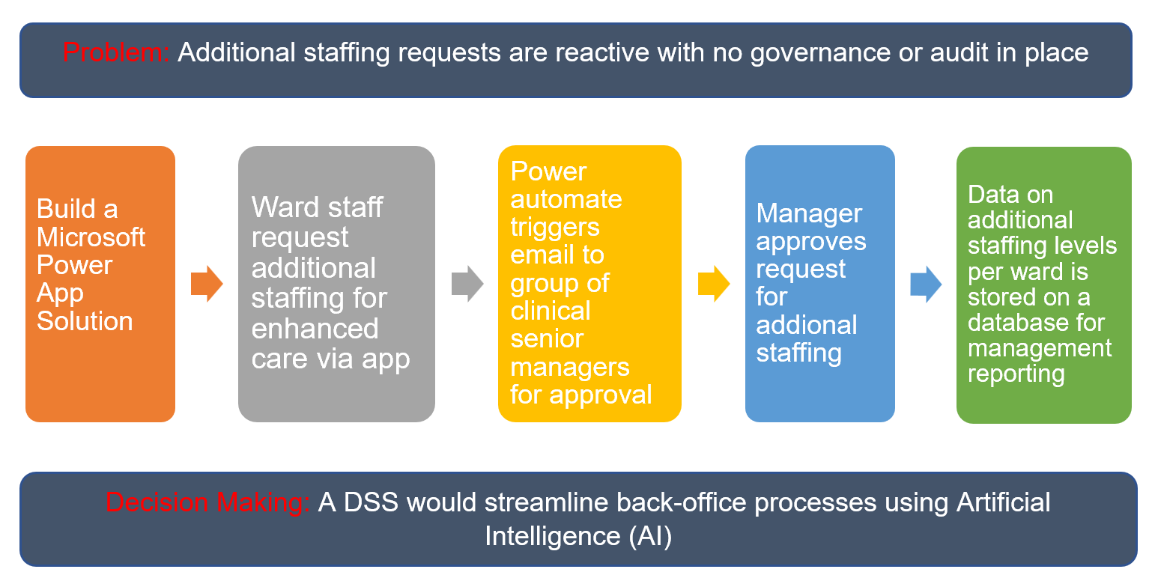
A decision support system, or otherwise referred to as a decision support tool in the context of this paper, could assist with the creation of a workflow to streamline back-office processes and safe staffing levels. If automated alerts were sent to a group of senior managers for additional staffing approval, this would provide an audit trail and governance. Access to data would support decision making on where demand is most needed and cost efficiencies by relying less on agency staff and more towards business as usual and adopting a consistent approach across each ward. Figure 1 depicts how a decision support tool can support the process.

Figure 1
Scope of decision support tool

Implementing a stand-alone DSS would allow for decisions to be made on in-ward staffing levels with the use of an electronic process which would facilitate:

- Managing information through clinical knowledge on staffing requirements
- Creating an alert, focusing managers’ attention by providing evidence that additional staffing is required to support patients at risk on the ward.
- Recommending specific actions and decisions, tailored for the clinical condition of the patient.
- Storing data in a database for future streamlining of staffing and budget monitoring.

- Evidence Review

2.1 Methods

The intention of this scoping review was to explore the scope and breath of literature on decision support systems in a healthcare setting, enhanced care, and similar types of care in an in-patient care setting where safe staffing management, alerts, automation and workflows have supported decision making, and to identify any concerns and challenges with the process and outcomes relating to the quality of care emerging from the literature, in line with NICE guidance SG1 recommendations 1.4.1 to 1.4.4 which provides a methodical approach to maintaining nurse staffing levels that ensure patients are able to receive the level of nursing care they need.

In order to assess the relevance of the literature review, the PRISMA framework or Preferred Reporting Items for Systematic Reviews and Meta-Analyses (PRISMA), developed by Moher (2013) was used which is a recommended tool for systematic literature reviews, critical literature analyses and meta-analyses.

2.2 Search strategy

The literature review search covered the period January 1996 to January 2023 which comprised of four online databases: MEDLINE, Embase, Ovid and ProQuest Nursing. Grey literature sources were also included as there was limited research on the area of study and Google. The following themes were used based on the review objectives to search for literature which included ‘decision support systems’ OR ‘Personnel Staffing and Scheduling’ OR ‘staffing management’ OR ‘specialling clinical decision support system’ OR ‘sitting clinical decision support system’ OR ‘enhanced care clinical decision support system’ OR ‘streamlining back-office processes. To address computerised decision support systems, at least one of the following had to be eligible for inclusion: impact on safety; quality, performance or organisational.

To the best of the researcher’s knowledge, there was little available research which examined the effects of developing a DSS to support safe staffing or streamlining back-office processes. To address this gap, we looked to review literature that could be transferable and if DSSs have supported nurses, and to analyse the effects of automated information processing on decision making, workflows, care delivery and patient outcomes.

2.3 Results

As there was little recent literature on enhanced care OR specialling OR sitting DSS, the search range was widened to provide further evidence which was relevant and transferable. The initial search generated 4201 articles. The articles were imported into Endnote and duplicates were removed, leading to 3251 articles. The articles were then screened by title, language, general topic, and type of publication, resulting in 150 articles. Screening based on abstracts resulted in 102 articles for full-text review. After the full-text review, 96 articles were excluded. Ten articles were included in the final selection as evidenced in table 1.

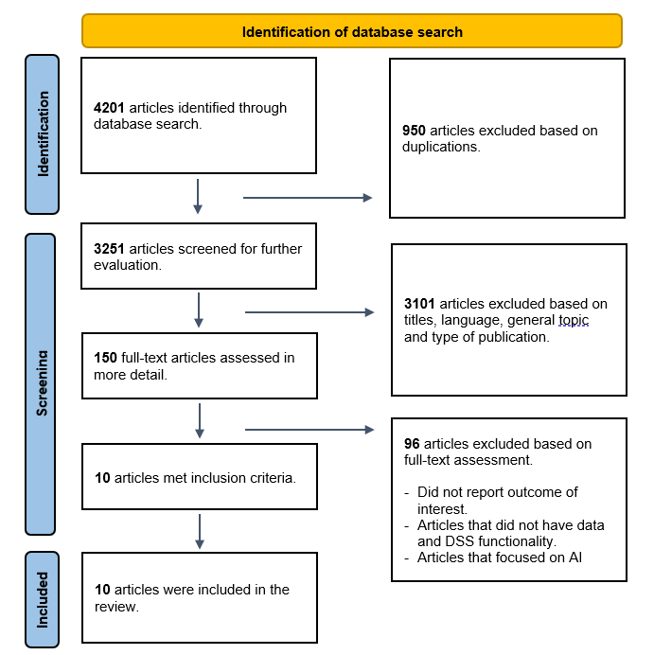

Table 1
Prisma flow diagram of searches including systematic reviews.

From searches carried out from the four online databases, 4043 systematic reviews related to decision support systems, 19 related to capacity and resource management. 11 related to staffing management, 0 related to streamlining processes, 0 related to specialling CDSS, 0 related to enhanced care CDSS and 0 related to sitting CDSS.

In order to grade the effectiveness of the literature review, the researched used the Cochrane risk of bias grading tool which was developed in 1993 to evaluate systematic reviews of all relevant randomised controlled trials in the field of healthcare. The results of the review are shown in table 2.

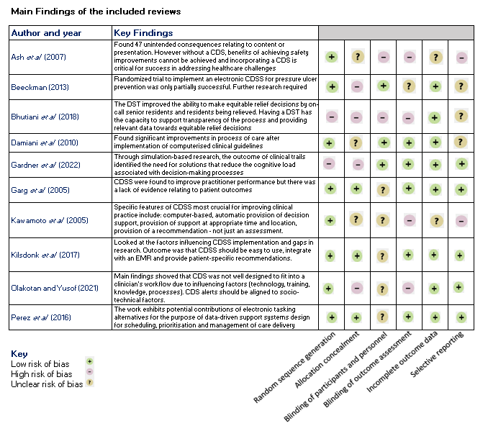

Table 2
Cochrane risk of bias grading tool

2.3.1 Evidence for the effectiveness of computerised decision support systems
Improving practitioner performance

The research identified that clinical decision tools can support practitioner performance, especially when providing an automated process as identified by Garg et al. (2005). For example, CDSS had positive impacts in 16/21 (76%) of the studies investigating the issuing of reminders. This correlates with the success found by Kawamoto et al. (2005), where using automatic prompts to use a system and developing a custom-tailored software designed internally to enable business processes and objectives, tailored to the organisations needs can be combined into a clinician’s routine workflow, which provides clear recommendations (Damiani et al., 2010).

2.3.2 Embedding AI features into workflows to support clinical decision-making.

Research carried out by Perez et al. (2016) evidences the need to replace traditional paper methods to review staffing workload management with data driven digital alternatives. The results showed that electronic tasking for data-driven support systems could support scheduling, prioritisation, and management of care delivery in secondary care.

Chen and Decary (2020) reported that to enable integrating AI into healthcare, it requires AI tools to form part of an organisations workflows to allow for clinical decision making to take place. By integrating AI into the workflows, it supports access to data, evidence decision-making, deliver value and reduce costs. However, a systematic literature review carried out by Kilsdonk et al. (2017) revealed that DSSs can disrupt workflow, especially in the case of stand-alone systems. Many early CDSS were designed as systems that required the provider to document or source information outside their typical workspace. DSS also disrupt workflow if designed without human information processing and behaviours in mind.

2.3.3 Effects of DSSs on safe staffing

Data shared from the Nottingham University Hospitals NHS Trust (NUH) app reported that senior teams previously relied on manual collation of nurse staffing levels at key points in the day and the data was not visible across the trust. Management was spending at least 2 hours per site, per day, collating the staffing data manually and this time was released to focus on hospital flow and effective deployment of staff when needed. The app allowed reports to be generated with information about fill rates, skill mix and numbers of bank and agency staff, which meant the nurse in charge could assess whether the ward was safely staffed.

2.3.4 Alert Fatigue

A qualitative case study evaluation was conducted by Olakotan and Yusof (2021) around CDSS alerts in supporting clinical workflows. The qualitative case study evaluation in Malaysia was based on investigating the features and functions of alert appropriateness and workflow-related issues. The findings were that technology (useability, alert content and timing); human factors associated with training, knowledge and skills, organisation rules and processes affected the use of the CDS. The review also identified the importance of incorporating the right alert with the right information which has meaning to support clinical workflow. Without these considerations, the alerts will be ignored, thereby undermining patient safety.

Ash et al. (2007) reported that up to 95% of CDSS alerts are insignificant and quite often clinicians disagree with or distrust them, and other times they do not read them. If they are presented with excessive or unimportant alerts, they end up suffering from alert fatigue which was evidenced by Khalifa and Zabani (2016).

2.3.5 Cost-effectiveness of computerised decision support systems

There has been little evidence on the cost effectiveness of a computerised CDSS, and most research avoids detailing any cost-effectiveness considerations. Sutton et al. (2020) reported that 74% of those identified in their research said the financial viability remained challenging. Ongoing costs continue to be an issue as new staff need to be trained to use the system, and system updates are required to keep pace with current knowledge.

However, from reviewing grey literature, Nottingham University Hospitals NHS Trust (NUH) developed a Safe Staffing App in 2015 to allow managers and staff to see an accurate, live staffing position across the wards. The Stroke department saw a £60k reduction in spend over a three-month period due to fewer temporary nurses being used.

2.3.6 Ensuring safe implementation of computerised decision support.

Although the evidence of actual harm associated with computerised decision support systems is limited (Koppel et al., 2005) the introduction of these technologies may have a detrimental effect on care processes and outcomes if not implemented appropriately.

In 2021, the Health, Safety and Welfare regulatory body carried out an independent report, following a cyber-attack that affected over 80% of the IT infrastructure at Irish Health Services. There were many findings, including the need to build cybersecurity and resilience into their IT architecture, establish an operational policy and transform their legacy IT estate. Ensuring safe governance and the safety of systems or applications is vital when implementing a new system. This is where a Data Protection Impact Assessment (DPIA) can be used as a tool to help organisations identify and address data protection and privacy concerns at the design and development stage of a project (Information Commissioner’s Office, 2021), including a cyber security assessment to identify the level of risk a system could pose on an organisation.

2.3.7 Factors that influence the use or Intention to use and successful implementation in clinical practice.

As evidenced by Devaraj (2014) and Murray et al. (2011), a lack of technological competence can be hindering when engaging with a CDSS. This can vary by the design details of the CDSS, but some have been found to be overly complex as evidenced by Jansen-Kosterink et al (2021), relying too much on user skill. Baseline evaluations of users’ technological competence may be appropriate along with training to facilitate full use of CDSS capabilities and adoption.

Horn et al. (2010) and Sharkey et al. (2013) reported that factors associated with successful CDSS implementation in clinical practice were involvement of the administrator or head of nursing in the process; highlighting the importance of leadership that was actively engaged as an internal champion who can be a persuasive leader as the change facilitator. In addition, Horn et al. (2010) and Beeckman (2013) reported that consideration of clinical workflows, training, and previous education activities for professionals on the use of clinical decision support systems was a fundamental requirement.

Catwell & Sheikh (2009) reported that computerised decision support systems work best when they meet a perceived need, for example they are tailored to clinicians’ requirements rather than enforced on them. This relates with the findings from Robertson et al. (2010) that safe implementation and adoption involves an iterative process which requires engagement and empowerment with the end-user.

2.3.8 How improved decision-making enhances the service user’s experience.

Improved clinical decision making is integral to enable a clinicians’ ability to access the most relevant and recent information to make evidence-based decisions regarding a patient’s healthcare. Sutton et al. (2020) reported that there is increasing recognition of the value of CDSS in facilitating evidence-based decision making however realising the benefits in clinical practice over an extended period of time has proven difficult due to limited adoption. (Pearce and Whyte, 2018). Gardner et al. (2022) carried out an evaluation of a clinical decision support tool using 25 clinical and non-clinical staff. The results showed that 2% reported to have more time to complete a task which took 0.1% less mental time.

However, Bhutiani et al. (2018) carried out a study looking at the implementation of an automated DST to improve equitable decision making for clinical relief at a graduate medical education setting in America, which showed real value. The percentage of residents held at the setting beyond 5:30pm on any given day decreased from 18.09% to 12.64%, and a post implementation survey reported that the DST aided their ability to make equitable relief decisions which was at 60% pre implementation versus 94% post implementation.

Hawai’i Pacific University identified that nurses report that when their employers gave them authority to make clinical decisions, they were more likely to be satisfied in their jobs. They may be less susceptible to burnout and more likely to stay in the profession. When employers treat nurses as clinicians, they are more likely to retain staff, which can help stem the nationwide nursing shortage that the health care system faces.

As there was little available research in this area, further investigation is required to demonstrate how having improved decision making can enhance the service users experience.

Comparison of decision support systems

The clinical decision support systems market size was valued at USD 4.48 billion in 2021 and is estimated to expand at a compound annual growth rate of 10.4% from 2022 to 2030.

Chen and Decary (2020) reported that electronic health records (EHRs) serve as the foundation of digital healthcare systems, and the preferred approach is to embed AI features directly into EHR systems. This has been endorsed by the US Government’s Health and Medicare acts, who financially encourage CDS implementation into EHRs. In 2013, an estimated 41% of U.S. hospitals had integrated a CDS with their EHR, and in 2017, 40.2% of US hospitals had advanced CDS capability. This interoperability to enhance decision making is also being used as part of the HIMSS Analytics Electronic Medical Record Adoption Model (EMRAM) to transform an England Hospital to becoming fully digital.

In 2013, NHS England developed a tool to support GPs with electronic cancer decision support (CDS) which was integrated into GP practices clinical system; EMIS Web. Since 2021 it has been adopted across England and Wales, supporting GPs with electronic cancer decision support tools. GPs reported that around 20% of patients who were referred for further investigation would not have been if the software had not been in place.

Triantafyllidis and Tsanas (2019) indicated that artificial intelligence (AI) algorithms in digital health can be effective in improving health outcomes across a range of conditions, for example, patient self-management, diagnostics, drug control, and much more. Shortliffe and Sepúlveda (2018) reported a growing interest from the public, health service providers, policymakers, and funding organisations in the possibility of linking a CDSS to a data-driven (AI) based algorithms, as these can facilitate human decision-making. There is however little evidence on the effectiveness of CDS systems linked to data-driven AI-based algorithms and some have cautioned against the excitement associated with AI-based technologies used in healthcare delivery and the potential pitfalls. (Academy of Medical Royal Colleges AI publication, 2019).

In 2001, Subbe et al. created The Modified Early Warning Score (MEWS) as a predictive tool for early detection of inpatients’ clinical deterioration and potential need for higher levels of care, using a rule-based algorithm on clinical data to calculate a risk score. Although Khalifa et al. (2019) reported that no literature has been found regarding its usability or potential effect, the MEWS has been tested for external validity multiple times in different clinical areas, settings, and populations, and the updated version of NEWS2 has been endorsed by NHS England and NHS Improvement as a key tool for patient safety and improving patient outcomes.

Limitations

This review has several limitations. No studies were identified which assessed a decision support system that supported capacity and resource management or reducing the demand on agency staff in the field of enhanced care OR specialling. Previous reviews of nursing DSSs have been limited to describing system features or examining patterns or have been focused on specific clinical problems which were outside of scope. There are also cultural differences between PTHB and organisations from other countries, and evidence is based on secondary care where PTHB only provides community hospital care. There were no studies identified which assessed how a DSS could support capacity and resource management when looking at one to one specialling or enhanced care, so the papers reviewed focused on aspects that could be transferrable to the given operational process.

Gaps

Earlier reviews of DSSs in nursing have been limited to describing system features or examining patterns of use or have focused on specific clinical problems. There was little and none in some cases of literature available of existing CDSSs to that looked at the benefits a CDSS could support decision making with staffing levels or capacity and demand. Therefore, further research is required to understand how automation can improve safe staffing and the streamlining of back-office processes using AI.

- Barriers to Implementation

The NHS is continually changing as research and knowledge supports the development of new technology and new ways of working. According to Lumbers (2018), resistance to change occurs when staff fear about adapting or coping with new methods, and this is where change models and leadership are important.

The key to developing highly usable systems is employing user centred design, ensuring staff are at the core of any service change and realising what benefits will bring and their input in the process.

Davies and Lloyd-Williams (1999) reported that not all projects have been successful which have been down to the lack of power, structure, planning, lack of stakeholder engagement and assessment of risk. These failures can lead to a loss of confidence in IT applications from users and senior management, and a loss of healthcare money.

The health foundation (2015) evidenced a number of factors that could pose as a barrier when looking to make improvements in the NHS, for example, lack of fit with current processes, staff resistance, lack of leadership & management or funding constraints. These were combined with challenges around the design, delivery, and dissemination where people don’t realise there is an issue that needs changing, they feel the intervention is not correct, or it might be difficult to get data collection and monitoring systems in place.

When Nottingham University Hospitals NHS Trust introduced the safe staffing app, the trust ensured they engaged ward nurses with the new development to ensure that the tool was user friendly, highlighted the necessary areas of concern, provided a platform for professional judgement which incorporated an escalation process.

To support the immediate change, it is recommended that a collaborative leadership approach is delivered to allow ward staff to feel included and consulted on the change. Forbes (2017) reported that companies adopting a collaborative approach were five times as likely to be high performing which supports the results of a study from Carr and Walton (2014), that working collaboratively on a task, boosted the performance of individuals; “Feeling like your part of a team of people working on a task makes people more motivated as they take on challenges”.

There are several risks that could be seen as challenges when looking to implement the decision support system as evidenced in table 1.

Ref. | Risk | Mitigation
1. | Nurses on ward not completing the digital request. | Providing training on the application. Removing the current manual process. Supporting staff through the transition.
2. | Difficulties accessing the Microsoft application if clinical staff don’t use a computer. | Access to tablets that the staff can use ad-hoc or a hot-desking room which is equipped with IT equipment and access to the DSS
3. | Low appetite from ward staff as the paper process is quicker. | Communication the benefits of the change. Removing the current “reactive” process to it being a managed, consistent, and informed decision support tool that will support staffing levels.
4 | Not communicating the change with stakeholders. | Providing webinars, face to face meetings and regular updates. Listening to concerns and addressing or recording on the issue log.
5 | Managers not responding to the alert or reminder notification | Providing training.  Piloting with one ward and reviewing the data to see what it is telling them. New efficiencies? New staffing interventions? Lessons learned before adopting across all wards.
6 | Staff may be sceptical about the safety or effectiveness of the new CDSS. | Evidence the known benefits of the CDSS. Identify current challenges v new ways of working

Table 1
Identified risks to implementation of the desired decision support tool.

A method that is generally used in a public health setting to support behaviour change is the capability, opportunity, and motivation model (COM-B) where the 3 elements interact, which was developed by Michie, Van Stralen and West in 2011. The model can be an effective tool as it identifies what element of behaviour needs to be changed for an intervention to be successful as shown in diagram 1 which has been broken down into a behaviour change wheel (BCW) shown in diagram 2.

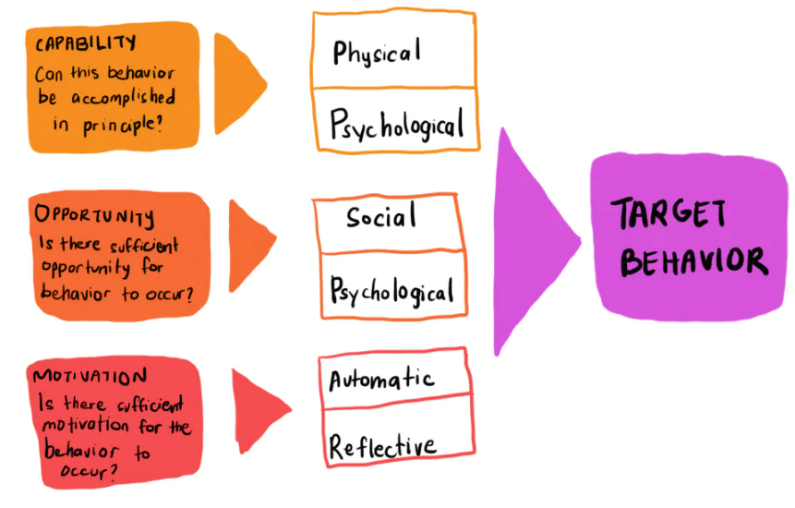

Diagram 1
The COM-B System – a framework for understanding behaviour.
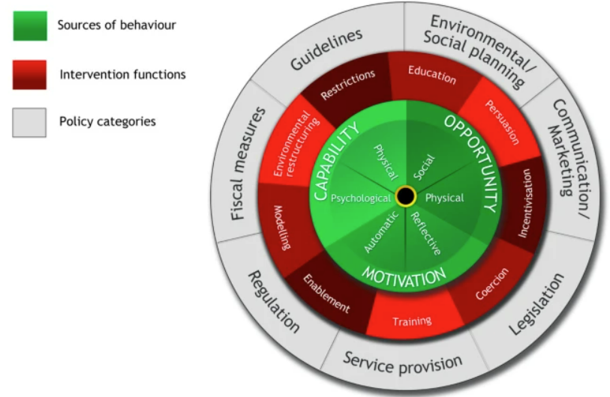

Diagram 2
The Behaviour Change Wheel

The BCW approach identifies that behaviour towards change can arise from combinations of any of the components of the behaviour system and that these need to be considered to guide understanding of interventions and change.

- Evaluation

In research from Choo (2006), the “knowing organisation” model examines how people and groups work with information to achieve three outcomes: (1) to make sense of change in its environment, (2) to create new knowledge for innovation, and (3) make decisions about what action needs to take place to make the change. Given that it has been identified that change is required to develop a decision support tool for enhanced care, and the results of the literature review strongly recommend the need for training, guidelines, and standards to adopt, it is important to evaluate if the change has been successfully implemented.

As reported by NHS England, evaluating the impact of using decision support tools is important. For a clinician, how easy a decision support tool is to use is pivotal to their adoption. Understanding barriers to adoption at the level of a team or a pathway is of great importance, and they recommend a plan, study, do act (PDSA) approach to facilitate adoption.

Evaluations tell us what works and what does not. As noted by Menon et al. (2009), an evaluation should form a structured assessment of an ongoing or completed task, programme, policy, or intervention that will establish the effectiveness of the change and whether it is achieving its objectives and contributing to decision-making.

Carroll et al. (2002) evidenced the importance of involving clinicians in the design and usability evaluations of predictive tools and CDS before they are implemented. Having this in place is likely to reduce their concerns that integrating predictive tools and CDSs into their workflow would increase their workload or decrease their efficiency and productivity.

Usability evaluation is a method used to ascertain the quality of a user’s experience when interacting with products or systems and reviewing the effectiveness of the change. As Bill Gates said, “Your most unhappy customers are your greatest source of learning”. Understanding the customer is critical to the design process and so it is good practice to establish a baseline on an existing process or product, and then following the expression, “test early and often”, as promoted by the United Nations Development Programme.

The SUS scale developed by John Brooke in 1986 is a simple but valid tool for measuring usability, using a 10-item attitude Likert scale which would provide a benchmark score for differentiating between a usable and unusable system as evidenced in table 2. The measurements of useability have three different aspects:
- effectiveness (can users successfully achieve their objectives)
- efficiency (how much effort and resource are expended in achieving those objectives)
- satisfaction (was the experience satisfactory)
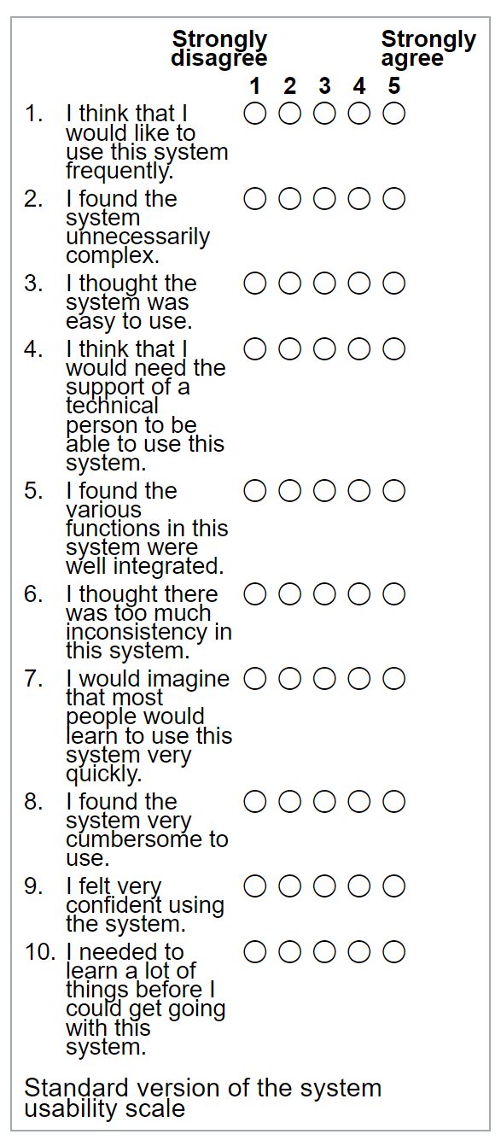
Table 2
Standard version of the system useability scale (SUS)

It is recommended that this approach is used to ascertain how well received the CDSS is to support the streamlining of staffing and what themes emerge from the results. Without this in place, it will be unknown if the CDSS has been well received and is working in practice, or whether staff are reverting back to the paper-process of requesting additional staffing levels to support patient safety.

Alongside the SUS scale is the Technology Acceptance Model (TAM) designed by Davis (1989), which was created to evaluate why users reject or adopt a system, which is widely used in health care today. It is an influential model of technology acceptance that highlights the "perceived ease of use" and "perceived usefulness" to analyse attitude against actual system use as shown in figure 1.
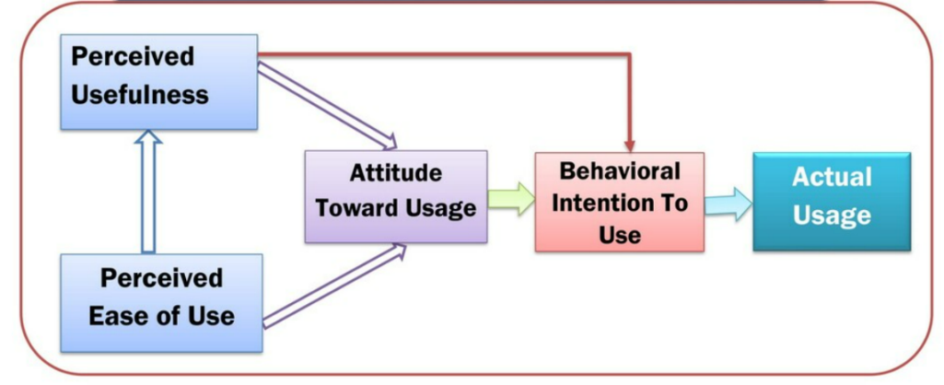

Figure 1
Technology Acceptance Model (TAM), by Davis 1989

The results from the SUS will work alongside the TAM model as a framework to understand what, if any, elements of adoption are related to either the extent to which the DSS has improved decision making with staffing levels and if the amount of effort required to use the CDSS has increased or decreased. Having a framework in place will allow for incremental developments to take place as the tool is implemented, with the aim of embedding as a successful decision support tool.

A high-level plan has been provided in table 3 showing the steps required to evaluate the effectiveness of the change.
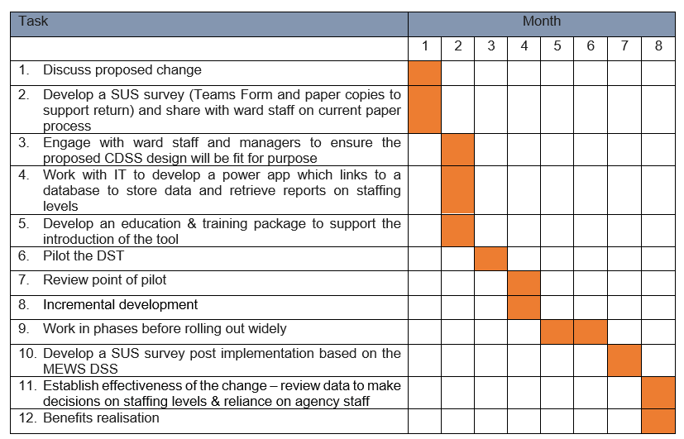

Table 3
High level milestone plan

Discussion

There is evidence that CDSSs integrate to numerous other systems, i.e., electronic patient record, clinical systems, which can bring together different types of knowledge and data to support decision making. However, there is a fine balance where decision support tools could increase a clinician’s confidence in managing cases of clinical uncertainty (Artificial Intelligence in Healthcare, 2019), and at the same time the user could become less independent by relying less on their own judgement, knowledge, and skills, and become less equipped for a task if they moved to an environment without a CDSS. (Sutton et al., 2020).

It is evident from the literature review that there is a strong focus on the need to reduce variation in care practices through the introduction of training and tools that better support the decision-making process. For this to become embedded effectively, it would also require the introduction of a strong set of guidelines and standards which would ensure the quality of care provided is ‘effective, safe and provides a positive experience’ (Swinglehurst et al., 2014).
There will be resistance to change the current manual process to an automated electronic process, so a strong leadership approach will be required to manage the new ways of working and remove variation of care practice which is supported by the findings of Horn et al. (2010) and Sharkey et al. (2013).

Conclusion

Computerised decision support systems appear to vary in design and how they operate and can be used by any professional in any healthcare setting. The range of application of these systems is large and can support both clinical and non-clinical activities.

The evidence in the available literature about the effects of clinical decision support systems (used by nurses) is still insufficient, it is therefore necessary to carry out studies that look at the adoption and interaction of nurses with CDSSs, as well as studies with a representative sample of health care professionals on in-patient community wards. In addition, long-term follow-up is necessary to assess the effects of clinical decision support systems that can demonstrate a more real, measurable, and significant effect on streamlining workflows to support clinical decision making.

References

- Academy of Medical Royal Colleges (2019). Artificial intelligence in healthcare. Available at: http://www.aomrc.org.uk/reports-guidance/artificial-intelligence-in-healthcare. (Accessed 30 January 2023)

- Akbar, S., Lyell, D., & Magrabi, F. (2021). Automation in nursing decision support systems: A systematic review of effects on decision making, care delivery, and patient outcomes. Journal of the American Medical Informatics Association: JAMIA, 28(11), 2502–2513. https://doi.org/10.1093/jamia/ocab123

- Ash, J. S., Sittig, D. F., Campbell, E. M., Guappone, K. P., & Dykstra, R. H. (2007). Some unintended consequences of clinical decision support systems. AMIA ... Annual Symposium proceedings. AMIA Symposium, 2007, 26–30.

- Bailey, S., Vigor, J., Walsh, N., & Weaks, L. (2019). NHS leadership and culture: our position. Available at: https: www.kingsfund.org.uk/projects/positions/NHS-leadership-culture (kingsfund.org.uk). (Accessed 23 January 2023).

- Beeckman, D., Clays, E., Van Hecke, A., Vanderwee, K., Schoonhoven, L., & Verhaeghe, S. (2013). A multi-faceted tailored strategy to implement an electronic clinical decision support system for pressure ulcer prevention in nursing homes: a two-armed randomized controlled trial. International journal of nursing studies, 50(4), 475–486. https://doi.org/10.1016/j.ijnurstu.2012.09.007

- Bhutiani, M., Jablonski, P. M., Ehrenfeld, J. M., McEvoy, M. D., Fowler, L. C., & Wanderer, J. P. (2018). Decision Support Tool Improves Real and Perceived Anesthesiology Resident Relief Equity. Anesthesia &Amp; Analgesia, 127(2), 513–519. https://doi.org/10.1213/ane.0000000000003479

- Carr, P. B., & Walton, G. M. (2014). Cues of working together fuel intrinsic motivation. Journal of Experimental Social Psychology, 53, 169–184. https://doi.org/10.1016/j.jesp.2014.03.015

- Carroll, C., Marsden, P., Soden, P., Naylor, E., New, J.P., & Dornan, T. (2002). Involving users in the design and usability evaluation of a clinical decision support system. Computer methods and programs in biomedicine, 69 2, 123-35.

- Catwell, L., & Sheikh, A. (2009). Information technology (IT) system users must be allowed to decide on the future direction of major national IT initiatives. But the task of redistributing power equally amongst stakeholders will not be an easy one. Informatics in primary care, 17 1, 1-4

- Chen, M., & Decary, M. (2020). Artificial intelligence in healthcare: An essential guide for health leaders. Healthcare management forum, 33(1), 10–18. https://doi.org/10.1177/0840470419873123

- Choo, C. W. (2006). The Knowing Organization: How Organizations Use Information to Construct Meaning, Create Knowledge, and Make Decisions (2nd ed.). Oxford University Press, New York.

- Health IT (2018) ‘Clinical Decision Support’. Health IT Safety. Available at: https://www.healthit.gov/topic/safety/clinical-decision-support. (Accessed 27 January 2023)

- Cochrane Training (2022). Available at: https://training.cochrane.org/handbooks. (Accessed 10 February 2023)

- Damiani, G., Pinnarelli, L., Colosimo, S. C., Almiento, R., Sicuro, L., Galasso, R., Sommella, L., & Ricciardi, W. (2010). The effectiveness of computerized clinical guidelines in the process of care: a systematic review. BMC health services research, 10, 2. https://doi.org/10.1186/1472-6963-10-2

- Davis, F. D. (1989). Perceived usefulness, perceived ease of use, and user acceptance of information technology. MIS Quarterly, 319-340.

- Devaraj, S,. Sharma, S.K,. Fausto, D.J., Viernes, S,. Kharrazi,. H. (2014). Barriers and Facilitators to Clinical Decision Support Systems Adoption: A Systematic Review. Journal of Business Administration Research. 3. 10.5430/jbar.v3n2p36

- Gardner, C., Halligan, J., Fontana, G., Fernandez Crespo, R., Prime, M., Guo, C., Ekinci, O., Ghafur, S., & Darzi, A. (2022). Evaluation of a clinical decision support tool for matching cancer patients to clinical trials using simulation-based research. Health informatics journal, 28(2), 14604582221087890. https://doi.org/10.1177/14604582221087890

- Garg, A. X., Adhikari, N. K., McDonald, H., Rosas-Arellano, M. P., Devereaux, P. J., Beyene, J., Sam, J., & Haynes, R. B. (2005). Effects of computerized clinical decision support systems on practitioner performance and patient outcomes: a systematic review. JAMA, 293(10), 1223–1238. https://doi.org/10.1001/jama.293.10.1223

Gaskell, A. (2017). New Study Finds That Collaboration Drives Workplace Performance. Available at: www.forbes.com/sites/adigaskell/2017/06/22/new-study-finds-that-collaboration-drives-workplace-performance/?sh=2e6e80c13d02. (Accessed 29 January 2023).

Grand View Research. (nd) Clinical Decision Support Systems Market Size, Share & Trends Analysis Report By Product. Available at www.grandviewresearch.com/industry-analysis/clinical-decision-support-system-market. (Accessed 30 January 2023).

- Hawaii Pacific University (nd). Clinical Decision Making in Nursing Practice. Available at: https://online.hpu.edu/blog/clinical-decision-making-in-nursing/. (Accessed 5 February 2023).

- HITECH Act Enforcement Interim Final Rule. https://www.hhs.gov/hipaa/for-professionals/special-topics/HITECH-act-enforcement-interim-final-rule/index.html

- Horn, S. D., Sharkey, S. S., Hudak, S., Gassaway, J., James, R., & Spector, W. (2010). Pressure ulcer prevention in long-term-care facilities: a pilot study implementing standardized nurse aide documentation and feedback reports. Advances in skin & wound care, 23(3), 120–131. https://doi.org/10.1097/01.ASW.0000363516.47512.67

- Health, Safety & Welfare (2021). HSE publishes independent report on conti cyber attach. Available at: www.hse.ie/eng/services/news/media/pressrel/hse-publishes-independent-report-on-conti-cyber-attack.html. (Accessed 17 February 2023).

- Information Commissioner’s Office (2021). Data protection impact assessments. Available at: www.ico.org.uk/for-organisations/guide-to-data-protection/guide-to-the-general-data-protection-regulation-gdpr/accountability-and-governance/data-protection-impact-assessments/. (Accessed 17 February 2023).

- Jansen-Kosterink, S., Van Velsen, L., & Cabrita, M. (2021). Clinician acceptance of complex clinical decision support systems for treatment allocation of patients with chronic low back pain. BMC Medical Informatics and Decision Making, 21(1). https://doi.org/10.1186/s12911-021-01502-0

- Kawamoto, K., Houlihan, C. A., Balas, E. A., & Lobach, D. F. (2005). Improving clinical practice using clinical decision support systems: a systematic review of trials to identify features critical to success. BMJ (Clinical research ed.), 330(7494), 765. https://doi.org/10.1136/bmj.38398.500764.8F

- Khalifa, M., & Zabani, I. (2016). Improving Utilization of Clinical Decision Support Systems by Reducing Alert Fatigue: Strategies and Recommendations. Studies in health technology and informatics, 226, 51–54.

- Khalifa, M., Magrabi, F., & Gallego, B. (2019). Developing a framework for evidence-based grading and assessment of predictive tools for clinical decision support. BMC Medical Informatics and Decision Making, 19(1). https://doi.org/10.1186/s12911-019-0940-7

- Kilsdonk, E., Peute, L. W., & Jaspers, M. W. (2017). Factors influencing implementation success of guideline-based clinical decision support systems: A systematic review and gaps analysis. International journal of medical informatics, 98, 56–64. https://doi.org/10.1016/j.ijmedinf.2016.12.001

- Knowles, E. (2014). Oxford Dictionary of Quotations (8th ed.). Oxford University Press.

- Koppel, R., Metlay, J. P., Cohen, A., Abaluck, B., Localio, A. R., Kimmel, S. E., & Strom, B. L. (2005). Role of computerized physician order entry systems in facilitating medication errors. JAMA, 293(10), 1197–1203. https://doi.org/10.1001/jama.293.10.1197

- Lumbers, M. (2018). Approaches to leadership and managing change in the NHS. British Journal of Nursing, 27(10), 554–558. https://doi.org/10.12968/bjon.2018.27.10.554

- Menon, S., Karl, J., Wignaraja, J. (2009). Handbook on planning, monitoring, and evaluating for development results. Available at: Handbook on Planning Monitoring and Evaluating for Development Result (undp.org). (Accessed 24 January 2023)

- Michie, S., Van Stralen, M. M., & West, R. (2011). The behaviour change wheel: A new method for characterising and designing behaviour change interventions. Implementation Science, 6(1). https://doi.org/10.1186/1748-5908-6-42

- Murray, E., Burns, J., May, C., Finch, T., O'Donnell, C., Wallace, P., & Mair, F. (2011). Why is it difficult to implement e-health initiatives? A qualitative study. Implementation science: IS, 6, 6. https://doi.org/10.1186/1748-5908-6-6

- National Institute for Health and Care Excellence (2014). Safe staffing for nursing in adult inpatient wards in acute hospitals. Available at: https://www.nice.org.uk/Guidance/SG1. (Accessed 29 January 2023).

National Institute for Health and Care Excellence (2016). Development of a Safe Staffing App. Available at: https://www.nice.org.uk/sharedlearning/development-of-a-safe-staffing-app. (Accessed 29 January 2023).

- National Institute for Health and Care Excellence. (2021). Standards for shared-decision-making supporting tools, including patient decision aids. Accessible at: www.nice.org.uk/corporate/ecd8. (Accessed on 19 January 2023).

- NHS England (nd). Evaluating the impact of using decision support tools. Available at: https://www.england.nhs.uk/personalisedcare/shared-decision-making/decision-support-tools/evaluating-the-impact-of-using-decision-support-tools/. (Accessed 2 February 2023)

- NHS England (nd). National Early Warning Score (NEWS). Available at: https://www.england.nhs.uk/ourwork/clinical-policy/sepsis/nationalearlywarningscore/

- NHS England (nd). Supporting GPs with electronic cancer decision support (CDS) tools. Available at: https://transform.england.nhs.uk/key-tools-and-info/digital-playbooks/cancer-digital-playbook/supporting-gps-with-electronic-cancer-decision-support-tools/

- Olakotan, O. O., & Mohd Yusof, M. (2021). The appropriateness of clinical decision support systems alerts in supporting clinical workflows: A systematic review. Health Informatics Journal, 27(2), 146045822110075. https://doi.org/10.1177/14604582211007536

- Osheroff, J.A., Teich, J., Levick, D., Saldana, L., Velasco, F., Sittig, D., Rogers, K., & Jenders, R. (2012). Improving Outcomes with Clinical Decision Support: An Implementer's Guide, Second Edition (2nd ed.). HIMSS Publishing. https://doi.org/10.4324/9780367806125

- Pearce, R., & Whyte, I. (2018). Electronic medication management: is it a silver bullet?. Australian prescriber, 41(2), 32–33. https://doi.org/10.18773/austprescr.2018.012

- Perez, I., Brown, M., Pinchin, J., Martindale, S., Sharples, S., Shaw, D., & Blakey, J. (2016). Out of hours workload management: Bayesian inference for decision support in secondary care. Artificial Intelligence in Medicine, 73, 34–44. https://doi.org/10.1016/j.artmed.2016.09.005

- Robertson, A., Cresswell, K., Takian, A., Petrakaki, D., Crowe, S., Cornford, T., Barber, N., Avery, A., Fernando, B., Jacklin, A., Prescott, R., Klecun, E., Paton, J., Lichtner, V., Quinn, C., Ali, M., Morrison, Z., Jani, Y., Waring, J., Marsden, K., Sheikh, A. (2010). Implementation and adoption of nationwide electronic health records in secondary care in England: qualitative analysis of interim results from a prospective national evaluation. BMJ (Clinical research ed.), 341, c4564. https://doi.org/10.1136/bmj.c4564

- Royal College of Nursing (2022) ‘What is the nurse staffing levels (Wales) Act 2016’. Safe and effective care. Available at www.rcn.org.uk/wales/Get-Involved/Safe-and-Effective-Care. (Accessed 12 February 2023).

- Sharkey, S., Hudak, S., Horn, S. D., Barrett, R., Spector, W., & Limcangco, R. (2013). Exploratory study of nursing home factors associated with successful implementation of clinical decision support tools for pressure ulcer prevention. Advances in skin & wound care, 26(2), 83–p.94. https://doi.org/10.1097/01.ASW.0000426718.59326.bb

- Shortliffe, E. H., & Sepúlveda, M. J. (2018). Clinical Decision Support in the Era of Artificial Intelligence. JAMA, 320(21), 2199–2200. https://doi.org/10.1001/jama.2018.17163

- Sim, I., Gorman, P., Greenes, R. A., Haynes, R. B., Kaplan, B., Lehmann, H., & Tang, P. C. (2001). Clinical decision support systems for the practice of evidence-based medicine. Journal of the American Medical Informatics Association: JAMIA, 8(6), 527–534. https://doi.org/10.1136/jamia.2001.0080527

- Subbe, C. (2001). Validation of a modified Early Warning Score in medical admissions. QJM, 94(10), 521–526. https://doi.org/10.1093/qjmed/94.10.521

- Sutton, R. T., Pincock, D., Baumgart, D. C., Sadowski, D. C., Fedorak, R. N., & Kroeker, K. I. (2020). An overview of clinical decision support systems: benefits, risks, and strategies for success. NPJ digital medicine, 3, 17. https://doi.org/10.1038/s41746-020-0221-y

- Swinglehurst, D., Emmerich, N., Maybin, J., Park, S., & Quilligan, S. (2014). Rethinking 'quality' in health care. Journal of health services research & policy, 19(2), 65–66. https://doi.org/10.1177/1355819613518522

- The Health Foundation (2015). What’s getting in the way? Barriers to improvement in the NHS. Available at: www.health.org.uk/sites/default/files/WhatsGettingInTheWayBarriersToImprovementInTheNHS.pdf. (Accessed 15 February 2023)

- Triantafyllidis, A. K., & Tsanas, A. (2019). Applications of Machine Learning in Real-Life Digital Health Interventions: Review of the Literature. Journal of medical Internet research, 21(4), e12286. https://doi.org/10.2196/12286

- United Nations Development Programme (nd). Inclusive Digital Development Programme. Available at: www.undp.org/digital/standards/3-test-early-and-often. (Accessed 10 February 2023)

- Vijayakumar, V. K., Mustafa, T., Nore, B. K., Garatun-Tjeldstø, K. Y., Næss, Ø., Johansen, O. E., & Aarli, B. B. (2021). Role of a Digital Clinical Decision-Support System in General Practitioners' Management of COPD in Norway. International journal of chronic obstructive pulmonary disease, 16, 2327–2336. https://doi.org/10.2147/COPD.S319753

- Wood, V. J., Vindrola-Padros, C., Swart, N., McIntosh, M., Crowe, S., Morris, S., & Fulop, N. J. (2018). One to one specialling and sitters in acute care hospitals: A scoping review. International journal of nursing studies, 84, 61–77. https://doi.org/10.1016/j.ijnurstu.2018.04.018

