

‘Break a leg – it’s all in the mind’ How does repeated exposure to trauma impact police officers’ mental health?

Ffion Isaac
2236484
Word count 8077
BSc Hons Professional policing.

Acknowledgments
I would like to thank Jane Davies and Andrew James for their support throughout the course of the dissertation process. Additionally, I would like to thank PEQF staff for their support over the past 3 years whilst completing this degree.
Lasty, I would like to give sincere thanks to my friends, family and colleagues for their constant support and compassion. Their kindness, time and support throughout my time in university has been astonishing. I cannot express my gratitude and how lucky I am to have this foundation of support, now and in the future.

Declaration
STATEMENT 1
This dissertation is being submitted in partial fulfilment of the requirements for the degree of BA.
Signed: Ff.Isaac
Date: 01/10/2025

STATEMENT 2
This dissertation is the result of my own independent work/investigation, except where otherwise stated.
Other sources are acknowledged by footnotes giving explicit references. A bibliography is appended.
Signed: Ff.Isaac
Date: 01/10/2025

STATEMENT 3
I hereby give consent for my dissertation, if accepted, to be available for photocopying and for interlibrary loan, and for the title and summary to be made available to outside organisations.
Signed: Ff.Isaac
Date:01/10/2025

STATEMENT 4
I hereby give consent for my dissertation, if accepted, to be available on the university’s IT system to those who have consent to use the system.
Signed: Ff.Isaac
Date:01/10/2025

Abstract
This dissertation explores the impact of what repeated exposure of traumatic incidents to police officers’ mental health. The research aims to determine whether the incidents that officers are attending are having a direct impact on their mental health and whether there is enough support available to officers to support them post incident. A mixed method approach was employed, combining quantitative and qualitive questions in the form of a survey from 20 officers. The findings indicate that officers do not believe that there is enough support easily available for them post incidents with some officers being offered no support at all. The findings contribute to issues surrounding the support that officers receive in the job.

Table of Contents
Chapter 1 Introduction 7
1.1 Introduction. 7
1.2 Background. 7
1.3 Research Rational 7
1.4 Aims and objectives. 8
1.5 Research structure. 8
1.6 Conclusion. 9
Chapter 2 Literature review 9
2.1 Introduction 9
2.2 The objectives for this chapter 10
2.3 Definition 10
2.4 Trauma and the brain. 11
2.5 Trauma and Mental health conditions. 12
2.6 Are TRiM referrals an effective referral to support police officers? 14
2.7 Conclusion. 16
Chapter 3 Research Methods 16
3.1 Introduction. 16
3.2 Research Strategy 17
3.3 Data collection 17
3.4 Data analysis 18
3.5 Ethical considerations. 18
3.6 Limitations 19
3.7 Conclusion. 19
Chapter 4 Data analysis. 20
4.1 Introduction 20
4.2 Data protection 20
4.3 Data Analysis 21
4.4 Results 21
4.5 Discussion of findings 28
Chapter 5 Findings and Conclusions 31
5.1 Introduction 31
5.2 - Main findings 31
5.3 - limitations 32
5.4 - Further Research 32
5.5 - Conclusion 32
Bibliography 33
Abstract 39
Distributed survery 39
Ethics form 43

Chapter 1 Introduction

1.1 Introduction.
The purpose of this dissertation is to investigate how trauma affects a police officer's mental health, if there is enough support to available to officers if they are struggling with the effects of attending traumatic incidents or if different provisions need to be implemented. The chapter of the dissertation provides the background, for the study. It will outline and explain the aim and objectives of the research, with its research structure.

1.2 Background.
Policing in the UK presents unique psychological challenges. Police officers are expected to respond with professionalism and composure in emotionally volatile and sometimes life-threatening incidents which is undoubtedly impacting an officer's mental health, all whilst under intense public scrutiny and organisational pressures.
Whilst the physical risks of policing are well recognised, often the psychological toll of exposure to traumatic incidents is underestimated. In recent years, increased attention has been paid to the mental health challenges faced by police officers worldwide, including post-traumatic stress disorder (PTSD), anxiety, depression and burnout (Santre, 2024). Historically, the psychological effects of policing have received less attention. However, in recent years, concerns have been growing over the mental health in the police has brought renewed focus to the invisible wounds that officers often carry.

1.3 Research Rational
Concerningly figures for police officers taking their own lives are increasing with 100 officers committing suicide within the past 3 years (Roberton, 2025). Despite the concerning raise in officer suicides, the stigma around mental health remains deeply embedded within UK policing culture, often discouraging officers seeking help for the fear of being seen as
weak and unreliable (Bell et all, N.D).
Despite research showing that exposure to trauma, impacts a person's mental health which significantly impacts the brain development, causing long term problems with emotional regulation and impulse control (The Mulberry Bush, 2025), there is a grey area as to whether police forces are providing enough support to officers to prevent long-lasting struggles following exposure to traumatic events. It is therefore the mission of this independent essay to contribute to a deeper understanding of how to support police officers and their mental health.

1.4 Aims and objectives.
The aim of this research project is; To investigate the impact trauma on mental health of police officers in the UK and analyse the support systems provided by UK police forces.
These aims will be achieved by completing the following objectives:
- Critically examine the links between trauma and mental health issues
- Analysing if the current mental health referrals are adequate or if more appropriate referrals are necessary.
- To assess the cultural and intuitional barriers to seeking mental health support within UK policing.

1.5 Research structure.
To meet the objectives of this research, the dissertation will contain five chapters.
Chapter 1 – Introduces the research background, rational and the aims and objectives.
Chapter 2 – reviews academic literature related to trauma, mental health, the brain and support within UK police forces.
Chapter 3 – outlines the research methodology, including ethical considerations, data collection methods and limitations.
Chapter 4 – presents and analyses the research findings
Chapter 5 – reviews the aims and objectives, explains the main findings, recommendations and limitations to the research.

1.6 Conclusion.
Chapter 1 introduced the research, identified the aims and objectives, and briefly discussed the grey area surrounding the support provided for police officers.

Chapter 2 Literature review

2.1 Introduction
*This dissertation features discussion of suicides and other mental health conditions. *
In the UK, the role of a police officer involves a wide range of responsibilities, it involves having to adjust to everyday exposure to incidents that for some people might only happen once in a lifetime, these incidents include, responding to ongoing emergency incidents such as domestics, assaults, road traffic collisions and suicides/sudden deaths (Thames Valley Police, 2025). Often, there is a degree of trauma associated with attending these incidents, whether that be due to the level of injury the victim sustained, the severity of the crime, or watching someone die, it is believed that police officers are exposed to 400-600 traumatic incidents in their careers as opposed to a member of public where it is expected that they will experience 3-4 traumatic incidents in their lives (Police Care UK, 2025). During the financial year of 2023-2024, it was reported that 14,508 police officers were signed onto the sick due to depression, stress, anxiety and PTSD, this is an increase of 9% in comparison to 2022-2023 (Police Federation, 2024). While the exact numbers of absence specifically linked to trauma are difficult to pinpoint, the increasing figures indicate a growing concern about the impact of traumatic incidents on officers' mental health (West Yorkshire Police, 2024).

2.2 The objectives for this chapter
This chapter of the dissertation seeks to provide an analysis of key, relevant, authoritative and academically valued sources of literature in relation to the topic of how trauma impacts a police officer's mental health.
Furthermore, the purpose of this chapter is to achieve objective one and two of the dissertation, which for reference, is:
- Critically examine the links between trauma and mental health issues
- Analysing if the current mental health referrals are adequate or if more appropriate referrals are necessary.

2.3 Definition
The following definition will be used to describe trauma for the purpose of this dissertation;
1. A deeply distressing or disturbing experience that can cause significant emotional and psychological harm. (Merriam-Webster, N.D)
These objectives will be met through examining literature collected through the online library database of UWTSD, as well as a search engine named Google Scholar. This search engine presents information from verified academics with information from journals, professional textbooks and government publications along with other sources qualified to publish information regarding trauma, such as doctors.
Furthermore, to meet the stated objectives, general research and information surrounding the links between trauma and mental health issues, the incidents that officers deal with and the support provided post incident will be reviewed and analysed, an insight into what incidents officers deal with could answer why some will struggle with their mental health post incident.
To retrieve such information search terms used involving this topic consist of: ‘trauma’ ‘mental health’ ‘links between traumatic incidents and police officers' mental health’ and ‘police mental health referrals.

2.4 Trauma and the brain.
The brain areas implicated in the stress response include the amygdala and hippocampus both located deep within the temporal lobe and the prefrontal cortex found at the very front of the frontal lobe of the brain, it has been widely accepted within the scientific community that traumatic stress can be associated with lasting changes in these 3 areas of the brain through impacting a person's cognitive functions, the ability to regulate emotions and respond to stress (Bremner, 2022). The role of the amygdala is to process fear and anxiety, and it is referred to as being our ‘flight or fight’ area of the brain and it’s overactivity can lead to excess worry and fearfulness which could potentially lead to a person developing mental health conditions such as depression or anxiety. (AbuHasan, Reddy, Siddiqui. 2023). The hippocampus is a key brain structure which is crucial for turning short-term memories into long-term storage and additionally is essential for forming new memories and works in connection with the amygdala (Cleveland Clinic, 2024). Ajmera (2023) has stated that once the hippocampus is damaged it can create too much cortisol known as the stress hormone and that could also lead to mental health conditions such as depression, anxiety and PTSD. The role of the prefrontal cortex is to order cognitive functions such as decision making, personality expression and maintaining social appropriateness (El-Baba & Schury, 2023). It is believed that once the prefrontal cortex is damaged then a person may have a number of different deficiencies, primarily affecting emotional regulations and change in moods and the ability to make decisions which is a crucial skill for a police officer (Denslow, 2023). When someone experiences a traumatic event, the chemistry in the brain is altered and the brain will function differently to act as a protection mechanism (University of Northern Colorado, 2022) this happen through shutting down the prefrontal cortex to act as a safety mechanism and shift the thought process from being rational to more emotive within the amygdala area of the brain (Arnsten, Mazure, Sinha, 2016)

2.5 Trauma and Mental health conditions.
While there is no set number of the traumatic incidents that automatically effect the brain, according to the World Health Organisation (2024) repeated or chronic trauma exposure significantly increases the risk and severity of several mental health conditions including PTSD and depression. Due to the roles and responsibilities of police officers, they are typically considered a high risk group for the development of psychological illness due to the number of traumatic events they will experience during their careers (Santre, 2024).
According to a survey The Policing: The Job & The life conducted by Police Care UK and the University of Cambridge in 2018 shows that 90% of the UK police forces have had experience on the some sort of traumatic incidents, with officers recognising the trauma they have seen and after the initial incident is over the an officers reaction could include exhaustion, confusion, dissociation and numbness, however typically these symptoms resolve without severe long-term consequences, due to the resilience and the development of coping strategies including the use of social support (SAMHSA, 2014), However 20% or 1 in 5 of officers within the survey were identified as still being affected by some of the incidents they have witnessed to a more clinical level i.e having some sort of PTSD, but were unaware that their were suffering. PTSD is characterised by specific symptoms including intrusive thoughts, hyperarousal, and changes in a person's mood (Bremner, 2022), extending for beyond one month and in some cases, can occur long after a traumatic incident.

According to the NHS (2022), there is a direct link between trauma and PTSD with them stating that PTSD can develop after an officer witnesses something distressing, stressful or after a prolonged period of exposure to trauma, they stated that they are unable to comment exactly why some officers will develop PTSD and others not, but have argued that there are a number of reasons as to some of the causes of PTSD, for some it could occur for a survival mechanism response forcing the person to relive the incident time and time again in order to be prepared and act quicker should a similar incident occur again, however this has been argued by the NHS (2022) and a number of other medical experts stating that PTSD will primary make an officer more vulnerable to similar situations and can worsen an officers well-being over time (SAMHSA, 2014). The NHS has also stated that once a person develops PTSD parts of the persons brain will appear different on scans, showing that the hippocampus is smaller in size with professionals believing that the malfunctioning of this section may prevent flashbacks and nightmares of the incident being processed properly meaning that an officers anxiety may not reduce overtime.

According to Rothbaum and Rauch (2020), the following mental health conditions could also be linked to a traumatic incident:
Anxiety disorder, this involves repeated episodes of sudden feelings of intense terror (Mayo Clinic, 2018); Rothbaum have Rauch have argued that although this is a typical response to trauma, overtime reminders such as a location, specific smells, or similar situation may impact on officers mental health making it harder for an officer to complete their daily role. If an officer has anxiety they may be hyper vigilant, and although this may not be a bad thing for their shift, if it continues after shift then an officer may have a harder time relaxing and sleeping both of which are crucially needed so that an officer is ready for their next shift (Mind, 2025).
Depression, this is a serious mental illness and is characterised by persistent low moods (World Health Organisation, 2025). Depression may develop directly as a result of trauma or through a more indirect pathway including negative changes in thinking causing a downward spiral, where officers withdraw from social interaction and loss of interest outside of work. It is believed that depression is closely linked with PTSD and both often overlap one another, meaning that it is crucial to address both conditions when treating individuals who have experienced trauma (Wang et al, 2023).
Suicide, death caused by self-harm with the intent to die (Cleveland Clinic, 2025). Data received from a freedom of information requested made to the National Chiefs Council (2024) shows that between 2021 and 2024, there were 80 suspected suicides amongst officers, information provided states that there was information available for 57 of these officers, showing that 47 male officers and 10 female officers ended their lives. Though police suicide is the result of complex interactions between personal vulnerabilities and environmental factors, research has shown that the two leading causes of police suicide include workplace stressors such as burnout and workplace trauma (Stuart, 2008). Trauma is known for leaving deep and emotional scars for offices, rendering their ability to cope post incident. Research consistently finds links between traumatic experiences and suicidal thoughts and behaviors, it is thought that the following events can increase the risk of suicide. Intense emotional distress; feeling such as anger and despair can become unbearable for a person to have to deal particularly for police officers who often have a difficult time expressing their emotions due to stigma still within forces which could lead to an officer feeling isolated and alienated on shift, the absence of a support network and the intense feeling of despair can often lead officers to contemplate suicide as a means to escape their suffering (Papyrus, 2025).

2.6 Are TRiM referrals an effective referral to support police officers?
TRiM was originally introduced in 2008 for armed forces within the UK and despite no specific date, was adopted by police forces within the UK shortly after in an attempt to recognise the need for an evidence-based approach to managing the psychological impact of trauma on police officers (UK Government, N.D). TRiM is an early intervention and peer-led process used to support officers and police staff after a potentially traumatic incident, it is stressed that TRiM is not formal counselling or debrief but rather structured risk assessment designed to help officers identify and managed the impact of the incident they witnessed (NHS, 2020).
Evidence found by Watson and Andrew (2018), states that officer who have used TRiM following a traumatic incident reported fewer symptoms of PTSD and reduced stigma associated with mental health barriers within the police allowing officers to seek help without the fear of judgement. Officers identified within the TRiM process of needing professional support will be referred immediately with costs being covered for treatment even if it falls outside the normal provisions for healthcare (UK Government, N.D). It has been argued that support should be available to officers day in day out to support their mental health as opposed to a one off referral made 72hours post incident (Van Der Velden et, 2010) this is because trauma can take months to develop for a person and more often than not the referral would have been lost or there may be more embarrassment for an officer to ask for another referral to be made (SAMHSA, 2014). In comparison there is another trauma referral that Sargent or above could refer an officer to is STEP, this intervention is not currently used in SWP, however other forces throughout England and Wales do use this referral. STEP was introduced due to the amount of officers and police staff taking their lives due to the traumatic incidents that they were witnessing (Police Federation, 2019) STEP is a model providing care where the most effective and less intrusive care is delivered in the first instance, this then provides an option to ‘step up’ to a more intensive or specialist services if needed (NHS Inclusion, 2025). The aim of a STEP referral is to optimise allocation of treatment and ensure officers are receiving the right level of care at the right time (Starling Minds, 2021). It has been argued by a number of professionals throughout the NHS, that TRiM referrals are likely more effective than a STEP referral. This is because TRiM has an emphasis on evidence-based approach and reacting proactively to offers struggling with the effects of traumatic incidents, in comparison to a STEP referral whereby help is offered to police officers in a stepped manner and only when an officer is in significant need of help will that potentially be provided to them (NHS, ND). Despite STEP being a valuable model for providing care in general, it is believed that TRiMs is a more effective for trauma-related referral due to how proactive it is and how the focus is solely there is support people from the effects of trauma and it places an emphasis on prevention and resilience amongst officers (UK Government, N.D)

2.7 Conclusion.
To being this chapter, there was background information provided for the topic, primarily focusing on the number of traumatic incident that a police officer would witnesses throughout their career which averaged to be approximately 400 to 600 in comparison to a MOP whereby it is expected that they would witness 3 to 4 incidents. Within this paragraph there was also mention about how many officers are currently on the sick due to work-related mental health problems with this number appearing to be increasing yearly. Progressing through the chapter, there was information provided on what sections of the brain try and process trauma, namely the amygdala, hippocampus and the prefrontal cortex and the effects that trauma would have on these sections one the brain and the issues that a person may develop as a result trauma. There was then a discussion of the typical mantal health conditions an officer would develop as a result of witnessing these traumatic incidents with an emphasis being placed on PTSD and how this is linked with other mental health issues. Lastly, it was discussed what TRiM was and how effective it was in comparison to a STEP referral.

Chapter 3 Research Methods

3.1 Introduction.
This chapter will be discussing the research method that will be used to obtain data around the topic of this research which is how trauma impacts a police officer's mental health. The objective for the whole dissertation is to establish the links between trauma and mental health. However, within this chapter it will be established how participants will be asked if they believe that the force do enough to support them following a traumatic incident, if the referrals put in place are adequate or if more is needed to be done to support officers and asking if officers believe that there is still stigma about accepting help following incidents. This research is being conducted as there appeared to be a lack of officer perspective available when discussing if the support offered to them following exposure to trauma was suffice or if something needed to change.

3.2 Research Strategy
To answer stated objectives, serving officers will be asked to act as participants to complete a survey. A survey is a technique for collecting data by asking appropriate questions to a group of individuals to gain insight about a certain topic (Qualtrics, 2025). This survey will be created using Microsoft forms, due to its ease in creating the survey and collecting responses from participants (LouisvilleGeek 2025)
This method research strategy has been chosen as it will provide key insight into respondent's opinions in relation to the stated objectives. officers will remain anonymous throughout the survey allowing for officers to truly express how they feel about the support provided. A survey is also beneficial to participants as they can complete at a time that is suitable for them as opposed to having to meet face to face like some methods require, it will also be a straight forward survey taking no more than 5 to 10 minutes to complete, which wouldn’t make it feel like a chore for an officer to complete. This survey will be disseminated to serving officers whether that be current response officers or officers working within an office. The reason these respondents have been chosen is because, officers who are typically working in an office are experienced and it will be interesting to see how their perspective change. This survey will be published through police group chats to begin. The survey will initially be disseminated into police group chats as this is an easy way of monitoring how many people have viewed the message to assess if the survey needs to be shared on other platforms. Additonally,the message will be sent instantly, meaning an admin approval is not required which could have taken several days resulting in a delay in obtaining results. Consideration has been given to publishing the survey onto internal police forces’ websites, however there is a concern that participants would not engage and would scroll past the survey making it difficult to obtain results.

3.3 Data collection
This survey will mainly consist of qualitative questions, however, will also feature some quantative questions. A qualitative survey uses open-ended questions to gather detailed and descriptive information about a participants’ opinions and perspectives rather relying on numerical data (Tenny & Brannan, 2022). The benefit of asking qualitative questions is the flexibility and open-ended responses, which allows an understanding of the questions asked to participants. Another benefit of using a qualitative survey is that it could be adapted as new information allowing for a change in approach for researchers and explore unexpected angles (Deaking University, 2024), despite this being an advantage it is unlikely that answers will be changed within the survey after receiving completed surveys. This is to keep the research consistent and will result in a true and accurate reflection of the discussed topic, it is likely that the only change to the survey should several participants notice a flaws or issues that need resolving. One of the biggest disadvantages to using this method is difficulty in generalising findings and comparing it to pre-existing information due to the difference in opinions (Vypr, 2025).
As stated, a small section of the survey will be quantitive questions, which is a structured survey with closed-ended questions to collect numerical data from participants (SurveyMonkey, N.D). Although only a few questions within the survey will be quantitive it will be easier to analyse the data collected allowing for trends to be identified because it relies on numbers in comparison to interpretations (Walsh, 2025). Potentially the biggest disadvantage of having quantitive questions, is the participants inability to explain their answers and will not capture the motivation behind the participants answer (Lal, 2025).

3.4 Data analysis
Once all information is collected, the findings will be presented in the form of graphs to convey themes and insights of the survey. Graphs will be used to show the findings as it will allow for a structured display of information and will assist in showing any emerging trends. Additionally, graphs are easy to read making it accessible for readers. Consideration will be given to using direct quotes pulled out of responses should the need arise.

3.5 Ethical considerations.
Due to the topic of this survey, participants will be told what the survey is about, the purpose of the essay and how the data will be used, participants will also be informed that participation is voluntary and there is no pressure to participate. Participants will be informed that all results are anonymous and will be stored securely. Participants will be informed of this due to the sensitivity of the topic and the potential feelings that the topic could cause.

3.6 Limitations
The biggest issue that is foreseen with this research, is the lack of response. The reason these objectives have been chosen is due to the lack of information already provided. Although the lack of responses from the survey would not make this research impossible to continue with, it could make it difficult to find any new trends in comparison to pre-exiting data. Consideration needs to be given to the emotions that this survey could cause for respondent, therefore the way that each question is worded will have to be with considerate and it should be expected that not every officer this survey will be sent to will be willing to participate due to the nature of the questions .

3.7 Conclusion.
In conclusion, this chapter has discussed the objectives that want to be reached through publishing a survey to officers through work group chats, although the survey will be quick for participants there will be a mixture of qualitative and quantitative questions, with the findings being presented in the form of graphs with the potential of using quotes and the reasons why these methods have been chosen have been outlined. Within this chapter, the limitations to this survey and the foreseen issues have been discussed along with the potential issues it could cause for the rest of the research.

Chapter 4 Data analysis.

4.1 Introduction
This chapter will analyse data collected via the questionnaire which examined the effects of how trauma impacts a police officer's mental health. This chapter will also include sub-sections explaining data preparation, data analysis techniques, results and discussion of findings. A questionnaire was utilised due to its ease and the ability for it to be shared to several persons. This method also allows for the researcher to collect data cost-effectively and promptly. A questionnaire was created and published via Microsoft Forms (Microsoft Forms, 2025) there was an aim of collecting 30 responses. However, the questionnaire generated 24 answers conclusively, a potential slight discrepancy for the overall study.
The results and analysis of these findings will allow for conclusions to be drawn on the initial aims and objectives. The aim of the study is to identify how many police officers suffered mentally due to the constant exposure to trauma and if there is adequate support provide to officers.

4.2 Data protection
To produce clean data, the raw data that is initially collected must be analysed by using data preparation. Consequently, it is essential for researchers to address any mistakes, improve data quality, and aim for thorough results to reach reliable conclusions. Of the 24 participants 1 completed the questionnaire partially, and to produce clean and comprehensive findings, this partial result must be discounted. This will eliminate any discrepancies and confusions regarding findings. The website used to collect data also produces pie charts to appropriately display the data, allowing the reader to easily understand the findings from the results of the study.

4.3 Data Analysis
This study consists of both quantitative and qualitative questions with the researcher utilising descriptive statistics to analyse the data collected. This term refers to the act of describing and summarising data, often done by using graphs and charts. (Oxford Brookes University, 2025). This method allows for conclusions to be drawn and helps readers understand underlying patterns and trends (Bhandari, 2022). This method was chosen due its ability to provide the researcher data at a glance, using graphs and tables. The overall goal of the research is to identify the impact of trauma on officers and to establish if there is enough support for officers after attending a traumatic incident. By using graphs descriptive statistics

4.4 Results
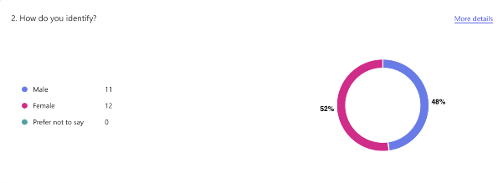
Figure 1: A graphical representation of the gender of the police officers who responded to the questionnaire.

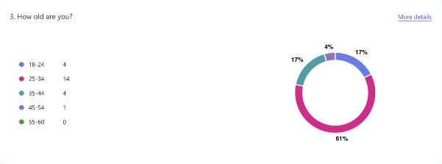Figure 2: A graphical representation of the age group of respondents

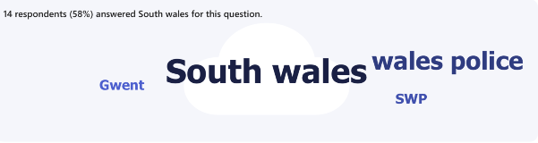Figure 3: A graphical representation of the different police forces represented by respondents

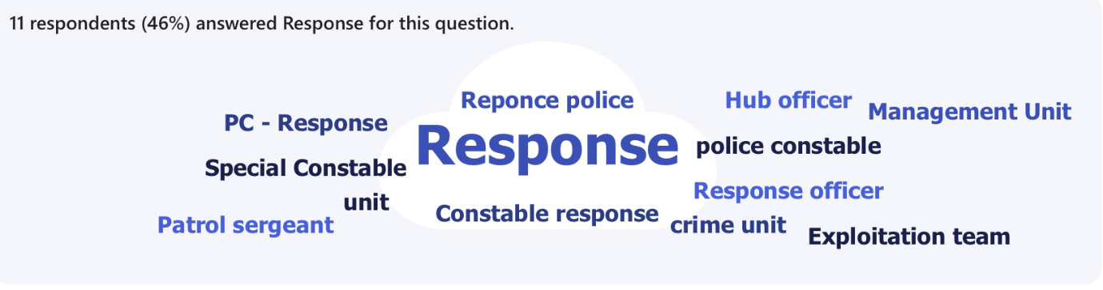Figure 4: A graphical representation of the variety of departments represented by respondents

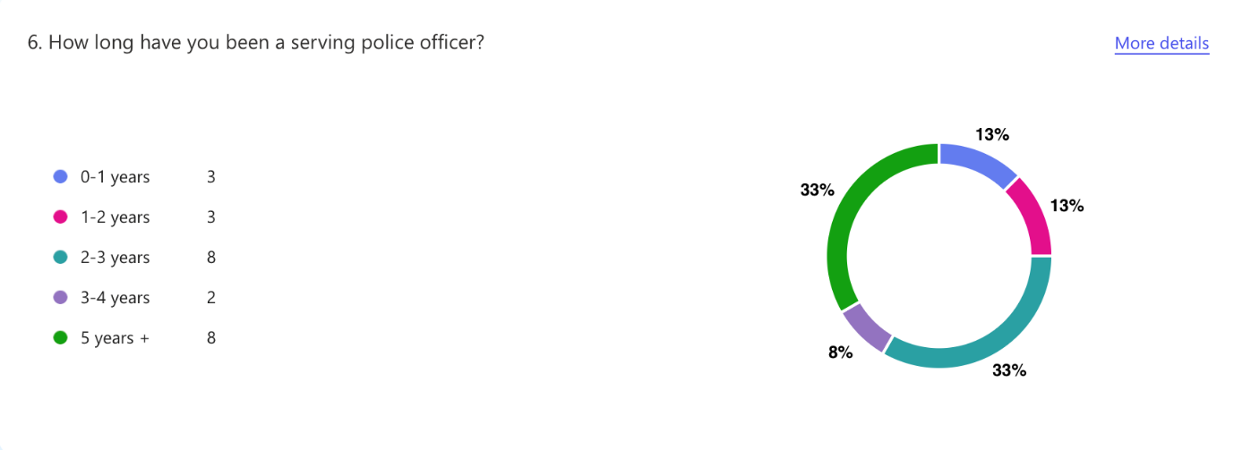Figure 5: A graphical representation of years of service by respondents.

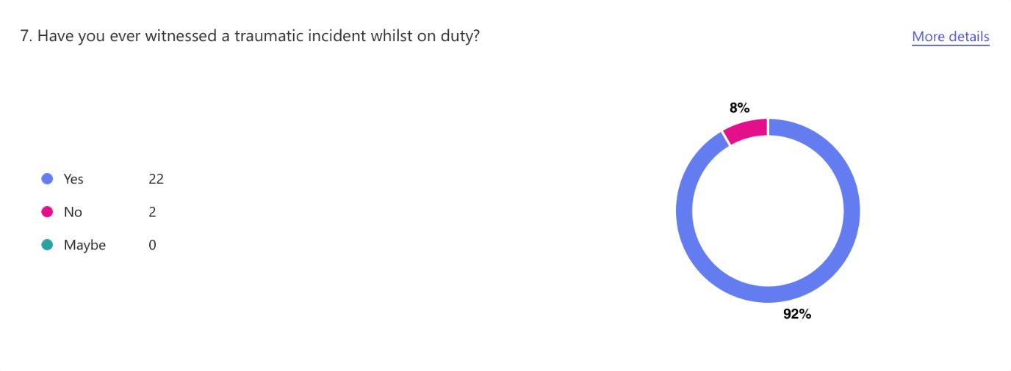
Figure 6: A graphical representation of whether respondents have experienced trauma on duty

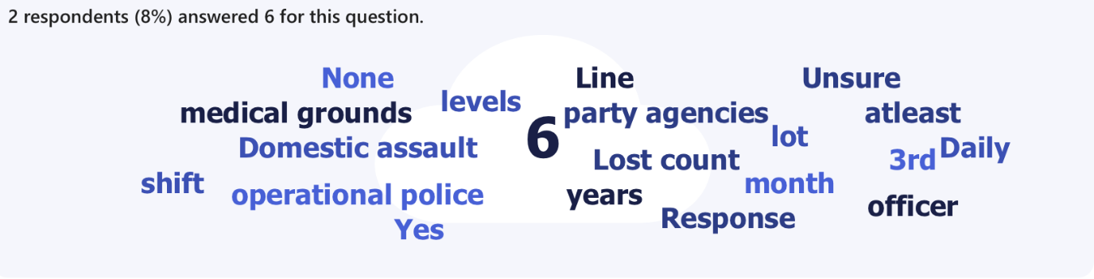
Figure 7: A graphical representation of illustrating the frequency of officers’ exposure to traumatic incidents.

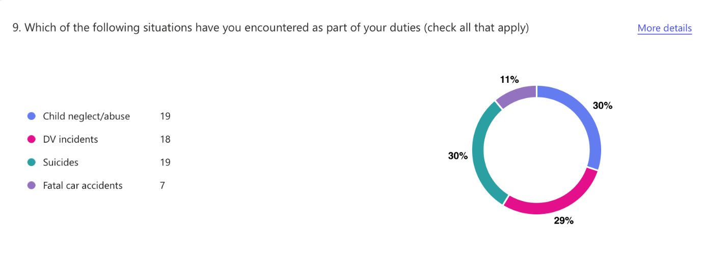Figure 8: A graphical representation depicting the various types of incidents attended by respondents

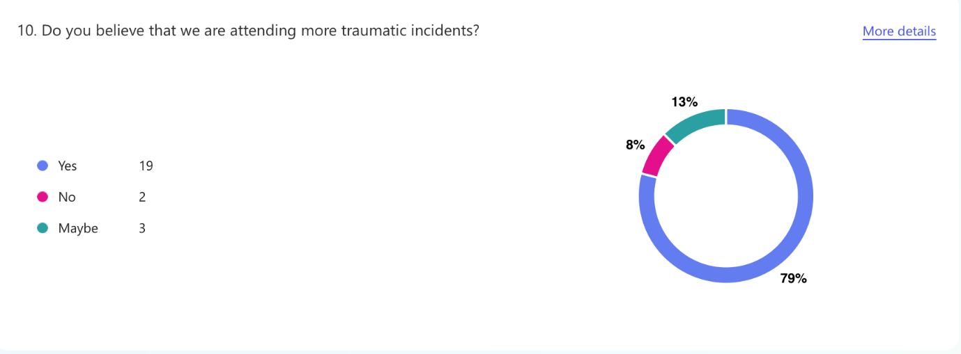
Figure 9: A graphical representation illustrating officers’ perceptions on attending more traumatic incidents

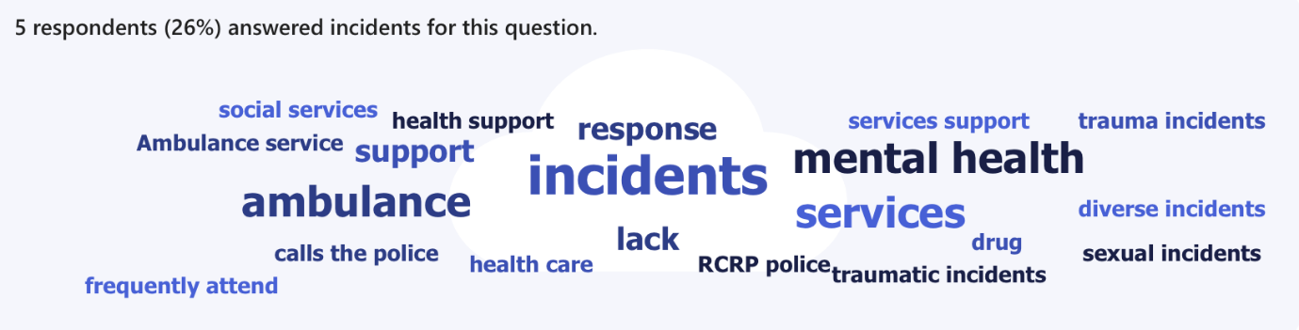
Figure 10: A graphical representation of respondents’ opinions on why they are attending more traumatic incidents.
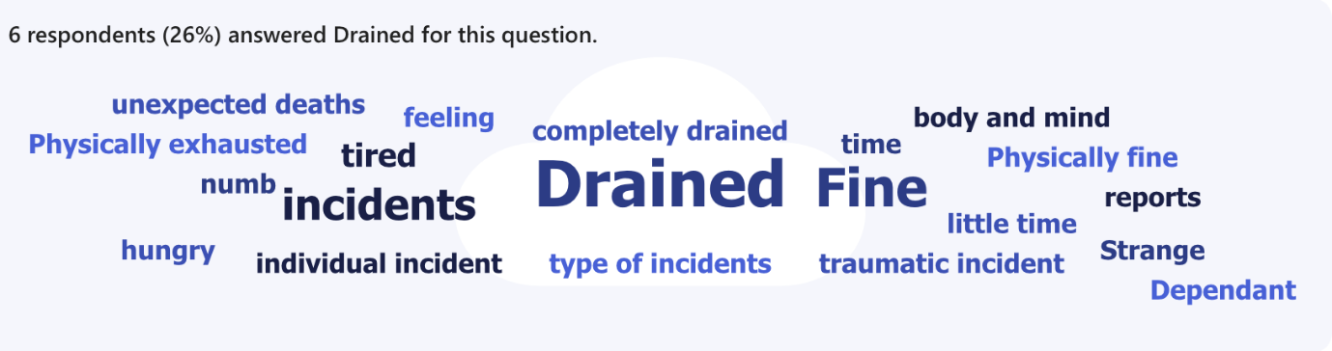Figure 11: A graphical representation of how respondents feel physically after attending a traumatic incident

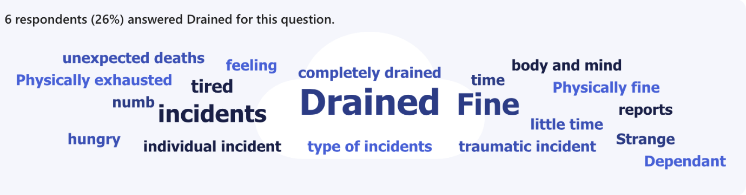Figure 12: A graphical representation of how respondents mentally feel after attending a traumatic incident
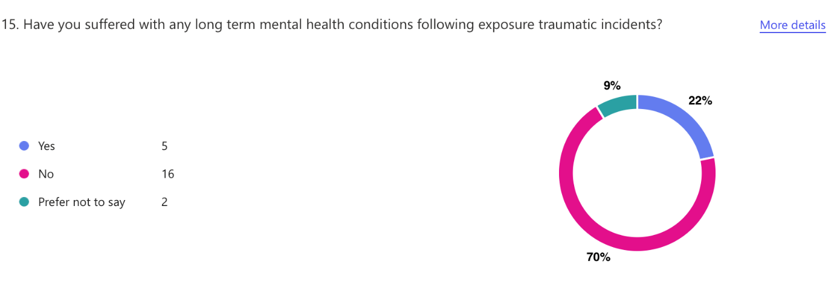Figure 13: A graphical representation illustrating whether respondents experienced long-term mental health effects following a traumatic incident.
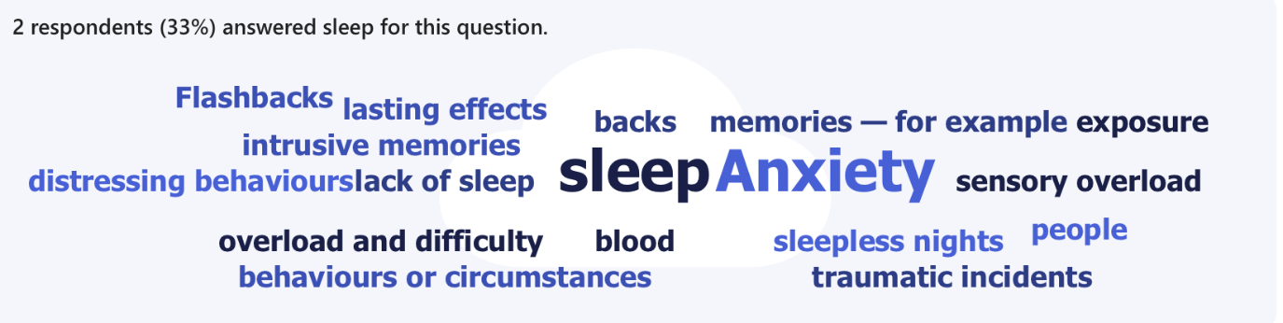
Figure 14: A graphical representation illustrating the symptoms experienced by respondents following traumatic incidents

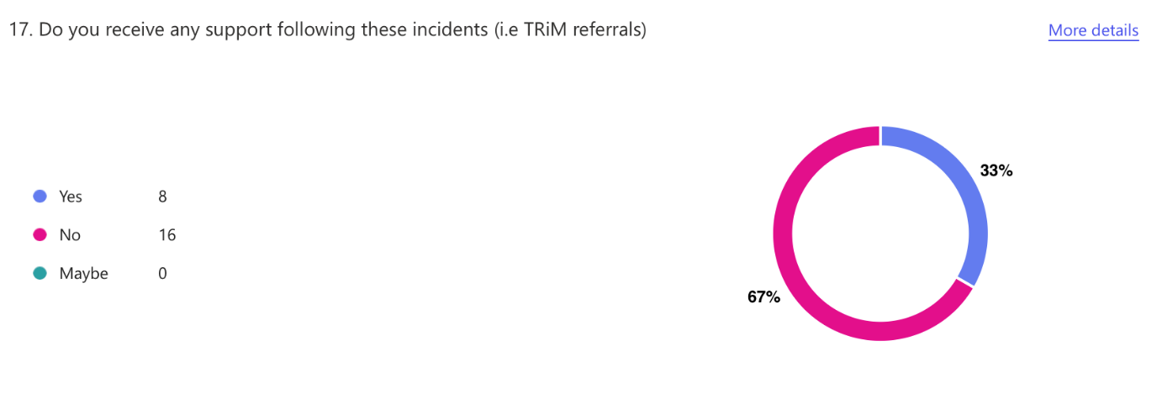Figure 15: A graphical representation showing if respondents received any support following exposure to a traumatic incident

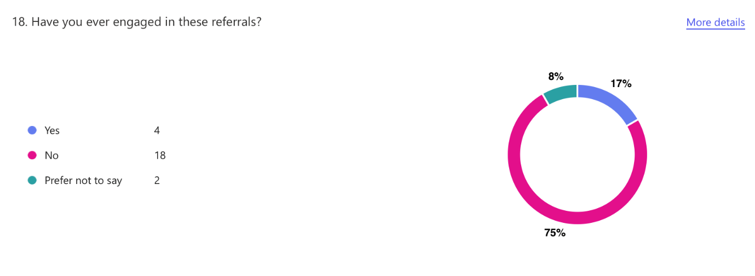Figure 16: A graphical representation illustrating respondents' engagement with available support
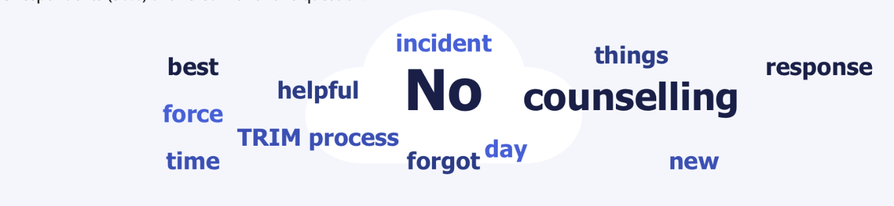Figure 17: A graphical representation of the views expressed by those who engaged with available support.

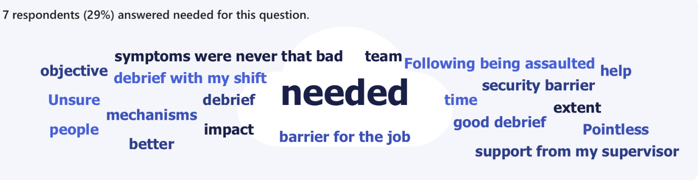Figure 18: A graphical representation of the views expressed by those who haven't engaged with available support

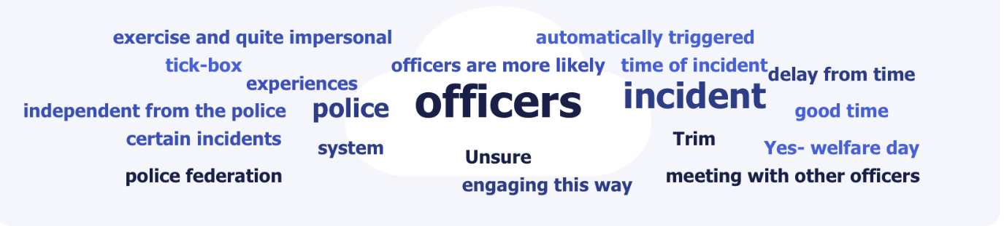Figure 19: A graphical representation of respondents’ views on whether other support should be offered
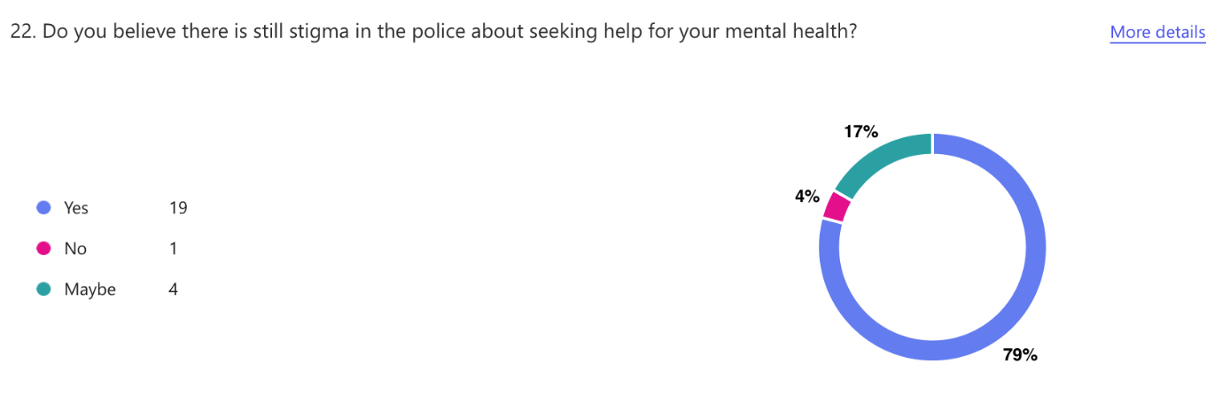Figure 20: A graphical representation of respondent's views on whether there is still stigma surrounding seeking help for mental health in the police

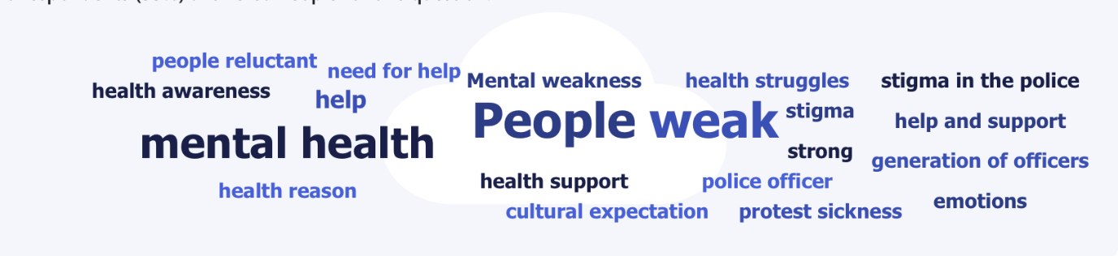Figure 21: A graphical representation of respondent views on why there is still stigma in the police

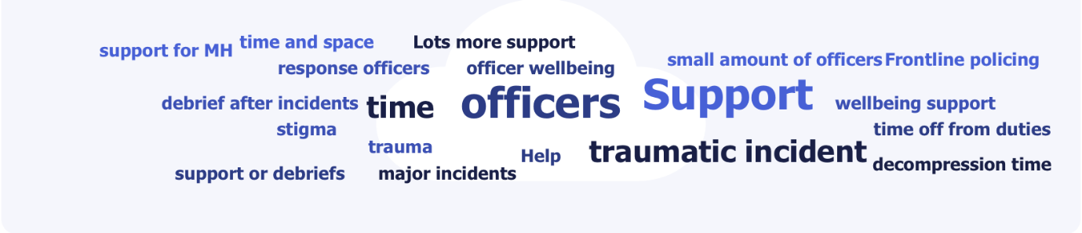Figure 22: A graphical representation of respondents’ views on how police forces can better support officers exposed to trauma.

4.5 Discussion of findings
This section of the chapter is dedicated to discussing responses received from the questionnaire. Of the 23 participants, more females (52%) answered the survey, in comparison to males (48%). Most participants were also between the ages of 25-34 (61%) closely followed by age groups 18-24 & 35-44 (both 17%). Most participants had 2-3years of service and surprisingly 5+ years (both 33%). As a whole, the figures correspond to the trend of increased inexperience within police forces (Police Federation, 2023).
Potentially a downfall in this questionnaire is the lack of responses from respondents and lack of responses from more than two police forces. Most responses came from South Wales Police officers (58%) with Gwent officers following behind (42%). There were no responses from other another force Dyfed Powys. Most responses came from officers on response (46%), positively this questionnaire included responses from 5 other departments including organised crime and the exploitation team. This allows for a variety of perspectives to be included in the findings.
Participants were asked if they have ever attended a traumatic incident, an unsurprising amount (92%) stated that they have which corresponds the trends of around 90-95% police officers nationwide experiencing traumatic incidents (Miller et all, 2021). A significant 76% of respondents reported a rise in the number of traumatic incidents they attend, with several respondents stating that they are attending incidents which they feel unequipped to deal with, placing greater demand on officers and exposing officers to traumatic incidents which would have been best dealt with by other agencies.
Respondents were asked if their long-term mental health was affected following exposure to traumatic incidents, and surprisingly 70% answered no. This statistic is surprising as resent research conduct through other studies shows that the mental health of police officers is declining (Santre, 2024). Concerningly, the respondents that answered that their mental health had been affected noted that they experience flash backs, the inability to sleep and not wanting to engage in social activates, these are all concern signs of PTSD. Despite 70% of respondents stating that they haven't suffered with long –term mental health issues all participants noted that following their attendance at a traumatic incident they feel physically and mentally drained and emotionally disconnected from the rest of their shift, most respondents stated that these symptoms typically last for 2-3 days, with one respondent stating that these feelings never go away and certain triggers will remind you of incidents.
Respondents were asked if they are ever offered support following exposure to a traumatic incident, and worryingly 75% stated that they have never been offered support. Of the 33% who were offered support in the form of TRiM only 17% engaged, with there being mixed review of whether it was beneficial or not, some stated that the counselling was good, however others thought that no amount of talking would compensate for what they saw. One respondent stated that one the day they were meant to have their TRiM session, the force forgot about it however did try to accommodate the following day. Respondents were asked why they didn’t engage with the support offered with most responding that they didn’t feel like their symptoms were bad enough to warrant engaging with services, some respondents stated that they didn’t have the time to engage with TRiM officers and others believed that they had enough support from their supervisors. 41.7% of respondents believed that there should be a support system other than TRiM within the police, most stated that TRiM feels like a tick box exercise and impersonal. Respondents recommended having station champions to speak to in confidence when needed as opposed to waiting for a TRiM referal that may never arrive. Some suggested a mandatory debrief after the incidents and for senior management to appreciate that this is something that is needed.
Respondents were asked if there was still stigma in the police about struggling with their mental health, concerningly 79% stated yes, with most stating that admitting you’re struggling mental health is seen as weak and if an officer was to go on the sick due to struggling with their mental health, senior management teams will look at is as a protest and officers feel as if they will get punished for taking the time off. This corresponds with other studies that have found that there is still stigma within policing due to officers not wanting to be seen as weak (Bell & Eski, nd)

Chapter 5 Findings and Conclusions

5.1 Introduction
The previous chapters of the dissertation have guided the research project through the introductory, research, planning and analysis phases of the research project. The most recent chapter of this project presented the analysis and findings of primary data collected through the quantitative and qualitive survey.
This chapter will provide a conclusion surrounding the research question of; “Break a leg – it’s all in the mind’ How does repeated exposure to trauma impact police officers’ mental health?”, this chapter highlights both the limitations of this project and the avenues for future academic research in this area.

5.2 - Main findings
Throughout the dissertation, multiple findings have been present throughout each section of the process. Firstly, it was clear that attend a significant amount of traumatic, with a large amount of research being readily available on what incidents officers often attend.
There were clear gaps in officers receiving support following exposure to traumatic incidents which was evident in the survey completed by serving police officers and the research found within the literature review chapter. It was evident from both chapters that officers are exposed to trauma as part of their role within the force, with officers discussing the little support offered to them by officers of higher rank.
It was evident from the findings within the literature review that repeated exposure has an impact on the brain's development, namely the amygdala, hippocampus and the prefrontal corte with this further discussing how this will impact a person's mental health in the long term. Results from the survey indicated that officers did struggle with their mental health, however, did not state what.
The questionnaire within this survey proved that officers are constantly exposed to trauma which impacts their mental health and what support was available, this was confirmed by officers that the support they have is little to none, with officers making recommendations on how to support them further.

5.3 - limitations
The biggest limitation within this essay was the lack of research available on how effective TRiM refers are. There were several articles available to explain what a TRiM referral was, however, little statistics to support its effectiveness. This made it difficult to examine if this is the most effective referral currently amongst forces.
The second limitation of this essay was the lack of responses provided within the survey; the hope was that 30 officers would engage from different departments to gather. range of responses. However, only 24 officers did with most respondents being from response officers, this likely impacted the results as there over 145,000 officers in the UK (UK Government, 2025). Granted a response from every serving officer is impossible, however a greater response may have painted a different picture.

5.4 - Further Research
As mentioned above, the biggest limitation to this essay was the little information surrounding the effectiveness of TRiMS, further research alongside the NHS would provide an opportunity to adapt this referral to the needs of officers, following this another survey could be created to compare the effectiveness should the referrals change.

5.5 - Conclusion
This dissertation has highlights and gives attention to the effects that trauma has on an officers’ mental health. Gaps in literature have been identified within this chapter. These gaps could be investigated soon to improve access to support.

Bibliography
AbuHasan, Q; Reddy, V; Siddiqui, W (2023) Neuroanatomy, Amygdala. Available at https://www.ncbi.nlm.nih.gov/books/NBK537102/#:~:text=[4] The circuit has been,food, sex, and drugs. (Accessed on the 26th of April 2025)
Ajmera, R (2023) What is the hippocampus? Available at https://www.medicalnewstoday.com/articles/313295?c=143997475446 (Accessed on the 26th of April 2025)
Arnsten, A, Mazure, C & Sinha, R (2016) Neural circuits responsible for conscious self-control are highly vulnerable to even mild stress. When they shut down, primal impulses go unchecked and mental paralysis sets in. Available at https://pmc.ncbi.nlm.nih.gov/articles/PMC4774859/#:~:text=When things are going well,help you keep your composure. (Accessed on the 26th of April 2025)
Bell, S & Eski, Y (N.D) “Break a Leg – It’s all in the mind”: Police officers’ attitudes towards colleagues with mental health issues. Available at https://core.ac.uk/download/pdf/42478708.pdf#:~:text=Officers seeking counselling or support can be,problems are a marginalised community within policing. (Accessed on the 27th of September 2025)
Bell, S Palmer-Conn, S Kealey, N (ND) ‘Swinging the lead and working the head’ – An explanation as to why mental illness stigma is prevalent in policing. Available at https://journals.sagepub.com/doi/pdf/10.1177/0032258X211049009#:~:text=Karaffa and Tochkov (2013) suggest,prolonging or intensifying the condition. (Accessed on the 28th of September 2025)
Bhandari, P (2022) Descriptive Statistics | Definitions, Types, Examples. Available at https://www.scribbr.co.uk/stats/descriptive-statistics-explained/#:~:text=Your data set is the,variable in numbers or percentages. (Accessed on the 23rd of September 2025)
Bremner, DJ (2022) Traumatic stress: effects on the brain. Available at https://www.tandfonline.com/doi/full/10.31887/DCNS.2006.8.4/jbremner#d1e107 (Accessed on the 26th of April 2025)
Cleveland Clinic (2025) Suicide. Available at https://my.clevelandclinic.org/health/articles/suicide (Accessed on the 28th of April 2025)
Cleveland Clinic (N.D) Hippocampus. Available at https://my.clevelandclinic.org/health/body/hippocampus (Accessed on the 26th of April 2025)
Dealing University (2024) Surveys & questionnaires. Available at https://deakin.libguides.com/qualitative-study-designs/surveys#:~:text=Strengths * Qualitative surveys can help a,an evolving and responsive method of research. (Accessed on the 16th of June 2025)
Denslow, E (2023) Prefrontal Cortex Damage: Understanding the Effects & Methods for Recovery. Available at https://www.flintrehab.com/prefrontal-cortex-damage/ (Accessed on the 26th of April 2025)
El-Baba, R & Schury, M (2023) Neuroanatomy, Frontal Cortex. Available at https://www.ncbi.nlm.nih.gov/books/NBK554483/#:~:text=The prefrontal cortex is known to be,social appropriateness, and other complex cognitive behaviors.&text=Research has proven that the dominant (left),working memory as well as spatial processing. (Accessed on the 26th of April 2025)
Lal, I (2025) Pros and Cons of Quantitative Research – Key Insights. Available at https://heymarvin.com/resources/pros-and-cons-of-quantitative-research/#:~:text=What Are the Major Limitations,t tell the full story. (Accessed on the 16th of June 2025)
Mayo Clic (2018) Anxiety Disorder. Available at https://www.mayoclinic.org/diseases-conditions/anxiety/symptoms-causes/syc-20350961 (Accessed on the 27th of April 2025)
Merriam-Webster (N.D) Trauma. Available at https://www.merriam-webster.com/dictionary/trauma (Accessed on the 26th of April 2025)
Microsoft (2025) Microsoft Forms. Available at https://www.microsoft.com/en-gb/microsoft-365/online-surveys-polls-quizzes (Accessed on the 21st of September 2025)
Miller JK, Brewin CR, Peart A (2025) The development of a UK police traumatic events checklist. Available at https://journals.sagepub.com/doi/10.1177/0032258X211002597#:~:text=and treatment access.-,Introduction,et al., 2020). (Accessed on the 26th of September 2025)
Mind (2025) Coping with what you experience in the police. Available at https://www.mind.org.uk/news-campaigns/campaigns/blue-light-programme/blue-light-information/coping-with-what-you-experience-in-the-police/#:~:text=As a member of the police force, you may develop,contribute to feelings of anxiety. (Accessed on the 27th of April 2025)
National Police Chiefs Council (2024) FREEDOM OF INFORMATION REQUEST REFERENCE NUMBER: 246/2024. Available at https://www.npcc.police.uk/SysSiteAssets/media/downloads/publications/disclosure-logs/workforce-coordination-committee/2024/246-2024-officer--staff-suspected-suicide-statistics.pdf (Accessed on the 28th of April 2025)
NHS (2020) Trauma Risk Management (TRiM) Policy. Available at https://www.bsmhft.nhs.uk/wp-content/uploads/2023/09/Final-Version-TRiM-Policy-BSMHFT-1-1.pdf (Accessed on the 29th of April 2025)
NHS (2022) Causes - Post-traumatic stress disorder. Available at https://www.nhs.uk/mental-health/conditions/post-traumatic-stress-disorder-ptsd/causes/ (Accessed on the 27th of April 2025)
NHS (N.D) Supporting staff through trauma risk management. Available at https://www.england.nhs.uk/nursingmidwifery/shared-governance-through-collective-leadership/nursing-covid-19-catalogue-of-change/supporting-staff-through-trauma-risk-management/#:~:text=Learning and advice to be shared&text=The service is modelled on,mental heath following traumatic experiences. (Accessed on the 1st of May 2025)
NHS Inclusion (2025) Stepped Care Model. Available at https://inclusionthurrock.org/stepped-care-model/#:~:text=Stepped Care is a model of providing,up' to intensive/specialist services if clinically required. (Accessed on the 1st of May 2025)
Oxford Brooks University (2025) Descriptive Statistics. Available at https://www.brookes.ac.uk/students/academic-development/maths-and-stats/statistics/descriptive-statistics#:~:text=The term descriptive statistics refers,values and measures of spread. (Accessed on the 23rd of September 2025)
Papyrus (2025) THE IMPACT OF TRAUMATIC EVENTS ON SUICIDE RISK. Available at https://www.papyrus-uk.org/trauma-and-suicide/ (Accessed on the 28th of April 2025)
Police Care UK (2025) Post Traumatic Stress Disorder (PTSD/CPTSD). Available at https://www.policecare.org.uk/help/ptsd/#:~:text=In addition to usual life,to be experienced by civilians. (Accessed on the 25th of April 2025)
Police Federation (2019) STEP Campaign: The Impact Of Trauma On Officers. Available at https://www.polfed.org/hants/step/step-campaign-the-impact-of-trauma-on-officers/ (Accessed on the 30th of April 2025)
Police Federation (2023) 'A “significant proportion” of police officers in the force are inexperienced, which makes it difficult to deal with increasing demand’ Available at https://www.polfed.org/gloucs/news/latest-news/a-significant-proportion-of-police-officers-in-the-force-are-inexperienced-which-makes-it-difficult-to-deal-with-increasing-demand/ (Accessed on the 24th of September 2025)
Police Federation (2024) Record 14,508 officers signed off with poor mental health in past year. Available at https://www.polfed.org/news/latest-news/2024/record-14-508-officers-signed-off-with-poor-mental-health-in-past-year/#:~:text=Share,(up 343 per cent). (Accessed on the 25th of April 2025)
Qualtrics (2025) What is a survey? (Benefits, tips, best practices & free survey tool). Available at https://www.qualtrics.com/experience-management/research/survey-basics/#:~:text=Surveys can take many forms,understanding populations as a whole. (Accessed on the 16th of June 2025)
Roberton, J (2025) Exclusive: At least 100 police suicides in three years, investigation uncovers. Available at https://www.channel4.com/news/exclusive-at-least-100-police-suicides-in-three-years-investigation-uncovers (Accessed on the 28th of September 2025)
Rothbaum, B & Rauch, S (2020) PTSD: What Everyone Needs to Know. P14 Available at https://books.google.co.uk/books?hl=en&lr=&id=fsnhDwAAQBAJ&oi=fnd&pg=PP1&dq=what+happens+when+you+have+PTSD&ots=hnmhh0HHo8&sig=kJf8rS_2fZdT787WJWGKt7T1jsg&redir_esc=y#v=onepage&q&f=false (Accessed on the 27th of April 2025)
SAMHSA (2014) Chapter 3 Understanding the Impact of Trauma. Available at https://www.ncbi.nlm.nih.gov/books/NBK207191/ (Accessed on the 27th of April 2025)
SAMHSA (2014) Trauma-informed care in behaviour health services. Available at https://www.ncbi.nlm.nih.gov/books/NBK207191/ (Accessed on the 26th of April 2025)
Santee, S (2024) Mental Disorders and Mental Health Promotion in Police Officers. Available at https://pmc.ncbi.nlm.nih.gov/articles/PMC10875161/ (Accessed on the 26th of April 2025)
Santre, S (2024) Mental Disorders and Mental Health Promotion in Police Officers. Available at https://pmc.ncbi.nlm.nih.gov/articles/PMC10875161/ (Accessed on the 27th of September 2025)
Starling Minds (2021) Stepped Care: The Future Healthcare Model of Mental Health. Available at https://www.starlingminds.com/stepped-care-the-future-healthcare-model-of-mental-health/#:~:text=The advantage of the stepped care model,efficiency of support by optimizing resource allocation. (Accessed on the 1st of May 2025)
Stuart, H (2008) Suicidality among police. Available at https://pubmed.ncbi.nlm.nih.gov/18650696/ (Accessed on the 28th of April 2025)
SurveyMonkey (N.D) Qualitative vs. quantitative research: differences, examples and when to use each method. Available at https://uk.surveymonkey.com/mp/quantitative-vs-qualitative-research/ (Accessed on the 16th of June 2025)
Tenny, S, Brannan, J & Brannan, G (2022) Qualitative Study. Available at https://www.ncbi.nlm.nih.gov/books/NBK470395/#:~:text=Qualitative research, at its core,not meant to be quantified. (Accessed on the 16th of June 2025)
Thames Valley Police (2025) The role of a police officer. Available at https://tvpcareers.co.uk/roles/police-officer/# (Accessed on the 25th of April 2025)
The Government (N.D) Trauma Risk Management - TRiM. Available at https://assets.publishing.service.gov.uk/media/5a79e5f4e5274a18ba50f9cf/0392-12attachment2of2.pdf (Accessed on the 29th of April 2025)
The Mulberry Bush (2025) The Impact of Trauma on the Brain. Available at https://mulberrybush.org.uk/the-impact-of-trauma-on-the-brain/#:~:text=The disruption of key brain,healthier individuals and stronger communities. (Accessed on the 28th of September 2025)
UK Government (2025) Police workforce, England and Wales: 30 September 2024. Available at https://www.gov.uk/government/statistics/police-workforce-england-and-wales-30-september-2024/police-workforce-england-and-wales-30-september-2024 (Accessed on the 1st of October 2025)
University of Cambridge & Police Care UK (2018) The Policing: The Job & The Life Survey (2018). Available at https://www.cam.ac.uk/files/inner-images/thejobthelife_findings.pdf (Accessed on the 27th of April 2025)
University of Northern Colorado (2022) Neurobiology of Trauma. Available at https://www.unco.edu/assault-survivors-advocacy-program/learn_more/neurobiology_of_trauma.aspx (Accessed on the 26th of April 2025)
Van der Velden PG, Kleber RJ, Grievink L, et al. (2010) Confrontations with aggression and mental health problems in police officers: the role of organizational stressors, life-events and previous mental health problems. Available at Psychological Trauma: Theory, Research, Practice, and Policy 2(2): 135–144. (Accessed on the 29th of April 2025)
Vypr (2025) The Pros and Cons of Qualitative and Quantitative Research. Available at https://vyprclients.com/pros-and-cons-of-qualitative-and-quantitative-research/#:~:text=non-numerical data.-,Cons of Qualitative Research,topics they're uncomfortable with. (Accessed on the 16th of June 2025)
Walsh, G (2025) Qualitative vs. quantitative research: Everything you need to know. Available at https://www.gwi.com/blog/qualitative-vs-quantitative (Accessed on the 16th of June 2025)
Wang, S & Feng M Et al (2023) Psychological trauma, posttraumatic stress disorder and trauma-related depression: A mini-review. Available at https://pmc.ncbi.nlm.nih.gov/articles/PMC10294137/#:~:text=Traumatic events increase not only,related depression, and their therapies. (Accessed on the 27th of April 2025)
Watson L, Andrews L (2018) The effect of a Trauma Risk Management (TRiM) program on stigma and barriers to help-seeking in the police. Available at International Journal of Stress Management 25(4): 348 (Accessed on the 29th of April 2025)
West Yorkshire Police (2024) Freedom of Information. Available at https://www.westyorkshire.police.uk/freedom-of-information/october-2024-foi-2250230-24-officer-mental-health-and-ptsd (Accessed on the 25th of April 2025)
World Health Organisation (2024) Post-traumatic stress disorder. Available at https://www.who.int/news-room/fact-sheets/detail/post-traumatic-stress-disorder (Accessed on the 26th of April 2025)
World Health Organisation (2025) Depression. Available at https://www.who.int/health-topics/depression#tab=tab_1 (Accessed on the 27th of April 2025)

Abstract

Distributed survery
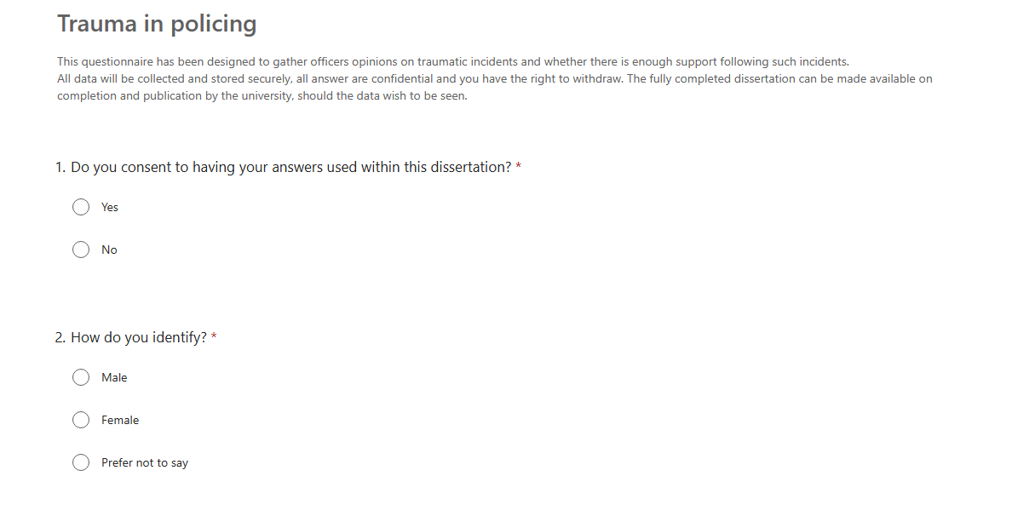
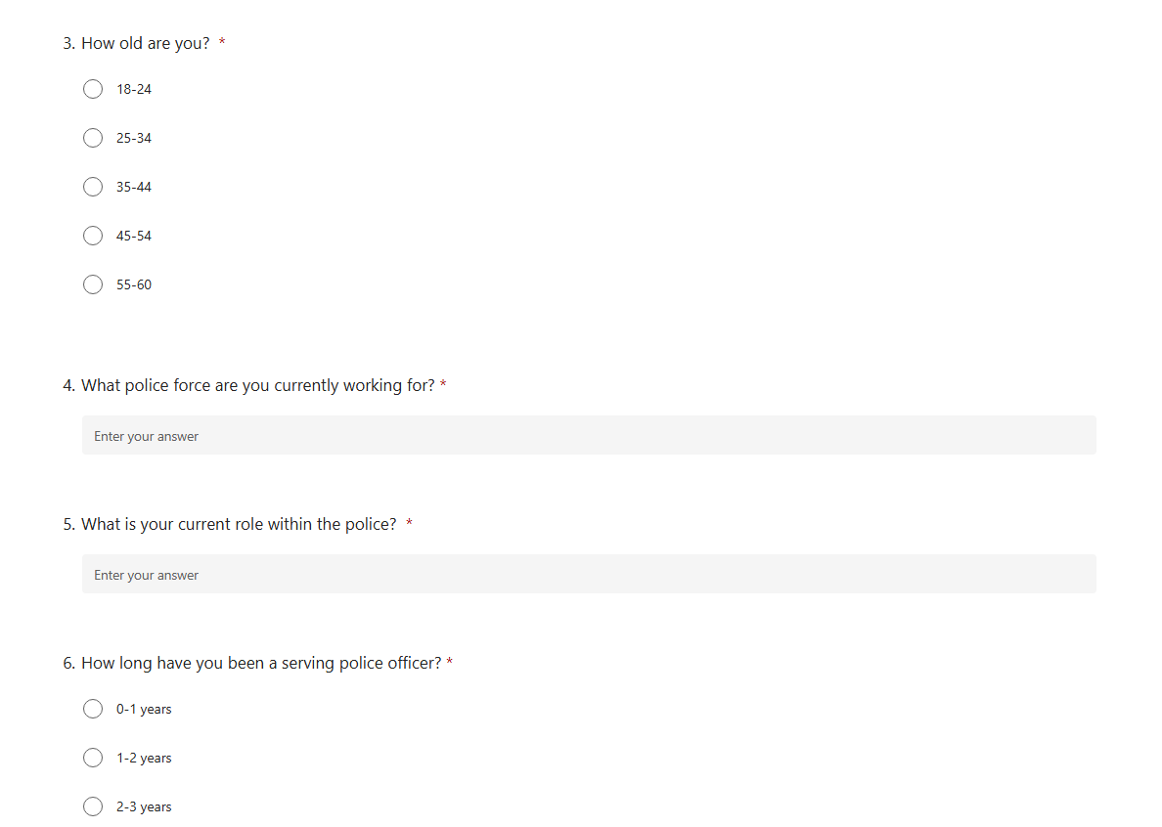
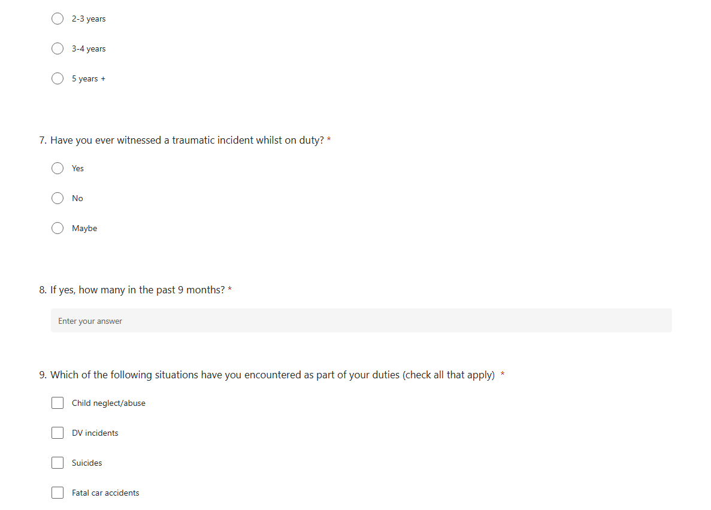
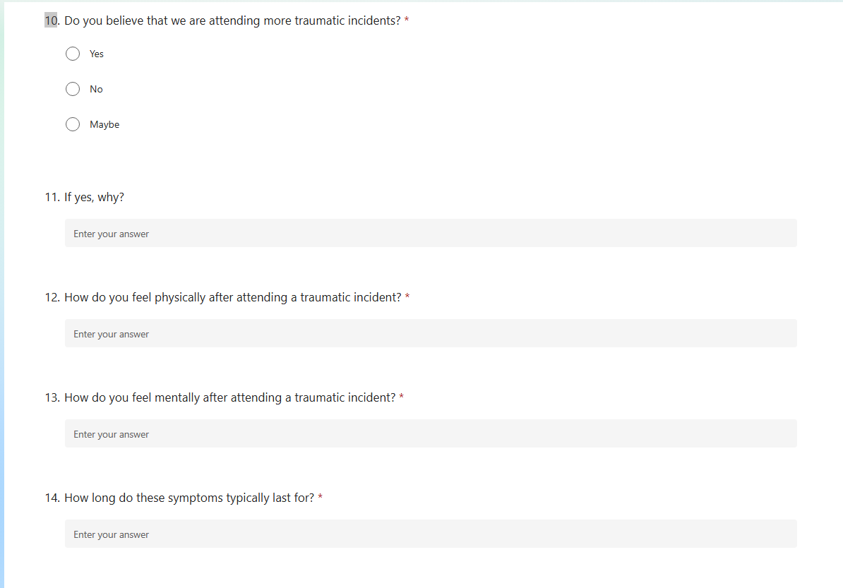
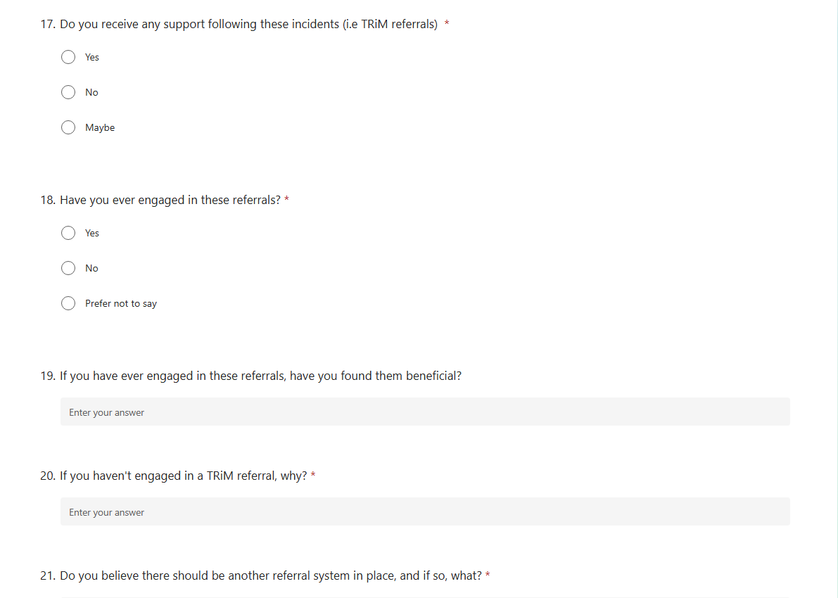
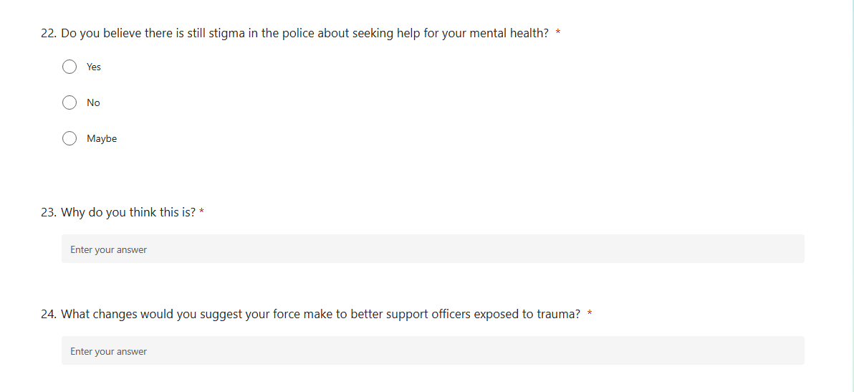

Ethics form


