Name: Jaskaran singh
Student id: 2221903
Module code: (LCBB4006)
Module name: Academic Skills
Lecturer: Dr.

Table of Contents
Introduction 3
Discussion 3
Effective Communication skill 4
Empathy 5
Understanding Different Personalities and Working Styles 5
Time Management 6
Prioritization 7
Organization 8
Conclusion 8
Reference List 10

Introduction
This paper introduces the details of the overview of the people and the task management development skill discussed by Cottrell(2019). It is mentioned that developing the mentioned skills is very important as well as essential to achieving the rate of success in a personal and corporate career. The author writes that the ability to effectively communicate, organize one’s time, and set priorities is essential to handling both employers and individuals.
Cottrell recommends focusing on one’s communication skills, empathy, and knowledge of individual differences in order to improve one’s people management abilities. The three pillars of effective communication are attentive listening, precise expression, and objective criticism. Good relationships and output may result from members of the team being empathic towards one another, knowing one another’s needs and limits, and working in a supportive setting. In addition, Cottrell suggests using time management techniques like prioritization, task analysis, and goal planning to accomplish one’s objectives and stay productive. The author also stresses the value of pauses and the need to prevent burnout. The ability to delegate work and monitor progress depends on the user’s level of organization and familiarity with the project’s parameters. Moreover, this paper also aims to share the improving one’s capacity to manage both individuals as well as tasks based on Cottrell’s article. Success in one’s personal and professional life may be achieved via the use of these methods of time and resource control.

Discussion
Managing people, as well as projects, effectively is a talent that will serve users well in user’s personal and professional endeavors. Better interpersonal connections, higher output, and less anxiety may all result from efficient management of both people and tasks. Cottrell (2019) outlines a number of methods for improving areas such as communication, empathy, personality as well as work style awareness, time management, priority setting, and general organization in their study paper.

Effective Communication skill
Once it comes to managing people and projects, nothing is more important than good communication. Active listening, clearly articulating objectives and expectations, and offering constructive criticism are just a few of the methods for improving communication skills that Cottrell (2019) discusses in her study article. In order to reply effectively to what other people are saying, it is important to pay careful attention to the things they’re saying. This is crucial for establishing rapport and attending to the concerns of team members. Expressing oneself effectively and giving explicit instructions or feedback is necessary for effective goal and expectation articulation (Alvarenga et al. 2019). This reduces the potential for error and boosts efficiency. For feedback to be considered constructive, it must be timely, detailed, as well as actionable. In turn, this aids team members in performing better and accomplishing more. Better interpersonal connections, output, as well as stress tolerance are all possible outcomes of a life spent honing one’s communication abilities.
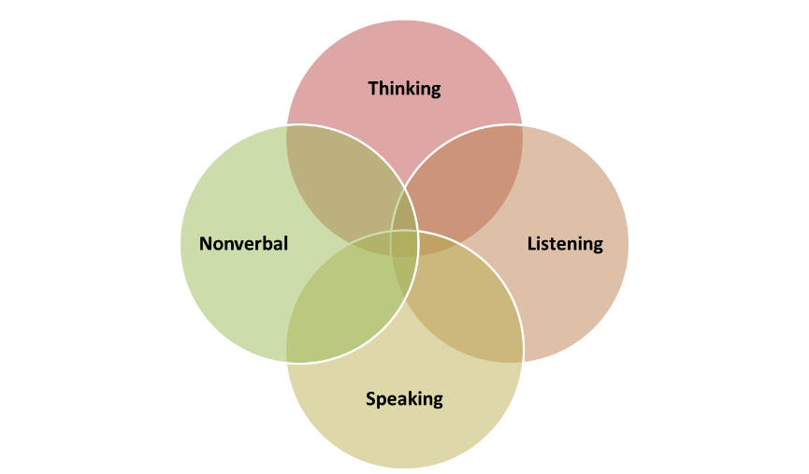
Figure1: Effective communication skill key
(Source: Research gate, 2021)

Empathy
Having empathy for others is essential for managing projects and people efficiently. Cottrell (2019) proposes a number of methods for improving one’s capacity for empathy, including as being aware of one’s personality and others’ weaknesses as well as strengths, empathizing with others, including cultivating an encouraging workplace. One’s own strengths and shortcomings, as well as those of one’s team members, may be better understood and accommodated upon the realization of these constraints (Sergey, Boris and Nadiia, 2020). Understanding how somebody could be feeling and expressing genuine care for their happiness is being sensitive to their thoughts and feelings. This contributes to establishing a trusting and cooperative atmosphere in the workplace. The capacity to manage people and tasks is enhanced by cultivating empathy, which in turn benefits interpersonal relationships, and output, including stress levels.

Understanding Different Personalities and Working Styles
Management of people as well as projects requires an appreciation for the variety of human nature and work methods. Cottrell (2019) outlines a number of methods for honing this ability in her scholarly article, such as learning to appreciate as well as accommodate differences in others, encouraging a welcoming and diverse workplace, and embracing new perspectives. Each member of a team has their own set of skills, interests, and quirks, and it’s important to recognize these variances. Adjusting one’s style of management to accommodate the demands of each team member is an important part of adapting to varied personalities as well as working styles. The result is stronger bonds and more efficient work. Creating a welcoming atmosphere that recognizes as well as appreciates individuality is an important step in fostering a diverse and inclusive culture (Maganoet al. 2020). A more energized and effective team may be built in this way. One’s capacity to manage people and tasks, as well as interpersonal connections, may benefit by learning about and adapting to a variety of work styles as well as personality types.
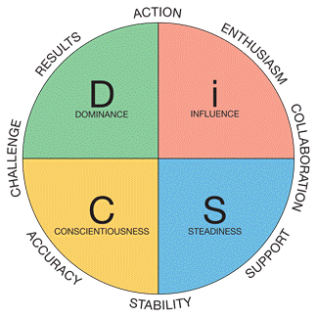
Figure2: Understanding Different Personalities and Working Styles
(Source: Research gate, 2019)

Time Management
Effective management of both people and projects requires a mastery of time management. Strategic planning, minimizing distractions, as well as avoiding procrastination are just a few of the time management tactics suggested by Cottrell (2019) in her study report. Prioritization is the process of deciding which activities are most essential and devoting time to them. This ensures that the most important jobs are done on time, while the less crucial ones don’t hog too much of anyone’s attention. Minimizing interruptions and maintaining concentration are key to distraction management. This aids in enhancing focus and output. If users want to avoid procrastinating, start working on users projects right away and divide them up into smaller, relatively manageable parts. Feelings of being overwhelmed are lessened, and a sense of accomplishment is fostered. The other’s professional and interpersonal connections, as well as one’s productivity level and stress tolerance, may all benefit from the cultivation of time management skills.

Prioritization
Managing both individuals as well as duties efficiently requires the ability to set priorities. Setting clear objectives and deadlines, recognizing urgent and critical activities, and delegating work are just a few of the methods for learning to prioritize that Cottrell (2019) discusses in her study article. Defining what has to be done and by when may be seen as the first step in setting objectives. This helps in setting priorities and making time commitments. The first step in prioritizing users’ work is figuring out what has to be done right now and what can wait. This aids in making sure that critical chores are done on time and that less essential ones don’t eat up a great deal of their time (Adams and Blair, 2019). When users delegate work, then provide it to a team member who is most suited to do it. In addition to fostering collaboration, this also frees up valuable resources.
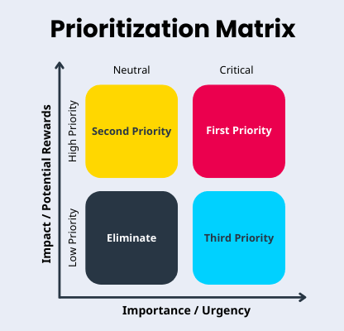
Figure3: Prioritization
(Source: Research gate, 2020)

Organization
Effective management of both people and projects requires the ability to organize and direct resources efficiently. Cottrell (2019) recommends numerous methods for improving time as well as task management abilities, including the use of to-do lists, organizing software, and a tidy work area. Making a to-do list entails writing down everything that needs doing, ranking it in order of importance, and crossing off items as they are finished. The user won’t miss any deadlines or misplace any paperwork if the user uses this method (Cerezo-Narváez et al. 2019). Software and apps like calendars, software for managing projects, as well as email filters, are all examples of technological industry tool use that may help with organization. This aids with work management, deadline monitoring, and minimizing interruptions. Keeping a clutter-free workstation requires a commitment to order as well as cleanliness. As a result, stress levels drop while output rises.

Conclusion
This paper concluded the details of the reasons why it’s important to learn how to effectively manage both people and projects in order to succeed in life. Cottrell’s (2019) study article highlights the need for a number of essential methods, including clear communication, compassion, awareness of diverse personality types as well as work styles, time management, prioritizing, and organization. Individuals may improve their relationships, efficiency, as well as stress levels by using these methods to enhance their people as well as task management skills. Keep in mind that mastering these abilities is a process that might include trial and error. Yet with fortitude and dedication to betterment, people as well as task management abilities may be continually developed and refined, leading to greater achievement in all aspects of life.

Reference List
Adams, R.V. and Blair, E., 2019. Impact of time management behaviors on undergraduate engineering students’ performance. Sage Open, 9(1), p.2158244018824506. https://journals.sagepub.com/doi/pdf/10.1177/2158244018824506
Alvarenga, J.C., Branco, R.R., Guedes, A.L.A., Soares, C.A.P. and e Silva, W.D.S., 2019. The project manager core competencies to project success. International Journal of Managing Projects in Business. https://www.emerald.com/insight/content/doi/10.1108/IJMPB-12-2018-0274
Cerezo-Narváez, A., de los Ríos Carmenado, I., Pastor-Fernández, A.,Yagüe Blanco, J.L. and Otero-Mateo, M., 2019. Project management competences by teaching and research staff for the sustained success of engineering education. Education Sciences, 9(1), p.44. https://www.mdpi.com/416646
Cottrell, S., 2019. The study skills handbook. Bloomsbury Publishing. https://books.google.co.in/books?hl=en&lr=&id=RR1HEAAAQBAJ&oi=fnd&pg=PP1&dq=Cottrell,+S.+(2019)+The+Study+Skills+Handbook,+5th+Ed.+London:+Red+Globe+Press.&ots=3tXNB9jPRD&sig=LCOv1ctCGp0cm3L-RCCXdJqfX7A
Magano, J., Silva, C., Figueiredo, C., Vitória, A., Nogueira, T. and PimentaDinis, M.A., 2020. Generation Z: Fitting project management soft skills competencies—A mixed-method approach. Education sciences, 10(7), p.187. https://www.mdpi.com/774606
Sergey, B., Boris, K. and Nadiia, R., 2020. Modeling of empathy, emotional intelligence and transformational leadership to the project success. In Mathematical Modeling and Simulation of Systems: Selected Papers of 14th International Scientific-Practical Conference, MODS, 2019 June 24-26, Chernihiv, Ukraine (pp. 209-222). Springer International Publishing. https://link.springer.com/chapter/10.1007/978-3-030-25741-5_21

