Advancing Business Intelligence in the Health Sector: Insights from Agile Methodologies and Data Science

Name: Marius Boldeanu
Student ID: 2224837
Module code and title: LCBB5000, Data Handling and Business Intelligence
Lecturer’s name: Dr Zahra Mohammadnazari

Table of Contents
Introduction 3
Trends and Applications of Business Intelligence in the Healthcare Sector 3
Big data analytics 4
Implementation of Agile BI Delivery Framework 4
Value Chain 5
Analytic tools employed 5
Future prospects 6
Conclusion 6
References 8

Introduction
Business Intelligence has dramatically changed in the past years. More specifically, the new wave is that of big data(Eidizadeh, Salehzadeh and Chitsaz Esfahani, 2017). This new paradigm is one combining data science and fast analytics with agile methodologies to create disruptions in industries using data. This brings great volumes of potential opportunities to healthcare's vast and varied sets of data. The present report casts insight into current trends in Business Intelligence within the healthcare setting, using current exemplary frameworks such as the Information Value Chain and Agile BI Delivery Framework to portray ways in which big data is being harnessed to have an eventual positive effect on patient outcomes, drive operational efficiency, and inform key strategic decisions. The frameworks used are drawn from the literature of Larson and Chang (2016).

Trends and Applications of Business Intelligence in the Healthcare Sector
Business intelligence has grown to be one of the most crucial roles of an organization in various sectors, helping businesses enable with data-driven actions. Big data discovery had massive influences on BI by enhancing its functionalities through the deployment of advanced analytics, machine learning, and real-time data processing. This paper picks up the existing trends in BI, orienting around the Agile BI Delivery Framework and the Information Value Chain, and elaborates these concepts by picking examples from the health sector.
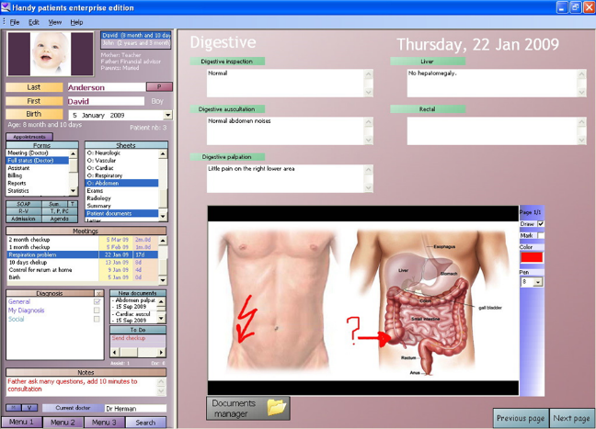
Figure 1: Healthcare business intelligence applications (EHR)(AdmiralKhairul, 2022)

Big data analytics
The most prominent trend which exists within BI is adoption of big data analytics. The volume and variety of data produced today are huge, while the velocity is flash fast, demanding highly specialized tools and methodologies to process efficiently for extracting information. Organizations tap into big data to gain actionable insights that benefit operational efficiencies and strengthen the decision-making processes (Puklavec, Oliveira and Popovič, 2018). For example, big data analytics has changed the face of healthcare with early diagnoses and personalized treatment plans. Acording to statistics, In the UK 87% of healthcare providers use EHR, 69% use electronic prescribing, and 62% offer online appointment booking. Such information extracted from EHRs can be used to identify trends and to predict the onset of diseases in order to provide timely interventions for better patient outcomes. (Larson and Chang, 2016).
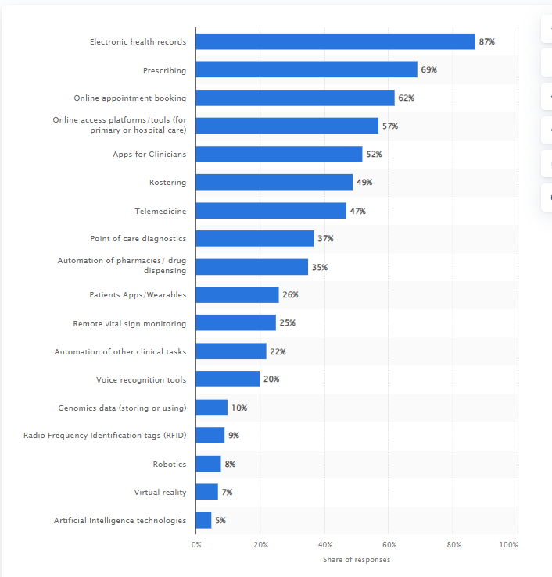
Fig 2. Technology adoption in UK healthcare system (Statista, 2021)

Implementation of Agile BI Delivery Framework
The other important trend in BI involves the use of an Agile BI Delivery Framework. Agile methodologies, adapted from software development, bring flexibility, collaboration, and the speed of delivery into BI projects. Emphasizing iterative development, stakeholder collaboration, and adaptive planning, the Agile BI Delivery Framework supports the continuous improvement of BI solutions to remain relevant with a constantly changing business environment (Larson and Chang, 2016). It is also applicable to very natural places like healthcare, where priorities or needs related to data might drastically change in a matter of minutes. For instance, in the case of a healthcare crisis, say a pandemic, Agile BI may turn new data sources in time for the practitioners and policymakers to make real-time decisions.
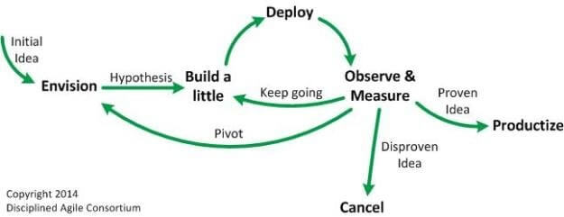
Figure 3: A Guide to Agile Business Intelligence & Data Analytics (Durcevic, 2023)

Value Chain
The Information Value Chain describes another key concept of BI. It refers to turning simple data into information and then into actionable insights. At the same time, this value chain includes the following four stages: collecting data, integration, analysis of data, and delivery of information. Data collection is the very foundation of the value chain, hence requiring robust systems for gathering information that is accurate and comprehensive from diverse sources (Eidizadeh, Salehzadeh and Chitsaz Esfahani, 2017). This may involve data collection from EHRs, wearable devices, and patient surveys in a healthcare setting. Afterwards, the different data sets are combined into a unified format that allows for comprehensive analysis through a data integration process. These meaningful insights are arrived at through the aid of advanced analytical tools and then presented to the stakeholders in the form of intuitive dashboards and reports. Healthcare organizations have a number of tools and platforms that enable them to manage and analyse big data efficiently. Electronic Health Records have been the centralized system for managing patient data that integrates and analyses clinical data. Data warehousing tools such as Amazon Redshift and Google BigQuery offer storing data from different sources in one place for an overall analysis and reporting. These similarly applied tools to business intelligence, specifically Tableau, Qlik, and Power BI, allow for data visualization and reporting, allowing healthcare providers to interpret the complex data and get actionable insights (Ramanathan, Bentley and Pang, 2016).

Analytic tools employed
SAS, SPSS, and R are some of the predictive analytics tools that allow for advanced statistical analysis and machine learning applications. Such a tool in the hands of a healthcare organization can generate predictive models capable of predicting patient outcomes, resource requirements, even risks. For example, machine learning algorithms applied to large genomic data can detect genetic markers associated with a particular disease, after which therapies can be targeted and more effective. Moreover, predictive analytics is integrated with Artificial Intelligence and Machine Learning platforms, such as the IBM Watson Health and TensorFlow, thus making its capabilities get activated by mechanising data processing and depicting much deeper insights (Yang and Forney, 2016).

Future prospects
Future prospects Big data analytics in BI manifests views that are bright and beguiling, where several emerging trends are bound to change the way things have been working until now in this sector. Further development in AI and ML technologies will propel the growth in predictive analytics through increasingly more accurate and timely insight. For example, artificial intelligence algorithms can decipher complex data, such as genomic information, for genetic markers that might be related to specific diseases and lead to personalized treatment plans. Moreover, the integration of AI with clinical decision support systems will help healthcare providers in their decision-making process, which will reduce the chances of error and enhance patient outcomes (Eidizadeh, Salehzadeh and Chitsaz Esfahani, 2017). The other significant focus area would belong to interoperability in BI in the time to come. Improved the standards in data interoperability would help different systems share data with each other seamlessly and attain a better overview about organizational operations. For health care, it means more coordinated care because of the presence of complete patient records at all points of care. This means that patients will benefit from more consistency and understanding where care is concerned; therefore, medical errors will be reduced, with a corresponding increase in overall health outcomes (Puklavec, Oliveira and Popovič, 2018, p. 212). Security and privacy are significant concerns in a world of big data, more so in sectors that deal with sensitive information (Zhao and Zhang, 2016). With an increase in data breach incidents, it is only right that organizations do whatever is within their capacities to help protect sensitive information. To this end, there is an imperative need to adopt robust encryption protocols, secure data storage solutions, and continuous monitoring systems in order to guard against data breaches. Compliance with regulatory standards, in this case, healthcare's HIPAA standard, is also going to be very vital to retaining patient trust but avoiding litigation risks as well (Larson and Chang, 2016).

Conclusion
Business Intelligence has its statement made in various industries in giving better decision making and operational efficiency and strategizing. Application of frameworks such as Agile BI Delivery Framework and Information Value Chain ensures effectiveness in management and utilization of data. With fast-changing technology, health will be among the sectors to mainly hang on sophisticated data analytics to drive innovation and raise service delivery in the future. The enablers for change will include AI and ML integration, improvement in interoperability of data, patient-centeredness in care, and tighter security measures on all organizations dishing out quality, cost-effective services.

References
AdmiralKhairul .2022. Healthcare business intelligence applications. https://within3.com/blog/healthcare-business-intelligence.
Durcevic, S. 2023. Your guide to agile business intelligence & data analytics. https://www.datapine.com/blog/agile-business-intelligence-analytics/.
Eidizadeh, R., Salehzadeh, R., and Chitsaz Esfahani, A. 2017. Analysing the role of business intelligence, knowledge sharing and organisational innovation on gaining competitive advantage. Journal of Workplace Learning, 29(4), 250-267.
Larson, D., and Chang, V. 2016. A review and future direction of agile, business intelligence, analytics, and data science. International Journal of Information Management, 36(5), 700-710.
Puklavec, B., Oliveira, T., and Popovič, A. 2018. Understanding the determinants of business intelligence system adoption stages: An empirical study of SMEs. Industrial Management and Data Systems, 118(1), 236-261.
Ramanathan, U., Bentley,Y., and Pang, G. 2016. How system quality influences mobile BI use. International Journal of Information Management, 36(6), 907-917.
Statista. (2021). Adoption rates of health digital technologies in the UK. Retrieved from https://www.statista.com/statistics/1255634/adoption-rates-of-health-digital-technologies-in-the-uk/.
Yang, K., and Forney, J. A. 2016. Understanding mobile marketing adoption intention: An empirical investigation in the healthcare sector. International Journal of Information Management, 36(4), 478-492
Zhao, Y., and Zhang, J. 2016. A multicultural study of biometric privacy concerns. International Journal of Information Management, 36(5), 919-927.

