Chloe Wilson
Coca-Cola’s Strategy:
A report evaluating strategic management tools
Executive summary
This report critically evaluates Coca-Cola’s corporate, business strategy by using a variety of strategic management tools including a PESTLE Analysis, SWOT Analysis, Ansoff’s Matrix and a Stakeholder Analysis. It was identified that Coca-Cola has recently evolved its strategy to become a total beverage company by diversifying and expanding the product portfolio and focusing on what consumers want to purchase.
The PESTLE analysis identified some of the macro external factors effecting Coca-Cola which included the rapidly changing technological environment, health and obesity concerns and the global issue of plastic and pollution. The SWOT Analysis identified opportunities and threats as well Coca-Cola’s internal strengths and weaknesses, which included the significance of their market share, the ability to be a global busines that operates on a local scale and the competition within the beverage market, for example Pepsi.
The Ansoff Matrix identified the need for product development and diversification in order for Coca-Cola to remain competitive. Additionally, the Stakeholder Analysis highlighted Coca-Cola’s stakeholders in relation to their power and interest. Customers were recognised as an important stakeholder and one that needed to be managed closely due to Coca-Cola’s strategy that aims to meet customer needs and demands.

Contents

1.0 Introduction 3

2.0 Report Objectives 3

3.0 Background 3

4.0 Strategy 4

5.0 Strategic Management 5

6.0 Coca-Cola’s Strategy 6

7.0 Strategic Management Tools 8

8.0 External Environment 8

9.0 PESTLE 9

10.0 SWOT Analysis 10

11.0 Evaluation of PESTLE and SWOT 12

12.0 Ansoff Matrix 12

13.0 Stakeholder Analysis 13

14.0 Conclusion 14

15.0 Bibliography 15

16.0 Appendices 20

Introduction

This report will analyse Coca-Cola’s strategy, by referring to strategic theories, as well as critically analysing the components of Coca-Cola’s internal and external environment. This will be achieved by utilising strategic management tools, including a PESTLE analysis, SWOT Analysis, Ansoff’s Matrix and a Stakeholder Analysis.

2.0 Report Objectives

- To identify Coca-Cola’s business strategy and their current position within the business environment.
- To evaluate Coca-Cola’s business strategy using relevant academic sources.
- To analyse a variety of strategic management tools.

3.0 Background

Coca-Cola was established in 1886, in Atlanta, Georgia by Dr. John Stith Pemberton. He created a syrup and sold it as a soda beverage (Coca-Cola,2020). Today, Coca-Cola are present in nearly every non-alcoholic beverage category, have over 500 brands and over 4,700 different product options and their red and white Coca-Cola logo is recognised by 94% of the world’s population. This highlights that it is one of the worlds most established and valued brands (Bhasin,2011).
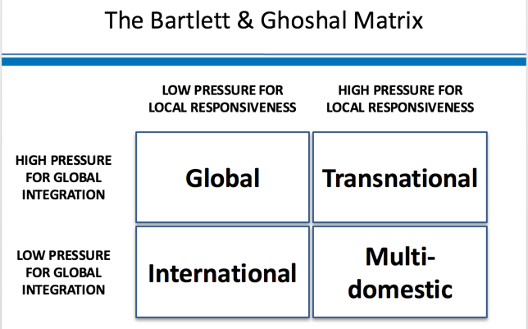
Coca-Cola operate in over 200 countries and five regions globally and are a, ‘global business that operates on a local scale’ (Coca-Cola,2020). Bartlett and Ghoshal created a model outlining the strategies for operating a multinational company based on the pressure for local responsiveness and the pressure for managing costs (see fig 1) (Bartlett et al, 2002). It can be identified that Coca-Cola have adopted a transnational strategy as they have achieved global integration and economies of scale at the same time adapting and customising products to meet local needs and the customers within that country.

(Fig 1) (Riley,2018)

4.0 Strategy

Porter, et al (2012), define strategy as, ‘the set of integrated choices that define how you will achieve superior performance in the face of competition’. Porter believes that organisations need to evaluate competition and identify a competitive advantage before developing a strategy.
Drucker suggested the fallacy of a business having a single objective, for example profit, and instead suggested eight key objectives, from marketing standing and innovation, to worker performance and public responsibility (Mullins , 1993).
Johnson, et al (2009), believes that, ‘strategy is the direction and scope of an organisation over the long term, which achieves advantage in a changing environment through its configuration of resources and competences with the aim of fulfilling stakeholder expectations’.
Mintzberg’s view on strategy suggested that organisations create intended strategies. However, unexpected opportunities and challenges can occur and organisations respond to these changes using emergent strategies. Ultimately, the intended and emergent strategies each contribute to an organisation’s realised strategy (see fig 2) (Mintzberg,2007).
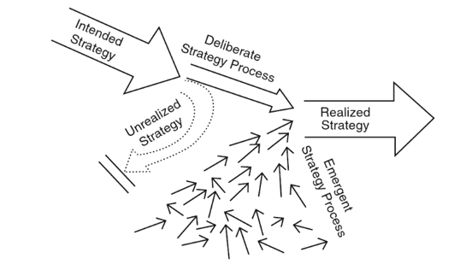

(Fig 2) (IBID)
It can be identified that Porter’s strategy focusses on a more traditional planned approach. Drucker highlights the importance of focusing on several factors instead of a single factor. Similarly, Johnson’s view on strategy addresses several elements. It encourages organisations to question ‘what direction do we want to take the organisation and how will we do?’ as well as identifying the need to analyse external and internal environments and the importance of meeting the needs of stakeholders. Mintzberg’s view on strategy is most relevant to the world organisations operate in today, as it considers that an intended strategy can become an emergent strategy due to opportunities and threats in the environment.

5.0 Strategic Management

According to Johnson, et al (2009), strategic management has three main elements, ‘understanding the strategic position of an organisation, making strategic choices for the future and managing strategy in action’. Figure 3 highlights the elements of strategic management that need to be considered by an organisation.
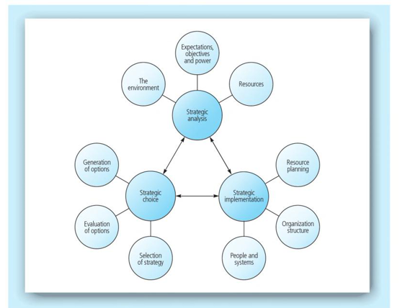

(Fig 3) (IBID)

Lynch (2018) states that, ‘strategic management deals with the major intended and emergent initiatives taken by general managers on behalf of owners, involving utilisation of resources, to enhance the performance of firms in their external environments’. Additionally, Lynch believes that organisations need to manage their strategies in three main ways:
- The organisations internal resources
- The external environment that an organisation operates in
- The organisations ability to add value to what it does.
(IBID)
Davenport et al (2006) states that, in the 21st century strategic management has become, ‘how organisations can continually adapt, shape, change, innovate, create and network to survive and prosper in global market environments that are quickly becoming unpredictable’.
It can be identified that each of these theorists see the importance of an organisation being able to adapt and change their internal resources to meet the needs of the external environment.

6.0 Coca-Cola’s Strategy

In recent years Coca-Cola has had a significant transformation and evolved its corporate/business strategy to become a total beverage company by diversifying and expanding the product portfolio across all geographies. Coca-Cola is building a portfolio of consumer centric brands and focusing on what consumers want to purchase (Coca-Cola,2017). The new business strategy focuses on choice, convenience and the consumer. James Quiency CEO of Coca-Cola believes that competitive advantage can be achieved, ‘if we embrace where the consumer is going, our brands will thrive and our system will continue to grow’ (IBID). This represents a major cultural shift as the brand once only focused on Coke (Nightly Business Report, 2018).
It can be identified that Coca-Cola’s strategy algins with Mintzberg’s theory on strategy. Mintzberg’s strategy identifies that organisations need to utilise emergent strategies as well as planned strategies to create a realised strategy. Mintzberg’s strategy approach is more relevant to the world that organisations operate in today as Porter’s traditional planned approach has become less relevant (Moore,2011). Today, an organisation’s strategy is constantly evolving due to the changing environment which is driven by technological and environmental factors (Mintzberg,2007).
Additionally, Porter, et al (2012), highlights that the pressure to grow is among the largest threats to strategy and that organisations frequently believe that any growth is good. For example, organisations might add new products which ultimately undermines competitive advantage. Additionally, Porter believes that, ‘organisations should concentrate on extending a strategic position rather than broadening and ultimately compromising it’. However, it could be argued that Coca-Cola are able to expand their product portfolio and still achieve a competitive advantage as they are a longstanding, well established, international brand.

Culture
Johnson, et al (2008), highlights that environments can change which means internal resources need to develop or ‘stretch’, to match such change. Organisations need to understand internal drivers such as culture. It can be identified that Coca-Cola’s new strategy has also included significant changes in the structure of its workforce. In 2017, when James Quincey became the CEO of Coca-Cola, he quickly developed and introduced a new strategy. This was viewed as Coca-Cola’s biggest cultural shift in 130 years (Caruso et al, 2018). In order for Coca-Cola’s strategy to be successful it was critical for the brand to create new ecosystems of products as well as people. According to Drucker, a strategy will not be successful in an environment of failed culture and that ‘culture eats strategy for breakfast’ (Laudicina,2020). Additionally, culture can help an organisation adapt to change and ultimately foster an organisation’s capacity to thrive in challenging times (Groysberg et al, 2018).

Sustainability
Business sustainability refers to the effect that organisations have on the environment and society. A sustainable business strategy seeks to positively influence and address these factors (Chladek,2019). It can be identified that sustainability is a significant factor in Coca-Cola’s strategic management approach, as they state in their vision, ‘We act in ways to create a more sustainable and better shared future. To make a difference in people's lives, communities and our planet by doing business the right way’ (see fig 4). Coca-Cola achieve this by focusing on five key areas which include, sustainable packaging, new sustainable products, water stewardship, sustainable agriculture and climate solutions (Coca-Cola,2020). It is vital for Coca-Cola to incorporate sustainability into their business strategy as it provides value and contributes to long-term success (Chladek,2019).
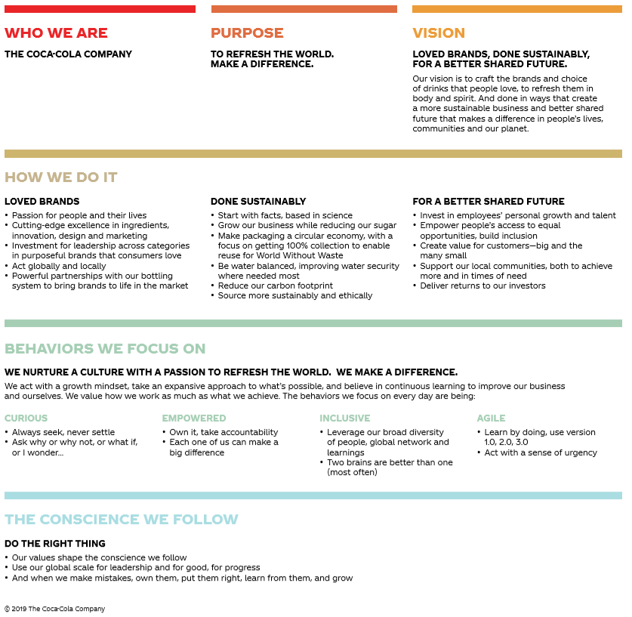

(Fig 4) (Coca-Cola,2019)

Business Resilience
Resilience can be defined as, ‘the ability to recover from setbacks, adapt well to change, and keep going in the face of adversity’ (Ovans,2015). Whilst Coca-Cola are resilient, they are also attempting to envisage what challenges may occur by identifying potential risks and opportunities prior to them happening as part of their strategy (Coca-Cola,2020). This highlights that Coca-Cola are using strategic management tools to assess their internal and external environments.

7.0 Strategic Management Tools

Strategic management tools are a critical element when forming an effective strategy (Wright, et al, 2012). Strategic management tools provide organisations with an extended knowledge of the business environment, identify opportunities and threats which potentially help to eliminate risks when making important choices and provide a framework for assessing the importance of various stakeholders (Nouri,2017).

8.0 External Environment

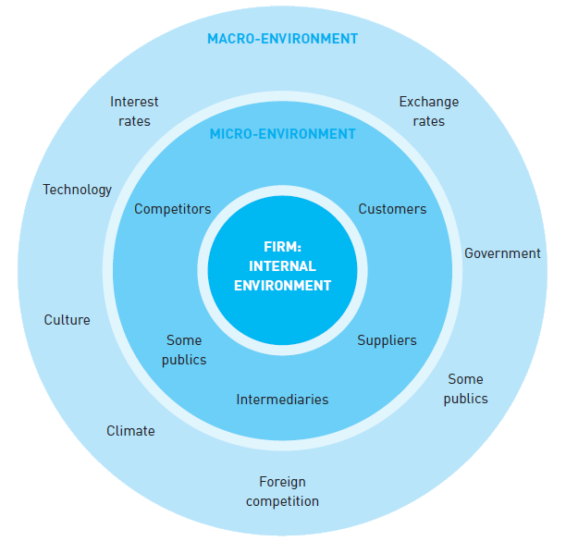
The external influences on strategy are categorised under the macro-environment and the micro-environment. The macro-environment consists of ‘non-controllable elements’ that affect society and the micro-environment consists of ‘controllable elements’ which an organisation can influence and have some level of control over (see fig 5) (Megicks, et al, 2009).

(Fig 5) (Blythe,2014)
Megicks, et al (2009), believe that, ‘the external environment is a significant determinant of strategy and organisational performance’. External changes can potentially highlight the need for a specific type of organisational structure and culture which is then shown in a balanced portfolio of products and an adaptive management approach (Wilson et al, 2005), as seen in Quiencys new Coca-Cola strategy. Without this approach, organisations have an increased risk of missing key trends in the market.

9.0 PESTLE

The PESTLE framework is a strategic tool which will help an organisation analyse the external influences and key drivers for change that are likely to have a significant impact on an organisations strategy. PESTLE involves identifying political, economic, social, technological, legal and environmental factors. It is important to analyse how the external influences are changing and how they could have an impact on an organisation in the future. Without this information, an organisation would not be able to take the decisions that allow for effective action (Johnson et al, 2008).
The main advantages of the PESTLE framework are that it enables organisations to assess a variety of influential factors that could affect the success of product launches. This gives organisations a greater understanding when strategically planning (Perera,2017). However, the main disadvantage of the PESTLE analysis is the fast pace environment which is more agile than ever. This makes it difficult to anticipate developments that will change and affect an organisation in the future (Weeks,2020).
In order for the PESTLE analysis to be effective, Coca-Cola would be required to repeat the process regularly due to the fast pace of change within the environment. Some of the macro external factors effecting Coca-Cola can be viewed in the table below (see fig 6) (please refer to appendix 1 for a full PESTLE analysis on Coca-Cola).
(Fig 6)
Political | - UK Sugar Tax  - European soft drink sugar reduction  - Migration
Economic | - Global pandemic  - Recession
Social | - Health and obesity  - Increasing vegetarian and vegan diets
Technological | - Artificial Intelligence  - Social media
Legal | - Legal GDPR (General Data Protection Regulations)  - Nutrition fact labels
Environmental | - Plastic  - Air Pollution

10.0 SWOT Analysis

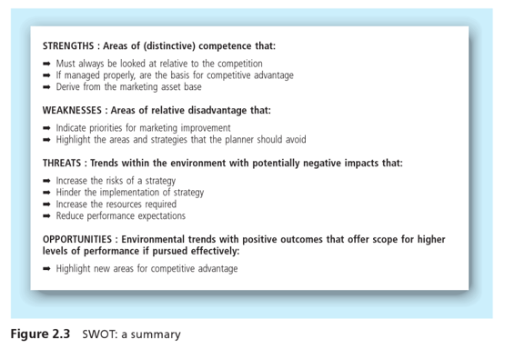
The SWOT analysis is an example of a strategic management tool that enables an organisation to understand its internal strengths and weaknesses as well identifying external opportunities and threats (see fig 7) (Gopinath et al, 2014).

(Fig 7)

According to Johnson, et al (2008), the SWOT analysis should be focused and prompt organisations to act if any significant weaknesses, threats or opportunities are identified. Organisations should prioritise and rank factors in order, to ensure they add value and maximise the use of analytic tools.
Wilson, et al (2013), recognise that the SWOT analysis is an adequate strategic planning tool, however, it does have some caveats. For example, competitor’s capabilities can be underestimated or misunderstood and the tool fails to relate strengths and weaknesses to critical success factors. The strengths, weaknesses, opportunities and threats related to Coca-Cola can be viewed below (see fig 8).

Strengths | Weaknesses
- Dominant market share within the non-alcoholic beverage industry. Only Pepsi and Nestle can compare (Jurevicius , 2020).  - Diversified product portfolio by being active in seven beverage categories and having over 500 different brands (Jurevicius , 2020)  - Coca-Cola are a global business that operate on a local scale as they provide different products within each country they operate in (Coca-Cola,2020).  - Coca-Cola’s distribution network allows them to target a significant number of consumers, increase brand awareness as well enabling them to introduce new products easily. | - There are alternative competitive products within the beverage market e.g Pepsi.  - Consumers have become more health conscious and concerned about obesity. Carbonated beverages are a big influencer of these health complications (NHS, 2007).  - Coca-Cola are only active in the non-alcoholic beverage market.
Opportunities | Threats
- Coca-Cola could be more sustainable with regards to the packaging of their products.  - Coca-Cola could expand into the food market like their competitor Pepsi. However, this could potentially undermine their strategic position.  - Coca-Cola could offer additional healthier products in order to further increase profitability.  - Coca-Cola could expand into the alcoholic beverage market. | - Water is the main resource of Coca-Cola’s beverages, however, it is a limited resource. The ever-increasing population growth and persistent pollution of current freshwater sources have created water shortages in various countries (Coca-Cola). Coca-Cola may suffer increasing production costs or face capacity restrictions, which could affect its profitability in the future.  - The growing concerns of obesity and regulations could affect Coca-Cola’s sales and profitability as they could experience a decrease in the demand for its products.
(Fig 8).

11.0 Evaluation of PESTLE and SWOT

The PESTLE and SWOT analysis have identified a range of internal and external factors that Coca-Cola need to consider to ensure they remain competitive otherwise it would have an effect on the success of their strategy. The main factors that Coca-Cola need to consider are the growing concerns of obesity, the rapidly changing technological environment, the global issues of plastic and pollution and competitors within the beverage market.

12.0 Ansoff Matrix

The Ansoff Growth Matrix aids organisations to map strategic product market growth (Ansoff Matrix , 2018). The Ansoff Matrix consists of four growth strategies. These include penetrating existing products markets, product expansion, applying the same products in new markets and diversifying into new products (see fig 9).

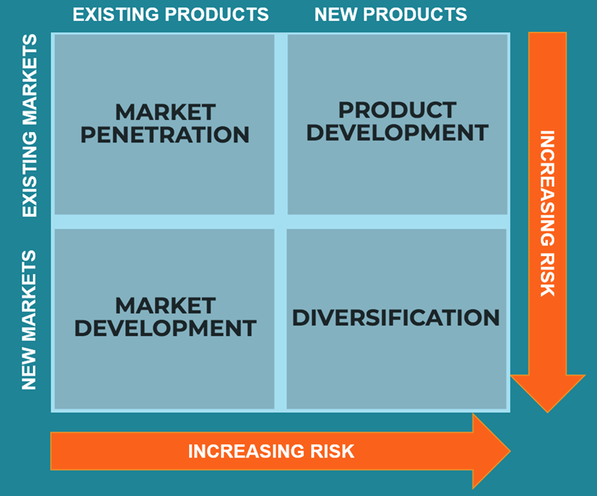
(Fig 9)
It can be identified that Coca-Cola have utilised two growth strategies which include product development and diversification. The product development strategy includes introducing new products into existing markets as well as the modification of an existing product. Diversification can be classified as related or unrelated diversification. These involve creating and marketing new products to an existing industry that an organisation is familiar with or marketing products to a new industry. Diversification is viewed as a significantly risky strategy (Ansoff Matrix , 2018). Coca-Cola have utilised the product development strategy by modifying 400 of their products by reducing sugar content. Additionally, Coca-Cola have diversified by becoming a total beverage company and expanding their product portfolio (Coca-Cola,2020). However, the main disadvantage of the Ansoff Matrix is that it only concentrates on product and market and does not consider other factors such as profitability (Bachmeier, 2008).

13.0 Stakeholder Analysis

It is important for organisations to understand different stakeholder expectations and their influence on strategic purpose (Johnson et al 2008). In 1981, Mendelow developed a framework to help analyse stakeholder power and interest. These factors help to identify the relationship between a company and its stakeholders and the ability of the organisation to manage stakeholder concerns (Norton, 2008). Figure 10 identifies the different levels of stakeholder relationships.

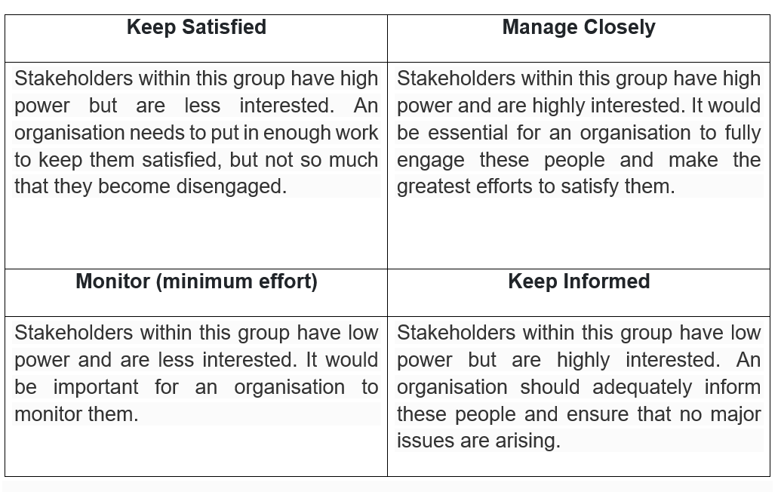
(Fig 10) (MindTools, 2020).

Figure 11 identifies the positioning of Coca-Cola’s stakeholders. Customers are an example of a stakeholder who would have to managed closely. This is because Coca-Cola’s strategy is to follow consumer demand and provide products that meet their needs. Additionally, competitors are an example of a stakeholder that Coca-Cola would have to monitor to ensure they remain competitive.

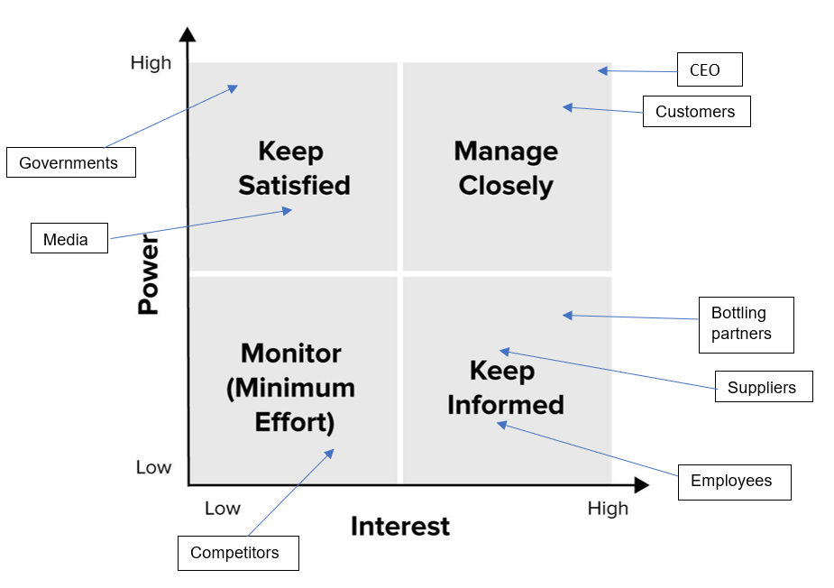
(Fig 11)

14.0 Conclusion

This report has met its objectives by critically analysing Coca-Cola’s strategy utilising strategic management tools. Firstly, the PESTLE and SWOT Analysis highlighted internal and external factors that could potentially affect Coca-Cola’s strategy, including the growing concerns of obesity, sustainability opportunities and the rapidly changing technological environment. Additionally, the Ansoff Matrix identified the need for product development and diversification and the stakeholder analysis highlighted the importance of satisfying stakeholders in relation to their power and interest. Coca-Cola’s strategy is resilient in the current business environment as they have identified the need to evolve, diversify and expand the product portfolio to become a total beverage company.

15.0 Bibliography

Aldrick , P., & Swinford, S. (2020, May 08). Coronavirus could cause deepest recession on record, Bank warns. Retrieved from The Times: https://www.thetimes.co.uk/article/coronavirus-pandemic-could-cause-deepest-recession-on-record-bank-warns-k7nsrqs8g
Ansoff Matrix . (2018). Ansoff Matrix: A Guide to the Ansoff Product Market Growth Matrix. Retrieved from Ansoff Matrix: https://www.ansoffmatrix.com/
Bachmeier, K. (2008). Analysis of Marketing Strategies Used by PepsiCo Based on Ansoff's Theory. Germany : Grin Verlag.
Bartlett, C., & Ghoshal, S. (2002). Managing Across Borders: The Transnational Solution. Massachusetts: Harvard Business School.
BBC News . (2016, October 26). Coke revenues continue to lose their fizz. Retrieved from BBC News: https://www.bbc.co.uk/news/business-37775344
Bhasin, K. (2011, June 10). 15 Facts About Coca-Cola That Will Blow Your Mind. Retrieved from Business Insider: https://www.businessinsider.com.au/facts-about-coca-cola-2011-6#31-of-all-beverages-consumed-around-the-world-are-coca-cola-products-1
Blythe , J. (2014). Principles and Practice of Marketing. London: SAGE Publications Ltd.
British Council . (2020). Vegetarian UK. Retrieved from Learn English Teens : https://learnenglishteens.britishcouncil.org/uk-now/read-uk/vegetarian-uk#:~:text=This%20means%20there%20are%20over%20three%20million%20vegetarians,will%20see%20a%20wide%20range%20of%20vegetarian%20ingredients
Caruso , D., & Petersen , M. (2018). Developing a Growth-Mindset at Coca-Cola. Retrieved from Leadership for a Networked World: https://lnwprogram.org/content/developing-growth-mindset-coca-cola
Chladek, N. (2019, November 06). WHY YOU NEED SUSTAINABILITY IN YOUR BUSINESS STRATEGY. Retrieved from Harvard Business School: https://online.hbs.edu/blog/post/business-sustainability-strategies
Clement, J. (2020, July 15 ). Number of social network users worldwide from 2017 to 2025. Retrieved from Statista : https://www.statista.com/statistics/278414/number-of-worldwide-social-network-users/
Coca Cola . (2017, December 13). Coca Cola Continues to Provide More Product Info in More Places. Retrieved from The Coca Cola Company: https://www.coca-colacompany.com/news/coca-cola-provides-more-product-info
Coca Cola. (2020). Sustainable Business. Retrieved from The Coca-Cola Company : https://www.coca-colacompany.com/sustainable-business
Coca-Cola . (2020). The Birth of a Refreshing Idea. Retrieved from The Coca-Cola Company: https://www.coca-colacompany.com/company/history/the-birth-of-a-refreshing-idea
Coca-Cola. (2017, February 23). New Business Strategy to Focus on Choice, Convenience and the Consumer. Retrieved from The Coca-Cola Company: https://www.coca-colacompany.com/news/new-focus-on-choice-convenience-and-consumers
Coca-Cola. (2019). Coca-Cola Consolidated Inc. SWOT Analysis. 1-6.
Coca-Cola. (2019). WHO WE ARE. Retrieved from The Coca-Cola Company : https://www.coca-colacompany.com/content/dam/journey/us/en/our-company/purpose-and-vision/coca-cola-company-purpose-summary.pdf
Coca-Cola. (2020). BUSINESS RESILIENCE. Retrieved from Coca-Cola HBC: https://www.coca-colahellenic.com/en/about-us/corporate-governance/business-resilience
Coca-Cola. (2020). Climate. Retrieved from The Coca-Cola Company: https://www.coca-colacompany.com/sustainable-business/climate
Coca-Cola. (2020). Sugar Reduction. Retrieved from The Coca-Cola Company : https://www.coca-colacompany.com/sustainable-business/in-our-products/sugar-reduction
Coca-Cola. (2020). THE COCA-COLA SYSTEM. Retrieved from The Coca-Cola Company : https://www.coca-colacompany.com/company/coca-cola-system
Davenport, T., Leibold, M., & Voelpel, S. (2006). Strategic Management in the Innovation Economy: Strategic Approaches and Tools for Dynamic Innovation Capabilities. Germany : Wiley .
FDA. (2020, October 07). Changes to the Nutrition Facts Label. Retrieved from Food and Drug Administration: https://www.fda.gov/food/food-labeling-nutrition/changes-nutrition-facts-label
Gibbons, S. (2019, September 19). The Technology Of The Future Is Changing Business Today. Retrieved from Forbes: https://www.forbes.com/sites/serenitygibbons/2019/09/19/the-technology-of-the-future-is-changing-business-today/#4c82cfd94fe1
Gopinath, C., & Siciliano, J. (2014). Strategize!: Experiential Exercises in Strategic Management. Ohio : South Western Cengage Learning .
Gov.UK. (2018, April 5). Gov.UK. Retrieved from https://www.gov.uk/government/news/soft-drinks-industry-levy-comes-into-effect
Groysberg, B., Lee, J., Price , J., & Cheng , Y.-J. (2018, February ). THE CULTURE FACTOR. Retrieved from Harvard Business Review: https://hbr.org/2018/01/the-culture-factor
Hern, A. (2018, May 21). What is GDPR and how will it affect you? Retrieved from The Guardian : https://www.theguardian.com/technology/2018/may/21/what-is-gdpr-and-how-will-it-affect-you
Johnson, G., Scholes , K., & Whittington, R. (2009). Fundamentals of Strategy. Essex: Pearson Education Limited .
Johnson, G., Scholes, K., & Whittington, R. (2008). Exploring Corporate Strategy: Text & Cases. Essex: Peason Education Limited .
Jurevicius , O. (2020, January 10). SWOT analysis of Coca Cola (6 Key Strengths in 2020). Retrieved from Strategic Management Insight: https://strategicmanagementinsight.com/swot-analyses/coca-cola-swot-analysis.html
Laudicina, P. (2020, April 17). Does Culture Eat Strategy In Times Of Crisis? Retrieved from Forbes : https://www.forbes.com/sites/paullaudicina/2020/04/17/does-culture-eat-strategy-in-times-of-crisis/#77a2896353c3
Lynch , R. (2018). Strategic Management. London : Pearson .
Magretta, J., & Porter , M. (2012). Understanding Michael Porter: The Essential Guide to Competition and Strategy. Boston: Harvard Business Review.
Marr, B. (2017, September 18). The Amazing Ways Coca Cola Uses Artificial Intelligence And Big Data To Drive Success. Retrieved from Forbes: https://www.forbes.com/sites/bernardmarr/2017/09/18/the-amazing-ways-coca-cola-uses-artificial-intelligence-ai-and-big-data-to-drive-success/#1168501178d2
Megicks, P., Donnelly , R., & Harrison , G. (2009). CIM Coursebook: The Marketing Planning Process. Oxford : Elsevier.
MindTools. (2020). Stakeholder Analysis. Retrieved from MindTools: https://www.mindtools.com/pages/article/newPPM_07.htm
Mintzberg, H. (2007). Tracking Strategies: Toward a General Theory. Oxford : Oxford University Press .
Moore, K. (2011, March 28). Porter or Mintzberg: Whose View of Strategy Is the Most Relevant Today? Retrieved from Forbes: https://www.forbes.com/sites/karlmoore/2011/03/28/porter-or-mintzberg-whose-view-of-strategy-is-the-most-relevant-today/#59fd2e9d58ba
Mullins , L. (1993). Management and Organisational Behaviour. London: Pearson.
NHS. (2007, July 24). Fizzy soft drinks linked to health risk. Retrieved from NHS: https://www.nhs.uk/news/food-and-diet/fizzy-soft-drinks-linked-to-health-risk/
Nightly Business Report. (2018, December 17). Coca-Cola's CFO on new business strategy. Retrieved from YouTube: https://www.bing.com/videos/search?q=coca+cola+strategy&qpvt=coca+cola+strategy&view=detail&mid=82F32A1BDD5C491E479182F32A1BDD5C491E4791&&FORM=VRDGAR&ru=%2Fvideos%2Fsearch%3Fq%3Dcoca%2Bcola%2Bstrategy%26qpvt%3Dcoca%2Bcola%2Bstrategy%26FORM%3DVDRE
Norton, A. (2008). CIMA Official Learning System Integrated Management. London: CIMA.
Nouri, B. (2017). ANALYZING THE USE OF STRATEGIC MANAGEMENT TOOLS AND TECHNIQUES BETWEEN IRANIAN FIRMS. Academy of Strategic Management Journal, 1-18.
Nunez, C. (2019, February 04). Air pollution, explained. Retrieved from National Geographic : https://www.nationalgeographic.com/environment/global-warming/pollution/
Office for National Statistics . (2020). Unemployment. Retrieved from Office for National Statistics: https://www.ons.gov.uk/employmentandlabourmarket/peoplenotinwork/unemployment
Ovans, A. (2015, January 05). What Resilience Means, and Why It Matters. Retrieved from Harvard Business Review : https://hbr.org/2015/01/what-resilience-means-and-why-it-matters#:~:text=A%20small%20but%20intriguing%20new%20survey%20by%20a,and%20keep%20going%20in%20the%20face%20of%20adversity.
Perera, R. (2017). The PESTLE Analysis. Sri Lanka: Nerdynaut.
Riley , J. (2018). Bartlett & Ghoshal Model of International Strategy. Retrieved from tutor2u: https://www.tutor2u.net/business/reference/bartlett-ghoshal-model-international-strategy
The Independent . (2020, August 28). Coca-Cola cuts thousands of jobs across US and Canada amid declining sales. Retrieved from The Independent: https://www.independent.co.uk/news/world/americas/coca-cola-job-losses-coke-cuts-us-canada-sales-coronavirus-a9694046.html
The Vegan Society . (2019). Statistics. Retrieved from The Vegan Society: https://www.vegansociety.com/news/media/statistics
Thompson, R. (2017, July ). Future of the Sea: Plastic Pollution. Retrieved from Government Office for Science : https://assets.publishing.service.gov.uk/government/uploads/system/uploads/attachment_data/file/634433/Future_of_the_sea_-_plastic_pollution_final.pdf
UNESDA . (2019, June 20). UNESDA Soft Drinks Eurpoe . Retrieved from https://www.unesda.eu/news/european-soft-drinks-industry-on-track-to-meet-commitment-to-reduce-added-sugars-by-10-by-2020/
Weeks, A. (2020, February 26). CIPD. Retrieved from https://www.cipd.co.uk/knowledge/strategy/organisational-development/pestle-analysis-factsheet
Wilson , R., & Gilligan, C. (2013). Strategic Marketing Management. Oxford : Routledge .
Wright, R., Paroutis, S., & Blettner, D. (2012). How Useful Are the Strategic Tools We Teach in. Journal of Management Studies, 92-125.

16.0 Appendices

Appendix 1
Full PESTLE Analysis on Coca-Cola
Political | UK Sugar Tax  In 2018, the UK Government introduced the 'Sugar Tax' with the aim of helping to reduce sugar in soft drinks as well as tackling childhood obesity ( Gov.UK, 2018)  European soft drink sugar reduction  The European soft drinks industry made a voluntary commitment to reduce sugar content in products by 10% by the end of 2020 ( UNESDA , 2019).  Coca-Cola reduced sugar in over 400 of their products in 2018. Today, around 40% of their beverages are low or no sugar options. This ensures that Coca-Cola have options and choices to support consumer needs (Coca-Cola,2020).  Migration  The Office for National Statistics shows that the unemployment rate was 4.5% in the UK in August 2020 (Office for National Statistics , 2020). When relating this to Brexit, there is uncertainty whether economic migration into the UK will be allowed.  This will potentially impact Coca-Cola as they could have unfilled vacancies within the UK.
Economic | Global pandemic  Due to the global pandemic, Coca-Cola was forced to cut thousands of jobs in America and Canada due to declining sales. Coca-Cola’s share were down 13% amid the coronavirus pandemic (The Independent , 2020)  Recession  The UK could potentially suffer its worst recession in over 300 years due to the economy shrinking by 14% from March-June 2020. Additionally, an estimated two million people are expected to lose their jobs (Aldrick & Swinford, 2020)  This could potentially effect Coca-Cola’s sales and profitability as consumers will have less disposable income.
Social | Health and obesity  The NHS reported that people who consume fizzy drinks daily are likely to develop obesity and high blood pressures (NHS, 2007).  This has had a significant effect on Coca-Cola. For example, ‘Coca-Cola’s global revenues slid 7% in the three months to September as consumers kept the lid on fizzy drinks’. Additionally, Coca-Cola’s revenue fell to £8.67bn which was the sixth consecutive quarterly decline in revenue (BBC News , 2016). However, Coca-Cola have addressed this issue as in 2018 they reduced sugar in over 400 products and now 40% of their beverages contain limited or no sugar (Coca-Cola,2020).  Vegan and vegetarian diets  There are approximately 3 million vegetarians in the UK (British Council , 2020). Additionally, the number of vegans in the UK has quadrupled between 2014 and 2019. In 2019 there were 600,000 vegans (The Vegan Society , 2019).  Coca-Cola need to ensure they provide a range of vegetarian and vegan products to meet the needs of these consumers. It can be identified that a limited amount of Coca-Cola’s beverages contain any animal derivatives (Coca-Cola,2020).
Technological | Artificial Intelligence  Forbes reported that technological change is the most significant external factor organisations face today. Additionally, many CEO’s lack the necessary knowledge to manage a rapidly changing technological environment. Organisations need to prioritise artificial intelligence as a core business function (Gibbons, 2019).  Coca-Cola need to invest in AI to ensure they remain competitive. The global director of digital innovation at Coca-Cola stated that, ‘artificial intelligence is the foundation for everything we do’ (Marr, 2017). Coca-Cola has re-ordered itself to become a technology-driven company with a focus on artificial intelligence meaning it should keep its position as leader of the non-alcoholic beverage industry.  Social media  It is essential for Coca-Cola to utilise social media as it is used by a large number of the population. For example, in 2020, an estimated 3.6 billion people were using social media worldwide and this is projected to increase to 4.41 billion in 2025 (Clement, 2020).  Social media is a vital technological tool for Coca-Cola to utilise as it has low or no costs which helps reduce overall marketing costs.
Legal | GDPR (General Data Protection Regulations)  In May 2018 the EU passed the GDPR law which is a replacement of the 1995 Data Protection Act. The new law has significantly improved consumer rights as they are allowed to request that organisations reveal or delete any personal data they hold of them (Hern, 2018).  This has an impact on Coca-Cola as it will potentially prevent them from getting customer data easily which will impede their ability to directly market.  Nutrition fact labels  In 2016, the Food and Drug Administration (FDA) published rules for organisations to state scientific information and include links between diet and chronic diseases such as obesity and heart disease. The new labels make it easier for consumers to make better informed choices (FDA, 2020).  Coca-Cola has adopted SmartLabel which is a QR code and gives consumers access to information about the ingredients, allergens, and calories of products (Coca-Cola, 2017). This provides consumers with more information than can be found on normal packaging.
Environmental | Plastic  An environmental factor that is of great concern currently is the rising level of plastic and has has been identified as a significant global issue. Additionally, around 40% of all plastic produced is used for single use packaging which represents a major proportion of the waste managed via landfill (Thompson, 2017). It is essential for Coca-Cola to follow ethical and sustainable practices as it will create value for consumers.  Coca-Cola aim to collect and recycle the equivalent of every bottle/can they sell globally by 2030 (Coca-Cola Company,2020). Additionally, Coca-Cola are working to make all their packaging 100% recyclable by the year 2025 and to include 50% recycled content across all their primary packaging globally by 2030 (IBID).  Air pollution  Air pollution has been noticed as a global health hazard. For example, poor air pollution caused an estimated 4.2 million premature deaths in 2016 and it was reported that 90 percent of these deaths were in developing countries. Additionally, Air pollution has been linked to higher rates of cancer, heart disease, stroke, and respiratory diseases such as asthma (Nunez, 2019).  Coca-Cola recognise that they have a responsibility to contribute solutions by both reducing emissions and building resilience through helping businesses and communities to adapt to climate change. Additionally, Coca-Cola have cut their carbon footprint by 24% which is in line with their target of a 25% reduction by the end of 2020 (Coca-Cola,2020).

