
This Photo by Unknown Author is licensed under CC BY

Effective team working and communication
Veselin Dzhonev 2124097
BMSW4002
Muhammad Islam
Effective Teamworking for team success

Introduction
The following report will research and outline some of the frame works and models used for creating effective teams. The task of setting and choosing team members is hard and these models aid the process. Gersick(1988), Tuckmans Model(1965) and Wheelan’s model. On the other hand, Belbin suggestion that its needed balance of different personalities in effective team also contributes to effective team building. There is difference between team and group of people and if there are not outlined rules and common goal the team won’t be effective as it should. There are many skills that need to be acquired to have effective and cohesive team. The culture code by Coyle (2018) outlines some important skills as well. As well, the role of team leader plays important part in effective teams. In the report will be used diagrams, pictures and anything that makes clear what effective team is. Below are the main points that the report will concentrate on:

- How can effective team be developed, and what theoretical model can be used?
- What are the types of roles needed to create effective team?
- Impact that effective teamworking have on team success?
- What are the barriers to effective team working?
Team is a unit of people who are working together to achieve same target. Everyone in a team has different role and all the team is accountable for reaching the desire team goal. Teams plan together, cooperate, communicate, and make better well-informed decisions on the common topic. When all these steps applied correctly the team is effective. Effective teamwork is critical for the organisation success. Individuals who work in teams and learn to cooperate with other increase their chances of solving shared problems and meeting personal needs. (Qin, Johnson and Johnson, 1995).
Contributing to team effectiveness is the diversity of the team itself and the leadership that team have. Every team needs a leader who laws the ground rules, make clear what the team common goal is, encourage, correct, support team members, and resolve any issues that may appear. Also, team need to be cohesive and collaborate well to succeed. Every team member has unique roll and skill that contribute to team effectiveness. As mentioned by Luis Daniel J. (2010) the culture of the organisation and the environment have positive effect on effective teamwork. Another attributes like cooperation, communication, diversity, team size, trust, mutual respect, creativity all has positive effect on teamwork.

Models of team development.
The report will consider looking at Tuckman model as its more detailed and provides in depth information on team development. As its important to know what stages people go through to develop effective team this model is widely used. This model has 5 stages, each stage has its part in hoe team develop. The Gersic model is more connected to the task as the Tuckman’s and Wheelan model concentrate on the stages team goes through while developing. Also, the Culture Code by (Coil 2018) needs to be part of company’s way to develop effective team. If implemented right this theories and models will lead any organisation to success. It also depends on the team size which model is used.

Tuckman’s Model
This framework consists of 5 stages:
- Forming
- Storming
- Norming
- Performing
- Adjourning

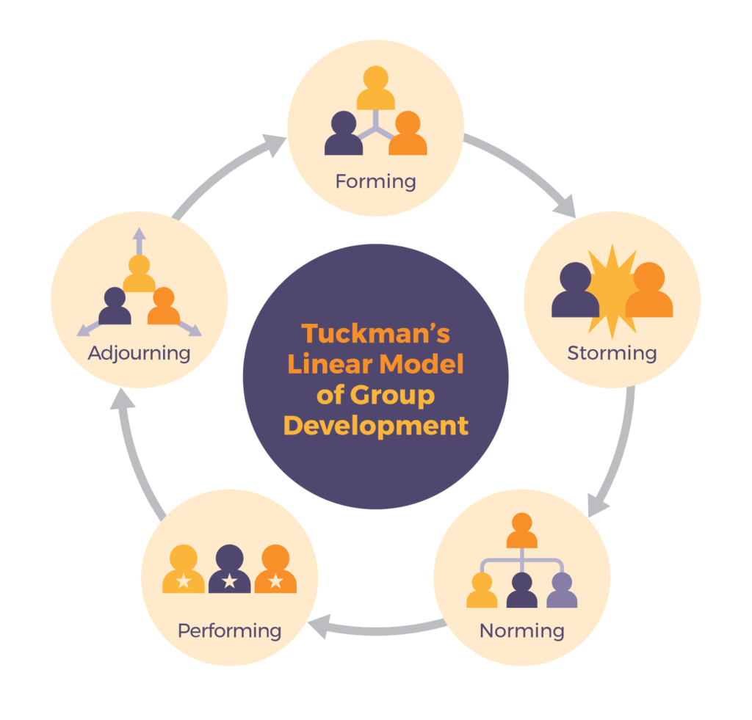

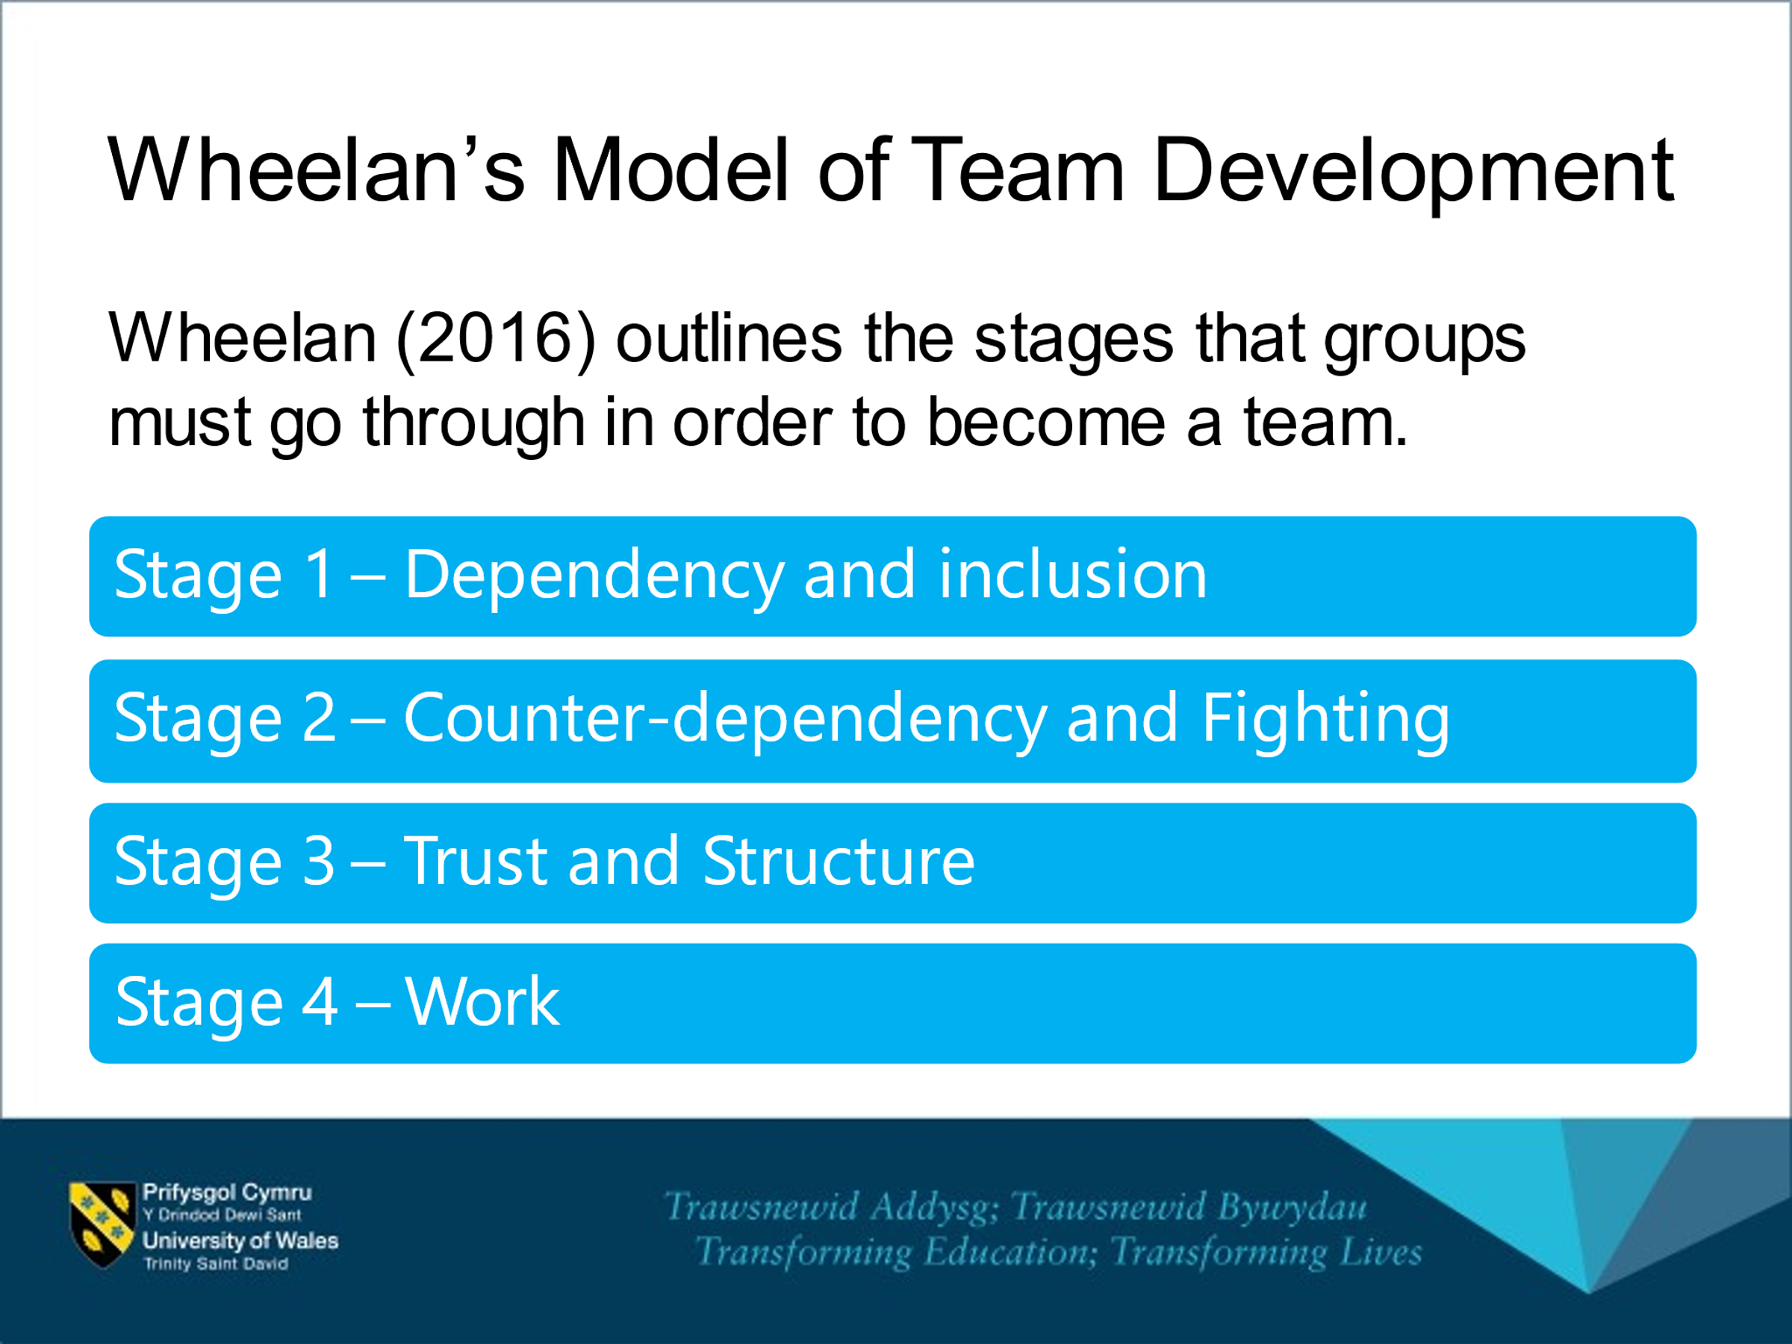
This framework helps to understand the stages people go trough in order to become effective team. Combining the models and Belbin’s team roles is the key to success for any organisation when implemented the right way.

Belbin divides 9 roles in to 3 categories

Everyone is different and the way people perform is not same. However, when combining people’s ideas and skills this produce effectiveness. Some people are thinkers, others are people of actions, and some people are good at analysing and reflecting upon. Belbin states that effective teams need a mixture of personality to be effective and this is proven in many cases and organisations who realise and implement this theory are very successful. Also leadership skills and creative thinking are another important aspect of team effectiveness to look at.
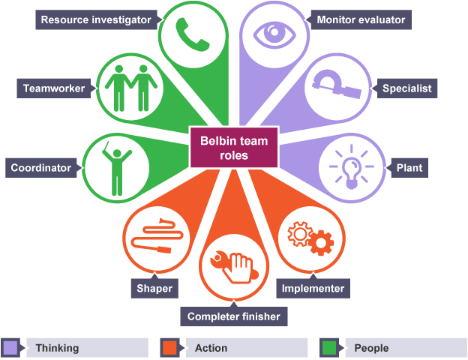

Type of Team Roles
Griffiths and Dunham (2015) mention how important is that who is in the team or the team composition. Teams’ diversity is vital as this contributes to more points of view and experience brought to the table, also the culture and understanding help teams to reach common goals and become more effective. Every team needs creative people, people with ideas and people of action as when combined they produce efficient workload. On the other hand, there need to be IT specialist and people who evaluate everything. Also, there are people with very strong personalities who take over the other people and they cannot take part and don’t share ideas or feel excluded and not part of a team that’s why the team leader must implement good working practice and be fare and include everyone. Creative thinking is useful in bringing people together and motivating them. Team building activities, surveys and team meetings are good ways to track the team productivity and identify any potential issues and resolve them as they do not affect effective teamwork. People must learn to listen each other and respect others’ ideas also to allow everyone to talk so all ideas reach the team table and opportunities are not missed. When creating a team, the organisation needs to make sure the team has diversity and uniqueness. Personality clash can happen and can lead to internal conversations between employees and team conflicts. That’s where monitoring and team meetings are important and implementing positive approach as well as cooperation and communication. When structured well team meetings would pick up on any team issues and challenges and build good working relationship between team members. Creative thinking in situation of challenges is important as the team leader can use various activity to resolve and promote team effectiveness.

Impact of effective team working.

There are many advantages when team is effective. Achieving the goal that is appointed and building trust and good working relationship. On the other hand, another advantage is that when team is effective the workload can be bigger, and team finish the task on time. The organisation needs to ensure the team is functioning well and if there are any issues this needs to be monitored, reflect on it and if needed changes to be made to maintain the long-term team effectiveness as suggested by Michael A West. Of big importance is the positive approach, inclusion and praising staff for hard work. When relationships are positive and there is sense for community this as well shows effective teamwork. Holding regular surveys, team meeting and team building events makes everyone come together and get to know each other better and resolve any differences. Also, of great importance are the rewards and the appreciation team members receive, because when employee is feeling underpaid or not appreciated and hard work is not recognised this leads to issues witch if not resolved will affect the team effectiveness and good companies know how important is to praise and reward staff, so they keep up with the good work and know their hard work is verry much appreciated. Positive attitude goes long way in any scenario. In bigger groups there is more challenges as is harder to control, where in small groups there is easier to identify and contain any challenge that may rise. As in smaller group is easier to take part where in larger group some members can not get chance to take part, and this may cause conflicts.
Barriers to effective teamworking
Experiencing some barriers when working together and in teams is normal, as there are mixed people with so many differences. Clash of personalities or points of views, alongside with miscommunication and language barrier are some examples. That’s why its of big importance organisations understand and know how to resolve barrier issues.
- Personalities/ points of view
- Cultures difference
- Lack of leadership
- Poor communication skills
- Body language
- Lack of knowledge
- Technological issues
- Lack of information on subject
- Discrimination/bullying
- Listening skills

When any of these barriers appear in a team, it becomes clear as team workload decrease and time frame that is needed for activity to be completed needs to be extended. Challenges need to be handled promptly and the root cause of the issue to be identified so it can be resolved. In the case scenario needs to be taken under consideration that this is international company and people of all backgrounds, cultures, age, and religions may work together in a team and this may cause challenges. That’s why is important to use suitable channels of communication and positive creative ways. Its important to monitor regularly as act fast to resolve issues. As if left for long time it can grow and affect the organisation more. Moreover, when there are strong personalities, it needs to make sure everyone is listened, and every opinion and idea is respected. Wheelan (2016) model can be helpful to resolve some of the barriers in the case.
Solution
Taking into consideration all the frameworks and models that can apply in the case of Next Plc. It is evident that the team meetings need to be structured better and target the issues between the team. There need to be positive approach and creative thinking used. As many issues that occur between the team are easy to resolve and communication can be approved. Consideration needs to be done as the diversity of the team including people of different parts of the world and different points of views. Inclusion and respect need to be implemented in the team and effective teamwork need to be promoted. In order not to have misinterpretation and misunderstanding within the team it needs to be clarity in members roles and the composition of the team. Also, the common goal and task needs to be clarified very clear so team can work together to achieve it. When there are clear roles and responsibilities in the team there is very little chance of conflicts. It is very important the communication and collaboration of the team members is proactive and positive. The important role in effective teams is the team leader role. Leader must make sure the team performs well and resolve any conflicts and problems. The team leader role is to inform, control, motivate, know how to use emotional expression. As its vital part on way to success. Team leader must effectively clarify the task and the rules that need to be followed and what’s acceptable and what not. To motivate staff and monitor the as to make sure the task gets completed on time using the right channels of communication.

REFERENCE LIST

- Luis Daniel, J. (2010), "The effect of workplace spirituality on team effectiveness", Journal of Management Development, Vol. 29 No. 5, pp. 442-456.
- https://www.google.co.uk/search?q=tuckman%27s+model&sxsrf=
- https://dotnetsharing.wordpress.com/2017/09/19/learn-belbin-team-roles-through-reflection/
- https://books.google.co.uk/books?lr=&id=dmIjlneC3HwC&dq=advantages+of+effective+teamwork&q=team+work#v=snippet&q=team%20work&f=false
- Belbin, M., (2010), Team Roles at Work, eBook Collection (EBSCOhost), Routledge
- Belbin, M. (2016) Team role circle, Available: https://www.belbin.com/media/2302/belbin-team-role-circle.pdf (Accessed: 19 June 2020).
- Griffith, B., and Dunham, E., (2015), Working in Teams: moving from high potential to
high performance Los Angeles: SAGE Publicación.
- Maund, A. et al. (2017) Certificate in higher education : skills for the workplace student yearbook. London:: Sage.
- Morgan, P. (2017), The Business Student’s guide to study and employability, London, SAGE.
- Pasleau, P., (2017), Tuckman Model: Understanding the stages of team formation, [video], Available at: https://www.youtube.com/watch?v=2QbXc6E08H4 (Accessed: 19 June 2020).
- Wheelan, S.A., (2016), Creating Effective Teams, 5th edn, London: SAGE.

