
Understanding and Engaging in the Customer Experience BMSW5103_LON
The HSBC`s quality systems and customer relationship management
Andreea Esanu (1713835)
Submission date
Lecturer name: HOSSEIN SHOKRI


Table of Contents
Introduction 2
HSBC background 2
Wealth and Personal Banking 2
Commercial Banking 3
Global Banking and Markets 4
HSBC Business Environment 4
SWOT Analysis on HSBC 4
HSBC CRM and Consumer Behaviour 7
CRM Definition 7
Consumer behaviour definition 9
HSBC Relationship Marketing Strategy 12
Quality Systems and Control at HSBC 16
Total Quality Management (TQM) 16
Internal and external factors that can influence HSBC`s quality systems 16
Conclusion 16
References 18
Appendix 20

Introduction
All over the world companies are adapting to their new customer base. During the current global pandemic situation (COVID-19) customers` behaviour has resulted changes, and the companies has forced to adapt a strategic function in order to improve the customers` experience, by using Customer Relationship Management (CRM) as their strategy. Therefore, the companies need to focus upon the development of a customer relationship as a key point of their business and dedicating their time and support to winning and keeping customers by creating and offer value better than competition. Competition is fierce, and if the companies doesn’t have a unique offering, they need to provide a great and memorable experience that consumer can rely on, especially if the company wants to improve customer loyalty and gain new ones.
This essay, critical analyse internal and external factors and discuss how HSBC UK improved CRM in order to achieve the objectives and maintaining good customer relationship through the current global pandemic situation.

HSBC background
Has been known that HSBC is one of the world`s largest banking and financial services organisations, offering services to more than 40 million customers through their global businesses such as Wealth and Personal Banking, Commercial Banking, and Global Banking and Markets. Being one of the largest banking organisations, their services covers 64 countries and territories in Europe, Asia, the Middle East and Africa, North America and Latin America (HSBC, nd).

Wealth and Personal Banking
HSBC is focused on customers` needs, supporting them in different ways such as self-service terminals, telephone service centres, and internet and mobile banking services. Also, by offering products and services to their customers in order to achieve their goals and aspirations, the company creates long-term relationship with their clients, supporting them in their home markets as well as connecting them to opportunities overseas. The Wealth and Personal Banking includes services such as:
- Personal Banking: current accounts, loans and savings products to customers in key markets around the world, for an easy accessibility to the personal banking
- HSBC Premier: this service includes the support of a plan life for customer and its family, designed to help the client to thrive by offering a financial expertise,
- HSBC Jade: gives you access to bespoke global and local wealth insights to support the client in developing individual wealth management strategy, also this service includes exclusive products and expertise to enable the client to grow and protect his wealth with an range of wealth solutions and digital platforms are designed to meet the individual needs.
- Global Private Banking: provides banking, investment, and wealth management solutions to support their clients to achieve their ambitions, also provides wealth planning, alternative investments and family governance.
- Wealth Solutions and Financial Planning: this program is design to provide wealth insurance products from HSBC, also this service is helping the clients to protect and grow their wealth through a financial planning process based on their needs
- Global Asset Management: this service is providing support to the financial ambitions of investors globally, such as institutional investors to commercial and corporate clients, financial intermediaries, retail, and private banking clients.
- HSBC Life: provides innovative insurance and financial solutions that promote better financial, physical and mental wellbeing, also this service offers a broad range of protection, wealth products and services to personal, commercial, corporate, institutional and private banking customers globally.
- International Services: in case you are moving to another country or maybe you just want to visit, this service can help you manage your finances and prepare for your journey

Commercial Banking
HSBC helps over 1.4 million of customers and business to grow by offering their services and expertise. Operating in 53 countries and territories, this service provides cross-border trade and treasury services, by helping the clients become more sustainable, and manage their finances efficiently.
This service has 5 fields where the relationship managers are operating:
- Global Trade and Receivables Finance
- Global Liquidity and Cash Management
- Markets and Securities Services
- Insurance and Investments
- Banking

Global Banking and Markets
This service provides support to their clients, based on high-quality relationships that maintain commercial opportunities in both developing and developed markets. Global Banking and Markets includes the following services:
- Banking and financing solutions
- Fund administrations, corporate trust, and loan agency
- Services in credits and rates
- Expertise in sustainable financing
- Investment solutions for institutions, financial intermediaries, and private investors worldwide

HSBC Business Environment

SWOT Analysis on HSBC
As we all know, SWOT is a technique to analyse Strengths, Weaknesses, Opportunities, and Threats of your organization. You can use this technique in order to create an advantage to your company to reduce the chances of failure by understanding at what point you`re lacking and where you stand as you progress.
Being one of the largest banking company in the world, HSBC can expand its market share by taking advantage of many opportunities, but in the same time the company cannot control the economy crisis, inflation, exchange rates, consumer behaviour. Therefore, the SWOT Analysis guides the company to review its strategies. As we can see in the image 1 below, here are the most valued strengths of the HSBC: Immense Power and Financial Banking, HSBC is the second most assets in banking, Recognition in social trends (cheap loans). As for weaknesses, HSBC can face the next situations: weak on current accounts, such as surplus on the financial capital or a current account can be unsustainable if is financed through borrowing, also higher inflation and exports over-priced reduce domestic demand. We can observe in picture 2 that UK deficit is high in 1988 because of unbalanced economy and high inflation. Therefore in 2016 the current account deficit rises with 7% and became a factor behind the depreciation in the value of Sterling, exacerbated by Brexit (Pettinger, 2019).
The next point in SWOT Analysis is opportunity/opportunities. Being one of the largest banks, HSBC has the opportunity to gain market share offering to its clients different ways to invest their money by providing a reliable and safe place to grow their wealth. Even though it is written in the table below that one opportunities represents the “emerging untouched Muslims market”, on 30 July 2014 The Guardian mentioned in the article “HSBC: the bank that likes to say no to Muslim accounts”, that some of their clients such as Finsbury Park mosque and other Islamic group, that they got a letter out of the blue telling it that the bank was going to close its account because it was no longer within its “risk appetite”, even if they didn’t know what that means and without getting any explanations or to be warned. (Fraser, 2014). This situation can affect the customer relationship management and customer behaviour and the bank can lose their clients very easily, where there will become “threats”- the next point in SWOT analyse.

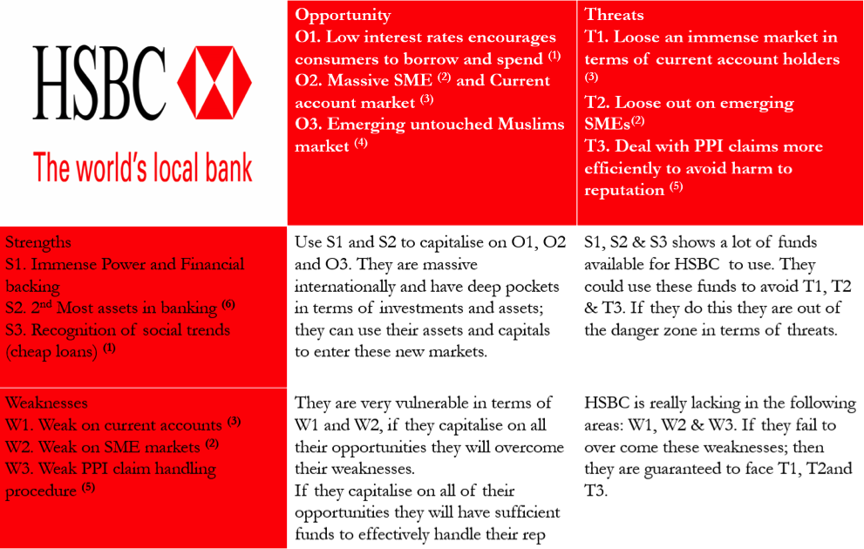
Picture 1
Source: https://uweguro.wordpress.com/

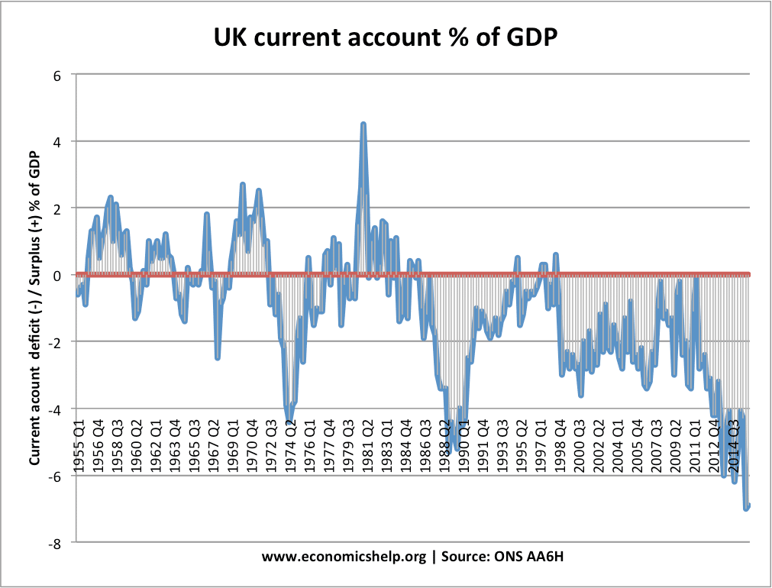
Picture 2
Source: https://www.economicshelp.org/macroeconomics/bop/probs-balance-payments-deficit/
The banks` threats can be identified by the following factors: the loss of an immense market in terms of current account holders, credit issues, rising interest rates can further threaten HSBC's profitability, the others countries where HSBC does business can make some changes who can affect the profitability, also some scandals can change the confidence in HSBC. For example, the Hong Kong Free Press in the article “ Hong Kong church says HSBC account frozen `in retaliation` for helping protesters last year”, says that the accounts of The Good Neighbour North District Church -the organiser of “Safeguard Our Generation” a group of volunteers who tried to “de-escalate violent clashes between protesters and police during last year`s anti-extradition bill protests”- and some other clients’ accounts were frozen without prior notification or justification (Chau, 2020). During this situation, the church has started an online petition in order to unfreeze their accounts (see appendix 1). Therefore, the press can have a negative impact to the company brand and can change the customer behaviour.

HSBC CRM and Consumer Behaviour
As we all know, for a successful business you must have customer knowledge, for high quality relationships, which is most valuable to HSBC. Even though consumer behaviour change, you must leverage deep consumer insights. Due this global pandemic situation (COVID 19) that has caused consumers to change their behaviours, HSBC had to improve their support in order to enable the bank to achieve its objectives by developing and maintaining good customer relationships.

CRM Definition
Customer relationship management is defined as “the core business strategy that integrates internal processes and functions, and external networks, to create and deliver value to targeted customers at a profit, grounded on high-quality customer-related data and enabled by information strategy” (Buttle and Maklan, 2015).
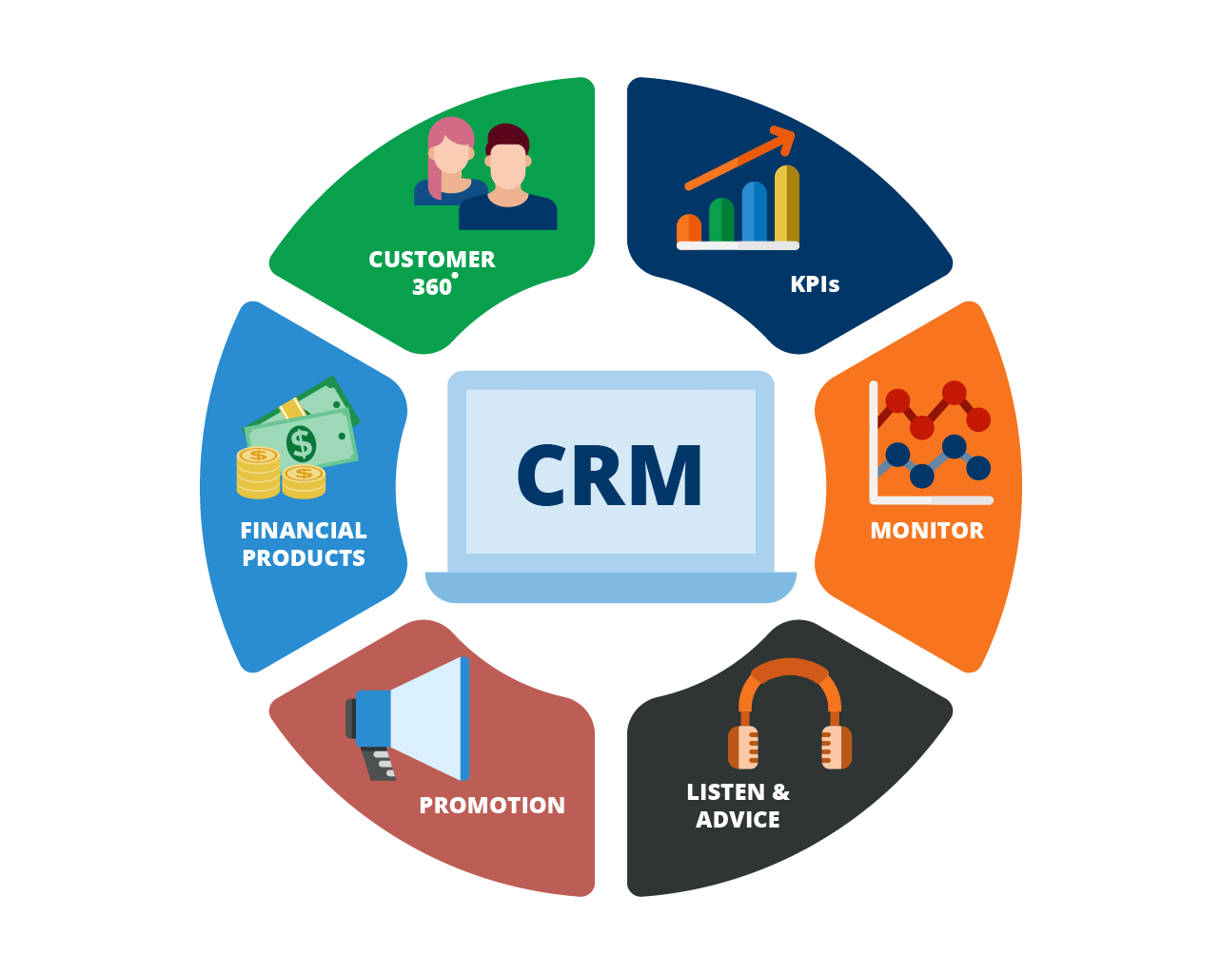
Source: https://www.cetrixcloudservices.com/blog/getting-the-most-out-of-crm-in-banking-industry-businesses
There are more definitions for CRM. Can be defined as a process to identifying, acquiring and retaining customers, helping the organizations maximize the value of every customer interaction across multiple channels, departments, lines of business and geographies. Also, CRM can be defined as a process of managing information system that helps the company to plan, schedule and control the pre-sales and post-sales activities, such as call centre, sales force, marketing, technical support, and field service. Each organisation is using CRM in order to improve long-term growth and profitability and this can happen though a better understanding of customer behaviour.
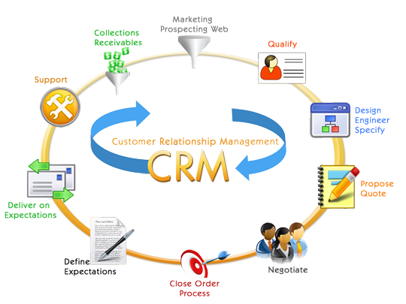
There are 3 dominant characteristic types of CRM:
- Collaborative- manage and synchronize customer interaction points and communication channels
- Operational- improve the efficiency of CRM businesses processes and compromise solutions for sales force automation and marketing automation
- Analytical- manage and evaluate knowledge for a better understanding of a customer behaviour, by using customer-related data for either strategic or tactical purposes.
Being one of the world’s largest banking and financial services organizations, HSBC adopted the Customer Relationship Management in order to improve and maximize the customer value, to provide better banking services anytime, anywhere and anyhow, and to have a top position in the market place by creating and delivering value better than competitors.

Consumer behaviour definition
CRM is playing a huge part in consumer behaviour helping the company in the process of understanding why clients buy particular goods and services by providing products that are needed in market place, and present in the best way the goods and services to the consumers.
Consumer behaviour is a process through which buyers make purchase decisions, which organizations select, buy, use, and dispose ideas, goods, and services to satisfy their needs and wants.
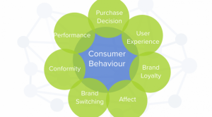
Source: https://www.williamjoseph.com/understanding-consumer-behaviour/

Consumer behaviour can have cultural influences (culture, value, beliefs) and family influences (teenagers and children represent a huge market and they can influence what their parents buy). It is affected also, by a number of internal factors (personal factors) such as: needs and motive, education and income level, marketing factors- price, packaging, promotion, design and distribution- cultural, psychological or situational factors. Therefore, every company uses touchpoints (image A) to collect customers data and not just to communicate with them, for example, emails and websites, or face to face meetings, calls. If a customer is a profitable, other information may need to be collected and analysed from touchpoints like customer wants and needs, their purchase and customer lifecycle, interaction opportunities and their profile. HSBC affirmed on their website that in 2019, 89% of their retail banking customers’ transactions were conducted via mobile or online channels.
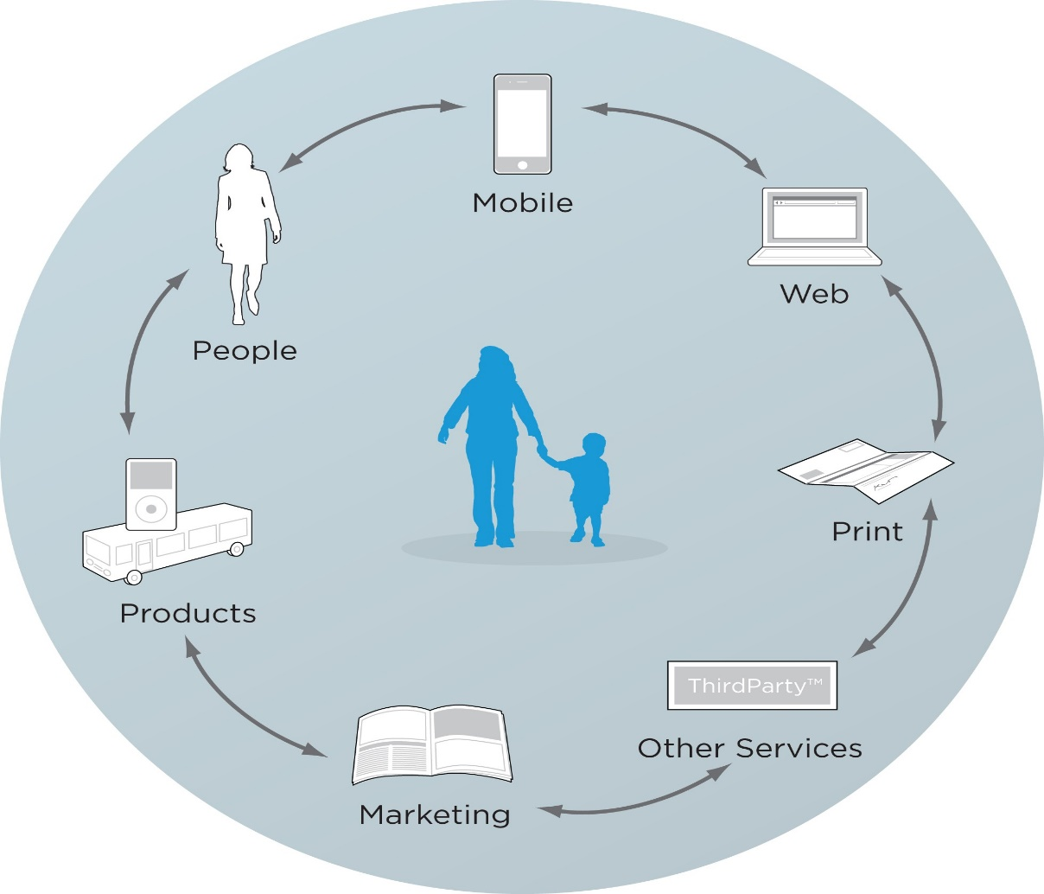
Image A
There is a customer lifecycle that represents stages that customers go through in their relationship with a company, as seen from the company’s perspective. A financial institution that effectively studies their customers lifecycle will provide information on auto loans at age 25, life insurance at 30, mortgage information at 35 and retirement at 55. In this case, the bank will always have the right data in order to know their client and keep them loyal to their services. In image B we can see that there is a consumer decision making process that establish which product is going to fulfil customer’s needs. The first step is called “need recognition” which a consumer becomes aware of what he/she needs, and the company must deliver the perfect product. For example, a client of HSBC was unsure about opening a Premier account because he wasn’t aware of all the benefits can get by doing this. In this situation, the Relationship Manager determine the targets demographic needs and considered that it would be an ideal time to advertise on it by offering financial advice to help the client adapt and thrive. The second step is “search for information” known also as pre-purchased search”. At this point the consumer is searching information and collecting data in order to make the right decision and putting some extra time in risk management.

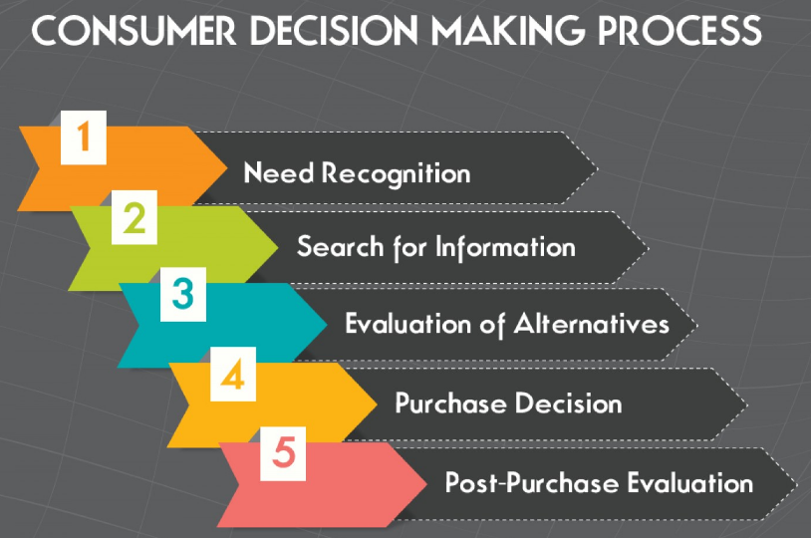
Image B
Source: https://consumerbehaviourmarketing.home.blog/2019/03/25/consumer-decision-making-process/
As our client was insecure about opening another account and he start searching the pros and cons to help him make the decision. The next step is number 3 in the process and says, “evaluation of alternatives”. At this step the consumer may start to ask questions regarding the brand or product that may select, and once the customer has determined what will satisfy their want or need he/she will begin to look out the best deal. This thing can be based on price, quality, or other factors that are important to them. For example, the HSBC client he was going to have a baby, and he wanted to open this separate account in order to support his family, but he had doubts regarding which will be the best option for him.
On the 4th step is all about the consumer that is ready to make a purchasing decision, after he analysed all the facts and passed all above steps. At this point the consumer is at his final conclusion, based on his personal experiences or emotional connections, also influenced by campaign`s marketing.
The final step is `post-purchase evaluation`, which refers to a complete evaluation and analysation of the product that customer bought in order to find that his purchase was useful for him or not. If the costumer had a positive experience with the purchase, this could influence other potential customers toward the product, or the same thing can happen with a negative experience.
Consumer decision making process can be complex and all depends upon the opinion of a customer over a particular product, as well comparing, evaluating, and selecting from a variety of products.

HSBC Relationship Marketing Strategy
Relationship Marketing (image C) refers to marketing activities such as development, growth, and maintenance a long-term relationship not only with customer but also with employees and suppliers, and any other partner for a common benefit.
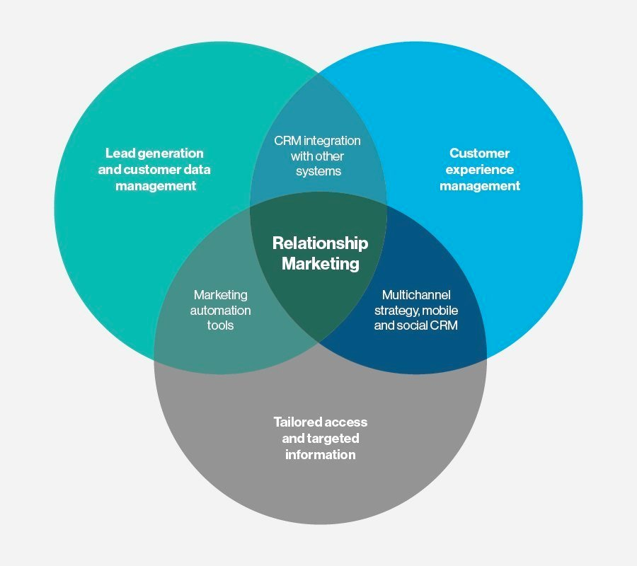
Image C
Source: https://searchcustomerexperience.techtarget.com/definition/relationship-marketing
There are four ways that organisations can use to build a long-term relationship:
- Collect data about their customers
- Analyse the information and use it in case if they need to modify the marketing mix
- Maintain interactions with customers
- Use the preferences and knowledge of their customers
In order to make the connection between customers to worldwide opportunities, HSBC developed strategic advantages. Being an international bank with access in high-growth markets, HSBC is maintaining a privileged position in high-growth market, especially in Asia and Middle East. The company has built a strong wealth business in 2019 with balances of USD1.4 trillion, the balance sheet becoming a further strategic advantage, and maintain a strong capital, funding, and liquidity position. Also, HSBC has a strong business with a premier international wealth proposition and scale retail banking operations in Hong Kong, the UK and Mexico. Supported by a faster pace of growth in Asia, the company`s wealth is expected to continue to rise
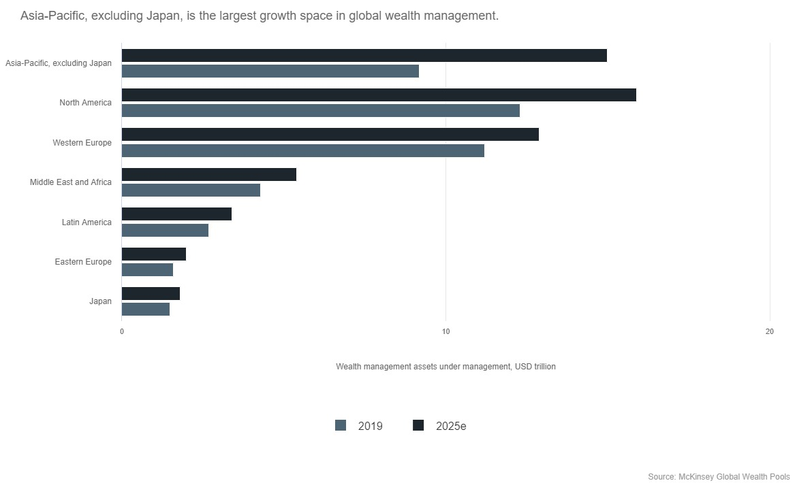
Source: https://www.hsbc.com/our-approach/our-strategy
To underpin their strategy, the company use its values to grow the business in the right way, values that define who they are as an organisation, and what makes the company distinctive. HSBC consider that the company is dependable, opened to different ideas and cultures, also, is connected to customers, communities, regulators, and each other (showing respect, being supportive and responsive). The company consider that their values reflect the best aspects of its heritage and remain key to a long-term success.
The Marketing Mix Strategy of HSBC analyse the company that covers 7Ps- Product, Price, Place, Promotion, Process, People, Physical Evidence, helping the company explaining its marketing strategy. In order to achieve business goals and objectives, many companies are using marketing mix framework to define the strategies.
The HSBC`s product marketing mix strategy can be shown as follow: with its four big segments mentioned above (in the company background) under which company has made its activities, that offered all over the world that differ slightly from country to country. The bank provides all kinds of services such as banking services from personal or business or corporate banking (which includes the relation with the other banks), also offering services to all small and medium business such as multi branch banking, phone banking and doorstep banking, giving an insight on the product strategy in the marketing mix of the company.
The next P from marketing mix strategy stands for price or pricing strategy. HSBC pricing policies is basically a subject to change according to the market trends and according to the policy changes by its rival banks (Bashin, 2019). In order to eliminate the competition as much as possible, HSBC adopted a policy of pricing that involves acquirement through available funds, by adding, also value pricing policies in order to develop a customer base through this services, and maintain its customers satisfaction as their prime concern.
In the next point we have the HSBC place and distribution strategy. Being the world`s largest bank, HSBC has the capacity to operate successfully in a wide area, expanding its branches all over the world to achieve its goals by spreading its wide network. The bank has set up services in many areas to help the customers to access the banking services in all different ways possible (mobile banking services, ATM set at strategic locations, depositing cash with the card etc).
As for promotion and advertising strategy, HSBC has decided to use a very fierce way to promote themselves, placing advertisements on newspapers, business magazines, radio and on billboards, reaching out to the people in every way possible. With their sponsorship for the sporting events (AS MONACO and some rugby teams- see image D1 and D2 below) and official banking partner of the “ Wimbledon Tennis Championship”, the bank has made sure to create a good image among the people.
Process is the next P in marketing strategy. HSBC must follow regulations and principles like any other bank`s format. Even though the bank has the standard documentations and forms, HSBC has their approach to the customers based on their needs, offering services in a easy way by e-outlet in order to perform the banking activities and increase the customer involvement.
As for the next P in the strategy which stands for `people`, we can easily say that HSBC is dedicated to their customers related directly to them. Since the prosperity and growth of the bank is based on its customers, employees, management and workers, the company makes sure that all are well connected to their needs.
The last one p in the marketing strategy stands for `physical evidence`, which the bank does not lack them, using their website, business card, brochures, pens, even diaries (to their employees) and furnishing as their source of physical evidence. 
Image D1
Source: https://www.asmonaco.com/en/the-goal-of-the-century-2/

Image D2
Source: https://www.hsbc.co.uk/sponsorship/rugby/

Quality Systems and Control at HSBC
In a competitive marketplace quality is a key component to a company`s success. As for banks there must a well-developed system in order to keep money and customers` data in safe place.

Total Quality Management (TQM)
We can define quality management as the continuous effort to improve products and work process in order to achieve the customer satisfaction and a world-class performance. For HSBC, the technology plays a crucial role to fight against financial crime, forcing the company to invest heavily in order to create a safe and an integrated system to keep away the criminals that are trying to access the banking records. Over the years, the bank had to improve their IT infrastructure, investing in a new and upgrade systems. With almost 700 million transactions across 240 million accounts, the bank has to screen and look for sings of financial crimes or money laundering.
Therefore, the company has to invest a lot in order to help itself to make a step change in their effectiveness, that benefit the bank and its customers.

Internal and external factors that can influence HSBC`s quality systems
Internal factors that can influence the quality systems to a company are those factors that are in the company and we can control, such as staff, human resources. As for external factors we can say that Brexit or the most recent one is COVID 19, that may lead to a huge crisis in the economy, generating significant instability and volatility in the global capital markets. Even if the financial sector has been the most affected by the global pandemic, HSBC offered financial support to its customers to make them feel safe and encouraging their employee to a flexible working.
Therefore, there are many factors that can interrupt the process to a successful business in achieving its objectives, but if the company will develop and maintain a good customer relationship, it can easily deal with the situations.

Conclusion
In conclusion, there are many steps that a company need to follow in order to deal with the situations like COVID-19 and to maintain and improve a good customer relationship, to achieve the company`s objectives. To an effective workplace environment, HSBC must understand the quality process in the workplace, analysing customers experiences and evaluate the benefits and challenging of developing and maintaining a good customer relationship. In the end, we conclude with the fact that this crisis helped the HSBC company to become more strengthen, even the competitivity put a big pressure on banks, forcing them to improve their quality systems and influencing their ability in maximising customer value, also primary goal being to improve long-term growth and profitability through a better understanding of customer behaviour.
To conclude, the changes that has made in HSBC company during this global pandemic period, modify the company strategies, leading to an continuous effort to improve workplace environment and customer expectations.

References
Bashin, H. (2019, March 22). Marketing mix of HSBC – HSBC marketing mix. Retrieved January 12, 2021, from MARKETING91: https://www.marketing91.com/marketing-mix-of-hsbc/
BBC Worklife. (n.d.). Retrieved December 13, 2020, from Coronavirus: How the world of work may change forever: https://www.bbc.com/worklife/article/20201023-coronavirus-how-will-the-pandemic-change-the-way-we-work
Buttle, F., & Maklan, S. (2015). Customer Relationship Management: Concepts and Technologies. Routledge.
Chau, C. (2020, December 8). Hong Kong church says HSBC account frozen ‘in retaliation’ for helping protesters last year. Retrieved December 17, 2020, from Hong Kong Free Press: https://hongkongfp.com/2020/12/08/hong-kong-church-says-hsbc-account-frozen-in-retaliation-for-helping-protesters-last-year/
Downey, E. (2019, March 25). Consumer Behaviour. Retrieved December 18, 2020, from Consumer Decision Making Process: https://consumerbehaviourmarketing.home.blog/2019/03/25/consumer-decision-making-process/
Fraser, G. (2014, July 30). HSBC: the bank that likes to say no to Muslim accounts. The Guardian. Retrieved December 16, 2020, from https://www.theguardian.com/commentisfree/2014/jul/30/hsbc-bank-no-muslim-accounts-finsbury-park-mosque
Henning, G., Malte, G., Lutz, K., & Brennan, W. (2003). Knowledge-enabled customer relationship management: Integrating customer relationship management and knowledge management concepts[1]. Journal of Kowledge Management , 7(5). doi:10.1108/13673270310505421
HSBC UK. (n.d.). Retrieved December 17, 2020, from Premier Banking: https://www.hsbc.co.uk/current-accounts/products/premier/
Pettinger, T. (2019, May 27). Economics. Retrieved December 16, 2020, from Problems of a current account deficit: https://www.economicshelp.org/macroeconomics/bop/probs-balance-payments-deficit/
Professional Academy. (n.d.). Retrieved December 17, 2020, from MARKETING THEORIES – EXPLAINING THE CONSUMER DECISION MAKING PROCESS: https://www.professionalacademy.com/blogs-and-advice/marketing-theories---explaining-the-consumer-decision-making-process

Appendix
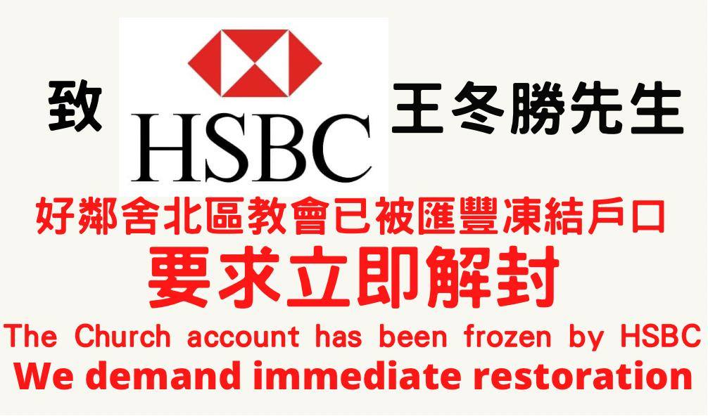
https://www.change.org/2ch9012rfas?fbclid=IwAR3IN3nOElXiSjYhoq8b4f_cHmRNZnPVJtwG-iJuPNzzHRZBsCwx_H7-DI4 Follow the link above to see the petition.

