
MENU
Valentine's Day 4-Course Dinner
£55 per person
Available February 14th and 15th

STARTERS
- Lobster Bisque with crème fraîche and chives
- Beetroot Carpaccio with whipped feta, pistachios, and honey
MAINS
- Fillet of Beef with truffle mashed potatoes, roasted vegetables, and red wine jus
- Pan-Seared Salmon with lemon risotto and grilled asparagus

DESSERT
- Chocolate Fondue for Two with strawberries, marshmallows, and shortbread
- Passionfruit Panna Cotta with raspberry coulis and mint

- Reservations are highly recommended.
- A deposit of £20 per person is required to secure your booking.

Add-Ons:

- A Bottle of House Red or White Wine - £20
- A Bottle of Champagne - £45
- Live Music Entertainment - £50 per hour
- All dishes can be made vegetarian or vegan upon request.
- Please inform your server of any allergies or dietary restrictions.

Offer:
Book a table for four or more and receive a complimentary bottle of house wine.

BEVERAGES
COCKTAILS

- The Trinity Martini - gin, vermouth, olives - 50ml - £8
- Strawberry Fields - vodka, strawberries, lemon, sugar, egg white - 50ml - £9
- Espresso Martini - vodka, espresso, Kahlúa - 50ml - £10

BEERS

- Peroni - 330ml - £5
- London Pride - 500ml - £6
WINES
WHITE

- Sauvignon Blanc, New Zealand - 175ml - £7 / bottle - £25
- Chardonnay, California - 175ml - £7 / bottle - £25
RED

- Merlot, California - 175ml - £7 / bottle - £25
- Cabernet Sauvignon, Chile - 175ml - £7 / bottle - £25

SOFT DRINKS

- Coca-Cola / Diet Coke - 330ml - £3
- San Pellegrino - 500ml - £4

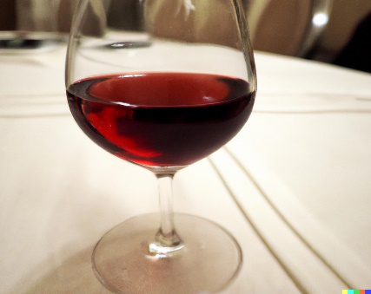
HOT DRINKS
- Cappuccino - £3.50
- Latte - £3.50
- All measurements are in ml.

References
Bondzi-Simpson, A. and Ayeh, J.K., 2017. Serving indigenous dishes in hotels: An inquiry into the conative response of menu decision makers. International Journal of Hospitality Management, 67, pp.115-124.
Fakih, K., Assaker, G., Assaf, A.G. and Hallak, R., 2016. Does restaurant menu information affect customer attitudes and behavioral intentions? A cross-segment empirical analysis PLS-SEM. International Journal of Hospitality Management, 57, pp.71-83.
Phillips, P., Barnes, S., Zigan, K. and Schegg, R., 2017. Understanding the impact of online reviews on hotel performance: an empirical analysis. Journal of Travel Research, 56(2), pp.235-249.
Sims, R., 2010. Putting place on the menu: The negotiation of locality in UK food tourism, from production to consumption. Journal of rural Studies, 26(2), pp.105-115.
Yang, C.Y. and Chang, T.Y., 2011. Binomial real option pricing for restaurant menu analysis. Cornell Hospitality Quarterly, 52(3), pp.273-282.

