Marketing Fundamentals
Module code: LCBB4004

Assignment Title:
Assessment 2 - Marketing Fundamentals Analysis and Evaluation

Student Name: Anastasia Slepuhin
Student Number: 2013044

Module Lecturer’s Name: Ze Zook

Contents
Introduction: 3
The role of marketing for creating value 4
Engagement of the stakeholders and influence on the marketing program 11
Conclusion: 13
References: 14

Essay on role of the marketing & Stakeholder impact on the marketing activities of an organisation

Introduction:
Marketing is considered as the boundary spanner of the organisation that creates an interconnection between the company and the external environment. It creates values for the company as well as the customers with time, knowledge, and place utility mainly. The activities included in taking the products from the manufacturing unit to the customer’s doorstep are considered as marketing practices. The marketers have to face influences of different parties who are economically or non-economically influenced by the organisation who they have to handle carefully emphasising on them according to their interest and power within the organisation. However, Nestle is a leading global fast-moving consumer good company that is serving over 190 countries with greater competency in marketing practices as well as managing the stakeholders in all 190 countries as reported in Nestlé Global. (2021). The following section is going critically analyse the way marketing creates values for the customers as well as its other roles and why to manage the stakeholders carefully defining how much attention they need.
Nestle is a leading global FMCG that originated from Switzerland and considered a food and drink processing conglomerate. The brand is conducting the operation with polycentric international marketing orientation matching the marketing strategies according to the special attributes there. The brand has experience of more than 1.5 centuries to operate in this industry. In 2018, the revenue of the brand was CHF91.43 billion (Nestlé Global. 2021).

The role of marketing for creating value
Marketing process:
According to Kotler and Armstrong (2013), marketing is the process of creating values for the customers and capture value from them in return for earning profit and a sustainable relationship with the target population. The marketers first define the market and then prepare the most appropriate products for them matching the values generated by the product and the expected cost of the consumers to avail it. Marketing is all about managing a sustainable and profitable customer relationship taking the customers at the center of concentration.
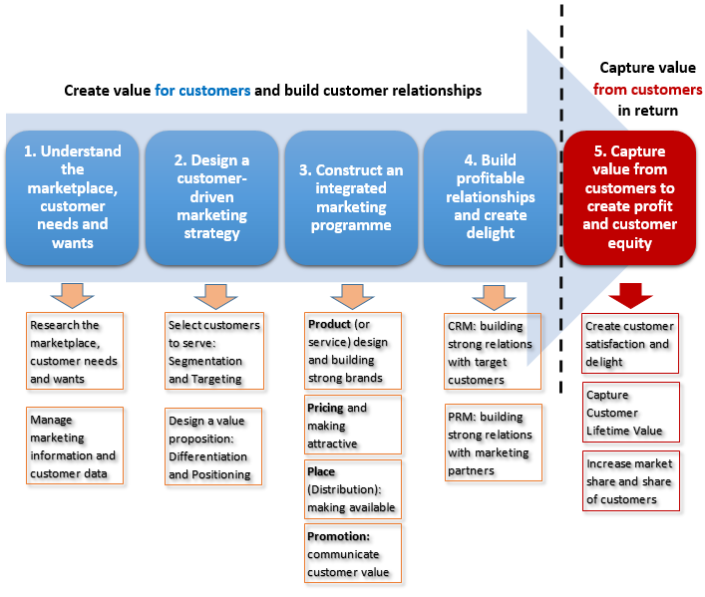
Figure 1: Marketing process
Source: (Kotler and Armstrong, 2013)
The above diagram has further illustrated the way the marketing process takes place defining the practices in each stage too. The operation starts with thorough marketing research on the external and internal environment of the market as well as consumer data that is followed by defining the target market and determining the set of value proposition they need. Then, the actual marketing program is designed according to the result of the previous analysis in this process; the strategies regarding the product, price, place and promotion are determined as opined by Armstrong, et al. (2018). To sustain the customer relationship as well as managing relationship with others with the customer relationship management and partner relationship management strategy. The successful completion of the program results in a set of satisfied customers boosted market share and customer lifetime value.
Marketing strategy
According to Brassington and Petitt, (2018), the organisation can't serve the total population of the market with the same marketing program in a concentrated way especially with the increasing competition and cultural diversity penetrated by globalisation. The organisations used to divide the market into different segment according to their homogeneity of need, choice, and interest and determine the most profitable one or more to serve with the organizational resources and capabilities. After justification of the attractiveness of the segments, the organisation has defined the targeting strategy determining the way, it is going to serve that market. Differentiated, undifferentiated, and concentrated marketing strategies are prominent in the business world but with the integration of technology in marketing practices, the emergence of one to one marketing and micro-marketing are notably taking the market attention. The brand must create a mark within the customer mind using its set of the value proposition to create a strong brand image. The positioning strategy can be developed by category, consumer, competition, attributes of the product, pricing strategy, and reputation as per the illustration of Philip (2017). Nestle has defined its target market with this marketing strategy and serving the market with the differentiated targeting strategy designing the products according to the customer segment. The positioning strategy of the brand was primarily based on the product category and attributes and now it has been successfully managed all the positioning strategy to create a strong position in the customer’s mind.
Customer value creation by marketing practices
With time different marketing philosophies have emerged with the changes in defining customer centralization. Production orientation was the most ancient concept of marketing where the marketers would perceive that availability and affordability matters to gain customer attention, therefore, they used to focus on economies of scale and cost leadership. According to Deepak and Jeyakumar (2019), when the competition in the market starts growing as well as the people have more purchasing power, the product concept arises and the marketers start focusing on product quality with the perception that the consumers will prefer the brand that provides them with the best quality. Nokia and Ford were such an organisation that has focused on the quality and attributes of the products ignoring the purchasing power or convenience and found huge success too. The selling concept has emerged with the excessive competition in the market when the marketers recognise that to draw customer attention in such huge competition, they have to push with a big threshold. They started to design the sales promotion tools competitively to grab the market attention that has emerged with the concept of everyday low pricing strategy. Walmart, Aldi, and other discount stores have gained growth with this concept.
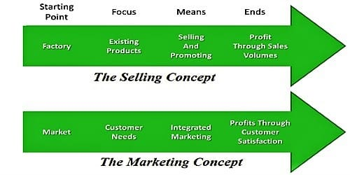
Figure 2: Selling vs marketing concept
Source: (Hollensen, 2019)
The next concept was the marketing concept where the organisation first define the market need and want and then design the marketing program accordingly and lastly define the cost and generate profit creating a sustainable relationship with the consumers. This concept is considered as the best concept among the previously discussed some as it centralises the market and recognises the customer needs first as illustrated by Hollensen (2019). However, later on, the increasing literacy rate and concern of the consumers on the ethical behaviour of the businesses as well as their participation in the social well-being has introduced the societal marketing concept and IKEA and Microsoft are the role model in this concept.

Roles of marketing
Product design
The motto of marketing practices is to create value for the customers in any format. The marketing process contributes to creating the exact solution of the customer need and want to design the product accordingly as opined by Homburg, et al. (2019). Nestle recognises the customer need while preparing the food supplements, for instance, NUN and Lactozen, the supplements for infants are prepared according to their age considering their physical growth, need of vitamins and minerals, and ability to take the supplement level as reported by Can’t, et al. (2019). They have managed a close look over their customers and well-researched product determining their attributes and characteristics.
Communication
According to Kotler and Keller (2016), marketing is called the boundary spanner of the organisation just because of establishing communication of the organisation with the internal and external parties or stakeholders of the organisation. While communicating with the consumers, Nestle uses both traditional and digital marketing tools applying the integrated marketing communication concept and reduce the knowledge barrier of the consumers effectively narrating the way their marketing offerings are going to support the healthy lifestyle of the target population. The brand has been successful in educating its consumers that penetrates its success in the infant food section largely as opined by Payaud (2018). The creative content of the message and the quality of food has boosted their acceptance to the customers.
Sales
The marketing program is mainly designed to increase the sales of the products communicating the organisational expertise to the target population. Apart from creating customer value, the marketers consider the sales growth first generating sales with different marketing mix stimulating customer preferences. Nestle has designed its products according to the customers need, manage fair pricing, and constantly communicating a strong brand image that induces its target population not only to purchase goods of Nestle for the first time but also boost the customer conversion rate as demonstrated by Sethi (2019).
Market research
The continuous market research contributes to the organizational success in defining the market gap and designs the product and total marketing program recognising each and every detail about the market. The marketing research not only contributes to product design but also determine the success of the products from the customer end, the changes required further and the contribution of the other elements of the marketing program in inducing organisational success. Nestle has investment 15% of its total marketing budget on research and development practices to define the consumer need properly and understand the market gap as explained by Kumar, et al. (2019). The brand is constantly monitoring the product success in the market and the changes in customer need so that they can be the first who adopt the change and be the first mover.
Customer service
The customer service program contributes to assuring customer satisfaction solving their problem before or after the purchase of the products assisting the consumers with the dilemma, they have. According to Koese (2018), this program added value to the customers with the appropriate solution to their problem as well as replicating the humble and empathetic attitude of the organisation for their customers. It is more important in the service industry as well as the business to the consumer market but nowadays with the increasing technological reach, it has got a penetration with the digital communication platforms. Nestle has managed a dedicated toll-free call center and 24/7-hour service for the target population helping them with any information regarding the product required. It has also a social media platform to be connected with the consumers and closely monitor their electronic word of mouth marketing following the customer movement online. The dedicated page of the brand helps the customer to find their solution.

Pricing
The pricing is the only elements that create value for the organisation and the brand used to create value for the consumers expressing their transparency in providing the goods for them at the right and fair price. There is a direct relationship between the price of the products and the product quality; it cannot be possible to provide quality products at a lower price. Therefore, the organisation should consider the balance between the price and quality and its impact on the customer mind as opined by Saxena (2015). Nestle is using a value pricing strategy to assure the right price of the products providing more value than that of the price charged. The brand is highly aware of the product quality as well as the purchasing power of the target market.
The marketing practices of the organisation also reduces the place barrier with the comprehensive distribution process and Nestle has focused on the indirect marketing channel to be closer to the customer with its team of distributors, wholesalers, and retailers.

Engagement of the stakeholders and influence on the marketing program
Stakeholders:
Those who are directly or indirectly affected by the organisational practices economically or non-economically are considered as the stakeholders of the organisation. The stakeholders of an organisation can be categorised into primary and secondary stakeholders. The primary stakeholders are the parties who have a direct economic transaction with the organisation including the customers, investors, suppliers, vendors, distributor, employees, creditors, and shareholders. On the other hand, those are not directly connected with the organisation with the economic transaction are the secondary stakeholder but they may have a strong influence on the decision-making process of the organisation as opined by Saxena (2015). For example, the government, legislative bodies, media, environmentalists, public, etc. are the secondary stakeholder who can affect the organisation strongly. For example, Maggie, the noodles of Nestle was banned by the media and government due to the existence of toxic ingredients there. The plastic industry facing a huge change due to environmentalists.
However, all of the stakeholders should be considered while defining the marketing program but not equally. The marketers have to understand the degree of interest and power of the stakeholders and take decision accordingly to decide how to treat them. Mendelow’s stakeholder matrix contributes to defining the impact and interest of the stakeholder suggesting the marketer’s attitude the interest and power correlation as per the illustration of Sethi (2019). Those whose power and interest is low for the organisation should be managed with minimal effort of the organisation with less concentration. The brand has to inform the stakeholders who have low power but high interest. For example, the suppliers and distributors of the organisation. They are highly affected by the changes in the organisation especially when the organisation changes the distribution process or product attributes. On the other hand, the organisation need trusted suppliers who provide quality ingredients and dedicated distributors who are supporting the brand to reach the target market, therefore, any change in the organisation has to inform them. The investors, shareholders, and creditors are also from this quadrant. The organisation has to keep the stakeholders satisfied who has high power but the low interest as they can change the organizational structure, culture, or the marketing program anytime. For instance, the government, media, public, and legislative bodies have low interest in the organisation but higher power to make change across the organisation anytime. Lastly, the most important stakeholders are those who have a high interest in the organisational practices as well as high power in the decision-making process of the organisation s expressed by Payaud (2018). The brand to consider them more in designing the marketing program as they are the key players of the organisation. The customer, employees and the board of directors are such parties of the organisation who have a direct impact on the organisation.
Stakeholders of Nestle
Nestle is highly concerned about the influence of the stakeholders on the organisation and design different tools to communicate with them. The brand shows a minimal effort to the parties who have low interest and low power on the organisation, for instance, the media have lower power on the organisation but it is a medium of public relation practices of the organisation, therefore, it provides minimal effort on this party but tries to keep a congenial relationship as their contribution can help the brand to create a strong brand image as opined by Saxena (2015). With the press release and press conference, the organisation communicates with the media.
Though Nestle has only to keep informed the suppliers and distributors for the changes in the organisation it has partnered with the suppliers to create a strong relationship with them to prepare a strong competitive strategy of the organisation as illustrated by Koese (2018). The brand manages the annual meeting with the suppliers, cares about the business practices of the suppliers and distributors to assure their ethical business practice. It has also managed a strong partnership with the distributors and dealers of the organisation with the different annual program. The shareholders and investors are communicated with the annual general meeting and the annual report of the organisation.
The brand is managing category C stakeholders keeping them satisfied. The brand is managing a strong relationship with the government and public with the sustainability report and the annual report of the organisation. The brand is prominent for its ethical behaviour with the transparency of the organisation strictly following the tax and tariff issues. Lastly, the key players are the core consideration of the organisation. Nestle regularly monitors the customers and try to manage interactive communication with them using traditional and digital marketing tools with organisational success and its Facebook page has already reached approximately 12 million people. With the informal communication system like WhatsApp group and the formal internal communication medium like the notice board, the brand is engaging the employees with the organisational goal as expressed by Kumar, et al. (2019). The board of directors has regularly informed with the organisational performance in the annual general meeting and any drastic change in the organisation has to be approved by them.

Conclusion:
The above section has contributed to understanding the role of marketing in an organisation and the way to manage stakeholders defining their influence on the organisation. Nestle is creating values for their customers with the help of its comprehensive marketing program that is supporting the determination of the product design, pricing strategy, communication process, branding, marketing research, and distribution process. Nestle knows the influence of their stakeholders and prepared a strong and effective system to manage the congenial relationship with all of them.

References:
Armstrong, G., Adam, S., Denize, S. and Kotler, P., 2016. Principles of marketing. Pearson Australia.
Brassington, F. and Petitt, S., 2018. Principles of marketing. London, NY: FT Prentice Hall.
Cant, M.C., Strydom, J.W., Jooste, C.J. and du Plessis, P.J. eds., 2019. Marketing management. Juta and Company Ltd.
Deepak, R.K.A. and Jeyakumar, S., 2019. Marketing management. Educreation Publishing.
Hollensen, S., 2019. Marketing management: A relationship approach. Pearson Education.
Homburg, C., Kuester, S. and Krohmer, H., 2019. Marketing management. McGraw-Hill Higher Education.
Koese, Y., 2018. Nestlé in the Ottoman Empire: Global Marketing with Local Flavor 1870—1927. Enterprise & Society, pp.724-761.
Kotler, P. and Armstrong, G., 2013. Principles of marketing. 15th ed. Boston: Pearson Prentice Hall.
Kotler, P. and Keller, K.L., 2016. Marketing Management 12e. France: Edition Pearson Education.
Kumar, A., NOIDA, G., GANGAL, D.V.K. and SINGH, K., 2019. Advertising and consumer buying behaviour: a study with special reference to Nestle Ltd. International Journal of Research in Commerce & Management, 2(10).
Nestlé Global. 2021. Home. Nestlé Global. Retrieved 17 March 2021, from https://www.nestle.com/.
Payaud, M.A., 2018. Marketing strategies at the bottom of the pyramid: Examples from Nestle, Danone, and Procter & Gamble. Global Business and Organizational Excellence, 33(2), pp.51-63.
Philip, K., 2017. Principles of marketing. Pearson higher education.
Saxena, R., 2015. Marketing management. Tata McGraw-Hill Education.
Sethi, S.P., 2019. Multinational corporations and the impact of public advocacy on corporate strategy: Nestle and the infant formula controversy (Vol. 6). Springer Science & Business Media.

