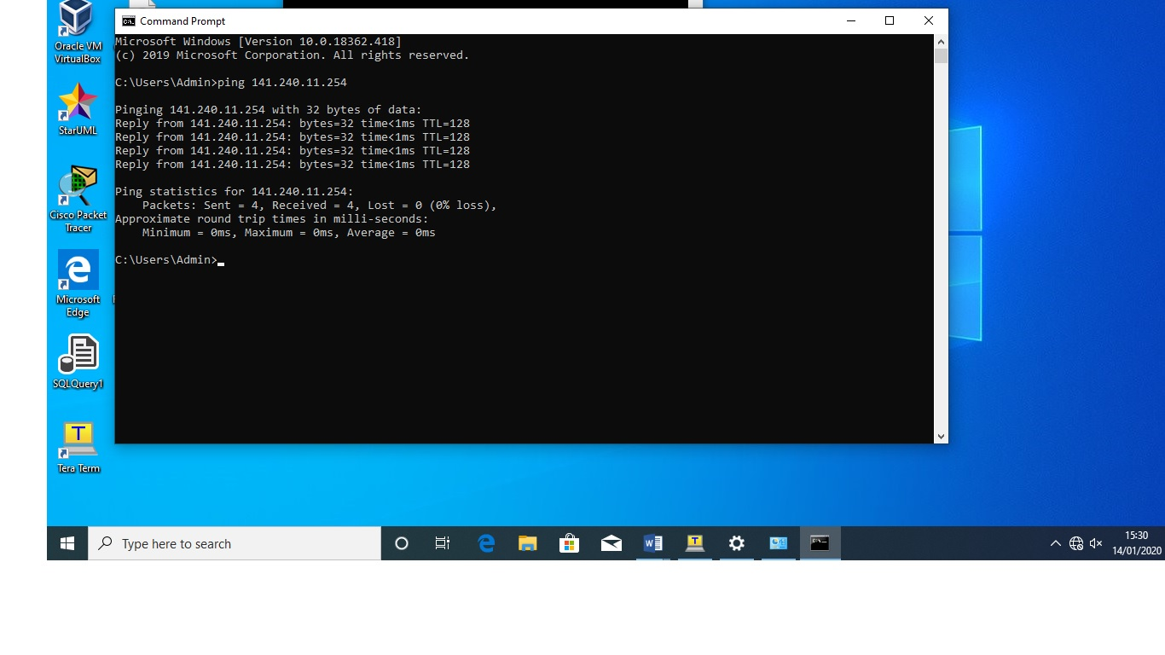

S1 con0 is now available

Press RETURN to get started.

This is authorized acces only

User Access Verification

Password:
Password:
Password:
S1>show run
^
% Invalid input detected at '^' marker.

S1>enable
Password:
S1#show run
Building configuration...

Current configuration : 1510 bytes
!
! Last configuration change at 00:55:07 UTC Mon Mar 1 1993
!
version 15.2
no service pad
service timestamps debug datetime msec
service timestamps log datetime msec
no service password-encryption
!
hostname S1
!
boot-start-marker
boot-end-marker
!
enable secret 5 $1$iuT3$o7QgoNCI0FY4wrvnCkp8g.
!
no aaa new-model
system mtu routing 1500
!
!
!
!
!
!
!
no ip domain-lookup
!
!
!
spanning-tree mode pvst
spanning-tree extend system-id
!
vlan internal allocation policy ascending
!
!
!
!
!
!
interface FastEthernet0/1
!
interface FastEthernet0/2
!
interface FastEthernet0/3
!
interface FastEthernet0/4
!
interface FastEthernet0/5
!
interface FastEthernet0/6
!
interface FastEthernet0/7
!
interface FastEthernet0/8
!
interface FastEthernet0/9
!
interface FastEthernet0/10
!
interface FastEthernet0/11
!
interface FastEthernet0/12
!
interface FastEthernet0/13
!
interface FastEthernet0/14
!
interface FastEthernet0/15
!
interface FastEthernet0/16
!
interface FastEthernet0/17
!
interface FastEthernet0/18
!
interface FastEthernet0/19
!
interface FastEthernet0/20
!
interface FastEthernet0/21
!
interface FastEthernet0/22
!
interface FastEthernet0/23
!
interface FastEthernet0/24
!
interface GigabitEthernet0/1
!
interface GigabitEthernet0/2
!
interface Vlan1
ip address 101.12.10.254 255.255.255.0
!
ip http server
ip http secure-server
!
no vstack
banner motd ^CThis is authorized acces only^C
!
line con 0
password class
login
line vty 0 3
login
line vty 4
password cisco1
login
line vty 5 15
login
!
end

S1 con0 is now available

Press RETURN to get started.

This is authorized acces only

User Access Verification

Password:
Password:
Password:
S1>show run
^
% Invalid input detected at '^' marker.

S1>enable
Password:
S1#show run
Building configuration...

Current configuration : 1510 bytes
!
! Last configuration change at 00:55:07 UTC Mon Mar 1 1993
!
version 15.2
no service pad
service timestamps debug datetime msec
service timestamps log datetime msec
no service password-encryption
!
hostname S1
!
boot-start-marker
boot-end-marker
!
enable secret 5 $1$iuT3$o7QgoNCI0FY4wrvnCkp8g.
!
no aaa new-model
system mtu routing 1500
!
!
!
!
!
!
!
no ip domain-lookup
!
!
!
spanning-tree mode pvst
spanning-tree extend system-id
!
vlan internal allocation policy ascending
!
!
!
!
!
!
interface FastEthernet0/1
!
interface FastEthernet0/2
!
interface FastEthernet0/3
!
interface FastEthernet0/4
!
interface FastEthernet0/5
!
interface FastEthernet0/6
!
interface FastEthernet0/7
!
interface FastEthernet0/8
!
interface FastEthernet0/9
!
interface FastEthernet0/10
!
interface FastEthernet0/11
!
interface FastEthernet0/12
!
interface FastEthernet0/13
!
interface FastEthernet0/14
!
interface FastEthernet0/15
!
interface FastEthernet0/16
!
interface FastEthernet0/17
!
interface FastEthernet0/18
!
interface FastEthernet0/19
!
interface FastEthernet0/20
!
interface FastEthernet0/21
!
interface FastEthernet0/22
!
interface FastEthernet0/23
!
interface FastEthernet0/24
!
interface GigabitEthernet0/1
!
interface GigabitEthernet0/2
!
interface Vlan1
ip address 101.12.10.254 255.255.255.0
!
ip http server
ip http secure-server
!
no vstack
banner motd ^CThis is authorized acces only^C
!
line con 0
password class
login
line vty 0 3
login
line vty 4
password cisco1
login
line vty 5 15
login
!
end

R1 con0 is now available

Press RETURN to get started.

Connected with PC1 to PC2

User Access Verification

Password:
Password:
R1>show run
^
% Invalid input detected at '^' marker.

R1>enable
Password:
Password:
R1#enable
R1#showrun
% Bad IP address or host name% Unknown command or computer name, or unable to find computer address
R1#
R1#show run
Building configuration...

Current configuration : 3477 bytes
!
! Last configuration change at 22:25:03 UTC Mon Sep 2 2013
!
version 16.9
service timestamps debug datetime msec
service timestamps log datetime msec
service password-encryption
platform qfp utilization monitor load 80
no platform punt-keepalive disable-kernel-core
!
hostname R1
!
boot-start-marker
boot-end-marker
!
!
enable secret 5 $1$bdsI$3Nwog25lC/.wfSDcNNFxn1
enable password 7 121A0C041104
!
no aaa new-model
!
ip admission watch-list expiry-time 0
!
!
!
!
!
!
!
!
!
!
subscriber templating
multilink bundle-name authenticated
!
!
!
crypto pki trustpoint TP-self-signed-1783363698
enrollment selfsigned
subject-name cn=IOS-Self-Signed-Certificate-1783363698
revocation-check none
rsakeypair TP-self-signed-1783363698
!
!
crypto pki certificate chain TP-self-signed-1783363698
certificate self-signed 01
30820330 30820218 A0030201 02020101 300D0609 2A864886 F70D0101 05050030
31312F30 2D060355 04031326 494F532D 53656C66 2D536967 6E65642D 43657274
69666963 6174652D 31373833 33363336 3938301E 170D3133 30393032 32313538
35315A17 0D333030 31303130 30303030 305A3031 312F302D 06035504 03132649
4F532D53 656C662D 5369676E 65642D43 65727469 66696361 74652D31 37383333
36333639 38308201 22300D06 092A8648 86F70D01 01010500 0382010F 00308201
0A028201 0100B036 6D4403EB C0FE0C53 8447E14B 00ABC5FA 44972A08 8CEB2341
0731F856 EEE0150E 104BD355 7D11EE5A FE2F9087 0FC36511 95067D80 295A2CCC
349EF609 E73A5F49 E4164AC5 B735C0CF 7C6EC2BF BDF825AC C10F4E24 EEC5DF3E
D502A09A C6E27F81 47A09C34 7E63B966 C9A353CC A37F868A 4F738D5A 39308226
4C022E59 1B305534 661489F8 A7AE395A 7F689865 C05BE1E5 6884C6D6 64FD901F
41E5F674 2E6C88F9 28480BC2 D3290CC7 60E8DC36 DF709299 DAC96657 B257465C
02E9893F 775812D9 C69C85C5 0534EFF6 883DE7F5 951591AA E11A538D 57DFCB46
04503239 9F9D7C19 504878EA 55371F4E 04EB7081 4FC64784 70588B96 18F94767
2127C11B 65BF0203 010001A3 53305130 0F060355 1D130101 FF040530 030101FF
301F0603 551D2304 18301680 144F7215 BA925ABA 65D40C72 9C31A3C9 85E4581D
AE301D06 03551D0E 04160414 4F7215BA 925ABA65 D40C729C 31A3C985 E4581DAE
300D0609 2A864886 F70D0101 05050003 82010100 A1BD663B DC060FBD B4115F9C
58A8479B 4FD05CEE 5B8C323D 2EC8C4E9 F90760DA 8BCD89B1 48E8EF0B 05E5DDEC
116FEA79 09EEBABF 57317768 E8A343AF A3437711 921D971D ED9CDE4A 4DB76B3C
9A99111D B4D3BCF2 981CECD4 C11E7978 38A1376F 09011319 6D1D98F0 30B4C3FB
15CBAFAB E5ECC544 CBE04729 D78F335F 8235E230 A5CD3AA8 D0C96A61 5B8CA0D2
631DE5CB 2BCE6190 1D5CC042 E3295D68 D7A1B3CD E2EFA45B 315400F7 F19BCE10
67CF762F 9B9A060B 48D619A8 CAA70E41 A3AC6074 BFE3DE7B 252F932B 1402EC9D
751D4527 E11DFC7E 36C191BC 2E6C706C C7205C7D 8CD89638 32593E08 6564A66D
D2631AA2 17041E3A 488E7AAE 32EF8CE0 A4060DAC
quit
!
license udi pid ISR4221/K9 sn FGL2235928E
no license smart enable
diagnostic bootup level minimal
!
spanning-tree extend system-id
!
!
!
!
redundancy
mode none
!
!
!
!
!
!
!
!
interface GigabitEthernet0/0/0
ip address 101.12.10.1 255.255.255.0
negotiation auto
!
interface GigabitEthernet0/0/1
ip address 141.240.11.1 255.255.255.0
negotiation auto
!
interface Serial0/1/0
no ip address
shutdown
!
interface Serial0/1/1
no ip address
shutdown
!
ip forward-protocol nd
ip http server
ip http authentication local
ip http secure-server
!
!
!
!
!
!
control-plane
!
banner motd ^CConnected with PC1 to PC2^C
!
line con 0
password 7 00071F071748
login
transport input none
stopbits 1
line vty 0 4
login
!
!
!
!
!
!
end

