Experimental Strategies
M5X01707
Simon Fudge
1904006
Lecturer Ryan Moule

Site Specific Group Exhibition

Illustrations & Photographic notes.
Fig 1 Environment Centre interior (S. Fudge).
Fig 2 Environment Centre interior (S. Fudge).
Fig 3 Environment Centre interior (S. Fudge).
Fig 4 No author, Local Authority publication. Lower Swansea valley: legacy and future. Published by Swansea City Council in 1982.
Fig 5 Lower Swansea valley: legacy and future. Published by Swansea City Council in 1982.
Fig 6 OS map, 1940’s. West Glamorgan Archive service.
Fig 7 OS map, 1940’s. West Glamorgan Archive service.
Fig 8 Lower Swansea valley: legacy and future. Published by Swansea City Council in 1982.

The venue for the exhibition is the first floor of the Environment Centre, Pier Street, Swansea. I made and presented a video of the setting.

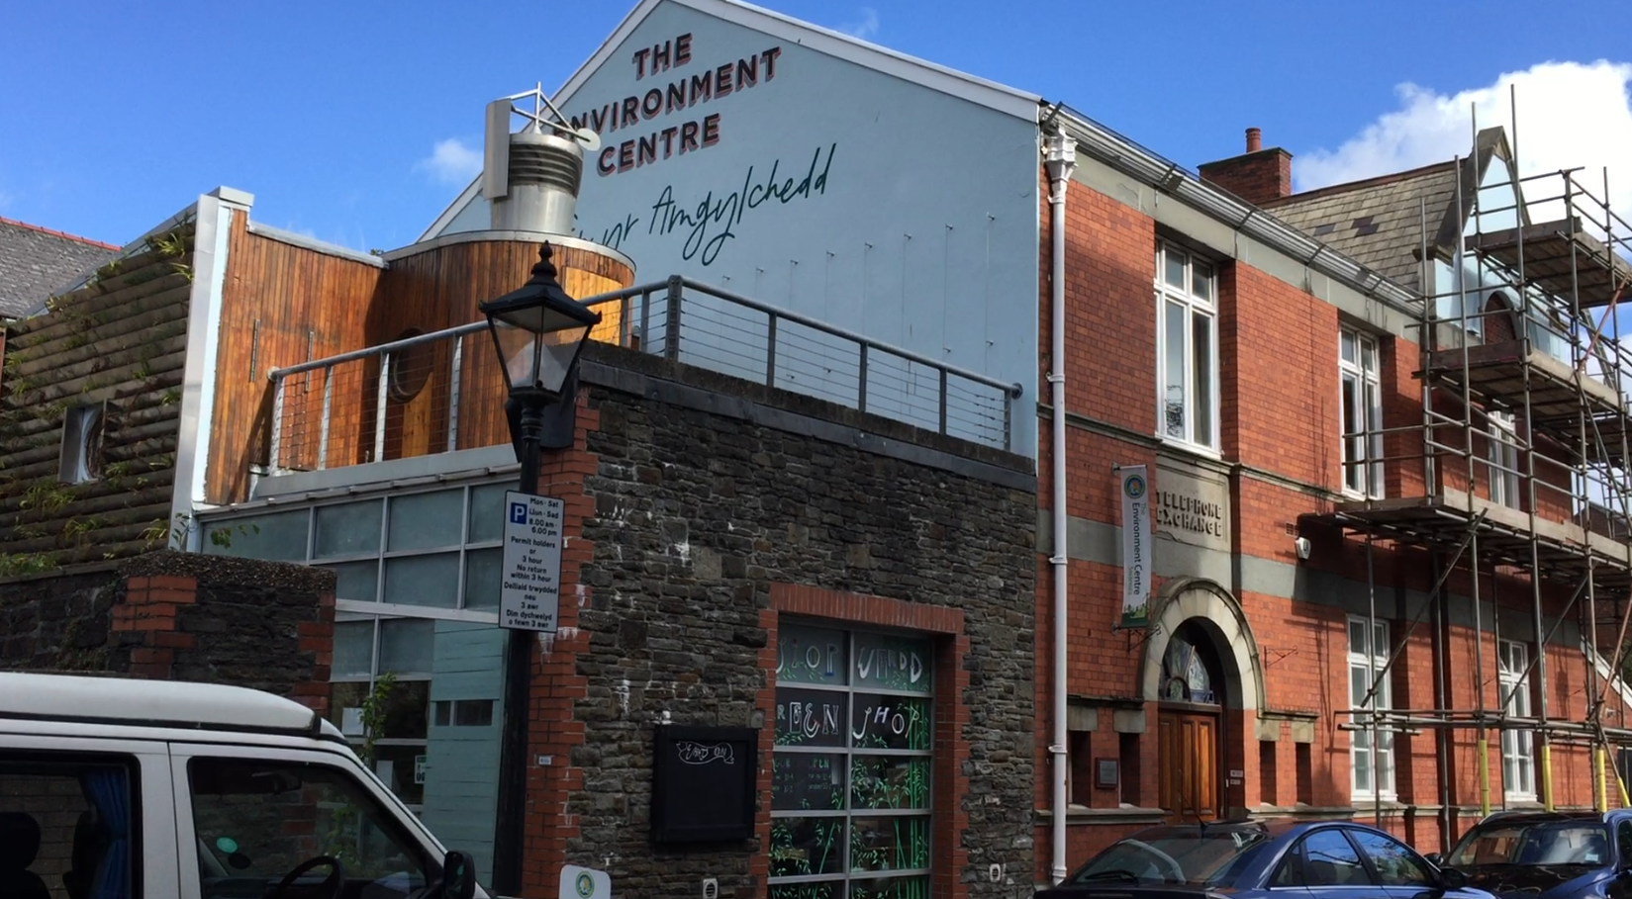
Fig 1

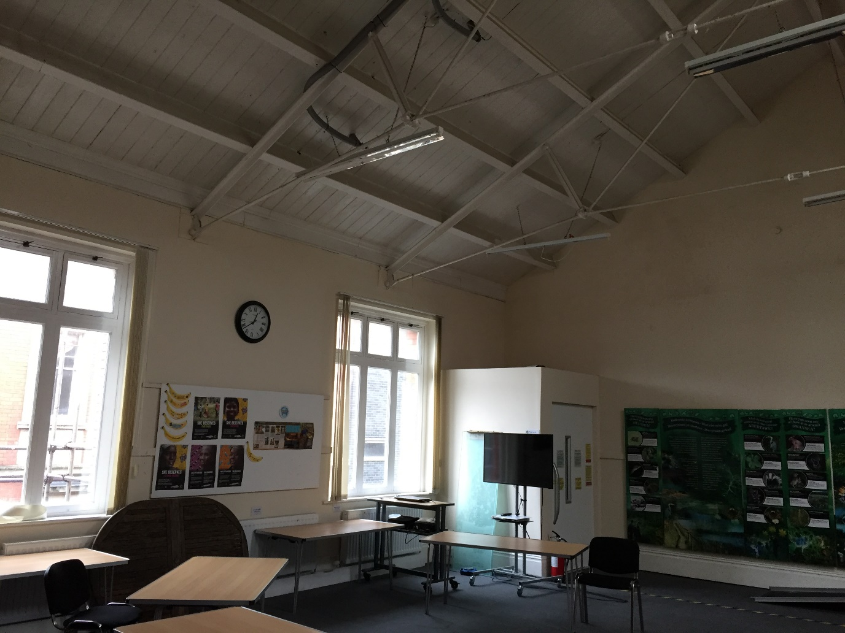
Fig 2

The Environment Centre is a charity whose aims are broadly to provide information, activities and inspiration for communities and individuals to make positive, ethical changes to help protect our environment.
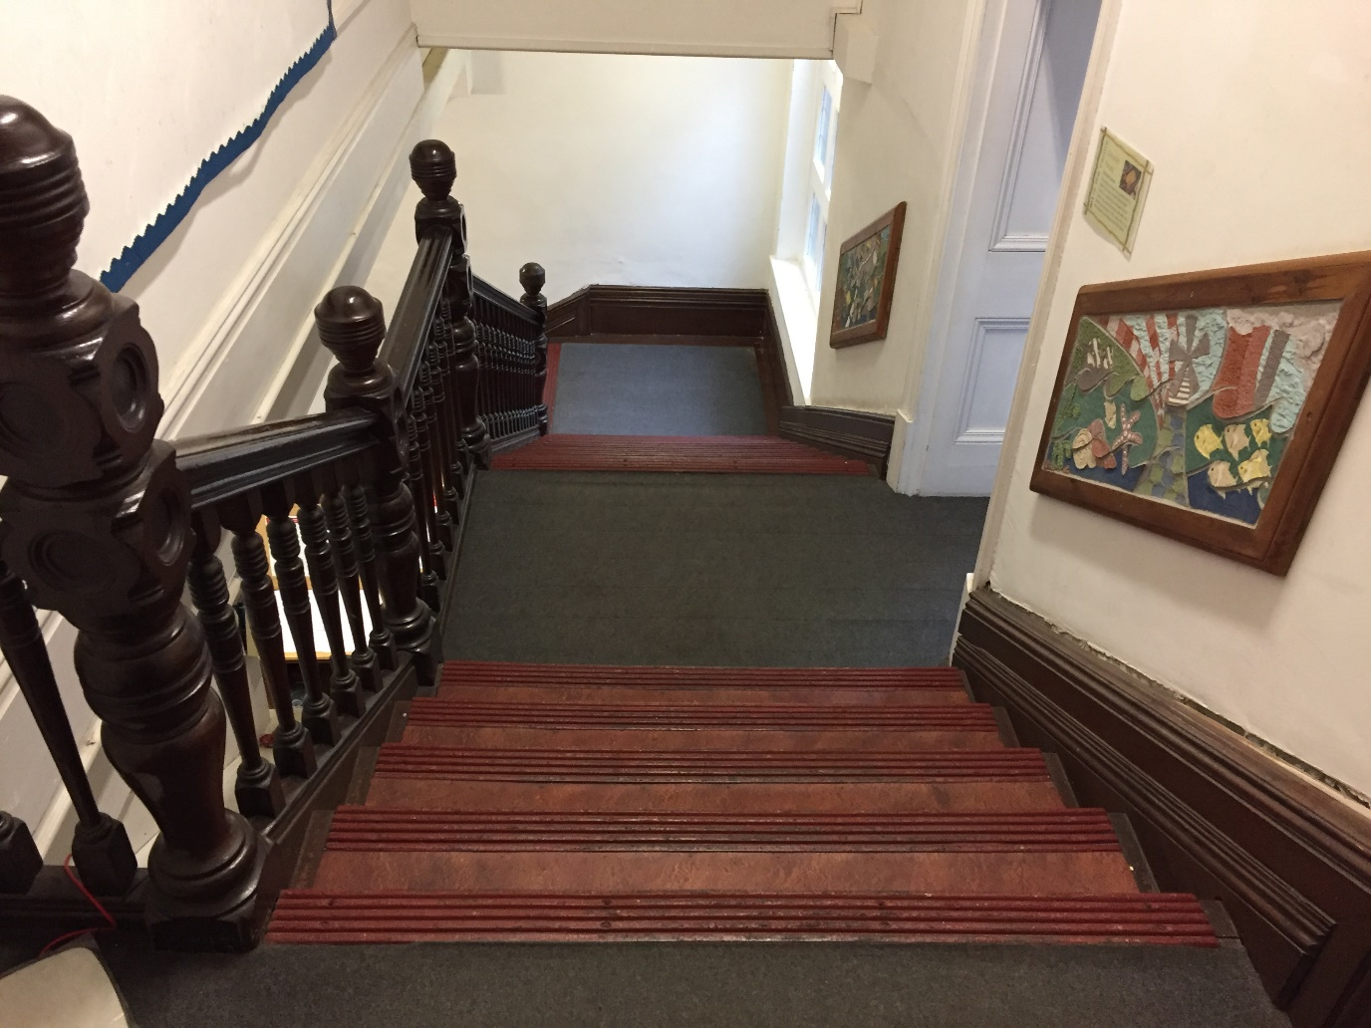
Fig 3

The building itself has been repurposed, having once been the telephone exchange for the town of Swansea. I am told by the staff that it was in commercial operation until the 1970’s.
It is built of red brick and is situated close to the river Tawe basin. It survived the bombings of the Luftwaffe during the second world war where much of this style of architecture was destroyed. The formal and ornate appearance of the building boasts of the wealth that was created in Swansea during the nineteenth and early twentieth centuries, much of which owed its origins to the metal smelting and related industries that flourished in the area. It is the location, history, purpose and repurposing of this site that has drawn us to it.
I grew up in Swansea with tales and stories, countlessly told and retold to me by my family over many decades about the metal smelting factories and their environmental repercussions. I clearly remember the devastation of the Tawe valley as a boy living in Llansamlet during the sixties and seventies. The air was often tainted with the gritty acrid traces of heavy industry and the land around the river looked like a dystopian lunar battlefield. I suffered from asthma but the doctors told my parents I was just a ‘nervous’ child and that the condition had nothing to do with pollution. Air quality and industrial emissions had a direct and painfully real impact on my childhood.

The ease of access to coal fields, the high quality of the coal and the proximity of the port made Swansea an ideal location for the establishment of metal smelting. It took three tons of coal to one ton of ore to sufficiently heat and release the valuable metals from the rock which came from Cornwall originally and later from other parts of the globe. My Uncle John was a merchant seaman and was involved in this trade.
The Industrial Revolution was well under way at the start of the nineteenth century and demand for copper and other smelted metals was great. The Royal Navy and merchant fleets needed large quantities of copper to line the hulls of their wooden ships so that Britain could build and impose its global Empire. Our city played its role in creating wealth and prosperity but it came at a price.
Evans & Miskell (2020), describe the appalling pollution produced by this industry and the shockingly dangerous, difficult and exploitative working conditions endured by the workers. The environmental toll and impacts to the landscape and the people living and working nearby was devastating.
I remember stories of children working in these hellish conditions. Some were sent up the factory chimneys to scrape off and recover the arsenic rich deposits and these unfortunate youngsters didn’t survive for long.
In creating our exhibition, our group not only have in mind the role played by the building in the commerce of Swansea but also in its current, repurposed role. The charity’s aims and activities resonate deeply with our thoughts around the effects of the metal smelting industry on the landscape and peoples of Swansea.
Also in our minds are thoughts of how Swansea has changed over the decades and what are the industries and exploited resources driving the economy of the city now. Hence, we have titled our exhibition ‘The New Coal’.
My individual work looks back at the site of the copper works owned and managed by the Vivian family and later by ICI (Metals Division). I researched the topic by visiting the site on a number of occasions and also visiting the Swansea library and the West Glamorgan Archive service.

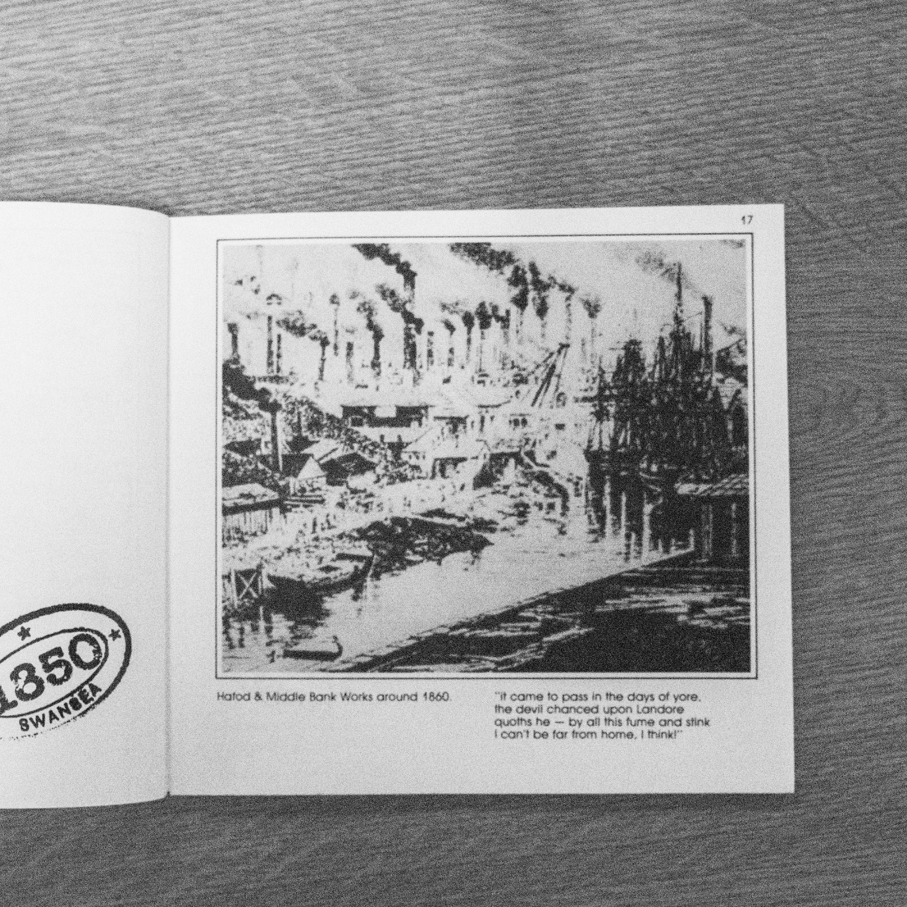
Fig 4

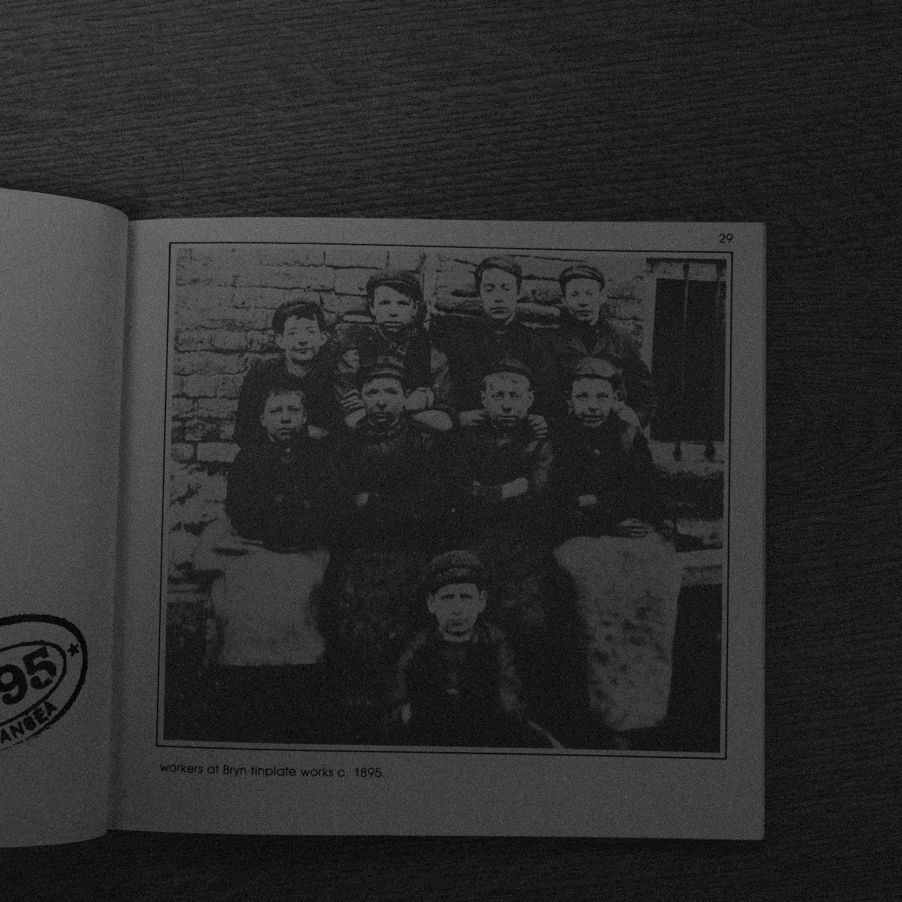
Fig 5

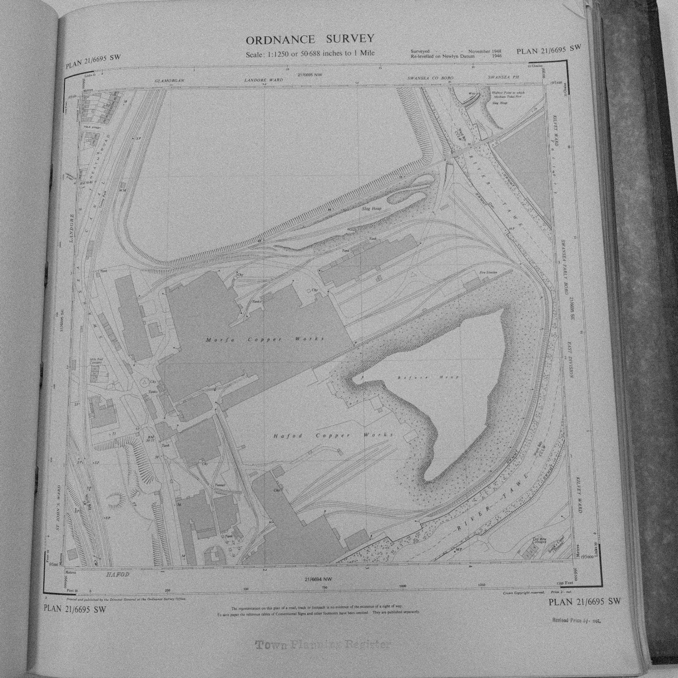
Fig 6

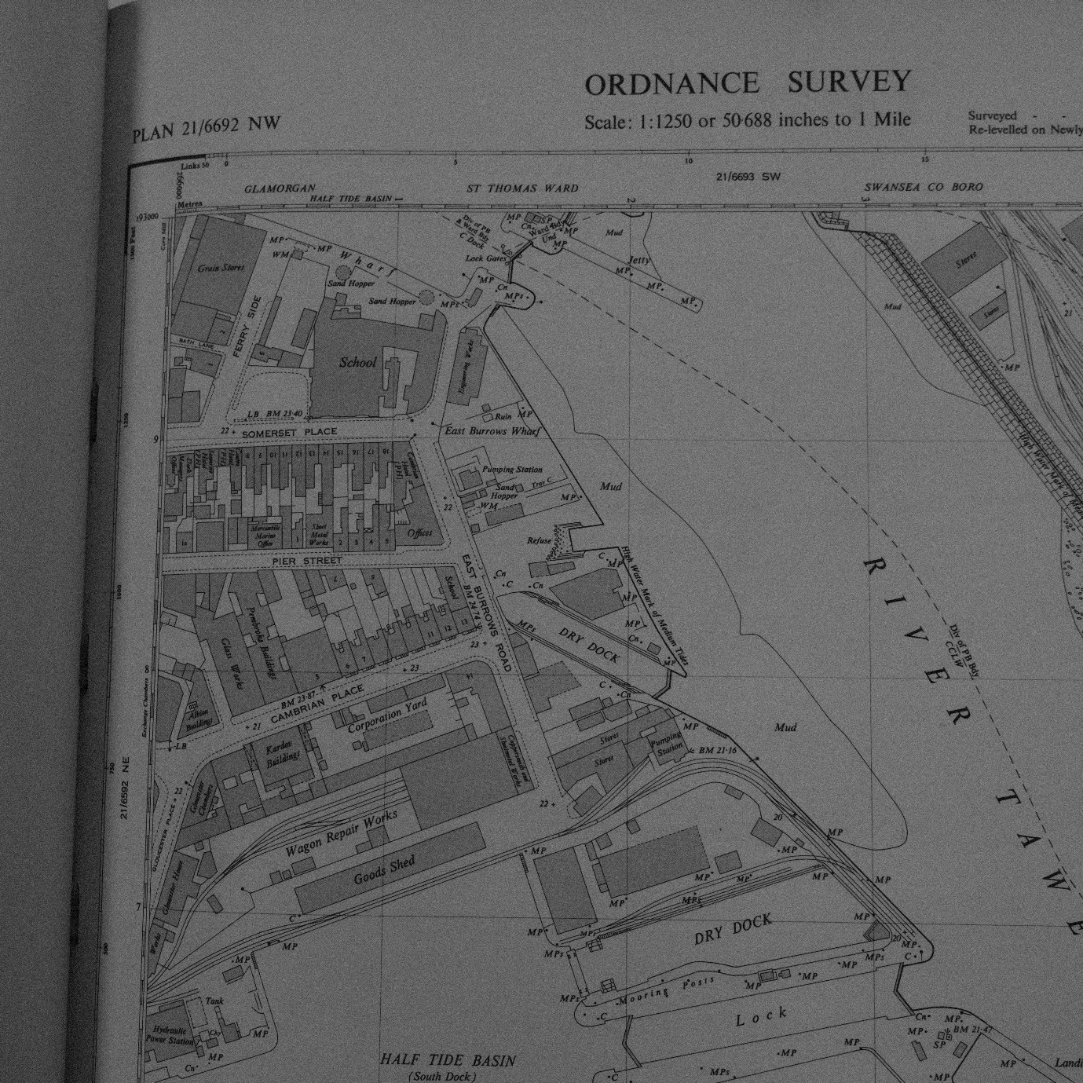
Fig 7

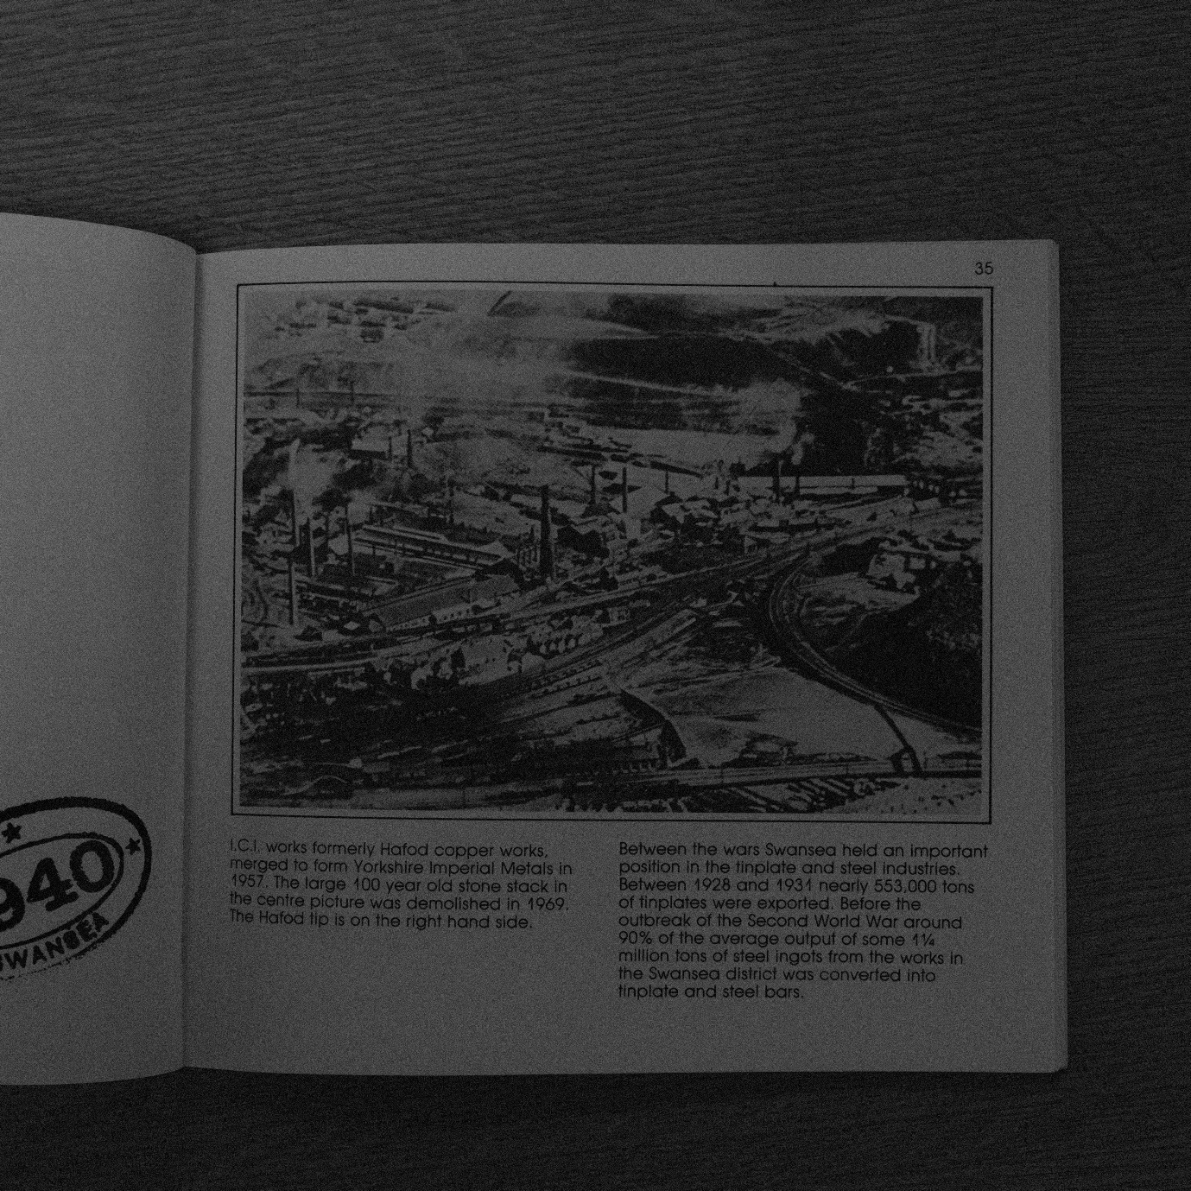
Fig 8

I arranged with Swansea University’s press officer a chaperoned photographic shoot of Singleton Abbey which was the Vivian family residence for many decades. The building is now the main administrative hub for Swansea University. It is perhaps the contemporary Education related conglomerates (with their Global expansionist aspirations), financed by the uncertain future indebtedness of many thousands of young people that drives much of the commerce of modern-day Swansea.
I thought about the many European countries that do not charge student tuition fees and about the quality of an education free of crude Capitalist and market values.

At the Morfa site, I thought about the working conditions in and around the furnaces, the heat, the smoke and the sulphurous and arsenic poisonous fumes. I was struck by the quiet and calmness of the place and how there was a dissonance there. The connections and visualisations were elusive but present with imagination. I was listening for the voices and visions of the past. For no clear or obvious reasoning that I can recall, but following feeling and instinct, I decided that I was seeking an otherworldliness to my images and I that I wanted to photograph at night.
Toomey, R. (1985) describes the copper trial of 1833 and how the Vivians managed to fight off a claim for public nuisance compensation by adjacent landowners whose land and livestock had been poisoned. This was one of the first ever environmental legal cases to be brought before the courts. The Vivians were able to afford the best lawyers and expert witnesses and successfully defended their case arguing that the coal and metal ore fumes were actually beneficial to good health. They called expert witnesses, including Michael Faraday to support their dishonest claims.
Of course, given that the Vivians were enormously wealthy and the MP’s for the area, they sat as magistrates in the courts and were high ranking officers in the local military militias, they successfully defended their case and were free to go on polluting and poisoning with impunity. It seems they had all angles covered.
I thought about the poisonous pollutants and residues still present under my feet. The poison of greed and dishonesty that seeps through still.
I thought about the acrid, choking smoke that must have filled the valley. I thought about how the pursuit of profit disregarded the health and wellbeing of workers, people and the environment.
Bull, S. (2010) describes how Surrealist photographers would use alternative methods in seeking to create a dreamlike or perhaps an unconscious quality.
Schaefer (1992) describes how Ansel Adams would use a torch in low light conditions to paint with light and illuminate the scene and I wanted to experiment with this method. I also burnt with a match some of my negatives. Some limited experiments with bleach and other chemicals failed as the emulsion was either completely removed or completely unaffected. (I suspect chemical alteration may work more effectively with colour film).
I arranged a visit to the Landore Social Club which was formerly the administrative offices of the works. I was drawn to the incongruity of the previously formal, oak lined boardroom, its past splendour and its current dilapidated state and damp and musty aroma. I reflected on how these men were venerated, how they might have seen themselves and how their portraits, memories and statues are now presented.
I have worked with the living tradition of film and printed in the darkroom on fibre-based papers (mainly). I am drawn to this method of creating photographic art. I feel more immersed with the process. It is a challenge and I sense that the results hold for me more of what Walter Benjamin might call an ‘aura’. The final image takes a longer and more arduous journey and demands diligence, respect and commitment. The processes are immersive.
I intend my images to be seen in person, as material entities and not digitalised and presented on a screen. I ponder on the trivialisation of a work of art when viewed through the increasingly problematic medium of an illuminated screen.
I have considered the use of text in or around my images perhaps as Bull (2010, p.40) suggests an anchor or relay but decided against it. I hope that the images create a narrative and invite engagement without written prompts.
These images will appear at the beginning of a timeline within the structure of the group show.
An artist that contextualises and informs my work is John Davies. It seems that many industrial landscapes of Britain deeply resonate with his lived experiences and that appears to be an important aspect when looking at his pictures. Davies (2018) explains that he is interested in the layers of history within the industrialised British landscape.
Like Davies I work in black and white for greater control and the more accessible darkroom processes. Davies suggests that colour adds a ‘sensual’ distraction which he wants to avoid.
The techniques of Ansel Adams both on location and within the darkroom have informed my practise. I have used his zone method for exposure and followed his dark room advice while experimenting with methods of printing. His ideas on visualisation, process and the importance of note taking were helpful.
Sally Mann’s ‘Antietam’ is also a body of work that I feel has influenced my intentions and outcomes.
Copyright permissions have been obtained from Professor Miskell and Chris Evans for sound reproduction of text from their book. Also, Kim Collis, West Glamorgan’s archivist has also kindly provided permission to use images contained in the publication Lower Swansea valley: legacy and future.
It is the plan that the other four artists respond to the more modern aspects of our concepts. My visual diary is contained in my notebooks, negative film holders and test prints which will be available for viewing on the day of the show.

References and Bibliography

Adams, A. (1996) Basic photo. 2, the negative - exposure and development. Little, Brown and Company. Boston, Mass.
Benjamin, W. The Work of Art in the Age of Mechanical Reproduction. Penguin
Bull, S. (2010) Photography. London: Routledge.
Davies, J. (2018). John Davies Interview: Deutche Borse Photography Prize 2008. [Video]. Available at https://www.youtube.com/watch?v=oIOua8NnlVM. (Viewed 16.11.21).
Evans, C. & Miskell, L. (2020) Swansea Copper: A Global History. John Hopkins University Press. Baltimore.
Mann, S. (2003) What Remains. Bulfinch Press. Boston, Mass.
Schaefer, J. (1992). An Ansel Adams Guide. Basic Techniques of Photography. Little, Brown and C. Boston, Mass.
Toomey, R. (1985). Vivian and Sons, 1809-1924. A Study of Copper and Related Industries. Garland, New York, London.

