Assignment 1
Assignment Title:Business Report – FINAL Sept 24 Term
Name: Md Mustakim Miah Burhani
Student Number: 2246150
Module: Financial Management for the Hotel Industry
Module code: BMIH5007
Programme: BA (Hons) International Hotel Management
Lecturer’s Name: Tristan Hawkins BSc, PGDip, PGCHE
Submission deadline: Friday 18th October 2024, 23:59 pm
Word count (or equivalent): 2000

I confirm that I have not presented any AI generated text as my own work

``Business Report – Comparison of Shangri-La Hotels and Premier Inn Hotels’’.

Contents
Introduction 3
Total Revenue 4
Market Position 5
Growth Potential 6
Financial Commitment to CSR 7
Recommendations 9
Conclusion 11
References 12

Introduction
This report presents a comprehensive analysis and comparison of two prominent players in the hospitality industry: The two big direct competitors include Shangri-La Hotels and Premier Inn Hotels. The emphasis is made on assessing their specific strategies on financial management with reference to the several important sectors which define their financial status and solvency.
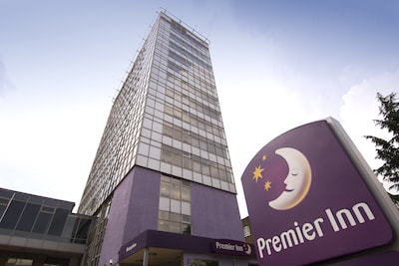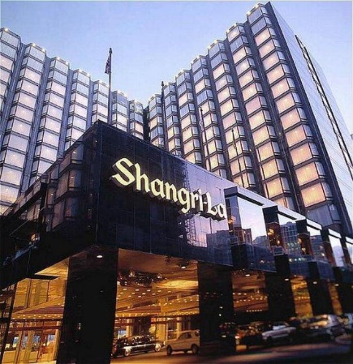
Fig: Shangri-La Hotels and Premier Inn Hotels

Total Revenue
Shangri-La Hotels
Shangri-La Hotels is a luxury Hotel Company with lots of Hotels across the Asia-Pacific region. Currently the main sources of the group’s revenue include room sales, food and beverage sales and units and other income producing activities (Alhemeiri et al., 2019). From the provided sources, detailed earning figures are missing, however, what can be clearly seen is that priority that Shangri-La gives to luxury markets brings significant earnings.
Since Shangri-La choose the luxury segment, the issue of setting higher room tariffs and you can spend more money on accredited services and products. This strategy ensures that hotels achieve high reeveue per available room (RevPAR) than normally attained by budget or mid-market hotels. That is because food and beverage operations are usually the main sources of the revenue for such groups since the groups’ focus is usually on offering excellent dining services (Chen & Chon, 2016).
Premier Inn Hotels
Marriott Courtyard is in the mid-priced and mid-boutique segment and Premier Inn is in the budget hotel segment and belongs to Whittbread PLC group. Its source of revenue is generated through the sale of rooms, targeting to deliver quality and affordable rooms (Page, and Connell, 2020). This has helped the company to record improved revenues over the years because of the consistency that is achieved when the company ensures that there are high quality properties.
They are using the revenue structure style of high volume and low margin in terms of their business. In striving to accomplish that goal, the brand achieves higher average occupancy much more than luxury hotels standards. Chibili (2019) opinion that this strategy also makes it possible for Premier Inn to earn very high total revenues even though the room rate is relatively low.
Comparison
One can note that the revenue models of these two hotel groups are very different because of that positioning. Most researches suggest that shangri-la’s revpar is probably higher from the hospitality stock list because of its luxury positioning while Premier Inn’s revenue is likely from higher occupancies and volume business ( Chen & Chon, 2016).
Non-room sources of revenue in Shangri-La are also higher and fairly robust which include food and beverage, spa and wellness and banbqua services. Such diversification may offer certain protection from economical instability, but simultaneously entail higher expenses to operate. Whereas in the case of Premier Inn, whose revenue generation is focused only on rooms sales, gives more leeway in the operational channel and perhaps more enhanced profitability even if generating relatively lower overall revenues per room.

Market Position
Shangri-La Hotels
Lan has established Shangri-La Hotels in the luxury segment of the market and targets business and high-end leisure customers. The group has significant market across Asia, and the expansion is gradually taking grips in the other parts of the world (Abdullah, 2015). That is, Shangri-La’s market position is defined as the commitment to Asian hospitality along with the luxury experiences only which serves the purpose of giving it a competitive edge in the global market.
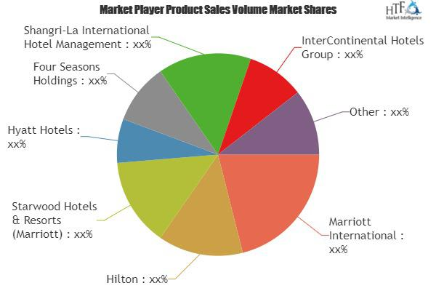
Source: (Abdullah, 2015)
Proudly embodying the brand positioning strategy is the guarantee of superb services of high quality, accent on lavish and universally appealing interior features, and coherent reference to the multicultural ethos of the Asian nations. This strategy has helped Shangri-La to position itself as not just a ‘copy cat’ of the Western luxury hotel chain and provided an exclusive selling proposition to appeal to the Asian. Therefore, using a comparative lens, the current article discusses how the Shangri-La’s approach of incorporating local culture has allowed the company to establish differentiation factors to the Western luxury hotel chains, and appeals to both Asian and international tourists (Ren, 2020).
Premier Inn Hotels
Premier Inn is one of the largest and most famous brands of low-cost hotels especially in UK. It occupies a strategic market position that sells standardized commodities, focusing on the idea that excellent quality of service at an affordable price is of outmost importance for the business as well as leisure travelers. The company has managed to achieve growth objectives set in different global markets by espousing reliability and comfort of their car brands.
Premier Inn targets its market with the slogan ‘We’ll give you a good night sleep, guaranteed’ stressing on the quality of bedding and rooms. This emphasis on the basics of hospitality justifies well with price-sensitive consumers who do not have to compromise quality and hygiene for a wide range of services (Page and Connell, 2020).
Comparison
Though both the hotel groups enjoy a good market share, the market niche they operate in, differ from each other. Shangri-La can charge higher rates due to its luxury segment appeal while Premier Inn targets the greater number of customers in the economy segment effectively covering large market share (Hu and Trivedi, 2020).
The difference in their market positioning also weighs down on their financial plans and results. IAsync as a luxury hotel brand, Shangri-La needs to permanently reinvest into maintaining its luxury positioning and to organicly and inorganically add new services or product offering to its portfolio to be able to sustain high-end price points. Although operating at relatively low profit margins, Premier Inn has the capability to reach its aims of high profitability and rapid growth with the help of high occupancy rates.

Growth Potential
Shangri-La Hotels
The Global Strategic Map shows that Shangri-La Hotels has an outstanding opportunity for growth, especially outside of the Asian region. Thus far, the group has been expanding its operation in Europe and North America because the market for Asian influence luxurious service is on the rise (Ren, 2020). However, high competition in the luxuries hotel industry and heavy capital that may be needed for expansion may act as constraints to its expansion rate.
The strategies on the group’s growth are the geographical expansion, brand diversifications, experience goods and services, and probably alliances or acquisitions. These strategies are intended to capitalize on Shangri-La’s excellent brand image it had created while at the same time dealing with the issues of brand diversification at markets it entered into.
Premier Inn Hotels
In the case of Premier Inn, dynamics of growth has been shown well in the areas of international markets. The brand is currently popular in the UK and this makes it easier to move to other countries since there is growing appreciation of good quality cheap branded accommodations (Chibili, 2019). Another important success factor is that structures the company established by Premier Inn is differentiated from the traditional heavy asset ownership approach by relying on management contracts and franchises for quicker expansion with less capital investment necessary.
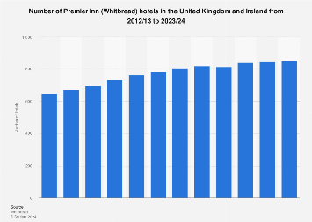
Source: (Chibili, 2019)
Key areas of growth prospects are the internationalisation, the application of new technology the market segmentation and partnerships with other companies. A well-developed system of organization and an ability to offer considerable value allow the brand to enter new areas rapidly.
Comparison
The strategies of both hotel groups depict a great potential for growth although by employing varying means. However, the projection of this growth of Shangri-La is likely to be more slow because of the high costs that accompanies establishment and expansion of luxury hotel and need to preserve the brand’s sophistication. While Haven’s plan of growth may not be so aggressive, it has great potential to show high growth than Premier Inn because its business model is fully scalable and because travelers all over the world are increasingly demanding inexpensive hotels as compared to Luxury and First Class hotels (Munjal and Singh, 2017).
Besides, the value of the plan for Shangri-La is still dependent on the development of the luxury traveller segment and the growth in the wealthy nations and other regions globally. While Premier Inn, belonging to the economy segment, still can boast greater opportunities and faster growth rates. Two major strategic issues that both brands wrestle with as they extend their brand and services worldwide include preserving the brand essence and achieving service consistency.

Financial Commitment to CSR
Shangri-La Hotels
Based on extent analysis, it is found that Shangri-La Hotels has shown a good focus toward CSR activities. It has set up several sustainability initiatives, most of which address environmental responsibility, stakeholder management, and company compliance (Bauer, 2017). Unfortunately, numbers are not available publicly, but from the fact that CSR is a part of Shangri-La business philosophy and marketing strategies, it is clear that a company invests a lot of money into it.
Major components of Shangri-La’s CSR programs comprise and extend to the spheres of environmental responsibility, community investment, suppliers and ethics, and culture. Indeed, these CSR activities involve a huge capital expenditure are essential in defining the Shangri-La brand and attracting the socially conscious, discerning luxury traveller.
Premier Inn Hotels
The six Hospitality Company including Premier Inn being a subsidiary of Whitbread PLC have also embraced the CSR of the company especially in Substantiality of Environmental Responsibility and Support of the Community. Energy efficiency has been incorporated in various technologies and in general construction of buildings owned by the company (Sinha and Fukey, 2020). CSR of Premier Inn involves a lot of cost conservation measures supported by the theory of business being smart when engaging in sustainable practices.
The CSR activities aims at the company are done in the areas of energy conservation, waste management, support of community, as well as management of resources. The identified pattern of interaction between the brand and CSR that has been found is that CSR is incorporated into operational efficiency objectives so that it aligns well with its long-term value based business model.
Comparison
Therefore, different hotel groups consider CSR as an essential factor of the effective system of managing the hospitality businesses. But the goals and strategies vary in scope of operations and extent of coverage. It is usually the case that Shangri-La’s CSR activities are broader and more in tune with its luxury brand strategy, and more costly. Although Premier Inn’s CSR engagements are comprehensive they are, however, more focused towards operational excellence cost cutting initiative consistent with the company’s economy-price model (Kaur, 2016).
Such difference is due to the differences in market positioning and the business models adopted by the two hoteling groups. Shangri-La has committed more of its resources to invest in CSR due to its efforts to sustain its luxurious image in the market and support cost leadership strategies that may allow for higher pricing of its products. In a way, Premier Inn’s opportunities and tactics are more realistic and functional to support significant CSR activities alongside the continuing affordable brand plan.

Recommendations
Recommendation for Shangri-La Hotels
These are the reasons why it is suggested that Shangri-La Hotels should put emphasis on adding various revenue sources by offering up and upper-upscale options. It would ensure that the group targets a wider market and at the same time retain the luxury positioning of Sharpu. To overcome the high costs of luxury Hotel chain development Shangri-La has the opportunity to create sub-brand or join with local hospitality providers (Qian, 2018).
Specific recommendations include:
- Create a sub-brand for the company to appeal for the upper-upscale demographic.
- Increase the applications of management contracts and franchising system.
- Expand the use of the digital promotion for targeting young food Torahs who are likely to travel affordably.
- It is advisable to embrace personalization technologies in order to improve the guests’ experience, as well as improve their loyalty.
- Better align corporate social responsibility actions with guests.
Recommendation for Premier Inn Hotels
There are many opportunities that Premier Inn should explore to make their business even better primarily through the use of technology. The use of artificial intelligence and virtual reality in different organizational functions can enhance the booking systems, as well as enhance the guest experience, and efficiency, including resource usage (Thelen, 2022). This technological emphasis makes sense for Premier Inn in terms of its value proposition and can drive profit improvements through cost take out and revenue generation to help drive its growth strategy.
Key recommendations include:
- Online and RFID based inventory, AI-based and smart pricing, and smart revenue management tools need to be adopted.
- Design and implement a mobile app with added functionalities that can make a guest’s stay much more comfortable.
- Use IoT system to enhance Room Management and Energy Management across smart and connected buildings.
- Research into virtual reality technology solutions for marketing before the stay and during the stay.
- Improve quantitative data analysis to have a clearer picture of what leads to customer’s actions.

Conclusion
Shangri-La Hotels and Premier Inn Hotels are the examples of different approaches to the management of accommodations with the set of the peculiarities, which contribute to the development of these businesses. The fact that Shangri-La is in the luxury market segment means that the business has a high earning capacity, but at the same time, it comes with high fixed investments required, while Premier Inn’s strategy locates it in a budget market segment and thus appeals to the broad market due to its cheaper rates while at the same time has a huge growth potential due to its flexible investments. These two companies show their effective market status and development opportunities, even though the choices are different. It is evident that their strategies of CSR correspond with their brands and their markets. Applying the given recommendations, both hotels’ groups can improve their businesses’ financial results and positions in the new conditions of the global environment.

References
1.Abdullah, H.H., 2015. Strategy Building and Sustaining Competitive Advantage: A Case Study of Shangri-La Hotels (Malaysia) Berhad.
2.Alhemeiri, N., Ali, N., Alawlaqi, M., Almarzooqi, Y., Alshowab, A. and Nobanee, H., 2019. Financial analysis of Shangri-La Hotel.
3.Bauer, T., 2017. Human rights obligations of international hotel chains. In Sustainability in hospitality (pp. 8-24). Routledge.
4.Chen, A.L. and Chon, K., 2016. Transferability of Asian paradigm in hospitality management to non-Asian countries. In Tourism and hospitality management (pp. 143-157). Emerald Group Publishing Limited.
5.Chibili, M.N., 2019. The Hospitality Industry–Past, Present and Future. In Modern Hotel Operations Management (pp. 16-47). Routledge.
6.Hu, F. and Trivedi, R.H., 2020. Mapping hotel brand positioning and competitive landscapes by text-mining user-generated content. International Journal of Hospitality Management, 84, p.102317.
7.Kaur, S., 2016. CSR in Indian Tourism and Hospitality Industry: A Special Reference to Aviation and Hotel Industry and CSR Initiatives by Punjab, Haryana, and Himachal Tourism. In Corporate Social Responsibility in the Hospitality and Tourism Industry (pp. 106-117). IGI Global.
8.Munjal, S. and Singh, A., 2017. The Growth Story OF Hotels In India: Looking Beyond The Rhetoric. In The Indian Hospitality Industry (pp. 17-42). Apple Academic Press.
9.Page, S.J. and Connell, J., 2020. Tourism accommodation and hospitality services. In Tourism (pp. 216-241). Routledge.
10.Qian, J., 2018. Use of language strategies for hotel website evaluation in China.
11.Ren, L., 2020. The Development of Hotel Management Contracts in China. In The Routledge Companion to International Hospitality Management (pp. 271-278). Routledge.
12.Roy, S., 2022. Changes in Hotel Accommodation Trends in the Past Decades. ATITHYA: A Journal of Hospitality, 8(1).
13.Sinha, M. and Fukey, L.N., 2020. Circular Economy: Assessing a Progress of Resources Efficient Practices in Hotel Industry. In Circular Economy for the Management of Operations (pp. 89-117). CRC Press.
14.Thelen, A.E., 2022. The Challenges and Benefits of Implementing Virtual Reality and Augmented Reality in the Hotel Industry.

