Hannah Ashton
Student Number: 2219397
Word Count: 2944
‘Analyse completion rates of return to work interviews in the organisation and their impact on sickness absence trends’
A Research Report carried out at TSUK

Contents

Introduction 2
Literature Review 3
Methodology 4

Findings 5
Conclusions 9
Appendices 10
References 16

Introduction
The research regards return to work (RTW) interviews and will be conducted in the Hot Rolled Products Department (HRP) at TSUK (TSUK). Research shows that RTW interviews have many benefits and significant impacts on sickness absence trends (Lucas, 2019).
My particular interest in this topic was sparked from the high levels of sickness absence in TSUK, which had an estimated cost of £1.84 million in August alone (TSUK, 2023a) in addition to the recent digitalisation of the RTW process. RTW interviews should provide a focus to address any ongoing health concerns and ensure the correct support is in place to allow individuals to be healthy at work which should in turn tackle sickness absence rates (Suff, 2023).
The aim of this research is to ‘Analyse completion rates of Return to Work interviews in the organisation and their impact on sickness absence trends’. Sickness absence accounts for massive economical costs across organisations and the United Kingdom as a whole. Public Health England (2020) estimate that the total cost of sickness absence in the UK accounts for more than £100 billion per calendar year. There has been plenty of research into RTW processes and this highlights that larger organisations see less impact from RTW than small-medium sized organisations (HR Solutions, 2023), so how can this be addressed for large organisations like TSUK?
In order to address the aim, the research will be broken down into 4 objectives:
- Critically analyse the RTW process through theoretical and secondary research
- Undertake primary research to evaluate the role of the manager in the RTW process
- Investigate the link between the RTW completion rates on sickness and absence
- Propose recommendations on how the RTW process can be improved to allow the organisation to effectively support their employees

Literature
On a review of the literature surrounding the RTW process, it is evident that following a period of sickness absence, an employer should hold a RTW meeting with the employee to ensure they are ready to return and whether any further support is required (ACAS, 2023; Klevanger et al. 2021). The meetings are also typically conducted to address any underlying concerns with an aim to reduce absence levels (Davey, 2021).
Legal advice from both Davidson Morris (2021) and Burnetts (Anna Lovett, 2019) suggest that an organisation should have a unified policy and standard procedure to address RTW interviews. A number of HR and Advice Support Businesses including HR Specialist Solutions (2021) and Bright HR (2021) recommend that a return-to-work interview should be conducted as soon as possible and ideally on the first day the employee returns to the workplace. On the other hand, there is research that states from employee perspective the RTW process is useless when they don’t require any adjustments or further support (Foldal, et al., 2020).
While there are many benefits of having a structured RTW process for both employees and employers, one of the most significant relates to legislation requirements. A successful RTW interviews should identify whether reasonable adjustments are required for an employee, particularly any related to a disability complying with the Equality Act 2010 (Peninsula Group, 2021). There are many Employment Tribunal cases where failure to implement reasonable adjustments have resulted in large monetary and organisational perceptions consequences. One particular case represented by Redmans Solicitors (2022) involved an individual who after being diagnosed with multiple sclerosis, was later dismissed on grounds of punctuality. Following a tribunal, the individual was compensated £30,000 as the employer failed to implement reasonable adjustments and discriminated against an employee as a result of their disability (Redmans Solicitors, 2022). RTW interviews are particularly instrumental in industries, like TSUK. If individuals are involved in an incident following or due to sickness there is serious consideration by the Health and Safety Executive as to whether the risks have been appropriately assessed and an individual is truly fit to work, this can have great impact on levels of sanction (Health and Safety Executive, 2023).
However, there are some limitations and potential disadvantages of RTW interviews that must be considered by any organisation looking to adopt a successful process. Where the approach to RTW interviews differs between employees and individuals are treated inconsistently, allegations of bullying, discrimination or harassment could possibly arise (HR Solutions, 2023). It is also recognised that in order for RTW interviews to be successful, the managers conducting the meetings must be equipped with the training and skills to allow them to offer adequate support (CIPD, 2021). An article from the Journal of Occupational Rehabilitation written by Christian Stahl and Frieda Andersson (2018) also emphasises the importance and need to embed organisational policies into the culture to promote their value and influence those with any resistance or hesitations.
The importance of RTW interviews cannot be underestimated. A survey of 182 organisations found that 64% said RTW interviews reduce sickness and in connection with my specific research in TSUK, the survey showed that 70% of manufacturing and production companies felt the interviews had a positive impact on sickness trends (Crail, 2007). This is further supported by research carried out on behalf of the Department for Work and Pensions and Department of Health and Social Care where 70% of employees felt the RTW process helped them RTW quicker through adjustments and further support (Jacobs, G. et al., 2023).

Methodology
The overall aim of the research is to ‘Analyse completion rates of Return to Work interviews in the organisation and their impact on sickness absence trends’. As line managers are responsible for carrying out the RTW interviews, their opinions and understanding of the process are essential in reaching a balanced conclusion and to draw meaningful recommendations. In order to gather this information in such a large organisation, the most suited method of primary research was a questionnaire.
Questionnaires are recognised as having limitations in acquiring an in-depth picture or opinion of a topic due to the lack of intuitive discussion and ability to see reactional emotions to topic questions (Patten, 2017). Patten (2007) also highlights that even when questionnaires are made anonymous, a lot of respondents may respond based on what they feel is socially desirable. To try and eliminate both of these limitations, I have included some ‘free text’ responses and have also made the questionnaires anonymous to try and reduce any influenced responses (Ong and Weiss, 2000). Advantages of questionnaires are that they are an economical method of data collection in terms of cost and time and produce an output of a standard set of data which allows for more concise analysis (Denscombe, 2010).
The questionnaire (Appendix D) was created in Microsoft Forms and sent out via the managers’ works email address. The questionnaire consisted of 11 questions and following research into successful research methods specifically surrounding triangulation, contained a combination of qualitative and quantitative questions (Dawson, 2009).
Due to TSUK being an employer of over 8000 people (TSUK, 2023b), the primary data collected was from a smaller pool of employees and the questionnaire was sent to the 82 line managers within the HRP department. Despite the initial request to complete the questionnaire being sent out on the 20th June 2023 with a return date of 7th July 2023, only 18 managers responded. There could have been multiple factors that attributed to the lack of response. Firstly, a large proportion of team leaders, section leaders etc. are based on plant would not have the same accessibility to their emails. Secondly, the largest population of employees in the HRP department are shift workers who have rotational 18 day breaks and may not have been present in work during the period. Finally, in the project implementation plan, it was planned for there to be an initial communication to the line regarding the project, its purpose, value and requirements from the line managers. Unfortunately, due to time constraints specifically surrounding the researcher’s change of role, this did not take place. It is important when considering the output of this report that the data is not representative of a large population of TSUK and before any potential recommendations are implemented, a larger data group should be addressed.

Findings
Objective 1: Critically analyse the RTW process through theoretical and secondary research
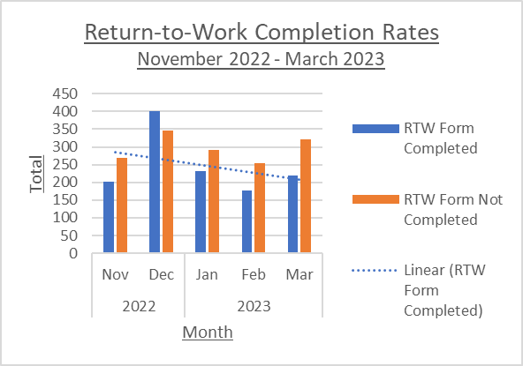
Following pilots, on 1st April 2023, TSUK moved all RTW forms digital (Appendix A, Appendix B). Prior to this, the paper RTW process had been in place since at least 2015 (Appendix C) with variations of the form across the business.
Figure 1 – A Graph to show return to work completion trends between November 2022 and March 2023
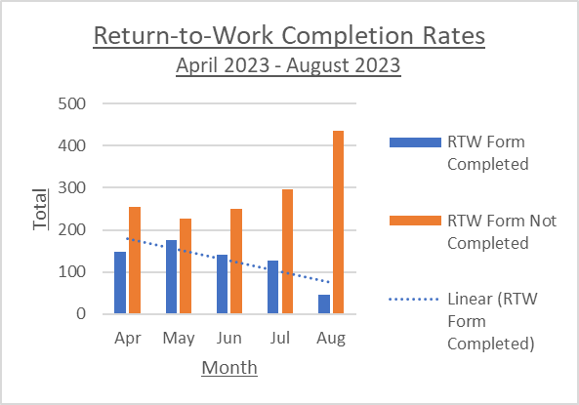
Analysis of RTW completion rates spanned a 5 month period for both non-digital (November 2022 - March 2023) and digital periods (April 2023 - August 2023). While completion rates would likely decrease during holiday seasons due to annual leave, this is not apparent from the data. The completion rate in August 2023 is low, but it must be documented that the data was extracted on 5th September 2023, leaving little time for RTW interviews. A analysis into holidays at Whosoff, showed asides from Christmas, August is the most desired time for annual leave (Ellis, 2019) this could be a contributing factor to lack of RTWs completed.
Figure 2 – A Graph to show return to work completion trends between April 2023 and August 2023
After approximately 7-8 years of paper RTW forms, the process had low completion rates. The completion rates for the non-digital and digital forms were 45.33% and 30.25% respectively. It may appear that the paper process was more successful than the digital, but at the time of data collection the paper process had been in place for 7 years and the digital was a brand new process. In support of this, the questionnaire showed only 1 manager preferred the paper form to the digital form, it would be interesting to understand the reason for this and whether the manager has limited access to IT. Furthermore, it is clear in Figure 1 that completion rates of RTWs were already decreasing prior to the digital form being introduced, this questions whether the decrease in April - August was a result of the digital forms, or just an onwards trend from the previous five months. The RTW figures on a whole are lower than desired and in comparison to other organisations, with Manchester City Council having a 78% completion rate for RTWs (Manchester City Council, 2018).
As previously discussed, RTWs can ensure compliance with legislation but also provide an opportunity to welcome the employee back and update them with organisational changes (Burman, 2023). RTW interviews can also provide valuable information to recognise where absences may re-occur, allowing to plan and support (Clover HR, 2023). Although, in some cases of long term absence, the trigger for returning to work is sick pay as employees rely on their income (Nice and Thornton, 2004). This is a definitive theme that is seen running through TSUK from first-hand experience.
Objective 2: Undertake primary research to evaluate the role of the line manager in the RTW process
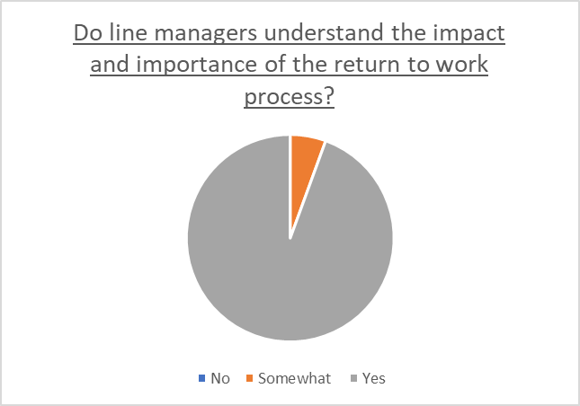
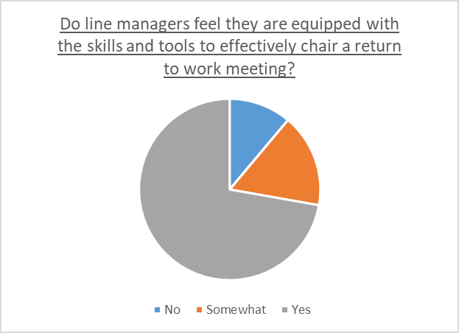
Figure 3 shows the majority of line managers felt they were equipped with the skills to effectively chair a RTW meeting. Figure 4 also illustrates that that all of the line managers who participated had at least some understanding of the impact and importance of the RTW process. In contrast to this, a survey by the CIPD found employer support with regards to developing line manager in absence management activities was not adequate and at the time of the report, in 2016, had decreased (CIPD, 2016). While research shows that the onus of absence management is increasingly on line managers (CIPD, 2020), the fact that the digital process for RTW interviews was launched without training, this raises concerns that managers may not be fully aware of what is expected from them, the key information required from the meeting and how to deal with any difficult conversations. CIPD’s survey in 2016 highlighted that only a minority of organisations (38%) trained line managers in managing absence (CIPD, 2017). Literature also supports the point that manager’s often find it difficult on how to approach, discuss and respond to their subordinates health problems (Maiwald, et al., 2013).
Figure 4 – A pie chart to show line manager responses to the questionnaire on whether they ‘understand the impact and importance of the return to work process’.
Figure 3 – A pie chart to show line manager responses to the questionnaire on whether they ‘feel they are equipped with the skills and tools to effectively chair a return to work meeting’.
Megan Woods and Mandy Matthewson (2021) discuss the strains that can caused from the RTW process and state that this can be mitigated by key factors, particularly the RTW literacy of the employees’ line manager. A key output from the Business in the Community’s (BITC) Mental Health at Work Report 2018 was that 40% of employees did not feel their line manager was genuinely concerned for their wellbeing (BITC, 2019). It is important to note that many individuals returning to work may also be suffering from stress and anxiety which could add additional strain (Nielson and Yarker, 2023). Therefore, it is essential that managers are aware of their role to play in the RTW process.

Objective 3: Investigate the link between the RTW completion rates on sickness and absence
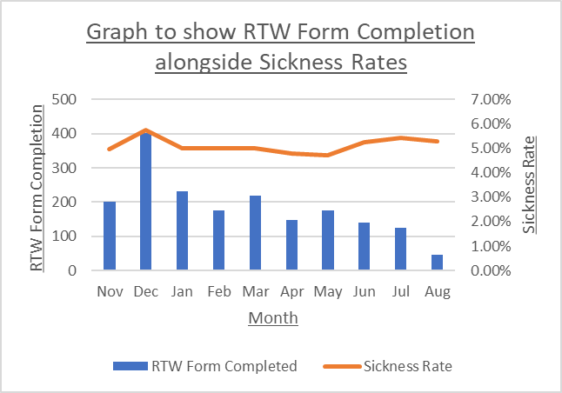
Figure 5 shows the number of RTW Forms completed per month against the sickness rate. From the graph you can see that exception from June, where the RTW form completion per month increases, the sickness rate for the following month decreases. The graph could suggest a positive correlation between RTW completion and sickness absence. Conversely, over the 10 month period there are only 3 occasions where the completion of RTW forms increases and therefore it is difficult to determine that a true correlations exists. It is evident that data based forecasts are more accurate when more historical data exists and Advanced Analytic Planning (2020) have determined that a minimum of 2 years data is required to produce reliable forecasts. Research suggests that a successful RTW would be considered a return without relapse in the following 4 week-period (Etuknwa, et al., 2019) unfortunately, the data available does not allow for analysis to that extent, however is a point to address for any further research.
Figure 5 – Graph to show RTW Form Completion against Sickness Rates per month for the period of November 2022 to August 2023.
An investigation by Caroline Gilbert, et al. (2011) on 1363 employees showed employee commitment can be enhanced through their line managers consistently and effectively deploying HR practices. Although, research also suggests that this is reliant on employee personalities, backgrounds, their previous experience with HR Processes and their relationship with those in the workplace (Beurden, et al. 2020). This suggests that employees do appreciate the support and if conducted properly will comply fully with the process.

Additional Findings
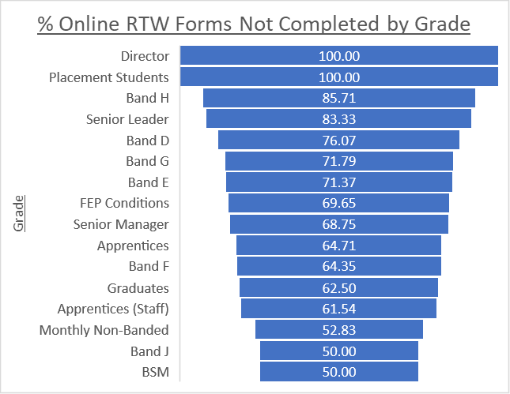
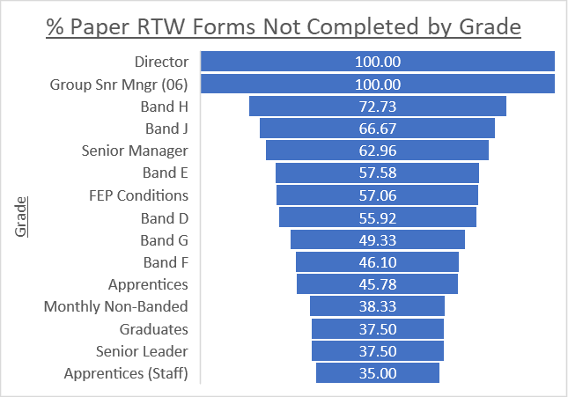
An interseting output from the data collection was the spread of completion rates by grade. Figure 6 and Figure 7 show that the highest rates of incompletion of RTW forms is in within the management structure. When changes are made in an organisation it is vital that management legitimise the change by deploying the process (Campbell, 2021). Management set a precedent for subordinates and often results in a domino effect (Egan, 2016). A lack of particpation could also result in a negative domino effect where poor attitudes are developed (Rajagopal, no date; Clear, 2016).
Figure 7 – A funnel chart to illustrate percentage completion of online return to work forms by grade.
Figure 6 – A funnel chart to illustrate percentage completion of paper return to work forms by grade.

Conclusions
The overall aim of the research is ‘Analyse completion rates of Return to Work interviews in the organisation and their impact on sickness absence trends’. The research study over the 10 month period shows a significant number of uncompleted RTW forms - 2946 forms within 10 months. There was a decrease in completion rates when digital forms were introduced, but there was already a clear decreasing trend prior to their implementation. In terms of the impact of RTWs on sickness absence rates, there were three definitive months where RTW completion increased and the sickness absence rate decreased in the following months. However, the data collection should take place over a longer period of time to determine the reliability of the data. A key aspect in ensuring RTW interviews are impactful is the knowledge and skill base of the line manager’s completing them, the questionnaire showed line manager’s had a good understanding of the process and their part to play. However, based on secondary research regarding the lack of absence management training provided across all organisations and personal knowledge of the lack of training for managers at TSUK, it does raise doubt that line managers are aware of potential impact of RTW interviews. When reviewing the research and considering any proposed recommendations, it is necessary to refer to the completion rates of the questionnaire, out of a research group of 82 line managers, only 18 responded, the research was already a small sample of TSUK (approximately 6.06%). For more representative data, the research group would need to be expanded to ascertain a broader perspective within different departments.
In conclusion, whilst it is recognisable that the primary research undertaken as part of this research report lacked response rate and representation for the wider UK business, the secondary research does provide clarity of the importance of RTW interviews. The necessity of RTW interviews not only lays within creating a positive culture but also to comply with legislation, such as the Equality Act 2010 and more specifically the move to digital forms complying with General Data Protection Regulation.

Appendices

Appendix A: Email Confirming RTW ‘Go-Live’
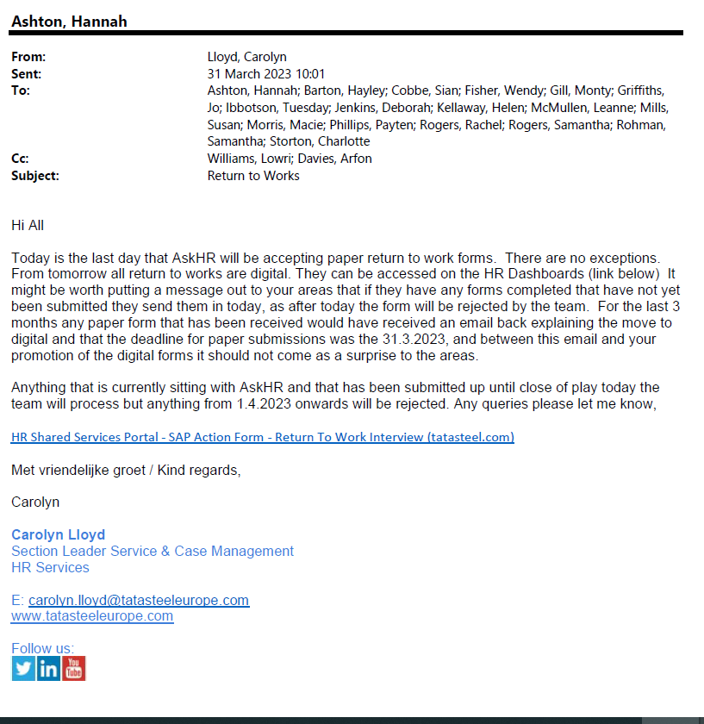

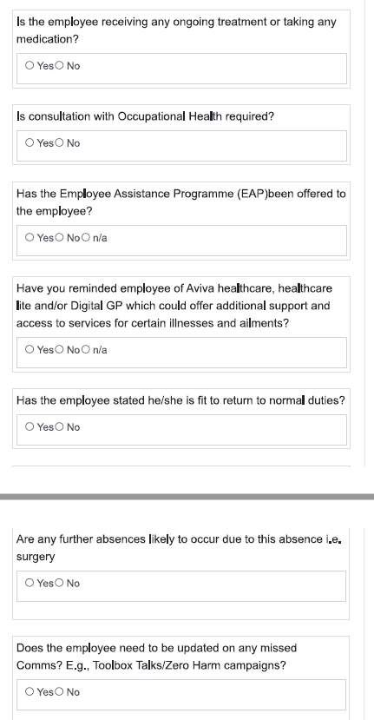
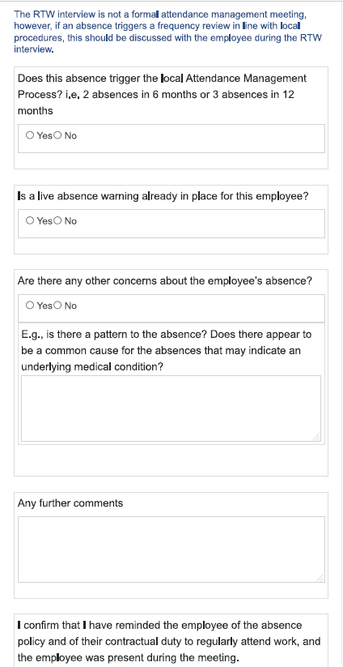
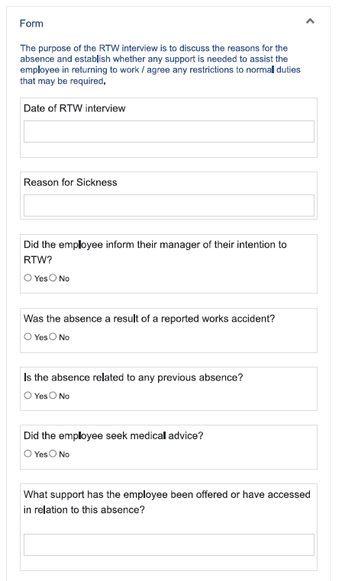
Appendix B: Online RTW Form

Appendix C: Paper RTW Form
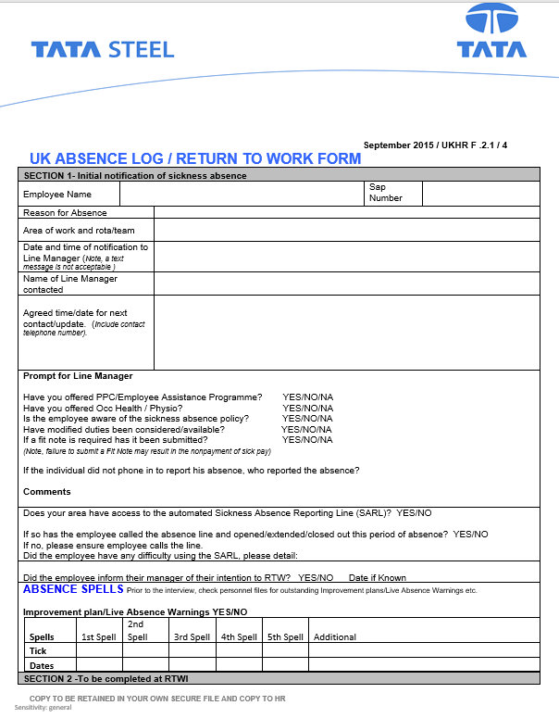

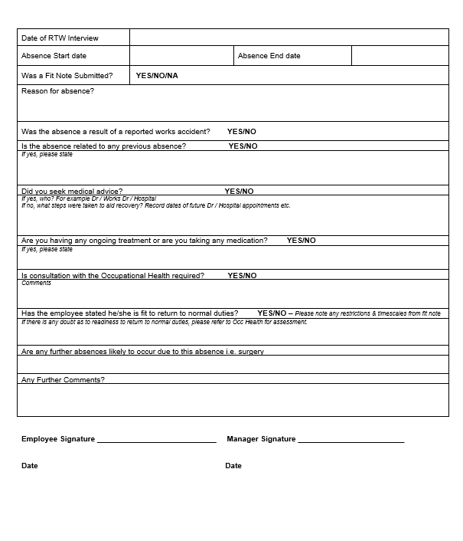

Appendix D: Questionnaire Form
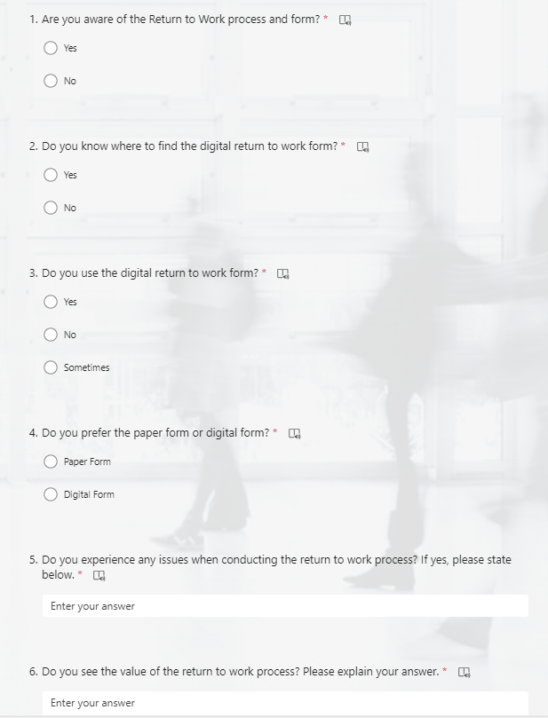

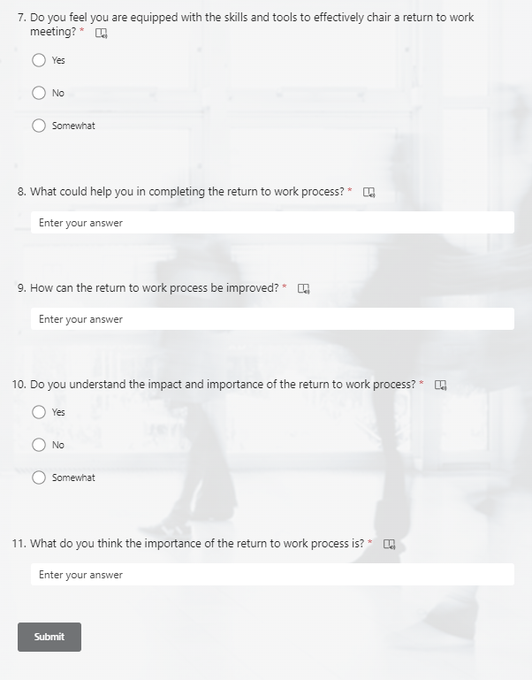

References
ACAS (2023) Returning to work after absence. Available at: https://www.acas.org.uk/returning-to-work-after-absence (Accessed: 09 September 2023).
Advanced Analytic Planning (2020) How much data is required for forecasting?. Available at: https://www.anamind.com/anamind-blog/how-much-data-is-required-for-forecasting/ (Accessed: 23 September 2023).
Anna Lovett (2019) Making RTW interviews give a good return. Available at: https://www.burnetts.co.uk/blog/making-return-to-work-interviews-give-a-good-return (Accessed: 17 September 2023).
Beurden, J., Voorde, K. and Veldhoven, M. (2020) 'The employee perspective on HR practices: A systematic literature review, integration and outlook', The International Journal of Human Resource Management, Issue 2, pp. 359-393. Available at: https://www.tandfonline.com/doi/full/10.1080/09585192.2020.1759671. (Accessed: 25 September 2023).
BITC (2019) Mental Health at Work Report 2018. Available at: https://www.bitc.org.uk/report/mental-health-at-work-report-2018/ (Accessed: 25 September 2023).
Bright HR (2021) RTW interviews. Available at: https://www.brighthr.com/articles/leave-and-absence/return-to-work/employee-return-to-work-interviews/ (Accessed: 17 September 2023).
Burman, C. (2023) What is a RTW interview? Available at: https://www.mad-hr.co.uk/blog/what-is-a-return-to-work-interview (Accessed: 25 September 2023).
Campbell, M. (2021) Understanding the Role of Managers during Change. Available at: https://www.cmcpartnership.com/thought-leadership/understanding-the-role-of-managers-in-change#:~:text=The%20role%20of%20managers%20and,organisation%20may%20impact%20their%20role. (Accessed: 23 September 2023).
CIPD (2016) Absence Management 2016. London: CIPD. Available at: https://www.cipd.org/globalassets/media/knowledge/knowledge-hub/reports/absence-management_2016_tcm18-16360.pdf (Accessed: 23 September 2023).
CIPD (2020) Health and Well-Being at Work. Reference number: 7998. London: CIPD. Available at: https://www.cipd.org/globalassets/media/comms/news/eehealth-and-well-being-2020-report_tcm18-73967.pdf (Accessed: 25 September 2023).
CIPD (2021) Managing a RTW after long-term absence: Guidance for people professionals. Available at: https://www.cipd.org/uk/knowledge/guides/managing-return-to-work-after-long-term-absence/#shared-responsibility-for-supporting-returning-employees (Accessed: 17 September 2023).
Clear, J. (2016) How to Create a Chain Reaction of Good Habits. Available at: https://jamesclear.com/domino-effect#:~:text=The%20Domino%20Effect%20holds%20for,another%2020%20minutes%20of%20procrastination. (Accessed: 25 September 2023).
Clover HR (2023) The Lowdown and Top Tips For Conducting a RTW Interview. Available at: https://www.cloverhr.co.uk/the-lowdown-and-top-tips-for-conducting-a-return-to-work-interview/(Accessed: 25 September 2023).
Crail, M. (2007) Return-to-work interviews do cut sickness absence rates. Available at: https://www.personneltoday.com/hr/return-to-work-interviews-do-cut-sickness-absence-rates/ (Accessed: 17 September 2023).
Davey, O (2021) RTW after sickness interview question examples. Available at: https://realbusiness.co.uk/return-work-sickness-interview-question-examples (Accessed: 09 September 2023).
Davidson Morris (2021) How to Conduct a RTW Interview. Available at: https://www.davidsonmorris.com/return-to-work-interview/ (Accessed: 17 September 2023).
Dawson, C. (2009) Introduction to research methods: a practical guide for anyone undertaking a research project. 4th edn. Oxford: How to Books. Available at: https://www-vlebooks-com.ezproxy.uwtsd.ac.uk/Product/Index/2036027?page=0&startBookmarkId=-1. (Accessed: 18 September 2023).
Denscombe, M. (2010) The good research guide: for small-scale social research projects. 4th edn. England: McGraw-Hill. Available at: https://www-vlebooks-com.ezproxy.uwtsd.ac.uk/Product/Index/155522?page=0&startBookmarkId=-1. (Accessed: 19 September 2023).
Egan, A. (2016) 'The Domino Effect of Leadership', LinkedIn, 13 November. Available at: https://www.linkedin.com/pulse/domino-effect-leadership-alexandra-egan/ (Accessed: 23 September 2023).
Ellis, C. (2019) 'Your staff in numbers: essential sickness and annual leave statistics', Whosoff, 2 May. Available at: https://www.whosoff.com/blog/your-staff-in-numbers-essential-sickness-and-annual-leave-statistics (Accessed: 22 September 2023).
Etuknwa, A., Daniels, K. and Eib, C. (2019) 'Sustainable RTW: A Systematic Review Focusing on Personal and Social Factors'. Journal of Occupational Rehabilitation, pp. 679–700. Available at: https://link.springer.com/article/10.1007/s10926-019-09832-7https://link.springer.com/article/10.1007/s10926-019-09832-7. (Accessed: 25 September 2023).
Foldal, V., Standal, M., Aasdahl, L., Hagen, R., Bagoien, G., Fors, Egil., Johnsen, R. and Solbjor, M. (2020) Sick-listed workers’ experiences with motivational interviewing in the RTW process: a qualitative interview study. BMC Public Health. Available at: https://doi.org/10.1186/s12889-020-8382-9 (Accessed: 25 September 2023).
Gilbert, C., De Winne, S. and Sels, L. (2011) 'The influence of line managers and HR department on employees' affective commitment', The International Journal of Human Resource Management, Volume 22, Issue 8, pp. 1618-1637. Available at: https://doi.org/10.1080/09585192.2011.565646. (Accessed: 25 September 2023).
Health and Safety Executive (2023) Managing sick leave and RTW. Available at: https://www.hse.gov.uk/sicknessabsence/ (Accessed: 17 September 2023).
HR Solutions (2023) RTW Interviews. Available at: https://www.hrsolutions-uk.com/return-to-work-interviews/ (Accessed: 17 September 2023).
HR Specialist Solutions (2021) How do I carry out RTW Interviews?. Available at: https://specialisthrsolutions.co.uk/how-do-i-carry-out-return-to-work-interviews/ (Accessed: 17 September 2023).
Jacobs, G., McHugh, S., Shaw, A., Anand, T. (2023) Employee research Phase 2: Sickness absence and RTW. Available at: https://assets.publishing.service.gov.uk/government/uploads/system/uploads/attachment_data/file/1142737/employee-research-phase-2-sickness-absence-and-return-to-work-quantitative-qualitative.pdf (Accessed: 17 September 2023).
Klevanger, N., Fimland, M. and Rise, M. (2021) 'Aligning stakeholders’ understandings of the return-to-work process: a qualitative study on workplace meetings in inpatient multimodal occupational rehabilitation', International Journal of Qualitative Studies on Health and Well-Being, volume 6, Page reference. Available at: https://www-tandfonline-com.ezproxy.uwtsd.ac.uk/doi/epdf/10.1080/17482631.2021.1946927?needAccess=true
Lucas, E. (2019) '5 reasons you should be doing back-to-work interviews', Cezanne HR, 4 April. Available at: https://cezannehr.com/hr-blog/2019/04/5-reasons-you-should-be-doing-back-to-work-interviews/ (Accessed: 25 September 2023).
Maiwald, K., Meershoek, A., Rijk, A. and Nijhuis, F. (2013) Policy on manager involvement in work re-integration: Managers’ experiences in a Canadian setting. Netherlands: IOS Press. Available at: 10.3233/WOR-131727 (Accessed: 25 September 2023).
Manchester City Council (2018) Attendance Management Update. Available at: https://democracy.manchester.gov.uk/Data/Overview%20and%20Scrutiny%20Human%20Resources%20Sub%20Group/20180614/Agenda/3._Attendance_Mgmt_update.pdf (Accessed: 25 September 2023).
Miller, J. (2017) Developing the line on absence and wellbeing. Available at: https://www.cipd.org/uk/views-and-insights/thought-leadership/cipd-voice/archive/absence-well-being-findings/ (Accessed: 23 September 2023).
Nice, K. and Thornton, P. (2004) Job Retention and Rehabilitation Pilot: Employers' management of long-term sickness absence. Leeds Department for Work and Pensions. Available at: https://eprints.whiterose.ac.uk/73241/1/Document.pdf (Accessed: 25 September 2023).
Nielsen, K. and Yarker, J. (2023) What can I do for you? Line managers’ behaviors to support RTW for workers with common mental disorders. 38 (1), United Kingdom: White Rose. Available at: https://doi.org/10.1108/JMP-09-2021-0500 (Accessed: 25 September 2023).
Ong, A. and Weiss, D. (2000) 'The impact of anonymity on responses to sensitive questions', Journal of Applied Social Psychology, 30(8), pp.1691-1708. Available at: https://www.researchgate.net/publication/280778863_The_impact_of_anonymity_on_responses_to_sensitive_questions. (Accessed: 25 September 2023).
Patten, M. (2017) Questionnaire Research. 4th edn. New York: Routledge. Available at: https://api.taylorfrancis.com/content/books/mono/download?identifierName=doi&identifierValue=10.4324/9781315265858&type=googlepdf. (Accessed: 19 September 2023).
Peninsula Group (2023) RTW interviews. Available at: https://www.peninsulagrouplimited.com/resource-hub/leave-absence/return-to-work-interviews/ (Accessed: 17 September 2023).
Public Health England (2020) Health and work infographics. England: UK Government. Available at: https://assets.publishing.service.gov.uk/government/uploads/system/uploads/attachment_data/file/949524/References_Health_and_Work_infographics_v_final.pdf (Accessed: 24 September 2023).
Rajagopal, K. (no date) 6 common reasons why teams underperform. Available at: https://www.predictiveindex.com/blog/reasons-teams-underperform/ (Accessed: 23 September 2023).
Redmans Solicitors (2022) Case study: client wins over £30,000 in Employment Tribunal after successful disability discrimination claim. Available at: https://redmans.co.uk/insights/case-study-client-wins-over-30000-in-employment-tribunal-after-successful-disability-discrimination-claim/ (Accessed: 17 September 2023).
Stahl, C and Andersson, F. (2018) 'Shifting to Value-Based Principles in Sickness Insurance: Challenges in Changing Roles and Culture', Journal of Occupational Rehabilitation, 28, pp. 730-739. Available at: https://link.springer.com/article/10.1007/s10926-018-9759-9 (Accessed: 17 September 2023).
Suff, R. (2023) Absence measurement and management. Available at: https://www.cipd.org/uk/knowledge/factsheets/absence-factsheet/#Absence (Accessed: 25 September 2023).
TSUK (2023a) 'TSUK - Monthly Sickness Dashboard'. TSUK. Unpublished.
TSUK (2023b) 'TSUK – Weekly Headcount Dashboard'. TSUK. Unpublished.
Woods, M. and Matthewson, M. (2021) Managing and Mitigating Suffering in the Return-to-Work Process. Online: Front Psychol. Available at: 10.3389/fpsyg.2021.805855 (Accessed: 25 September 2023).

