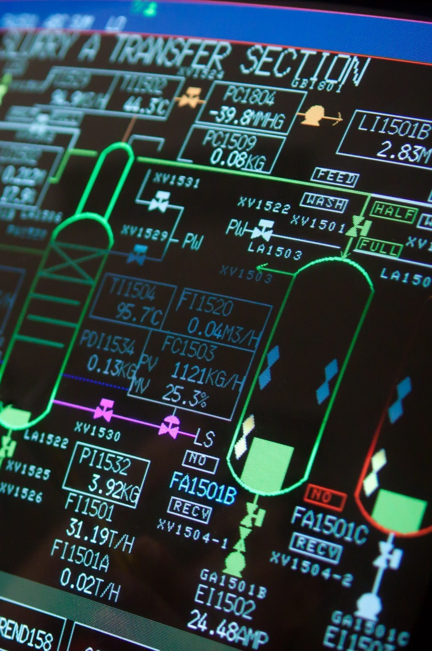

Control System Design

George Atkins | OME: Instrumentation & Control | Date
Contents
Introduction 3
Simulation Set-ups 3
Results 4
Creating Single Transfer Function 9
Results of Single Transfer Function 14
Discussion 0
Conclusion 1

Table 1 2

Figure 1 3
Figure 2 4
Figure 3 5
Figure 4 5
Figure 5 6
Figure 6 6
Figure 7 7
Figure 8 8
Figure 9 10
Figure 10 12
Figure 11 12
Figure 12 13
Figure 13 14
Figure 14 15
Figure 15 15
Figure 16 16
Figure 17 0

Equation 1 2
Equation 2 3
Equation 3 8
Equation 4 8
Equation 5 10

Introduction
Control systems comprise of several components which are interconnected with the goal of achieving a desired purpose. Control System engineering is the process by which engineers design, model and implement these components, which consist of sensors and actuators, into a system which controls either a process or an element of the environment. [1]
There are 2 main types of control system Open-Loop Control and Closed Loop Control. Open-Loop control has no feedback to report what is happening in the system [2] hence the term open loop. Closed-Loop control on the other hand, does have a feedback loop. This is where the difference between the desired output and the actual output is measured, then fed back into the system to allow it to adjust its inputs accordingly. [3]

Simulation Set-ups
The angular positioning system attached to an automatic CIWS (Close-In Weapons System [4]) turret is the example used in this paper. CIWS are the most common ship mounted weapons system to defend against anti-ship missile attack. [5]
The angular positioning system has the transfer function G(s) given by equation 1 below.
$$G\left(s\right)=\frac{1}{{as}^{2}+bs+c}$$
Equation 1

a | b | c
2 | 2 | 2
Table 1
$$G\left(s\right)=\frac{1}{{2s}^{2}+2s+2}$$
Equation 2
Figure 1 shows the initial block diagram for the closed loop control system drawn up in MATLAB. It comprises a unit step input going into an add block. This then feeds into a PID controller which in turn flows into the transfer function, equation 1, which is assigned the values from table 2, resulting in equation 2. A feedback loop is the final element which runs from the transfer function back into the minus terminal of the add block.
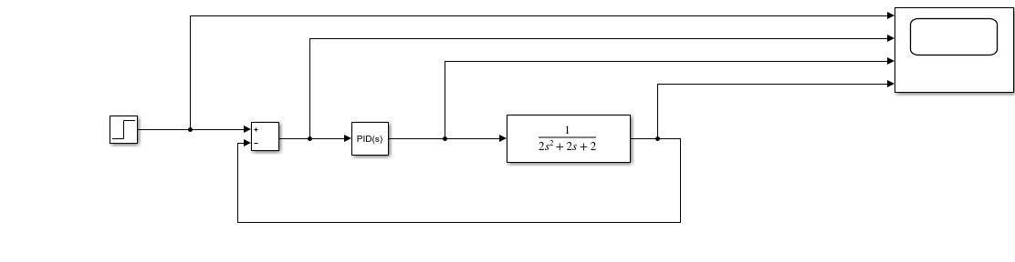
Figure 1
The scope is set up to record at various points of the simulation. The first is recording the raw signal from the unit step input. The second then records what has happened after this signal has passed through the add block, the third shows the result of passing through the PID controller and finally the fourth shows how the transfer function alters the signal.

Results
The scope traces in Figure 2 show what is happening in the control system at a base level without altering any of the controller values. The first row shows the raw signal from the unit step input. The second trace is showing what has happened to this signal after it has passed through the add block. The third window shows the resultant signal after passing through the PID controller and the fourth and final plot shows how the transfer function alters the signal.
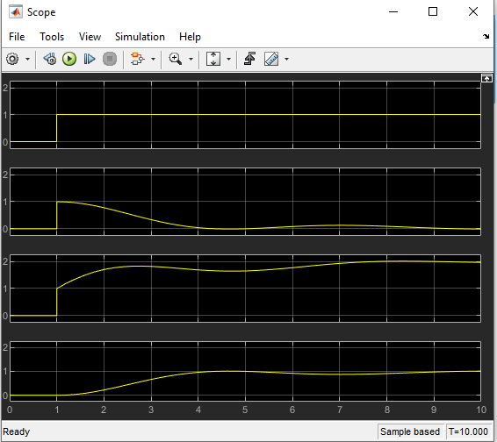
Figure 2
The plot in figure 3 shows how the amplitude of the signal changes with time. The brief stipulates that the overshoot over/under amplitude 1 must be 5% or less and the time taken for the signal to settle on an amplitude of 1 must take 2 seconds or less. Figure 4 shows that although the overshoot is within the acceptable range (1.48%) the rise and settling times are too high, both combined lead to an overall time of 6.76s. Figure 4 also shows the PIDN values for the PID controller. Changing these parameters are what brings the control system into specification. MATLAB has a system which makes this easier than just guessing random numbers though. The two sliders at the top of figure 3 can be adjusted to change the response time of the system and also its transient behavior (robustness).
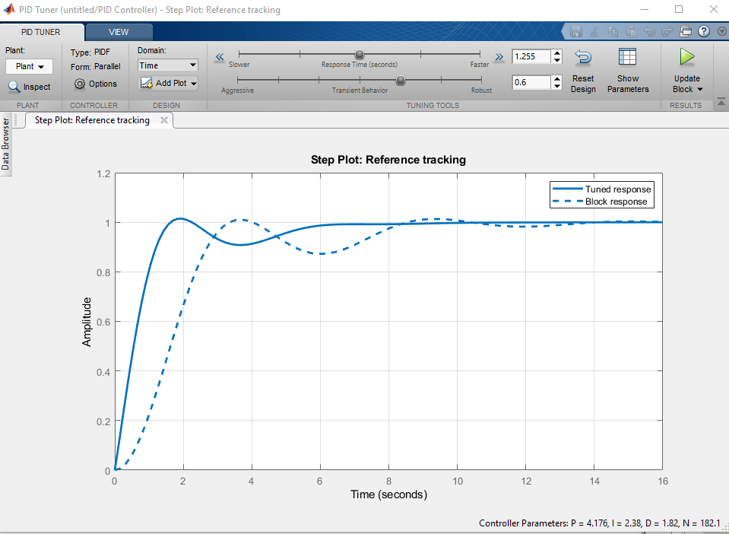
Figure 3
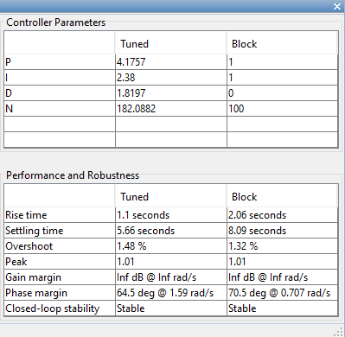
Figure 4
The sliders from figure 3 were adjusted until an appropriate response time and overshoot were achieved. These values are shown in Figure 5.
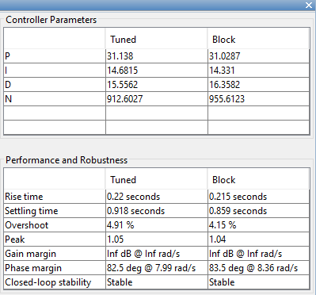
Figure 5
The rise time and settling time combine to give an overall response time of 1.38 seconds and an overshoot of 4.91%. To achieve the response time and overshoot, the PIDN values must be changed. Figure 5 also shows what these values need to be in order get the desired results from the control system.
Figure 6 shows the same plot as Figure 3 but with the updated values, demonstrating the appropriate response time and overshoot.
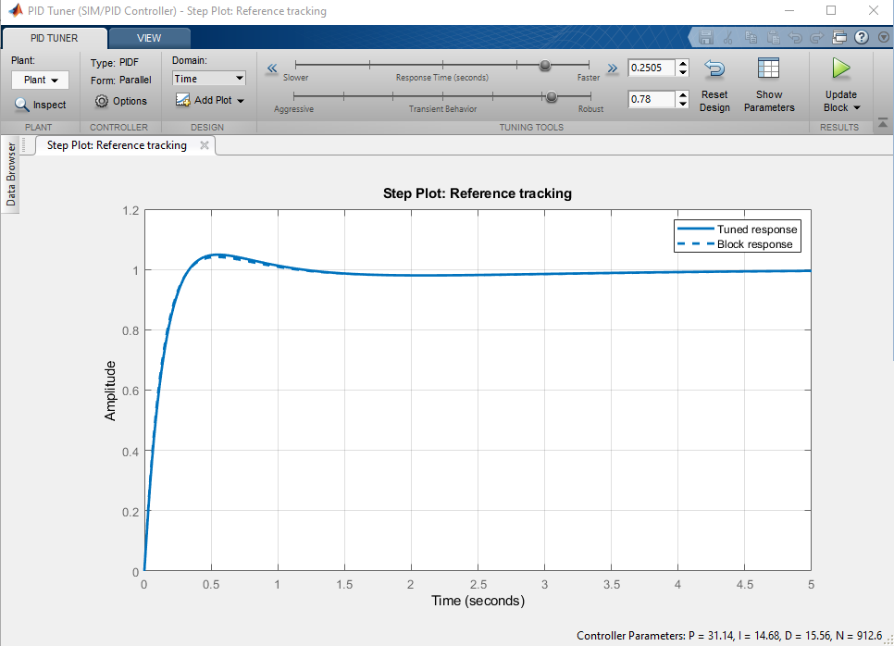
Figure 6
Figure 7 shows the results on the scope after updating the PID values to the ones which were calculated by the MATLAB software
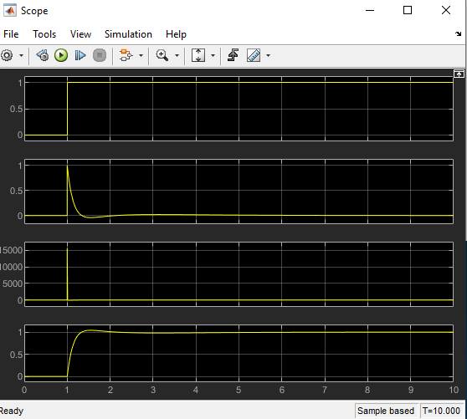
Figure 7
Figure 8 shows the values that MATLAB has assigned to the PID controller in order to provide the desired outcome.
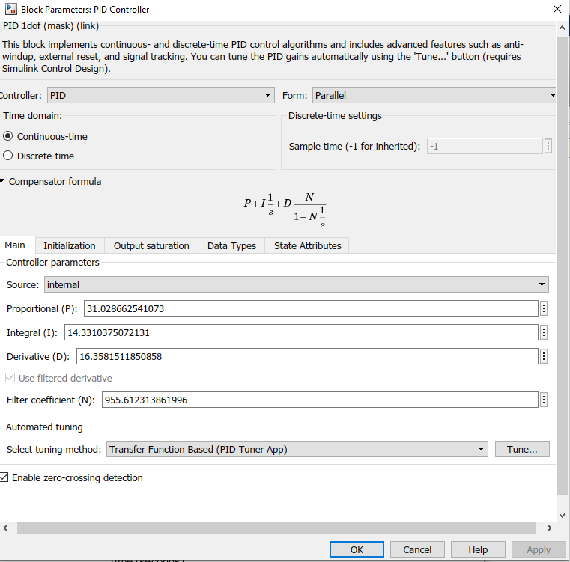
Figure 8

Creating Single Transfer Function
In order to change the original system form an open loop into a closed loop system the transfer function needs to be rewritten. To do that the original transfer equation (equation 3) must be multiplied by the compensator formula that MATLAB gives from figure 8 and is written as equation 4)
$$G\left(s\right)=\frac{1}{{as}^{2}+bs+c}$$
Equation 3

$$Gc\left(s\right)=Kp+Ki\frac{1}{s}+Kd\frac{N}{1+N\frac{1}{s}}$$
Equation 4
$$\left(\frac{1}{{as}^{2}+bs+c}\right) ×\left(Kp+Ki\frac{1}{s}+Kd\frac{N}{1+N\frac{1}{s}}\right)$$

Simplify Gc(s) to make it easier to multiply with G(s):
$$\frac{N}{1+N\frac{1}{s}} = \frac{N}{\frac{s}{s}+\frac{N}{s}}$$
$$= \frac{N}{\frac{N+s}{s}}$$
$$=\frac{sN}{N+s}$$
Substitute this into Gc(s):
$$Kp+Ki\frac{1}{s}+Kd\frac{N}{1+N\frac{1}{s}}=Kp+\frac{Ki}{s}+\frac{KdNs}{N+s}$$
Multiply Gc(s) by$\frac{s(s+N)}{s(s+N)}$:
$$\left(Kp+\frac{Ki}{s}+\frac{KdNs}{N+s}\right)×\frac{s(s+N)}{s(s+N)}=\frac{s\left(s+N\right)Kp+\left(s+N\right)Ki+s(KdNs)}{s(s+N)}$$
Expand Brackets:
$$\frac{s^{2}Kp+sNKp+sKi+NKi+KdNs^{2}}{s^{2}+Ns}$$
Gather like terms:
$$=\frac{\left(Kp+KdN\right)s^{2}+\left(NKp+Ki\right)s+NKi}{s^{2}+Ns}$$
Multiply G(s) by Gc(s):
$$\left(\frac{\left(Kp+KdN\right)s^{2}+\left(NKp+Ki\right)s+NKi}{s^{2}+Ns}\right)×\left(\frac{1}{{as}^{2}+bs+c}\right)$$
$$= \frac{\left(Kp+KdN\right)s^{2}+\left(NKp+Ki\right)s+NKi}{{(s}^{2}+Ns)({as}^{2}+bs+c)}$$

$${(s}^{2}+Ns)\left({as}^{2}+bs+c\right)=as^{4}+bs^{3}+cs^{2}+aNs^{3}+bNs^{2}+cNs$$
Gather like terms:
$$= {as}^{4}+(aN+b)s^{3}+(bN+c)s^{2}+cNs$$
Therefore, the Forward Transfer Function can be written as:
$$\frac{\left(Kp+KdN\right)s^{2}+\left(NKp+Ki\right)s+NKi}{{as}^{4}+(aN+b)s^{3}+(bN+c)s^{2}+cNs}$$
Equation 5

At this point the block diagram could be redrawn to include the Controller & Plant as a single block, but still include the feedback loop as demonstrated in Figure 9.
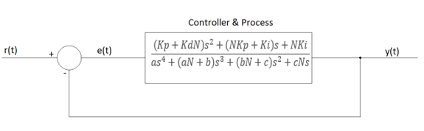
Figure 9
The feedback loop can be removed and the transfer function of the system calculated as a whole using the formula:
$$TF= \frac{G}{1+GH}$$
Where TF is the transfer function of the whole system, G is the Forward Transfer Function, and H is the transfer function of the feedback loop, in this case $H=1$
$$\frac{\left[\frac{\left(Kp+KdN\right)s^{2}+\left(NKp+Ki\right)s+NKi}{{as}^{4}+(aN+b)s^{3}+(bN+c)s^{2}+cNs}\right]}{1+\left[\frac{\left(Kp+KdN\right)s^{2}+\left(NKp+Ki\right)s+NKi}{{as}^{4}+(aN+b)s^{3}+(bN+c)s^{2}+cNs}\right]×1}$$
1 can be written as $\frac{{as}^{4}+(aN+b)s^{3}+(bN+c)s^{2}+cNs}{{as}^{4}+(aN+b)s^{3}+(bN+c)s^{2}+cNs}$ and multiplying by 1 changes nothing, which gives:
$$\frac{\left[\frac{\left(Kp+KdN\right)s^{2}+\left(NKp+Ki\right)s+NKi}{{as}^{4}+(aN+b)s^{3}+(bN+c)s^{2}+cNs}\right]}{\left[\frac{{as}^{4}+(aN+b)s^{3}+(bN+c)s^{2}+cNs}{{as}^{4}+(aN+b)s^{3}+(bN+c)s^{2}+cNs}\right]+\left[\frac{\left(Kp+KdN\right)s^{2}+\left(NKp+Ki\right)s+NKi}{{as}^{4}+(aN+b)s^{3}+(bN+c)s^{2}+cNs}\right]}$$
Add together denominator terms:
$$\frac{\left[\frac{\left(Kp+KdN\right)s^{2}+\left(NKp+Ki\right)s+NKi}{{as}^{4}+(aN+b)s^{3}+(bN+c)s^{2}+cNs}\right]}{\left[\frac{{as}^{4}+(aN+b)s^{3}+(bN+c)s^{2}+cNs+\left(Kp+KdN\right)s^{2}+\left(NKp+Ki\right)s+NKi}{{as}^{4}+(aN+b)s^{3}+(bN+c)s^{2}+cNs}\right]}$$

Simplifying gives the final Transfer Function as:
$$\frac{\left(Kp+KdN\right)s^{2}+\left(NKp+Ki\right)s+NKi}{{as}^{4}+(aN+b)s^{3}+(bN+c)s^{2}+cNs+\left(Kp+KdN\right)s^{2}+\left(NKp+Ki\right)s+NKi}$$
The values obtained from tuning the system in Simulink can then be inputted.
$$Kp=31.02866$$
$$Ki=14.33104$$
$$Kd=16.35815$$
$$N=955.61231$$
Giving the Final Transfer Function with numbers as:
$$\frac{\left(31.02866+15632.04951\right)s^{2}+\left(29651.36946+14.33104\right)s+13694.91824}{{16s}^{4}+(1911.22462+2)8^{3}+(1911.22462+c)4^{2}+955.61231s+\left(31.02866+15632.04951\right)s^{2}+\left(29651.36946+14.33104\right)s+13694.91824}$$

This can be written into MATLAB using the code in figure 10 and the drawing of the block diagram is shown in figure 11. The simulation was run with both the original set up of PID controller and feedback loop alongside the new single transfer function in order to compare them effectively.
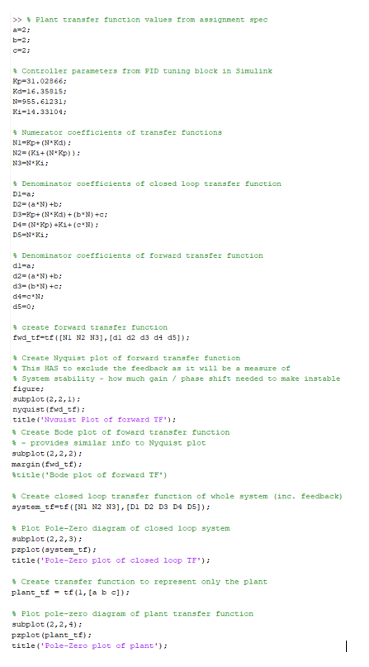
Figure 10
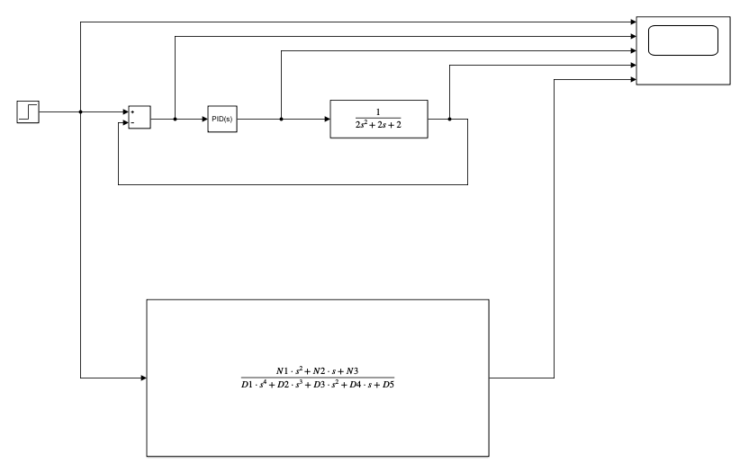
Figure 11

Results of Single Transfer Function
Figure 12 is a graph showing the full transfer function results.
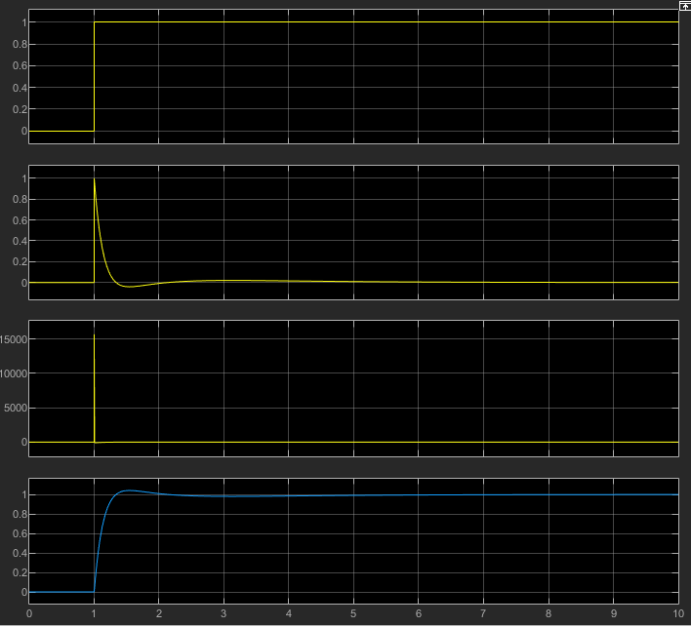
Figure 12
To generate some more graphs to further explore the results the code from figure 13 was inputted to MATLAB. This code would generate the Nyquist plot, Bode plot; and pole-zero plots for the control system.
Figure 14 shows the Bode plot; figure 15 the Nyquist plot; figure 16 the pole-zero plot of the plant; and figure 17 the pole-zero plot of the closed loop transfer function.
Figure 13
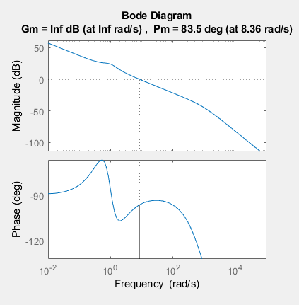

Figure 14
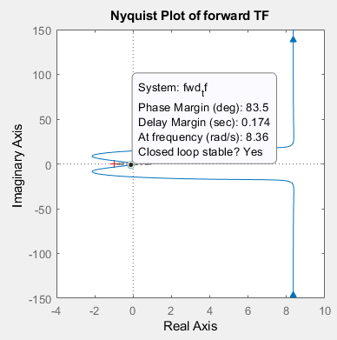
Figure 15
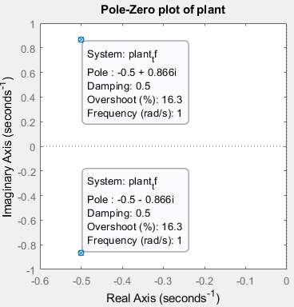
Figure 16
The results for the pole positions off the graph can be verified correct by performing the mathematical operation below.
$$G\left(s\right)=\frac{1}{{2s}^{2}+2s+2}$$
Using the Quadratic formula to solve for s gives:
$$s=\frac{-b±\sqrt{b^{2}-4ac}}{2a}$$
$$s=\frac{-2±\sqrt{2^{2}-4×2×2}}{2×2}$$
$$s=\frac{-2±\sqrt{4-16}}{4}$$
$$s=\frac{-2±\sqrt{-12}}{4}$$
$$s=\frac{-2±\sqrt{12}\sqrt{-1}}{4}$$

$s=\frac{-2}{4}+\frac{\sqrt{12}\sqrt{-1}}{4}$ $s=\frac{-2}{4}-\frac{\sqrt{12}\sqrt{-1}}{4}$

$s=-0.5+\frac{2\sqrt{3}j}{4}$ $s=-0.5-\frac{2\sqrt{3}j}{4}$
$s=-0.5+\frac{\sqrt{3}}{2}j$ $s=-0.5-\frac{\sqrt{3}}{2}j$
The results from performing the maths are identical to the result from the MATLAB simulation so it is correct.

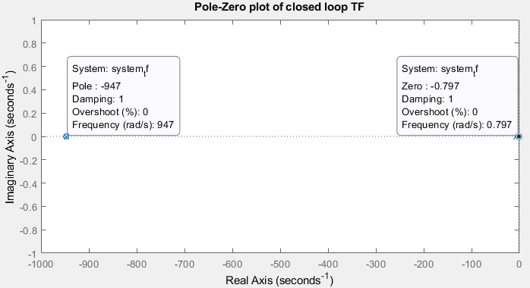
Figure 17

Discussion
Figure 12 is a graph showing the full transfer function with the above calculated values does the same job as the PID & feedback loop version of the controller. The blue line which is the full closed loop transfer function follows the exact same path as the yellow line from the PID & feedback loop version.
Figure 14 shows the Bode plot. The top graph plots the gain of the system in dB against frequency in radians per second, bottom graph plots the phase shift of the system in degrees against the frequency in radians per second. As the frequency of the input changes, so to do the results of gain and phase shift change. Plotting these changes gives the Bode plot which shows the response of the system due to changes in frequency, shortened to frequency response. [6]
The gain from the top graph trends towards infinity in both directions and shows a gain margin of infinity at all frequencies which means that the amplitude of the outputted signal can be increased from the original as much as desired and the system will remain stable. The phase angle on the bottom graph shows a phase margin of 83.5, meaning the system will be stable as long as the output does not go more than 83.5.
Figure 15 shows the Nyquist plot. For a data point on the graph, the distance from the origin shows gain, but not in dB like the Bode plot, the Nyquist plot shows it in the linear scale. The phase shift of the data point is shown by the angular component of where the plot is, that is how far round it is from the horizontal. Frequency is not plotted directly, but for each data point used to construct the diagram the frequency is obviously changing. The critical point, which must be avoided so as not to experience oscillations in the output is shown by the red cross on the Nyquist plot. [6]
As the Nyquist plot for the transfer function does not touch the critical point, it can be assumed that the control system is stable.
Figure 16 shows the pole zero plot of the plant. It shows the location in the complex plane of the poles and zeros of the transfer function. On this graph the two poles are in the left half plane of the graph which demonstrate that the system is stable.
Figure 17 shows the pole zero plot of the closed loop transfer function. On this graph the two poles are also in the left half plane of the graph which further demonstrate that the system is stable.

Conclusion
To conclude, both the original PID controller with feedback loop and the closed loop control system provide a stable control system with a rise/settling time and overshoot that conform to the specification of the assignment.
The rise time and settling time combine to give an overall response time of 1.38 seconds and an overshoot of 4.91%.
The PID controller with the feedback loop was much easier to construct and tune to get the desired output than the closed loop system which involved a lot of mathematical calculation to get to the end point. An error could easily be made during the construction of the forward transfer function which could result in an incorrect output of the system, which in the context of a CIWS could prove disastrous.

References

[1] | R. Dorf and R. Bishop, "Chapter 1," in Modern Control Systems, Pearson Education Limited, 2018, p. 31.
[2] | R. Larsen, "Open-Loop Control Revisited," Control Engineering, vol. 52, no. 2, 2005.
[3] | L. Grosenick, J. H. Marshall and K. Deisseroth, "Closed-Loop and Activity-Guided Optogenetic Control," Neuron, vol. 86, no. 1, 2015.
[4] | B. Vance, A Dictionary of Abbreviations, Oxford: Oxford University Press, 2011.
[5] | K. Yoon-Hwan, R. Chang-Kyung and T. Min-Jea, "Guidance Synthesis for Evasive Maneuver of Anti-Ship Missiles Against Close-In Weapon Systems," IEEE Transactions on Aerospace and Electronic Systems, vol. 46, no. 3, 2010.
[6] | Matlab, Director, Nichols Chart, Nyquist Plot, and Bode Plot | Control Systems in Practice, Part 10. [Film]. The MathWorks, Inc. , 2020.

