

Cultivating Data Culture in Manufacturing:
Bridging Cultural Barriers for Sustainable Growth.

Written by: Gareth Frost
Student Number: 2126962
Date: March 2024
Module: Masters Project
Module Code: ACFA 7003
Programme: MSc Industry 4.0 Advanced Manufacturing

Declaration Statement

I confirm that this thesis is entirely my work and has not been previously submitted for any other degree or qualification, either in whole or in part. All sources of information and materials used in this thesis have been appropriately acknowledged and cited.
Any assistance I received during the preparation of this thesis has been duly acknowledged. I assure that this thesis is a sincere and authentic representation of my academic efforts and research discoveries.



Gareth Frost 23rd February 2024

Acknowledgements

I would like to express my sincere gratitude to everyone who contributed to the completion of this thesis. Foremost, I am deeply thankful to Safran Seats GB and its members for their invaluable guidance, unwavering support, and insightful feedback throughout this endeavour. Their expertise and encouragement have played a crucial role in shaping this work.
I also want to thank Alan Mumby, for his valuable insights and constructive criticism, which have greatly enhanced the quality of this study. He has always been available to support and guide “stillinshed.”
A big thank you goes to the University of Wales Trinity Saint David, for providing the resources and facilities necessary for conducting this research.
To my colleagues and friends, your encouragement and support have been a constant source of motivation during this academic endeavour.
I am profoundly grateful to my family for their unconditional love, understanding, and unwavering support. Their presence has been my pillar of strength throughout.

Thank you all for your invaluable contributions.

Abstract
The manufacturing industry is undergoing a substantial metamorphosis, mostly attributable to the assimilation of cutting-edge technology and the advent of Industry 4.0. The aforementioned transformation is intricately connected to the use of large-scale datasets, a phenomenon that has profoundly restructured the culture inside the manufacturing sector. This paper presents a comprehensive analysis of the correlation between manufacturing culture and the integration of big data in contemporary industrial environments.
Historically, the manufacturing culture was distinguished by the presence of hierarchical organisational frameworks, standardised operational procedures, and a primary emphasis on achieving cost-effectiveness. Nevertheless, there has been a discernible transition towards a more dynamic and data-centric methodology in recent years. The utilisation of big data analytics has facilitated manufacturers in making decisions that are influenced by data, drawing upon information derived from a multitude of sources such as sensors, Internet of Things (IoT) devices, and production lines. This transformation not only enhances operational efficiency but also cultivates a culture of ongoing improvement.
Furthermore, the integration of big data into manufacturing operations fosters a heightened sense of collaboration within the work environment. Data-sharing platforms play a crucial role in enabling interdepartmental access to up-to-date information, so promoting collaborative problem-solving and innovation, and cultivating a flexible and responsive manufacturing environment.
The influence of big data extends significantly to quality control and product customisation as well. The implementation of continuous monitoring and data collecting across manufacturing processes facilitates the timely identification of defects, elimination of waste, and customisation to cater to the unique tastes of individual customers. This fosters a cultural environment that prioritises excellence and places a strong emphasis on customer-centricity.

Contents

Declaration Statement 1
Acknowledgements 2
Abstract 3
1. Introduction 7
1.1 Aims 8
1.2 Objectives 8
1.3 Justification 8
1.4 Research Methodology 9
1.5 Literature Methodology 10
1.5.1 Search Strategy 11
1.5.2 Refinement of Search: 11
1.5.3 Variations in Search Terms: 11
1.5.4 Manual Assessment: 12
1.5.5 Results Compilation: 12
1.6 Ethics 12
2. Industry 4.0 & Big Data in Manufacturing 13
2.1 Introduction to Big Data in Manufacturing 14
2.2 Big Data in Manufacturing 14
2.3 The Three Vs of Big Data 14
2.3.1 Velocity 14
2.3.2 Volume 15
2.3.3 Variety 15
2.4 Predictive Maintenance and Efficiency 16
2.5 Demand Forecasting and Inventory Management 16
2.6 Real-time Monitoring and Quality Control 16
2.7 Adaptive Manufacturing 16
3. What is Organisational strategy 17
3.1 Development of a Strategy 17
3.2 The Composition of Successful Strategies 18
3.2.1 Corporate Level Strategy 18
3.2.2 Business-level Strategy 18
3.2.3 Functional-level Strategy 19
3.3 Different types of strategy 19
3.3.1 Differentiation 19
3.3.2 Concentration 20
3.3.3 Growth 21
4. Overview of the role of big data in organisational strategy 22
4.1 Importance of data-driven decision making 22
4.2 Challenges in Incorporating Big Data into Organisational Strategy 23
5. Organisational Culture 25
5.1 Organisational Culture Models 26
5.1.1 Handy’s Model 26
5.1.3 Hofstede Model 29
5.2 Cultural Implications of Big Data Implementation 31
6. Case study introduction 32
6.1 Employee Interview Methodology 33
6.2 Analysis of Questionnaire 33
6.2.1 How would you define big data in the context of the organisation? 33
6.2.2 Provide examples of how big data is currently utilised within the Organisation.? 33
6.2.3 What tools and technologies does the Organisation use for big data storage and processing? 34
6.2.4 How are large volumes of data, both structured and unstructured handled? 34
6.2.5 How does the Organisation leverage big data for business analytics and decision-making? 35
6.2.6 Instances where big data has led to actionable insights or improvements? 35
6.2.7 How does leadership within the Organisation promote the adoption of big data technologies? 35
6.2.8 Is there a clear vision for integrating big data into the overall business strategy? 36
6.2.9 Are there initiatives in place to train employees on big data technologies and analytics? 36
6.2.10 How do you ensure that your workforce is equipped with the necessary skills to work with big data? 37
6.2.11 To what extent does the Organisation encourage cross-departmental collaboration in utilising big data? 37
6.2.12 How is information about big data initiatives communicated across different levels of the organisation? 37
6.2.13 Does your organisation encourage experimentation and innovation in the use of big data? 38
6.2.14 Are there instances where taking risks with big data has resulted in positive outcomes? 38
6.2.15 How flexible is the organisation in its use of big data to drive improvements? 39
6.2.16 Can you provide examples of how the company has pivoted in light of data be it negative or positive? 39
6.2.17 How would you assess the current state of big data adoption within the organisation? 40
6.2.18 What challenges have been presented in the utilisation of big data? 40
6.2.19 Are there future plans for incorporating big data into the organisation's growth strategy? 40
6.2.20 How do you envision the role of big data evolving within the company in the coming years? 41
6.3 Case Study Findings 42
7. Closing 46
7.1 Conclusion 46
7.2 Further Research Considerations 47
7.2.1 Change Management 47
7.2.2 Psychology of Change 47
7.2.3 A leaders Influence on Strategic Change 48
7.3 Limitations 49
8. Appendices 55
Appendix 1, Questionnaire 55
Appendix 2, Email Invitation 59
Appendix 3, Question 1 60
Appendix 4, Question 2 60
Appendix 5, Question 3 61
Appendix 7, Question 5 62
Appendix 11, Question 9 64
Appendix 13, Question 11 65
Appendix 15, Question 13 66
Appendix 17, Question 15 67
Appendix 19, Question 17 68
Appendix 21, Question 19 69
Appendix 22, Question 20 69

INTRODUCTION

Introduction
In the ever-changing landscape of modern business, the significance of workforce creativity and resourcefulness is amplified, particularly in the era of extensive data analysis. As organisations navigate the complexities of a data-driven approach, employees' creativity becomes pivotal for operational efficiency and harnessing the transformative potential of big data. Academic research delves into the intricate relationship between workforce dynamics and big data adoption, underlining the importance of fostering a conducive workplace culture that aligns with the demands of technological evolution. The integration of big data into organisational processes introduces a new dimension to factors influencing innovative work behaviour. The importance of nurturing a positive workplace culture, as underscored by this (Gilar-Corbi R, 2019), becomes increasingly relevant in the context of big data utilisation. A critical aspect is a culture that acknowledges the significance of individual contributions while fostering a collaborative approach to data exploration and analysis. Empowering and motivating employees is crucial for them to effectively engage with vast datasets, transforming raw data into actionable insights. Within the realm of big data, motivation takes on a unique aspect. The sheer volume and complexity of data necessitate a workforce motivated not only by traditional incentives but also driven to tackle data challenges with creativity. Researchers explore how organisations can align their motivational strategies with the distinctive demands of big data initiatives, recognising that uncovering insights in this setting requires a blend of technical proficiency and creative problem-solving. Employee engagement, a cornerstone in discussions about innovation, assumes heightened importance as organisations grapple with the integration of big data analytics. An engaged workforce in the age of big data comprehends not only the organisation's objectives but also recognises the critical importance of data-driven decision-making. Researchers examine ways for organisations to foster an environment where employees actively participate in data exploration, contributing diverse perspectives and ideas to enhance the quality of analytical outcomes. Furthermore, the impact of big data on employee well-being comes to the forefront. Dealing with extensive datasets and staying abreast of technological advancements can introduce new sources of stress. Addressing employee well-being in the realm of big data involves not only physical health but also providing mental and emotional support, acknowledging the potential strain associated with navigating the intricacies of data analytics.

1.1 Aims
The main aim of this research is to delve into the intricate connections and parallels among organisational cultural traits that enable the effective utilisation of Big Data, within the context of Industry 4.0 and the implementation of Quality 4.0 practices, all with the overarching goal of enhancing overall efficiency. At its core, this study proposes that by aligning these cultural characteristics, it becomes possible to establish a comprehensive framework that not only encourages creativity and the adept application of Big Data but also cultivates trust and bolsters efficiency across various operational domains.
Furthermore, this study endeavours to not only explore the theoretical underpinnings but also substantiate the practical feasibility of nurturing a culture that mutually benefits from these intersecting elements. By doing so, It aims to establish a connection between abstract principles and their practical implementation, providing valuable insights and actionable strategies for organisations aiming to thrive in the dynamic landscape of Industry 4.0 and Quality 4.0 integration. Through rigorous analysis and empirical evidence, this research aims to contribute to the ongoing discourse on organisational culture and its pivotal role in driving innovation, efficiency, and competitive advantage in the digital era.

1.2 Objectives
The main objective of this research is to explore how organisational cultural traits influence the effective use of Big Data within the context of Industry 4.0, aiming to enhance overall efficiency. The study proposes that by aligning these cultural characteristics, it is possible to create a comprehensive framework that not only promotes creativity and skilful application of Big Data but also fosters trust and bolsters efficiency across different operational areas. Additionally, the research seeks to establish a connection between theory and practice by investigating the practical feasibility of nurturing a culture that benefits from these intersecting elements. Through empirical research and rigorous analysis, the study aims to provide actionable insights for organisations attempting to prosper in the changing terrain of Industry 4.0 integration. By shedding light on the role of organisational culture in driving innovation and efficiency in the digital era, this research contributes to the continuing discussions on improving organisational performance.

1.3 Justification
Understanding the dynamics among employee motivation, engagement, and creativity is integral to fostering an effective organisational culture. Prior research has convincingly shown that motivated and engaged individuals, combined with an organisational strategy prioritising innovation, confer a substantial competitive edge (You Yutian, 2022) (Thuy Thi Diem Vo, 2022). Job quality and characteristics emerge as pivotal factors, with relevant and challenging tasks, opportunities for personal and professional growth, and a supportive work environment fostering innovation among employees.
Additionally, the positive influence of organisational learning on personnel's inventive performance underscores the importance of prioritising ongoing skill and knowledge development. Organisations that prioritise learning create a culture that accentuates growth and innovation, contributing significantly to competitive advantage and goal attainment. Investing in employee well-being is identified as another crucial element in establishing an innovative organisational culture. Studies consistently reveal a strong correlation between employee well-being and both innovation performance and overall company success (Goeckeritz, 2022).
The correlation between employee motivation, engagement, and creativity not only defines a productive organisational culture but also serves as a strategic advantage over competitors. Effective communication and teamwork are identified as indispensable for fostering creativity within an organisation. Cultivating a culture that prioritises open and transparent communication facilitates the exchange of ideas and knowledge, enabling diverse perspectives and disciplines to contribute to innovative solutions (Matos, 2023).
Leadership, as a central element in fostering innovation, requires exemplary behaviour, a willingness to explore novel domains, and the ability to inspire teams. Leaders who delineate a clear vision, motivate their subordinates, and encourage the exploration of unorthodox methodologies foster a shared sense of purpose and motivation. The impact of organisational culture on effectiveness and its role in supporting the organisational strategy cannot be overstated (Gonçalves, 2020).
Empowering staff and demonstrating trust in their decision-making capacity is imperative for leaders seeking to create an environment conducive to creativity and innovation. Autonomy and opportunities for experimentation, coupled with consistent feedback and recognition, foster a sense of ownership and pride within the workforce (Gashema, 2019). This comprehensive understanding of organisational culture's multifaceted role in fostering innovation justifies the need for further research to explore and refine strategies for creating and sustaining innovative workplace cultures.

1.4 Research Methodology
To achieve this objective, a mixed-methods strategy will be employed, combining quantitative and qualitative research methodologies for extensive data collection and in-depth insights. The quantitative research component will involve systematically gathering and examining numerical data from various sources, such as industry reports, statistical databases, and surveys. This data will provide measurable comprehension of the current levels of acceptance and advantages of Big Data within the framework of Industry 4.0. Additionally, this study aims to ascertain potential barriers and difficulties encountered by enterprises when using Big Data solutions for change management.
To enhance the quantitative research, qualitative research approaches will be used. This methodology will include interviews with industry professionals, managers, and experts in change management. These interviews will offer significant insights into the experiences, viewpoints, and methods employed by organisations in utilising Big Data for efficient change management in the Industry 4.0 era (McKinsey, 2016) (Kraus, 2021).
Additionally, a thorough examination of relevant scholarly literature will be undertaken to gain a full comprehension of the current body of research pertaining to Industry 4.0, Big Data, and Change Management. This literature study will analyse scholarly articles, books, and other pertinent sources to discover fundamental theories, concepts, and frameworks. Furthermore, this approach will aid in identifying any deficiencies or areas requiring additional investigation (FasterCapital, 2023)
In conjunction with the literature review, the analysis and synthesis of the quantitative and qualitative research components will be conducted. This process will involve organising and categorising data, identifying patterns and themes, and formulating conclusions based on theoretical frameworks and concepts found in the literature review.
To uphold the integrity and validity of the research findings, several precautions will be implemented. A meticulous data collection procedure will be conducted using standardised measurement instruments and methodologies to ensure the reliability and validity of the quantitative data. Various techniques, including member verification and triangulation, will be used in the analysis of qualitative data to bolster the legitimacy and integrity of the findings.

1.5 Literature Methodology
Before starting the research, A comprehensive review of the existing literature was conducted to grasp the breadth of available resources on the topic. This involved exploring academic journals, books, and articles to gather insights from previous studies. The methodology involved defining research objectives, selecting appropriate methods, and meticulously collecting data through surveys, interviews, or existing sources. Ethical considerations were paramount throughout, ensuring participant consent, confidentiality, and adherence to guidelines. The collected data was analysed rigorously to identify patterns and draw meaningful conclusions. Finally, findings were interpreted to draw implications, contributing valuable insights to the field. Overall, the research methodology was systematic and robust, aiming to provide reliable findings and contribute to the existing knowledge base.
1.5.1 Search Strategy
The literature evaluation process began with a meticulously planned search strategy using the university's online library database. Key terms such as "Cultural resistance," "Management resistance," and "Utilisation of Big Data" were strategically chosen to guide the search. Employing various search techniques like keyword searches and Boolean operators ensured thorough coverage of relevant literature.
Efforts were made to access recent publications as well as seminal works in the field, providing a balanced perspective. Filtering search results based on publication dates and relevance ensured the inclusion of up-to-date and authoritative sources. Throughout the process, careful documentation of the search strategy and consulted sources ensured transparency and reproducibility.
This systematic approach laid a strong foundation for subsequent research stages, enriching the analysis with diverse perspectives and insights.

1.5.2 Refinement of Search:
In refining the search process, adjustments were made to include a range of publication dates to capture both recent studies and foundational research. This ensured a balanced approach, drawing on the latest developments and established insights in the field.
Additionally, the retrieved literature was carefully screened and organised based on its relevance to the research topic. This meticulous process prioritised sources closely aligned with the research objectives, aiming to gather material that would contribute significantly to the study.
Overall, these optimisations ensured that the obtained material was not only up to date but also directly relevant to the research subject. This rigorous approach bolstered the quality and significance of the literature review, laying a strong foundation for the subsequent stages of the research.

1.5.3 Variations in Search Terms:
To refine the search results, different versions of the main search terms were used. This strategy aimed to broaden the search scope and ensure a comprehensive exploration of relevant scholarly literature. By incorporating synonyms, related terms, and alternate phrasings, a wider range of potential sources was included, capturing literature that may have used different terminology or focused on different aspects of the research topic. Wildcard characters and truncation symbols were also employed to account for spelling variations, enhancing the precision of the search. Overall, employing alternative forms of primary search phrases facilitated a more thorough investigation of pertinent scholarly works, enriching the literature review process.

1.5.4 Manual Assessment:
Following the initial search, a manual evaluation was performed to determine the relevance of the retrieved articles to the research topic. This entailed thoroughly reviewing each article to ensure that it was related to the issue area and research goals. This manual examination picked the articles that were deemed the most relevant and informative for further investigation. This strategy ensured that only the most important information was included in following stages of the research, hence improving the study's quality and validity.

1.5.5 Results Compilation:
The search sheet, displayed in Table 1, provides a short overview of the findings from the literature search. This succinct overview provides easy access to the publications discovered throughout the search process. The study entailed a thorough process of selecting specific papers to include, and the search sheet is a useful tool for referencing these publications.
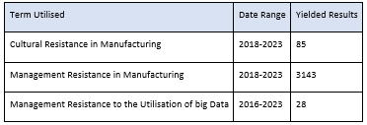
(Table 1)

1.6 Ethics
The data gathered for this study will be used ethically, adhering to a rigorous dedication to values that uphold the rights, privacy, and welfare of the participants. All participants will be required to provide informed permission, indicating their understanding of the goal and potential implications of the research. Stringent protocols shall be strictly adhered to safeguard the identities of persons and maintain the confidentiality of their sensitive information. The data will be maintained in a safe manner and will only be available to individuals who have been granted authorisation. The research process will be conducted in accordance with established codes of conduct and ethical review procedures, ensuring adherence to ethical principles. Efforts will be made to mitigate any potential negative effects or emotional discomfort experienced by participants, while also respecting their rights to discontinue their involvement in the study is upheld. The principles of transparency, honesty, and integrity will serve as guiding principles for the process of data collecting, analysis, and reporting, ensuring the maintenance of ethical standards throughout all stages of the research.
industry 4.0 & Big Data

Industry 4.0 & Big Data in Manufacturing
Industry 4.0, also known as the Fourth Industrial Revolution, aims to achieve full automation in manufacturing through data integration and modern technologies. While much research focuses on its technological aspects, there is a need for a comprehensive examination of implementation strategies, obstacles, and their effects on organisational operations and supply chains.
"The Influence of the Implementation of Industry 4.0 on Supply Chains" (Ghadge, 2020) investigates this. The authors' network relationship architecture sheds light on how Industry 4.0 affects supply chains, emphasising the need for adaptable connections between suppliers and customers to meet evolving market demands.
"Business Model Innovation through Industry 4.0: A Review" (Dorleta Ibarra, 2018) explores how Industry 4.0 transforms business models by altering value propositions, income streams, and customer connections. Organisations are urged to adopt Industry 4.0 to stay competitive globally.
"Industry 4.0 and its Impact on Employee Skills: A Systematic Literature Review" (Spöttl & Windelband, 2021) analyses the competencies individuals need to excel in an Industry 4.0 setting. Recommendations include training initiatives to cultivate these skills, emphasising ongoing learning and flexibility to manage technological changes.
"Industry 4.0 and the Future of Productivity" (Castellina, 2020) examines how Industry 4.0 enhances productivity and quality by integrating digital technology into production processes. Real-time monitoring, predictive maintenance, and quality control are highlighted, along with the potential of emerging technologies like AI and IoT to produce consistent, high-quality products.
Considering the human dimension is crucial. Research by (Nguyen Ngoc, 2022) investigates the role of human-centred design in Industry 4.0, emphasising the importance of employee well-being and contentment during its introduction. Creating a supportive work environment and offering training and development opportunities are crucial for a seamless transition to Industry 4.0 and maximising its benefits.

Introduction to Big Data in Manufacturing
The manufacturing industry is undergoing a significant shift in the era of digitalisation, mostly influenced by technological breakthroughs and the rapid expansion of data. At the heart of this paradigm shift lies the application of Big Data analytics, which is fundamentally transforming the operational, innovative, and competitive landscape of manufacturers. This thesis examines the significance of Big Data analytics in the manufacturing sector, encompassing its various applications and the profound revolutionary effects it has on the industry.

2.2 Big Data in Manufacturing
The manufacturing industry produces a significant volume of data. This encompasses data collected from various sources such as sensors deployed on the production floor, supply chain records, quality control measurements, and even feedback provided by customers. The term "Big Data" pertains to the process of gathering and analysing extensive and intricate datasets to derive significant insights. According to (kusiak, 2018), the utilisation of Big Data analytics enables manufacturers to harness the inherent value of this data and employ it for making informed decisions based on data analysis.

The Three Vs of Big Data
The fundamental concepts encapsulated by the three Vs of big data—Volume, Velocity, and Variety—are central to understanding the intricacies and opportunities associated with managing vast datasets in the realms of information technology and data science (Sicular, 2013). These three dimensions highlight the challenges posed by the sheer scale, speed, and diversity of data sources available today, underscoring the need for innovative approaches and technologies to effectively harness the potential of big data.

Velocity
When considering big data, velocity refers to the expeditious rate at which information is produced, gathered, and processed. The exponential growth of this phenomenon can be attributed to the pervasive integration of smart devices and the internet, which have revolutionised our routine exchanges into perpetual streams of data generation. Each action, including sharing, clicking, swiping, liking, or engaging in social media transactions, contributes to the enormous volume of data that is being generated in real-time. Consequently, in the contemporary digital environment, the capacity to effectively acquire, analyse, and extract insights from this inundation of data has grown in significance. (Lee, 2020)

Volume
In the context of Big Data, volume refers to the sheer amount of data collected and processed during a certain timeframe. This aspect of the Big Data paradigm emphasises the massive amounts of information that are beyond the capabilities of traditional databases and technology. With the exponential growth of digital interactions, such as online transactions, social media interactions, and sensor data, organisations are inundated with massive datasets that require advanced storage and processing solutions to effectively manage and extract insights from this wealth of data. (Lee, 2020)

Variety
Variety refers to the wide assortment of data types and formats encountered across different contexts. This includes structured data, which adheres to a defined schema and is organised in a tabular format like databases; semi-structured data, which lacks a rigid schema but has some organisational elements like XML or JSON files; and unstructured data, which lacks a predefined structure, such as text documents, images, videos, and sensor data. This diversity poses significant challenges for organisations aiming to extract insights from their data, as each type requires distinct processing and analysis techniques. Moreover, the proliferation of new data sources and formats in today's digital age adds complexity to the data landscape, necessitating adaptable approaches to data management and analysis. (Lee, 2020)

2.4 Predictive Maintenance and Efficiency
Predictive maintenance stands out as a notable utilisation of Big Data analytics within the manufacturing sector. Through the analysis of data obtained from various sensors and machines, manufacturers possess the capability to anticipate and forecast equipment failures prior to their actual occurrence. The implementation of this proactive method serves to mitigate instances of unforeseen operational disruptions, diminish expenditures associated with maintenance activities, and guarantee optimal operational efficiency. Furthermore, it enables the optimisation of maintenance schedules, leading to additional cost reductions (Serkan Ayvaz, 2021)

2.5 Demand Forecasting and Inventory Management
The utilisation of Big Data analytics enables the process of demand forecasting through the examination of historical data and market patterns. Manufacturers possess the capability to make precise forecasts on demand, hence enabling enhanced efficiency in inventory management and production planning. According to (Mafakheri, 2020), the implementation of this approach not only mitigates the issues of excessive inventory and wastage but also guarantees the availability of items promptly for customers.

2.6 Real-time Monitoring and Quality Control
The application of Big Data analytics in real-time monitoring of manufacturing processes is of paramount importance. Manufacturers can ensure adherence to quality standards by engaging in a constant analysis of data derived by sensors and machinery. According to (Dai, 2019), any deviations from the established standard can prompt alerts and subsequent changes, ensuring a consistent level of product quality and minimising the occurrence of faults.

2.7 Adaptive Manufacturing
The adoption of Big Data analytics facilitates the implementation of adaptive manufacturing, a paradigm in which production processes can be dynamically modified in response to real-time data insights. Manufacturers possess the ability to promptly adapt to dynamic circumstances, such as fluctuations in market demand or unforeseen disturbances in the supply chain. The ability to swiftly adapt enables organisations to sustain operational effectiveness and remain competitive in rapidly changing market environments. (kusiak, 2018)

Organisational Strategy

What is Organisational strategy
An organisational strategy serves as an all-encompassing blueprint that directs the decision-making procedures of a business and facilitates the fulfilment of its overarching objectives and strategic aspirations. For the purpose of optimising business operations, delineation between the distribution and configuration of resources is needed, including financing, personnel, infrastructure, and inventories. In addition, it promotes organisational transparency.
This tool assists both teams and individuals in the organisation in the process of prioritising projects and duties, thereby promoting the efficient use of available resources. Additionally, the strategy ensures that processes and procedures are consistent, which facilitates streamlined operations. Moreover, it serves a pivotal function in cultivating a unified goal and shared mission within heterogeneous teams.
The ability of the organisational strategy to adequately prepare the business to respond and adjust to forthcoming challenges and changes is a critical component. Adopting a proactive stance guarantees the organisation's ability to withstand challenges and transform.
Irrespective of the size or nature of the organisation (startup or multinational) it operates under, an organisational strategy continues to serve as a powerful and effective tool for facilitating effective strategic decision-making.

Development of a Strategy
An organisational strategy is comprised of several vital elements, and it is optimal that strategic management and stakeholders from across the organisation work in concert to develop it. Before its formulation, it is critical to establish a solid foundation of preparation. This foundational effort comprises:
Audits, both internal and external: The evaluations unveil the present state of the organisation with regard to its competitive landscape, customer base, consumer segments, strengths, vulnerabilities, market position, and prevailing trends.
Reinforced Structure: The implementation of a successful organisational strategy requires a clearly defined framework that specifies duties, responsibilities, and key performance indicators.

Core organisational values serve as the foundation for the strategy, embodying the culture, mission, and vision of the company. These principles direct the actions and judgements of personnel.
After establishing this foundation, the organisation may commence its strategic planning. This process entails delineating priorities, setting objectives, and charting its long-term course. The strategy establishes SMART objectives:
- Specified: defining the organisation's objectives precisely.
Determining achievement criteria and measurement metrics constitutes measurability.
- Attainable: Guaranteeing that the strategy, despite its ambitious nature, can be practically executed.
- Critical: Forging a distinct correlation between objectives and the overarching mission of the organisation.
By adopting this all-encompassing methodology, the organisational strategy is not only substantiated but also perfectly harmonises with the values, vision, and overarching mission of the company.

The Composition of Successful Strategies
Effective organisational strategies are composed of three key components: vision and mission, goals and objectives, and strategies and tactics. The vision and mission serve as the foundation, outlining long-term aspirations and guiding principles, while goals and objectives translate these aspirations into concrete targets and measurable steps. Strategies define overarching plans for resource allocation and response to challenges, while tactics detail specific actions for execution. Together, these components create a unified roadmap for achieving organisational objectives, ensuring alignment with the organisation's overarching vision and mission. (Diaz, 2022)

3.2.1 Corporate Level Strategy
The corporate strategy is a fundamental document that outlines a company's objective and influences all aspects of the organisational strategy. It acts as a guide for the business's direction, helps achieve organisational goals, and improves profitability. This comprehensive approach has a broad range and focuses on long-term goals and milestones.

3.2.2 Business-level Strategy
The business strategy acts as the intermediary that connects the overarching corporate strategy to the more specific functional strategy. It translates the established mission in the corporate strategy into distinct strategic programmes and activities that are included in the functional strategy. Furthermore, it offers transparency to departments, teams, and individual staff members, clarifying how their endeavours contribute to achieving the organisation's objectives and obtaining its business goals.

3.2.3 Functional-level Strategy
The functional strategy defines specific activities and actions that are necessary for departments and teams to meet the criteria outlined in the business strategy. The objective is to achieve the objectives specified in the corporate strategy. These strategies are distinguished by their detailed specificity, providing managers with a clear directive on how to allocate and the fulfilment of tasks by individuals in their teams.

Different types of strategy
Organisational strategies are varied and flexible, tailored to address the individual requirements of enterprises. These frameworks adapt and develop according to specific situations, objectives, and dynamics within the sector. plans include a spectrum of methods, ranging from growth-oriented tactics that prioritise expanding into new markets, to defensive plans that aim to protect against external dangers. The life cycle of a firm has a significant impact on its strategy. Start-ups tend to focus on penetrating the market, whereas older companies often opt for diversification. The selected strategy is greatly influenced by the organisational environment, which includes factors such as business culture, industry trends, and competitive landscapes. To summarise, the intrinsic adaptability of organisational strategies enables organisations to choose and customise their strategy, ensuring it aligns with specific goals and contextual circumstances. Generally, the tactics may be categorised as follows: (nomadia, 2023)

3.3.1 Differentiation
Businesses use differentiation strategies to get a competitive advantage by emphasising distinctive attributes in their goods or services. To execute this approach with efficiency, organisations carry out comprehensive market research to comprehend customer preferences, scrutinise competition products, and pinpoint market voids. This study offers useful information that empowers organisations to customise their products to differentiate themselves.
Refining processes and procedures is a vital component of differentiation, whereby organisations prioritise providing superior goods or services and demonstrating competence in the industry. The dedication to excellence and specialised knowledge strengthens the perceived worth of products or services, hence enhancing their distinctiveness.
Furthermore, differentiation tactics include focused marketing initiatives that highlight the organisation's dedication to innovation or excellence. These marketing initiatives effectively convey unique attributes to the intended audience, creating a desire for the product or service and cultivating a favourable perception of the brand. Marketing efforts have a crucial impact on moulding how consumers perceive a product or service and fostering brand loyalty, so reinforcing the differentiation approach.

3.3.2 Concentration
Concentration strategies, or rationalisation, refer to the process of restructuring a company to enhance its efficiency. This involves deliberately implementing changes to streamline and enhance multiple facets of the organisation. Commonly used tactics encompass:
- Staff Reduction:
Intentionally reducing the number of employees by reorganising teams, removing redundant roles, or introducing strategies to enhance worker productivity. The objective is to provide a highly streamlined organisational framework that optimises production.
- Consolidating Facilities and Locations:
Concentration techniques may also include downsizing the number of facilities, shop locations, or company units. This may include streamlining operations, shutting down failing stores, or divesting from non-essential business segments to attain a more concentrated and efficient operating structure.
- Product line reduction is the process of abandoning certain items or limiting options to prioritise core, high-performing products. This enables the organisation to efficiently allocate resources and focus its efforts on goods that have the greatest market potential.
Concentration methods are often used when an organisation reaches a level of complexity that results in inefficiencies. These techniques are essential for revitalising the firm and making it more controllable and lucrative. The choice to use concentration techniques is often grounded on a comprehensive examination of the organisation's structure, operations, and market dynamics. The objective is to enhance agility, minimise expenses, and position the organisation for long-term success in a fiercely competitive business environment.

3.3.3 Growth
Organisations often use expansion strategies to broaden their business activities. These tactics include a range of different methods, including:
- Market Expansion:
Investigating potential in unexplored regions, both domestically and globally, to attract a wider customer base and enhance market dominance.
- New Products:
Introducing novel items or broadening the product range to appeal to a broader client base and augment income sources.
- Diversification:
Refers to the strategic expansion into new and unrelated company sectors to reduce risks and take advantage of a wide range of income sources.
Acquisitions and mergers:
Consolidation of resources by purchasing or combining with rivals or complementary organisations. This strategy aims to enhance market position and accelerate development.
These strategies for growth serve as a navigational tool, directing organisations through phases of expansion. They provide an organised blueprint for distributing resources, delineating precise approaches for regions of expansion. Moreover, these strategies include quantifiable indicators of achievement, enabling enterprises to assess and analyse the efficiency of their expansion endeavours. This methodical approach guarantees efficient decision-making and allows the organisation to take advantage of sustainable and strategic development prospects.
Big Data and Organisational Strategy

Overview of the role of big data in organisational strategy
The extensive incorporation of big data analytics has brought about substantial changes in the manufacturing sector, compelling organisations to reevaluate their processes and revealing novel opportunities for making well-informed decisions. This investigation highlights the potential of big data to produce significant insights and impact the processes of strategic decision-making. The subsequent research investigates the implications of big data across multiple dimensions, including organisational productivity, competitiveness, and overall success. Furthermore, this emphasises the significance of comprehending potential obstacles that institutions may confront when incorporating big data analytics into their strategic frameworks.

Importance of data-driven decision making
The incorporation of big data analytics in the industrial sector signifies a significant and transformative change for organisations, enabling them to adopt data-driven decision-making as opposed to traditional approaches that rely on intuition or past experiences (Thomas H. Davenport, 2013). The importance of this paradigm change cannot be overstated in the current industrial environment, where the vast amount and rapid pace of data produced throughout production processes, supply chains, and consumer interactions require sophisticated analytical methods to facilitate informed decision-making.
Real-time data analytics is of significant importance in the industrial sector as it contributes to the improvement of operational efficiency and competitiveness (Thomas H. Davenport, 2013). Through the utilisation of advanced analytics tools, enterprises have the ability to derive significant and valuable insights from the extensive volumes of data that emanate from their production lines. This facilitates a flexible and responsive strategy towards production management, facilitating prompt adjustments to evolving circumstances and enhancing the allocation of resources.
Furthermore, the influence of big data analytics extends beyond the confines of the factory floor, encompassing the realm of supply chain management. The capacity to analyse and interpret data throughout the entirety of the supply chain affords organisations a comprehensive perspective of their operational activities. A thorough comprehension of this subject matter facilitates the implementation of proactive measures to manage risks, identify areas of congestion, and optimise logistical operations. Consequently, this enhances the overall resilience and efficiency of the supply chain (Thomas H. Davenport, 2013).
Customer feedback, an essential element within the realm of big data, plays a substantial role in informing the decision-making process within the manufacturing industry. By utilising sentiment analysis and various customer-centric analytics techniques, manufacturers are able to acquire significant data about market preferences, product performance, and potential areas for enhancement. The adoption of a customer-centric strategy enables the creation of products and services that are more closely aligned with the expectations of consumers, hence promoting higher levels of customer satisfaction, and building long-term loyalty (Thomas H. Davenport, 2013).
The increasing adoption of data-driven decision-making in the manufacturing industry is motivated by the acknowledgement that conventional methods frequently struggle to manage the intricacies of contemporary production settings. The reliance on intuition and past experiences, however valuable, may be inadequate in comprehensively addressing the complexities arising from the dynamic nature of markets and the growing interconnectedness of global supply chains. In contrast, the utilisation of big data analytics presents a structured and empirically supported approach to decision-making, enabling organisations to effectively address the complexities associated with the digital age. (Thomas H. Davenport, 2013)

4.2 Challenges in Incorporating Big Data into Organisational Strategy
The integration of big data analytics into organisational strategy is an intricate process fraught with challenges that span several critical areas. One of the primary challenges lies in ensuring Data Quality and Integration. High-quality data is fundamental to the success of analytics initiatives, necessitating accuracy, consistency, and relevance (R. Y. Wang, 1995). The integration aspect involves harmonising disparate data sources to derive meaningful insights, a task compounded by the diverse nature and sheer volume of data (Chen, 2012)
Data Security and Privacy emerge as paramount concerns in the era of big data analytics. With organisations leveraging vast datasets containing sensitive information, safeguarding against unauthorised access, and breaches, and ensuring compliance with privacy regulations is imperative (Pentland, 2022). The dynamic landscape of cyber threats requires robust security protocols and proactive measures to preserve the confidentiality and integrity of data (Lim, 2023).
Cost considerations represent a pivotal challenge in the seamless incorporation of big data analytics. The required infrastructure for data storage, processing, and analytical tools often demands substantial financial investments (Uthayasankar Sivarajah, 2017). The dynamic nature of the analytics landscape further complicates the cost-benefit analysis, requiring organisations to optimise their analytical capabilities while adhering to fiscal responsibility.

Personnel Skills pose another critical hurdle in the integration of big data analytics. The effective utilisation of analytics demands a skilled workforce capable of navigating complex analytical tools, interpreting results, and applying insights to strategic decision-making. The shortage of professionals proficient in data analytics, machine learning, and related fields exacerbates this challenge, underscoring the need for ongoing investment in training programs and recruitment initiatives (CIPD, 2013).
Tool Complexity adds another layer of intricacy to the incorporation of big data analytics into organisational strategy. The rapid evolution of analytical tools, frameworks, and technologies necessitates continuous adaptation. Selecting and implementing the right tools aligned with organisational objectives require nuanced decision-making. The complexity of these tools can pose a steep learning curve for users, emphasising the importance of comprehensive training and ongoing support to maximise their potential (DeBrusk, 2023).
Navigating these challenges requires organisations to adopt a holistic and adaptive approach, combining technological innovation with strategic planning and investment in human capital. Recognising the interplay of these challenges and formulating strategies that acknowledge the dynamic nature of the big data analytics landscape is crucial for success in the digital era.

Culture

Organisational Culture
The culture of an organisation relates to its distinct character and personality. It consists of common ideas, presumptions, and viewpoints on appropriate work practices, decision-making processes, and interpersonal behaviour. The organisation's culture is shaped in part by its past, present, and internal members.
It is essential for a leader to comprehend the business culture to be successful. Managers and other leaders may better develop and accomplish their objectives when they are aware of the organisational culture. Attempting to use tactics that are in opposition to the corporate culture may encounter opposition and turn out to be more difficult or even impossible. Conversely, strategies that fit in with the culture are probably going to go more smoothly and have a better chance of succeeding. Understanding an organisation's current culture inside and out is crucial for implementing changes.
While determining the precise elements that form a culture might be challenging, witnessing its impact is often easier. The culture of a huge financial business, for example, may vary significantly from that of a hospital or university, and it may also differ from that of a tiny, informal software firm. It might take months or even years for new personnel to properly comprehend and integrate into the culture. In any case, how effectively the company manages the onboarding process is critical. Under some circumstances, a large number of new hires—especially those in senior roles—may change the culture that already exists.
It is critical to understand that, despite the existence of an overall organisational culture that specifies acceptable behaviour generically, subcultures may emerge in reaction to specific job duties or other connections. Individuals' subjective perceptions and interpretations of the company's culture will unavoidably vary depending on their own opinions. Certain facets of culture may apply to them more than others, depending on their positions.
An organisation's relationships, values, and behaviours should be evaluated in conjunction with its declared and unwritten laws to get a thorough knowledge of its culture. (Young, 2023)

Organisational Culture Models
Although there are many different model types the most well-known models are by Charles Handy, Edgar Schein and Geert Hofstede. These models are known as the Handy, Schein and Hofstede models for Organisational culture.

5.1.1 Handy’s Model
According to Handy's concept, there are four distinct management styles, each with its own set of values. These beliefs and expectations gradually define the organisational culture. There are four cultures: Club Culture, Role Culture, Task Culture, and Existentialist Culture. Handy's concept links each of the cultures to the ancient Greek Gods for ease of remembrance. (Handy, 2009)
- Club/Power Culture (Zeus)
The club culture revolves around power, connections, and respect. It is often seen in organisations with like-minded members and a charismatic entrepreneur at the helm.
In this society, speed is more important than perfection. Decisions are often dependent on what the CEO wants, therefore it is critical to agree with the organisation's leader.
This culture style is more suited to organisations where rapid expansion is taking place or where the organisation is dealing with a succession of crises.
In club culture, personal ties are often more important than the substance of your arguments or beliefs. To negotiate this, consider the requirements of your allies and critical stakeholders. Gaining their support is critical to moving your initiatives and ideas forward.
- Role Culture (Apollo)
Large, hierarchical, and bureaucratic organisations frequently have a role culture. Work is discussed in terms of a person's function or a specific task that must be completed. Stability, efficiency, and predictability take precedence over individual demands.
The role culture works best in government agencies, industries with slow change, and companies with a long history of high-quality product delivery. It is also useful when team members need to follow specific rules, regulations, and procedures.
- Task Culture (Athena)
With task culture, what matters most in an organisation is how well people perform and how many problems they can solve. Expertise, talent, creativity, and the ability to face challenges are all highly valued and rewarded. This culture encourages high levels of engagement and enthusiasm, attracting expert professionals who genuinely want to contribute to the organisation's success.
The task culture works particularly well in industries where problem-solving is the primary focus. Examples include R&D, marketing, advertising, and consulting. It is also useful when an organisation is expanding or seeking to develop new products or services.
- Existential/Person Culture (Dionysus)
With Club, Role and Task Culture, individuals contribute to the organisation by attempting to meet its objectives. In contrast, existentialist culture views the organisation as a tool to help individuals achieve their higher purpose. This is where an individual's talents and skills are prioritised as the organisation's most important assets. The existentialist culture complements organisations that rely significantly on the experience and talents of professionals, particularly those who stand out. For example, virtual businesses that include contractors and employees usually use an existentialist strategy. Many start-ups and collaborations reflect an existentialist culture.
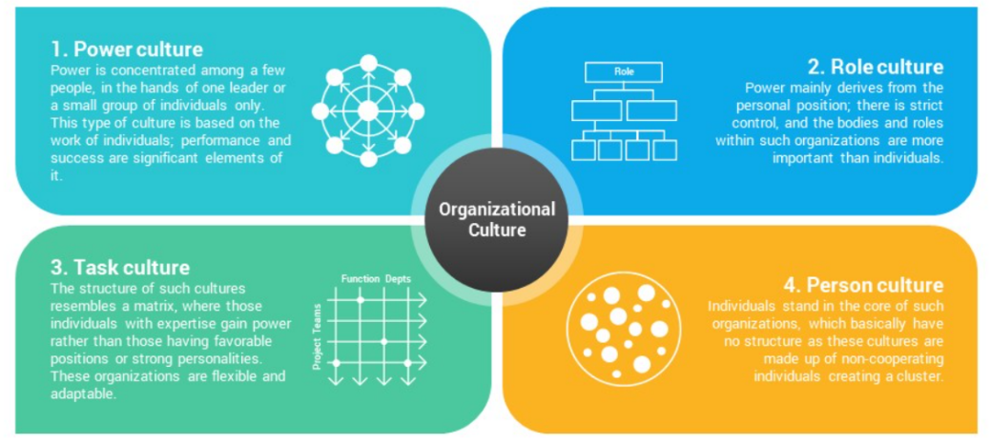
Image taken from (Slide Salad, n.d.)
5.1.2 Schein Model
The Organisational Culture Model by Edgar Schein offers a thorough framework for comprehending the different aspects of corporate culture. Three interlinked layers make up the model: artifacts and symbols, espoused values, and basic underlying assumptions. Schein highlights the interactions between these layers and the value of taking a comprehensive approach to evaluating, comprehending, and maybe changing organisational culture. Organisations are able to manage cultural complexity with a more advanced and successful approach thanks to this appreciation. (Fripp, 2024)
- Artifacts and Behaviours
Artefacts are observable aspects of corporate culture, such as workplace layout, clothes, branding, and rituals. They show underlying ideals, such as teamwork in open offices.
Behaviours represent how individuals interact within an organisation, developing norms and values. Leadership and social dynamics both have an impact.

- Espoused Values
Espoused values are the views, ideals, and principles that a company publicly expresses and promotes to its members. These values are usually defined in formal documents like mission statements, codes of conduct, or corporate philosophies.
They also lay the groundwork for the organization's culture, directing decision-making procedures, attitudes, and interactions among its members. They symbolise the organization's desired identity and goals. However, it is vital to recognise that there may be times when the organisation's actual activities do not fully line with these professed ideals.
- Basic Underlying Assumptions
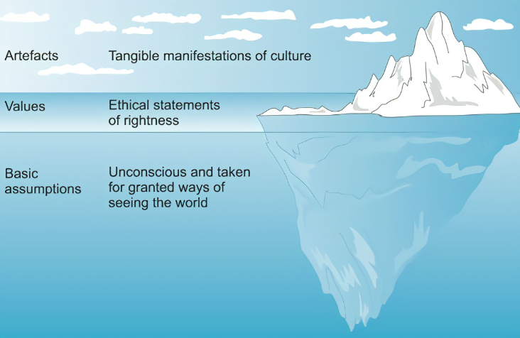
Basic underlying assumptions are deeply held beliefs, attitudes, and unconscious thoughts that influence how people behave and make decisions in an organisation. These assumptions are so firmly ingrained that they are typically accepted without question because they are part of the organisation's structure. They influence how people believe they perceive the world, comprehend their circumstances, and interact with peers. Essentially, these assumptions serve as the foundation for organisational culture, determining the organisation's rules, behaviours, and mindsets.

Image taken from (Pintrest, n.d.)

5.1.3 Hofstede Model
Geert Hofstede's Cultural Dimensions Theory stands as a significant framework for comprehending the diverse cultural variations present in nations and organisations. Crafted by the Dutch social psychologist Geert Hofstede, this model unveils six distinct cultural dimensions, shedding light on the fundamental values and behaviours entrenched within societies. (The Culture Factor Group, 2024)
- Power distance index
The Power Distance Index assesses how individuals in an organisation perceive the uneven distribution of power. In environments with high power distance, weaker members typically accept hierarchical structures, while in settings with low power distance, they tend to seek explanations for power imbalances.
- Masculinity v Femininity
The debate between masculinity and femininity centres on the importance of particular ideals. "Masculine" ideals include accomplishments, bravery, aggressiveness, and competition; they represent a society that emphasises aspiration and personal prosperity. 'Feminine' values, on the other hand, highlight a culture that values harmony in relationships, cooperation, communal well-being, and humility as well as the general quality of life. Gaining an understanding of these differences can help one better understand the cultural makeup of a community or organisation.
- Individualism v Collectivism
Individualism vs. collectivism explores how an organisation weighs the demands of the individual against the interests of the collective. Individuals are expected to prioritise their own interests and well-being in a culture that values individuality. Conversely, collectivism emphasises teamwork and the welfare of the group as a whole, creating a climate in which members actively address and consider the needs of one another. Knowing this aspect clarifies whether the emphasis is on group collaboration or individual autonomy, offering important insights into the organisational dynamics.
- Uncertainty avoidance index
This is all about determining how comfortable people are in the face of uncertainty and ambiguity, as well as whether a company should actively create the future or take a wait-and-see strategy. Those who score high on this indicator are more likely to conform strictly to established behavioural standards and are less willing to tolerate unusual ideas or acts. It essentially captures the organisation's attitude towards the unknown and its readiness to negotiate ambiguity, providing useful insights into how it tackles change and innovation.

- Long-term orientation v short-term orientation
Long-term-focused organisations are more likely to take actions that will pay off in the long run. This strategy places a strategic emphasis on long-term activities and practices that create the foundation for long-term success. Organisations that have a short-term orientation, on the other hand, tend to be sceptical of change and show a preference for upholding current cultural norms. This distinction in orientation influences an organisation's adaptability, resilience, and overall approach to long-term success by illuminating how it strikes a balance between short-term goals and a strategic vision for the future.
- Indulgence v restraint.
Introduced in 2010, this dimension is a more recent addition to Hofstede's model. There is a strong focus on fostering leisure, meeting personal needs, ensuring happiness, and placing general well-being as a top priority in companies with indulgent cultures. The search for personal fulfilment is acknowledged and encouraged in such cultures. Conversely, companies with restrained cultures are less likely to highlight these features, and emotional expressiveness is typically less overt. This component sheds light on how organisations view individual well-being within the larger organisational environment by illuminating how they strike a balance between personal fulfilment and conformity to standards.
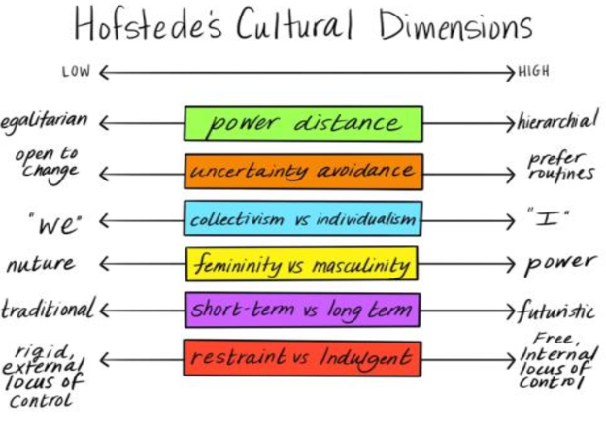
Image taken from (Nassar, 2023)

Cultural Implications of Big Data Implementation
The integration of big data into manufacturing decision-making processes has substantial cultural consequences, as it brings about significant alterations that challenge existing conventions inside organisations. Throughout history, the process of decision-making in the industrial sector has been significantly dependent on the extensive expertise and intuitive insights of specialists inside the industry. Nevertheless, the traditional method has been challenged by the emergence of big data analytics, leading to the advent of a novel era characterised by decision-making based on data (Thomas H. Davenport, 2017).
The workforce has significant hurdles in terms of acceptance, which can be attributed to the cultural ramifications of this transformation. According to (Thomas H. Davenport, 2017), employees who are firmly immersed in a culture that places high importance on personal expertise and intuition may demonstrate reluctance and unease when it comes to adopting algorithms and analytics as their main decision-making tools. The aforementioned resistance highlights a conflict between entrenched hierarchical systems and power dynamics within organisations, as well as the revolutionary impact of big data (Rehman N, 2021)
One of the key cultural ramifications pertains to the possible erosion of trust in human competence and the hierarchical frameworks that have traditionally governed decision-making processes. With the growing reliance on data-driven insights, organisations are seeing a potential cultural transformation towards a more inclusive decision-making process, which challenges the conventional authority held by seasoned experts (Thomas H. Davenport, 2017). This transition has the potential to prompt a reassessment of the prevailing organisational culture, thereby influencing the dynamics of leadership and altering the perception and valuation of knowledge among employees.

Case Study

Case study introduction
When considering the potential of big data to revolutionise operations in manufacturing, extensive research has revealed that there is no one-size-fits-all solution. While leveraging data can lead to transformative changes, it is also accompanied by a host of challenges spanning various fronts. These challenges include navigating cultural shifts, overcoming leadership obstacles, and the critical necessity of crafting a well-defined strategy that aligns with the company's overarching vision.
Upon delving deeper into the effective utilisation of big data, it becomes evident that certain industries have been particularly successful in maximising its benefits. Companies in the service sector, like McDonald's, Amazon, and Uber Eats, serve as shining examples of organisations that have harnessed big data to drive innovation and enhance efficiency in their operations. However, applying these strategies to the manufacturing realm demands a nuanced approach.
To gain deeper insights into the complexities of implementing big data initiatives in manufacturing, we conducted an in-depth case study focused on Company X. This allowed us to identify and analyse the specific constraints and challenges associated with integrating big data solutions. To facilitate this research, we actively engaged a diverse group of staff members from various departments within Company X, gathering valuable perspectives and insights.
By exploring the experiences of Company X and similar organisations, the aim is to unravel the intricacies surrounding big data utilisation in the manufacturing sector. It is essential to examine the micro-level factors that influence organisational change, fostering an environment conducive to internal evolution.
As we navigate the complexities of big data implementation, we understand the significance of not only recognising challenges but also identifying opportunities for growth and optimisation. Through collaborative research and a concerted effort to grasp the unique dynamics at play, we strive to pave the way for transformative change within manufacturing companies. This endeavour aims to propel them toward greater efficiency, innovation, and competitiveness in the dynamic landscape of modern industry.

Employee Interview Methodology
A company based in South Wales stood out for its role in driving innovation and maintaining high standards in manufacturing, covering everything from crafting individual components to overseeing large-scale assembly. The company's strong market position within its industry and extensive network of sister sites worldwide played a significant role in the decision to focus on it.
Given the broad scope and complexity of the organisation, a thorough questionnaire was developed, Appendix 1, to gather detailed responses from a diverse group of participants. The aim was to give participants ample time to fully express their thoughts and observations, ensuring that each question received an honest and direct evaluation. The questionnaire was carefully crafted to encourage respondents to elaborate on their answers, leading to a comprehensive and nuanced understanding of the organisation's methods and perspectives. Participation was sent via email to a broad selection of staff, this was done anonymously to protect the value of the data. Appendix 2.
After collecting and reviewing the data, the responses were meticulously organised, resulting in the creation of extracts from the questionnaire that are included in the appendices of the study. These excerpts highlight the main themes and ideas that emerged from the feedback provided by participants, offering insight into the prevailing attitudes and priorities within the organisation.

6.2 Analysis of Questionnaire

6.2.1 How would you define big data in the context of the organisation?
Based on the analysis, it is clear that opinions within the organisation regarding big data are varied. Some see its potential and stress its importance in decision-making and business transformation, while others believe it is not being used effectively or is rarely utilised. The emphasis on gathering data from key business systems shows an understanding of the significance of data sources but also acknowledges the difficulties in handling large and complex datasets. In summary, these perspectives highlight both obstacles and prospects in making the most of big data in the organisation, indicating a need for strategic alignment, better utilisation, and ongoing improvement efforts. Appendix 3.

6.2.2 Provide examples of how big data is currently utilised within the Organisation.?
The main point we gather from these responses is that there is a difference in how much people know about and use big data within the organisation. Some give detailed examples of how big data helps with analytics and improving processes, while others say they have not seen any evidence of it being used. This suggests that there might be inconsistencies in how big data initiatives are rolled out and communicated across different parts of the organisation. It emphasises the need for clear communication and real-life examples to show everyone the benefits of using big data for things like improving performance and producing new ideas. Appendix 4.

6.2.3 What tools and technologies does the Organisation use for big data storage and processing?
The analysis of tools and technologies used for big data storage and processing highlights several key aspects within the organisation's data management framework. Firstly, there is a recognition that some individuals may lack technical proficiency in big data tools and technologies, potentially indicating a need for training or support in this area. The reliance on the ERP system, Baan, underscores its significance as a central tool for managing various aspects of operations, sales, and the supply chain, suggesting a core role in data management. Additionally, the use of specialised software systems across different departments or locations, such as the performance output system in MU, highlights a tailored approach to meeting specific data needs. The organisation's embrace of cloud storage services and mobile devices reflects a flexible and accessible approach to data management, promoting efficiency and mobility in accessing and storing data. Furthermore, the utilisation of spreadsheets and collaboration tools emphasises the importance of teamwork and ease of use in data processing and collaboration. Finally, the adoption of Business Intelligence (BI) tools like PowerBI highlights a strategic focus on deriving valuable insights from data. Overall, these responses depict a diversified and adaptable strategy in managing and analysing data, aligning with different departmental needs and functions within the organisation. Appendix 5.

6.2.4 How are large volumes of data, both structured and unstructured handled?
The responses shed light on how the organisation manages large volumes of both structured and unstructured data. They utilise summary reports and analytical tools such as Crystal Reports, Birst, and Power BI for structured data analysis, with specialised tools like Lean DNA for specific datasets like inventory and supplier information. Cloud computing and data storage servers are employed for scalability and cost-effectiveness, while data governance and security measures are ensured by individuals and security systems. However, some respondents express uncertainty or lack of knowledge about data management practices, indicating potential communication gaps. Structured data is organised into tables, but the management of unstructured data remains unclear. Challenges arise from ineffective data integration between different business systems, leading to disjointed data structuring and independent data provision. Overall, the organisation adopts a varied approach to managing data, combining tools and technologies, but faces challenges in integration and communication. Appendix 6.

6.2.5 How does the Organisation leverage big data for business analytics and decision-making?
The organisation leverages big data for business analytics and decision-making in several ways. Firstly, big data serves as evidence for decision-making and building customer confidence, although there's awareness of the potential for data manipulation. Secondly, it is used for focused improvement by collecting key input parameters to identify weaknesses and drive real-time improvements, particularly evident in Kaizen events. Thirdly, big data plays a role in these improvement initiatives, focusing on specific areas within the organisation. However, there is some uncertainty among respondents regarding how big data is utilised, indicating potential gaps in understanding or communication. Additionally, custom dashboards aligned with business KPIs are utilised, though there's room for improvement in streamlining analytics processes for greater efficiency and data integrity. Overall, big data is integrated into various aspects of decision-making and improvement initiatives within the organisation, although challenges such as potential data manipulation and the need for process improvements persist. Appendix 7.

6.2.6 Instances where big data has led to actionable insights or improvements?
These examples illustrate how big data analysis has driven actionable insights and improvements within the organisation. Firstly, through sales order optimisation, data analysis revealed capacity issues in meeting customer demands, prompting efficiency-focused improvements. Additionally, a multi-million-pound investment in manufacturing equipment underscores the impact of data-driven decisions on enhancing manufacturing capabilities. Insights from the digital factory identified areas for improvement, such as reducing waiting times through targeted enhancements in interstage inspections. Moreover, analysis of product non-conformance reports led to quality improvements, reducing defects per unit, and enhancing customer satisfaction. Lastly, productivity gains in final assembly and increased equipment effectiveness in manufacturing plants highlight the operational benefits derived from data-driven insights. Collectively, these examples underscore the value of big data in informing strategic decisions and driving tangible business outcomes, from optimising sales processes to enhancing manufacturing efficiency and product quality. Appendix 8.

6.2.7 How does leadership within the Organisation promote the adoption of big data technologies?
The responses shed light on how leadership within the organisation facilitates the adoption of big data technologies. While some departments struggle with limited awareness and difficulty in translating the importance of big data to lower levels, others express dissatisfaction with leadership's promotion efforts. However, there are positive signs, such as training initiatives within the operations department aimed at educating managers on leveraging data for improvement. Nonetheless, scepticism persists in some areas, indicating a lack of widespread endorsement or integration of big data initiatives. Overall, these responses highlight a mixed landscape of leadership engagement, suggesting a need for stronger communication, training, and organisational alignment to fully harness the potential of big data technologies for driving improvements. Appendix 9.

6.2.8 Is there a clear vision for integrating big data into the overall business strategy?
These responses provide a nuanced perspective on the clarity of integrating big data into the overall business strategy. While some express uncertainty, citing the hiring of a Chief Data Officer as indicative of a growing focus on data discussions, others highlight a lack of clear understanding regarding the implementation of big data integration. Additionally, there is an acknowledgement of fragmented understanding regarding big data's potential and expectations. However, there are positive instances, such as a clear vision within the operations department driving improvements through data. Yet, challenges persist, as evidenced by a manufacturing-centric strategy that may not fully align with broader organisational objectives. Moreover, one respondent outright denies the existence of a clear vision, indicating potential gaps in alignment and communication. Overall, these insights underscore the need for enhanced communication, alignment, and leadership engagement to effectively integrate big data initiatives into the organisation's overarching strategy. Appendix 10.

6.2.9 Are there initiatives in place to train employees on big data technologies and analytics?
The responses shed light on the presence and effectiveness of initiatives to train employees in big data technologies and analytics within the organisation. While some departments exhibit efforts in this regard, there is a notable lack of cohesion and consistency across the organisation, indicating disjointed training approaches. Criticism is levelled at the execution of training initiatives, with some deeming them poorly executed and untimely, emphasising the need for more proactive and well-timed efforts. However, there are instances of structured training programs focusing on technologies like M3 and ongoing initiatives targeting areas like Overall Equipment Effectiveness (OEE) and specialised apps, highlighting a commitment to enhancing employee skills. Despite these efforts, there is a prevailing lack of awareness among some respondents regarding such initiatives, suggesting potential communication gaps. Additionally, some note a selective implementation of training, hinting at a fragmented strategy rather than a comprehensive approach. Overall, the responses underscore the need for a more coordinated and proactive training approach, ensuring uniform skill development across the organisation to effectively leverage big data in various roles. Appendix 11.

6.2.10 How do you ensure that your workforce is equipped with the necessary skills to work with big data?
The responses shed light on how organisations ensure their workforce is equipped with the skills to work with big data. Some emphasise structured training programs focused on specific tools like Minitab, PowerBI, and Python, showing a proactive approach to skill development. Others stress the importance of standardisation in reporting and data management to ensure consistency and transparency. Strategic planning is highlighted as essential for aligning training efforts with organisational goals and technological needs. Additionally, there is a focus on training in current technologies and data security measures, reflecting a comprehensive approach to skill development. Supportive leadership is deemed crucial in fostering a culture of continuous learning and skill enhancement, with managers actively encouraging the use of data visualisation tools. Lastly, the emphasis on maintaining a high learning rate underscores the need to adapt to technological advancements swiftly. Together, these approaches aim to equip the workforce with the skills necessary to leverage big data effectively for decision-making and business insights. Appendix 12.

6.2.11 To what extent does the Organisation encourage cross-departmental collaboration in utilising big data?
The responses provide a diverse range of perspectives on the extent of cross-departmental collaboration in utilising big data within the organisation. While some respondents note limited collaboration, others highlight fragmented improvement efforts and cultural challenges hindering effective collaboration. Additionally, there is the acknowledgement of minimal practical experience in cross-departmental collaboration, indicating a gap between aspirations and implementation. Some respondents observe limited collaboration in specific processes, suggesting that while there may be pockets of collaboration, it is not widespread. Moreover, challenges with business systems integration pose obstacles to collaboration and data sharing. Overall, these insights underscore the need for concerted efforts to foster a collaborative culture, address structural barriers, and integrate systems for seamless collaboration in utilising big data across departments. Appendix 13

6.2.12 How is information about big data initiatives communicated across different levels of the organisation?
The responses reflect a variety of approaches to communicating information about big data initiatives within the organisation. Some rely on digital platforms like newsletters and the company's internet homepage, indicating a modernised approach to dissemination. However, others highlight challenges such as limited communication, with some feeling that information about big data projects is shared in isolated silos rather than fostering cross-functional collaboration. Interestingly, operational activities like Quick Response Quality Control are seen as avenues for spreading data-driven insights, suggesting that certain processes may naturally facilitate information sharing. Nevertheless, there's uncertainty among some respondents about communication methods, while others resort to traditional channels like email and bulletins. Overall, while there is a mix of approaches, there is a need for a more cohesive strategy to address challenges such as limited collaboration and uncertainty, ensuring effective communication and engagement across all levels of the organisation. Appendix 14.

6.2.13 Does your organisation encourage experimentation and innovation in the use of big data?
The responses reveal a diverse array of perspectives on whether the organisation promotes experimentation and innovation in utilising big data. Some respondent’s express uncertainty or a lack of awareness about such initiatives, suggesting potential gaps in communication or visibility. Conversely, others assert that the organisation actively encourages experimentation and innovation, reflecting a proactive approach towards embracing new technologies. One respondent highlights a collaborative partnership with a university to explore industry trends, underscoring the organisation's openness to external collaborations for technological advancement. However, some individuals admit to limited awareness or experience with innovation initiatives related to big data, indicating possible communication deficiencies or low participation rates. Additionally, one respondent notes that innovation efforts may be more concentrated within specific functions rather than organisation-wide endeavours. Overall, while there are signs of encouragement for experimentation and innovation, there are also areas of uncertainty and limited awareness. Addressing these issues may require improved communication, increased participation, and a cohesive organisational strategy to cultivate a culture of innovation and experimentation across all levels and functions. Appendix 15.

6.2.14 Are there instances where taking risks with big data has resulted in positive outcomes?
The responses offer varied perspectives on whether taking risks with big data has led to positive outcomes within the organisation. While some respondent’s express uncertainty or lack of awareness regarding such instances, others affirm that there have indeed been positive outcomes resulting from strategic risk-taking with big data. One respondent cites machinery investment in the manufacturing unit as an example of successful risk-taking, while another highlights a specific case where changing the interstage inspection process led to improved product standards. However, some respondents admit to not being aware of any positive outcomes from risks with big data, indicating potential communication gaps or limited visibility of such successes. Overall, while there are indications of positive outcomes resulting from risk-taking with big data, there are also instances of uncertainty and limited awareness. Addressing these gaps may require enhanced communication, knowledge sharing, and a culture that fosters experimentation and calculated risk-taking to fully leverage the potential benefits of big data initiatives within the organisation. Appendix 16.

6.2.15 How flexible is the organisation in its use of big data to drive improvements?
The responses provide various viewpoints regarding the organisation's flexibility in using big data for improvement. Some respondents see the organisation as inflexible, suggesting a slow uptake despite a growing understanding of data integration. Others view the organisation's approach as inconsistent, with different departments utilising big data to varying degrees. Some express uncertainty about the organisation's flexibility, indicating a lack of clarity or knowledge in this area. However, there is a positive outlook on flexibility within operations, implying a supportive environment for big data in certain areas. Nevertheless, concerns about cost could hinder big data implementation due to perceived barriers. While there's recognition of big data's importance, it does not necessarily mean high flexibility in its use. Overall, while some areas show flexibility and acknowledgement of big data's significance, challenges like rigidity, inconsistency, uncertainty, and cost-consciousness may hinder its effective utilisation. Overcoming these challenges may require concerted efforts to foster flexibility, improve understanding, and remove perceived barriers across the organisation. Appendix 17.

6.2.16 Can you provide examples of how the company has pivoted in light of data be it negative or positive?
The responses offer a comprehensive overview of how the company has adjusted its strategies based on data-driven insights, resulting in both positive and negative outcomes. One respondent highlights the adoption of basic data collection in a digital factory, indicating a shift towards leveraging data for operational improvements, albeit in simple forms. Conversely, another respondent expresses uncertainty about specific instances of pivoting in response to data, suggesting a potential lack of clarity or awareness about data-driven initiatives. Additionally, late project releases are noted by one respondent, suggesting that although data may have been utilised to assess project timelines, it did not lead to favourable outcomes, indicating areas for improvement in data utilisation. On a positive note, the mention of data-driven recruitment strategies illustrates a pivot towards addressing recruitment challenges and optimising supplier relationships, demonstrating the proactive use of data for process enhancement. However, some respondents admit to limited experience with data-driven pivots, implying that certain areas of the organisation may still be lagging in implementing such initiatives. Nonetheless, one respondent highlights increased productivity resulting from data-driven initiatives, indicating successful utilisation of data insights to optimise processes and resource allocation. Overall, the responses underscore the importance of ongoing optimisation and improvement in data-driven decision-making processes within the organisation, recognising both successes and areas for further refinement. Appendix 18.

6.2.17 How would you assess the current state of big data adoption within the organisation?
The responses reflect a diverse range of perspectives on the organisation's current state of big data adoption. Some respondents indicate a lack of awareness or uncertainty about whether the organisation is considering big data adoption, suggesting potential gaps in visibility, or understanding of big data initiatives. On the other hand, there are indications of moderate progress, with the implementation of a new ERP system leading to a slightly more cohesive approach to data integration. However, there are also mentions of limited understanding, early stages, and low maturity in big data adoption, highlighting challenges such as a lack of clarity on usage and benefits, as well as skill gaps within the organisation. Despite these challenges, there is a positive assessment from some respondents, suggesting that there may be positive developments in leveraging big data effectively. Overall, these responses underscore the need for efforts to enhance awareness, build capability, and foster a supportive culture to advance big data initiatives across the organisation. Appendix 19.

6.2.18 What challenges have been presented in the utilisation of big data?
The responses outline various hurdles faced in the organisation's utilisation of big data. Firstly, there are difficulties in accessing current data, hinting at potential flaws in data management systems. Secondly, concerns about data manipulation raise doubts about the integrity and reliability of the data, which could compromise decision-making. Thirdly, inadequate IT infrastructure, especially concerning IoT standards, poses challenges in collecting and analysing data effectively. Additionally, there is a recognised need for a cultural shift towards data-driven decision-making, indicating a departure from traditional judgment-based approaches. Moreover, a lack of awareness and expertise among individuals underscores the necessity for educational initiatives and skill development programs. Overall, addressing these challenges requires a comprehensive strategy encompassing improvements in data management, infrastructure, culture, awareness, and skill development to facilitate successful big data utilisation within the organisation. Appendix 20.

6.2.19 Are there future plans for incorporating big data into the organisation's growth strategy?
The responses offer diverse perspectives on the organisation's future incorporation of big data into its growth strategy. Some respondents admit uncertainty or lack of detailed knowledge about these plans, hinting at potential communication gaps. However, despite this uncertainty, there is a prevailing positive sentiment among several respondents, suggesting a widespread acknowledgement of big data's importance for future growth and innovation. Moreover, strategic integration of big data into broader organisational strategies is highlighted, with mentions of alignment with industry standards like the Industry 4.0 framework. Additionally, specific integration into quality management strategies, such as through the use of ETQ, highlights a proactive approach to leveraging big data for organisational success. Overall, while awareness levels may vary, there is a clear recognition of big data's significance, indicating a forward-looking attitude towards incorporating it into growth strategies. Addressing any communication gaps will be essential to ensure seamless integration and alignment with organisational objectives. Appendix 21.

6.2.20 How do you envision the role of big data evolving within the company in the coming years?
The responses collectively shed light on the anticipated evolution of big data's role within the company in the forthcoming years. Initially, the organisation is depicted as being in the nascent stages of embracing big data, with discussions just commencing and some individuals endeavouring to assimilate the concept into operations. However, there is a notable consensus on the increasing significance of big data for decision-making, particularly in enhancing customer confidence and driving business outcomes. This underscores a growing acknowledgement of big data's value within the organisation. Moreover, respondents stress the necessity of adopting a structured approach to maximise the benefits of big data initiatives, emphasising the importance of strategic planning and organisation-wide alignment. The emergence of a more data-driven culture, exemplified by the success of initiatives like the digital factory, signals a broader shift towards embracing big data for operational enhancements. Challenges related to data volume are acknowledged, especially in industries characterised by high variety and low volume production, yet there's recognition of the potential to overcome these challenges through effective capture point development. Furthermore, the significance of investing in training, support, and effective communication is highlighted as pivotal for harnessing big data's full potential in facilitating faster and more effective decision-making. Lastly, there is an emphasis on integrating big data into core business activities like Value Stream Mapping (VSM) and Continuous Improvement (CI) initiatives, indicative of a vision where big data becomes intrinsic to organisational processes, fostering efficiency and innovation. Overall, these responses underscore a trajectory towards greater integration and utilisation of big data, driven by evolving cultural attitudes and strategic planning, with a focus on addressing challenges to unlock the full benefits of big data in driving organisational success. Appendix 22.

6.3 Case Study Findings
Based on the summary of responses provided by the respondents, several trends have emerged, highlighting key projects that demonstrate how manufacturing can effectively leverage the utilisation of big data across the organisation.:
Big Data Empowerment: Expanding the organisation's utilisation of big data involves a multifaceted approach across four key categories:
Firstly, investment in empowerment: Strategic investments in training and infrastructure upgrades modernise IT systems and enhance workforce skills through online learning platforms. Prioritising skill enhancement lays a solid foundation for effectively leveraging big data.
Secondly, improving data integration and communication: Initiatives aimed at enhancing information sharing between departments break down silos and foster collaboration, allowing data to flow freely and informing decision-making processes.
Thirdly, establishing technical competence: Implementing structured training programs ensures employees possess the skills to use big data tools effectively. Comprehensive training sessions tailored to the organisation's needs equip employees with technical proficiency to navigate complex datasets and derive actionable insights.
Lastly, deploying communication and education strategies: Effective communication and education initiatives raise awareness of big data's role in decision-making and organisational transformation. Workshops, seminars, and educational campaigns disseminate knowledge about big data's significance and practical applications, fostering a data-centric culture.
By implementing these programs, organisations empower employees to use big data effectively, enhancing performance, fostering creativity, and driving innovation across all levels.
Standardisation of Big Data Utilisation: Standardising the use of big data across different departments is akin to establishing a common set of rules for handling data. It entails creating a shared playbook that guides how data is collected, processed, and analysed to inform decisions and enhance processes.
Organisations achieve this by defining clear protocols and guidelines outlining the best practices for utilising big data in various contexts. It is not just about dictating actions but also explaining the rationale behind preferred approaches and their alignment with overarching objectives.
For example, in data analysis, standardisation involves agreeing on consistent methods for data collection and analysis. This ensures uniformity in tools and techniques, facilitating comparison of results and extraction of meaningful insights.
Likewise, in process optimisation, standardisation means establishing common criteria for identifying issues and implementing data-driven solutions. By adopting a shared approach, duplication of efforts is avoided, and resources are efficiently directed towards addressing critical business challenges.
Standardisation also fosters transparency and accountability. Consistent adherence to established rules enables easier tracking of progress and accountability for outcomes. This fosters trust and collaboration among team members, as decisions are based on reliable, standardised data.
Moreover, standardisation mitigates risks by reducing the likelihood of errors or inconsistencies in analyses. This enhances confidence in the insights derived from big data, empowering informed decision-making.
Leadership Alignment and Engagement Initiative: The objective of the Leadership Alignment and Engagement Initiative is to guarantee that organisational leaders possess a comprehensive understanding of and actively engage in big data initiatives. This programme acknowledges the essential role that leaders play in effectively incorporating big data into organisational strategies. The focus is not solely on providing executives with training and support, but rather on enabling them to fully incorporate big data into the business plan.
Through the provision of appropriate training and assistance, it assists leaders in efficiently integrating big data into the wider organisational structure. This entails assisting them in comprehending the intricacies of big data and its potential effects on various facets of the business. Leaders who possess a genuine comprehension of the significance of big data can make well-informed decisions that propel the company's progress.
Leaders who are aligned and actively involved can use data insights to enhance operations, boost productivity, and accomplish strategic objectives. They possess the ability to discern patterns and trends within the data, revealing potential avenues for innovation and expansion. Leaders may steer the organisation towards increased success in the rapidly evolving digital environment by leveraging the potential of big data.
Moreover, when leaders actively engage in big data efforts, it fosters a culture of data-driven decision-making throughout the organisation. This cultural transformation fosters a culture of cooperation and openness, as employees at every hierarchical level embrace the use of data-driven insights to inform their decision-making.
The Leadership Alignment and Engagement Initiative serves as a catalyst for driving organisational transformation. Through the strategic utilisation of big data, we facilitate the alignment of leaders and foster their active engagement, enabling them to confidently lead and propel significant organisational transformation.
Cultural Transformation for Data-Driven Decision Making:
Transforming the workplace culture to prioritise data-driven decision-making is about creating an environment where relying on data insights becomes second nature. It means encouraging everyone to trust in data rather than just going with their gut feelings. This shift requires fostering a mindset that values experimentation, innovation, and the use of data to guide decisions.
To make this change happen, organisations implement various initiatives like workshops, seminars, and recognition programs. These activities aim to educate employees about the importance of using data for decision-making and equip them with the skills needed to analyse and interpret data effectively.
By embracing data-driven insights, manufacturing companies can improve decision-making in significant ways. Firstly, making decisions based on data instead of relying solely on intuition leads to more informed choices, which can ultimately give the organisation a competitive edge.
Encouraging a culture of experimentation and innovation empowers employees to think creatively and explore new ideas. This can lead to the development of innovative solutions to challenges and drive continuous improvement across the organisation.
Additionally, prioritising data-driven decision-making helps streamline processes and reduce waste, ultimately improving efficiency. Analysing data to identify areas for improvement allows organisations to make targeted changes that save time and resources.
In essence, altering the workplace culture to accept data-driven decision-making is critical for manufacturing companies to thrive in today's dynamic business environment. Organisations may improve their outcomes and stay ahead of the competition by fostering a culture that prioritises evidence-based decision-making and supports innovation.
Flexibility and Adaptability Enhancement: Enhancing flexibility and adaptability within the organisation is all about being able to swiftly respond to changes, especially when it comes to using big data to improve processes. It means developing strategies to tackle challenges like rigidity, inconsistency, uncertainty, and being overly focused on costs.
By fostering a more agile approach to using big data, manufacturing organisations can make the most of insights to streamline processes, improve decision-making, and keep up in a market that is constantly changing.
To achieve this, organisations need to be open to change and willing to adapt their approaches as needed. This might involve rethinking traditional methods or embracing new technologies to stay ahead of the curve.
It is about being proactive rather than reactive, anticipating changes and having the flexibility to adjust course quickly when necessary. This might mean investing in training and development to keep employees' skills up to date or implementing new systems and processes to improve efficiency.
Ultimately, by prioritising flexibility and adaptability, organisations can position themselves to thrive in an ever-evolving market. They will be better equipped to respond to challenges and seize opportunities as they arise, ensuring long-term success and sustainability.
Strategic Integration into Growth Strategy: To seamlessly integrate big data efforts into our growth plan, they must be synchronised with the organisation's long-term vision and expansion ambitions. This includes adhering to industry standards, particularly those established by Industry 4.0, and incorporating the usage of massive datasets into our overall objectives. To accomplish this, collaborate with diverse stakeholders and actively participate in strategic planning meetings to identify chances for efficiently exploiting big data. The goal is to promote innovation and long-term success inside the organisation.
Each of these projects is critical to the successful integration of massive datasets into the company's production operations. The organisation can achieve these goals by enhancing communication channels, introducing specialised training programmes, enlisting effective leadership, encouraging cultural change, and ensuring alignment with the overall plan at all levels. This holistic strategy promotes long-term development and innovation. Adopting this comprehensive strategy ensures that the company's usage of big data considerably improves its overall performance and market competitiveness.

Closing & Further Research Considerations

Closing

Conclusion
The primary objective of this master's thesis was to examine the complex interrelationships among an organisation's culture, workforce dynamics, and the efficient utilisation of massive quantities of data in the context of Industry 4.0. The study aimed to bridge the distance between theoretical understanding and practical application by furnishing organisations with valuable insights that could aid them in effectively managing the complexities and opportunities of the digital era.
Upon the conclusion of an extensive examination of the pertinent scholarly works and empirical evidence, several noteworthy findings emerged. Ensuring the development of a robust organisational culture that prioritises data-driven decision-making, innovation, and creativity is of paramount importance for harnessing the full potential of big data. This is the initial and critical stage of the procedure. Beyond merely providing technical instruction and infrastructure, this must also be achieved through the promotion of an atmosphere that fosters innovation and ongoing education.
Furthermore, the study emphasised the importance of strategic leadership synchronisation and active integration during the advancement of big data initiatives. It is imperative that leaders possess the requisite knowledge and skills to recognise the profound importance of big data and seamlessly incorporate it into the overarching business strategy.
Moreover, establishing standard operating procedures and processes is critical for ensuring consistency in the implementation of big data across multiple departments. The implementation of precise directives can enhance the overall operational effectiveness of the organisation while also facilitating the optimisation of decision-making processes.
Furthermore, the study emphasised the criticality of possessing adaptability and agility to effectively confront the obstacles that arise from the utilisation of big data. To ensure the ability to adapt swiftly and capitalise on emergent opportunities, organisations must develop strategies to surmount challenges including rigidity and unpredictability.
Ultimately, to foster sustainable development and innovation, it is critical to integrate big data initiatives into long-term growth objectives in a strategic manner and to comply with industry standards. By effectively incorporating the application of big data into their strategic objectives, organisations can potentially attain a competitive edge in the marketplace.
This thesis concludes with a contribution to the ongoing discourse regarding organisational culture and its impact on fostering innovation, efficiency, and a competitive advantage in the digital age. By furnishing businesses with practical guidance and critical insights, it empowers these entities to attain success in an era where data is increasingly pervasive.

7.2 Further Research Considerations
Further research is needed to deepen the understanding of facilitating organisational change, building upon the insights gained from previous research. Exploring various aspects such as change management strategies, stakeholder engagement, organisational culture, and leadership dynamics can provide valuable insights for more effective change initiatives. Additionally, investigating case studies and employing innovative methodologies can offer a holistic understanding of organisational change. Continuous research efforts are essential for refining approaches to navigating change in today's dynamic business environment.

7.2.1 Change Management
Change management refers to a structured process aimed at planning and implementing new operational methods within an organisation. Various academic disciplines have extensively researched and formulated theories regarding effective approaches to organisational change. A common objective across these theories is to facilitate organisational progress by garnering full support and cooperation from all stakeholders affected by the change. Recognising that change transcends individual positions or departments, change management models emphasise the holistic impact of change throughout the organisation. These models are designed to address change comprehensively, preparing individuals for its effects and fostering widespread buy-in for the transition. Numerous change management models exist, offering organisations the flexibility to select the most suitable approach. Among the influential figures in this field is John Kotter, a renowned professor at Harvard Business School and the founder of Kotter International, a leading management consulting organisation. (Dana Miranda, 2022)

7.2.2 Psychology of Change
Change is an inevitable aspect of life, impacting both personal and professional realms and eliciting various emotions and responses. For leaders, the challenge lies in guiding organisational change while fostering a positive team mindset. While change is vital for organisational competitiveness and fosters opportunities for growth and innovation, its successful management demands meticulous planning, transparent communication, and insight into human psychology. Individuals often resist change due to a preference for familiarity, but adept leaders can overcome this by highlighting the change's purpose and offering unwavering support.
Psychological principles serve as a cornerstone for facilitating organisational change, necessitating leaders to comprehend and address resistance factors proactively. By reinforcing desired behaviours and equipping teams with the necessary skills and resources, leaders empower their workforce to embrace change constructively. Additionally, recognising individual differences in responses to change is pivotal, as a uniform approach may not suffice. Cultivating an inclusive environment that values diversity ensures everyone feels respected and supported amid transitions.
Effective communication is paramount throughout the change journey, with leaders tasked with articulating the change rationale consistently and transparently. Transparency, honesty, and authenticity foster trust and enhance employee engagement. Moreover, leaders must display adaptability and openness to feedback, adjusting strategies based on evolving circumstances. Demonstrating flexibility and empathy fosters a culture conducive to collaboration and innovation.
In essence, successful organisational change hinges on a profound understanding of human behaviour, adept communication, and adaptive leadership. By prioritising team well-being and embracing diversity, leaders can steer change effectively, propelling sustainable growth and success for their organisations. (Barnes, 2021)

7.2.3 A leaders Influence on Strategic Change
The failure rate of organisational transformations remains high, with many leaders struggling to implement lasting change effectively. Three common pitfalls often sabotage change efforts: scope naiveté, change laziness, and misjudging how others perceive the leader's motives.
Scope naiveté in organisational change refers to the tendency of leaders to underestimate the complexity and effort required for successful transformation. This often leads to fragmented initiatives and ineffective communication. To address this, leaders must carefully plan and integrate change efforts, ensuring coherence and alignment with the organisation's goals and capabilities. Effective communication and strategic sequencing of initiatives are essential to navigating through the challenges of organisational change successfully.
Change laziness refers to the tendency of leaders to overestimate the organisation's readiness for change while neglecting to provide sufficient support. This often manifests in superficial communication efforts that fail to address the challenges of change or actively listen to employees' concerns. Successful transformation requires leaders to honestly assess the organisation's capacity for change, engage in active listening, and demonstrate personal commitment to the transformation process.
Misjudging how others perceive a leader's motives can have detrimental effects on trust and commitment to change initiatives within an organisation. It is crucial for leaders to maintain transparency regarding their connection to the transformation and to actively demonstrate genuine commitment to its success. This entails openly sharing personal stories and experiences related to the change journey, allowing employees to connect with the leader on a more human level. Additionally, leaders should engage employees in the change process by soliciting their input, addressing their concerns, and involving them in decision-making whenever possible. By fostering open communication and collaboration, leaders can build trust and alignment around the transformational goals, ultimately driving greater buy-in and success for the change efforts.
In conclusion, successful organisational change requires leaders to address these common pitfalls by understanding the scope of change, providing adequate support, and building trust through authentic leadership. By recognising the challenges ahead and committing to personal and organisational growth, leaders can navigate the complexities of transformation more effectively. (Carucci, 2021)

7.3 Limitations
It is imperative to acknowledge that although this paper may serve as a valuable resource for businesses, every organisation possesses unique characteristics. The information and observations provided here are meant to serve as recommendations rather than rigid principles, given that specific actions may vary and are not directly aligned with the research that has been presented. Consequently, further investigation and analysis are advised to be undertaken regarding each of the aforementioned topics to attain a more comprehensive comprehension and customise strategies to suit the distinct circumstances of individual organisations.
Each business operates within a unique configuration of conditions, encompassing financial constraints, expertise, resources, and standards of excellence. Organisations must therefore thoroughly assess how to modify and apply the provided information to suit their specific circumstances and requirements.
Moreover, it is imperative to underscore that the content presented in this paper is meant to aid organisations in their endeavours towards sustainability; however, it should not be considered a comprehensive compilation. Additional inquiry and investigation are necessary in each of the highlighted areas to obtain a more exhaustive understanding and tailor approaches to the specific circumstances of each organisation.
References
Barnes, G., 2021. The Psychology of Change. [Online]
Available at: https://www.roffeypark.ac.uk/knowledge-and-learning-resources-hub/the-psychology-of-change/
[Accessed 11 February 2024].
Carucci, R., 2021. How Leaders Get in the Way of Organizational Change. [Online]
Available at: https://hbr.org/2021/04/how-leaders-get-in-the-way-of-organizational-change
[Accessed 11 February 2024].
Castellina, N., 2020. Industry 4.0 and the Future of Productivity. [Online]
Available at: https://www.sdcexec.com/software-technology/article/21160015/infor-industry-40-and-the-future-of-productivity
[Accessed 1 November 2023].
Chen, H. a. C. R. H. L. a. S. V. C., 2012. Business Intelligence and Analytics: From Big Data to Big Impact. MIS Quarterly, 1st December, pp. 1165-1188.
CIPD, 2013. Talent analytics and big data , London: Chartered Institute of Personnel and Development.
Dai, H.-N. &. W. H. &. X. G. &. W. J. &. I. M. &. D. H.-N. &. X., 2019. Big Data Analytics for Manufacturing Internet of Things: Opportunities, Challenges and Enabling Technologies.. Enterprise Information Systems, 14(6).
Dana Miranda, C. B., 2022. The Four Principles Of Change Management. [Online]
Available at: https://www.forbes.com/advisor/business/principles-of-change-management/
[Accessed 11 February 2024].
DeBrusk, C., 2023. TECHNOLOGY COMPLEXITY AND ITS IMPACT ON INNOVATION. [Online]
Available at: https://www.oliverwyman.com/our-expertise/insights/2022/jan/technology-complexity-and-its-impact-on-innovation.html
[Accessed 11th November 2023].
Diaz, D., 2022. What is an organisational strategy?. [Online]
Available at: https://online.wlv.ac.uk/what-is-an-organisational-strategy/
[Accessed 13 January 2024].
Dorleta Ibarra, J. G. J. I. I., 2018. Business model innovation through Industry 4.0: A review. Procedia Manufacturing, Volume 22, pp. 4-10.
FasterCapital, 2023. Stay Safe: The Art of Effective Risk Communication in Organizations. [Online]
Available at: https://fastercapital.com/content/Stay-Safe--The-Art-of-Effective-Risk-Communication-in-Organizations.html#:~:text=It%20will%20also%20help%20to%20identify%20any%20gaps%20or%20areas
[Accessed 29 October 2023].
Fripp, G., 2024. Schein’s Model of Organizational Culture. [Online]
Available at: https://www.myorganisationalbehaviour.com/scheins-model-of-organizational-culture/#google_vignette
[Accessed 21 January 2024].
Gashema, B. &. M. J. K., 2019. Trickle-down effect of CEO transformational leadership on employee’s innovative work behaviors: Examining the role of managerial innovation behavior and organizational innovation culture. International Journal of Business Ecosystem & Strategy, 1(2).
Ghadge, A. E. K. M. M. H. a. G. M., 2020. The impact of Industry 4.0 implementation on supply chains. Journal of Manufacturing Technology Management,, 31(4), pp. 669-686.
Gilar-Corbi R, P.-R. T. S. B. C. J.-L., 2019. Can emotional intelligence be improved? A randomized experimental study of a business-oriented EI training program for senior managers.. PLoS ONE, 14(10).
Goeckeritz, J., 2022. Five Ways To Foster Innovation And Why Its Crucial To Every Company. Forbes Communications Council, 24 March.
Gonçalves, D. B. M. B. R. &. A., 2020. Cultural aspects of organizational agility affecting digital innovation.. Journal of Entrepreneurship, Management and Innovation, 16(4), pp. 13-46.
Handy, C. B., 2009. Gods of Management: The Changing Work of Organisations. London: Souvenir Press.
Kraus, S. J. P. K. N. W. A. C. N. &. R. N., 2021. Digital transformation: an overview of the current state of the art of research.. SAGE Open, 11(3).
kusiak, A., 2018. Smart Manufacturing. International Journal of production Research, Volume 56, pp. 508-517.
Lee, A., 2020. Volume, velocity, and variety: Understanding the three V's of big data. [Online]
Available at: https://www.datasource.ai/en/data-science-articles/volume-velocity-and-variety-understanding-the-three-v-s-of-big-data
[Accessed 23 february 2024].
Lim, A., 2023. An Executive View of Key Cybersecurity Trends and Challenges in 2023. [Online]
Available at: https://www.isaca.org/resources/news-and-trends/industry-news/2023/an-executive-view-of-key-cybersecurity-trends-and-challenges-in-2023
[Accessed 11th November 2023].
Mafakheri, M. S. &. F., 2020. Predictive big data analytics for supply chain demand forecasting: methods, applications, and research opportunities. Journal of Big Data, 7(53).
Matos, K., 2023. How fostering collaboration can boost innovation. [Online]
Available at: https://www.cultureamp.com/blog/how-fostering-collaboration-can-boost-innovation
[Accessed 28 October 2023].
McKinsey, 2016. How companies are using big data and analytics. [Online]
Available at: https://www.mckinsey.com/capabilities/quantumblack/our-insights/how-companies-are-using-big-data-and-analytics
[Accessed 29 October 2023].
Nassar, W. S. S., 2023. Communication Screen Shot in Projects of Multicultural Diversity. Complexity and Sustainability in Megaprojects., Volume 342, pp. 237-254.
Nguyen Ngoc, H. L. G. &. I., 2022. Human-centred design in industry 4.0: case study review and opportunities for future research. Journal of Intellegent Manufacturing, Volume 33, pp. 35-76.
nomadia, 2023. Types of Business Strategies: Benefits and Examples. [Online]
Available at: https://www.nomadia-group.com/en/resources/blog/types-of-business-strategies-benefits-and-examples/#:~:text=Different%20Types%20of%20Business%20Strategy%201%20Differentiation%20Strategy,3%20Niche%20Strategy%20...%204%20Growth%20Strategy%20
[Accessed 22 December 2023].
Pentland, H. R. a. A., 2022. The New Rules of Data Privacy. Harvard Business Review, Data management, 25 February.
Pintrest, n.d. visualizing emotional journeys. [Online]
Available at: https://www.pinterest.co.uk/pin/103793966394711970/
[Accessed 21 January 2024].
R. Y. Wang, V. C. S. a. C. P. F., 1995. A framework for analysis of data quality research. IEEE Transactions on Knowledge and Data Engineering, 7(4), pp. 623-640.
Rehman N, M. A. I. M. M. S. I. N. M., 2021. The Psychology of Resistance to Change; The Antidotal Effect of Organizational Justice, Support and Leader-Member Exchange. Frontiers in Psychology, Volume 12.
Serkan Ayvaz, K. A., 2021. Predictive maintenance system for production lines in manufacturing: A machine learning approach using IoT data in real-time. Expert Systems with Applications, Volume 173.
Sicular, S., 2013. Gartner's Big Data Definition Consists of Three Parts, Not to Be Confused with Three "V"s. [Online]
Available at: https://www.forbes.com/sites/gartnergroup/2013/03/27/gartners-big-data-definition-consists-of-three-parts-not-to-be-confused-with-three-vs/
[Accessed 13 January 2024].
Slide Salad, n.d. Charles Handy’s Organizational Culture Model. [Online]
Available at: https://www.slidesalad.com/product/charles-handys-organizational-culture-model-google-slides-template/
[Accessed 21 January 2024].
Spöttl, G. & Windelband, L., 2021. The 4th industrial revolution – its impact on vocational skills. Journal of Education and Work, 34(1), pp. 29-52.
The Culture Factor Group, 2024. Country Comparison Tool. [Online]
Available at: https://www.hofstede-insights.com/country-comparison-tool
[Accessed 21 January 2024].
Thomas H. Davenport, J. D., 2013. Big Data in Big Companies. [Online]
Available at: https://www.retailinsiders.nl/docs/fc2537b1-2e58-4bff-91c5-0379081b7d73.pdf
[Accessed 11 November 2023].
Thomas H. Davenport, J. H., 2017. Competing on Analytics: Updated, with a New Introduction: The New Science of Winning. Revised ed. s.l.:Harvard Business Review Press.
Thuy Thi Diem Vo, K. V. T. C.-W. C., 2022. Work Motivation: The Roles of Individual Needs and Social Conditions. Behav Sci (Basel), Issue 12.
Uthayasankar Sivarajah, M. M. K. Z. I. V. W., 2017. Critical analysis of Big Data challenges and analytical methods. Journal of Business Research, Volume 70, pp. 263-286.
You Yutian, H. Z. L. J. W. Y. X. M., 2022. The Effect of Organizational Innovation Climate on Employee Innovative Behavior: The Role of Psychological Ownership and Task Interdependence. Frontiers in Psychology, Volume 13.
Young, J., 2023. Organisational climate and culture. [Online]
Available at: https://www.cipd.org/uk/knowledge/factsheets/organisation-culture-change-factsheet/
[Accessed 21 January 2024].

Appendices

Appendices

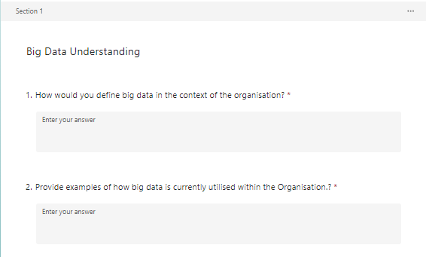
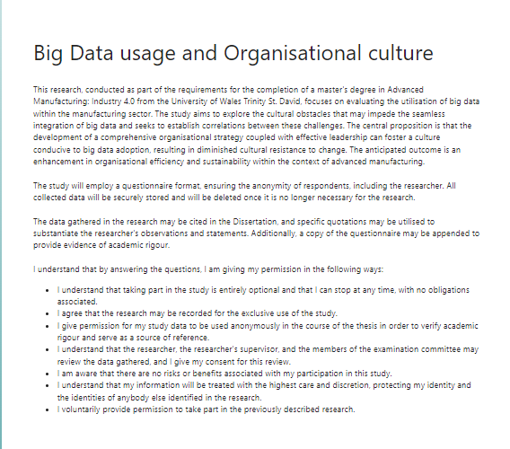
Appendix 1, Questionnaire

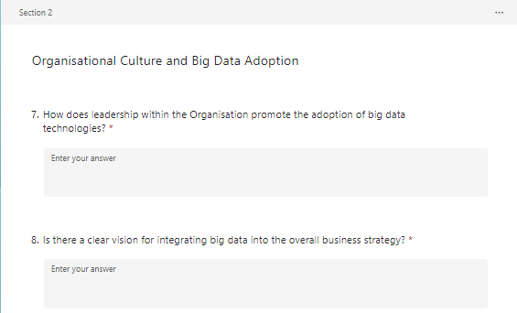
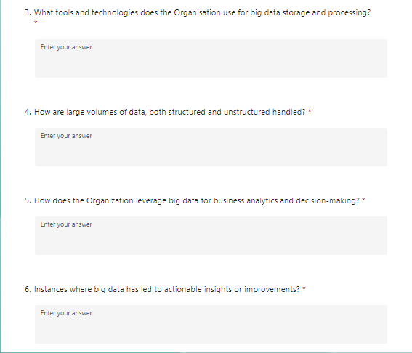

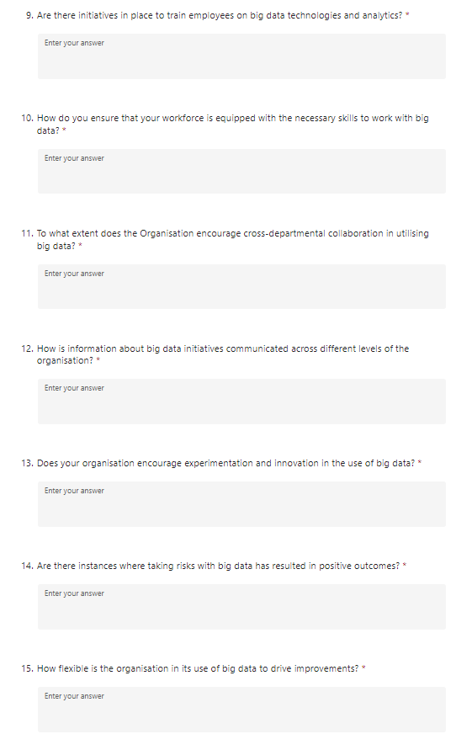

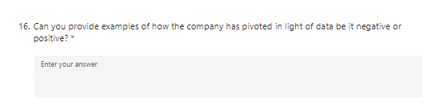
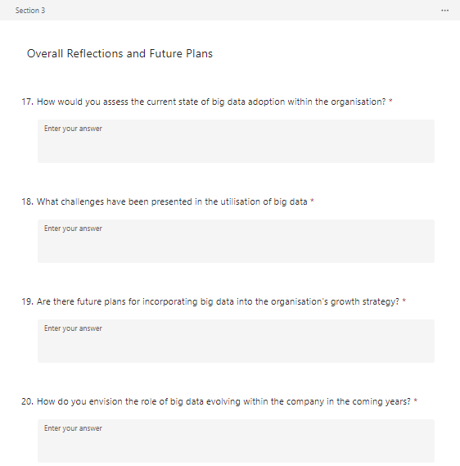

Appendix 2, Email Invitation
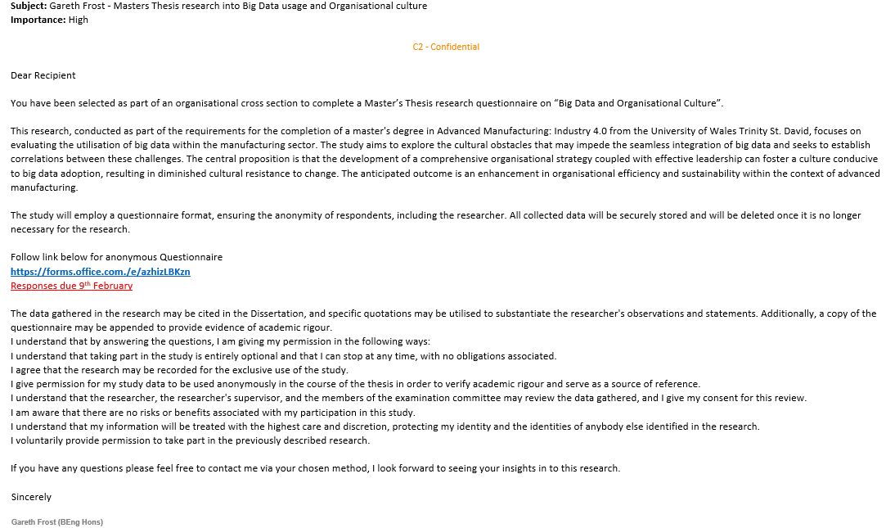

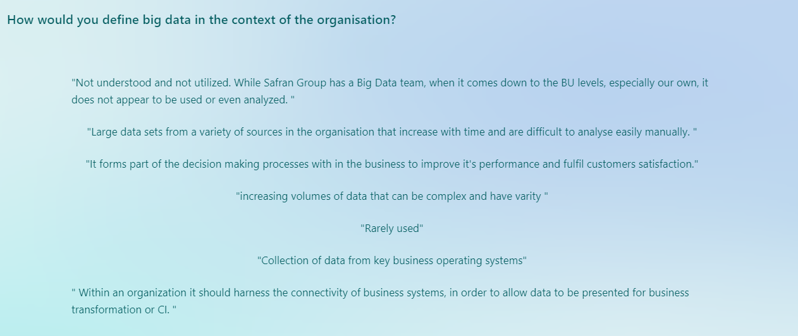
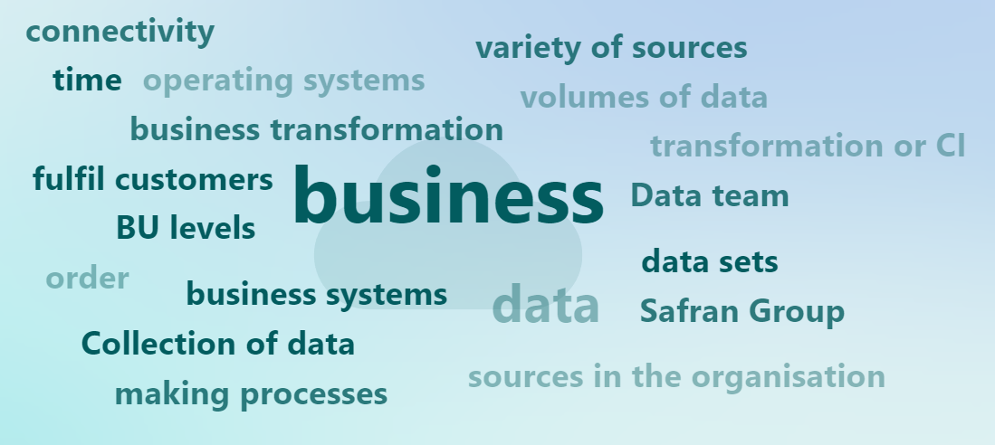
Appendix 3, Question 1

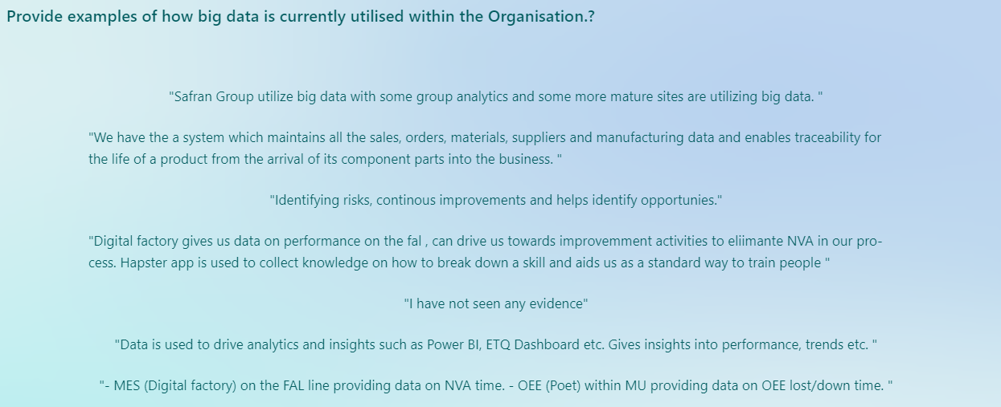
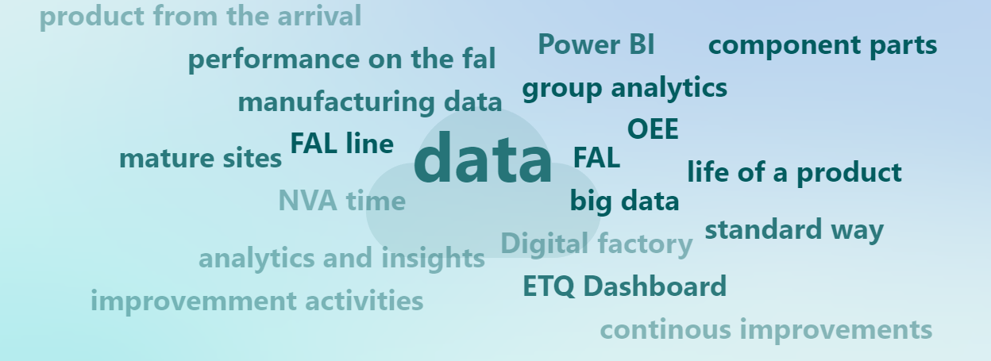
Appendix 4, Question 2

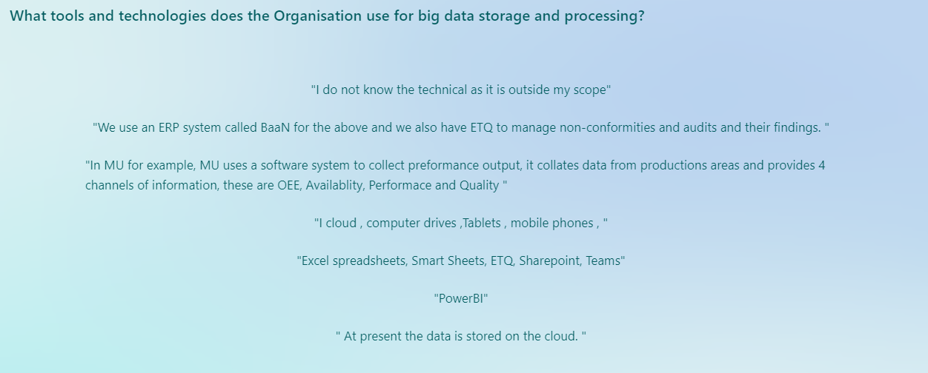
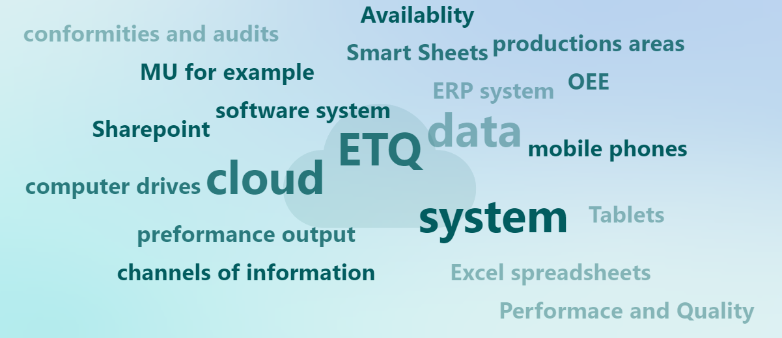
Appendix 5, Question 3

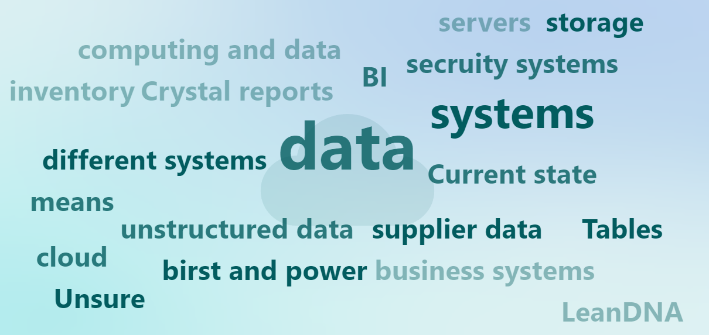
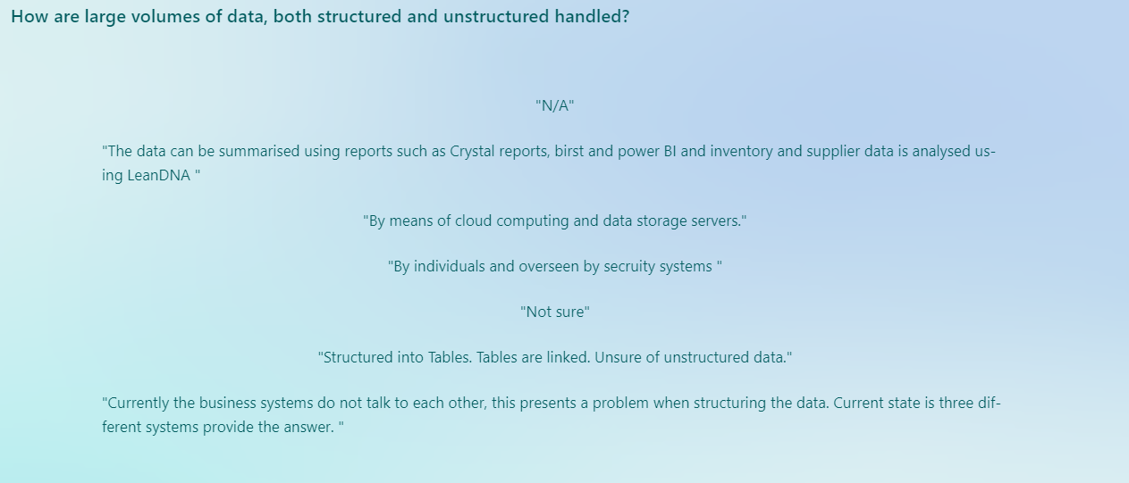
Appendix 6, Question 4

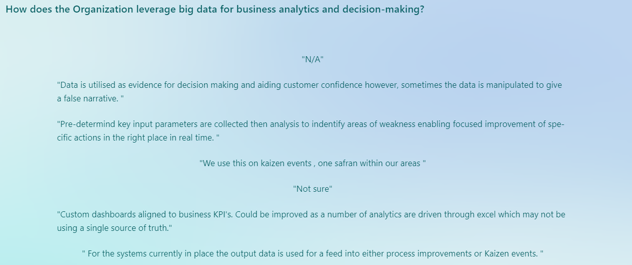
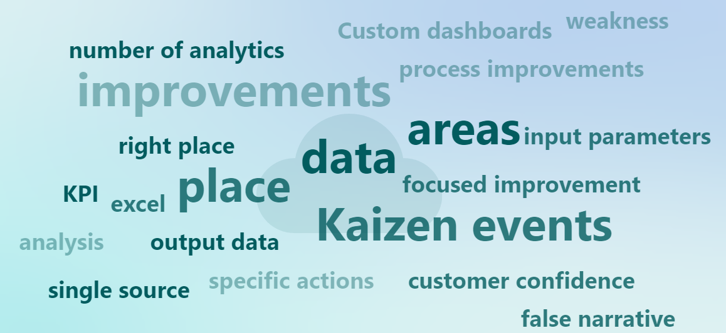
Appendix 7, Question 5

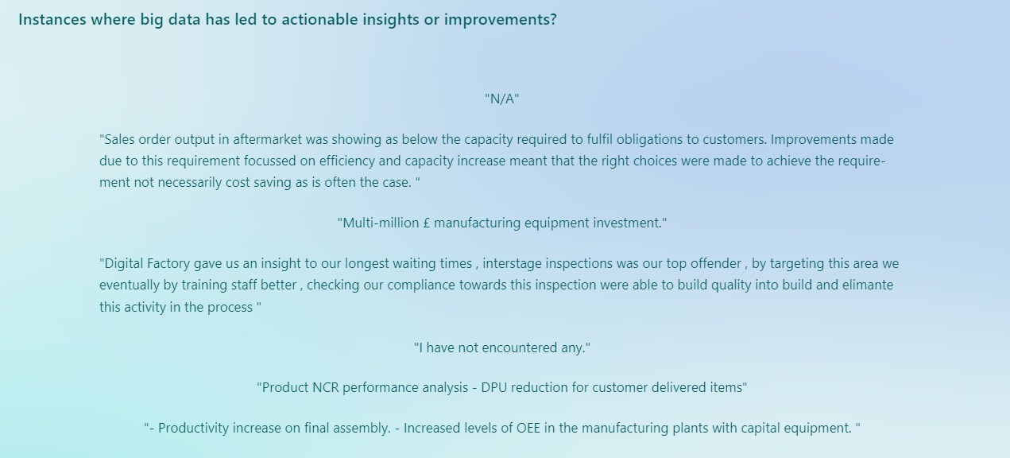
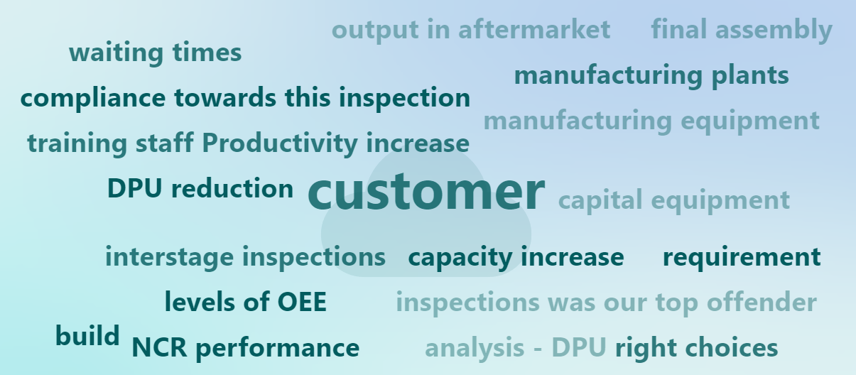
Appendix 8, Question 6

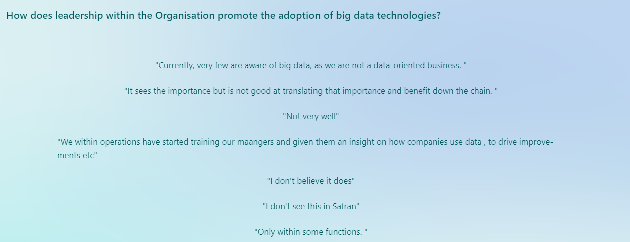
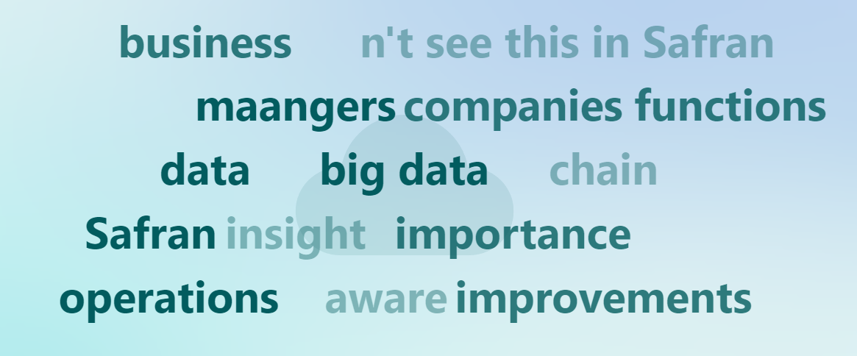
Appendix 9, Question 7

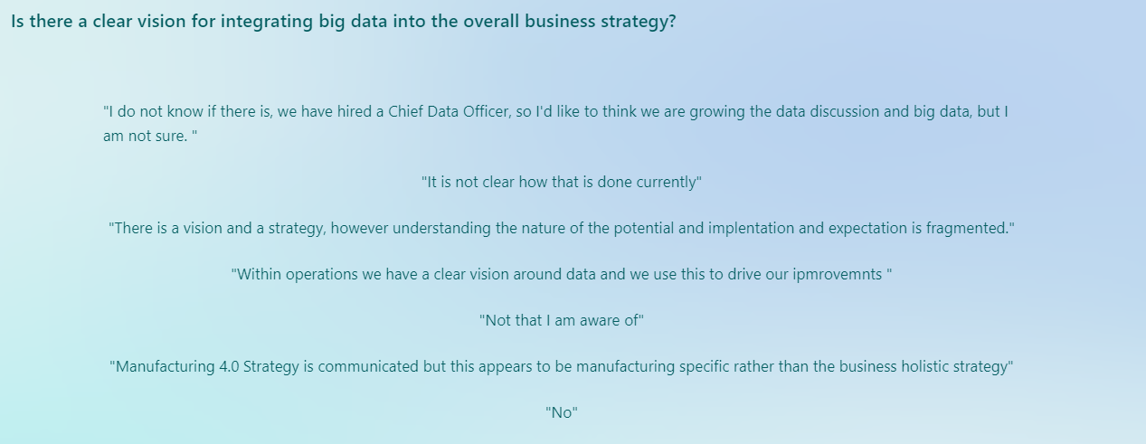
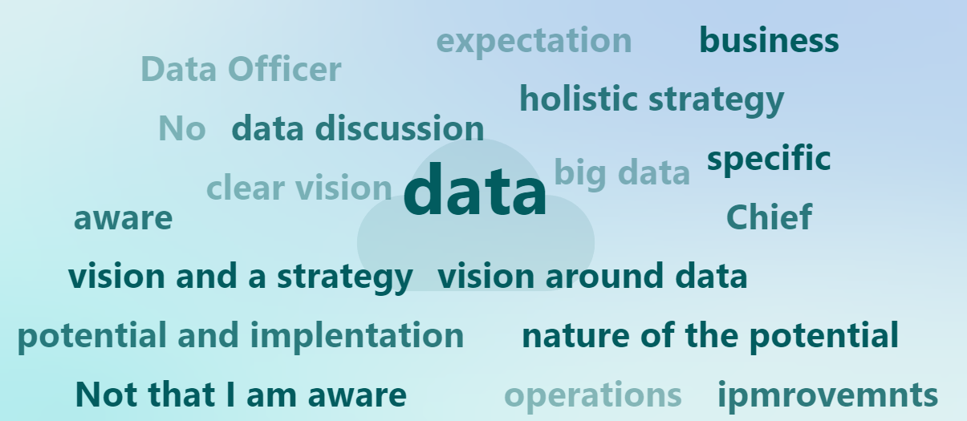
Appendix 10, Question 8

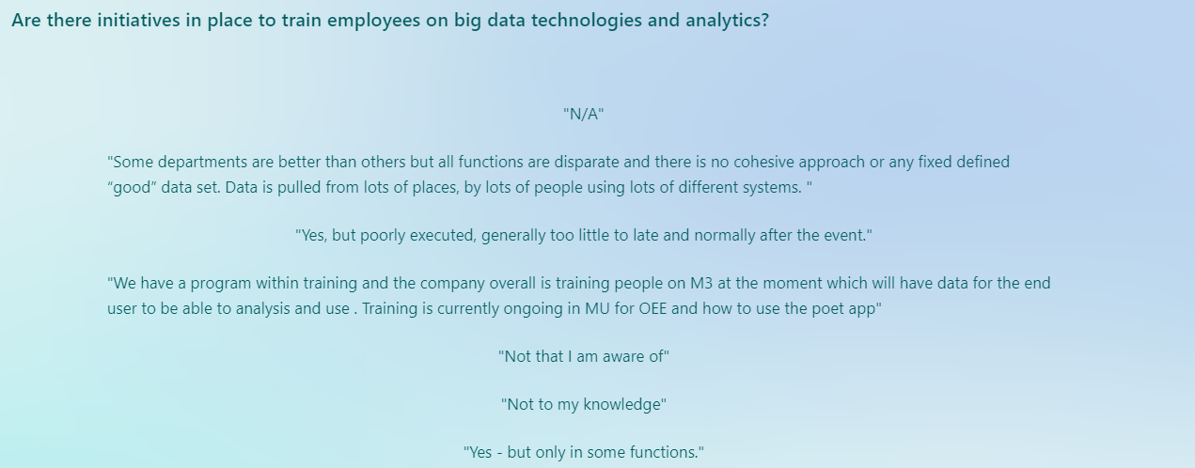
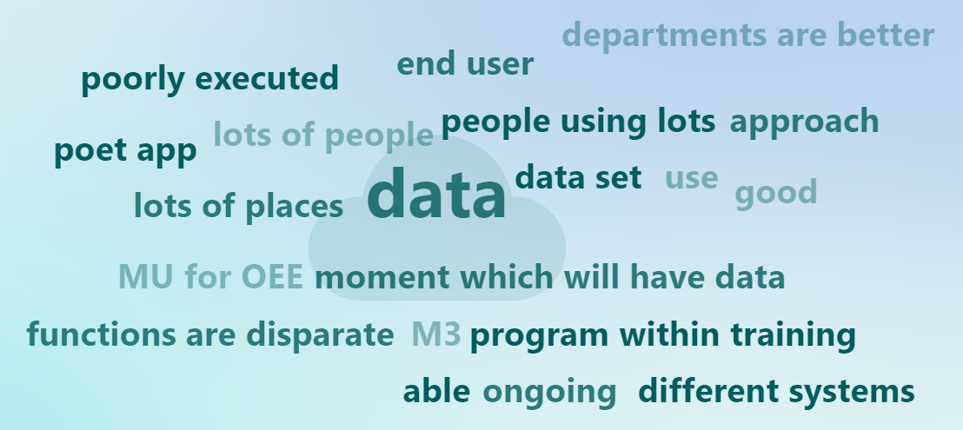
Appendix 11, Question 9

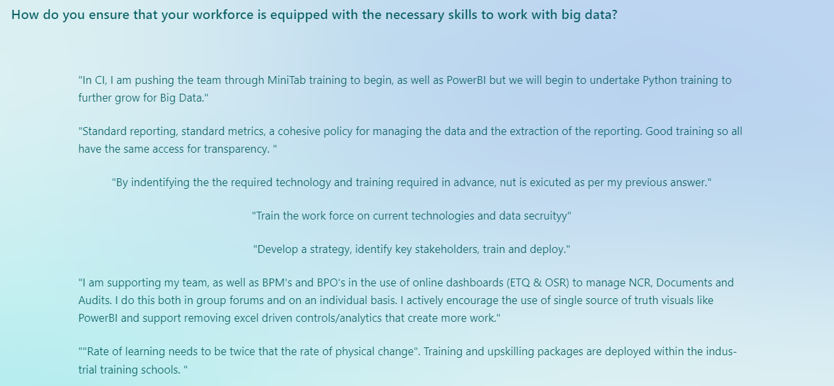
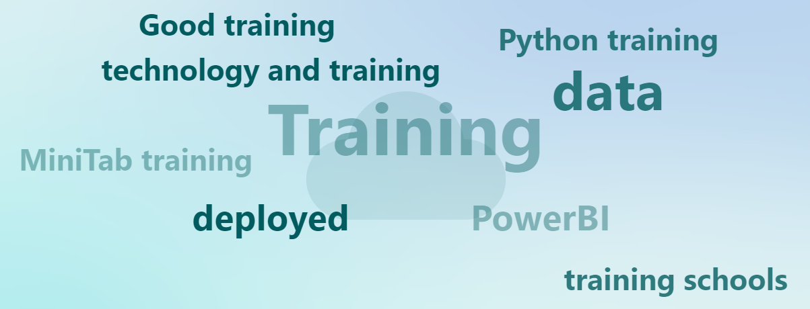
Appendix 12, Question 10

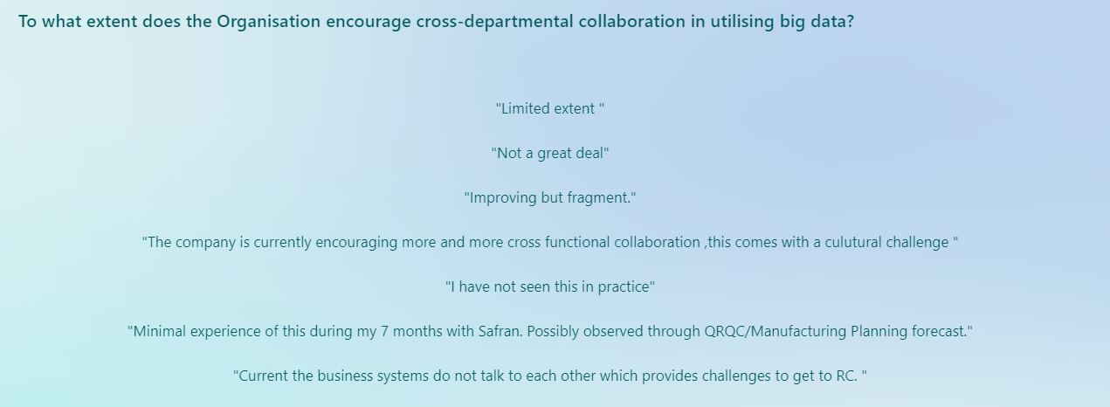
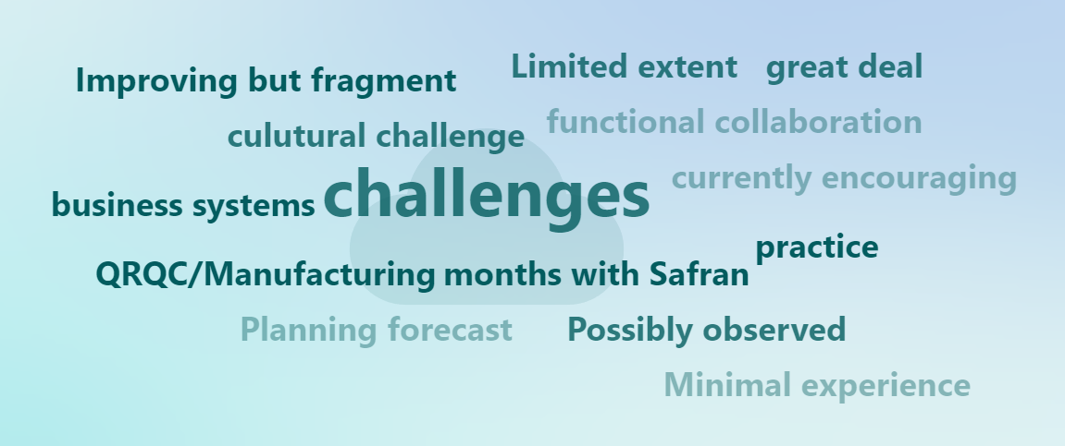
Appendix 13, Question 11

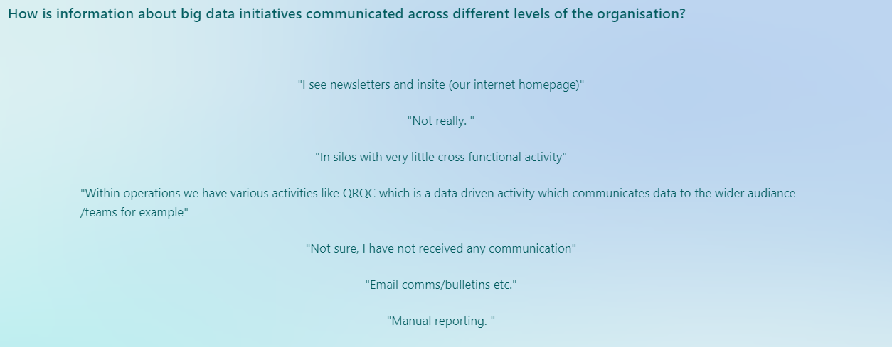
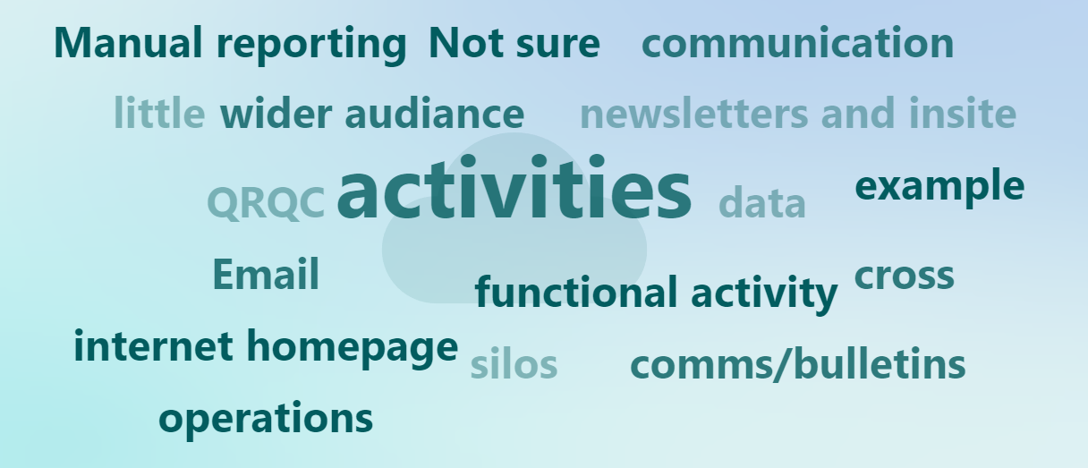
Appendix 14, Question 12

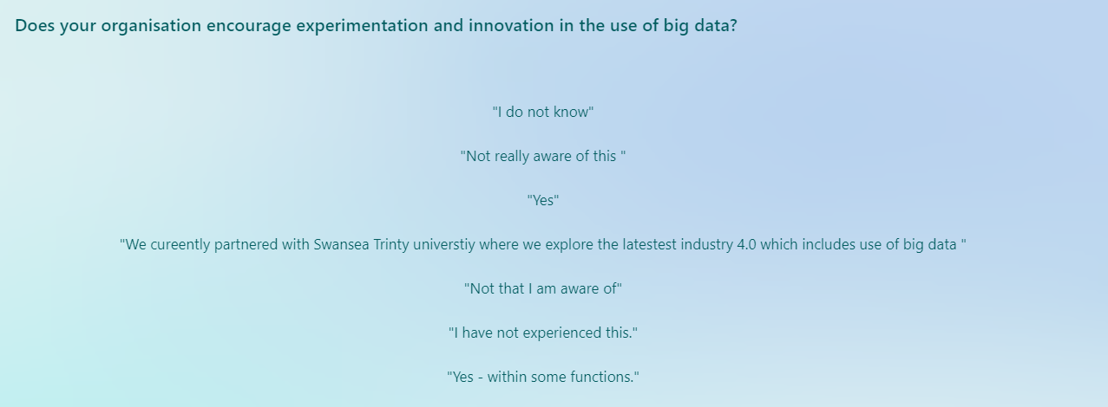
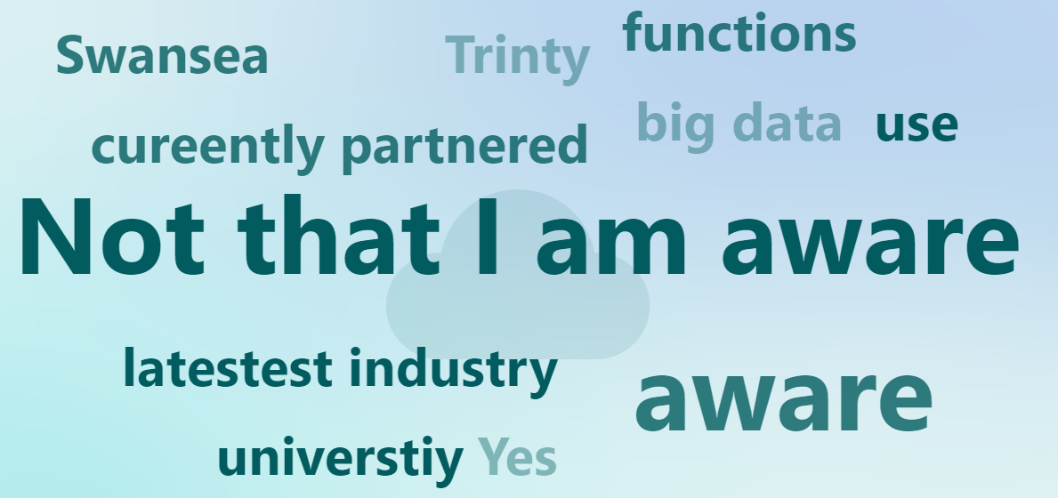
Appendix 15, Question 13

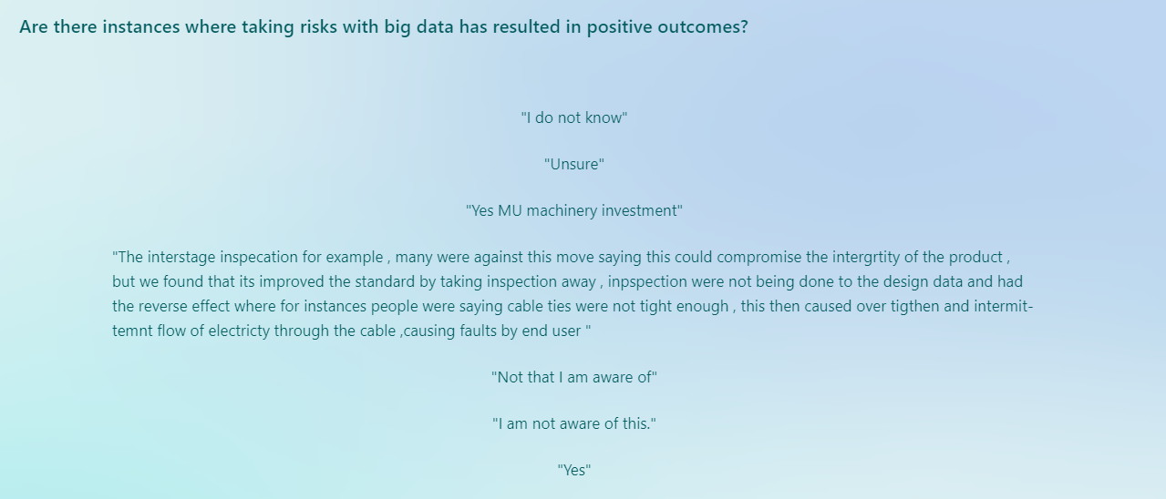
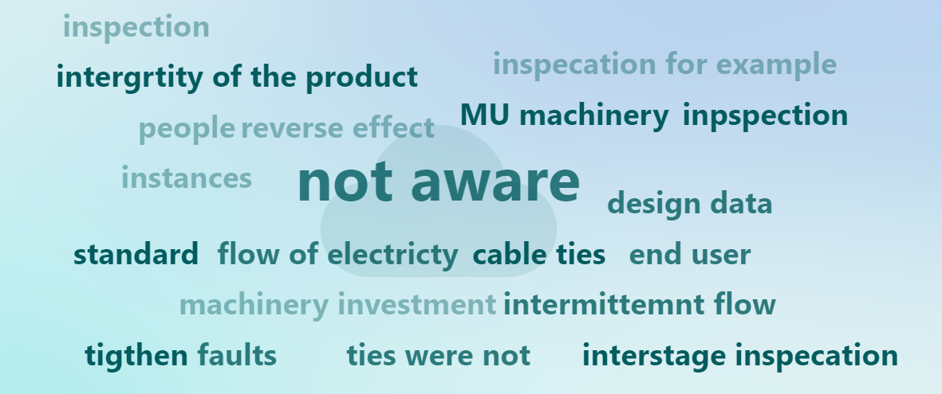
Appendix 16, Question 14

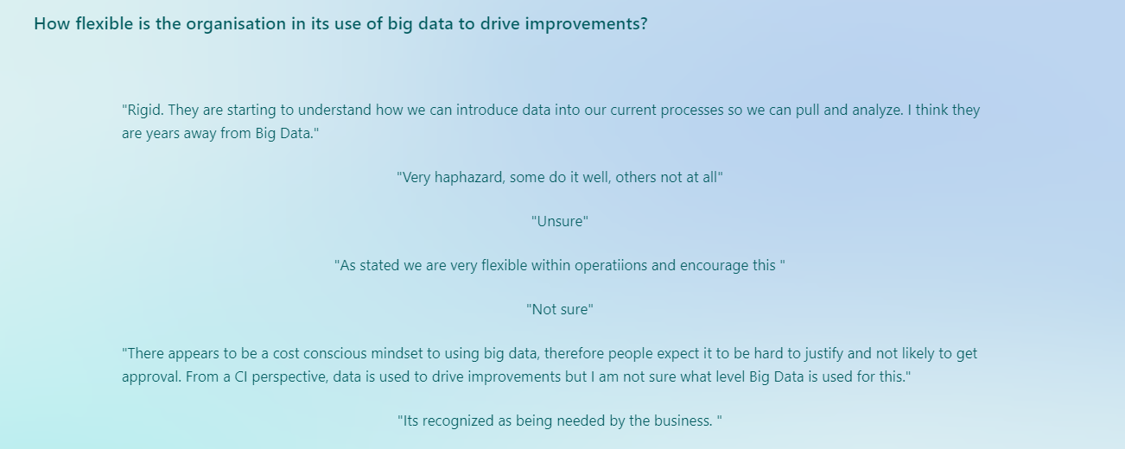
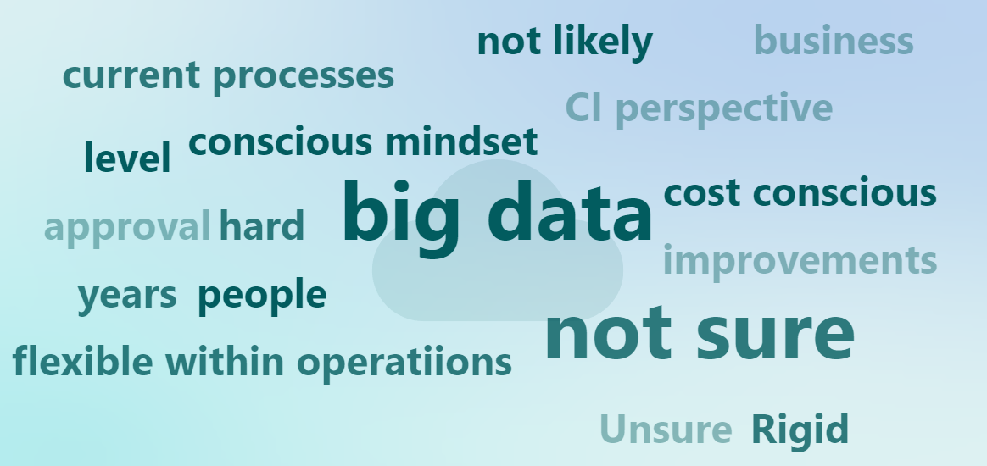
Appendix 17, Question 15

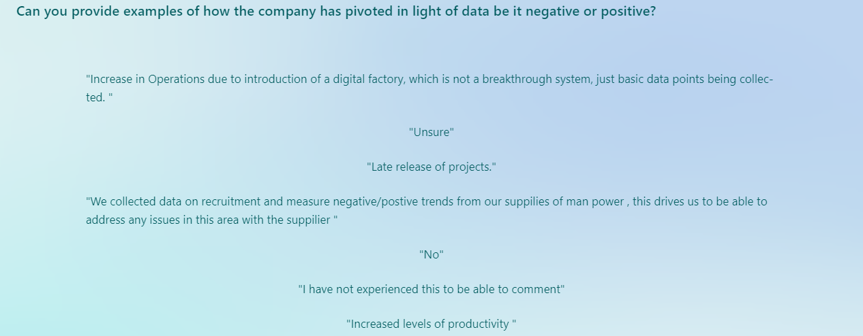
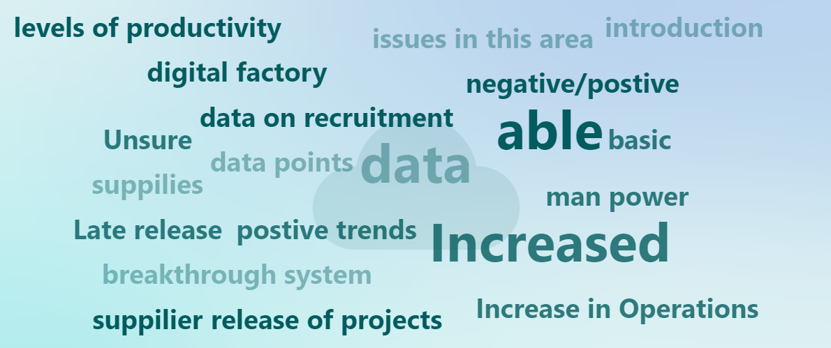
Appendix 18, Question 16

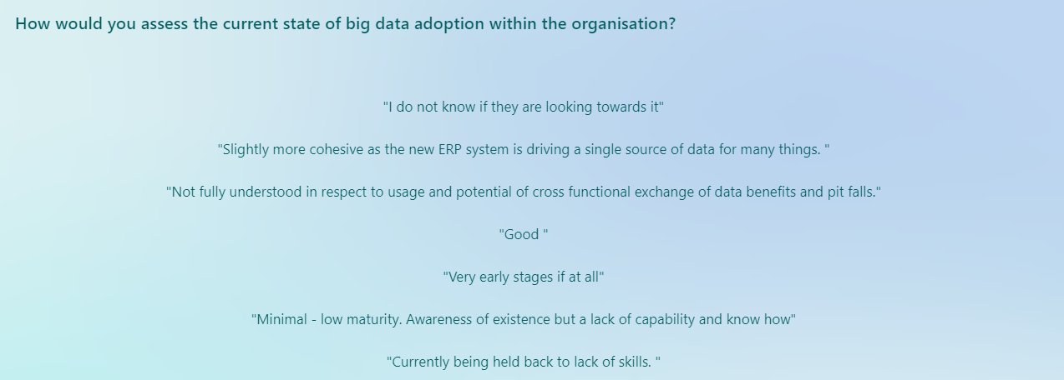
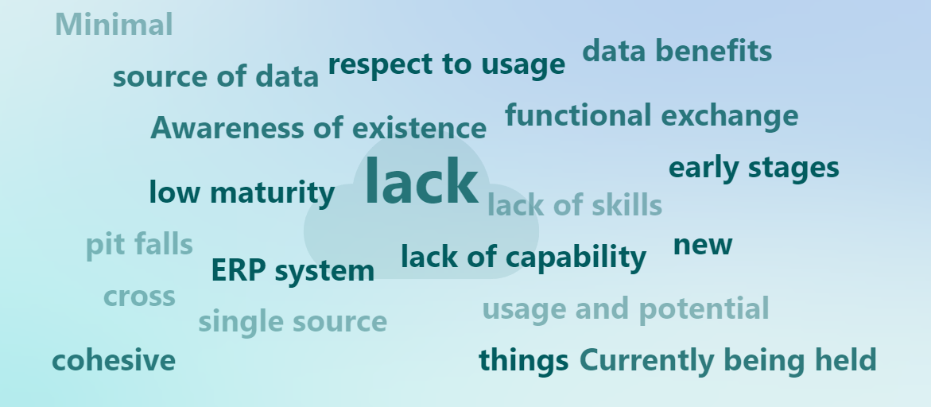
Appendix 19, Question 17

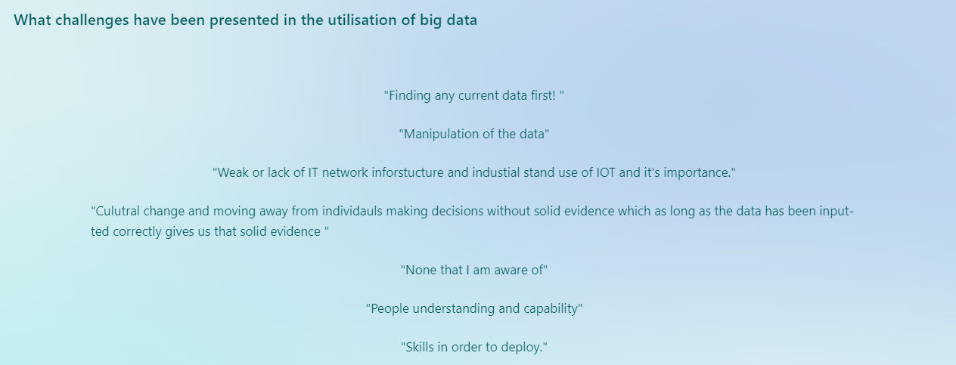
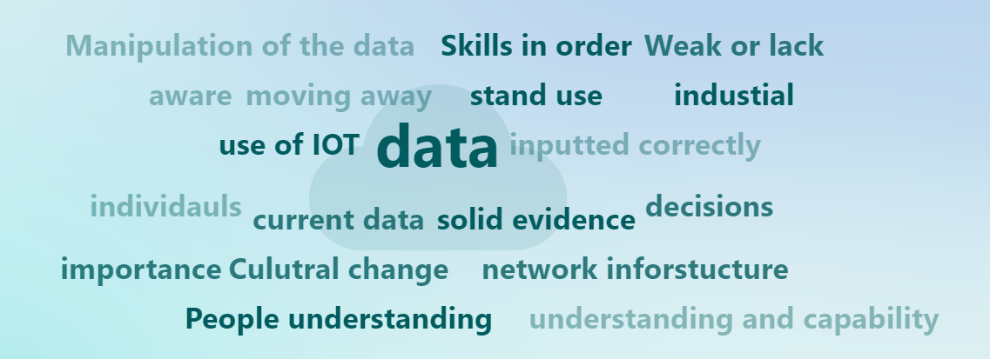
Appendix 20, Question 18

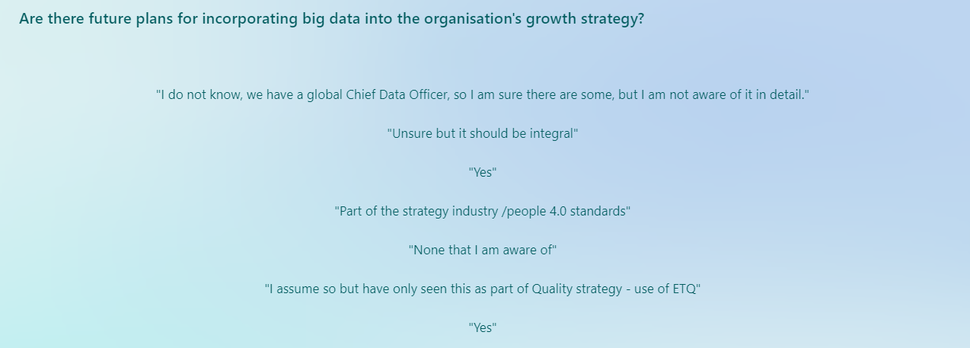
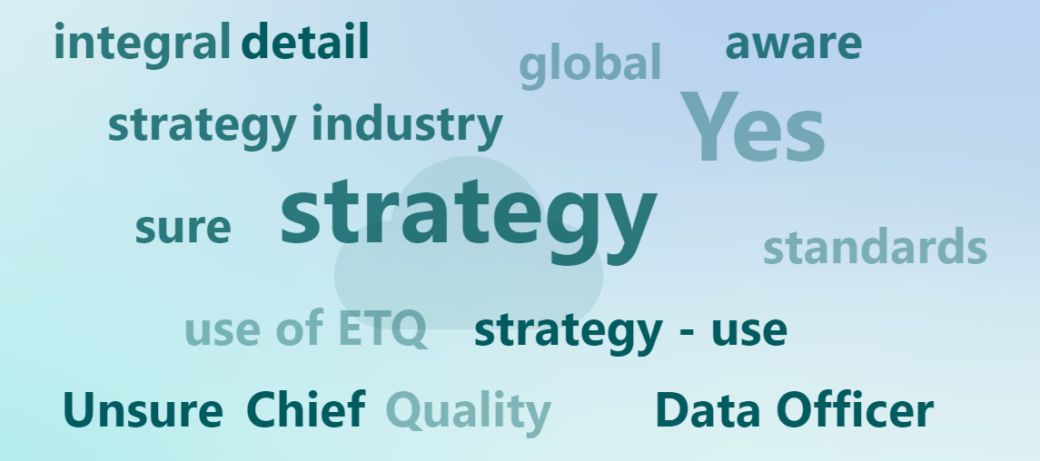
Appendix 21, Question 19

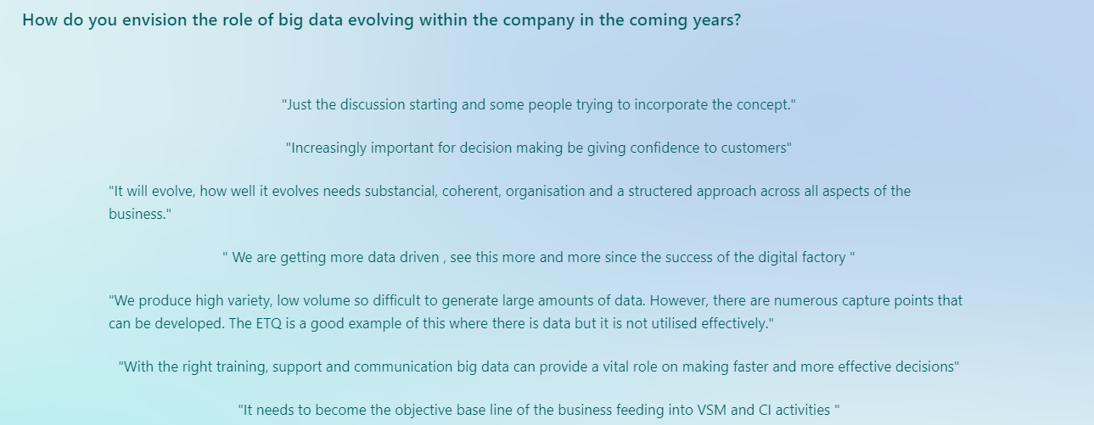
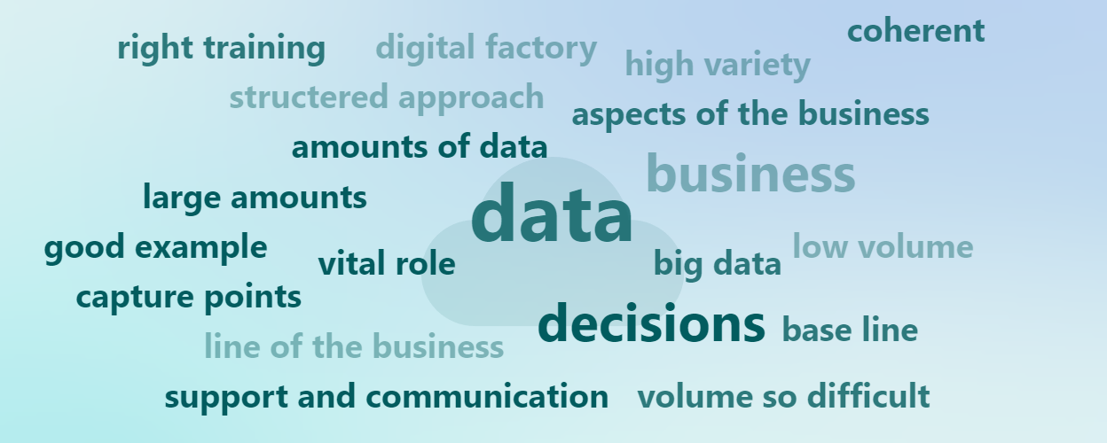
Appendix 22, Question 20

