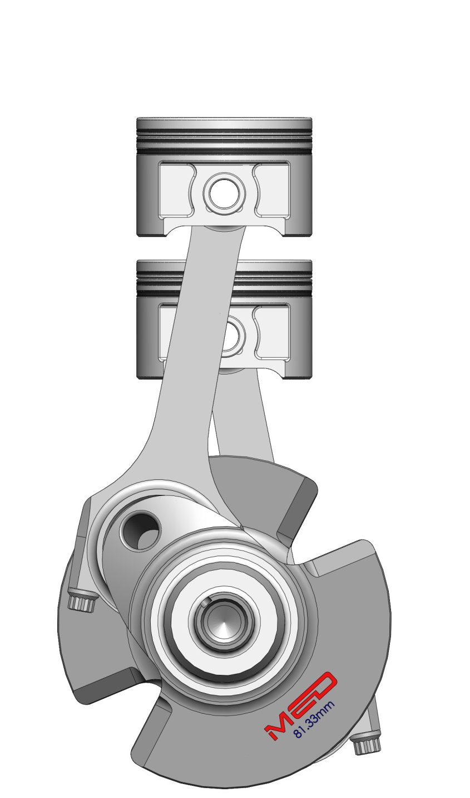
Analytical Methods with Study Skills
Conrod Dynamic Forces Report
Alexander Wright (1701086)

Contents
Abstract displayed below (illustrated as page 2)
Page:
3. Graphs and figures (through to 6)>
4. >
5. >
6. >
7. Introduction and research to report (including methodology)
8. Analysis
9. Conclusion

Abstract
The following report will look into the forces experienced by a connecting rod within an internal combustion engine. To look at this, a spreadsheet resource will be utilised to amass a selection of data relating to the forces acting upon a connecting rod within a chosen engine. From this, a number of graphs can be produced to help analyse the forces. Before undertaking this analysing; research and an insight into the science behind the forces will be explained.
Figures and Graphs
Fig 1: (Standard: idle speed)
Fig 2: (Standard: 3500RPM)
Fig 3: (Standard: 7000RPM)
Fig 4:
Fig 5: (750 gram piston)
Fig 6: (50mm crank at 2500RPM
Fig 7: (100mm Crankshaft at 2500RPM)
Fig 8: (100mm Conrod)
Fig 9: (150mm Conrod)
Fig 10: (100mm Crankshaft, 150mm conrod and max RPM)

To undertake the analysis, I will use a spreadsheet resource that has been provided to me to enter my gathered engine data and produce a number of graphs to assist in the analysis. The graphs will aid the analysis process due to their easy to read and understand format.
Introduction & Research
Within an internal combustion engine, the job of transferring the reciprocating force produced by the movement of the pistons into a rotational force at the crankshaft is achieved with the use of a connecting rod. During operational conditions, the connecting rod undergoes a large amount of compressive and tensional forces as it travels up and down the cylinder.
To understand the forces acting upon the conrods, Newtons second law of motion should be analysed, thus stating; ‘The acceleration of an object as produced by a net force is directly proportional to the magnitude of the net force, in the same direction as the net force, and inversely proportional to the mass of the object. - http://www.physicsclassroom.com/class/newtlaws/Lesson-3/Newton-s-Second-Law
In basic terms, this law states that the acceleration of an object is primarily affected by two variables; the mass and the net force acting upon said object.

Analysis
To give a basic illustration of what the forces look like on a graph, Fig 1 shows the forces and acceleration of a conrod under an average idle speed of 1000RPM, with all the standard measurements and figures for the engine. Notice that the forces exerted on the conrod while under these running conditions are very low due to the low rotational speed of the crankshaft.
With increased engine speed, it’s clear that the acceleration values will dramatically increase as the crankshaft is rotating at a much faster rate (3500RPM on Fig 2 & 7000RPM redline on Fig 3). With this increased engine speed comes larger compressive and tensional forces acting upon said conrods, as depicted with the variation of force on the graphs.
One of the main factors that affect the forces experienced by the conrod is the mass of the piston. While this value may change the force acting upon the connecting rods, it does not change the acceleration, as the engine speed remains the same (This can be observed in Fig 4). As with Fig 2, the engine is rotating at 3500RPM, however the piston mass is now reduced from 510g, down to around 430g. This represents the fitment of lighter pistons (Produced by burton power). The mass of the piston directly changes the maximum tensile force on the connecting; for example, the result of a piston with twice the mass would consequently double the maximum tensile force on the conrod.
Fig 5 illustrates a much heavier piston than the standard 510g, instead weighing in at 750g. This increase in mass means the resultant tensile force on the conrod has increased at an equivalent rate. Alongside changing the mass of the piston, changing the dimensions on critical components (them being the crankshaft diameter and the connecting rod length) can also directly affect the forces exerted on the conrods themselves.
Changing the diameter of the crankshaft can majorly affect the resultant forces. The reason for this is; the larger the diameter, the further the conrod will have to travel up and down the cylinder. A shorter crank throw would also put less strain on the conrod, reducing the angle of movement.
Both Fig 6 & Fig 7 show the different conrod lengths, with 6 being 50mm at 2500RPM and 7 being 100mm at 2500RPM. It is clear to observe that with the 50mm crank diameter, the forces are a lot lower at the same RPM, in addition to the acceleration, as the conrod does not have to travel as far in the same cycle with its shorter throw given by the crankshaft. Notice how the curves on the graph for force and acceleration (Fig 6) are a lot shallower and smoother than Fig 7. This is a result of the shorter distance and height that the conrod has to travel in the same distance.
As shown in Fig 8 & 9 with the graphs, a shorter conrod length has a much larger variation in force when compared to a longer unit.
Finally, I created another figure (Fig 10) to show what forces could be achieved at a higher engine speed with a larger crankshaft diameter and heavier piston mass to deliver a large amount of force. In real world use under operating conditions, these figures could result in excessive forces being transmitted through the conrod, which could lead to catastrophic engine failure.
Conclusion
Overall, the analysis performed during this report, along with the data gathered has delivered a clearer insight into the forces experienced by connecting rods in an internal combustion engine. Resultant forces can be affected by a number of factors that can change the mass, motion and travel of the conrod. As stated in the analysis, there are a number of key factors and points to look back on that the figures highlight. The variation of forces produced with some basic engine measurement changes is dramatic, and can ultimately lead to the smooth operation of an engine.

