Executive Summary:
InterContinental Hotels Group (IHG) employs a decentralized structure with regional hubs managing local operations, enabling quick adaptation to market dynamics while maintaining centralized control over branding and quality standards. This structure aligns with both contingency theory and the resource-based view, ensuring flexibility and leveraging local expertise for competitive advantage. IHG’s organizational culture emphasizes customer-centricity, innovation, and inclusivity, empowering employees to enhance guest experiences and fostering a culture of continuous improvement and respect for diversity. These cultural values are reflected in daily operations and align with Edgar Schein’s organizational culture model. IHG's goals focus on becoming the leading hotel company globally through sustainable growth, brand differentiation, and customer satisfaction. These goals are specific, measurable, achievable, relevant, and time-bound (SMART), and are evaluated using a balanced scorecard approach.
Recent Change Initiatives and Impact
Digital Transformation: Implementing advanced technologies to streamline operations and enhance guest experiences.
Sustainability Efforts: Reducing environmental footprint through energy-efficient designs, waste reduction, and renewable energy investments.
Portfolio Expansion: Acquiring new hotel chains to diversify offerings and increase market share.
Objectives and Outcomes: Operational Efficiency: Optimized resource allocation and improved productivity through digital innovations.
Guest Experience: Enhanced satisfaction and loyalty via personalized and seamless interactions.
Brand Reputation: Strengthened by sustainable practices appealing to eco-conscious travelers.
Market Share: Increased through strategic acquisitions and expanded global presence. Strategic Direction IHG focuses on market positioning through brand differentiation and segmentation, balanced growth strategies combining organic expansion and strategic acquisitions, and a commitment to sustainability and innovation. These efforts ensure IHG's resilience and competitiveness in the dynamic hospitality industry.
By prioritizing innovation, sustainability, and strategic growth, IHG maintains its leadership position and continues to deliver value to customers, shareholders, and the environment.

Contents
Organization Structure: 2
Organizational Culture: 3
Organizational Goals: 4
Balanced Scorecard Approach: 5
Recent Change Initiatives and Their Impact: 6
Change Initiatives: 6
Digital Transformation: 6
Sustainability Efforts: 7
Acquisitions: 7
Objectives and Outcomes: 8
Enhanced Operational Efficiency: 8
Strengthened Brand Reputation: 8
Increased Market Share: 9
Market Expansion and Growth: 10
Impact and Management: 10
Strategic Direction: 11
Market Positioning: 11
Growth Strategy: 12
Sustainability and Innovation: 12
References: 14

Organization Structure:

IHG’s decentralized structure involves regional hubs that manage day-to-day operations within their respective areas, granting them autonomy to respond swiftly to local market dynamics and customer preferences. This decentralization fosters agility, enabling IHG to tailor its services and offerings to specific regional demands efficiently (Meijaard, Brand, and Mosselman, 2005). However, despite the autonomy granted to regional hubs, IHG maintains centralized control over key aspects such as branding consistency and quality standards. 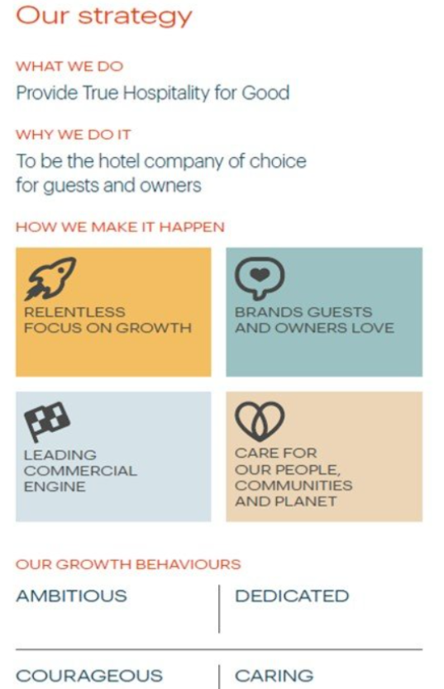
From a theoretical standpoint, IHG’s organizational structure embodies principles from both contingency theory and the resource-based view (RBV). Contingency theory posits that organizations should structure themselves in a manner that aligns with external environmental factors, such as market conditions and regulatory requirements. In IHG’s case, its decentralized structure allows it to adapt swiftly to diverse regional environments, aligning with the flexibility advocated by contingency theory (Hao, Kasper, and Muehlbacher, 2012). By empowering regional hubs and leveraging their local knowledge and expertise, IHG taps into a valuable internal resource – the ability to respond effectively to regional nuances and customer preferences. This localized approach not only enhances customer satisfaction but also contributes to IHG’s overall competitiveness in the global hospitality industry (Csaszar, 2012).In essence, IHG’s decentralized structure represents a strategic balance between adaptability to external environmental factors and the effective utilization of internal resources, aligning with both contingency theory and the resource-based view to maintain its position as a leader in the hospitality sector (Joseph, Klingebiel, and Wilson, 2016).
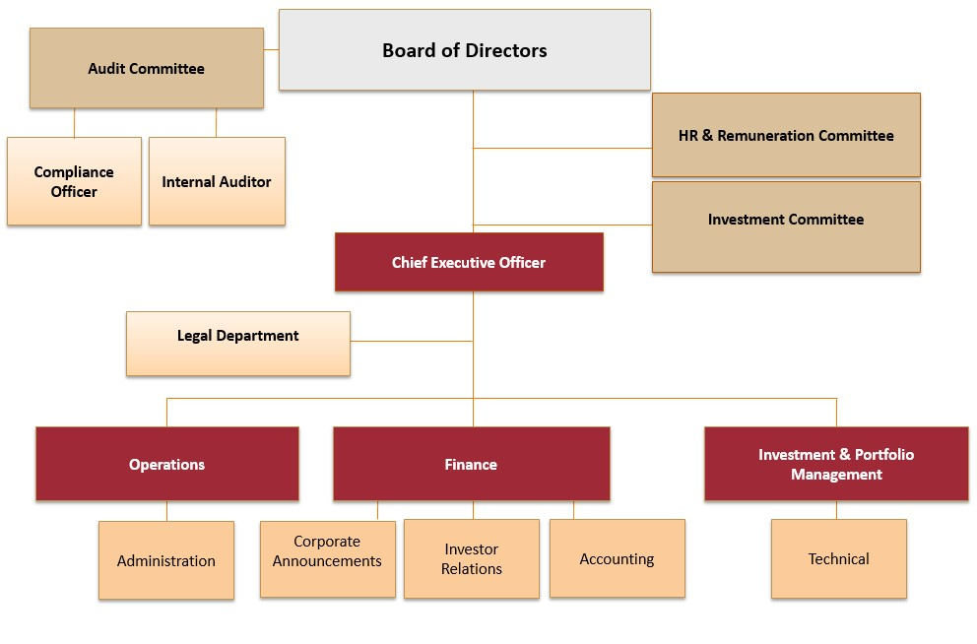

Organizational Culture:
At IHG, the culture emphasizes customer-centricity, innovation, and inclusivity. This ethos shapes employee behavior and decision-making, empowering them to enhance guest experiences. By giving employees the authority to address and resolve guest needs proactively, IHG fosters a sense of ownership, accountability, and responsiveness. (Shahzad et al., 2012). Inclusivity is another cornerstone of IHG’s culture, where diversity and respect for individuals are celebrated and embraced. Employees from diverse backgrounds are valued for their unique perspectives and contributions, fostering a sense of belonging and mutual respect within the organization (Martinez, Beaulieu, Gibbons, and Singh, 2015). From a theoretical standpoint, IHG’s culture aligns closely with Edgar Schein’s organizational culture model. Schein identifies two levels of organizational culture: espoused values (what an organization says it values) and enacted values (what an organization actually prioritizes through its actions).
IHG exhibits both espoused and enacted values that emphasize the importance of service excellence and adaptability. The espoused values at IHG revolve around the commitment to delivering exceptional service and continuously striving for excellence in guest satisfaction. On the other hand, IHG’s enacted values are evident in the organization’s day-to-day operations and interactions. Employees are empowered to go above and beyond to meet guest expectations, demonstrating a commitment to service excellence in their actions.

Organizational Goals:
InterContinental Hotel Group (IHG) has set ambitious, yet attainable goals aimed at solidifying its position as the leading hotel company globally. These goals are not only aspirational but also adhere to the SMART criteria, ensuring they are Specific, Measurable, Achievable, Relevant, and Time-bound. Furthermore, IHG employs a balanced scorecard approach to measure its progress across various dimensions, including financial performance, customer satisfaction, internal processes, and learning and growth perspectives (Kotlar, De Massis, Wright, and Ravasi, 2018).
Specific: IHG’s goal of becoming the leading hotel company globally is clearly defined and specific, leaving no room for ambiguity. The company aims to achieve this by focusing on sustainable growth, brand differentiation, and customer satisfaction. Each aspect of this goal is precisely articulated, outlining the specific areas where IHG intends to excel (Jung, 2011).
Measurable: IHG’s goals are measurable, allowing the company to track progress and assess performance effectively. Metrics such as market share, revenue growth, brand perception, and customer loyalty can be quantified and monitored over time to gauge IHG’s success in achieving its overarching objective (Gary, Yang, Yetton, and Sharma, 2017).
Achievable: While IHG’s goal of becoming the leading hotel company globally is ambitious, it is also realistic and attainable. The company has a solid foundation, a diverse portfolio of brands, and a global presence, providing it with the necessary resources and capabilities to pursue sustainable growth and differentiation strategies (Rahim and Clemens, 2012).
Relevant: IHG’s goals are highly relevant to its core business objectives and strategic priorities. Sustainable growth, brand differentiation, and customer satisfaction are fundamental to IHG’s long term success and competitive advantage in the hospitality industry. By focusing on these areas, IHG aims to enhance its market position and drive shareholder value (Shore and Strauss, 2008).
Time-bound: IHG has established a timeline for achieving its goals, ensuring a sense of urgency and accountability. While the pursuit of becoming the leading hotel company globally is a long term endeavour, IHG sets shorter-term milestones and targets to track progress and maintain momentum along the way.

Balanced Scorecard Approach:

IHG’s goals align with a balanced scorecard approach, which considers multiple perspectives to evaluate performance comprehensively. By examining financial metrics, customer satisfaction levels, internal processes, and learning and growth initiatives, IHG gains a holistic understanding of its performance and identifies areas for improvement across the organization (Kotlar et al., 2018).

Recent Change Initiatives and Their Impact:

Change Initiatives:
InterContinental Hotel Group (IHG) has undertaken a series of change initiatives aimed at driving innovation, sustainability, and growth across its operations. These initiatives encompass digital transformation, sustainability efforts, and portfolio expansion through acquisitions, with the overarching goal of enhancing operational efficiency, reducing environmental impact, and capitalizing on emerging market trends (Burtonshaw-Gunn and Salameh, 2011).

Digital Transformation:
IHG’s digital transformation initiative involves leveraging technology to streamline operations, enhance guest experiences, and improve overall efficiency. This includes implementing advanced reservation systems, mobile check-in/out options, personalized marketing campaigns, and digital concierge services. By embracing digital innovations, IHG aims to meet the evolving preferences of tech-savvy travellers, optimize resource utilization, and drive revenue growth through enhanced
customer engagement.


Sustainability Efforts:

IHG is committed to reducing its environmental footprint and promoting sustainable practices throughout its operations. This includes initiatives such as energy-efficient building design, waste reduction programs, water conservation measures, and the use of eco-friendly materials and amenities. IHG also invests in renewable energy sources and collaborates with suppliers to ensure sustainable sourcing practices. By prioritizing sustainability, IHG not only minimizes its environmental impact but also strengthens its brand reputation and appeals to environmentally conscious consumers.

Acquisitions:

IHG has pursued strategic acquisitions to expand its portfolio of brands and strengthen its market position globally. Recent acquisitions have included renowned hotel chains and boutique properties, allowing IHG to diversify its offerings and target new customer segments. These acquisitions provide IHG with access to key markets, additional revenue streams, and opportunities for cross-selling and brand synergies. By expanding its portfolio, IHG enhances its competitive edge and reinforces its leadership in the hospitality industry.

Objectives and Outcomes:

Enhanced Operational Efficiency:
Through digital transformation initiatives, IHG aims to streamline processes, optimize resource allocation, and improve productivity across its properties. By automating routine tasks and leveraging data analytics, IHG can make more informed decisions, reduce costs, and allocate resources more effectively. This increased operational efficiency enables IHG to deliver high-quality services while controlling expenses, ultimately contributing to improved financial performance (Meijaard et al., 2005). Improved Guest Experiences: IHG’s digital transformation initiatives also focus on enhancing the guest experience through personalized and seamless interactions.
By offering mobile check-in/out options, personalized marketing campaigns, and digital concierge services, IHG caters to the evolving preferences of tech-savvy travellers. This not only increases guest satisfaction but also encourages loyalty and retention, as guests are more likely to return to a hotel brand that provides a tailored and convenient experience (Shahzad et al., 2012).

Strengthened Brand Reputation:
IHG’s sustainability efforts strengthen its brand reputation and appeal to environmentally conscious travelers. By investing in energy-efficient practices, waste reduction, and eco-friendly amenities, IHG demonstrates its commitment to corporate social responsibility. This differentiates IHG from competitors and attracts customers who value sustainability. (Prajogo and McDermott, 2011).

Increased Market Share:

IHG’s portfolio expansion through strategic acquisitions allows it to increase its market share and strengthen its global presence. By acquiring renowned hotel chains and boutique properties, IHG gains access to new markets, customer segments, and revenue streams. These acquisitions also provide opportunities for cross-selling and brand synergies, further enhancing IHG’s competitiveness in the hospitality industry (Csaszar, 2012).
Sustainability efforts help IHG minimize waste, conserve resources, and mitigate environmental impact, contributing to a more sustainable future for the hospitality industry.
By integrating sustainable practices into its operations, IHG aims to reduce its environmental footprint and contribute to a more sustainable future. This includes initiatives such as energy conservation, waste reduction, and responsible sourcing of materials (Choi and Yu, 2014). Such sustainability practices not only minimize environmental impact but also enhance IHG’s brand reputation and appeal to the growing segment of eco-conscious travellers (Maletič, Maletič, and Gomišček, 2018). By prioritizing sustainability, IHG meets evolving customer expectations and strengthens its competitive positioning in the hospitality industry.

Market Expansion and Growth:

Meanwhile, inorganic growth is facilitated through strategic acquisitions and partnerships, enabling. IHG to rapidly scale its operations and enter new market segments (Alaaraj et al., 2018). This growth strategy aligns with Ansoff’s Matrix, which emphasizes market penetration, product development, and diversification as drivers of sustainable growth and shareholder value (Setyawan et al., 2024).

By embracing digital transformation, promoting sustainable practices, and expanding its portfolio through acquisitions, IHG positions itself for success in a rapidly evolving hospitality landscape while delivering value to customers, shareholders, and the environment (Kerber and Buono, 2005).

Impact and Management:

The impact of IHG’s recent change initiatives has been a mixed bag. Digital transformation initiatives have yielded positive results, enhancing guest experiences and operational efficiency. Guests benefit from streamlined booking processes, personalized services, and seamless interactions, while IHG sees improved resource allocation and cost savings (Cameron and Green, 2019). However, integrating acquired brands into IHG’s portfolio has presented challenges. Cultural differences and disparate systems can lead to friction and inefficiencies, hindering the realization of synergies and the maximization of potential benefits (Errida and Lotfi, 2021). Effective change management is essential in navigating these challenges. A structured approach, such as Kotter’s 8-step model, can guide IHG in successfully implementing change initiatives. This model emphasizes the importance of clear communication, strong leadership alignment, and empowering employees to embrace and drive change (Graetz and Smith, 2010).

Strategic Direction:

Market Positioning:

IHG’s strategic direction revolves around brand differentiation and market segmentation. By offering a diverse portfolio of brands targeting various market segments, IHG aims to cater to a broad spectrum of customers; needs and preferences.
This strategy allows IHG to capture a larger share of the market while mitigating risks associated with economic fluctuations and industry disruptions (Blankson et al., 2013). Through effective market positioning, IHG strengthens its competitive advantage and enhances its resilience in a dynamic business environment (Iyer et al., 2019). By focusing on specific market segments and tailoring its offerings accordingly, IHG differentiates itself from competitors and establishes a strong market position (Mokaya, Kanyagia, and Wagoki, 2012).

Growth Strategy:
IHG pursues a balanced approach to growth, incorporating both organic and inorganic strategies. Organic growth is achieved through new hotel openings, expansion into new markets, and the development of innovative products and services (Weinzimmer, 2000). Meanwhile, inorganic growth is facilitated through strategic acquisitions and partnerships, enabling IHG to rapidly scale its operations and enter new market segments (Alaaraj et al., 2018).
This growth strategy aligns with Ansoff’s Matrix, which emphasizes market penetration, product development, and diversification as drivers of sustainable growth and shareholder value (Setyawan et al., 2024).
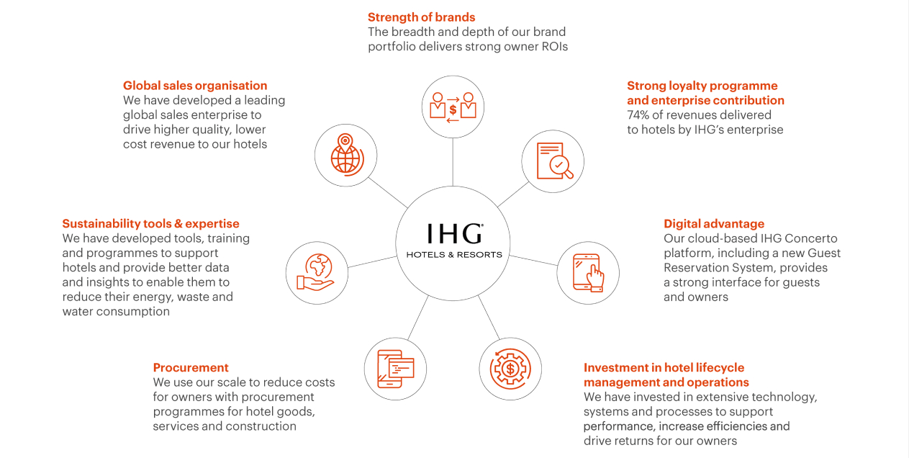

Sustainability and Innovation:
IHG’s strategic direction underscores its commitment to sustainability and innovation. By integrating sustainable practices into its operations, IHG aims to minimize its environmental footprint and contribute to a more sustainable future. This includes initiatives such as energy conservation, waste reduction, and responsible sourcing of materials (Choi and Yu, 2014).
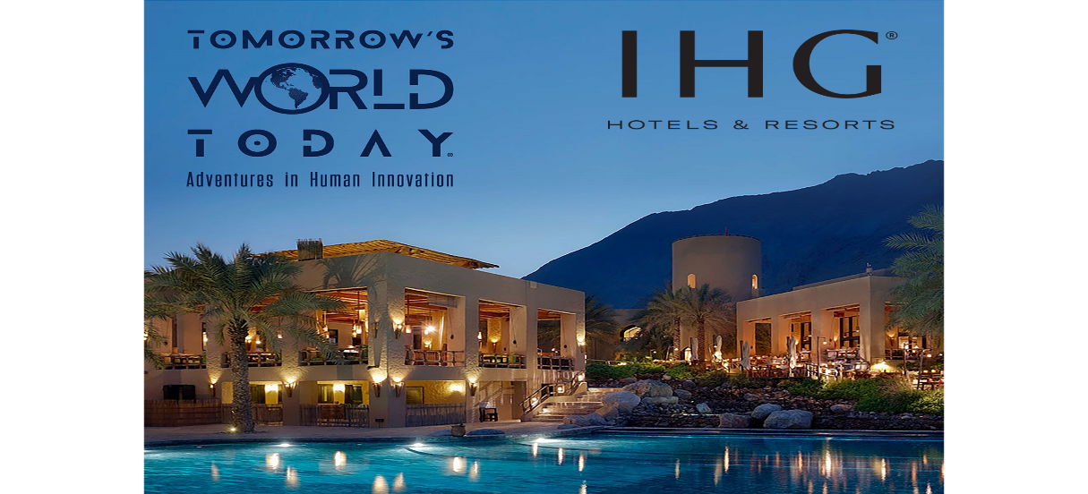
Such sustainability practices not only minimize environmental impact but also enhance IHG’s brand reputation and appeal to the growing segment of eco-conscious travellers (Maletič, Maletič, and Gomišček, 2018). By prioritizing sustainability, IHG meets evolving customer expectations and strengthens its competitive positioning in the hospitality industry. Additionally, IHG invests in innovation, leveraging technology to enhance guest experiences, improve operational efficiency, and drive business growth (Cameron and Green, 2019).
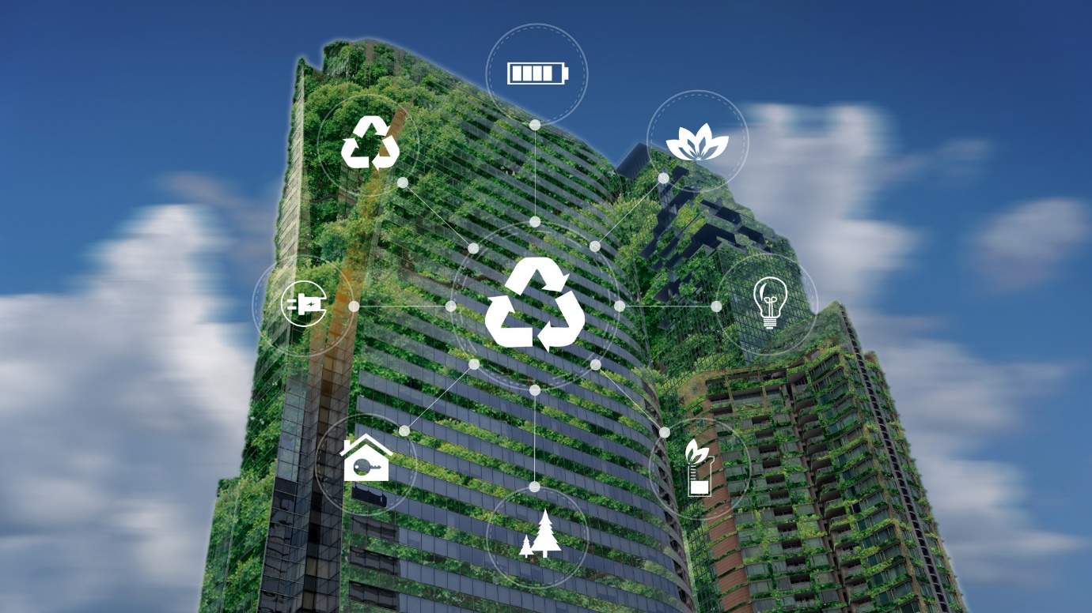
IHG’s overarching goals of sustainable growth, brand differentiation, and customer satisfaction are meticulously aligned with the SMART criteria and reflect a balanced scorecard approach to performance management. By setting clear objectives, measuring progress, and focusing on key success factors, IHG continually strives to solidify its position as a global leader (Kotlar et al., 2018). The company’s recent change initiatives, including digital transformation, sustainability efforts, and portfolio expansion through acquisitions, underscore its commitment to innovation and strategic growth.
Embracing these initiatives, IHG not only enhances operational efficiency and reduces its environmental footprint but also successfully navigates the challenges of integrating new brands (Errida and Lotfi, 2021). Overall, IHG’s dedication to innovation, sustainability, and strategic growth positions it for continued success in a rapidly evolving hospitality landscape. By delivering consistent value to customers, shareholders, and the environment, IHG remains resilient and competitive in the dynamic and competitive market (Setyawan et al., 2024).

References:

Alaaraj, S., Mohamed, Z.A., et al., 2018. External growth strategies and organizational performance in emerging markets: The mediating role of inter-organizational trust. Review of International Business and Strategy, 17(3), pp.251-265.
Blankson, C., Cowan, K., Crawford, J., et al., 2013. A review of the relationships and impact of market orientation and market positioning on organisational performance. Journal of Strategic Marketing, 21(5), pp.342-361.
Burtonshaw-Gunn, S. and Salameh, M., 2011. Change management and organizational performance United Kingdom.
Cameron, E. and Green, M., 2019. Making sense of change management: A complete guide to the models, tools and techniques of organizational change. Kogan Page Publishers.
Choi, Y. and Yu, Y., 2014. The influence of perceived corporate sustainability practices on employees and organizational performance. Sustainability, 6(1), pp.348-372. Csaszar, F.A., 2012. Organizational structure as a determinant of performance: Evidence from mutual funds. Strategic Management Journal, 33(6), pp.681-698.
Errida, A. and Lotfi, B., 2021. The determinants of organizational change management success: Literature review and case study. Journal of Engineering Business Management, 12(1), pp.21-34.
Gary, M.S., Yang, M.M., Yetton, P.W. and Sharma, P., 2017. Stretch goals and the distribution of organizational performance. Organization Science, 28(6), pp.1230-1248.
Hao, Q., Kasper, H. and Muehlbacher, J., 2012. How does organizational structure influence performance through learning and innovation in Austria and China. Chinese Management Studies, 6(1), pp.4-21.
Iyer, P., Davari, A., Zolfagharian, M., Paswan, A., 2019. Market orientation, positioning strategy and brand performance. Industrial Marketing Management, 48(6), pp.1237-1247.
Joseph, J., Klingebiel, R. and Wilson, A.J., 2016. Organizational structure and performance feedback: Centralization, aspirations, and termination decisions. Organization Science, 27(6), pp.1427-1442.
Jung, C.S., 2011. Organizational goal ambiguity and performance: Conceptualization, measurement, and relationships. International Public Management Journal, 14(3), pp.254-284.
Kotlar, J., De Massis, A., Wright, M., Ravasi, D., 2018. Organizational goals: Antecedents, formation processes and implications for firm behavior and performance. International Journal of Management Reviews, 20(3), pp.261-283.
Maletič, M., Maletič, D., Gomišček, B., 2018. The role of contingency factors on the relationship between sustainability practices and organizational performance. Journal of Cleaner Production, 231, pp.1151-1163.
Martinez, E.A., Beaulieu, R., Gibbons, R. and Singh, S., 2015. Organizational culture and performance.American Economic Review, 105(5), pp.336-341.
Meijaard, J., Brand, M.J. and Mosselman, M., 2005. Organizational structure and performance in Dutch small firms. Small Business Economics, 24(2), pp.163-182.
Mokaya, S.O., Kanyagia, C.P., Wagoki, J., 2012. Market positioning and organizational performance inthe airlines industry in Kenya. International Journal of Arts and Sciences, 2(1), pp.1-14.
Prajogo, D.I. and McDermott, C.M., 2011. The relationship between multidimensional organizational culture and performance. International Journal of Operations &amp; Production Management, 31(7), pp.712-735.
Rahim, K. and Clemens, B., 2012. Organizational goals and performance measurement criteria for content marketing. Journal of Communication and Media Studies, 1(2), pp.1-15. Shahzad, F., Luqman, R.A., Khan, A.R. and Shabbir, L., 2012. Impact of organizational culture on organizational performance: An overview. Journal of Contemporary Research in Management, 1,pp.1-13.
Shore, T.H. and Strauss, J., 2008. The political context of employee appraisal: Effects of organizational goals on performance ratings. International Journal of Management, 25(2), pp.251-268.Reduced Environmental Footprint: Weinzimmer, L.G., 2000. Measuring organizational growth: Issues, consequences and guidelines. Journal of Management, 31(4), pp.551-560.
Organizational Structure for IHG Available at : organizational structure of Intercontinental hotel group - Search Images (bing.com) (Accessed: 27 May 2024)
IHG Hotels & Resorts Available at: Our strategy - InterContinental Hotels Group PLC (ihgplc.com) (Accessed: 27 May 2024)
IHG Development Available at: growth strategy of Intercontinental hotel group - Search Images (bing.com) (Accessed: 28 May 2024)
Sustainable Hotel Practices: Going Green in the Hospitality Industry Available at: sustainability and inovation of Intercontinental hotel group - Search Images (bing.com) (Accessed: 28 May 2024)
Digital transformation in Hotel Sector Available at: digital transformation of Intercontinental hotel group - Search Images (bing.com) (Accessed: 28 May 2024)

