Critically discuss the biological and cognitive effects that may result from damage to the highlighted area.

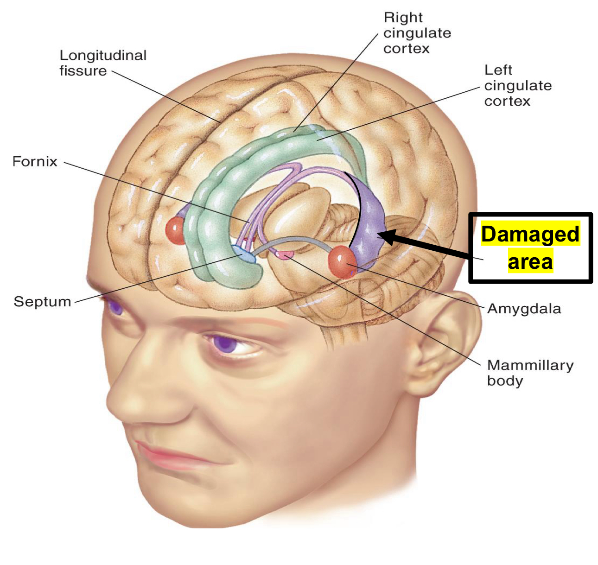
This essay will critically discuss the biological and cognitive effects that may result from the damage to the highlighted area on the image provided as part of the module assessment. The area has been identified as the hippocampus, an important part of the human brain in the medial temporal lobe (MTL) (Barnes & Pinel, 2022). The hippocampus is located beneath the cerebral cortex and is made up of two interlocking parts known as the hippocampus proper and the dentate gyrus. Its shape resembles that of a seahorse, which is where it gets its name in Greek. In humans and mammals, the hippocampus is a paired structure, consisting of both left and right hippocampi (Wright, 2017). Damage to the hippocampus can be sustained by injury, disease or genetics and as a result, cause memory, language and spatial impairments. The image provided shows damage to the left hippocampus which is theorised to be mainly associated with language and memory-related processe. This essay will mainly discuss the potential effects on different types of memories affected by the damage to the hippocampus.
Researchers have conducted studies to gain a deeper understanding of the role of the hippocampus in memory and learning. Various methods such as longitudinal studies of patients, lesions to specific areas of the brain, and neuroimaging techniques like magnetic resonance imaging (MRI) and electroencephalography (EEG) on humans with brain damage, primates, and rodents have been used to understand the role of the hippocampus better.
There are two main views on the function of the hippocampus, spatial (O’Keefe & Dostrovsky, 1971) and memory (Scoville & Milner, 1957). The essay will discuss the memory function of the hippocampus, which research (Ezzati et al., 2016; Tulving et al., 1994) suggests is related to the left side of the hippocampus as highlighted in the provided image. However, it is worth noting that there is some overlap in the function of the left and right hippocampus when it comes to both spatial and memory perspectives (Maguire & Frith, 2003).
Much of what is understood of the functions of the hippocampus within the MTL can be credited to Henry Molaison also known as Patient H.M. Molaisan was offered a bilateral medial temporal lobectomy to stop his epileptic seizures which had increased overtime and proving nearly impossible for him to lead a normal life. Scoville had proposed to remove the medial part of both of H.M.’s temporal lobes including the hippocampus and the amygdala (Barnes & Pinel, 2022). Even though the surgery stopped the epileptic seizures, H.M developed anterograde amnesia where he could not form new memories (Augustinack et al., 2014). Further tests were done to assess the effect of memory deficit which showed that H.M. was not able to remember anything new however his intellectual ability was not affected (Scoville & Milner, 1957) which was also researched by Corkin (1984), and the results showed that memory process was separate to other cognitive functions such as problem-solving. Furthermore, Scoville and Milner (1957) discovered that deficits in memory of patients with lesions or removal of the hippocampus which was related to the extent of removal of this part of the MTL and it revealed that individuals who underwent damage or removal of their hippocampus experienced memory deficits that were proportionate to the extent of damage. This highlights the importance of the hippocampus in memory processes and the importance of avoiding damage to this area as possible to promote optimal functioning.
H.M.’s case made major contributions to our understanding of different types of memories and the cognitive and biological effects the damage to the hippocampus has on the memory process. H.M. participated in various studies like memory and behavioural tasks, neuroimaging, longitudinal studies etc over the span of 55 years and his contribution extended past his death when researchers were able to section is brain to learn more (Annese et al., 2014; Augustinack et al., 2014; Corkin, 2002; Scoville & Milner, 1957).
The topic of memory has been a widely discussed subject among researchers and several theories have been put forward. One such theory is the memory consolidation theory first proposed by Müller in the 1900s. The process of systems consolidation involves the reorganisation of memories over time. At first, memories are stored in the hippocampus, but as time goes on, they are gradually transferred to other areas of the neocortex, creating a more permanent memory. This happens through a series of gradual changes in the neocortex that eventually move the memories from the hippocampus (Nadel & Bohbot, 2001; Squire et al., 2015). H.M.’s case provided an insight into this concept after he developed partial retrograde amnesia. He could not recall memories shortly before the surgery but memories from his earlier life were still present. This was also true of the various other patients who had a similar damage to their MTL and hippocampus, leading the researcher to develop the memory consolidation theory (Scoville & Milner, 1957; Squire & Alvarez, 1995).
Although studying patients with hippocampal damage can be informative, the limitations of such research are evident as they are based on the extent of each patient's damage. On the other hand, animal models(Squire & Zola-Morgan, 1991) with hippocampal lesions have proven to be a valuable tool in exploring the relationship between these lesions and temporally graded retrograde amnesia. While not all studies consistently demonstrate a temporal gradient of retrograde amnesia, some findings suggest that memories evolve to become less reliant on the hippocampus as they age (Morgado-Bernal, 2011; Nadel & Bohbot, 2001). Studies have shown that inducing hippocampal lesions soon after training can lead to memory loss, while inducing them at later stages can help preserve memory. This finding suggests that memories undergo a reorganisation process over time, transitioning from hippocampal dependence to cortical reliance. These findings demonstrate the brain's ability to store and retrieve memories in a dynamic way, providing evidence that memories can alter their neural substrates as they mature (Akers & Frankland, 2009).
Moscovich and Nadel (1998) proposed an alternative theory, the Multiple-Trace Theory (MTT) suggesting that hippocampus is necessary for the retrieval of memories and is always required no matter the age of the memory. These theories present varying perspectives on the hippocampus's role in memory processes, with Consolidation Theory emphasising temporary involvement of the hippocampus, while MTT highlights continuous engagement throughout a person's life. According to the Consolidation Theory, the hippocampus is essential for forming memories and consolidating them initially before other areas in the neocortex take over the responsibility of storing and retrieving memories independently of the hippocampus. The (MTT), on the other hand, argues that each autobiographical memory creates a permanent trace in the hippocampus, indicating that the hippocampus remains involved in memory retrieval, even for remote memories (Maguire & Frith, 2003; Nadel & Bohbot, 2001).
One of the limitations of the consolidation theory is that it overemphasises the relationship between memory systems and the hippocampus overlooking other parts of the brain that might also be involved. A study (Westmacott et al., 2001) conducted on patients with semantic dementia, difficulty in remembering words, faces challenges the consolidation theory and found that people with damage to neocortical area but relatively intact hippocampus showed a reverse gradient in memory loss where recent memories were affected more than remote memories. From the comparison of memories from semantic dementia and patient with amnesia the study found that hippocampus role in the storage and retrieval of memories is permanent challenging the time-limited finding of consolidation theory and being more in line with MTT.
Another theory that has given insight to the effects of damage to the hippocampus is the Cognitive Map Theory (CMT) proposed by the O’Keefe and Nadel (1998) proposes that the hippocampus is crucial in forming and retaining spatial memories especially in helping us remember and locate ourselves in a physical space. The theory also suggests that there is a difference of function in the left and right hippocampus. Several studies have shown that there the right hippocampus is related to spatial function and the left to language and memory (Maguire & Frith, 2003; Nemati et al., 2023). The working memory theory proposed by Alan Baddeley (1992, 2003) links to the left hippocampus with regards to the phonological loop which stores and rehearses speech is responsible for processing language.
A digit-span test + 1 (Wickelgren, 1968) carried out with H.M. gave insight on short term memory loss from hippocampal damage. H.M. was given 5 digit at an interval of 1 seconds to repeat he was able to repeat a string of 6 digits but was not able to move forward from a 8 digit sequence in contrast to most people who can go up to a string of 15 digits (Barnes & Pinel, 2022)
To understand how damage to left hippocampus effects the verbal memory researchers have conducted studies on the humans and animals. One study (Tsalouchidou et al., 2023) conducted on patients with temporal lobe epilepsy, mild cognitive impairment and healthy subjects supported that the left hippocampus has a role to play in verbal memory. Another study (Papanicolaou et al., 2002) to observe neural activity was carried out using magnetic source imaging (MSI) to understand the how hippocampus is involved in the memory processes of different stimuli, in the case words and pictures. Double dissociation (opposite effects of two variables) was observed in this case the left hippocampus processing words had greater activity and right more activity was seen in the right hippocampus processing pictures (Milner, 1971).
Damage to the hippocampus can have various implications on an individual's life. Trying to remember names, details of conversation or trying to commit new words to memory might occur. Language impairments may cause difficulty in understanding complex sentences, finding the right words while having simple conversations, or reading and understanding written text. For students, hippocampal damage can impact their academic performance if they are unable to remember what is taught or follow instructions. In a professional setting, individuals may struggle with recalling job specific terms, or it can affect their ability to communicate with work mates. Daily functioning like organising and planning a day, remembering appointments or events can be frustrating and lead to decline in confidence and overall well-being.
Alzheimer's disease is one of the examples of the result to hippocampal damage or aging (Fjell et al., 2014) causing forgetfulness and loss of spatial awareness. Children experience hippocampal damage different to adults where they are able to imagine a made up story but not remember past events and adults are unable to do both (Cooper et al., 2011).
There are treatments available to help some extent of hippocampal damage such as exercise (Wilckens et al., 2021), speech and language therapy to enhance the patient's quality of life.

