1.(A)

The Spanning Tree Protocol (STP) is performed with different sub processes.
Types of STP switch
At first in the switched domain various switches are assigned a specific role and name by the STP. Now in the world of STP, switches are commonly referred as bridge. And there are two kinds of bridge in the STP, which are
- Root Bridge
- Non-root Bridge
Root Bridge is the central or say the main switch in the STP domain, and all other switches are Non-Root Bridges. Also, in order to handle the communications between LAN to root Bridge, a Designated Bridge is selected from each segment.

Bridge ID - Bridge ID is actually the identity of the switch. The Bridge ID is of 8 bytes and it incorporates Bridge Priority uses 2 bytes memory and 6 bytes memory is used by the MAC adress.

During the STP operation the Bridge ID plays a very important role, as because the Root Bridge is selected on the basis of Bridge ID.

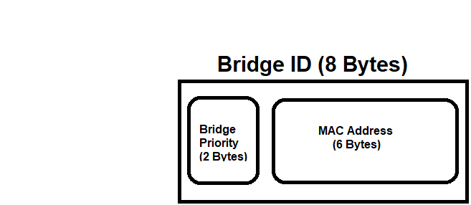

Root Bridge Selection
Towards the start of STP, a root bridge is determined. It is done consequently by STP on the basis of Bridge ID values, moreover we can control Root Bridge Selection to choose an ideal switch. The subsequent way is generally a decent configuration habit.
Since, in such a case that a low limit switch turns into a Root Bridge, then, at that point, the network can be impacted seriously.
In some vendors we get the options to configure a switch as Root Bridge, however we can also do this my manipulating the Bridge IDs. Now since a Bridge ID incorporates Bridge Priority and the MAC address, and as we know we cannot change the MAC address, and hence we will have to change the Bridge Priority in order to configure a switch as Root Bridge. To make a switch the Root Bridge we will have to set the Bridge Priority as low as possible.
And hence among all the switches the switch with the lowest Bridge ID is assigned Root Bridge.

STP Port Roles
In the STP operation, the Port Roles is also determined.
The STP Port Roles are mentioned below.
- Root Port - responsible for connecting a switch to Root Bridge with the minimum cost.
- Designated Port - responsible for connecting a switch to Non-Root segment
- Blocked or Non Designated Port - all other Ports leaving the Designated Port are Blocked or Non Designated Ports.

1.(B)
CEF stands for Cisco Express Forwarding and it is a packet switching technique, also this technique is used as default in most of the Cisco routing platforms.
The CEF technique is able to reduce the load on router’s processor, by providing an ability to switch packets via the device. And hence the routing process can be entrusted with managing different process that require bigger measures of processor time (QOS, Encryption, and so on.).

The advantages of CEF with other switching process are as follows:
- As compared to Process switching and Fast Switching route the CEF switching technique is less CPU intensive. As a result the services like encryption and QoS are able to get attention by the CPU as because CPU is able to offload CPU process.
- To each Line Card CEF is able to offer full switching capacity.
- In larger dynamic network the CEF technique offers stability and unparalleled level of switching consistency. On the other hand the entries of Fast Switching route are invalidated frequently, this is just because of routing changes which puts more load on process switching, as a result the CPU load is very high.

2. (A)

By default, EIGRP supports load balancing with equal-cost over four links. Equal-cost means that multiple routes should have the same metric to reach the destination, so that the router can decide to balance load across links of equal cost.
To better demonstrate the load balancing with equal cost concept, consider this example.

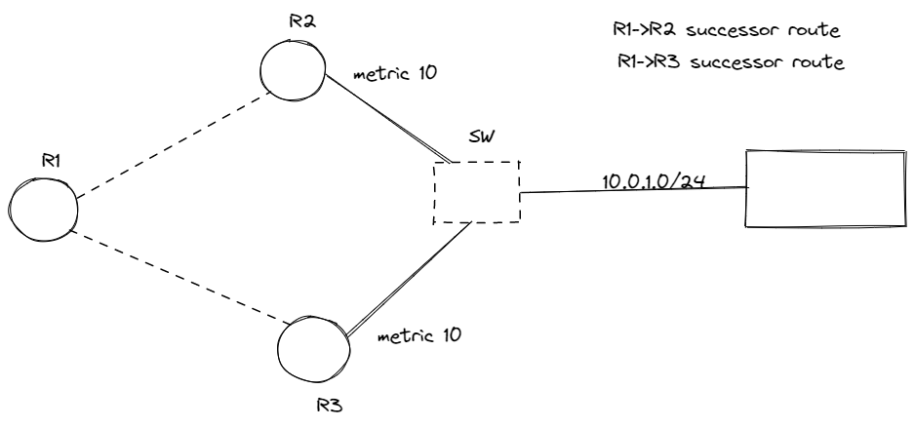

All three routers are running EIGRP. R2 and R3 routers are connected to the 10.0.1.0/24 subnet as shown in the figure. Both the routers advertise the route to reach the aforementioned subnet to R1. R1 receives two routing updates for the subnet 10.0.1.0/24 with the same metric. The metric stays same because both routers connect to the subnet 10.0.1.0/24 and R1 across the links with the same bandwidth and delay values. Router R1 places both routes within the routing table and load balances across the three links.

2.(C).
Border Door Convention is fair inconceivably special, particularly when we compare it to other directing conventions. The exceptionally to begin with thing that produces BGP so special, is what it helps us do. It is as it were Outside Door Convention (EGP) in major utilize nowadays. We know we have our Interior Door Conventions (IGPs), which would appear as if OSPF running interior of some autonomous framework. But BGP is also an EGP, which implies that it is (ordinarily) aiming to take prefixes that are interior an independent framework and send all those to other independent frameworks.
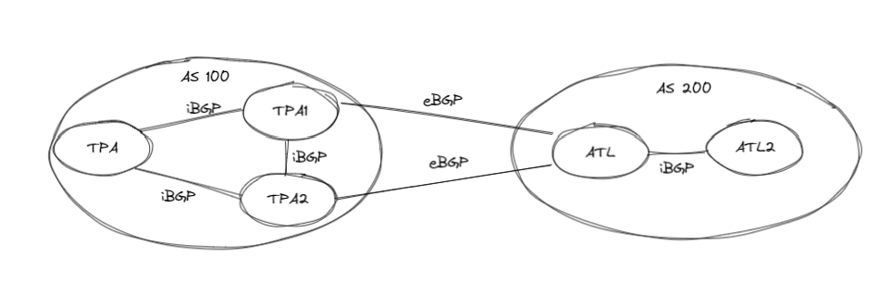
This can be why BGP is the convention that creates the Web work. Web Benefit Suppliers (ISPs) can utilize BGP to arrange to move prefix data between other Web Benefit Suppliers. The special characteristics of BGP do not fair halt there, although. Unique things that are exceptionally one of a kind the convention is that it shapes point-to-point peering with some other BGP speakers, and these peering must be made manually.

Q.4.
Here we are given 5 different city networks and we have to merge all of them into a single network which will require the concept of supernetting i.e. aggregating all the needed networks under a single network.
We can do supernetting only if these three conditions are satisfied:

I. All the IP addresses must be continuous.

II. Total size of the network must be in the power of 2’s.

We can connect all of these networks using the Mesh Topology so that there will be no single source point of failure and thus risk assessment is very less.
There will be a total of (N(N-1))/2 connections. Here in this case will be having 10 connections in total.

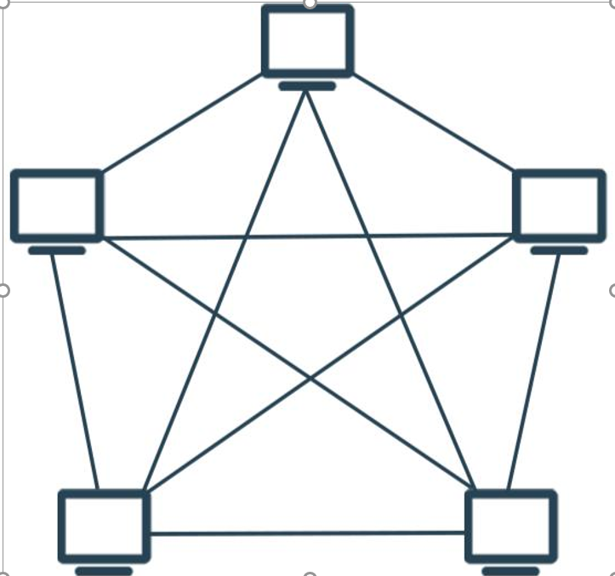

We will be connecting each network under MAN i.e. Metropolitan Area Network.

Each and every computer inside the network will pass the information from the gateway which will filter all the information that we want to transfer. Due to this feature, an additional layer of security gets added.

Each and every host inside the network will be connected to the routers.

For the host that is important such as servers, we can make the subnet mask different so that it will pass the information from the router outside the network which will hide the identity of the sender.

Devices we can use to connect the hosts can be the standard networking devices such as:

- Routers.

- Hubs.

- Bridges.

Hence using all the above-mentioned criteria we can merge the networks by also keeping the scalability and security at the top-notch priority.

