Apply the principles and practices of Data security, Governance and Compliance based on a NatureGarden company
Name:Yijun Kuang
Abstruct：This article, based on the actual situation of NatureGarden company, analyzed the information security vulnerabilities faced by the company. It designed a comprehensive network security strategy and conducted a dialectical analysis of the impact of new regulations.

Table of Contents
1.Introduction 1
1.1 Development of Internet Information Security.................................................................. 1
1.2 The Current State........................................................................................................................... 1
2. Research on Security Frameworks and Models 2
2.1 ITIL....................................................................................................................................................... 2
2.2 Security Models 4
2.3 Comparison of ISO 27000 and ITI .......................................................................................... 4
3. Safety Policy Design and Implementation 5
3.1 Security Status Analysis 5
3.2 Information System Security Design 6
3.3 Security Policies and Planning 8
3.4 Risk Management and Protective Mechanisms .........................................................................9
4. New Regulations Analysis............................................................................................................... 10
4.1 Importance of New Regulations 10
4.2 Impact of Regulatory Changes on Enterprises 10
5.Conclusion 11
Reference .................................................................................................................................................. 11

1.Introduction
  - Development of Internet Information Security
Over the past few decades, the application of the internet has become incredibly widespread. Nowadays, more than 4.5 billion people around the world regularly use the internet, and this number is still growing. The ubiquity of the internet has not only changed the way we entertain ourselves and obtain information but has also greatly transformed the way businesses operate. However, with the surge in internet users, issues of cybersecurity have significantly increased as well. Threats like personal data breaches, online fraud, and hacker attacks have become increasingly severe problems in today's world.
As more and more businesses move their operations online, the transmission and storage of sensitive information such as financial data, identity information, and intellectual property on the internet become more frequent and widespread. Consequently, the security of this information has become a major challenge for both individuals and businesses. In the current environment, the role of Information Technology (IT) professionals has become particularly important. They are not only responsible for managing and maintaining increasingly complex network systems but also for protecting these systems from the growing number of cyber threats.

  - The Current State
For modern enterprises, the internet has become an indispensable part of the company. Whether it's directly selling products through e-commerce platforms or using cloud computing resources to improve operational efficiency, the reliance of new businesses on the internet is continuously increasing. However, this dependency brings significant risks. Cybersecurity threats can lead to substantial financial losses, damage to company reputation, and even threaten the healthy development of the business.
Over the decades of internet development, methods of cyber-attacks have also become more varied and covert. From individual hackers to state-supported cyber espionage activities, the sources of attacks are diverse. For global companies like NatureGarden, corporate network information is varied and significant. Therefore, protecting its vast information assets and customers' personal data becomes extremely important. This requires companies not only to invest sufficient resources to protect their network infrastructure but also to establish comprehensive security strategies, including risk management, employee training, and emergency response plans.
In this context, for large enterprises like NatureGarden, designing and implementing an effective information security framework is not only a technical innovation and challenge but also a key component of business strategy. As the network environment continues to change, this task becomes more urgent and complex.

- Research on Security Frameworks and Models
  - ITIL
TIL (Information Technology Infrastructure Library) is a framework for IT Service Management (ITSM) that is widely recognized internationally. Originating in the 1980s from the UK government, its main purpose is to develop effective and efficient IT service management methods. ITIL's core consists of a series of processes and functions supporting the entire lifecycle of IT services, ranging from service design and development to delivery and support.

ITIL has four main characteristics:1. ITIL views IT service management as a lifecycle, including service strategy, design, transition, and operation; 2.ITIL is process-driven, emphasizing standardization and consistency, with clearly defined procedures to improve service quality and efficiency; 3.ITIL emphasizes understanding and meeting user needs, aiming to improve user satisfaction; 4.ITIL is flexible and adaptable, allowing organizations to adjust and adapt ITIL practices according to their needs.

Figure 1 illustrates ITIL's framework, which mainly includes the following five core components:
- Service Strategy: Primarily focuses on formulating IT's strategic direction and goals, ensuring alignment with the overall business.
- Service Design: Determines how to involve and implement IT services to meet various business needs and strategies.
- Service Transition: Introduces new or changed IT services into the production environment, ensuring system stability and smooth transition and operation.
- Service Operation: This component involves the actual operation and maintenance of IT services, such as handling failures, event management, and system request management.
- Continual Service Improvement: ITIL framework emphasizes continuous improvement, enhancing service quality through monitoring and evaluating existing IT services.

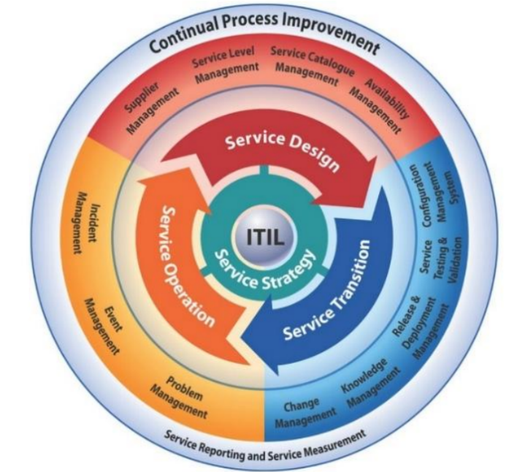
Fig.1 ITIL framework

Figure 2 shows event management application in ITIL. ITIL improves the reliability and efficiency of IT services, enhances service quality, better understands and meets customer needs, and increases customer satisfaction. Through proper resource management and service optimization, it reduces system costs and improves overall efficiency, improving resource utilization; it offers a set of clear standards and steps, maintaining transparent and measurable service management, conducive to continuous correction. However, ITIL implementation is costly and complex, requiring continuous resource investment by the organization.
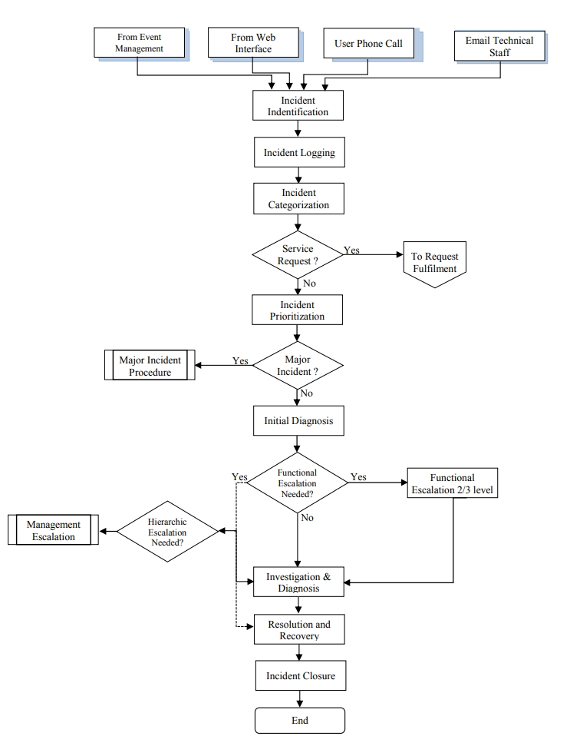
Fig 2.Incident management with ITIL
  - Security Models
The ISO 27000 series, developed by the International Organization for Standardization (ISO) and the International Electrotechnical Commission (IEC), is a set of standards for information security management. It helps organizations protect their information assets, such as financial information, intellectual property, employee details, etc. ISO 27001, the most well-known standard in this series, provides a framework for establishing, implementing, and continually improving an Information Security Management System (ISMS).

ISO 27000 has five main features:1.Comprehensive security management covering all aspects of an organization, such as human, processes, and IT systems; 2.Assessment and management measures for information security risks; 3.Adopting a Plan-Do-Check-Act cycle for continual improvement of security measures; 4.Strong compliance; 5.Applicability to all types of organizations.

Figure 3 illustrates the ISO 27001 meta-model. Organizations certified in ISO 27000 can demonstrate their commitment to information security to customers, reducing security risks through systematic risk management processes. However, implementing ISO 27000 can be costly and the framework somewhat rigid.
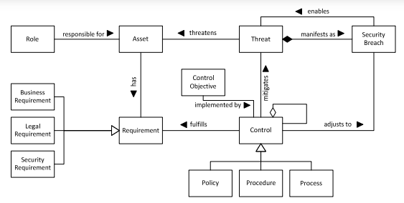
Fig 3.ISO 27001 Metamodel

  - Comparison of ISO 27000 and ITIL
The most significant difference between ISO 27000 and ITIL lies in their focus areas and approaches. ISO 27000 provides a framework for establishing, implementing, monitoring, reviewing, and maintaining a security management system. It focuses on information security management, aiming to protect the organization's information assets and ensure the confidentiality and integrity of data, applicable to any organization managing and protecting information. In contrast, ITIL offers a series of processes and best practices for managing IT services, focusing on high-quality IT service management. Its main goal is to improve the efficiency and effectiveness of services, ensuring better business objectives achievement, primarily applicable to businesses that need to optimize IT service management and improve customer satisfaction.

In summary, both the ISO 27000 series and ITIL have common goals in improving organizational management practices but focus on different areas. ISO 27000 is more focused on information security management, while ITIL concentrates on overall IT service management. The two can complement each other, and some enterprises might combine these frameworks to enhance both their information security and IT service management effectiveness.

- Safety Policy Design and Implementation
  - Security Status Analysis
NatureGarden Sales, as an international company, extensively uses cloud services to provide accurate and robust IT services to global users, with the vast majority of the network being wireless. Therefore, there are risks of data leakage and unauthorized access, and the network security strategy is considered from the following aspects:
- Wireless Network Security: The company's infrastructure is based on wireless technology, providing great portability and flexibility. However, there are significant security risks associated with wireless networks. Wireless networks are susceptible to unauthorized access, phishing attacks, and network intrusions, which can lead to the leakage of sensitive data and network interruptions.
2. Cloud Service Security: The enterprise relies on cloud services to store, manage, and use data, which brings great convenience to administrators, increases efficiency, and reduces costs. However, it also introduces issues related to data security and privacy breaches. Strict data confidentiality measures are required to ensure the security and integrity of data during the upload and download process.
3. Personal Device Security Issues: NatureGarden provides network services to its employees and users, and personal devices can access the company's network. This complexity in security management arises from the fact that personal devices are not subject to company security controls and supervision. This can result in security vulnerabilities and the potential for malware attacks on company data. Additionally, the company deals with a significant amount of personal and sensitive data, and compliance with data protection regulations such as GDPR is crucial. Unauthorized use of user's private data can result in serious legal and financial consequences. Therefore, employees should receive enhanced cybersecurity awareness training, as they may unintentionally click on malicious links, use weak passwords, or access sensitive data in insecure network environments, which is a cause for concern.
4. Intellectual Property Security: The company's intellectual property and trade secrets are a critical part of its competitive advantage. Protecting these assets, which are valued at billions of dollars, is of utmost importance. Network attacks and data breaches can lead to the leakage and loss of valuable assets, resulting in significant financial losses.
5. Compliance: The company needs to strictly adhere to information security standards and regulations, especially ISO 27000 and ITIL guidelines, to provide efficient, accurate, and secure IT services to users.

  - Information System Security Design
Based on the security status analysis, the company needs to strengthen the following six aspects:
- Strengthen Network Boundaries: Enhance the security of wireless networks through advanced firewalls and intrusion detection systems. This includes regularly updating firewall rules and signatures and monitoring and responding to suspicious activities.
- Data Encryption: Encrypt sensitive data from end to end for upload, storage, and transmission to cloud servers using strong encryption standards such as AES to ensure data remains unreadable even if it is leaked or intercepted.
- Multi-Factor Authentication: Implement multi-factor identification and authentication for all users accessing company resources, particularly for operations involving sensitive data or critical systems.
- Regular Security Audits: Conduct regular network audits internally to identify potential security vulnerabilities and compliance issues.
- Governance Structure: Establish a clear security governance structure, such as a cross-departmental information security committee, responsible for overseeing and guiding the company's information security strategy and regularly updating security systems.
- Compliance: Ensure that all security policies and measures implemented by the company comply with international standards and relevant national laws and regulations, such as the ISO 27000 series or GDPR.

In the security framework design, it is assumed that the following key premises guide the entire security framework design and implementation:
- Employees and users use personal devices to access the network: It is assumed that users use various personal devices such as smartphones, computers, and tablets to access the company's network. These devices may run different operating systems and may not have undergone the company's security configurations. Device security is assumed to be lower than that of company devices, and users may access company data in insecure public network environments, increasing the risk of data leakage.
- Predominant use of wireless networks: The company's IT infrastructure primarily relies on wireless networks, making it more susceptible to hacker attacks and data leakage during data transmission.
- Compliance with network security standards: The company must comply with specific industry security standards and various national laws, such as GDPR and ISO 27000. Legal regulations encompass technical measures, policies, procedures, and employee training.
- Uneven employee security awareness: Employees vary in their awareness of information security and precautions. Some employees may lack basic cybersecurity awareness, leading to inconsistent implementation of security policies and increased security vulnerabilities.

Figures 4 and 5 depict the risk assessment and security measures tables for the company, and these tables are used for modeling and policy formulation.
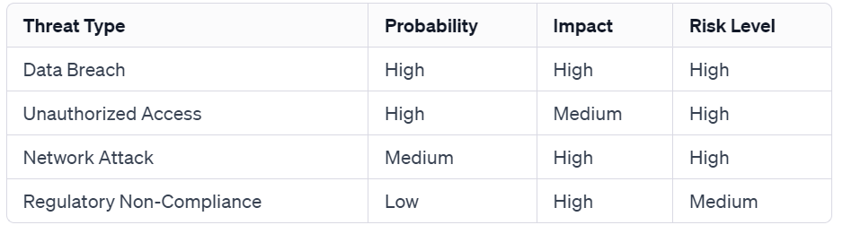
Fig 4.Risk Assessment Chart
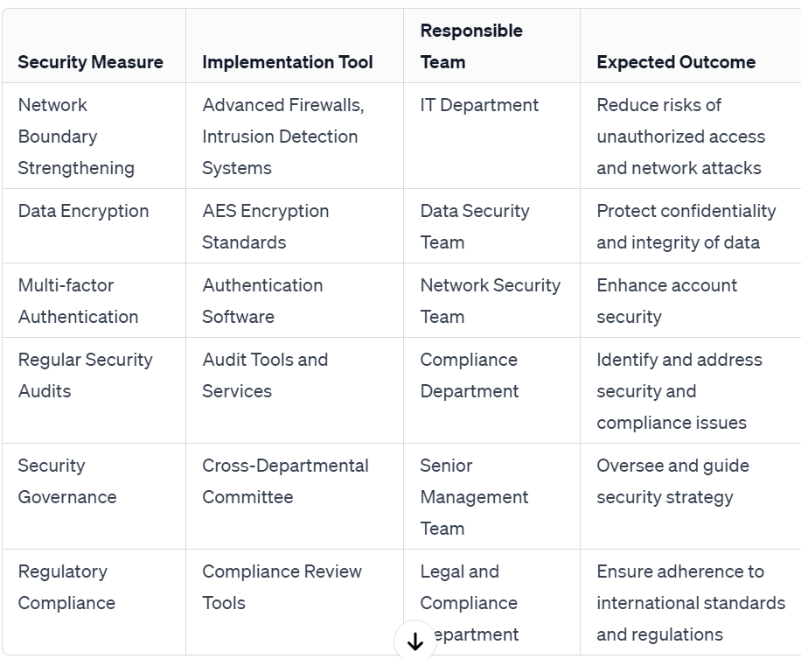
Fig 5.Security Measures Table

Figure 6 represents the information security control model and components, categorized by functionality and object, for controlling communication, authentication, access, content, structure, and encryption in information security.
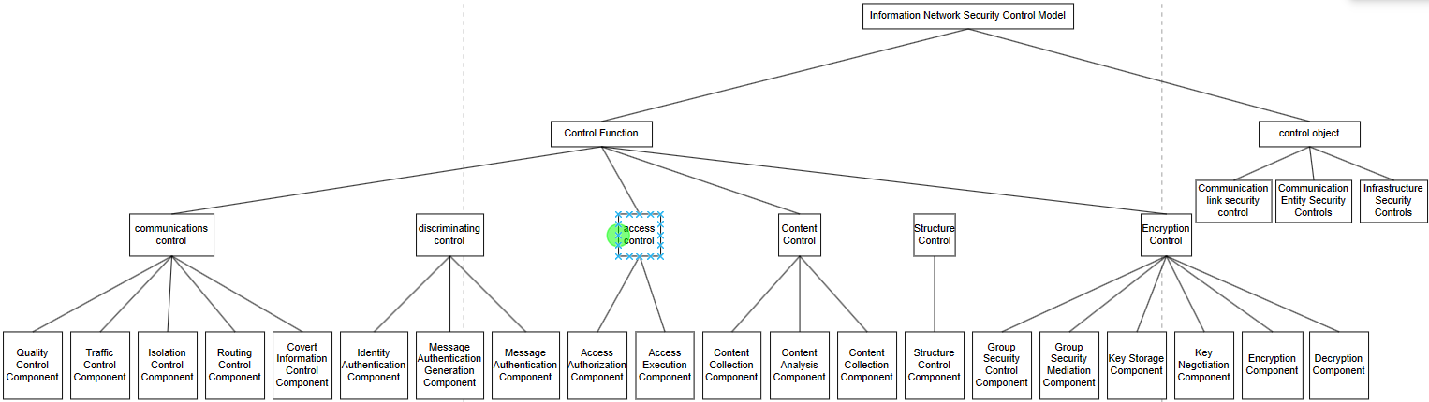
Fig 6.Cybersecurity control models and component systems

Figure 7 is a designed security control flowchart, where users access the company network, perform data input, undergo authentication including multi-factor authentication, ensuring that only authorized users can access the network and data. The firewall conducts network boundary security checks, filtering and monitoring inbound and outbound network data flows, filtering and alerting on illegal and suspicious traffic. Data encryption is then performed, encrypting data during transmission and storage on cloud servers. Access control and permission management distinguish user permissions and access purposes to ensure that users with sufficient permissions can access sensitive information. Comprehensive security monitoring and alerts are conducted when users access company data, and any abnormal activities trigger automatic alerts and response mechanisms. Lastly, regular audits and compliance checks are conducted to ensure that all security measures and operations comply with standards.
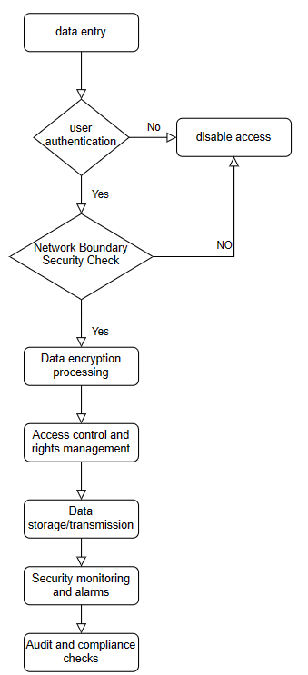
Fig 7.Security Control Flowchart

  - Security Policies and Planning
In today's digital world, compliance with regulations is a critical component of any organization's success. Compliance strategies primarily focus on protecting personal and corporate data from unauthorized access and misuse. The company needs to strictly adhere to data protection regulations such as the General Data Protection Regulation (GDPR) to ensure that all data processing activities are conducted within a legal framework. A clear compliance strategy helps the company identify and mitigate potential compliance risks.

It is assumed that the company has the organizational flexibility to adapt and implement new security measures. For example, there is strong management support for security measures, and a culture of cross-departmental collaboration ensures that security policies are implemented throughout the company. Additionally, the company's culture encourages open communication and employee reporting of security issues, contributing to a strong security awareness. Effective security governance is the foundation for the successful implementation of NatureGarden's information security strategy, involving the establishment of a clear organizational structure, delineation of responsibilities at each level, and the continuous updating of security systems. This not only improves decision-making transparency but also ensures consistent and unified execution of security policies throughout the organization. By adopting a centralized governance approach, the company ensures alignment of its goals and security strategy, while also being able to rapidly respond to new security threats.

A stable strategic plan for security involves long-term network security planning for the company. The company is required to look beyond day-to-day operations and consider future security trends and technological developments. This planning involves the continuous building of IT infrastructure services, establishing a flexible security architecture to adapt to changing business needs and network environments. Additionally, employee training and security awareness are crucial to ensure that every employee becomes an active participant in the company's security strategy.

  - Risk Management and Protective Mechanisms
Risk management is the process of identifying, assessing, and mitigating security risks. In this design, security risk management involves three steps: 1. Conducting comprehensive security risk assessments regularly to identify new security threats, including risk assessments in the areas of technology, processes, and personnel management. 2. Implementing preventive measures based on the results of risk assessments, such as strengthening network defenses, improving data encryption, and enhancing identity authentication. 3. Formulating response strategies for identified risks, such as technical solutions, policy adjustments, and improvements to emergency response plans.

Emergency planning ensures a rapid and effective response in the event of emergencies and security threats. Emergency mechanisms are broadly categorized into three steps: 1. Develop detailed emergency response strategies, including incident identification, response, recovery, and post-incident analysis. 2. Conduct regular simulation drills to improve response efficiency and speed. 3. Continuously improve emergency plans based on the experience gained from drills and actual situations. Protective mechanisms should cover physical, network, and organizational behavior aspects to ensure facility security, such as access control systems, surveillance cameras, and security alarms. Advanced network security technologies should be applied, including firewalls, intrusion detection systems, and security information systems. Clear guidelines and ongoing training for employees are essential to ensure secure handling of sensitive data."

- New Regulations Analysis
  - Importance of New Regulations
The continuous emergence of new regulations can greatly improve network information security. It is assumed that technological and market trends are the main drivers for the updating of security regulations and standards. With rapid technological advancements such as cloud computing, the Internet of Things, and artificial intelligence, security threats are also constantly evolving.

These updates ensure that companies can adapt to ever-changing security threats, technological advancements, and legal requirements. Firstly, with technological development, new security threats constantly emerge. Updated regulations and standards can help companies better defend against these new threats, such as Advanced Persistent Threats (APTs) and ransomware. Due to the development of cloud computing and artificial intelligence technologies, companies need to continually update security measures to protect against new forms of unauthorized data processing and storage. Secondly, it is beneficial for compliance requirements and enhancing customer trust. As data protection and privacy laws strengthen, companies must update their policies and procedures to avoid legal violations. Compliance with the latest regulations and standards can also increase customer trust in the company. Lastly, adhering to the latest industry standards can help companies maintain their professional image and competitiveness in the market.

  - Impact of Regulatory Changes on Enterprises
The continuous changes in regulations and standards significantly impact the development of a company's security strategy. Compliance with new regulations may require investment in new technologies, system improvements, and employee training, which can temporarily increase operational costs. It may require modifying existing business processes, such as the way data is processed and customer data is collected. Additionally, some regulations may affect a company's market strategy; for example, restrictions on data storage in specific regions may impact the use of cloud services. Adapting to new regulations and standards may also require a change in the company's culture, especially in terms of raising awareness of security and compliance. Finally, improved compliance can strengthen customer relationships, especially in industries where data security and privacy are highly valued.

- Conclusion
The multi-dimensional security challenges faced by NatureGarden require a comprehensive solution. This includes not only technological improvements such as strengthening network boundaries, implementing data encryption, and multi-factor authentication but also the formulation of effective organizational strategies such as security governance, risk management, and emergency planning. Strengthening employee security awareness and building a culture of security are key to improving overall security. Finally, continued investment in the latest security technologies and regular review of existing security measures are necessary to address the development of new technologies, such as assessing the security of cloud computing and artificial intelligence.
The company's information security strategy requires a multi-faceted, dynamic approach that combines technological, managerial, and cultural factors to build a robust security system. This not only requires collaboration among various departments within the company but also the support and allocation of resources from senior leadership to ensure effective responses to current and future security challenges. With such an approach, NatureGarden can ensure the security, stability, and sustainable development of its business.

References
[1] N. Vignesh, R. Lohith, S. A. Kumar, H. Dagale and K. Sangeeta, "An IOT based network management system for enterprise network," 2017 International Conference On Smart Technologies For Smart Nation (SmartTechCon), Bengaluru, India, 2017, pp. 1089-1093, doi: 10.1109/SmartTechCon.2017.8358537.
[2] G. A. Marin, "Network security basics," in IEEE Security & Privacy, vol. 3, no. 6, pp. 68-72, Nov.-Dec. 2005, doi: 10.1109/MSP.2005.153.
[3] H. Hamed and E. Al-Shaer, "Taxonomy of conflicts in network security policies," in IEEE Communications Magazine, vol. 44, no. 3, pp. 134-141, March 2006, doi: 10.1109/MCOM.2006.1607877.
[4] G. W. Jackson and S. S. M. Rahman, "Security Governance, Management and Strategic Alignment via Capabilities," 2017 International Conference on Computational Science and Computational Intelligence (CSCI), Las Vegas, NV, USA, 2017, pp. 44-49, doi: 10.1109/CSCI.2017.8.
[5] A. Al-Omari, A. Deokar, O. El-Gayar, J. Walters and H. Aleassa, "Information Security Policy Compliance: An Empirical Study of Ethical Ideology," 2013 46th Hawaii International Conference on System Sciences, Wailea, HI, USA, 2013, pp. 3018-3027, doi: 10.1109/HICSS.2013.272.
[6] E. Marilly, O. Martinot, S. Betge-Brezetz and G. Delegue, "Requirements for service level agreement management," IEEE Workshop on IP Operations and Management, Dallas, TX, USA, 2002, pp. 57-62, doi: 10.1109/IPOM.2002.1045756.
[7] T. A. Longstaff, C. Chittister, R. Pethia and Y. Y. Haimes, "Are we forgetting the risks of information technology?," in Computer, vol. 33, no. 12, pp. 43-51, Dec. 2000, doi: 10.1109/2.889092.
[8] W. He and A. K. Somani, "Comparison of Protection Mechanisms: Capacity Efficiency and Recovery Time," 2007 IEEE International Conference on Communications, Glasgow, UK, 2007, pp. 2218-2223, doi: 10.1109/ICC.2007.373.
[9] J. Kong et al., "Guaranteed-Availability Network Function Virtualization with Network Protection and VNF Replication," GLOBECOM 2017 - 2017 IEEE Global Communications Conference, Singapore, 2017, pp. 1-6, doi: 10.1109/GLOCOM.2017.8254730.
[10] G. Suwala and G. Swallow, "SONET/SDH-like resilience for IP networks: a survey of traffic protection mechanisms," in IEEE Network, vol. 18, no. 2, pp. 20-25, March-April 2004, doi: 10.1109/MNET.2004.1276607.

