Corey jones BMSK4005 1812188
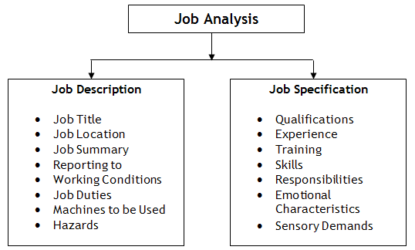
A person specification describes the personal attributes desired in a potential employee. It is similar to a job description, but more specific, A job description concentrates more on the job and leaves the employer to decide whether they are right for it or not. Writing a person specification can save time for selection process, it enables potential applicants to clearly determine whether they can meet the requirements of the job, therefore reducing unsuitable job-seekers at an earlier stage. It also gives you a chance to show your employer what attitudes u can bring to the workplace.
https://www.bath.ac.uk/guides/writing-a-job-description-and-a-person-specification/
A personal specification could include:
- Qualifications,
- Skills,
- Experience,
- Knowledge,
- Personal attributes
There are two integral parts of a job analysis. Which are Job description and job specification They define a job fully and guide both employer and employee.
A job specification is used to help a candidate analyse whether they would be suitable to apply for the specific role
A Job Description describes the roles, activities, duties and responsibilities a job.it is used to convey information essential to understanding the job role applying for, and you can compare your personnel specification to meet the job descriptions. (Monster Hiring Resource Centre, n.d.)
Based on a manager’s job advert for a mangers position at McDonalds, Personnel Specification to match the job descriptions would be telling the employer your Qualifications, and any experience you have endured. a degree in business administration essential for McDonalds manager position or Training may be obtained on-the-job and work experience is also required by some employers. good communication skills is a major skill for managers position as you be managing a team of employees, inter-personnel skills would also be important factor as the manager you would need to have good communication skills, negotiable , good working as a team, problem solving, be able to work under pressure , organised, reliable, good time management skills, Flexible for shift work and hours playing a vital role to maintain the quality of service to their consumers. (BestJobDescriptions.com, n.d.)(2019)
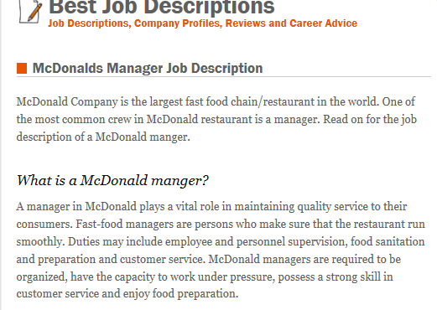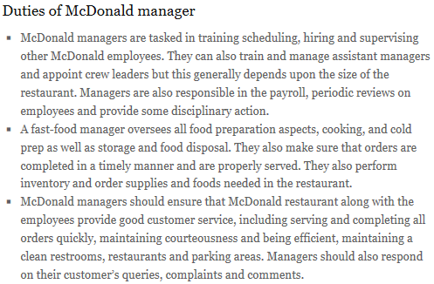
References
BestJobDescriptions.com. (n.d.). McDonalds Manager Job Description - BestJobDescriptions.com. [online] Available at: https://www.bestjobdescriptions.com/management/mcdonalds-manager-job-description [Accessed 22 Mar. 2019].
Managementstudyguide.com. (n.d.). Job Analysis Process. [online] Available at: https://www.managementstudyguide.com/job-analysis-process.htm [Accessed 17 Mar. 2019].
Monster Hiring Resource Center. (n.d.). How do I put together a person specification? | Monster.co.uk. [online] Available at: https://hiring.monster.co.uk/hr/hr-best-practices/recruiting-hiring-advice/screening-job-candidates/how-do-i-put-together-a-person-specification.aspx [Accessed 17 Mar. 2019].

