ACBA4017 Digital Surveying and Highway Design
Building Survey Project UWSTD IQ 1st floor
Student Name: Charlie Tee
Student ID: 2517370
Module: Digital Surveying and Highway Design
Module Code: ACBA4017

Contents
- Introduction
- Part 1: Planning the Survey
  - 2.1 Purpose of the Survey
  - 2.2 Survey Area Definition
  - 2.3 Site Assessment
  - 2.4 Risk Assessment Summary
  - 2.5 Survey Methodology
- Part 2: Practical Survey
  - 3.1 Survey Execution
  - 3.2 Evidence of Site Attendance
  - 3.3 Problems Encountered and Solutions
- Part 3: Measurement and Analysis
  - 4.1 Measurement Extraction
  - 4.2 Accuracy Assessment
  - 4.3 Comparison with Traditional Methods
- Conclusion
- References
- Appendices
1. Introduction
This Written Assignment covers the Survey me and other students Carried out at the University of Wales Trinity Saint David, Swansea Bay Campus. The Survey was carried out on the IQ Building on the First floor in a specified area. The purpose of the Survey was to conduct an Internal Survey using two different methods for Comparison. We used two different methods using separate equipment, one method used a traditional Surveying technique with Measuring Tapes and Lasers, and the Second Method used a 3D Scanner Called ‘Leica BLK2GO’. The main aim of this report is to discuss and analyse the differences found after conducting the two Surveys and discuss the relevant points that affected the results.
2. Part 1: Planning the Survey
2.1 Purpose of the Survey
As Stated above the building being Surveyed was the IQ Building 1st floor in university Wales Trinity Saint David. The area Surveyed was along the corridors and across the Main Bridge. The Focus of the Survey was to conduct a professional Survey Using digital technology to extract the processed data to extract accurate building measurements and other aspects of the Survey that could affect future works. The intended outputs from the building survey are that the measurements are accurate, there is information for the floor plan and that we have Point cloud data generated from the laser scanning survey. These outputs will then be taken away and used for the analysis of the building and obtain the dimensions for the specified area. In this particular Survey we carried out we used advanced laser scanning technology Which has much more significant benefits compared to the traditional method. The Laser scanners are much more reliable than a human because they capture the measurements at the highest precision possible, this is more effective than humans who will likely make errors using manual devices. Another benefit of the scanner is that it is much more efficient. When Me and my group surveyed manually in the selected area it took 1 hour, compared to the Scanner which took around 20 minutes. It also captures millions of points whilst you walk around with it which gives you much more detailed information about the building. When people manually measure you would do a Sketch alongside the measurements if you were to revisit or needed to visualise, the scanner generates a 3d image as you collect the data which is saved in point cloud data and can always be revisited.
2.2 Survey Area Definition
We originally intended to do the Survey on a different building on the campus but due to heat conditions the location was changed. the main survey area of the building was the first floor. More specifically, the Corridors. (As seen in the above image)
Level of Detail Required
An elevated level of detail was required throughout the survey due to the variety features present within the survey area, including beams, handrails, and changes in the corridors. Capturing these features accurately was essential to ensure that the survey data provided a reliable representation of the building. In contrast, certain elements such as long corridor sections, skirting boards and ceiling areas that did not contain visible services or noteworthy features required a lower level of detail, as recording them in extreme detail would provide limited benefit.
The detailed information obtained from the laser scanner provides substantial advantages when compared to traditional measurement methods. The point cloud data allowed us to examine the building remotely after the survey has been completed, reducing the need for repeat site visits and improving the efficiency of the data collection process. Furthermore, the level of detail captured can assist in identifying inconsistencies and potential defects that may not be immediately apparent during a conventional site survey.
Another benefit of capturing an elevated level of detail is the ability to gain a greater understanding of the building's construction. The scan data can provide visual information regarding materials, construction features and alterations that have occurred throughout the building's lifespan. This information can help surveyors make judgements regarding the age, condition and potential risks associated with the building. For example, identifying older construction materials may highlight areas that require further investigation or maintenance like asbestos.
However, despite the advantages offered by laser scanning technology, it should not be considered a substitute for professional judgement. While the scanner can record and display highly accurate information, it cannot independently assess building condition, diagnose defects, or recommend remedial works. The surveyor must therefore interpret the data collected and apply their knowledge and experience to produce accurate conclusions and recommendations.
2.3 Site Assessment
Access Arrangements
The access for the Survey was not limited as it was on the first floor so via the staircases so there was no risk of transporting equipment. the university is constantly filled with students and staff however there weren’t many people present so when we used the scanner, we were fortunate enough that it didn’t pick up the full human figures using the scanner enabling the survey to be as accurate as possible.
Scanning Positions
The Leica BLK2GO laser scanner did not require fixed tripod locations, unlike many traditional laser scanners. Instead, a walking route was planned to ensure complete coverage of the corridors and bridge area. Attention was given to structural features such as columns, beams, handrails, and changes in corridor direction to ensure that sufficient scan data was collected from all angles.
Environmental Conditions
The survey was undertaken indoors, which provided stable environmental conditions. Lighting levels were to a good standard throughout the survey area and did not significantly affect the data collection. However, General movement within the corridors had the potential to introduce unwanted objects into the point cloud data, as people can be captured by the scanner while moving through the survey area. However as previously discussed we managed to complete the survey on a day other students were not present therefore the university was quiet.
Safety Considerations
The Safety was taken into consideration before commencing the survey. The main risks included slips, trips and collisions with building users while conducting measurements and using the scanner. Awareness was required in the group of three as the one operating the scanner was focusing on collecting the data this was things like opening doors for the user and ensuring no traffic was in the path. Suitable footwear was worn and good housekeeping practices were maintained to reduce potential hazards.

2.4 Risk Assessment Summary
Hazard | Risk | Impact | Control Measures
Trip hazards | Injury | Medium | Barriers/signage
Public interaction | Disruption | Medium | Controlled access
Equipment damage | Data loss | Medium | Protective handling
Poor visibility | Inaccurate scans | Low | Additional scanning positions

2.5 Survey Methodology
Equipment Used
The equipment we used was the Leica BLK2GO laser scanner. However, we originally intended to use a terrestrial laser scanner called the RCT360, but we had to improvise to due conditions which will be discussed further on in the report. We made sure that whilst conducting the survey we had specific part of the building that we needed to capture on our walk along. Post Survey once the scan has processed it is converted into point cloud data for analysis.

3. Part 2: Practical Survey
3.1 Survey Execution
The survey was undertaken on 25 June 2026 using both traditional manual measurement techniques and the Leica BLK2GO laser scanner to compare efficiency and data capture methods. Working in a group of three, two members, including myself, were responsible for taking manual measurements while the third member recorded dimensions and annotations on a sketch. Using the traditional measuring approach, the survey took approximately one hour to complete. In contrast, the data capture with the Leica BLK2GO took around ten minutes, this already shows improvement in efficiency. Although each group conducted a single scan, multiple scans were collected across the class, and the highest-quality data was selected for everyone’s analysis. The reduction in survey time highlights one of the key advantages of laser scanning technology, particularly its ability to rapidly capture copious amounts of spatial data while reducing the labour requirements associated with traditional measurement methods.
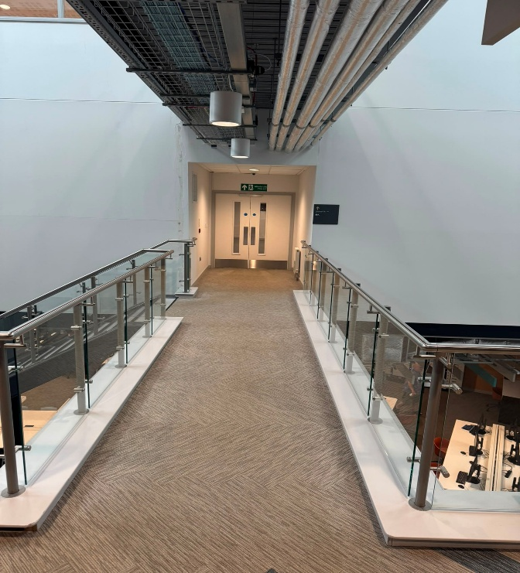
3.2 Evidence of Site Attendance
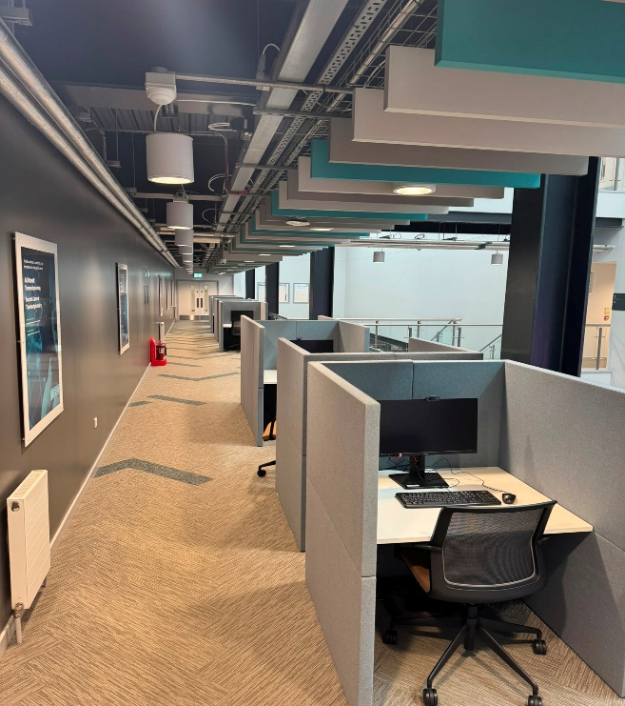
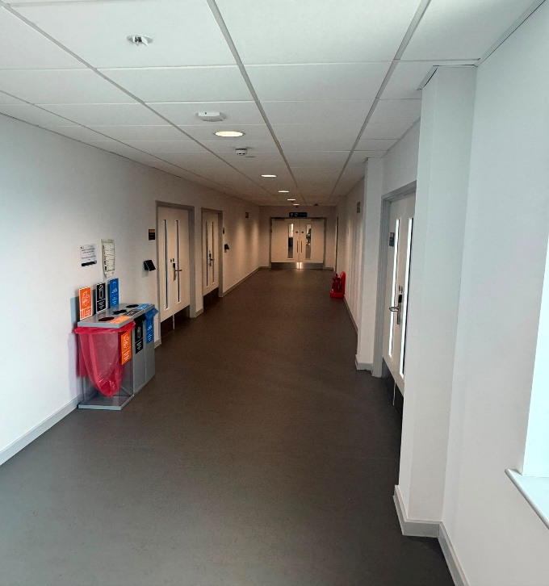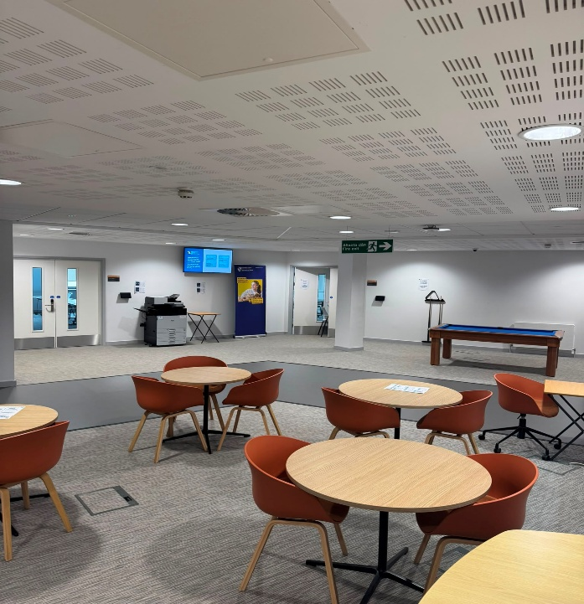
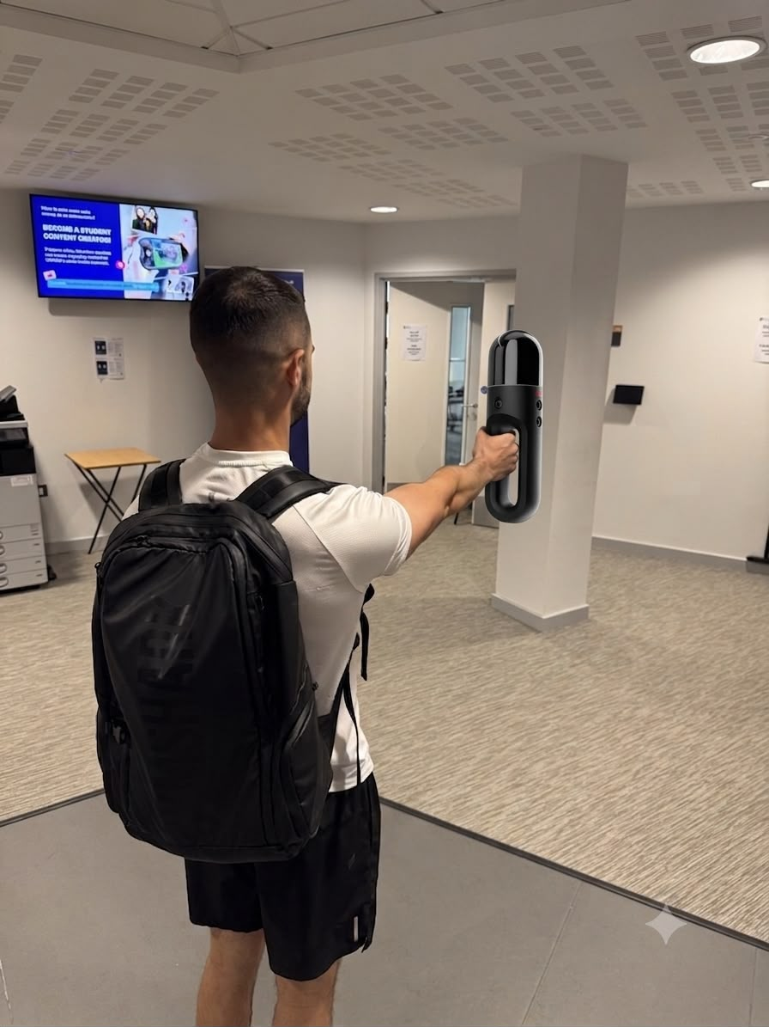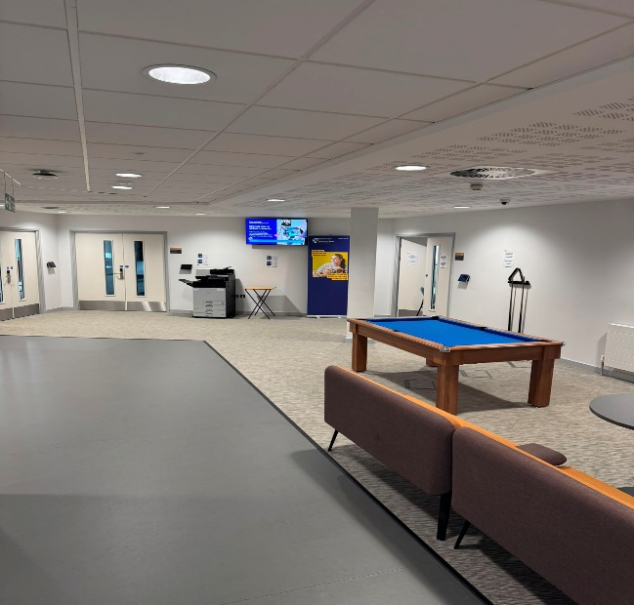
Example of student using the Leica BLK2GO Scanner
3.3 Problems Encountered and Solutions
On the day of the survey, the region was experiencing a heatwave. The original building selected for the survey contained large, glazed windows, which resulted in significant heat gain. Combined with the lack of adequate ventilation and cooling systems, this created a potential health and safety risk for the students undertaking the survey. To mitigate this risk, the survey was relocated to a newer university building (IQ) where the corridors were air-conditioned and provided a safer working environment, enabling the survey to be completed professionally and efficiently.
A second issue arose regarding the planned data collection method. The intention was to use the Leica RTC terrestrial laser scanner, as the team had previously studied and prepared to use this equipment. However, technical difficulties prevented the scanner from operating correctly. Consequently, an alternative solution was required that would still provide data of sufficient quality. Fortunately, the university had access to a wide range of surveying equipment, and the Leica BLK2GO was selected as a suitable replacement. This device could capture the accurate and reliable data required for the survey whilst allowing the project to proceed without significant delay.
4. Part 3: Measurement and Analysis
4.1 Measurement Extraction
Manual Measurements

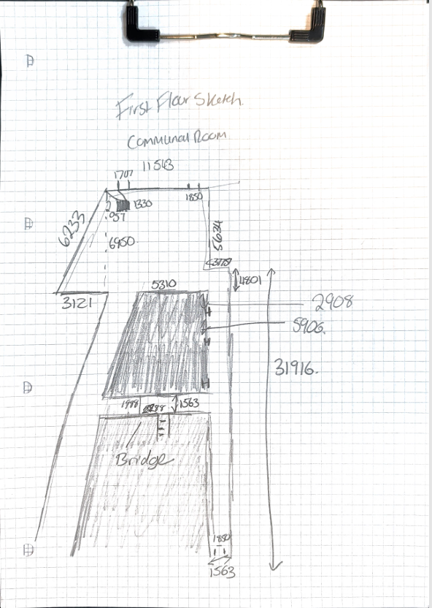
D
A)
C
B)
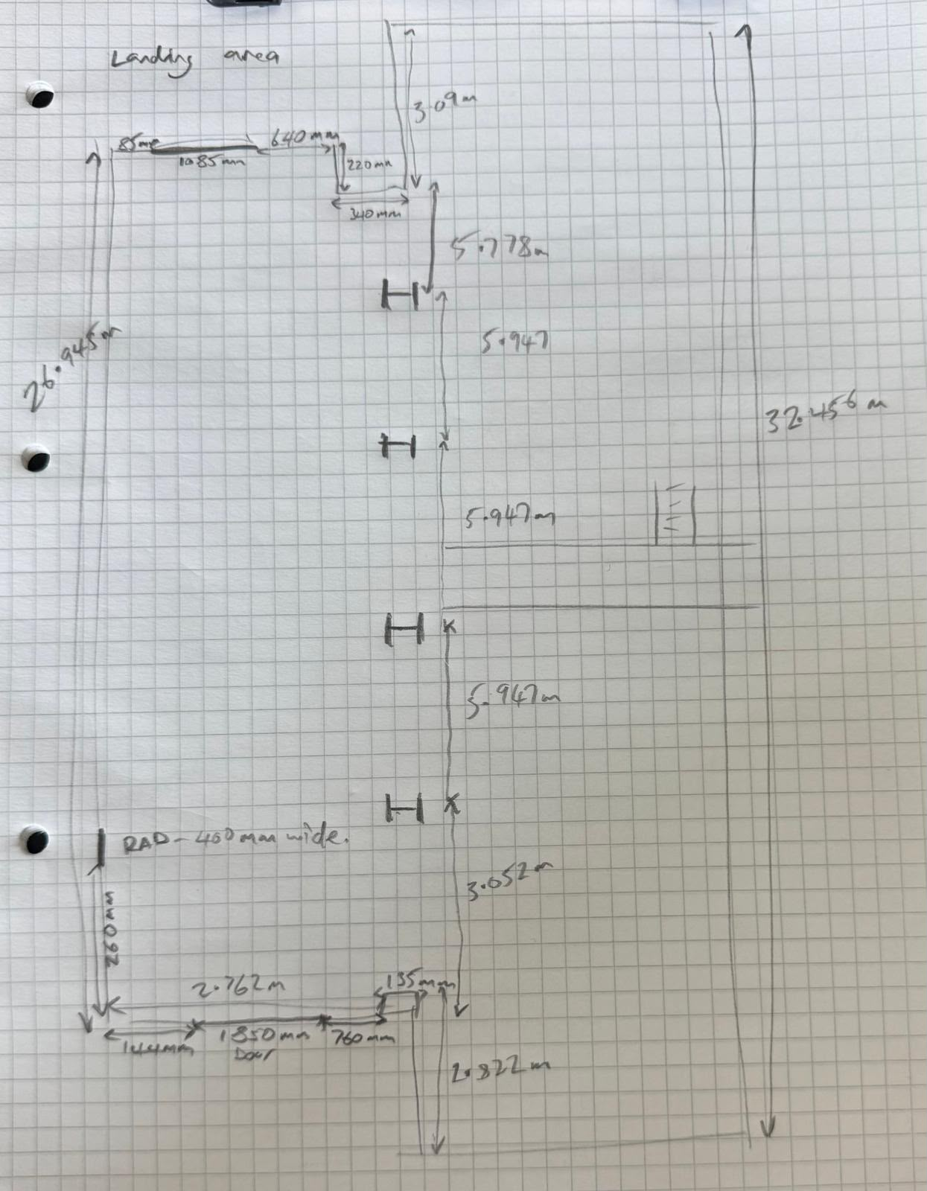
E

Leica BLK2GO Scanner Data
D
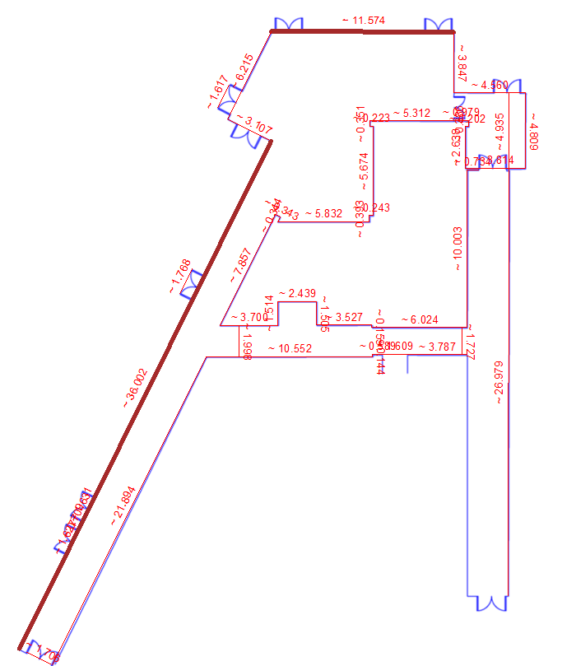
E
C
B
A
4.2 Accuracy Assessment
Firstly, I have extracted sketches and match both the manual survey and digital survey using the key (A, B, C, D and E) this way I am able to analyse the different surveys at the same point of the building.
Point A – Point A using the manual measurement of 6.233m with no other details of what might be on the wall whereas using the point cloud data shows a total meterage of 7.832m with two broken down measurements of the doorway included Aswell as the wall.
Point B – Point B Shows us that both measurements are roughly the same however the detail from the scanner identifies a doorway I believe human error may have occurred.
Point C – Point C also shows a similar measurement however the surrounding area captures all the little detail around the doorway whereas our manual survey does not.
Point D – In Point D although the digital scanner does identify two doorways it does not show us the detail whereas whilst we measured this area manually, we included this detail I believe if we entered that area the scanner would have given us that detail but we did not.
Point E – This measurement Digitally shows 26.979m whereas the Point cloud data using the scanner shows 32.456m this might be due to the tape/laser that we used not hitting the correct point of the wall (Human Error)
Observations and discussion between the different methods
The results above show that there are some differences between the measurements, which was highly expected. One reason for this is that a measuring tape is only as accurate as the person using it. If the user does not hold the tape correctly or reads the measurement incorrectly, human errors can be introduced into the results. However, laser scanners are not perfect either. Factors such as highly reflective surfaces can affect how the scanner interprets a point, which may lead to inaccurate data being collected. For example, using a laser scanner outdoors can be challenging in bright sunlight, as the sunlight can interfere with the laser signal and reduce measurement accuracy. In our case I believe the typical human errors may have occurred which affected the result.
Advantages of both methods
Some of the advantages of traditional measurement are that it is exceptionally low cost, simple to use, and highly reliable because it does not require batteries or specialist software. It is also effective for taking quick measurements and checking dimensions on site. On the other hand, the Leica BLK2GO scanner can capture millions of data points across a large environment in a brief period of time, creating a highly detailed and reliable 3D representation of the site. In addition, it stores a digital record of the survey, allowing measurements to be revisited and extracted later without the need for additional site visits, saving both time and resources.
Disadvantages of both methods
However, there are also disadvantages to both methods. As we experienced, traditional tape measurements are prone to human error and can be very time-consuming, especially when measuring a building of that size. The drawbacks of the Leica BLK2GO scanner include the prohibitive cost of purchasing and maintaining the equipment. In addition, users must be trained to navigate and interpret the scan data correctly. The large amount of data captured also requires significant storage space and often powerful computers to process and manage the files effectively.
5. Conclusion
Overall, I believe we achieved an accurate and professional survey, and by using the Leica BLK2GO scanner we collected a high-quality dataset that can be revisited at any time. The comparison between the two methods clearly demonstrates how much more efficient and comprehensive laser scanning technology can be. However, the survey also highlighted the importance of understanding the limitations of the equipment and the precautions that must be taken when carrying out a professional survey. Whilst laser scanning offers significant advantages in terms of speed, accuracy, and data capture, careful planning, suitable environmental conditions, and competent data processing are still essential to produce reliable results.
6. References
Bloor, C. (2025). Complete Guide to RICS Home Surveys. [online] CJ Bloor Property Consultants | Chartered Surveyors providing Premium Home Surveys. Available at: https://www.cjbloor.co.uk/advice/rics-home-survey/rics-home-survey-guide/ [Accessed 23 July 2026].
Guide, C. (2024). 3D Solutions. [online] 3D Solutions. Available at: https://www.3dmetrologysolutions.co.uk/blog/a-comprehensive-guide-to-the-benefits-of-laser-scanning [Accessed 16 July 2026].
Leica BLK2GO Handheld Imaging Laser Scanner. (2024). [online] Leica-geosystems.com. Available at: https://leica-geosystems.com/products/laser-scanners/scanners/leica-blk2go [Accessed 20 July 2026].

