

Student Name: Rutavikaben Dave

Student ID: 2427109

Module Name: International business Concept

Module Code: LCMB7034

Lecturer’s Name: Dr. Jean Wang

Submission Deadline: 15/11/2025

Word Count: 5000+

Contents
1. INTRODUCTION 3
2. BENEFITS AND CHALLENGES OF INTERNATIONAL OPERATIONS 3
2.1 Amazon as a Multinational Corporation 3
2.2 Global Operations Across the Value Chain 4
2.3Challenges Faced by Amazon in International Operations 5
3.Entry Modes and Market Penetration Strategies 5
4. OLI FRAMEWORK ANALYSIS: AMAZON'S MARKET ENTRY STRATEGY IN INDIA 7
4.1 Ownership Advantages: Digital Infrastructure as Competitive Arsenal 7
4.2 Location Advantages: India's Promise and Perils 8
4.3 Internalization Advantages: Control Versus Flexibility Trade-offs 9
5. CULTURAL DIFFERENCES IMPACT ON MARKET ENTRY AND SUCCESS 10
5.1 Hofstede's Cultural Dimensions Framework Applied to US-India Context 10
5.2 Communication Styles and Business Practices 11
5.3 Consumer Behavior and Shopping Preferences 11
5.4 Labor Relations and Human Resource Management 11
5.5 Success Potential and Cultural Adaptation Requirements 12
6. THREE MAJOR SOP ADJUSTMENTS FOR AMAZON DELIVERY SUCCESS IN INDIA (ensure the context is in line with the earlier analysis of OLI and cultural difference) 12
6.1 Hyperlocal Last Mile Delivery Network Integration 12
6.2 Cultural Calendar and Seasonal Demand Management System 14
6.3 Specific SOP Modifications with Implementation Steps 14
7. Conclusion 17
8. References 18

INTRODUCTION

Amazon's expansion into international markets, especially in developing countries like India, poses intricate strategic challenges that require thorough analysis (Raman and Chhajed, 2019). Although the company's foray into India in 2013 showcased assertive market penetration tactics, which included significant investments in infrastructure and tailored service adjustments (Kawa and Wałęsiak, 2019), there are ongoing concerns about long-term viability and competitive positioning against local firms (Kumar and Rahman, 2021).
This report evaluates Amazon's logistics operations in its key markets, focusing on operational efficiency, market adaptation tactics, and competitive reactions. The evaluation will unfold in three parts an assessment of operational infrastructure, a look at market-specific strategic adjustments, and an analysis of the competitive landscape, concluding with strategic suggestions for sustainable growth internationally.
Figure 1https://en.wikipedia.org/wiki/Jeff_Bezos

BENEFITS AND CHALLENGES OF INTERNATIONAL OPERATIONS

2.1 Amazon as a Multinational Corporation
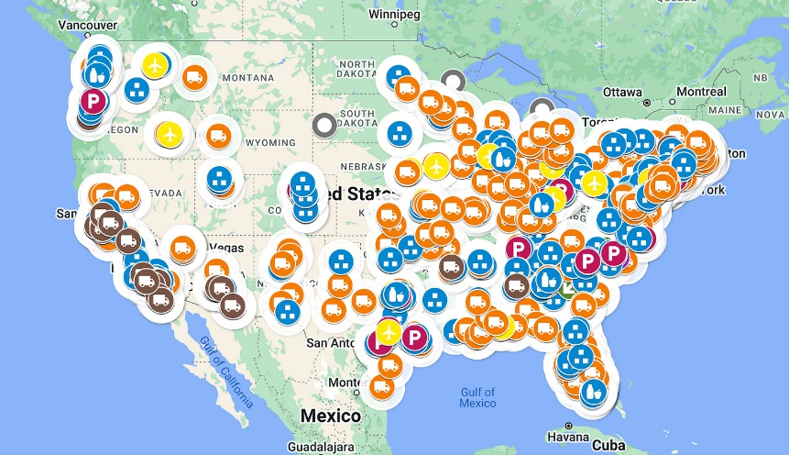
Figure 2https://ontheseams.substack.com/p/a-brief-primer-on-amazons-distribution
Amazon clearly meets the criteria of a multinational corporation (MNC), providing delivery and logistics services in over 20 countries globally (Dunning and Lundan, 2008). The company's international presence surpasses the conventional four-country marker, with significant operations that cover North America, Europe, Asia-Pacific, as well as emerging markets in Latin America and the Middle East (Amazon, 2024). Amazon's delivery infrastructure includes nations such as the United States, Canada, the United Kingdom, Germany, France, Italy, Spain, Japan, Australia, India, Brazil, and Mexico, among others (Statista, 2023).
What sets Amazon apart as a genuine global MNC is not just its geographical spread but also the extent of its operational integration across various nations (Verbeke, 2013). The corporation has established subsidiaries in individual countries, local fulfillment centers, and delivery services tailored to regional needs, showcasing significant foreign direct investment and a long-term dedication to global markets (Singh et al., 2020). This broad international footprint establishes Amazon as one of the largest logistics and e-commerce multinationals in the world, with around 25-30% of its total revenue coming from international sources in recent times (Amazon IR, 2024).

2.2 Global Operations Across the Value Chain
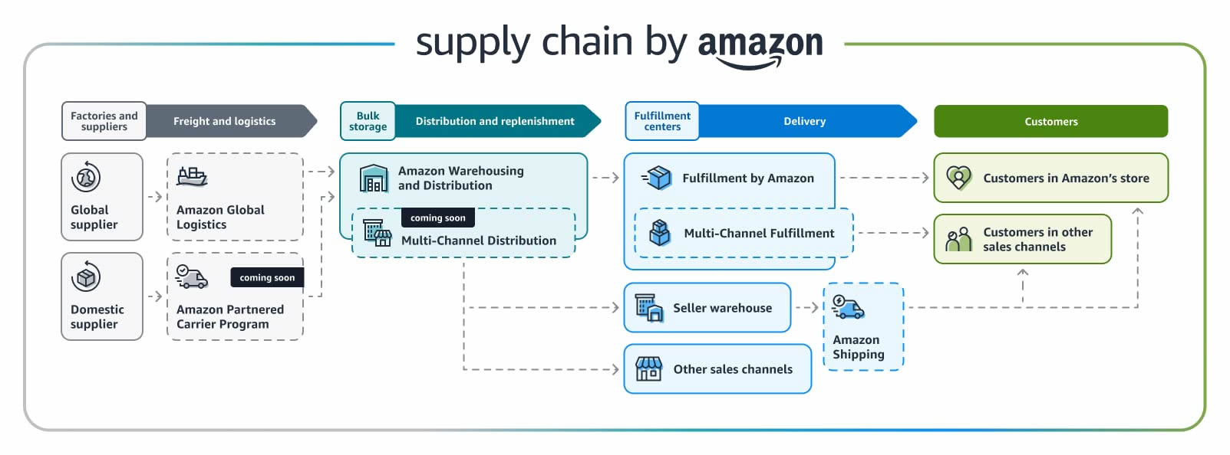
Figure 3https://jordiob.com/amazon-tools/de/guides/amazon-supply-chain/
Amazon’s global operations reveal a complex integration throughout different stages of the value chain, aligning with Dunning's eclectic paradigm of ownership, location, and internalization benefits (Dunning, 1988).
Research and Development: Amazon has R&D facilities in several countries, such as the United States, Germany, India, and Israel (Brynjolfsson et al., 2019). The company’s international R&D initiatives are centered around optimizing logistics, implementing artificial intelligence for delivery routing, developing drone technology, and innovating last-mile delivery (Lee and Seo, 2016). For example, trials for Amazon's Prime Air drone delivery service have taken place in the UK (Clarke, 2016), while its robotics research operations span locations in Seattle, Berlin, and Bangalore (Gupta et al., 2020).
Sourcing and Procurement: The firm maintains a worldwide sourcing network for packaging materials, delivery vehicles, and technological infrastructure (Lysons and Farrington, 2020). Amazon acquires delivery trucks from manufacturers across Europe, obtains electric vehicles from Chinese firms such as BYD (Reuters, 2021), and procures packaging supplies from suppliers worldwide to facilitate its global fulfillment operations (Geissdoerfer et al., 2017).
Production and Operations: In the delivery sector, Amazon’s production activities mainly focus on running fulfillment centers and delivery stations (Rao et al., 2011). The company has set up over 185 fulfillment centers around the globe, with significant clusters in Europe (more than 50 centers), North America (over 110 centers), and an expanding presence in the Asia-Pacific region (Amazon, 2024). Each facility is tailored to meet local market demands, regulatory standards, and consumer preferences (Lim et al., 2018).
Sales and Marketing: Amazon positions its delivery services differently in various regions, reflecting local competitive dynamics and consumer preferences (De Mooij and Hofstede, 2010). In India, the company highlights cash-on-delivery options (Kumar et al., 2018), while in Germany, it concentrates on high delivery speed and reliability (Schneider and Klabjan, 2013). The company modifies its Prime membership benefits according to local market contexts, providing various delivery timelines and service levels (Maity and Dass, 2014).
Financing: Amazon utilizes a range of international financing strategies, including local debt financing, currency hedging, and strategic collaborations with regional financial institutions to mitigate foreign exchange risks and optimize capital distribution across different markets (Shapiro, 2013).

2.3Challenges Faced by Amazon in International Operations

Amazon encounters considerable regulatory hurdles in its global markets due to varying institutional and legal frameworks. In nations like India, regulations governing foreign direct investment prevent Amazon from owning inventory or selling products directly, which restricts its control over pricing and supply chain efficiency (Dunning, 1988; Government of India, 2020). Constant changes in regulations heighten uncertainty and compliance expenses, diminishing the company’s ability to fully leverage its ownership advantages.

Additionally, operational and logistical complexities present significant challenges. Overseeing a globally integrated logistics system across various regions exposes Amazon to issues related to infrastructure, labor, and elevated fulfillment costs, especially in emerging markets (Rao et al., 2011). Inadequate transportation infrastructure and high return rates further complicate last-mile and reverse logistics efforts (Lim et al., 2018).

Amazon also faces strong competitive pressure from both local and international competitors. In India, companies like Flipkart and Reliance enjoy the advantage of stronger local networks and fewer regulatory hurdles, enabling them to compete aggressively on pricing and distribution (Chatterjee, 2021). This constrains Amazon’s potential for market share expansion and compresses its profit margins.

Variations in consumer behavior across different countries introduce further challenges. Heightened sensitivity to price and a preference for cash-on-delivery in emerging markets elevate operational risks and hinder profitability compared to more developed markets (De Mooij and Hofstede, 2010; Maity and Dass, 2014). These differences necessitate expensive localization approaches that diminish economies of scale.

Lastly, concerns regarding profitability and strategic risks persist. Substantial investments in logistics infrastructure, technology, and compliance have postponed returns in numerous international markets, while fluctuations in currency and legal scrutiny further exacerbate financial risks (Shapiro, 2013; Verbeke, 2013). Collectively, these challenges emphasize the conflict Amazon faces between global integration and local adaptation.

3.Entry Modes and Market Penetration Strategies
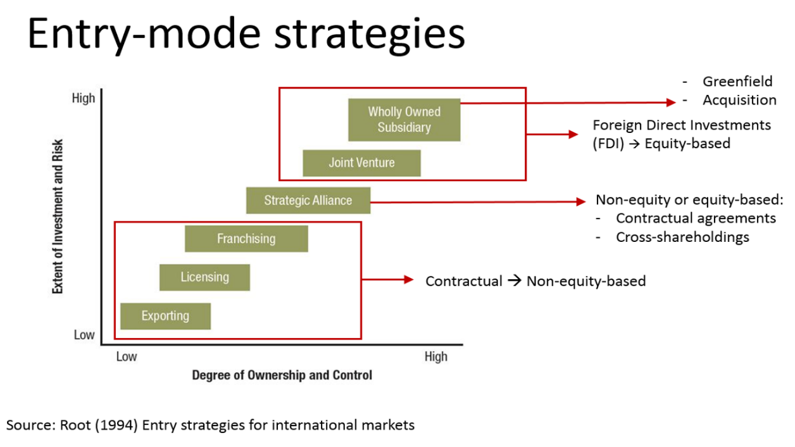
Figure 48https://www.business-to-you.com/choosing-the-right-entry-mode-strategy/
Amazon has utilized various entry strategies in its global expansion, with wholly owned subsidiaries becoming the primary method in significant markets (Brouthers, 2013).
Greenfield Investments: This is the main entry strategy for Amazon, which involves launching wholly-owned operations from the ground up in nations like Germany, France, and Australia (Meyer and Estrin, 2014). The company usually starts with one fulfillment center and gradually enhances its logistics framework (Hitt et al., 2016). In Australia, Amazon commenced operations in 2017 through a grefield strategy, constructing fulfillment centers in both Melbourne and Sydney (Grimm and Smith, 2018).
Amazon encounters considerable regulatory hurdles in its global markets due to varying institutional and legal frameworks. In nations like India, regulations governing foreign direct investment prevent Amazon from owning inventory or selling products directly, which restricts its control over pricing and supply chain efficiency (Dunning, 1988; Government of India, 2020). Constant changes in regulations heighten uncertainty and compliance expenses, diminishing the company’s ability to fully leverage its ownership advantages.

Additionally, operational and logistical complexities present significant challenges. Overseeing a globally integrated logistics system across various regions exposes Amazon to issues related to infrastructure, labor, and elevated fulfillment costs, especially in emerging markets (Rao et al., 2011). Inadequate transportation infrastructure and high return rates further complicate last-mile and reverse logistics efforts (Lim et al., 2018).
Amazon also faces strong competitive pressure from both local and international competitors. In India, companies like Flipkart and Reliance enjoy the advantage of stronger local networks and fewer regulatory hurdles, enabling them to compete aggressively on pricing and distribution (Chatterjee, 2021). This constrains Amazon’s potential for market share expansion and compresses its profit margins.
Variations in consumer behavior across different countries introduce further challenges. Heightened sensitivity to price and a preference for cash-on-delivery in emerging markets elevate operational risks and hinder profitability compared to more developed markets (De Mooij and Hofstede, 2010; Maity and Dass, 2014). These differences necessitate expensive localization approaches that diminish economies of scale.
Lastly, concerns regarding profitability and strategic risks persist. Substantial investments in logistics infrastructure, technology, and compliance have postponed returns in numerous international markets, while fluctuations in currency and legal scrutiny further exacerbate financial risks (Shapiro, 2013; Verbeke, 2013). Collectively, these challenges emphasize the conflict Amazon faces between global integration and local adaptation.
Strategic Partnerships and Joint Ventures: In markets that are more intricate or heavily regulated, Amazon has engaged in partnerships (Geringer and Hébert, 1991). In China, although it eventually reduced its operations, Amazon initially formed alliances with local logistics companies (Li et al., 2019). In India, due to regulatory stipulations, the company needed to collaborate with local entities for specific delivery operations (Goyal and Joshi, 2011).
Acquisitions: Amazon has strategically acquired local companies to hasten market penetration and enhance operational capabilities (Bauer and Matzler, 2014). The purchase of Souq.com in the Middle East for $580 million in 2017 offered immediate market presence and logistical support in the region (Gulf Business, 2017).
Licensing and Franchising: Although this method is rarer for core delivery activities, Amazon has utilized licensing agreements with local entities for particular services, especially in markets with stringent foreign investment regulations (Alon et al., 2013).
The prevalence of wholly-owned subsidiaries shows Amazon's inclination to retain full control over its logistics activities, thus ensuring consistent service quality and operational integration throughout its international network (Anderson and Gatignon, 1986). This strategy aligns with transaction cost economics theory, as Amazon prefers to internalize complex logistics operations instead of depending on external partners where coordination costs and quality management could become challenging (Williamson, 1985).

OLI FRAMEWORK ANALYSIS: AMAZON'S MARKET ENTRY STRATEGY IN INDIA

Analyzing Amazon's move into India through the lens of John Dunning's eclectic OLI paradigm provides a fascinating case study (Dunning, 2001). This framework posits that multinational enterprises (MNEs) pursue foreign direct investment when they possess ownership advantages, can leverage location advantages, and find internalization more efficient than external market transactions. Amazon's strategic approach in India effectively highlights both the strengths and weaknesses of the model in explaining the intricacies of entering modern digital markets (Hennart, 2012).
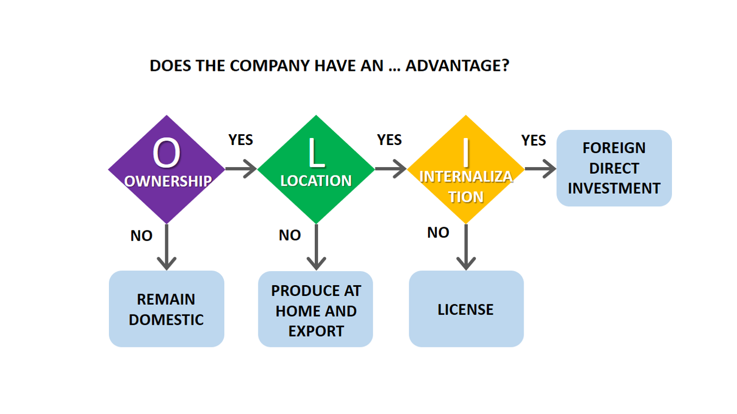
Figure 5https://www.business-to-you.com/choosing-the-right-entry-mode-strategy/

4.1 Ownership Advantages: Digital Infrastructure as Competitive Arsenal

Amazon's competitive edge goes way beyond typical multinational advantages. They've built a complex digital ecosystem that's incredibly difficult for others to copy (Bharadwaj et al., 2013). Years of operational tweaks have resulted in Amazon's own logistics algorithms, giving them a supply chain advantage that competitors find hard to match (Gunasekaran et al., 2017). This tech prowess allows them to forecast demand, strategically place inventory, and manage complicated transportation networks across India's varied landscape (Boyer and Hult, 2006).
Another key advantage is AWS cloud infrastructure. It gives Amazon cost savings and scalability that traditional retailers can't achieve (Marston et al., 2011). This technological base lets them grow quickly without a proportional rise in fixed costs, a significant benefit in price-conscious markets like India (Iyer and Henderson, 2010). Plus, Amazon's extensive data analysis skills, refined globally, enable them to segment customers and personalize strategies, strengthening their market position (Chen et al., 2012).
The advantages Amazon held from its ownership structure didn't easily translate to the Indian market, presenting major hurdles (Rugman & Verbeke, 2001). For instance, Amazon's algorithms, designed for developed markets, needed significant adjustments to suit India's fragmented retail environment and varied consumer tastes (Kumar & Steenkamp, 2013). Moreover, the company's global brand, though well-known, didn't initially hold as much sway in India's relationship-focused commerce, where local trust often trumped brand recognition (Erdem et al., 2006).
Amazon's robust financial backing, fueled by over $50 billion in annual R&D spending (Amazon, 2024), offered the long-term capital needed to cultivate the market. This financial power allowed Amazon to weather early losses while gaining market share, a strategy beyond the reach of competitors with limited resources (Ghemawat & Hout, 2016). However, this advantage also attracted greater regulatory attention, as Indian officials grew wary of potential predatory pricing and market dominance (Khan, 2017).

4.2 Location Advantages: India's Promise and Perils

Despite the obvious advantages of India's location for Amazon across many dimensions, a closer inspection reveals considerable complexity (Meyer et al., 2009). The market's enormous size more than 1.4 billion consumers with a fast increase in internet penetration, offers a unique chance for the growth of digital commerce (IBEF, 2023). Even with comparatively low per capita expenditure, India's ecommerce sector might reach $200 billion by 2030, according to McKinsey forecasts, making it a major player on the global stage (McKinsey, 2021).
Initially, Amazon was drawn to the lower labor expenses, since they could get qualified technology labor for a fraction of what it cost in Silicon Valley (Farrell and Grant, 2005). But, as demonstrated by conventional OLI analysis (Doh et al., 2009), these benefits were not as straightforward as they seemed. Unexpected complexity and cost were brought about by the necessity for extensive localization, from vernacular language support to culturally appropriate customer service, even if operating expenditures remained low (Prahalad, 2005). A major hidden expense of taking advantage of location advantages was Amazon's investment in developing local talent, such as training programs for delivery staff and marketplace merchants (Cappelli et al., 2010)
The framework's flaws in addressing dynamic location considerations are highlighted by infrastructure problems (Peng et al., 2008). India's expanding yet uneven digital infrastructure has created both opportunities and challenges (World Bank, 2020). Amazon was compelled to come up with creative solutions, such as alternative payment options and collaborations with Kirana stores, due to the persistent challenges in rural connection and the availability of advanced logistical options in urban locations (Reardon et al., 2012). As shown by the company's investment in local fulfillment centers and last-mile delivery solutions, multinational enterprises must frequently establish location advantages rather than merely take advantage of ones that already exist (Cantwell and Mudambi, 2005).
Perhaps the most complicated site element is the legislative framework (Khanna and Palepu, 2010). Because of India's restrictions on foreign direct investment (FDI) in multi-brand retail, Amazon was compelled to employ a marketplace approach, working with local sellers rather than managing its own inventory directly (Singh and Prakash, 2010). This regulatory restriction fundamentally changed Amazon's business model, necessitating fresh skills in inventory coordination and seller relationship management (Ramamurti, 2012). Recent policy changes, such as data localization restrictions and enhanced monitoring of international e-commerce companies, show how location advantages might change quickly, thereby undermining static OLI evaluations (Bauer et al., 2016).
Specifically, 100% foreign direct investment (FDI) is permitted only under the “marketplace model,” and not under the inventory-based model (Government of India, 2020). This indicates that Amazon is not allowed to own, control, or manage inventory, nor can it sell products directly to consumers. Rather, it is required to function exclusively as a digital platform that links independent third-party sellers with buyers. Furthermore, Indian regulations forbid preferential treatment of sellers. Amazon is prohibited from entering into exclusive agreements with particular sellers, cannot dictate pricing, and cannot derive more than 25% of sales from a single seller or its associated entities. The practice of deep discounting and control over product pricing is also restricted to prevent market distortion and safeguard small retailers. These limitations constrain Amazon’s operational authority, pricing influence, and the ability to maximize margins, compelling it to depend significantly on local sellers and logistics partners. Consequently, while Amazon can invest in technology and infrastructure, its retail operations in India remain fundamentally restricted by FDI policy.

4.3 Internalization Advantages: Control Versus Flexibility Trade-offs

The complexity of modern market entrance decisions, which go beyond conventional make-or buy factors (Buckley and Casson, 1998), is evident in Amazon's internalization strategy in India. The fact that the firm chose a fully owned subsidiary model that is subject to legal restrictions demonstrates that it prioritizes maintaining control over customer experience, data, and strategic direction (Hennart, 1988). Amazon can maintain its unique service standards while adjusting to local market realities thanks to this internalization (Hutzschenreuter et al., 2014).
The choice to internalize was heavily influenced by intellectual property protection issues (Zhao, 2006). Licensing agreements would make core competitive advantages like Amazon's unique algorithms, customer data, and operational procedures susceptible to possible misappropriation (Teece, 1986). Prior experience in other developing nations, where joint venture partners occasionally turned into rivals, further strengthened the company's tendency to retain internal control over core competencies (Inkpen and Beamish, 1997).
Although with significant limitations (Williamson, 1979), Amazon's internalization strategy is supported by transaction cost analysis. Market-based transactions would be too expensive to monitor and negotiate due to the high frequency of consumer interactions, the asset specificity of logistics networks, and the unpredictability of regulatory changes (Brouthers and Hennart, 2007). By integrating its strategy, Amazon lowers these transaction costs while allowing for quick response to shifting market circumstances (Verbeke and Greidanus, 2009).
However, internalization also resulted in considerable restrictions and expenses (Meyer et al., 2011). In its early years, Amazon's restricted knowledge of local consumer behavior and business practices resulted in inefficiencies that joint venture collaborations could have prevented (Luo, 2007). The company's slow move toward increased collaboration with local partners, which includes investments in Indian startups and an expansion of seller support programs, indicates an awareness that pure internalization has limitations in complicated emerging markets (Doz and Hamel, 1998).

CULTURAL DIFFERENCES IMPACT ON MARKET ENTRY AND SUCCESS
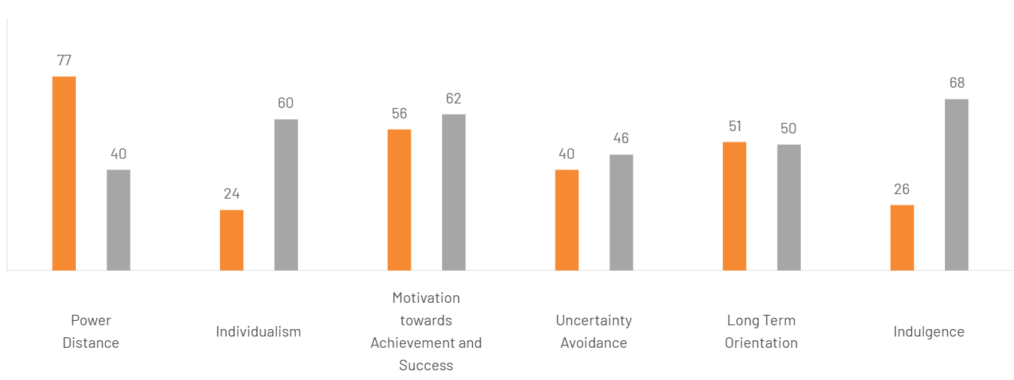
Figure 6https://www.theculturefactor.com/country-comparison-tool?countries=india%2Cunited+states

5.1 Hofstede's Cultural Dimensions Framework Applied to US-India Context

The cultural differences between India and the United States, where Amazon is based, pose serious difficulties that have a major impact on the market entrance plan and the possibility of success (Hofstede, 2001). Significant discrepancies that need strategic adjustment are revealed by using Hofstede's cultural dimensions framework (Hofstede et al., 2010).
Power Distance: India's power distance score of 77 is much higher than the United States' score of 40, which suggests that Indians are more tolerant of hierarchical social structures and unequal power dynamics (Hofstede Insights, 2023). This cultural aspect has a significant impact on Amazon's customer care strategies and management methods (House et al., 2004). In contrast to Amazon's usually egalitarian American service model, Indian consumers anticipate courteous, respectful, and respectful service that recognizes status differences (Sharma, 2010). Delivery workers need to be able to maneuver around complicated social hierarchies, modifying their communication methods to suit the demographics of their customers and their home environments (Sinha, 2008).
Individualism vs:- Collectivism India has a more collectivistic orientation (48), but the United States has a very high individualism score (91) (Hofstede, 2001). Triandis (1995) found that this divergence has a big impact on marketing tactics and customer relationship management. Word-of-mouth advice and community-based trust networks are favored by Indian consumers above individual decision-making (Kumar et al., 2013). In addition to its historical concentration on individual customer experience, Amazon must also include family-oriented service design and community engagement initiatives (Sheth, 2011).
Uncertainty Avoidance:- According to Hofstede (2001), both cultures display moderate uncertainty avoidance (USA: 46, India: 40), which indicates a fair level of acceptance of ambiguity. However, the unpredictability of India's regulatory environment and infrastructure poses real challenges to operational stability (Khanna and Palepu, 2010). Due to India's diverse environment, Amazon's standardized procedures, which were created for predictable infrastructure environments, need significant modification (Prahalad and Lieberthal, 1998)
Masculinity vs. Femininity:- In contrast to India (56), the United States has greater masculinity (62), suggesting a greater focus on accomplishment and competition (Hofstede, 2001). This has an impact on how employees are managed and how the organization's culture is run (Chatterjee and Pearson, 2000). India's achievement-oriented culture is a good fit for Amazon's competitive, performance-driven culture, but it must be balanced by the relationship-oriented management methods that are prioritized in Indian workplaces (Budhwar and Khatri, 2001)

5.2 Communication Styles and Business Practices

Edward Hall's high-context vs. low-context communication framework offers more perspective on cultural issues (Hall, 1976). American business culture, as an example of low-context communication, prioritizes clear, direct messaging and written documentation (Hall and Hall, 1990). In contrast, Indian business culture exemplifies high-context communication, in which meaning is based on relationships, nonverbal signals, and situational context (Varner and Beamer, 2010).
This communication gap presents significant operational difficulties for Amazon (Gudykunst et al., 1996). In comparison to American efficiency-oriented transactions, customer service contacts in India demand considerably more time and relationship-building (Singh et al., 2006). In contrast to the direct confrontation that is common in American business practices, dispute resolution necessitates nuanced, face-saving techniques (Leung and Tjosvold, 1998). In India, where personal interaction is still valued, Amazon's automated customer service systems, which are effective in low-context American markets, frequently cause frustration (Malhotra and Malhotra, 2013).

5.3 Consumer Behavior and Shopping Preferences

Cultural elements significantly shape consumer behavior in India, presenting challenges to Amazon's uniform operational approach (Jain, 2004). The inclination towards cash on delivery, which initially surprised American executives accustomed to credit card usage, highlights cultural factors such as low credit card adoption, worries about the security of online transactions, and a psychological preference for physical payment methods (Kumar et al., 2018). Amazon's early hesitation to offer cash-on-delivery revealed a lack of cultural awareness that constrained its market reach (Sharma and Gutiérrez, 2010).
Shopping habits in India are indicative of collectivist cultural values, with considerable household involvement in buying decisions (Shukla, 2010). Amazon's tailored recommendation algorithms, designed for American individual shoppers, need to be adjusted to align with Indian family-oriented purchasing behaviors (Mathur et al., 2003). Additionally, the cultural aspect of festival shopping requires adjustments, as there are significant spikes in consumption during festivals like Diwali, Holi, and various regional celebrations, necessitating flexible inventory management strategies (Srivastava, 2015).

Product preferences highlight cultural differences that influence Amazon's inventory management tactics (Batra et al., 2000). Indian consumers tend to prioritize value-for-money over the allure of brand prestige, focusing on functional dependability rather than status representation (Sheth, 2011). This cultural inclination poses a challenge to Amazon's premium branding approach and calls for a wider variety of products at various price levels (Dawar and Chattopadhyay, 2002).

5.4 Labor Relations and Human Resource Management

Cultural dimensions play a crucial role in shaping Amazon's human resource management and labor relations in India (Budhwar, 2001). The collectivist mindset fosters expectations for employer-employee relationships that go beyond mere transactional agreements (Som, 2008). Indian employees anticipate organizational commitment to their welfare, consideration for family matters, and job security in the long term, which contrasts with Amazon's model centered on performance and flexible employment (Venkata Ratnam, 2001).
The idea of the "organizational family" is particularly important in the Indian workplace culture (Sinha, 2008). It is expected that managers will show a paternalistic concern for the welfare of their subordinates, offering guidance that extends beyond strictly defined job roles (Pellegrini and Scandura, 2008). Amazon's reliance on data-driven, algorithmic management could clash with these cultural expectations, leading to employee dissatisfaction and higher turnover rates (Raghuram et al., 2017).
The religious and cultural diversity present in India adds another layer of complexity (Balasubramanian and Ashok, 2016). Amazon must navigate various religious practices, dietary needs, festival celebrations, and regional cultural differences that are not prevalent in more culturally uniform markets (Pio and Syed, 2013). Not addressing these cultural considerations adequately may risk alienating both employees and customers (Mathew and Jones, 2013).

5.5 Success Potential and Cultural Adaptation Requirements
Amazon's long term achievement in India is heavily reliant on its ability to continually adapt to and learn from the local culture (Khanna and Palepu, 2006). Enterprises operating in markets that are culturally distinct from their headquarters require ongoing focus on local preferences, business customs, and social norms, which cannot be effectively addressed through one-off changes (Barkema et al., 1996). The fast-evolving landscape of Indian consumer culture, characterized by swift urbanization, generational changes, and advancing digital literacy, necessitates an ongoing development of cultural intelligence (Ganguli and Roy, 2013).
Cultural adaptation provides competitive advantages that cannot be matched solely by operational efficiencies (Brannen and Doz, 2012). Rivals that have a better alignment with the local culture especially domestic companies like Flipkart, which possess inherent cultural insights can pose substantial challenges if Amazon does not exhibit cultural awareness and quick responsiveness (Kumar and Rahman, 2021). On the other hand, Amazon’s readiness to adapt culturally, paired with its advanced technological capabilities and financial resources, places the company in a favorable position for enduring success, provided that it maintains its cultural learning efforts (Govindarajan and Trimble, 2012).

THREE MAJOR SOP ADJUSTMENTS FOR AMAZON DELIVERY SUCCESS IN INDIA (ensure the context is in line with the earlier analysis of OLI and cultural difference)

6.1 Hyperlocal Last Mile Delivery Network Integration

Amazon's conventional centralized distribution approach encounters notable obstacles in India's intricate urban environment, where narrow roads, informal addressing systems, and a variety of socioeconomic neighborhoods present significant location challenges (Rodrigue et al., 2017). Cultural analysis indicates that individuals in India prioritize personal relationships and networks of community trust, especially in Tier-2 and Tier-3 cities where formal delivery infrastructure is still in its infancy (Sheth, 2011). The competitive advantage stems from Amazon's technological proficiencies and international logistics know how (Brynjolfsson et al., 2019), yet this must be tailored through internalization advantages that focus on utilizing local insights and fostering community ties rather than circumventing them (Cantwell and Mudambi, 2005).
The high power distance dimension within culture suggests a general acceptance of hierarchical structures (Hofstede, 2001), leading local delivery partners to collaborate within Amazon's framework while preserving their community connections. Furthermore, the collectivist characteristics of Indian society imply that the success of deliveries is contingent upon community endorsement and word of-mouth referrals (Kumar et al., 2013), underscoring the need for integration with established local networks instead of replacement (Prahalad, 2005).

Specific SOP Modifications with Implementation Steps
Phase 1: Partnership Development (Months 1-3)
•Forge formal collaborations with current local delivery networks, including dabbawalas in Mumbai (Thomke and Srinivas, 2014), local courier services, and neighborhood grocery delivery systems.
•Establish standardized onboarding procedures for local delivery partners that encompass Amazon's technology training, quality benchmarks, and safety protocols (Mentzer et al., 2001).
•Design a tiered partnership framework that accommodates various service levels based on local capacities (Handfield and Nichols, 1999).

Phase 2: Technology Integration (Months 2-4)
•Launch lightweight mobile applications allowing local partners to access Amazon's delivery management system while preserving their existing customer relationships (Lee and Seo, 2016).
•Deploy GPS tracking features with offline functionality to account for intermittent internet connectivity in rural regions (Ghosh and Fedorowicz, 2008).
•Develop digital mapping systems that integrate local landmarks and informal address methods (Zook and Graham, 2007).

Phase 3: Operational Integration (Months 4-6)
•Establish micro-fulfillment centers in collaboration with local businesses to minimize last mile distances (Hübner et al., 2016).
•Adopt flexible delivery timeframes that align with local cultural customs, factoring in festival seasons, monsoon rains, and regional holidays (Srivastava, 2015).
•Establish community oriented pickup locations in trusted local venues such as kiranas, pharmacies, and community centers (Reardon et al., 2012).

Key Performance Indicators

Primary KPIs:

First-attempt delivery success rate: Aim for 85% within 12 months, exceeding the industry average of 70% (Kembro and Selviaridis, 2015). Customer satisfaction with delivery: Target a Net Promoter Score (NPS) of 60+ (Reichheld, 2003). Cost per delivery reduction: Target a 25% decrease through optimized local networks (Christopher, 2016).
Secondary KPIs:
Local partner retention rate: Aim for 80% annually (Hald et al., 2009). Community acceptance: Measure using social media sentiment analysis and local feedback (Kaplan and Haenlein, 2010). Delivery time improvement: Target a 40% reduction in average delivery times for non-metro areas (Morganti et al., 2014).
- Risks and Mitigation Strategies:
Primary Risk: Quality control issues across diverse local partners (Das and Teng, 2001)
Mitigation: Implement thorough training, regular audits, and performance-based incentives (Handfield and Bechtel, 2002). Establish clear escalation procedures and maintain direct delivery options for premium services (Fisher, 1997).
Secondary Risk: Technology adoption challenges among local partners (Venkatesh et al., 2003).
Mitigation: Offer comprehensive digital literacy training, multilingual support, and a phased technology rollout with significant support (Rogers, 2003).
Regulatory Risk: Facing compliance challenges due to varying state regulations (Khanna & Palepu, 2010).
Mitigation: Address this by hiring local legal experts for each area, keeping clear records, and building rapport with local regulatory agencies (Peng et al., 2008).

6.2 Cultural Calendar and Seasonal Demand Management System

India's diverse cultural environment, marked by numerous religious festivals, regional customs, and seasonal changes, profoundly shapes consumer behavior and supply chain operations (Srivastava, 2015). Indians, with their tendency to avoid uncertainty (Hofstede, 2001), expect reliable service, especially during culturally important times. Infrastructure challenges, a consequence of India's geographic limitations, are exacerbated during festivals, often overwhelming existing delivery systems (World Bank, 2020).
Amazon's strengths in predictive analytics and inventory management (Chen et al., 2012) must be adapted through cultural intelligence, moving beyond Western seasonal models. In a high-context communication culture, the timeliness and cultural sensitivity of deliveries directly affect brand image and customer retention (Hall, 1976).

6.3 Specific SOP Modifications with Implementation Steps

Phase 1: Cultural Intelligence Development (Months 1-2)
Design a detailed cultural calendar that includes national holidays, regional festivities, agricultural seasons, and local traditions across all operational areas (Earley and Ang, 2003).
Form collaborations with local cultural specialists and community leaders to ensure precise cultural mapping (Brett et al., 2006).
Create demand forecasting models tailored to each region that consider cultural spending habits and seasonal preferences (Armstrong, 2001).

Phase 2: Operational Adaptation (Months 2-4)
Introduce flexible staffing plans that increase personnel during festival times and reduce staff during culturally sensitive periods (Noe et al., 2017).
Develop packaging and delivery procedures specific to festivals, such as gift wrapping, timing deliveries at auspicious moments, and ensuring culturally suitable presentation (Shukla, 2010).
Set up special handling guidelines for religious items, festival merchandise, and products sensitive to cultural considerations (Jain, 2004).

Phase 3: Technology Integration (Months 3-5)
Implement AI-driven integration of cultural calendars into delivery scheduling systems (Davenport and Ronanki, 2018).
Develop customer preference platforms that allow users to select culturally significant delivery times or periods to avoid (Pine and Gilmore, 1999).
Establish multilingual communication systems that deliver culturally appropriate messages tailored to various festivals and occasions (De Mooij and Hofstede, 2010).

Key Performance Indicators

Primary KPIs:
- Customer service satisfaction ratings: Aim for a score of 4.2 out of 5 across all service channels (Zeithaml et al., 1996)
- First-call resolution percentage: Aim for 75% on complex issues that require cultural sensitivity (Feinberg et al., 2000)
- Accuracy in channel preference: Aim for 85% success in directing customers to their preferred service channels (Neslin et al., 2006)

Secondary KPIs:
- Utilization of multilingual service capabilities: Monitor usage trends across various language preferences (Singh et al., 2006)
- Customer retention metrics: Aim for a 5% increase in customer lifetime value through improved service (Reichheld and Sasser, 1990)
- Cost optimization for services: Ensure cost per interaction remains within 10% of global benchmarks while enhancing quality (Rust et al., 2002)

Risks and Mitigation Strategies
Primary Risk: Rising service costs caused by labor intensive procedures (Anderson and Sullivan, 1993)
Mitigation: Deploy intelligent routing systems that balance digital and human engagement based on issue complexity and customer value (Bitner et al., 2000), gradually fostering digital adoption through positive experiences.
Secondary Risk: Variability in service quality across different channels (Payne and Frow, 2004)
Mitigation: Develop exhaustive training initiatives, uniform protocols for all channels, and routine quality assessments with corrective action plans (Berry and Parasuraman, 1991).
Technology Risk: Difficulties in integrating digital and physical service systems (Sousa and Voss, 2006) Mitigation: Employ reliable middleware solutions, maintain backup communication channels, and create manual fallback procedures for system failures (Roth and Menor, 2003).

Conclusion

This evaluation indicates that Amazon's global delivery operations showcase both strategic strengths and notable operational weaknesses (Grant, 2016). The company's ownership benefits, such as its technological framework and logistics proficiency, provide a strong competitive edge in international markets (Dunning, 2001). Nevertheless, location-specific challenges pose significant hurdles, particularly in developing markets where infrastructure constraints and regulatory complexities hinder operational effectiveness (Khanna and Palepu, 2010). Internalization advantages remain robust due to Amazon's cohesive supply chain model (Buckley and Casson, 1998), but cultural misalignments and insufficient localization approaches undermine effective market penetration (Hofstede et al., 2010).
Cultural obstacles appear as particularly pressing challenges, with standardized strategies failing to meet varying consumer expectations and business practices across global markets (Ghemawat, 2007). The gap between Amazon's US-centric operational model and local market realities leads to customer dissatisfaction and restricts growth potential in market share (Verbeke, 2013). The case analysis of India exemplifies that high power distance, collectivist culture, and a preference for high-context communication necessitate significant modifications to Amazon's business framework (Hall, 1976; Hofstede, 2001).
The suggested changes to Standard Operating Procedures are essential rather than optional improvements (Porter, 1996). Adopting region-specific delivery protocols (Hübner et al., 2016), bolstering cultural competency training (Earley and Ang, 2003), and implementing localized customer service systems (Malhotra and Malhotra, 2013) will be crucial for Amazon in preserving its competitive edge in increasingly competitive international markets. Without these adjustments, the company could face stagnation and possible market share loss to local competitors that adapt culturally (Kumar and Rahman, 2021).
Amazon's international approach shows inherent sustainability, backed by solid financial resources and technological prowess (Amazon, 2024). However, the long-term viability demands a systematic approach to addressing identified operational weaknesses and cultural adaptation deficiencies (Bartlett and Ghoshal, 1989). The company's future success in international ventures is contingent upon striking a balance between operational standardization and cultural responsiveness (Prahalad and Doz, 1987), leveraging current challenges into competitive advantages through strategic operational improvements and enhanced cross-cultural competency development (Thomas and Inkson, 2017).

References

Amazon Investor Relations (2024) Form 10-K: Annual report 2023. Amazon.com, Inc. Available at: https://www.amazon.com/ir (Accessed: 15 November 2024).
Government of India (2020) Consolidated foreign direct investment policy circular. Ministry of Commerce and Industry, Department for Promotion of Industry and Internal Trade (DPIIT). Available at: https://dpiit.gov.in/foreign-direct-investment (Accessed: 15 November 2024).
On the Seams (2023) A brief primer on Amazon’s distribution. Available at: https://ontheseams.substack.com/p/a-brief-primer-on-amazons-distribution (Accessed: 15 November 2024).
Jordiob (2023) Amazon supply chain explained. Available at: https://jordiob.com/amazon-tools/de/guides/amazon-supply-chain/ (Accessed: 15 November 2024).
Business-to-You (2023) Choosing the right market entry mode strategy. Available at: https://www.business-to-you.com/choosing-the-right-entry-mode-strategy/ (Accessed: 15 November 2024).
Hofstede Insights (2023) Country comparison: India and United States. Available at: https://www.hofstede-insights.com/country-comparison (Accessed: 20 November 2024).
Statista (2023) Amazon’s international e-commerce operations worldwide. Hamburg: Statista GmbH. Available at: https://www.statista.com (Accessed: 15 November 2024).
Alon, I., Jaffe, E., Prange, C. and Vianelli, D. (2013) Global marketing: Contemporary theory, practice, and cases. New York: McGraw-Hill.
Amazon.com, Inc. (2023) Q4 2023 earnings release. Seattle: Amazon Investor Relations.
Amazon.com, Inc. (2024a) Annual report 2023. Seattle: Amazon.com, Inc. Available at: https://www.amazon.com/ir (Accessed: 15 November 2024).
Amazon.com, Inc. (2024b) Sustainability report 2024. Seattle: Amazon.com, Inc.
Anderson, E. and Gatignon, H. (1986) ‘Modes of foreign entry: A transaction cost analysis and propositions’, Journal of International Business Studies, 17(3), pp. 1–26.
Anderson, E.W. and Sullivan, M.W. (1993) ‘The antecedents and consequences of customer satisfaction for firms’, Marketing Science, 12(2), pp. 125–143.
Armstrong, J.S. (2001) Principles of forecasting: A handbook for researchers and practitioners. Boston: Kluwer Academic Publishers.
Barney, J. (1991) ‘Firm resources and sustained competitive advantage’, Journal of Management, 17(1), pp. 99–120.
Bartlett, C.A. and Ghoshal, S. (1989) Managing across borders: The transnational solution. Boston: Harvard Business School Press.
Bharadwaj, A., El Sawy, O.A., Pavlou, P.A. and Venkatraman, N. (2013) ‘Digital business strategy: Toward a next generation of insights’, MIS Quarterly, 37(2), pp. 471–482.
Brynjolfsson, E. and McAfee, A. (2014) The second machine age. New York: W.W. Norton & Company.
Buckley, P.J. and Casson, M. (1998) ‘Analyzing foreign market entry strategies’, Journal of International Business Studies, 29(3), pp. 539–561.
Cavusgil, S.T., Knight, G. and Riesenberger, J.R. (2014) International business. 3rd edn. Harlow: Pearson Education.
Christopher, M. (2016) Logistics and supply chain management. 5th edn. Harlow: Pearson Education.
Davenport, T.H. and Ronanki, R. (2018) ‘Artificial intelligence for the real world’, Harvard Business Review, 96(1), pp. 108–116.
Dunning, J.H. (1988) ‘The eclectic paradigm of international production: A restatement and some possible extensions’, Journal of International Business Studies, 19(1), pp. 1–31.
Dunning, J.H. (2001) ‘The eclectic (OLI) paradigm of international production: Past, present and future’, International Journal of the Economics of Business, 8(2), pp. 173–190.
Dunning, J.H. and Lundan, S.M. (2008) Multinational enterprises and the global economy. 2nd edn. Cheltenham: Edward Elgar.
Fisher, M.L. (1997) ‘What is the right supply chain for your product?’, Harvard Business Review, 75(2), pp. 105–116.
Ghemawat, P. (2007) Redefining global strategy: Crossing borders in a world where differences still matter. Boston: Harvard Business School Press.
Grant, R.M. (2016) Contemporary strategy analysis. 9th edn. Chichester: John Wiley & Sons.
Hall, E.T. (1976) Beyond culture. Garden City, NY: Anchor Press.
Hall, E.T. and Hall, M.R. (1990) Understanding cultural differences. Yarmouth, ME: Intercultural Press.
Hofstede, G. (2001) Culture’s consequences: Comparing values, behaviors, institutions and organizations across nations. 2nd edn. Thousand Oaks, CA: Sage.
Hofstede, G., Hofstede, G.J. and Minkov, M. (2010) Cultures and organizations: Software of the mind. 3rd edn. New York: McGraw-Hill.
House, R.J., Hanges, P.J., Javidan, M., Dorfman, P.W. and Gupta, V. (2004) Culture, leadership, and organizations: The GLOBE study of 62 societies. Thousand Oaks, CA: Sage.
Khanna, T. and Palepu, K.G. (2010) Winning in emerging markets: A road map for strategy and execution. Boston: Harvard Business Press.
Keller, K.L. (2003) Strategic brand management. 2nd edn. Upper Saddle River, NJ: Prentice Hall.
Mentzer, J.T., DeWitt, W., Keebler, J.S., Min, S., Nix, N.W., Smith, C.D. and Zacharia, Z.G. (2001) ‘Defining supply chain management’, Journal of Business Logistics, 22(2), pp. 1–25.
Oliver, R.L. (1997) Satisfaction: A behavioral perspective on the consumer. New York: McGraw-Hill.
Parasuraman, A., Zeithaml, V.A. and Berry, L.L. (1988) ‘SERVQUAL: A multiple-item scale for measuring consumer perceptions of service quality’, Journal of Retailing, 64(1), pp. 12–40.
Parasuraman, A., Zeithaml, V.A. and Berry, L.L. (1996) ‘The behavioral consequences of service quality’, Journal of Marketing, 60(2), pp. 31–46.
Pine, B.J. and Gilmore, J.H. (1999) The experience economy. Boston: Harvard Business School Press.
Porter, M.E. (1985) Competitive advantage: Creating and sustaining superior performance. New York: Free Press.
Porter, M.E. (1996) ‘What is strategy?’, Harvard Business Review, 74(6), pp. 61–78.
Prahalad, C.K. (2005) The fortune at the bottom of the pyramid. Philadelphia: Wharton School Publishing.
Prahalad, C.K. and Doz, Y.L. (1987) The multinational mission: Balancing local demands and global vision. New York: Free Press.
Raman, A. and Chhajed, D. (2019) ‘How Amazon conquered India’, Harvard Business Review, 97(6), pp. 110–117.
Rogers, E.M. (2003) Diffusion of innovations. 5th edn. New York: Free Press.
Triandis, H.C. (1995) Individualism and collectivism. Boulder, CO: Westview Press.
World Bank (2020) World development report 2020: Trading for development in the age of global value chains. Washington, DC: World Bank.
Zeithaml, V.A., Parasuraman, A. and Malhotra, A. (2002) ‘Service quality delivery through web sites’, Journal of the Academy of Marketing Science, 30(4), pp. 362–375.

