Plastics in Civil Engineering

Module: ACBA5005
Name: Cerith Owen Davies
Student Number: 2115743

Table of Contents
1.a-Plastic as a replacement for aggregate 3
Compressive strengths 3
Flexural Strength 4
Load Deflection 4
Split tensile strength 5
6
Abrasion 6
1b-Plastic as a reinforcement in mortars 7
Cracking patterns 8
2-Plastic in road construction 9
2a-Production process 9
Dry Process: 9
Wet Process: 10
Modular: 10
2b-Design methodologies and incorporation 11
3-Conclusion 11
References 13

1.a-Plastic as a replacement for aggregate

With plastic being such an easily accessible material due to the drastic rise of production in the last 50 years and plastics being cheap, lightweight and durable. With there being such an excess of plastic waste, this has encouraged the research into whether plastics can be used to partially replace aggregates within a concrete mix. As aggregate covers around 85% of the concretes weight. Using recycled plastic will diminish the cost of concrete production enormously.
Longevity and endurance are plastics biggest advantages, this allows products containing plastic to be durable and need little to no maintenance. This will benefit due to being cost effective (Ragaert et al., 2017).
Table1. Waste plastic concrete mixtures (
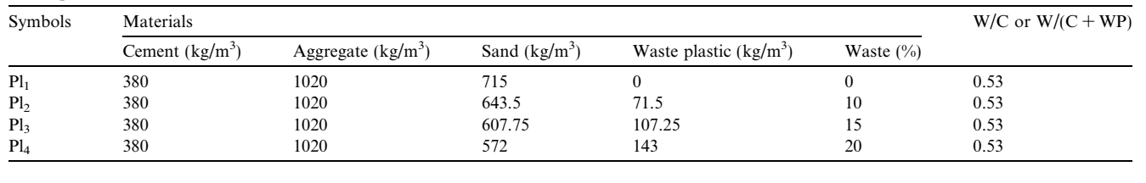
Compressive strengths were tested on 70 cubes of concrete all being 150 x 150 x 150 mm in size.
Flexural and toughness stress tests were carried out on 54 prisms all being 70 x 70 x 38 mm in size.

Compressive strengths
Fig. 1. Compressive Strength
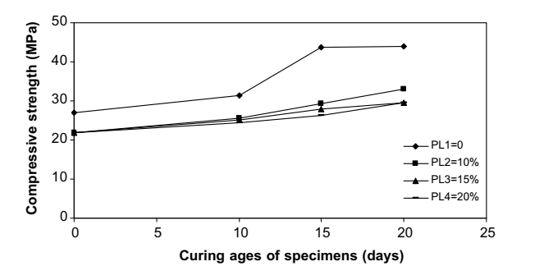
As seen in fig.1. above the results of the compressive strength test show that by increasing the amount of waste plastic in the specimen it shows a tendency that the compressive strength value decreases. In comparison with a standard plain mixture at each curing age interval. This is due to the adhesive strength between the cement paste and plastics surface; however, all values are larger than the compressive strength minimum required for structural concrete which is 17.24MPa.

Flexural Strength

Fig. 2. Flexural Strength
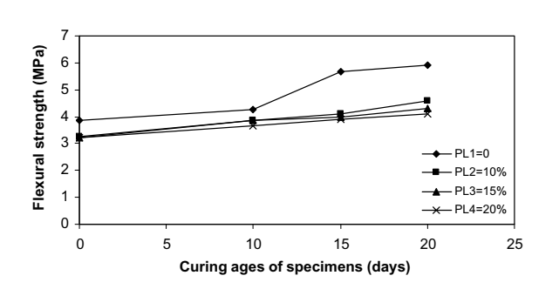
The overall outcome of this test shows no difference to the compressive strength test previously stated. As the specimen has an increase of waste plastic the flexural strength at each curing stage decreases. Again, attributed to the adhesive strength between both plastic particles surface and the cement paste.

Load Deflection

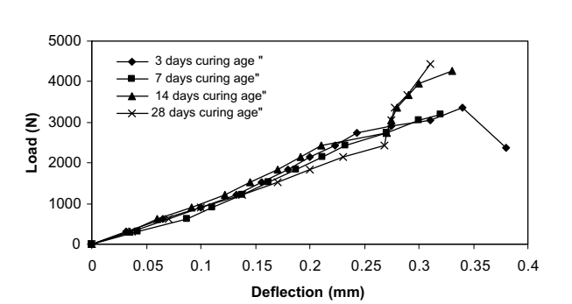
Fig. 3. Load-Deflection curve of 0% plastic Fig. 4. Load-Deflection curve of 20% plastic
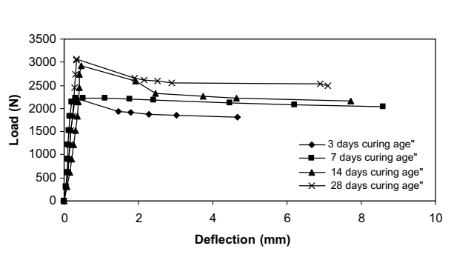
Comparing the two figures above (Fig. 3. & 4) one is with no plastic replacement and the other with the highest plastic replacement percentage carried out tests on. Figure 3 shows the load–deflection curves of the reference mixtures (Pl1) at all curing ages: 3, 7, 14, and 28 days. This photograph shows how the brittle nature of concrete leads to plain concrete to suddenly fail under CenterPoint loading on simple beams. Figure 4 displays the flexural load–deflection values for specimens containing 20% waste plastic, respectively. These illustrations demonstrate how adding waste plastic particles with fabiform shapes to concrete mixtures can stop the spread of microcracks.

Another factor considered when working with concrete is the workability, so the question is does plastic make the slump greater or less than your usual aggregates? After some testing it is shown that the higher the percentage of waste plastic in the mixture the lower the lower the slump (cm) is. As seen in the table below when 5% plastic was added the reductions to the slump were 68.3% and at the highest percentage of plastic it was at 95.33% which is a drastic drop in slump. This can be down to the fact of the sizing and shape of the plastic particles as some may be angular giving a better connection to the paste. However, it is to be believed that ‘waste plastic concrete mixtures have easy workability’. All figures can be seen in the image below (Fig. 5.)
Fig. 5. Slump of waste plastic concrete
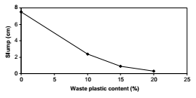

Split tensile strength

Fig. 6. Split tensile strength at 28 days curing.
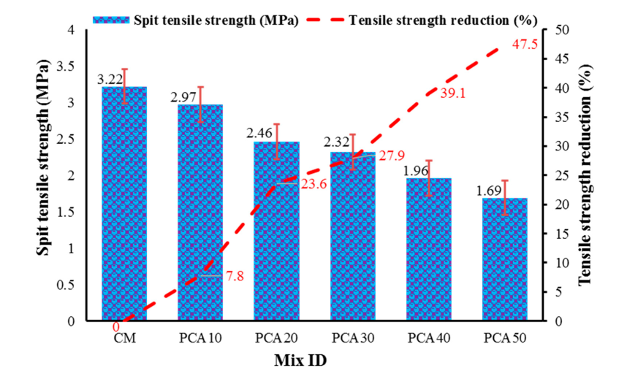

Fig. 8. Shows the variation in split tensile strength, The controlled mix come in with a tensile strength of 3.22 MPa at day 28 of the curing process, while concrete with 10, 20, 30, 40 and 50 percent plastic replacement comes in at 2.97 MPa, 2.46 MPa, 2,32 MPa, 1,96 MPa and 1.69 MPa the reduction percentage from the controlled mix to the ‘PCA 50’ was 47.5% at the 50% replacement level, with a 7.8% tensile strength reduction at 10% plastic replacement. Plastic concrete aggregate has less density, unit weight, rigidity, and strength with respect to normal concrete aggregate, hence producing a high-stress zone that facilitates the spread of damage, which is also considered as the reason for strength reduction.

The concrete surface's resistance to wear is gauged by its abrasion resistance. Concrete abrasion makes the material more susceptible to weathering over time, which weakens the concrete's durability. Concrete is susceptible to deterioration, a typical occurrence, due to its low resistance to abrasion. The graph below shows that replacing the aggregate with plastic waste is a positive alternative in regards of abrasion wear. As shows the standard concrete mix had a loss of 13.61 grams due to abrasions, whereas PCA50 has a 51.6 % decrease in abrasion weight making it better at withstanding friction from objects that connect with the concrete.

Abrasion

Fig. 9.PCA effect on abrasion loss of concrete
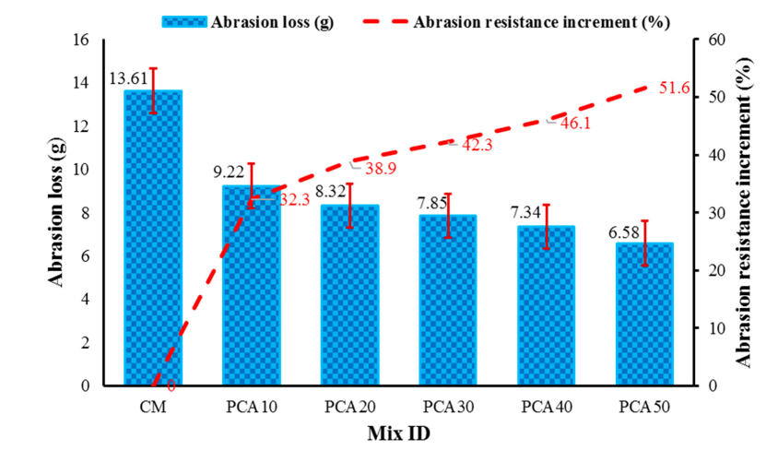

1b-Plastic as a reinforcement in mortars

It has been investigated using recycled fibres in mortars. There are two categories of those fibres: natural and synthetic. Commercial fibres like nylon from fishing net waste and plastic from polyethylene terephthalate can be substituted with synthetic fibres from industrial or post-consumer waste. Conversely, there are three categories of natural fibres: plant-based, mineral-derived, and animal-based.

Fig. 10. Flexural strength of fibre-reinforced cement mortars
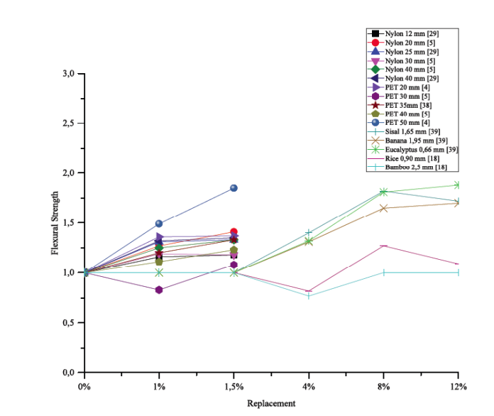

Flexural strength is correlated with properties like mortar adhesion strength and crack susceptibility. Adding fibres to mortars makes them more ductile, which improves the performance of flexural strength. This characteristic makes mortars reinforced with fibres more capable of absorbing energy.
Analysing the graph above has given a conclusion that reinforced mortars have a noticeably higher flexural strength than the reference mortar. When 1.5% (by volume) of 50mm-long PET fibres were added to mortars, the flexural strength increased by the greatest amount—85%—when compared to the control mortar. (Al-Tulaian et. Al. 2016).
In comparison to the control mortar, reinforced mortars containing sisal, eucalyptus, and banana fibres increased their flexural strength by approximately 88%, 82%, and 66% (by mass), respectively, according to a study by Savastano et al. The study yielded data for 12% of the fibres, with the lengths of the fibres from banana, eucalyptus, and sisal being 1.65 mm, 0.66 mm, and 1.95 mm, respectively.
When incorporated it was found by (Xie et. Al. 2015) that rice and bamboo fibres at a content percentage of 2 and 4 percent had a different effect on the flexural strength compared to the other fibres used as it caused a decrease in flexural strength. This is due to a small number of fibres not having a uniform distribution.

Cracking patterns

Juarez et. Al. (2015) evaluated the incorporation of flax fibres to have a positive effect on the performance when preventing cracking with 99.5% reduction in total cracking area when comparing to mortar with no fibre reinforcement. In the work of Savastano et. Al. sisal fibres delayed the appearance of the first crack due to higher energy absorption during cracking. Reinforced mortar with the use of 50mm long PET fibres give the overall best outcome in resistance, due to presenting no cracks at the early stages with only an incorporation of 1.5% in volume.
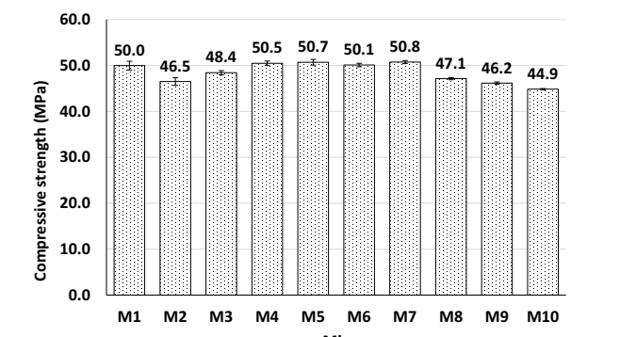
Fig. 11. Compressive strength of mortar mixtures tested.
The average ultimate compressive strength of four cube specimens after 28 days is represented by the test results in Figure 11. It was discovered that the mortar mixtures reinforced with hybrid blends of recycled fibres, M5, M7, M8, and M10, exhibited compressive strengths that were nearly identical to those of the mixes reinforced with steel fibres that were made, M2, M6, and M9. In contrast to control mix M1, several fiber-reinforced mixes, including M2, M3, M8, M9, and M10, displayed a 3% to 10% drop in compressive strength. This might be the result of non-uniform recycled fibre dispersion in certain combinations, which leads to fibre lumping. Even when some mixtures' compressive strengths slightly decreased, their final compressive strengths were still within the range of high-strength mortar.

2-Plastic in road construction

2a-Production process
Bituminous hot mixes using waste plastic used for road construction are split into 2 different processes known as ‘dry’ or ‘wet’ process. Dry process is considered simple, economical and environmentally friendly, whereas wet process requires more investment and machinery meaning the use of the dry process is more desired.

Dry Process:
- All impurities are removed from the plastic by drying and cleaning the plastic. Once complete the plastic will be cut down with the use of a shredding machine to multiple sizes ranging between 1.18 mm to 4.36mm. PVC should be eliminated in the cleaning process. Impurities must not exceed 1%.
- As per HRS specifications the aggregate will be heated to 165oC, and the bitumen then heated to 160oC this will give a good binding property. When in the mixing chamber the waste plastic will be added to the hot aggregate to apply a coating layer uniformly for around 30-45 seconds. Tests indicate that 8% is the optimum percentage of plastic waste compared to the bitumen weight.
- The coated aggregate will then be added to the bitumen and any temperature between 150oC to 165oC.

Wet Process:
- Plastic is collected ideally at sizes of 60 micron or less as its better for the following procedures. This allows the mixture between plastic and hot bitumen at the temperature of 160oC to 170oC to be far easier.
- The bitumen is heated to 160oC-170oC which is the melting temperature of plastic.
- The fine pieces of plastic is added to the hot bitumen at constant temperature mixture will then be stirred manually for about 20-30 minutes.

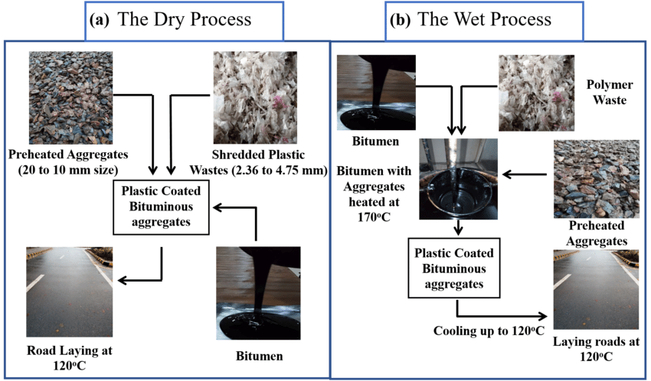
Figure 12- (a) the dry process (b) the wet process

(Abid et al. 2019) image available at: https://www.researchgate.net/publication/334273283_Efficient_Utilization_of_Plastic_Waste_in_Construction_of_Green_Roads

Modular:
Building elements or whole buildings are constructed in a controlled environment off-site using the process of modular construction. These components are then transported and assembled at the project site. By using standardised modules, this method ensures accuracy and consistency in building.
Due to its many advantages, modular construction is being increasingly utilised in road and bridge constructions, despite its early popularity in residential and commercial projects.

2b-Design methodologies and incorporation
One case with the use of plastic in road construction, India appears to have the most experience with plastics in road construction after promoting waste plastics into their highways and rural roads.
Table 2-Roads constructed in India using waste plastic and their condition.
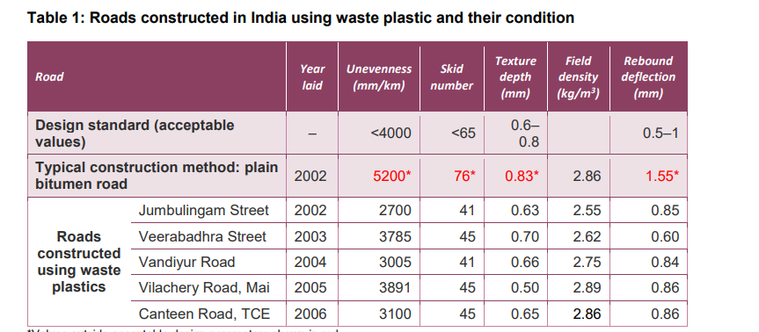

As you can see from Table 2 shows figures of the standard bitumen road compared to other roads which have used plastics in their construction, the roads containing plastic waste have coped with abrasion from vehicles far better than the standard road as the unevenness is far less. And the skid number is far less as the surface has stayed intact and the layer hasn’t worn down providing better connection between vehicle tyres and the surface.
Another case of plastic road construction internationally is in the Netherlands where a plastic road was created, this is a modular off site construction build. The modular pods are prefabricated and delivered to the location of assembly, the modular pods have a void for any services and water drainage. Other advantages include quicker installation times (up to 70% quicker), cost effective nearly half the price of usual road construction. It was tested on a 30m long stretch and monitored. And it to be believed from the monitoring that the modular was able to hold heavy vehicles with no deformation, and the actual modular that were going to be used were 2.5 times stronger than the ones used for testing. This shows that the road construction compressive strength was suitable for the road construction.
Waste plastic roads are in use in the UK as a company known as MacRebur come up with the solution to add plastics to asphalt, Durham County council then approved the use of it in on resurfacing a section of the A689 near Sedgefield as well as the runways and taxiways in Carlisle Airport.

3-Conclusion

Advantages and disadvantages of waste plastic in road construction
The main advantage is with the use of plastic in roads is it will help towards the large plastic waste problem by reusing it in large area of roads. Another advantage is costs as it is cheaper than the cost of bitumen and aggregates. However, onto its physical characteristics from most studies it is said that adding plastic to helps with reducing abrasion this is an advantage as it prevents the ground from breaking or having some form of deformation, this means that the road is likely to last longer and require less maintenance as a standard road. Another advantage is its superior resistance to corrosion which for a road is something that is needed to the travelling of cars so any brake fluid leaks, oil leaks and so on the waste plastic asphalt will be able to withstand the chemicals. A disadvantage to plastic is that it generally lacks high-temperature resistance so when wanting to use it within roads there is a need to be mindful of the environment, you’re in such as hot countries with constant warm weather will be more prone to deformation to their roads. Again, to do with weather, plastic can be permeable meaning road makeups can allow for rainfall to work its way through from the surface, avoiding any ponding of water which can prevent accidents. Plastic roads have increased binding and better bonding of the mixture components than regular asphalt roads this will prevent deformation of the roads.
Other disadvantages include:
The toxics present in the plastic wastes used in Plastic Road construction would start leaching, which creates difficulty while cleaning.
During the road laying process, the mixture of asphalt and plastic will release noxious HCL gas in the presence of chlorine from the surrounding.
After the laying of the Plastic Road, it is often found that the first rain will result in leaching, as the plastics will form a sticky layer over the surface of the road.

From looking over the data it shows in multiple studies that the partial replacement of aggregate with waste plastics within concrete has a negative effect on the compressive strength as the figures decreased with the more replacement of waste plastic, this also showed no difference in the flexural strength with the values decreasing lower than the standard concrete mixture.
The slump values of waste plastic concrete mixtures showed a tendency to decrease below the slump of the reference concrete mixture. Despite this decline in the slump of those mixtures, those mixtures are easy to work based on the consideration that workability has a broad range from very low to high workability for different applications.
In terms of plastic reinforcement in mortars there were a lot of positives for the most influential factors such as cracking patterns with some plastics giving 99.5% cracking reductions.
(Smethurst et.al. 2023) states that the unparalleled performance advantage of plastics over substitutes, which allows for broader benefits like energy savings, improved health and safety, or less maintenance, is a major justification for its usage in building. They are believed to exceed their risk of damage. Nevertheless, the usage of hazardous chemicals, which have the ability to seep into and affect human health.
(Hassan et.al. 2020) believes the adjusted mixture exhibits enhanced Marshall properties. The resistance to deformations under high wheel loads increases when the marshall stability value rises with plastic content and when the marshall flow value falls with the addition of polythene. Also, with these things in mind, we can guarantee that the polymer adjustments we do will result in a more stable and long-lasting mix for the pavements. This modest study gives us a better pavement with more strength and a longer lifespan in addition to making good use of the waste non-biodegradable plastics. Because this study will lessen the amount of plastic garbage that needs to be disposed of via land filling and incineration, it will benefit the environment.
In terms of plastic as a replacement for aggregate in concrete it is believed to have a positive effect on thermal and sound insulation. In addition, it can prolong the life of the structures and help us save a lot of energy. However, the overall weight of concrete is decreasing due to the lower density of plastic wastes compared to fine and coarse natural aggregates, resulting in lighter concrete with poorer structural performance. To summarise it is an optimal alternative in achieving environmental sustainability.
Environmental and financial benefits have been demonstrated when recycled plastics are used as aggregate or reinforced fibres in concrete applications. Additionally, it was discovered that the mechanical strength fell within acceptable bounds. Because it lessens overexploitation of aggregate quarries, energy consumption, and greenhouse gas emissions, the decreased need for natural aggregates in concrete applications is therefore both economically and environmentally justified.
(J. Orr et.al.2018) said “Typically, when you put an inert, man-made material like plastic into concrete, you lose a bit of strength because the plastic material doesn't bond to the cement paste in the material in the same way that a sand particle would. The key challenge here was to have a limit between a small reduction in strengths, which we achieved, and using an appropriate amount of plastic to make it worthwhile. It is really a viable material for use in some areas of construction that might help us to tackle issues of not being able to recycle the plastic and meeting a demand for sand.”
To conclude with all the research and evidence, it is believed that plastic replacement in concrete carries a lot of positives and outweigh the negatives, such as compressive strength decreasing however not drastically and still within tolerance.

References

ScienceDirect (2022) Producing sustainable concrete with plastic waste: A review. Available at: https://www.sciencedirect.com/science/article/pii/S2667010022001822#bib0030
(Accessed 26th November 2023)
ScienceDirect (2008) Use of waste plastic in concrete mixture as aggregate replacement. Available at: https://librarysearch.uwtsd.ac.uk/permalink/44WHELF_UWTSD/1ir6fgh/cdi_proquest_miscellaneous_21024410
(Accessed 27th November 2023)
Materials (2021) P.175. Performance evaluation of plastic concrete modified with E-waste plastic as partial replacement of coarse aggregate. Available at: https://librarysearch.uwtsd.ac.uk/permalink/44WHELF_UWTSD/1ir6fgh/cdi_doaj_primary_oai_doaj_org_article_366cfeb03740408ea447dffc7617cfc0
(Accessed 27th November 2023)
ResearchGate (2018) Effects of the incorporation of waste fibres on the cracking resistance of mortars: A review. Available at: https://www.researchgate.net/publication/328327453_Effects_of_the_Incorporation_of_Waste_Fibres_on_the_Cracking_Resistance_of_Mortars_A_Review
(Accessed 27th November 2023)
K4D (2019) Using waste plastic in road construction. Available at: https://assets.publishing.service.gov.uk/media/5d41b34040f0b60a86a5e5dc/595_Use_of_Waste_Plastics_in_Road_Construction.pdf
(Accessed 4th December 2023)
ResearchGate (2019) Efficient Utilization of Plastic Waste in Construction of Green Roads. Available at: https://www.researchgate.net/publication/334273283_Efficient_Utilization_of_Plastic_Waste_in_Construction_of_Green_Roads
(Accessed 12th December 2023)
RICS (2023) Why we must limit use of construction plastic. Available at: https://ww3.rics.org/uk/en/journals/built-environment-journal/plastics-construction-materials-health.html
(Accessed 12th December 2023)
ResearchGate (2020) Use of plastic in road construction. Available at: https://www.researchgate.net/publication/365760645_Use_of_Plastic_in_Road_Construction
(Accessed 13th December 2023)
University of Cambridge (2018) Waste plastic in concrete research wins award for potential impact worldwide. Available at: http://www.eng.cam.ac.uk/news/waste-plastic-concrete-research-wins-award-potential-impact-worldwide
(Accessed 13th December 2023)

