Student Name: Mojnu Miah  Student ID: 2233687  Module Title: Foreign Languages & Cultural Awareness  Module Code: BMIH 5003  Lecturer: Heidi Prosser  Date: 28/01/2024 | 
ASSIGNMENT 1: PORTFOLIO
(4 Components)

Component 1: Professional Reflection (500 words +/- 10%)

Weighting: 25%
While During the time that I worked at F & B, I saw a number of distinct occasions in which the barrier of understanding was present. On a number of instances, I was able to see this occurrence. Furthermore, as a consequence of this, it is possible that a number of different techniques are required in order to make the most efficient use of the working methodology. At one point in time, when I was working for the company, I saw that a guest who was not particularly proficient in the English language had arrived at the lobby. The fact that he needs a translation is one of the problems, and the guide that he had brought along with him has abandoned him for the scenario. His lack of a solid command of the English language was the most major obstacle that he faced. He was unable to communicate effectively in English. Even if he tries to communicate with us, it is not feasible for him to do so since there was a language barrier existing there. This is the case even if he tries to communicate with us.
We tried all in our ability to understand what he was saying, but we were unable to follow even a single word that he was saying. A person must learn at least one foreign language in order to make the most of any journey that they want to take in a different nation. This is an essential need. On the other hand, this traveller does not have any kind of guide with him, and as a result, he is unable to learn the language. Furthermore, he does not have the time to carry out the action. Because of this, he was exerting every effort so that he could provide us with the information that he was seeking for. On the other side, all of his words are in Mandarin, and so, we are unable to understand any of the terms that he was using to communicate with us. It is not going to be easy to talk with him since not a single member of our team is fluent in that language. As a consequence of this, there are problems that occur here because it is not going to be simple to communicate with him. It was in the morning, while visitors were going through the process of checking in, that the misunderstanding took place.
It seems inconceivable that the company that we work for, which is a well-known one, would have been informed of this type of event in advance, despite the fact that they are the ones that hire us. Due to the fact that this is the case, it is hard for them to have any clue what measures to do in this particular circumstance. The problem, on the other hand, could not be solved in the end. At the absolute least, we need to have someone who is able to communicate fluently in any of these languages. This is the identification that is the most significant. However, the misunderstanding happened as a consequence of the language barrier that was there at that specific moment in time.

References:
- Stavans, A., & Hoffmann, C. (2015). Multilingualism. Cambridge University Press. Stavans, A., & Hoffmann, C. (2015). Multilingualism. Cambridge University Press.
- Franceschini, R. (2011). Multilingualism and multicompetence: A conceptual view. The Modern Language Journal, 95(3), 344-355.
- Blommaert, J., Leppänen, S., & Spotti, M. (2012). Endangering multilingualism. In Dangerous multilingualism: Northern perspectives on order, purity and normality (pp. 1-21). London: Palgrave Macmillan UK.
Component 2: Training Plan (500 words +/- 10%)

Weighting: 25%

Identified cultural misunderstanding (in a few words) :
The cultural misunderstanding took place as there was no one who is well verse in foreign language. There are multiple steps that can be take to resolve this issue
Training plan (Why/What//Who/Where/When):
When it comes to providing outstanding customer service in the cutthroat hotel industry, nothing beats clear and concise communication. In hotels with a diverse clientele, language barriers could be a challenge. To enhance communication and guest pleasure, hotel workers need a well-thought-out training programme. Professional and effective language barrier-overcoming training is provided to staff using this manner.

- First I will recognise the importance of communication. I will begin the course by stressing the ways in which communication impacts the satisfaction of visitors. Provide examples of real-life scenarios when language barriers impacted the customer experience. Highlight the significance of effective communication in fostering relationships and generating loyalty.

- I will begin with the most often spoken languages by tourists and provide basic language lessons in those languages. Spell out hellos, questions, and requests often. A boost to worker morale and competence may be achieved by having them rehearse these terms. For self-study, make use of language-learning apps or resources.

- I will use cultural sensitivity training should educate employees on cultural norms and practices in order to foster an environment that is accepting of people from all walks of life. With this knowledge, we can all communicate more effectively and foster an environment where everyone feels welcome and valued.

- I will maximise personnel diversity by creating a diverse and multilingual staff roster. Assuming it is possible, assign language-skilled workers to shifts or roles that make the most of their abilities. This proactive strategy may help foresee and treat language issues.

- I will make use of translation tools. I will familiarise employees with language translation apps to facilitate instant communication. Incorporate these tools into routine operations and teach staff to use them successfully. Emphasise accuracy checking to avoid misunderstandings.

- I will use visual aids such as maps, signage, and menus to supplement spoken instructions. Despite language barriers, these tools may aid visitors in understanding. Provide visual assistance at key touchpoints and teach staff how to use them.

- I will engage in interactive role-playing games that mimic real-life language barriers. Workers may hone their language skills in a safe environment with this practical approach, which boosts their self-assurance.

- I will provide staff with training on active listening techniques, with a focus on body language and non-verbal cues. Motivate them to listen intently to guest feedback and find effective solutions, particularly when dealing with language obstacles.

- I will create a feedback loop to assess the effectiveness of language barrier training. It will help for continuously feedback and improve. I will find out what employees are struggling with, and use their feedback to make the training plan better.

- I will focus on continual professional development. I will promote the use of seminars, refresher courses, and language learning resources to enhance language and communication abilities. This helps employees stay current while also enhancing their abilities.
Hotel employees will be better equipped to handle language barriers with poise and professionalism after completing this comprehensive training programme, which will ultimately benefit guests.

References:
- Kemp, C. (2009). Defining multilingualism. The exploration of multilingualism, 11-26.
- Grutman, R. (2019). Multilingualism. In Routledge encyclopedia of translation studies (pp. 341-346). Routledge.
- Clyne, M. (2017). Multilingualism. The handbook of sociolinguistics, 301-314.

Component 3: Student Self-Reflection (500 words +/- 10%)

Weighting: 25%
To provide a welcoming and memorable experience for all guests, hospitality professionals must be culturally aware. In an era when globalisation has made hotels diverse, it is imperative that hospitality professionals comprehend and value other cultures.
Cultural understanding fosters an inviting atmosphere, which is of utmost importance. Make your visitors feel at home by honouring their unique heritage. Client satisfaction, positive evaluations, and loyalty are all enhanced as a result.
Being culturally aware is essential for effective communication. It encompasses not just language proficiency but also social norms, protocol, and customs. By gaining an appreciation for cultural diversity, hospitality professionals will be better able to meet the needs and preferences of guests from all walks of life. Being able to adapt to other cultures is a huge plus in the highly competitive hospitality industry. Hotels that are known for their cultural sensitivity attract a wider range of guests and set themselves apart from the competition. Misunderstandings are less likely to occur, and guests will feel appreciated the whole time.
Because it increases customer happiness, establishes credibility, and promotes a hotel as an inclusive and friendly worldwide destination, cultural awareness is crucial in the service business, which places a premium on great experiences. I have found that gaining cultural understanding has really enhanced my service in the hospitality industry. Understanding and appreciating other cultures allows us to build deeper connections with visitors and provide them with a more personalised experience, which is essential in a field where every contact is unique.
In addition to being able to identify and respect a wide range of cultural practices, I also make an effort to learn about the history of each visitor. I am able to provide an environment where people feel understood and valued since I am familiar with their requirements, preferences, and sensitivities.
Communicating with guests from different cultural backgrounds has helped me become a better host. I am able to converse with guests from all walks of life because of my cultural understanding, which goes beyond my language abilities. The result is enhanced communication, smoother connections, and a more favourable first impression.
Also, knowing other cultures makes it easier to stay out of trouble. I can avoid making any blunders that might negatively impact a guest's experience by familiarising myself with local conventions. I am capable of establishing a welcoming environment where all guests are acknowledged and valued during their stay.
When it comes to hospitality, cultural understanding affects everything. Personalisation is vital. It gives me the opportunity to go above and beyond for our global clients by catering to their unique tastes and expectations. As a result of the extra effort, I get positive reviews, return clients, and a reputation as a place that is sensitive to other cultures.

Cultural awareness is more than just a skill; it's a mindset that colours all of my interactions. This experience has made me a more thoughtful and capable hospitality professional by enhancing my capacity for learning and flexibility.
References:
- Grutman, R. (2019). Multilingualism. In Routledge encyclopedia of translation studies (pp. 341-346). Routledge.
- Aronin, L., & Singleton, D. (2012). Multilingualism (Vol. 30). John Benjamins Publishing.
- Cenoz, J. (2013). Defining multilingualism. Annual review of applied linguistics, 33, 3-18.
- Clyne, M. (2017). Multilingualism. The handbook of sociolinguistics, 301-314.

Component 4: Training Presentation (6 Slides)

Weighting: 25%
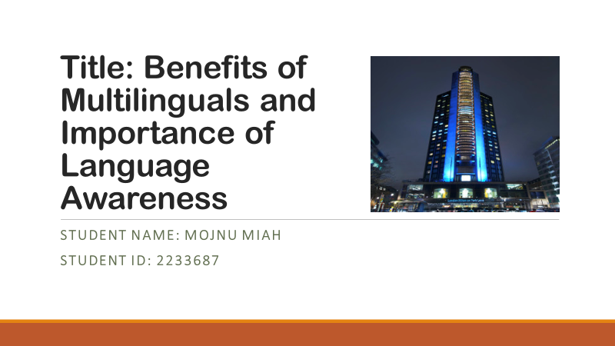
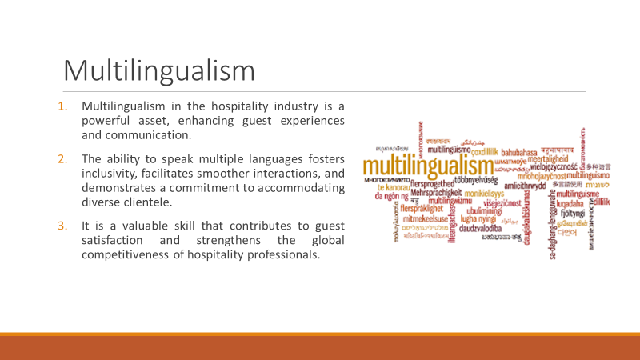
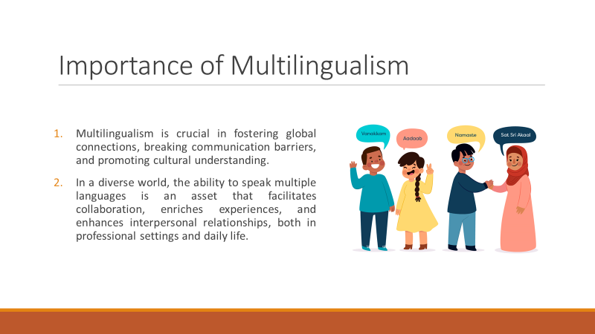
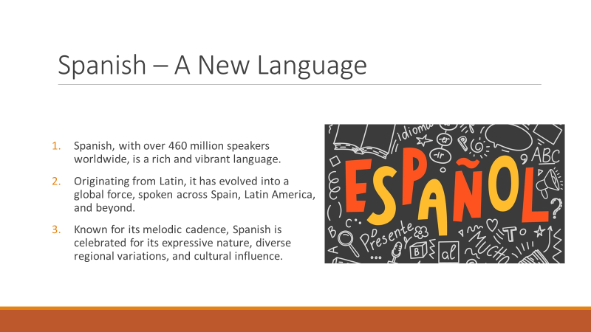
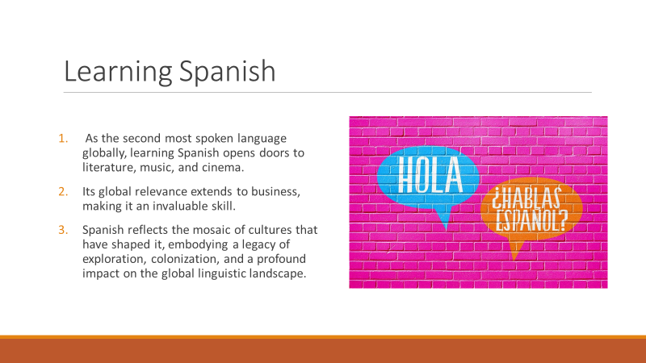
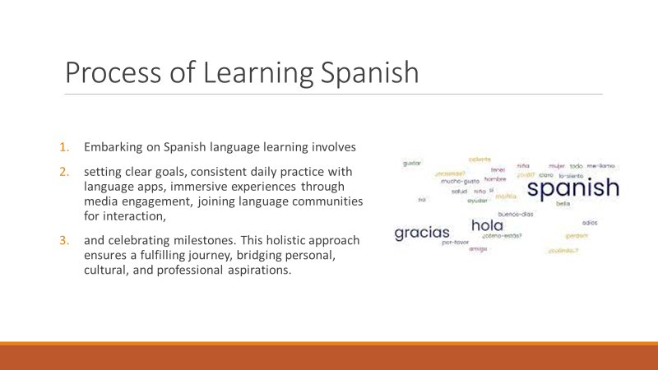
References (no screenshots):

- Coulmas, F. (2018). An introduction to multilingualism: Language in a changing world. Oxford University Press.
- Okal, B. O. (2014). Benefits of multilingualism in education.
- Higby, E., Kim, J., & Obler, L. K. (2013). Multilingualism and the brain. Annual Review of Applied Linguistics, 33, 68-101.
- Horner, K., & Weber, J. J. (2017). Introducing multilingualism: A social approach. Routledge.
- Stavans, A., & Hoffmann, C. (2015). Multilingualism. Cambridge University Press.
- Franceschini, R. (2011). Multilingualism and multicompetence: A conceptual view. The Modern Language Journal, 95(3), 344-355.

