STUDENT NAME;-AFSHAN ABBAS
STUDENT ID;-2515417
MODEULE NAME;- INTRODUCTION TO WEB AND DATABASE CONCEPT
ASSIGNMENT TITLE;- DESIGN AND IMPLEMENTATION OF A RELATIONAL DATABASE SYSTEM
SUBMISSION DATE;- 9TH JULY 2026

Scenario: Database Implementation for ‘AutoPark Management System’
Imagine that the operations director of a city-based parking service provider named “Auto Park Management System” has approached you to develop a robust database solution using Microsoft Access. The company currently manages multiple parking sites across the city, but all information regarding vehicle entries, parking slots, customer details, and payments is recorded manually. This has led to frequent errors, loss of data, and inefficient use of parking space.
The management now wants to automate the parking process through a centralized database system that accurately records and monitors vehicle movements, slot availability, and payment transactions in real-time.

1. Scenario Analysis
The business currently uses manual records to manage:
- parking sites
- parking slots
- customers
- vehicles
- bookings
- payments
This causes:
- data entry errors
- missing or lost information
- poor tracking of available slots
- inefficient use of parking capacity
The proposed database system should solve this by storing data centrally and allowing staff to monitor:
- vehicle entry and exit
- slot availability
- customer and vehicle records
- bookings
- payments
- operational reports

2. Main Entities, Attributes, and Relationships

Entity 1: Customer
Stores the details of each vehicle owner.
Attributes:
- CustomerID (Primary Key)
- FirstName
- LastName
- PhoneNumber
- Email
- Address
Relationship:
One customer can own many vehicles and make many bookings.

Entity 2: Vehicle
Stores details of vehicles registered in the system.
Attributes:
- VehicleID (Primary Key)
- CustomerID (Foreign Key)
- RegistrationNumber
- VehicleType
- Make
- Model
- Colour
Relationship:
Each vehicle belongs to one customer, but one customer may have multiple vehicles

Entity 3: ParkingSite
Stores information about each car park location.
Attributes:
- SiteID (Primary Key)
- SiteName
- Location
- Capacity
- ContactNumber
Relationship:
One parking site contains many parking slots.

Entity 4: ParkingSlot
Stores information about individual parking spaces.

Attributes:
- SlotID (Primary Key)
- SiteID (Foreign Key)
- SlotNumber
- SlotType
- Status
Relationship:
Each parking slot belongs to one parking site. One site can have many slots.

Entity 5: Booking
Stores parking reservations or active parking sessions.
Attributes:
- BookingID (Primary Key)
- CustomerID (Foreign Key)
- VehicleID (Foreign Key)
- SiteD (Foreign Key)
- BookingDate
- EntryTime
- ExitTime
- BookingStatus
Relationship:
Each booking links a customer, a vehicle, and a slot.

Entity 6: Payment
Stores payment information for each booking.

Attributes:
- PaymentID (Primary Key)
- BookingID (Foreign Key)
- PaymentDate
- AmountPaid
- PaymentMethod
- PaymentStatus
Relationship:
Each payment is linked to one booking.

3. Relationships and Cardinality

- Customer 1:M Vehicle
- Customer 1:M Booking
- Vehicle 1:M Booking
- ParkingSite 1:M ParkingSlot
- ParkingSlot 1:M Booking
- Booking 1:1 Payment (or 1:M if multiple payments are allowed)

4. ERD (Entity Relationship Diagram)
This ERD Entity Relationship Diagram includes;
- all six entities
- primary keys
- foreign keys
- relationship lines
- cardinality labels

- Customer (Customer ID, FirstName ,LastName, PhoneNumber,Email, Address)
- |
- |---< Vehicle (VehicleID, customerID,RegistrartionNumber,Vehicletype, Make,Model,Colour)
4. |
5. |---< Booking (BookingID,CustomerID, VehicleID, SlotID, BookingDate,EntryTime, ExitTime, BookingStatus)
6 |
7. | >--ParkingSlot (SlotID),SiteID,SlotNumber,SlotType,Status)
8. |
9. |---parkingSite (SiteID,BookingID, PaymentDate,AmountPaid, PaymentMethod,PaymentStatus)
10.
11. Booking
12. |
13. |---Payment (paymentID,BookingID, PaymentDate,AmountPaid, paymentMethod, paymentStatus)

5. Data Structure Development

Figure 1; -Customer Table

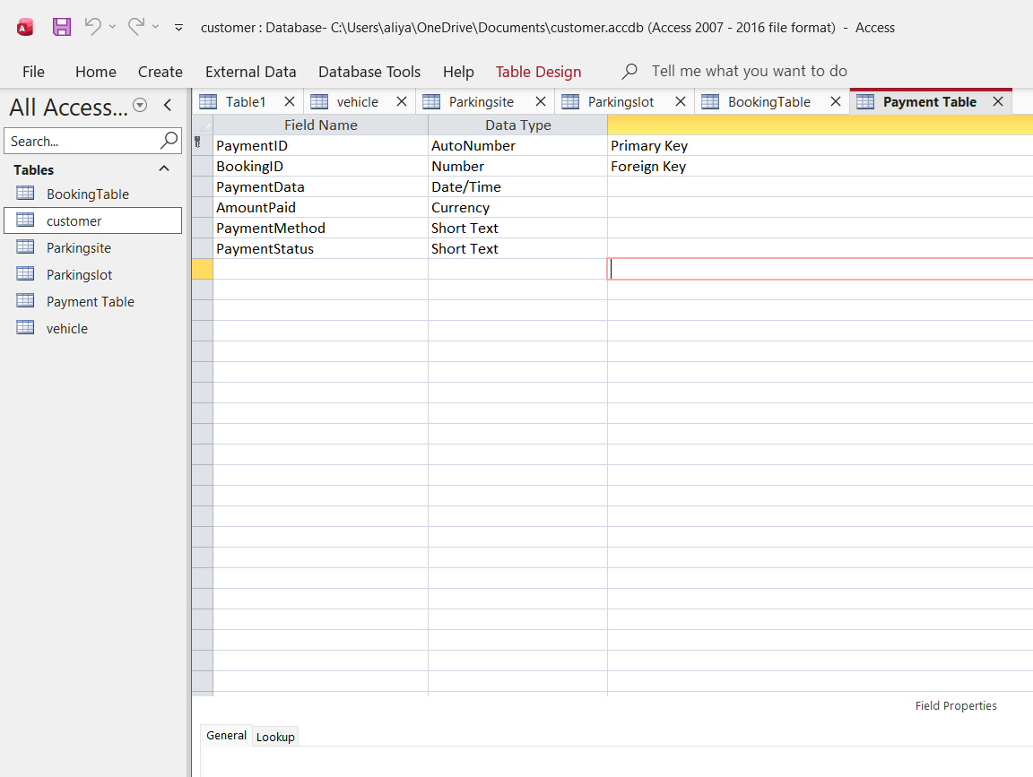

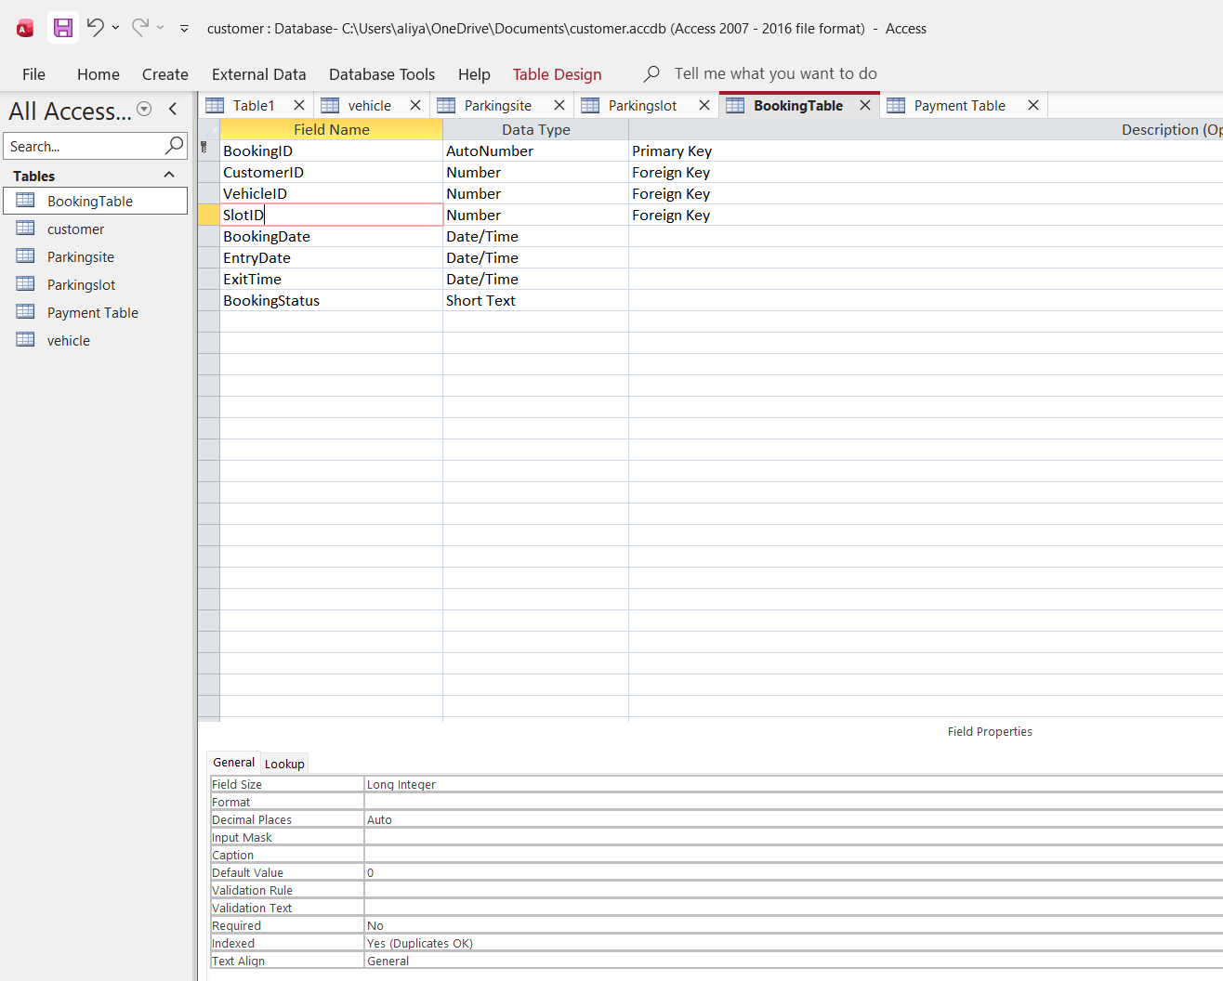

Figure 2; -Booking Table

Figure 3; -Parking Slot Table

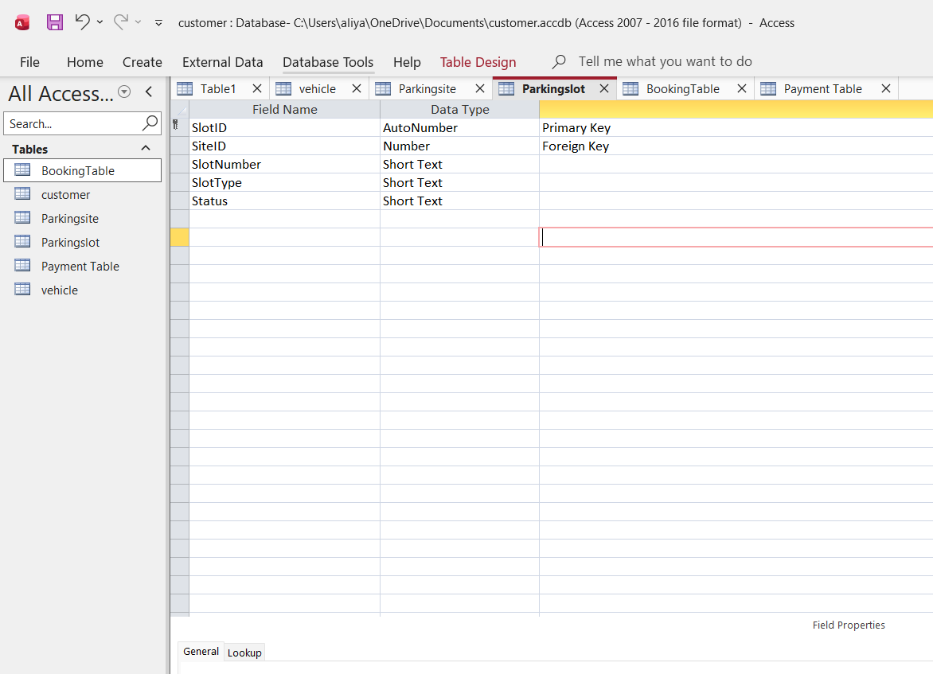

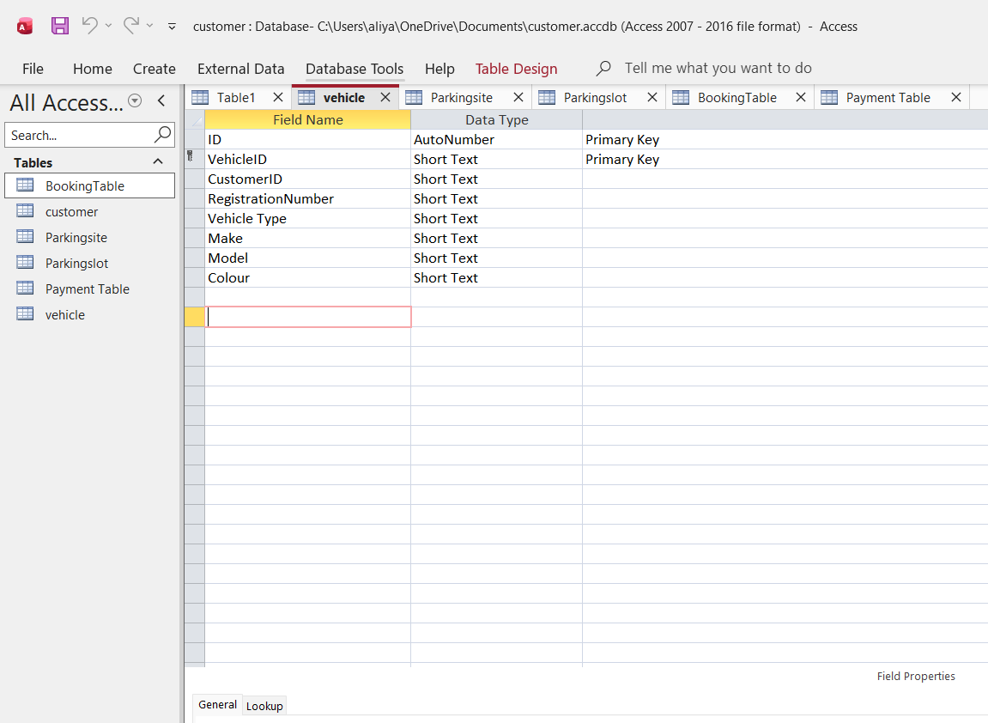

Figure 4; -Vehicle Table

6. Constraints for Data Integrity
- Primary keys uniquely identify each record
- Foreign keys create relationships between tables
- Referential integrity prevents orphan records
- Validation rules prevent incorrect data entry

Examples:
- RegistrationNumber must be unique
- AmountPaid must be >= 0
- Capacity must be > 0
- Slot Status allowed values: Available, Occupied, Reserved
- Payment Status allowed values: Paid, Pending, Failed
- Email can be validated for proper format

7. Normalisation to 3NF

First Normal Form (1NF)
- Each field contains only one value
- No repeating groups

Second Normal Form (2NF)
- All non-key attributes depend on the whole primary key

Third Normal Form (3NF)
- No non-key attribute depends on another non-key attribute

Why this database is in 3NF
- Customer details are only stored in Customer
- Vehicle details are only stored in Vehicle
- Parking site and slot details are stored separately
- Booking stores only transaction/session data
- Payment data is stored separately from bookings
- This reduces redundancy and update anomalies

8. Sample Data Population

Figure 1; -Customer

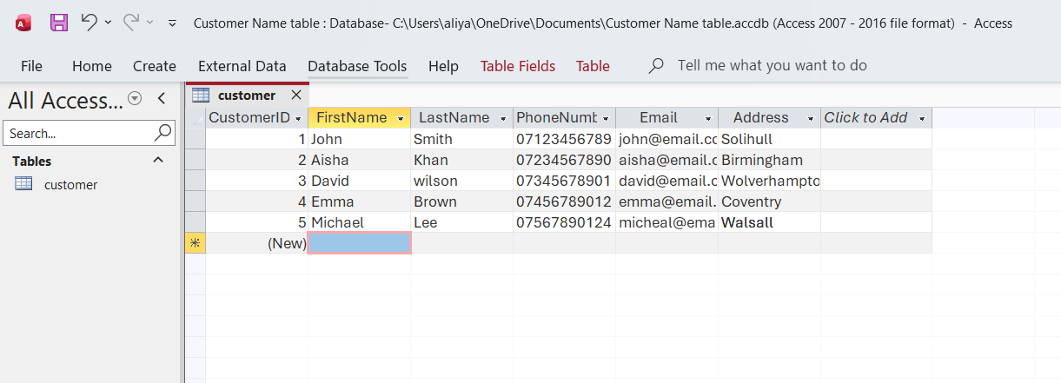

Figure 2; -Booking table
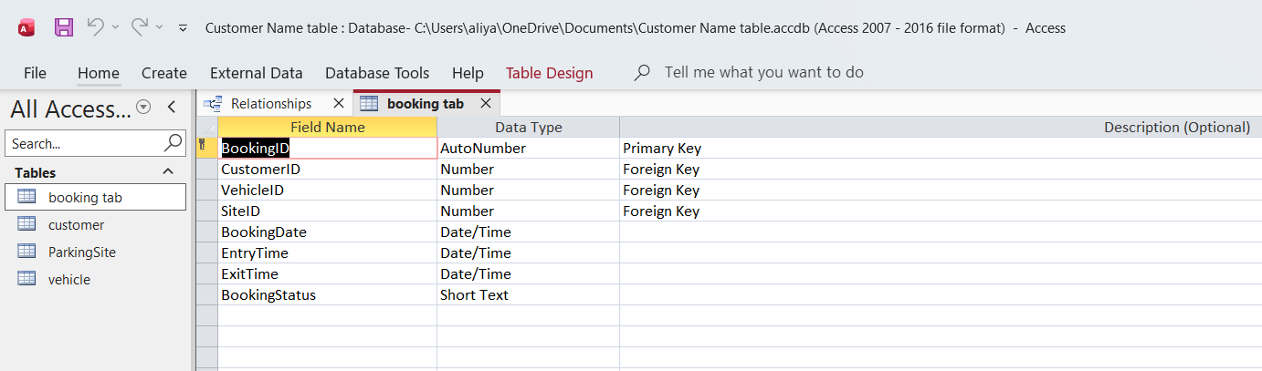

Figure 3; -Parking Site

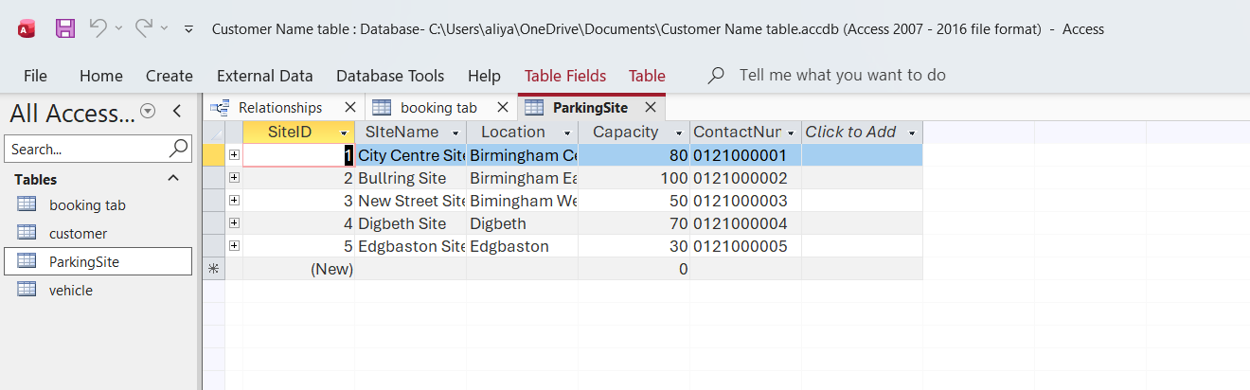

Figure 4; -Relationship Table

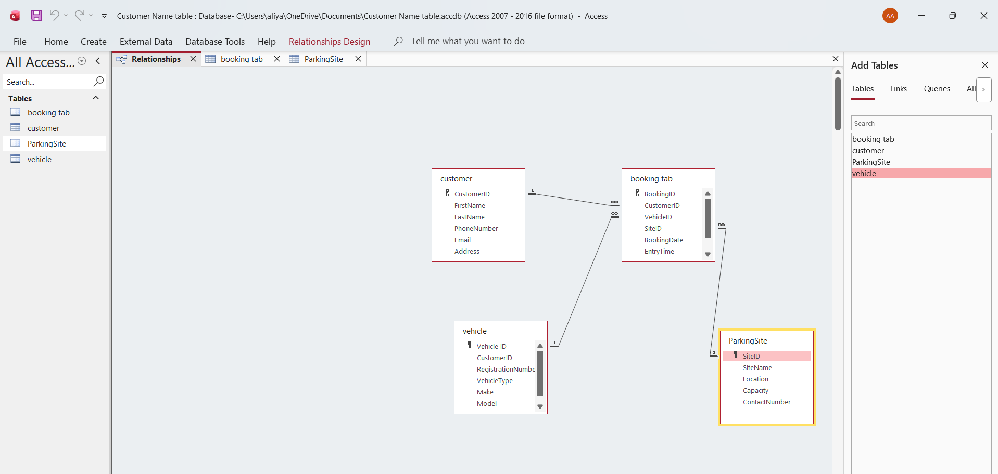

Figure 5; -Query Table

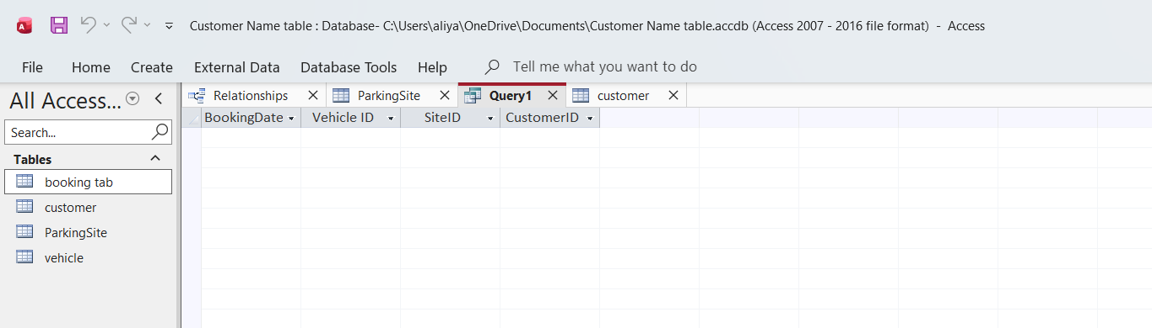

9. Query Development

Query 1: Parking slots currently in use
Shows all slots where status = Occupied.

Query 2: Vehicles parked at a particular time
Find vehicles with EntryTime before the chosen time and ExitTime after that time.

Query 3: Most in-demand parking location
Count bookings per site and sort descending.

Query 4: Vehicle parked in a particular slot
Join Booking, Vehicle, and ParkingSlot tables to find the vehicle occupying a selected slot.

Query 5: Total revenue by parking site
Join Payment, Booking, ParkingSlot, and ParkingSite, then sum AmountPaid by site.

Query 6: Customers with unpaid bookings
Show bookings where PaymentStatus = "Pending" or "Failed".

10. Validation and Testing
This is how the system was tested.
Examples of Tests
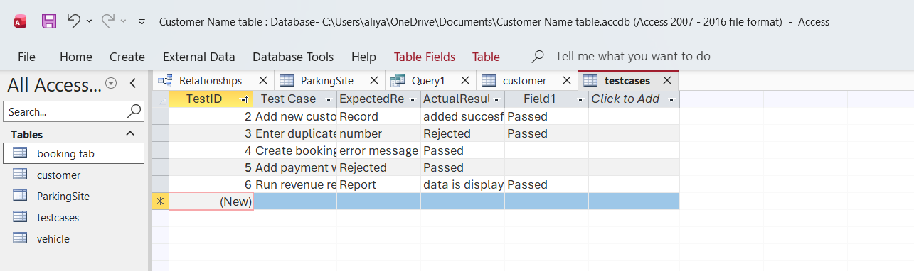
Figure 6;-Validation and Testing
- forms were tested for input accuracy
- relationships were checked in Access
- queries were tested using sample data
- validation rules prevented invalid entries

11. Reflection
The database was designed to improve the efficiency and accuracy of parking management by replacing manual paper-based records with a structured relational database. One challenge was ensuring that relationships between bookings, vehicles, and parking slots were correctly linked without redundancy. Normalisation to 3NF helped reduce duplication and improve consistency. In future, the system could be improved by adding automated payment processing, barcode ticketing, and dashboard-based reporting.

REFERENCES;-
  - D. M. Kroenke, D. J. Auer, S. L. Vandenberg, and R. C. Yoder, Database concepts. Hoboken, Nj: Pearson Education, Inc, 2020.

(2) Coronel, C. and Morris, S. (2023). Database systems: Design, implementation, and management. 14th ed. Australia ; United States: Cengage Learning.
(3) A. Jones, Advanced PostgreSQL Mastery: In-Depth Database Techniques and Performance Tuning. Walzone Press, 2025.

(4) Cohen, W., Yang, F. and Rivard Mazaitis, K. (2020). TensorLog: A Probabilistic Database Implemented Using Deep-Learning Infrastructure

