University of Wales Trinity Saint David

E-Portfolio Link:
Module Name: Learning In the Digital Era
Module Code: ACCA 4025

Student Name:
Student ID:
Group: 1

Lecturer’s Name: Koushik Modak

Table of Contents
Introduction 2
Main Body 2
Task 1: Essential Academic and Employment Skills for the future career Path 2
Task 1 (a): Report on Essential Academic and Employment Skills 2
Task 1 (b): Evaluation of Task 1 (a) based on Similarity report 2
Task 2: Collaborative Mind Map and Individual Poster 2
Mind Map (Collaborative) 2
Poster (Individual) 2
Task 3: Virtual Collaboration and RefWorks 2
Report on Virtual Collaboration 2
Step-by-step process of using RefWorks with visuals 2
Task 4: E-Portfolio Creation and Evaluation 2
Task 4 (a): E-Portfolio Creation 2
Task 4 (b): Illustrative Review of E-Portfolio tool Selection 2
Conclusion 2
References 2
Task 1 References: 2
Task 3 References: 2

Introduction

Main Body

Task 1: Essential Academic and Employment Skills for the Future Career Path

Task 1 (a): Report on Essential Academic and Employment Skills
Essential academic and employment skills are crucial to achieving success, especially in today’s rapidly changing world, whether as a student or a professional. I am referring to skills such as communication, critical thinking, time management, and teamwork.
the study revealed that employees who experience higher levels of communication apprehension are often viewed as less hardworking, less likely to achieve success, and report lower job satisfaction compared to those with lower communication anxiety [1]. As Yusuf, Florence Adeoti said, critical thinkers identify and articulate essential questions and problems with clarity, collect and evaluate relevant information, apply abstract concepts, maintain an open-minded perspective, and communicate their ideas effectively with others [2] Time management is crucial, requiring effort to utilize it effectively. It's a vital resource that enables high-quality goal achievement. The aim of time management isn't simply to increase the amount of time spent, but rather to improve the efficiency of tasks completed within that timeframe [3]. There is a difference between teamwork and group in terms of the relationship between group members that should be noted Typically in a group, when building projects the group work individually to achieve the tasks, while in a teamwork, the work is truly collaborative [4].
the illustration below highlights the key skills discussed in this article. Continue reading to discover the abilities that will enable you to thrive, not just survive, during your university journey [5].
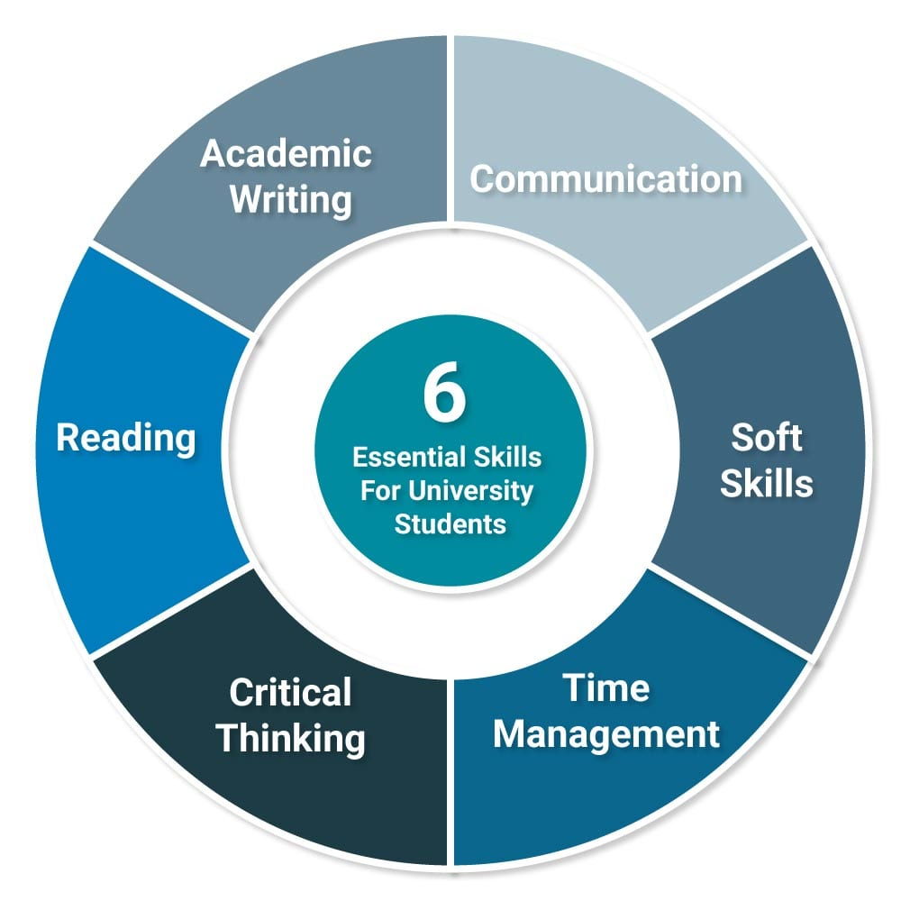
Figure 1: Essential Skills for Academic and Employment Career [5]
Mastering these skills will provide a strong foundation for my chosen career in computing. Effective communication skills will enable me to interact effectively with colleagues and clients, while critical thinking will empower me to solve problems efficiently and drive innovation in my work. Effective time management will ensure that I meet project deadlines and maintain high productivity, while teamwork will enable successful collaboration on multidisciplinary projects. Digital literacy will allow me to use technological tools confidently, keeping me competitive in a rapidly evolving workplace. Together, these skills will transform me into a professional who can not only perform tasks effectively but also adapt, innovate, and thrive in my career.

Task 1 (b): Evaluation of Task 1 (a) based on Similarity report

A Turnitin similarity report shows how much of your text matches existing sources, but the percentage alone doesn’t mean plagiarism. Some similarity can come from common keywords, standard academic templates, or reference lists, which are normal and not penalized. What matters is whether large sections of your writing are copied or poorly paraphrased. To improve your report, you should rewrite highlighted sentences in your own words, cite sources correctly, and minimize unnecessary direct quotes. If your similarity mainly comes from references or standard phrases, your work is generally acceptable.
I believe I deserve 8/10 because the answer clearly explains what a Turnitin similarity report means, identifies the acceptable sources of similarity (keywords, templates, and references), and ways to improve the text. It is concise, not to use copy past, well-organized, and follows the instruction .

Task 2: Collaborative Mind Map and Individual Poster

Mind Map (Collaborative)

Poster (Individual)

Task 3: Virtual Collaboration and RefWorks

Report on Virtual Collaboration
Put your Chosen topic here

Step-by-step process of using RefWorks with visuals

Task 4: E-Portfolio Creation and Evaluation

Task 4 (a): E-Portfolio Creation

Task 4 (b): Illustrative Review of E-Portfolio tool Selection

Conclusion

References

Task 1 References:

[1] | M. H. Abbasi, S. Attiya and u. A. A. Rahat, “Role of Effective Communications for Enhancing Leadership and Entrepreneurial Skills in University Students,” International Journal of Business and Social Science, vol. 2, no. 10, p. 242–249, Jun. 2011.
[2] | F. A. Yusuf and E. A. Adeoye, “Developing Critical Thinking and Communication Skills in Students: Implications for Practice in Education,” An International Multidisciplinary Journal, Ethiopia, vol. 6, no. 1, p. 311–324, 2012.
[3] | N. Cemaloğlu and F. Sevil, “The Relation Between Time Management Skills and Academic Achievement of Potential Teachers,” Educational Research Quarterly, vol. 33, no. 4, p. 3–23, 210.
[4] | R. H. Brookes, “DEVELOPING TEAMWORK SKILLS IN UNDERGRADUATE SCIENCE STUDENTS: THE ACADEMIC,” in Proceedings of the Australian Conference on Science and Mathematics Education, Clayton, VIC, Australia, 2017.
[5] | R. Needleman., “What Are The 6 Essential Skills For University Students,” 2025.

Task 3 References:

