Samuel Jay Lloyd

2110666
Advanced Digital Signal Processing
ACDA6018

Contents
Introduction 5
Research 5
Task 1 5
Task 2 7
Implementation 8
Task 1 8
Task 2 10
Results and Analysis 11
Task 1 11
Task 2 17
Ethical & societal impact 18
Task 1 18
Task 2 18
Conclusion 19
Task 1 19
Task 2 19
References 20

Figure 1: FM example 5
Figure 2: Modulation block diagram [5] 6
Figure 3: Demodulation Block Diagram [5] 6
Figure 4: FHSS TX example [9] 7
Figure 5: FM TX 8
Figure 6: FM RX 8
Figure 7: FM TX with Noise 9
Figure 8: FHSS TX 9
Figure 9: FHSS RX 10
Figure 10: FM RX for RTL-SDR 11
Figure 11: FM TX Time Sink before Modulation 12
Figure 12: FM TX Waterfall after Modulation 12
Figure 13: FM TX time Sink After Modulation 12
Figure 14: FM TX Frequency Sink after Modulation 12
Figure 15: FM TX Constellation Sink after Modulation 12
Figure 16: FM RX Waterfall Sink after Demodulation 13
Figure 17: FM RX Time Sink after Demodulation 13
Figure 18: FM RX Frequency Sink after Demodulation 13
Figure 19: FM TX + Noise Waterfall Sink after Modulation 13
Figure 20: FM TX + Noise Time Sink after Modulation 13
Figure 21: FM TX + Noise Frequency Sink after Modulation 14
Figure 22: FM RX + Noise Waterfall Sink after Demodulation 14
Figure 23: FM RX + Noise Time Sink after Demodulation 14
Figure 24: FM RX + Noise Frequency Sink after Demodulation 14
Figure 25: FHSS TX Waterfall 14
Figure 26: FHSS TX Time @channel B 15
Figure 27: FHSS TX Time @channel C 15
Figure 28: FHSS TX Frequency @channel B 15
Figure 29: FHSS TX Frequency @channel C 15
Figure 30: FHSS RX Waterfall 15
Figure 31: FHSS RX Time 16
Figure 32: FHSS RX frequency @channel B 16
Figure 33: FHSS RX frequency @channel C 16
Figure 34: FHSS RX Waterfall @Channel B with Large Noise on Channel B 16
Figure 35: FHSS RX Time @Channel B with Large Noise on Channel B 16
Figure 36: FHSS RX Frequency @Channel B with Large Noise on Channel B 16
Figure 37: FHSS RX Waterfall @Channel C with Large Noise on Channel B 17
Figure 38: FHSS RX Time @Channel C with Large Noise on Channel B 17
Figure 39: FHSS RX Frequency @Channel C with Large Noise on Channel B 17
Figure 40: RTL-SDR Frequency Sink 17
Figure 41: RTL-SDR Waterfall Sink 17
Figure 42: RTL-SDR Time Sink 18
Figure 43: RTL-SDR Constellation 18

Equation 1: FM Modulation [4] 6
Equation 2: NBFM formula [4] 6
Equation 3: NBFM formula [4] 6
Equation 4: Signal to Noise Power Ratio [8] 6
Equation 5: Decimation and Interpolation on sample rate [17] 10
Equation 6: The sample rate should be greater than twice the Nyquist frequency [18] 10

Introduction
This report documents 2 tasks, these will be researched, completed and concluded. Task 1 will be looking into the creation and advancement of a frequency modulator in GNU radio tool. Task 2 will be using a software defined radio attachment and GNU radio to demodulate a live radio signal.
For Task 1 this will start by creating an NBFM (Narrow Band Frequency modulation) system, passing an audio file, noting the effects this has on the file. Then adding noise to this system and noting the effects this has on the demodulation. Finally, creating FHSS (Frequency Hopping Spread Spectrum) which aims to reduce/ remove the effects of the added noise.
For Task 2 the aim is to connect an RTL-SDR, a form of Software defined radio attachment, to a laptop and create a GNU Radio receiver chain which will demodulate this and play the sound aloud.

Research

Task 1
First looking into what FM is, this is a method of modulation which processes the carrier by encoding it by changing the frequency [1]. An example of this can be seen in Figure 1, this shows how the message signal and carrier signal are combined into the modulated signal.
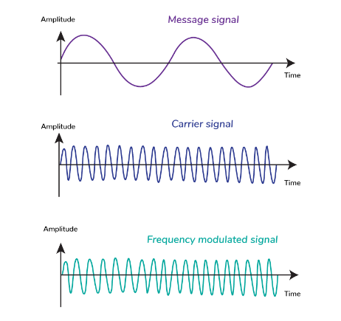
Figure 1: FM example
There are 2 main types of FM modulation these being NBFM, Narrow Band Frequency modulation, and WBFM, Wide Band Frequency Modulation. The Core difference is in the range of frequencies used to carry the message, for narrow band this this is a small range whereas wide band this is a larger range [2]. Examples of the use cases are [3]:
- WBFM – entertainment broadcasting
- NBFM – Wireless communication such as police radios

The Formula for FM is as seen in Equation 1
$$s\left(t\right)=A_{c}\cos{(2πf_{c}t +2πk_{f}\int{m\left(t\right) dt})}$$
Equation 1: FM Modulation [4]
For NBFM the Equation 2 must be True, if this was False this would make this a WBFM.
$$\left|2πk_{f}\int{m\left(t\right)dt}\right|≪1$$
Equation 2: NBFM formula [4]
Combing these both you end with the final formula of Equation 3
$$s\left(t\right)= A_{c}\cos\left(2πf_{c}t\right)-A_{c}\sin\left(2πf_{c}t\right)2πk_{f}\int{m(t)}dt$$
Equation 3: NBFM formula [4]
Using this logic a Frequency modulator and demodulator can be made with this block diagram as a base seen in Figure 2 and Figure 3. Using the combination of these formulas and block Diagrams the methodology could be determined.
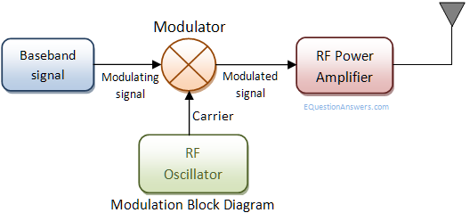  Figure 2: Modulation block diagram [5] | 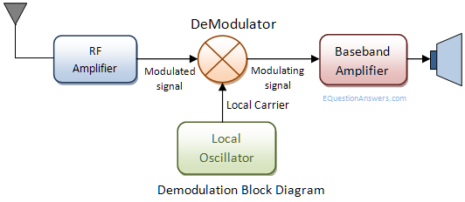  Figure 3: Demodulation Block Diagram [5]

Step 2 in the task will be to add the noise into the equation and monitor the effects attempting to use this to create a jammer effect [6]. This will be done by adding Gaussian noise to the system [7], this is used to simulate real noise that would be found out in the real world. Once implemented this will show a clear effect on the NBFM when demodulated. The implementation of this can be seen in Equation 4, using this and the previous step the methodology can be concluded.
$$SNR=\frac{S_{i}}{N_{i}}$$
Equation 4: Signal to Noise Power Ratio [8]
The Final step is to convert the NBFM system into a FHSS. Figure 4 shows an example of how an FHSS may look and the methodology required, in this case a frequency synthesizer is used with the input from a Pseudorandom code generator. This creates an appearance of a random output but with this being a known sequence which can be easily tracked at the RX end of the system.
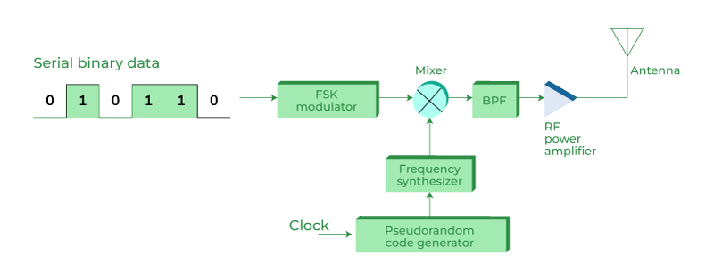
Figure 4: FHSS TX example [9]
Some of the advantages to using a FHSS are [10]:
- Enhanced security – due to rapidly changing frequency this makes the signal harder to intercept or jam unless the sequence is known.
- Spectrum efficiency – this uses a range of frequencies maximising the use of the available bandwidth.

Task 2
For task 2 the Aims would be to research an RTL-SDR, the modulation types for Radio and the Frequencies used by different radio stations.
First the RTL-SDR [11] is a simple SDR with none of the traditional components, instead this is all implemented by software on a computer device such as a laptop or Raspberry PI. This makes this a low-cost device that can be used from anything from 500kHz to 1.75GHz. In this case the software used will be GNU radio [12].
The main Types of traditional radio are AM and FM, in this case we will investigate the FM stations. FM modulations is considered better [13], even though AM is a simpler setup FM is less effected by noise, the sound quality is superior, higher bandwidth efficiency and more efficient use of power, this does have the negative of not traveling as far as AM so requires more radio stations.
With the Aim of listening into “BBC Radio 1” the frequency will be 97.1Mhz [14].

Implementation

Task 1
For the First part of Task 1 the modulation and demodulation can be seen bellow in Figure 5 and Figure 6.
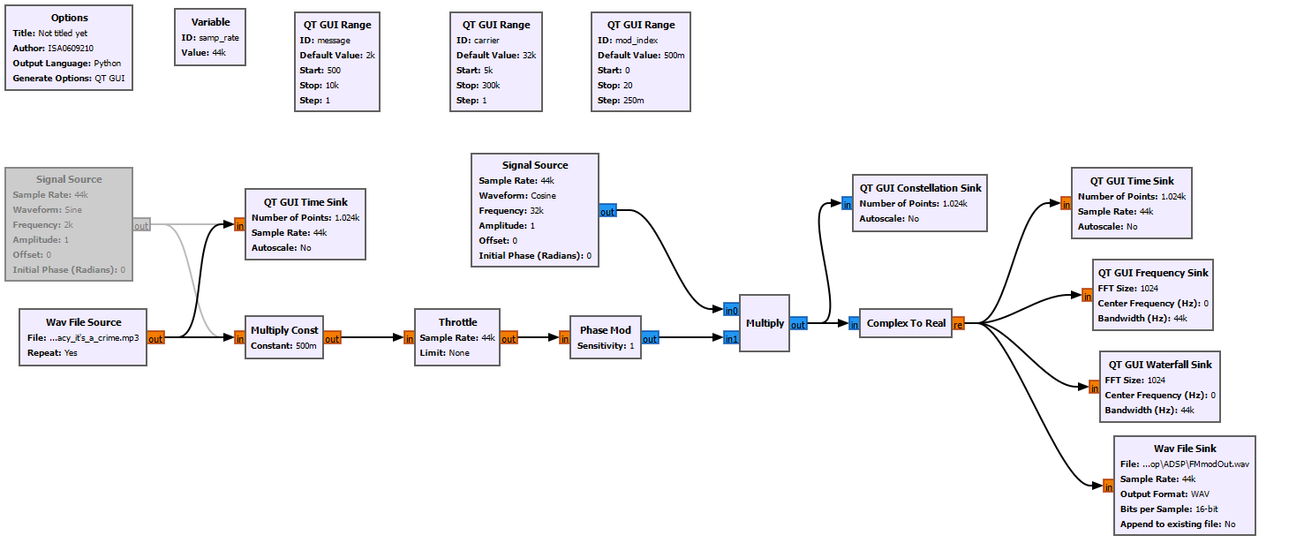
Figure 5: FM TX
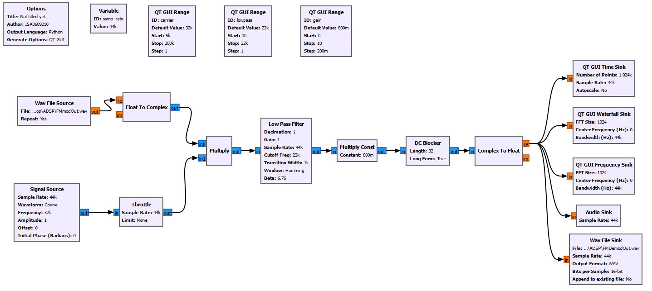
Figure 6: FM RX
For the second part of this task the modulation part also adds the Noise to the loop, this can be seen in Figure 7, the demodulation is the same as the first part so can be seen in Figure 6.
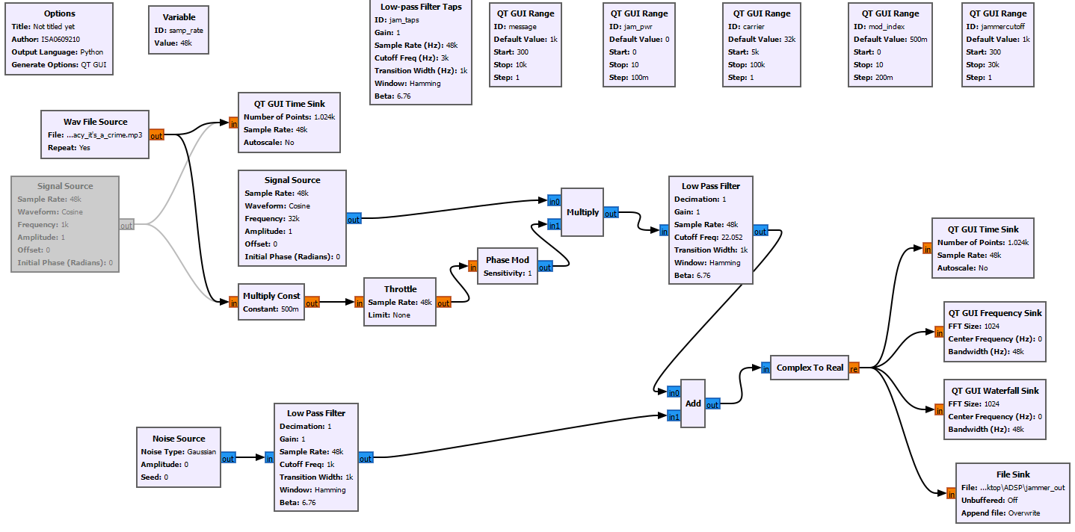
Figure 7: FM TX with Noise
For the Final part of this task the is to create an FHSS modulation and demodulation, these can be seen in Figure 8 and Figure 9.
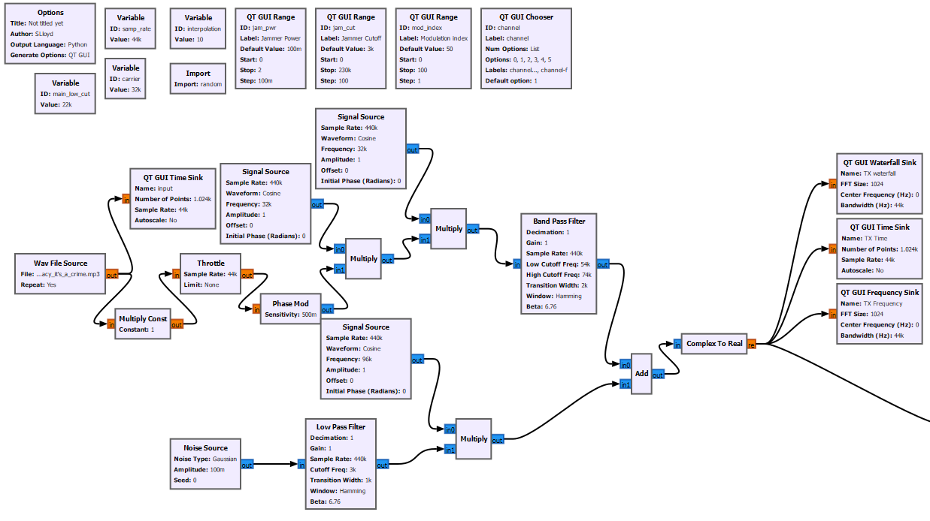
Figure 8: FHSS TX
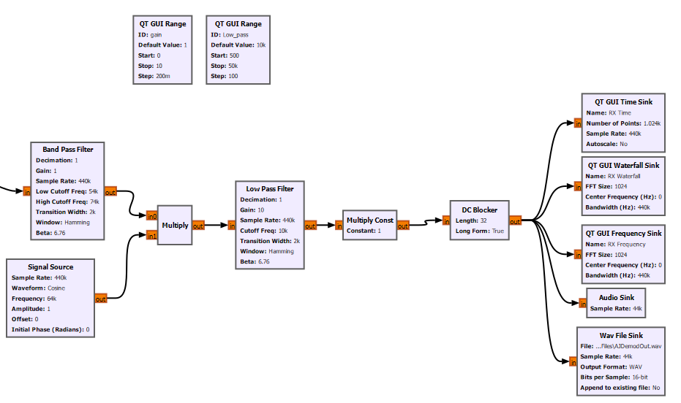
Figure 9: FHSS RX

Task 2
For task 2 First the RTL-SDR had to be connected to the laptop, once done the next step was to download the software required for this to operate [15]. The next step was to create the GNU radio RX for the desired frequency, this can be seen bellow in Figure 10, when used this required a small amount of tuning to get the Audio sounding clear but meaning the system ended up on not exactually 97.1MHz but was within this area. These components and values have been selected for:
- RTL-SDR – this is used to program the RTL-SDR to gather the desired data.
- Low pass filter [16] – removes any unwanted noise outside of the relevant range.
  - Decimation value (4) – reducing the computing power required from 2M to 500K
$$Output sample rate = current sample rate X \frac{Interpolation}{Decimation}$$
Equation 5: Decimation and Interpolation on sample rate [17]
$$Output sample rate = 2M X \frac{1}{4}$$
$$Output sample rate = 500K Hz$$
  - Cutoff (100K) – removing any unwanted noise above this value
Consider, $f_{max}=100 K$ Hz
$$f_{sample}≥2f_{max}$$
Equation 6: The sample rate should be greater than twice the Nyquist frequency [18]
$$f_{sample}=\frac{2 M }{4}=500 K$$
Therefore,
$$500 K ≥ 2* 100 K$$
$$Cutoff =f_{max}=100 KHz$$

- WBFM receiver [19] – used to demodulate a broadcasted FM Signal
  - Quadrature value (500K) – Input sample rate of complex baseband input, this value was found though trial and error.
- Rational Re sampler [20] – This is a polyphase FIR filter used to filter away unwanted noise and carrying out interpolation and decimation
  - Interpolation (48) Decimation (500) – this requires for a value of decimation to be higher to decrease the sampling rate. This reduces the sample rate from 500K input to 48K output. Using Equation 5:
$$Output sample rate = 500K X \frac{48}{500}$$
$$Output sample rate = 48 K Hz$$

- Multiply const is to increase the volume.
- Audio sink is to output the audio.
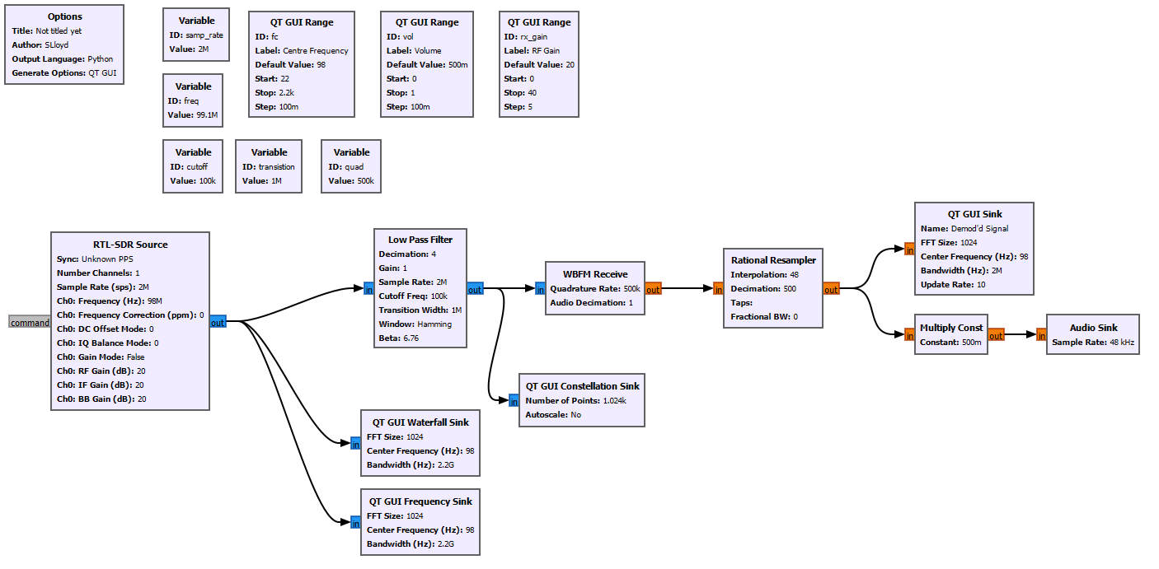
Figure 10: FM RX for RTL-SDR

Results and Analysis

Task 1
For the first part of Task 1 the Original Audio File can be seen in Figure 11, this will be found in the Zip file attached titled “OriginalAudio/Piracy_it's_a_crime.wav”. This then passes through the modulation and the output can be seen in Figure 12, Figure 13, Figure 14 and Figure 15. These all show the changes that occur during modulation, Figure 12 and Figure 14 show the difference in frequency from the Message and carrier, this comes to peaks at 12kHz, with the message being at 44 and carrier at 32, leaving a difference of 12 as expected. These also show the low bandwidth used by how narrow the lines are on the waterfall and how sharp the peaks are in the Frequency Sink. Figure 13 shows the wave created by Equation 3: NBFM formula [4]the modulation, also being seen in Equation 3. Figure 15 shows the output of the Constellation Sink, this creates a clear circle showing the range of outputs created, this being a clear circle shows that there is no effect from noise.
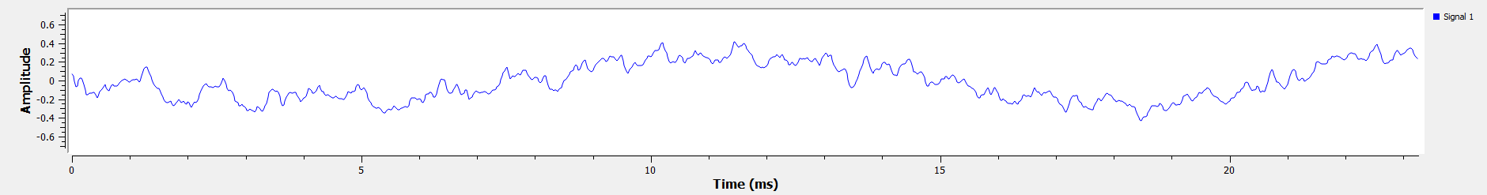
Figure 11: FM TX Time Sink before Modulation
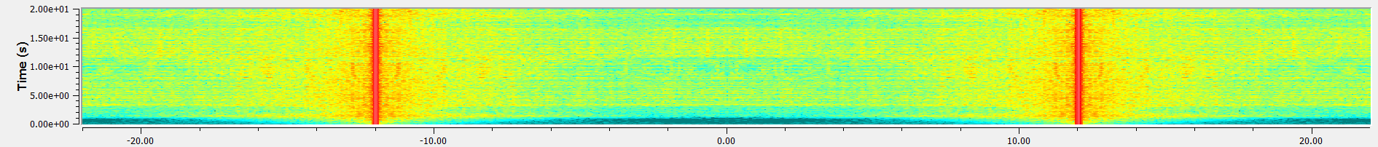
Figure 12: FM TX Waterfall after Modulation
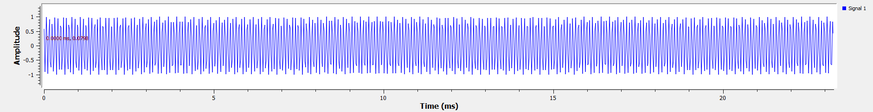
Figure 13: FM TX time Sink After Modulation
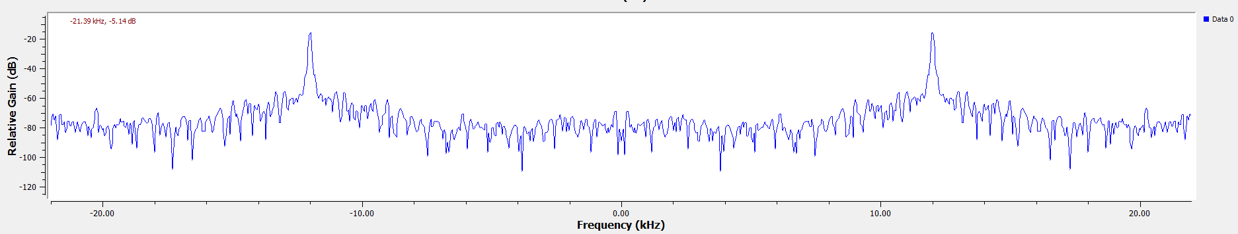
Figure 14: FM TX Frequency Sink after Modulation
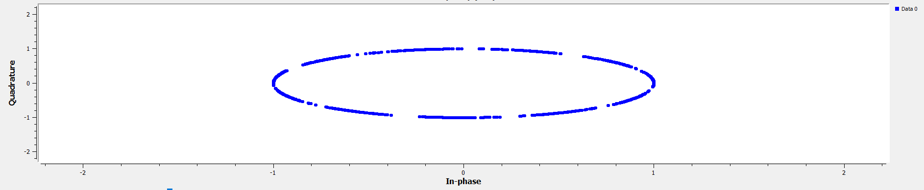
Figure 15: FM TX Constellation Sink after Modulation

The demodulation from the FM output can be seen in the images Figure 16, Figure 17 and Figure 18, the file can be heard in “DemodFiles/FMDemodOut” found in the ZIP. The Audio can clearly be made out as the same but is slightly affected and muffled. This again shows a lot of the same things previously discussed, showing the narrow bandwidth.
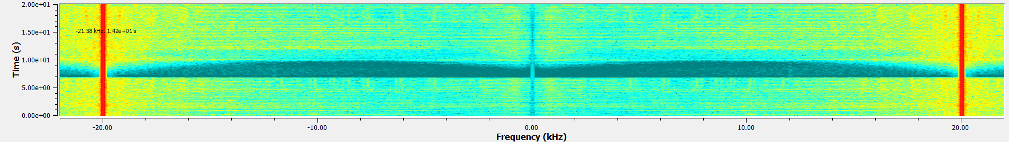
Figure 16: FM RX Waterfall Sink after Demodulation
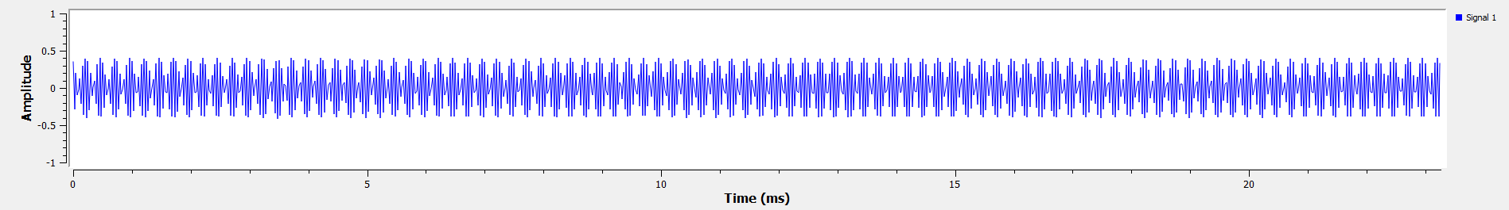
Figure 17: FM RX Time Sink after Demodulation
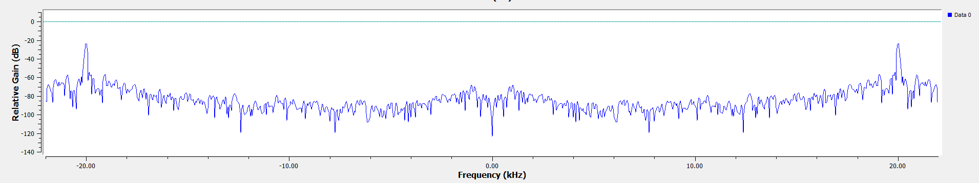
Figure 18: FM RX Frequency Sink after Demodulation

For the second part of task 2 this was to add the noise, this can clearly be seen in Figure 19, Figure 20 and Figure 21. Figure 19 compared to Figure 12 shows a large amount of noise in the center of the waterfall sink, this same noise can also be seen on Figure 21. Additionally, you can clearly see the distortion when comparing the Time Sink outputs of Figure 20 and Figure 13, the FM wave can still be seen in Figure 20 but the frequency is moving in amplitude as well creating the distortion.
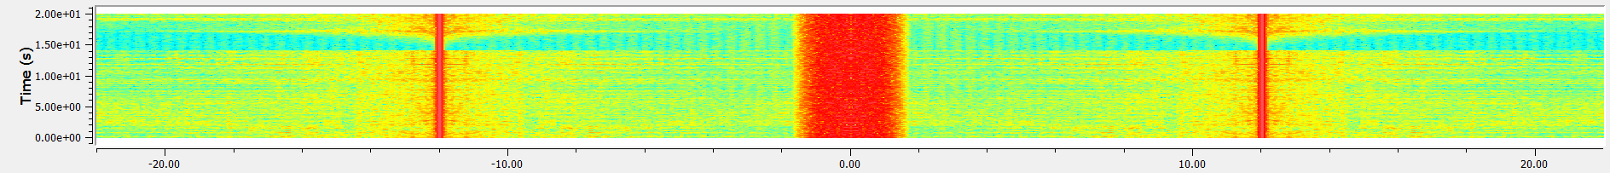
Figure 19: FM TX + Noise Waterfall Sink after Modulation
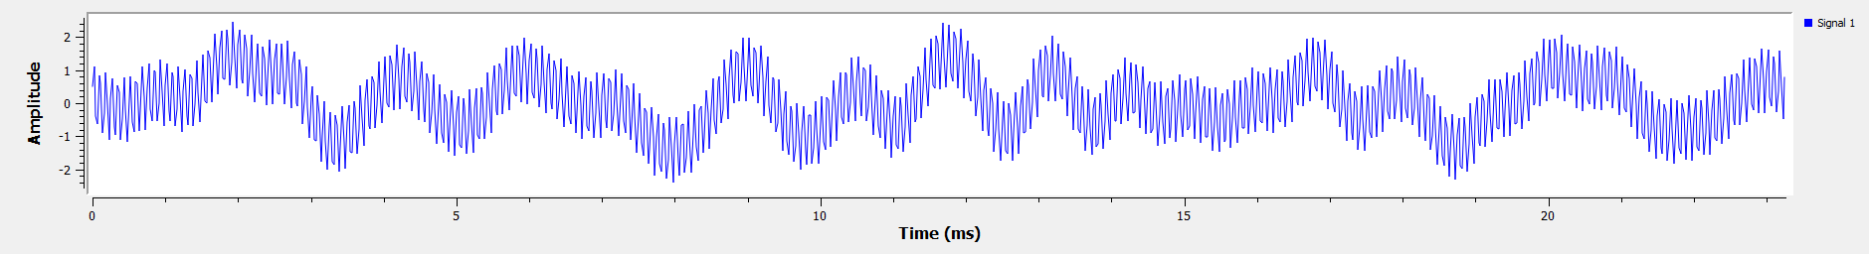
Figure 20: FM TX + Noise Time Sink after Modulation
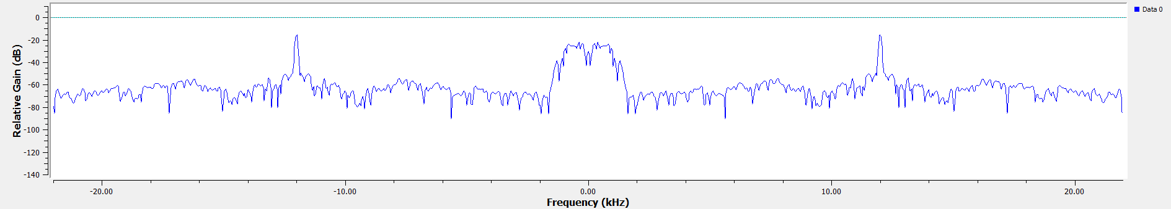
Figure 21: FM TX + Noise Frequency Sink after Modulation

When attempting to demodulate this it is a complete failure, the first ~5 Seconds where of a no Noise signal, after this the noise was added. The distortion can clearly be seen in all Figure 22, Figure 23 and Figure 24, there is no remains of the signal to be examined.
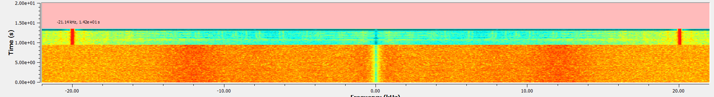
Figure 22: FM RX + Noise Waterfall Sink after Demodulation
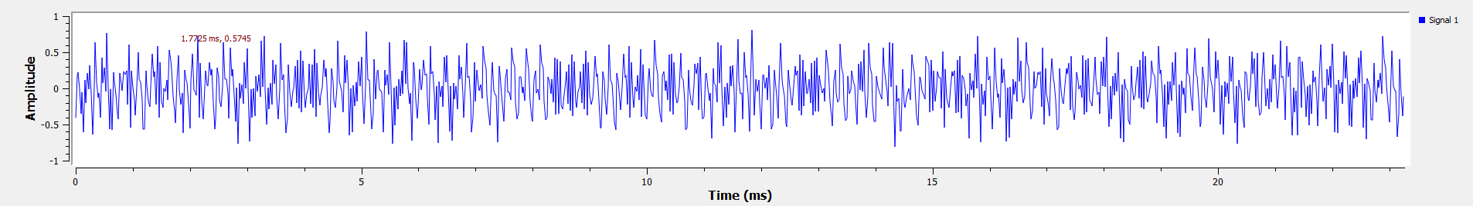
Figure 23: FM RX + Noise Time Sink after Demodulation
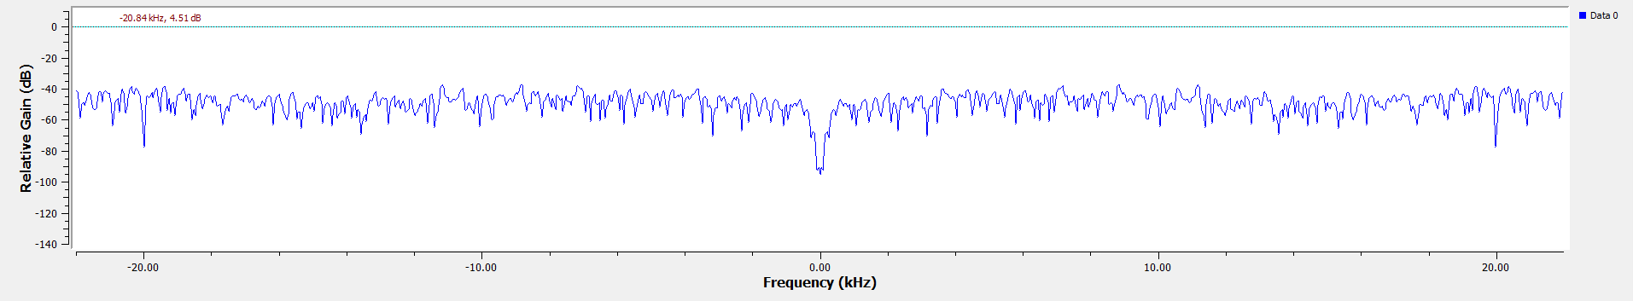
Figure 24: FM RX + Noise Frequency Sink after Demodulation

When producing the FHSS modulation the aim is to create a clear hopping pattern, this can be seen in Figure 25, this clearly shows the hopping between frequencies. Figure 26 and Figure 27 show the difference in the frequencies over channel B and C. Finally, Figure 28 and Figure 29 shows the difference in carrier frequency and bandwidth of the carrier. Figure 29 additionally shows where the noise can be seen, in this case the power on the noise of too low to create an effect, the power of this needs to be above 0.7 to cause distortion and above 2 to create an error in the sound.
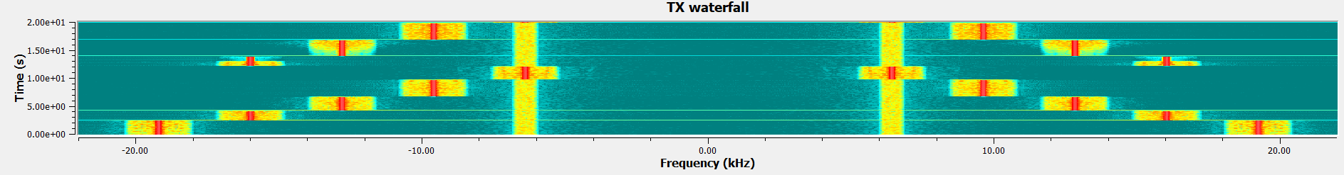
Figure 25: FHSS TX Waterfall
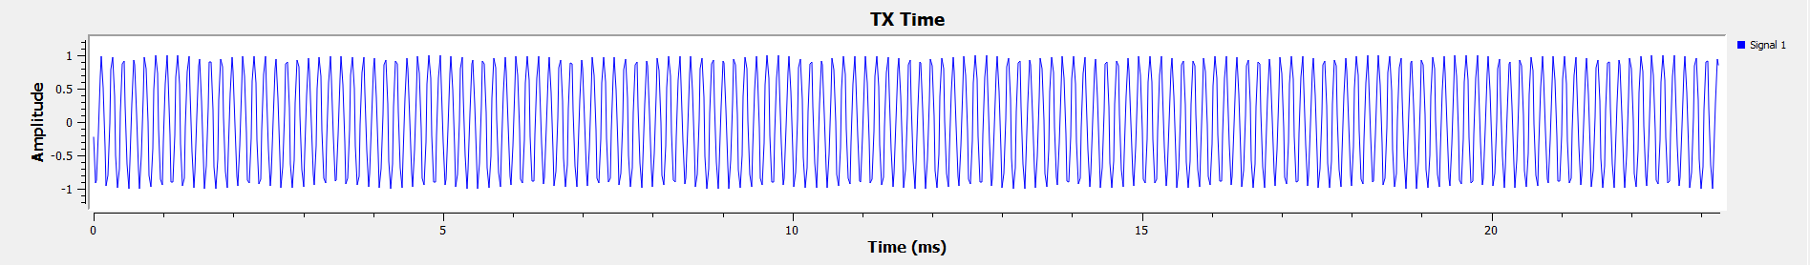
Figure 26: FHSS TX Time @channel B
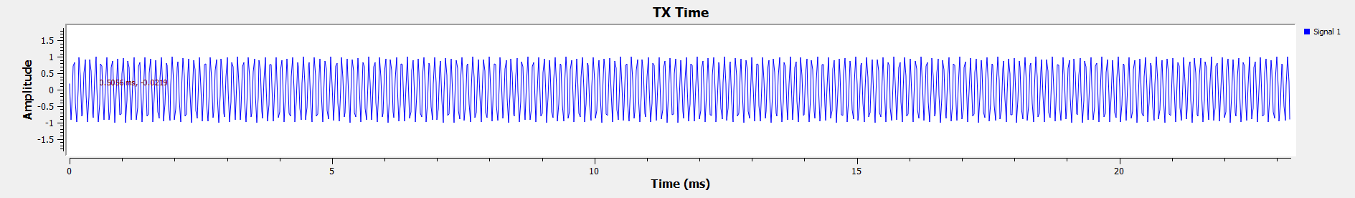
Figure 27: FHSS TX Time @channel C
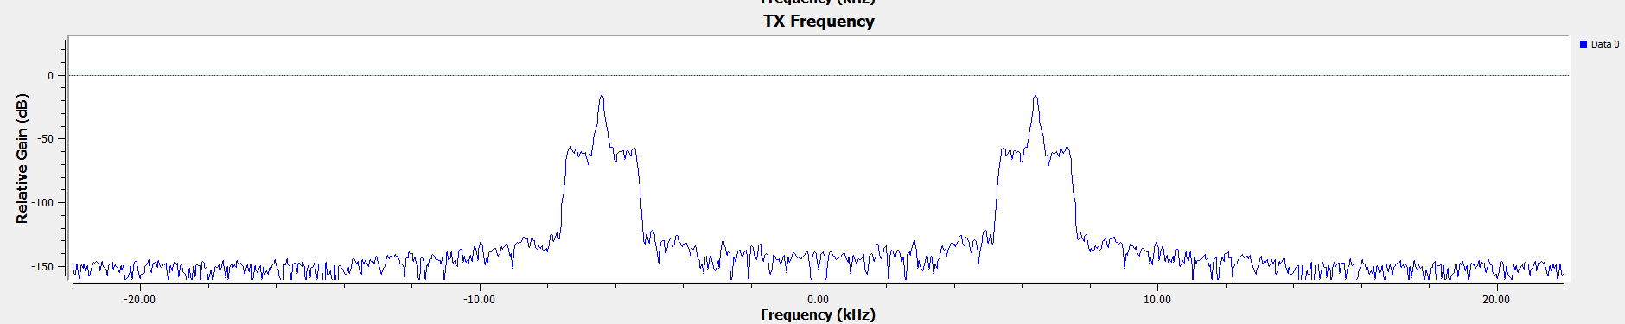
Figure 28: FHSS TX Frequency @channel B
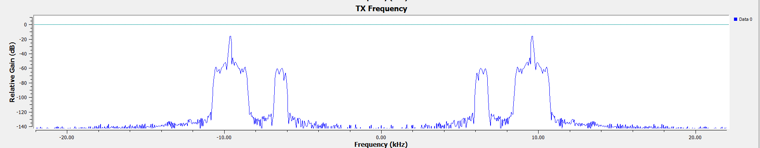
Figure 29: FHSS TX Frequency @channel C

In the demodulation Part of the FHSS the waterfall can be seen in Figure 30, this shows how the message is re centralised, and no real noise can be seen. This is also true for Figure 31, this shows the final output with little distortion. Figure 32 and Figure 33 show the between the carriers, showing the message clear in the middle and the varying width on the remaining carrier.
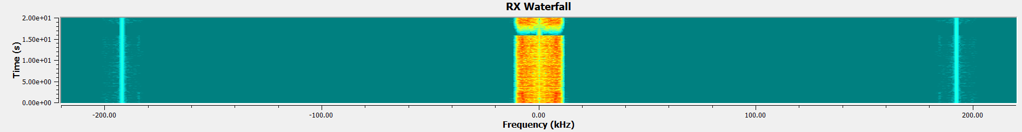
Figure 30: FHSS RX Waterfall
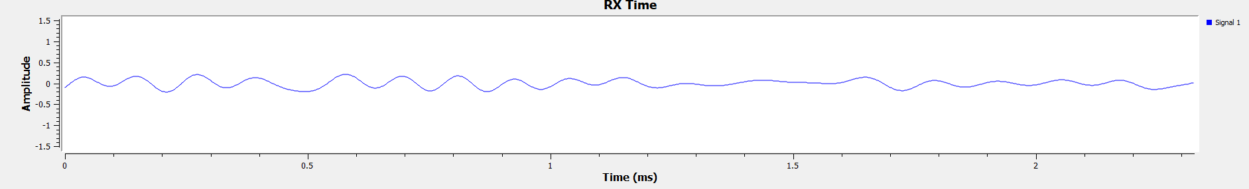
Figure 31: FHSS RX Time
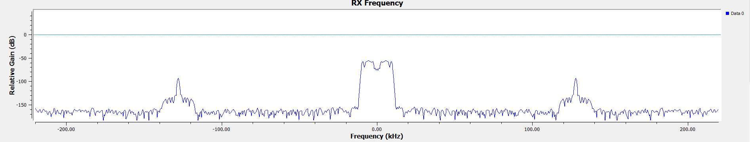
Figure 32: FHSS RX frequency @channel B
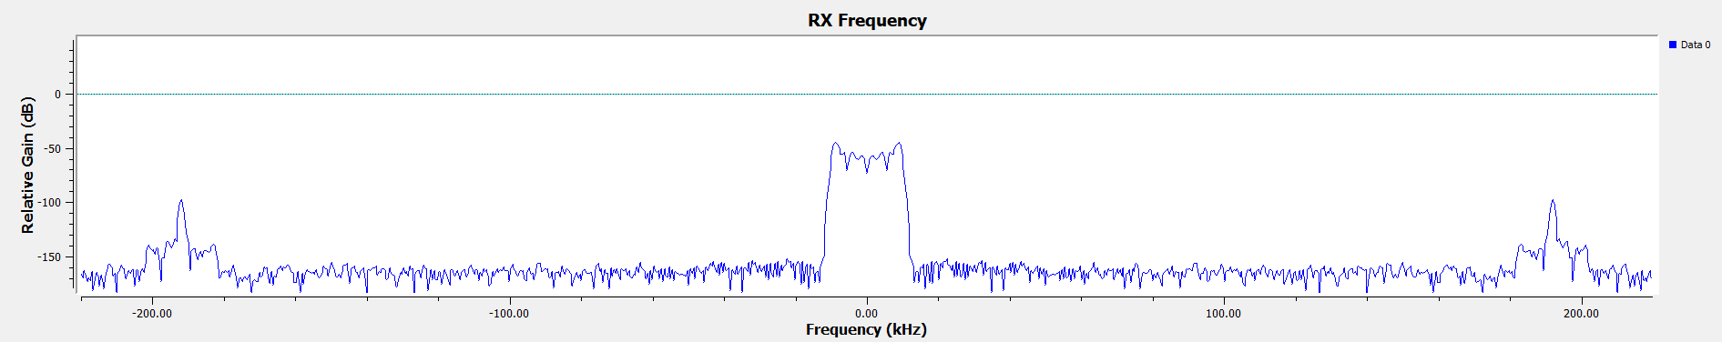
Figure 33: FHSS RX frequency @channel C
Figure 34, Figure 35 and Figure 36 show the Effect on the RX if the TX is set that a large amount of noise is input into a channel when transmitting on that channel, these clearly show the effects of the noise, showing distortion on the channel and a loss of information.
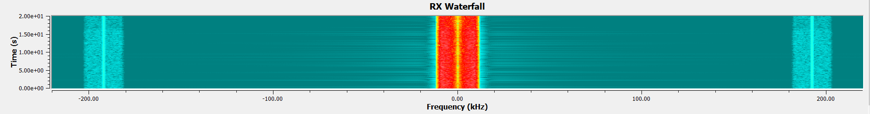
Figure 34: FHSS RX Waterfall @Channel B with Large Noise on Channel B
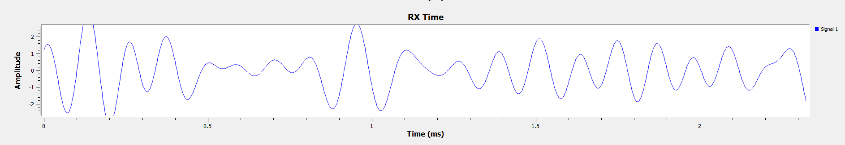
Figure 35: FHSS RX Time @Channel B with Large Noise on Channel B
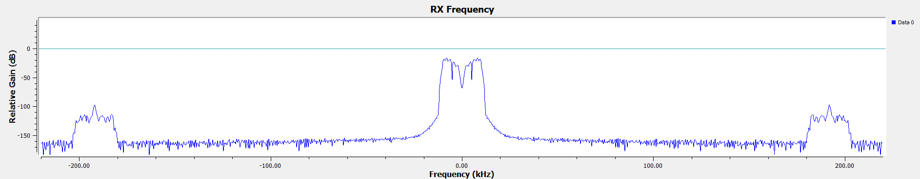
Figure 36: FHSS RX Frequency @Channel B with Large Noise on Channel B
Figure 37, Figure 38 and Figure 39 show the RX effect when the TX has noise but is on a different frequency, this shows no effects after changing transmission channel, this means that the data is protected against the jamming.
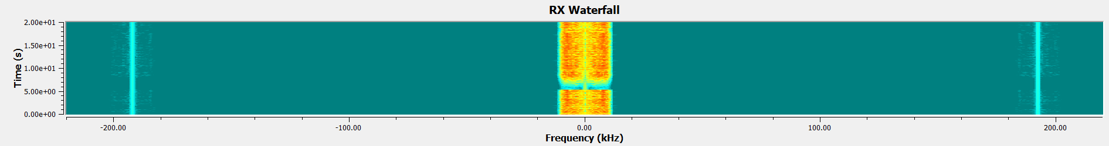
Figure 37: FHSS RX Waterfall @Channel C with Large Noise on Channel B
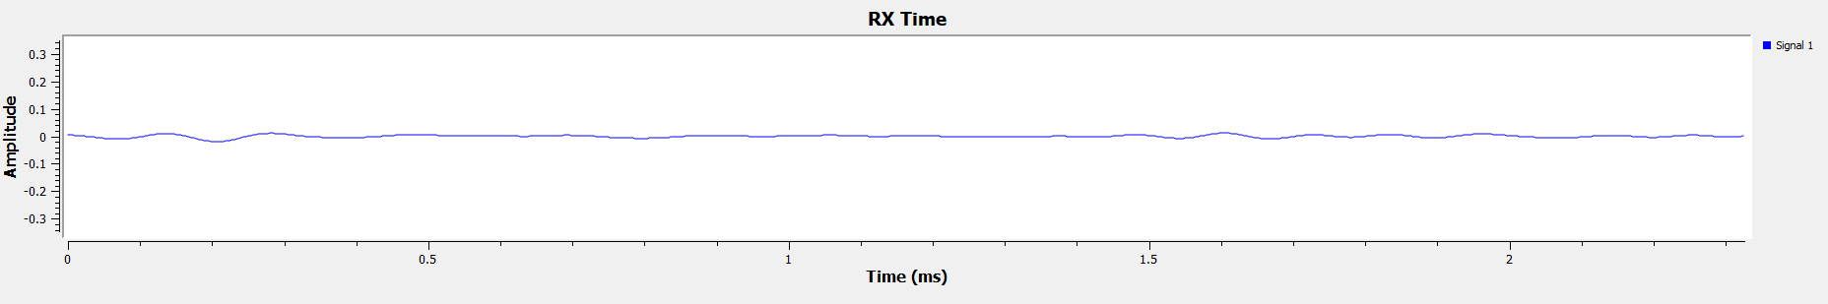
Figure 38: FHSS RX Time @Channel C with Large Noise on Channel B
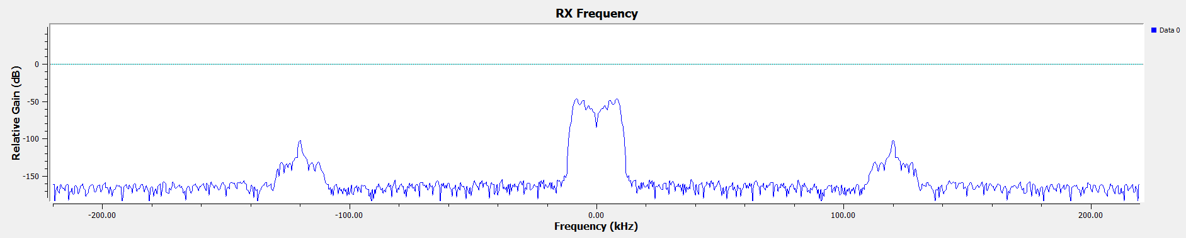
Figure 39: FHSS RX Frequency @Channel C with Large Noise on Channel B

Task 2
Figure 40 shows the frequency before demodulation, showing the message and modulation peak. Figure 41 shows the waterfall of frequency, this shows the surrounding noise before demodulation. Figure 42 this shows the time sink after demodulation, showing the received message, this being the Radio 1 Broadcast. Figure 43 shows the constellation Diagram after the low pass filter showing the points of variation on the modulated transmission.
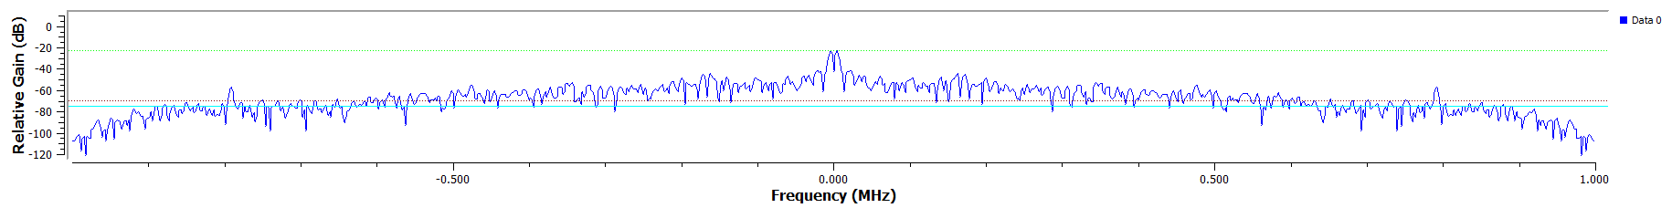
Figure 40: RTL-SDR Frequency Sink
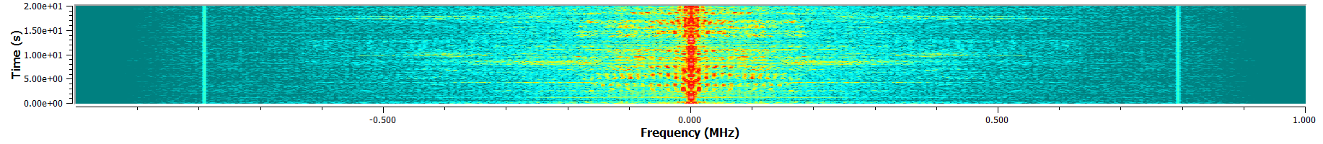
Figure 41: RTL-SDR Waterfall Sink
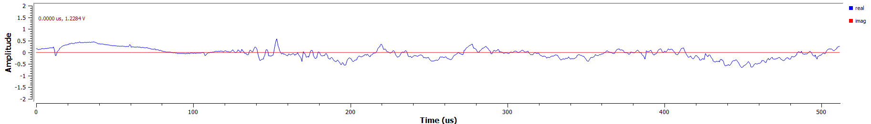
Figure 42: RTL-SDR Time Sink
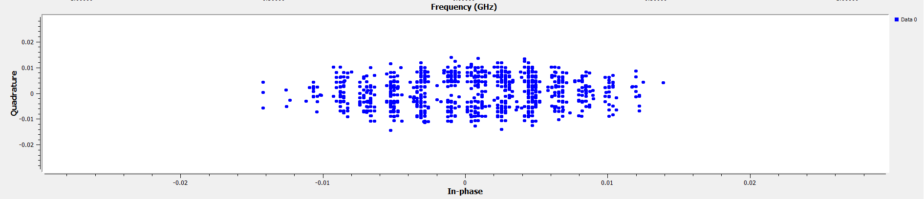
Figure 43: RTL-SDR Constellation

Ethical & societal impact

Task 1
For the Ethics and societal impact within this section this will look at Jamming and FHSS systems and generally more secure communication.
The effects of Jamming can vary largely depending on what is in the surroundings and what frequency is being jammed but in a modern-day society can be great due to the dependence on Radio systems [21]. Due to these threats from jamming can vary from simply nuisance factor, with wireless devices being affected, to security related effects, knocking out CCTV cameras and alarm systems or even communication systems within a Prison for example, this could even create Economic impact by creating loss of revenue for broadcasters.
The Ethical advantage of using FHSS is that it creates a more secure network [22] for communication, what this means is it becomes a lot more complicated of a system to jam as it is working over a much wider spectrum. This is an advantage for the user meaning there will be less of an effect when attempting to jam. This can be defeated but means either the system is too simple or has been recorded and the Pseudorandomness monitored, recorded and developed against. This can be countered by having a range of set Pseudorandomness and a user can change the settings to a different preset mode.
In general, it is important for a range of reasons to protect all types of communications, whether this is considering Privacy of information when looking at a CCTV system, or security within a Prison if a Jamming system would be put in place [23].

Task 2
For task 2 the Consideration is on the Ethics and Societal impact of SDR’s. The Key advantages of an SDR is the Flexibility of the devise [24], these are no single use build radios, they can be purchased and reused due to the programable framework, this means that thew same SDR hardware can be used for multiple radio architectures. This has the advantage of making creating complex radio systems a much cheaper and more efficient endeavor, making them open for more use cases and people. The negative of this is these can also be used maliciously; they could be used to create a reprogrammable jammer or even to create false communication.

Conclusion

Task 1
In conclusion this shows how simple it is to produce an NBFM system but also how simple this is to effect using simple jamming techniques. These simple systems are still useful in cases but should only be used if not part of a vital network. FHSS shows one of the solutions to this as a system which is harder to take down with jamming, but it is still possible. This together shows FHSS is a clear advancement to regular NBFM due to the fact it has a much wider band width making it more protected against jamming as seen above. For the ethical and social effect, it is important to have a secure communication system as this will mean that major parts of society are harder to take down.

Task 2
In conclusion, task 2 shows how simple SDR’s can be programmed and used for whatever job is desired. In this task the SDR was simply programed within GNU radio to act as a receiver for FM radio aimed to receive Radio 1 Broadcasts. This task shows the simplicity of the programing of an SDR and one of the possible use cases for this.

References

[1] | geeksforgeeks, “Frequency Modulation,” geeksforgeeks, https://www.geeksforgeeks.org/frequency-modulation/, May 2024.
[2] | differencebetween, “Difference Between Narrowband and Wideband,” differencebetween, https://www.differencebetween.net/technology/difference-between-narrowband-and-wideband/.
[3] | Sasmita, “Explain the difference between Narrowband FM and Wideband FM,” electronicspost, https://electronicspost.com/explain-the-difference-between-narrowband-fm-and-wideband-fm/, May 2020.
[4] | tutorialspoint, “Analog Communication - FM Modulators,” tutorialspoint, https://www.tutorialspoint.com/analog_communication/analog_communication_fm_modulators.htm.
[5] | equestionanswers, “Analog and Digital Modulation in the field of communications,” equestionanswers, https://www.equestionanswers.com/notes/modulation-analog-digital.php.
[6] | T. N. Taylor, “An Analysis of FM Jamming and Noise Quality Measures,” https://apps.dtic.mil/sti/tr/pdf/ADA274349.pdf, December 1993.
[7] | geeksforgeeks, “Gaussian Noise,” geeksforgeeks, https://www.geeksforgeeks.org/gaussian-noise/, June 2024.
[8] | libretexts, “4.3: Noise Characterization,” libretexts, https://eng.libretexts.org/Bookshelves/Electrical_Engineering/Electronics/Microwave_and_RF_Design_IV%3A_Modules_(Steer)/04%3A_Noise_Distortion_and_Dynamic_Range/4.03%3A_Noise_Characterization#:~:text=The%20most%20important%20noise-related%20metric%20is%20.
[9] | geeksforgeeks, “Frequency-Hopping Spread Spectrum in Wireless Networks,” geeksforgeeks, https://www.geeksforgeeks.org/frequency-hopping-spread-spectrum-in-wireless-networks/, Oct 2022.
[10] | wraycastle, “Understanding Frequency Hop Spread Spectrum: A Simple Guide,” wraycastle, https://wraycastle.com/blogs/knowledge-base/frequency-hop-spread-spectrum#:~:text=By%20rapidly%20changing%20frequencies%2C%20FHSS%20makes%20it%20difficult,eavesdroppers%20from%20easily%20tuning%20into%20the%20correct%20frequency., Aug 2024.
[11] | usradioguy, “What is RTL-SDR?,” usradioguy, https://usradioguy.com/what-is-rtl-sdr/.
[12] | gnuradio, “Tutorials,” gnuradio, https://wiki.gnuradio.org/index.php/Tutorials.
[13] | geeksforgeeks, “Difference between Amplitude Modulation and Frequency Modulation,” geeksforgeeks, https://www.geeksforgeeks.org/difference-between-amplitude-modulation-and-frequency-modulation/, DEC 2024.
[14] | media.info, “FM frequencies for radio stations in the UK,” media.info, https://media.info/uk/radio/data/platforms/fm.
[15] | nooelec, “Getting Started with NESDR,” nooelec, https://www.nooelec.com/store/qs?srsltid=AfmBOoqmrDRzo_QdgQEV0xs_7u88MeQZoCgarte5gkU6LnefvLfduXOv.
[16] | gnuradio, “Low Pass Filter,” gnuradio, https://wiki.gnuradio.org/index.php?title=Low_Pass_Filter.
[17] | gnuradio, “RTL-SDR FM Receiver,” gnuradio, https://wiki.gnuradio.org/index.php?title=RTL-SDR_FM_Receiver.
[18] | ni, “Acquiring an Analog Signal: Bandwidth, Nyquist Sampling Theorem, and Aliasing,” ni, https://www.ni.com/en/shop/data-acquisition/measurement-fundamentals/analog-fundamentals/acquiring-an-analog-signal--bandwidth--nyquist-sampling-theorem-.html?srsltid=AfmBOoq12giqn9qvNhTEB3s8mslf9b_fZUtdVuslC_WEyBfMBEfd5iuj&utm_source, Jul 2024.
[19] | gnuradio, “WBFM Receive,” gnuradio, https://wiki.gnuradio.org/index.php?title=WBFM_Receive.
[20] | gnuradio, “Rational Resampler,” gnuradio, https://wiki.gnuradio.org/index.php?title=Rational_Resampler.
[21] | IET, “Jamming & radio interference: understanding the impact,” IET, https://www.theiet.org/media/8779/jamming-and-radio-interference.pdf.
[22] | K. T. Hanna, “frequency-hopping spread spectrum (FHSS),” techtarget, https://www.techtarget.com/searchnetworking/definition/frequency-hopping-spread-spectrum.
[23] | jassykom, “The Ethics of Signal Jamming: Balancing Security and Privacy,” globalinterest, https://globalinterest.net/the-ethics-of-signal-jamming-balancing-security-and-privacy/, May 2024.
[24] | R. W. World, “Advantages of SDR | Disadvantages of SDR, Software Defined Radio,” RF Wireless World, https://www.rfwireless-world.com/Terminology/Advantages-and-Disadvantages-of-SDR-Software-Defined-Radio.html.

