University of Wales Trinity Saint David
School of Engineering

Analyse and Simulate a Mechanical Energy Recovery System
Dynamics
ACMA5010
Robert Dale Gubbins
2316959
17/11/2025

Word Count: Task A – 1498 / Task B – 1137. Total = 2635
Contents
1 Introduction 3
2 Historical Development of Flywheels 4
3 Modern Application of Flywheels 7
3.1 Regenerative Braking Systems 7
3.2 Off- Grid Systems 8
4 Kinetic Energy Recovery Systems (KERS) 9
4.1 Operating Principle 9
4.2 System Components 9
4.3 Design Implications 10
5 Mechanical Vs Chemical Batteries 11
6 Task B – Calculations & Analysis 12
6.1 Kinetic Energy of vehicle before braking at 55mph 12
6.2 Energy Stored in Flywheel when vehicle brakes from 55mph to rest: 12
6.3 Rotational Speed of the flywheel after braking (in RPM): 12
6.4 Speed of vehicle using only KERS flywheel: 13
6.5 Relationship between braking speed and final vehicle speed: 13
6.6 Determine re-acceleration when braking from 60mph: 13
6.7 KERS system for a smaller vehicle with a smaller flywheel: 14
7 Assumptions Made in the Analyses 15
8 Conclusion 17
9 References 18
10 Appendices 20

Introduction
Mechanical energy storage is an important way of improving energy efficiency and smoothing power demand in many engineering applications. One of the simplest and oldest ways of doing this is by using a flywheel. A flywheel is a rotating mass that stores kinetic energy in its angular motion (EngineerFix,2025). When extra energy is available the flywheel speeds up, and when energy is needed it slows down and returns that stored energy to the system. This basic idea is now used in Kinetic Energy Recovery Systems (KERS), which appear in some modern vehicles and stationary energy storage systems. In this report, the development of flywheels is outlined from their early use to current applications, followed by an analysis of a mechanical KERS fitted to a high-performance hybrid vehicle.

Historical Development of Flywheels
The use of flywheels can be traced back thousands of years. Early examples appeared in ancient civilisations such as Mesopotamia and Egypt, where potters used simple rotating wheels to help form clay vessels. These early devices demonstrated the basic idea of storing energy through rotational inertia and keeping a steady, controllable motion. As shown in Figure 1, the traditional potter’s wheel is one of the earliest known implementations of a flywheel, using a heavy rotating disc to smooth and sustain manual input forces (Britannica, 2024;Genta, 1985).
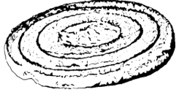
Figure 1 - Historical potters wheel (Genta, 1985, p.4)
The role of flywheels became more significant during the Industrial Revolution. Engineers including James Watt and Matthew Boulton used large cast-iron flywheels in steam engines to smooth out the uneven torque produced during each power stroke. This helped the engines run more reliably and improved the efficiency of early industrial machinery (National Geographic Society, 2014). Flywheels soon appeared throughout factories, powering textile equipment, presses and agricultural machines where a consistent rotational speed was essential. As shown in Figure 2, these rotative steam engines used substantial flywheels to smooth rotational motion before transmitting power to textile equipment, mechanical presses and agricultural machines where maintaining a consistent speed was essential.

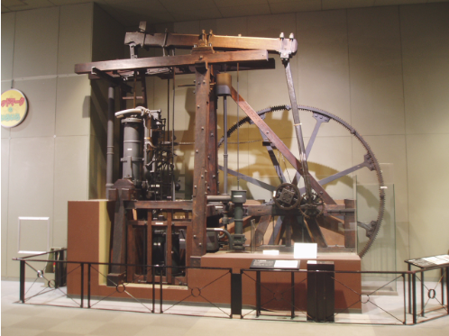
Figure 2 - The Watt rotative steam engine featuring a large cast-iron flywheel (Made up in Britain, n.d.)
By the 20th century, developments in materials made flywheels lighter and stronger. High-strength steels, and later composite materials such as carbon fibre, allowed engineers to increase rotational speeds without risking structural failure. These improvements also supported the transition from purely mechanical flywheels to electro-mechanical energy storage systems used in applications such as uninterruptible power supplies (UPS) and grid support technologies (Xu et al., 2023).
More recently, interest in renewable energy and sustainability has encouraged further refinement of flywheel systems. Modern high-speed flywheels typically operate in vacuum-sealed enclosures with magnetic bearings to reduce friction and extend operational life (Olabi, 2021). Figure 3 illustrates a modular flywheel facility where high-speed rotors are suspended in vacuum enclosures on magnetic bearings, enabling minimal friction and long operational lifetimes. Although very different in appearance from early potters’ wheels, they rely on the same fundamental principle of storing energy by rotating a mass at speed.
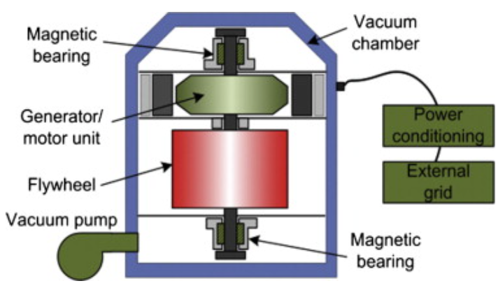
Figure 3 - Flywheel Energy Storage System, showing vacuum chamber, flywheel unit and magnetic bearings (Hawkins, Sikalidis and Lea, 2014)
Contemporary systems build on this principle using composite materials, precision balancing and integrated motor-generators to achieve far higher rotational speeds and energy densities than their historical counterparts (Xu et al., 2023). These advances demonstrate how a long-established mechanical concept has evolved into a highly efficient, clean and reliable technology capable of supporting modern renewable energy and grid stabilisation applications.

Modern Application of Flywheels
Modern engineering has seen a resurgence of interest in flywheel energy storage, driven by the global need for sustainable, efficient, and high-performance energy systems. The key advantage of flywheels lies in their ability to store and release energy rapidly without the chemical degradation associated with batteries. This section discusses two of the most significant modern applications, regenerative braking in vehicles and off-grid or grid-support energy storage systems.

Regenerative Braking Systems
In the automotive and transport sectors, flywheel systems are widely used for regenerative braking, where kinetic energy normally lost as heat during braking is instead captured and stored. When a vehicle decelerates, a Kinetic Energy Recovery System (KERS) transfers a portion of the vehicle’s kinetic energy to a high speed flywheel via a Continuously Variable Transmission (CVT) or an electromechanical coupling. The stored energy is then returned to the drivetrain during acceleration, reducing fuel consumption and emissions (Racecar Engineering, 2012).
One of the earliest and most notable implementations of mechanical flywheel energy storage was developed for Formula 1 (F1) racing. The Flybrid KERS system, produced by Flybrid Systems and later supported by Williams Hybrid Power, used a carbon-fibre flywheel capable of reaching speeds of around 64,500 rpm and storing roughly 400 kJ of recoverable energy (Hedlund et al., 2015). The success of this technology encouraged further development in road vehicle applications, including Volvo’s S60 flywheel-hybrid prototype, which reported fuel saving benefits of up to 25% in testing (Volvo Car Group, 2014). In the bus sector, the Gyrodrive system (developed by GKN Hybrid Power and used by the Go-Ahead Group) achieved similar fuel-savings of around 20%, showing how motorsport derived flywheel systems can benefit heavy-duty stop/start transport (Wired, 2014).

Off- Grid Systems
Beyond vehicle applications, flywheel systems are widely used for power-quality control, renewable-energy smoothing and off-grid energy storage (See Figure 4).
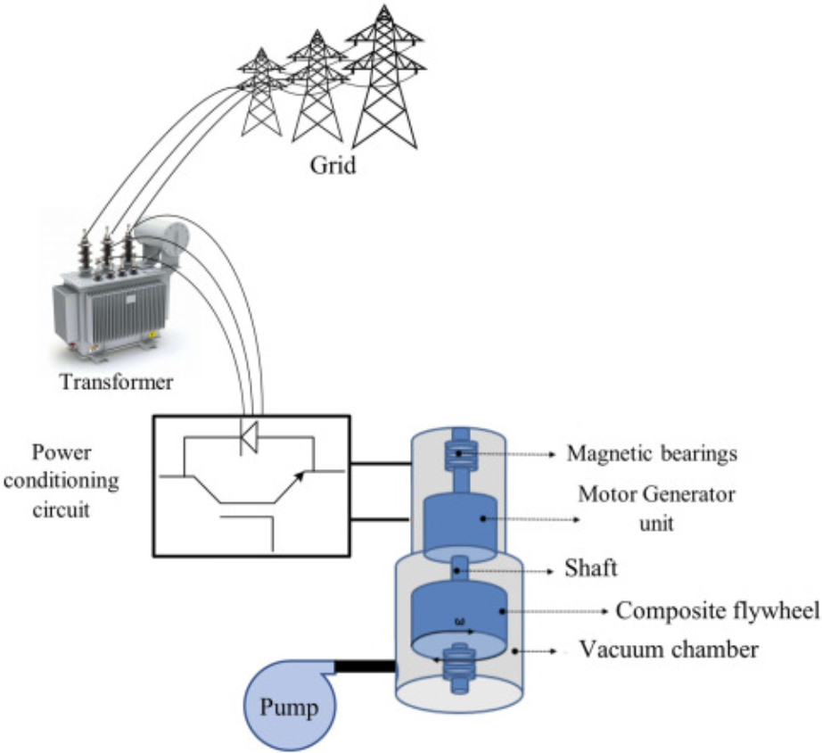
Figure 4 - Simplified structure of a flywheel energy storage system integrated with grid-support power electronics (ScienceDirect, 2025)
Their ability to withstand millions of charge/discharge cycles with minimal degradation makes them suitable for situations that require rapid and frequent energy exchange. Modern high speed flywheels typically operate within vacuum enclosures and use magnetic bearings to minimise friction losses, allowing round-trip efficiencies above 90% (Kesgin et al., 2019). This technology has been utilised commercially, for example, Beacon Power’s 20 MW flywheel facility in Pennsylvania uses carbon fibre rotors and supports grid-frequency regulation (Beacon Power, 2011). Flywheel storage also plays a role in renewable microgrids, one review noted their long service life, high cycling capability, and wide temperature tolerance as key advantages over chemical batteries (CNESA, 2015).

Kinetic Energy Recovery Systems (KERS)
Kinetic Energy Recovery Systems (KERS) are technologies designed to capture and store the kinetic energy that would otherwise be lost during braking, converting it into usable energy for later acceleration. In mechanical KERS, this energy is stored in a rotating flywheel rather than a battery. The system operates on the fundamental principle of energy conservation, where the vehicle’s kinetic energy is transformed into rotational kinetic energy in the flywheel during deceleration, and then converted back into vehicle motion during acceleration (Hedlund et al., 2015).

Operating Principle
When the driver applies the brakes, a Continuously Variable Transmission (CVT) or clutch-based coupling links the vehicle’s drivetrain to the flywheel system. Instead of dissipating braking energy as heat, the KERS diverts a portion of that energy into accelerating the flywheel, storing it as rotational kinetic energy (Hedlund et al., 2015). When additional power is required during re-acceleration, the CVT reverses the flow and transfers energy back to the wheels, supplementing engine output. Demonstration vehicles such as the flywheel-hybrid prototype by Volvo and Flybrid have shown fuel economy improvements of up to 25 % in urban driving (Volvo Car Group, 2014).

System Components
A typical mechanical KERS consists of:
- Flywheel Unit: Usually a high-strength steel or carbon-fibre composite disc, operating in a vacuum-sealed housing to minimise aerodynamic losses.
- Bearings: Often magnetic or hybrid to reduce friction and extend operational lifespan.
- Energy Transfer Mechanism: A CVT, planetary gearset, or torque converter that manages power flow between the vehicle and flywheel.
- Containment Housing: Provides safety by containing debris in case of flywheel failure at high rotational speeds.
- Control System: Electronic interface that regulates engagement, speed limits, and torque transfer for smooth operation.

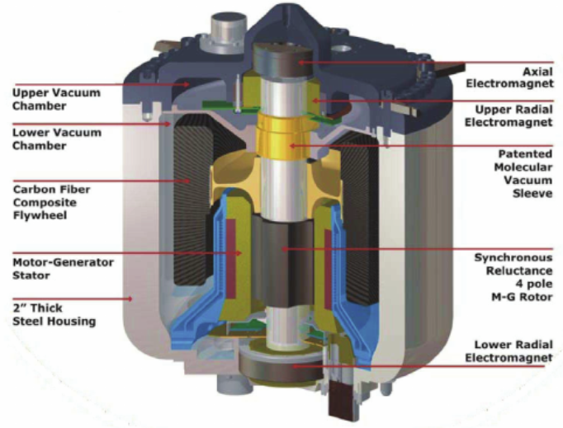
Figure 5 - Internal components of a flywheel energy storage module, showing the carbon-fibre rotor, magnetic bearings, motor–generator interface, containment housing and vacuum enclosure (POWERTHRU,n.d.)
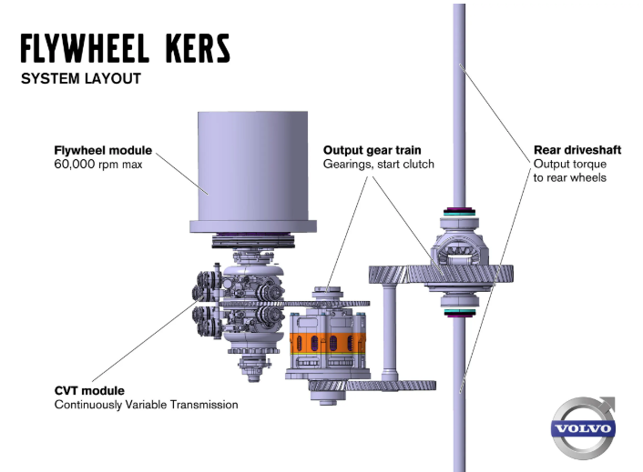
Figure 6 - Layout of a mechanical KERS installation in a passenger vehicle, illustrating the integration of the flywheel unit with the CVT and rear-axle drivetrain (Volvo Cars, 2014)

Design Implications
Designing a reliable mechanical KERS presents several engineering challenges. One of the most critical is ensuring that the flywheel is precisely balanced, as even small mass asymmetries can generate significant vibrational forces at rotational speeds that may exceed 50,000 rpm. As a result, high speed flywheels are balanced to very tight tolerances and mounted within robust housings to manage the consequences of a potential rotor failure, while operating inside a low-pressure enclosure to minimise aerodynamic drag (Olabi et al., 2021).
Material selection is also crucial. Carbon-fibre composites offer an outstanding specific strength-to-weight ratio, allowing higher rotational speeds and greater energy storage per unit mass compared with steel. However, composite flywheels require careful manufacturing and testing to avoid delamination under cyclic stress. The use of vacuum chambers and magnetic levitation bearings further reduces frictional losses, improving energy efficiency and operational safety (Reddy et al., 2021).

Mechanical Vs Chemical Batteries
Mechanical batteries store energy in the form of rotational motion, typically using a high speed flywheel, whereas chemical batteries rely on electrochemical reactions to absorb and release energy. Because they operate through purely mechanical means, flywheel systems can accept and deliver power extremely quickly, making them well suited to applications that require rapid charge/discharge cycling or high power density.
A major advantage of mechanical batteries is their long operational lifespan. High quality flywheel systems can undergo millions of charge/discharge cycles with very little performance degradation, in contrast to lithium-ion batteries, which gradually lose capacity as their electrodes and electrolytes deteriorate over repeated use. Flywheels also offer high round-trip efficiencies, commonly in the region of 85–95%, along with near instant response times. These characteristics make them very effective for applications such as grid frequency regulation, UPS backup and regenerative braking in vehicles, where fast and repeated energy exchange is required (Amiryar & Pullen, 2017).

Task B – Calculations & Analysis
The following analysis applies the assignment specification to evaluate the performance of a flywheel-based KERS during braking and re-acceleration. The flywheel is modelled as a 6.5 kg thin-ring rotor with an external diameter of 300 mm, operating within a vacuum-sealed enclosure and limited to a maximum speed of 50,000 rpm. A combined round trip efficiency of 80% is applied to represent the energy recovered and returned through braking and acceleration. Using these parameters, the calculations determine the kinetic energy available during braking, the energy stored in the flywheel, its resulting rotational speed, and the re-acceleration capability of the vehicle.

Kinetic Energy of vehicle before braking at 55mph
$$KE=1/2mv^{2} \\ 1mph=0.44704 m/s \\ 55mph=24.5872 m/s \\ KE=0⋅5×2080×{\left(24.5872\right)}^{2} \\ KE=628711.62J=628.712KJ$$

Energy Stored in Flywheel when vehicle brakes from 55mph to rest:
$$55mph=24.5872 m/s$$Efficiency (η) = 80% Combined Braking and Acceleration, therefore:
ηb = 0.8
∴ ηb.KE = 0.8 $×$ 628.712KJ = 502.97KJ

Rotational Speed of the flywheel after braking (in RPM):
Calculate Moment of Inertia using: I=MR² (Thin Ring Type)
I = 6.5 $×$ (0.3/2)² = 0.14625Kg.m²
Calculate Angular Speed: Given K$E=1/2Iω^{2}$ ∴ $ω=\sqrt{\frac{2KE}{I}}$
$ω=\sqrt{\frac{2 ×(502.97×{10}^{3}) }{0.14625}}$ = 2622.64rad/s
Convert to RPM:
2622.64 $×$ $\frac{60}{2π}$ = 25,044rpm

Speed of vehicle using only KERS flywheel:
Rearrange to find velocity: KE = $1/2$mv² ∴ v = $\sqrt{\frac{2kE}{m}}$ = $\sqrt{\frac{2 ×(502.970{×10}^{3}) }{2080}}$ = 21.99m/s
Convert to mph: $\frac{21⋅99}{0⋅44704}$ = 49.19mph


Relationship between braking speed and final vehicle speed:
Figure 7 - Relationship between braking speed Vs vehicle speed
Figure 7 shows a linear relationship between braking speed and the final speed achieved using the KERS flywheel. This occurs because the recovered kinetic energy scales with the square of the braking speed, while the resulting vehicle speed depends on the square root of that energy. The constant slope of approximately 0.894 (i.e. $\sqrt{80}$) reflects the 80% round-trip efficiency of the system. As braking speed increases, more energy is recovered, enabling higher re-acceleration speeds, although the vehicle cannot return to its original braking speed due to system losses.

Determine re-acceleration when braking from 60mph:
Calculate velocity at 60mph given final speed (v_{f} ) = $\sqrt{0.8}$ $×$ braking speed (v_{b} )
∴ v_{f} = 0.8944 $×$ 60 = 53.67mph
Convert to m/s: 53.67 $×$ 0.44704 = 23.99m/s
Given that acceleration ($a$): $a=\frac{Δv}{Δt}$ ∴ $a=\frac{23.99}{6⋅5}$ = 3.69m/s²

KERS system for a smaller vehicle with a smaller flywheel:
First, convert 60mph to m/s: 60 $×$ 0.44704 = 26.8224m/s
$KE=1/2mv^{2}$ ∴ $KE=0.5$ x 1510 x (26.8224)² = 543178J = 543.18KJ
Efficiency (η) = 80% Combined Braking and Acceleration, therefore:
ηb = 0.8
∴ ηb.KE = 0.8 $×$ 543.18KJ = 434.54KJ
Example for 120mm diameter:
Calculate Moment of Inertia using: I=MR² (Thin Ring Type)
I = 4.5 $×$ (0.120/2)² = 0.0162Kg.m²
Calculate Rotational Speed: Given K$E=1/2Iω^{2}$ ∴ $ω$ = $\sqrt{\frac{2kE}{I}}$
Convert to rpm using: rpm = $ω \frac{60}{2π}$
Example for 120mm diameter: $ω$ = $\sqrt{\frac{2 ×(434.54{×10}^{3}) }{0.0162}}$ = 7324.4rad/s
rpm = 7324.4 $×$ $\frac{60}{2π}$ = 69,924.87rpm
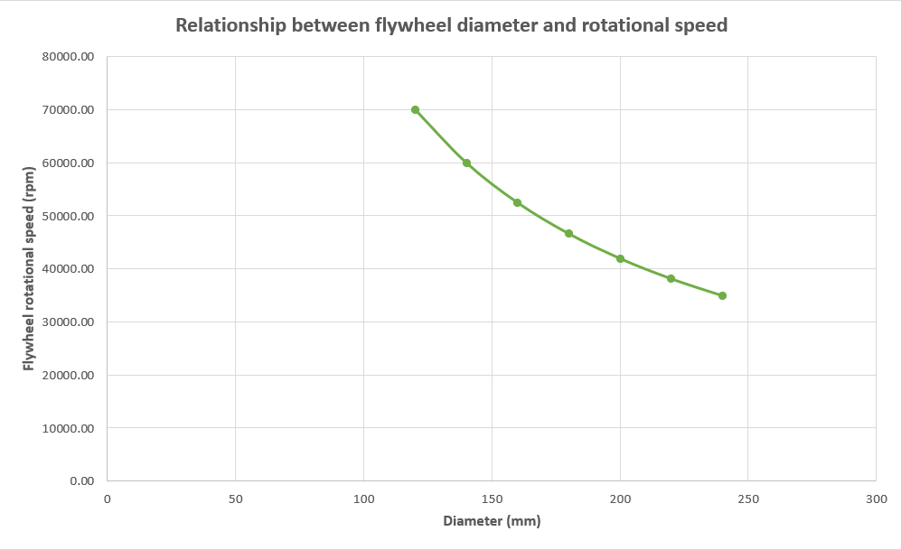
Figure 8 - Relationship between flywheel diameter and rotational speed

As shown in Figure 8, there is an inverse relationship between flywheel diameter and rotational speed. Increasing the diameter results in a lower operating rpm because the moment of inertia I=MR² increases with radius, allowing the same stored energy to be maintained at a reduced angular velocity. This improves mechanical safety by reducing stresses on the flywheel at high speeds. However, the results also show that smaller diameters approach or exceed the 50,000 rpm design limit, making them unsuitable for this application. This highlights the need to balance compactness with safe rotational speeds when selecting the flywheel dimensions for a KERS system.

Assumptions Made in the Analyses
A number of assumptions were made throughout the calculations in Tasks 1–7 to keep the analysis straightforward and consistent.
1. Vehicle treated as a single mass
The vehicle was modelled as a rigid mass, meaning factors such as rolling resistance, tyre slip and aerodynamic drag were ignored. This allowed the kinetic energy to be calculated using $1/2mv^{2}$.

2. Flywheel assumed to behave as a thin ring
The flywheel inertia was based on the thin-ring model I=MR² . This ignores hubs, spokes, and uneven mass distribution, but it provides as approximation for high-speed, thin-ring flywheels where most of the mass is near the rim.
3. One efficiency value applied once only
The given 80% round-trip efficiency (braking + acceleration combined) was applied a single time in Task 2 to determine the effective recoverable energy. All subsequent calculations used this stored-energy value directly, with no additional losses included.
4. No losses in the flywheel housing
The flywheel was assumed to operate in a perfect vacuum with no bearing friction or aerodynamic drag. In practice, magnetic bearings and vacuum systems are required to minimise these losses.
5. Ideal CVT operation
The CVT was assumed to be loss-free and capable of instant, unrestricted energy transfer at any ratio. Real CVTs have mechanical inefficiencies and torque limits, but these were beyond the scope of this analysis.
6. Constant acceleration in Task 6
Re-acceleration was modelled using constant acceleration in order to calculate an average value. Actual acceleration would vary with drivetrain power and resistive forces such as drag.
7. Structural limits only checked using the 50,000 rpm cap
No detailed stress analysis of the flywheel was performed. Instead, suitability was assessed by comparing calculated speeds to the given maximum operating limit of 50,000 rpm.
8. Diameter changes assume constant mass
In Task 7, the flywheel mass was kept constant while the diameter was varied. This isolates the geometric effect on rpm, though real flywheels would gain mass as diameter increases.

Conclusion
The development of flywheel technology spans thousands of years, beginning with simple mechanical devices such as potter’s wheels and evolving into highly engineered energy-storage systems used across modern transport and power networks. This report has shown how the fundamental principle of storing energy in rotational motion has remained unchanged while contemporary materials, magnetic bearings and vacuum housings have enabled far higher speeds, efficiencies and storage capacities. Modern applications demonstrate this, flywheels support grid-frequency regulation, stabilise renewable grids, and play a central role in regenerative braking systems such as mechanical Kinetic Energy Recovery Systems (KERS)
The review of KERS operation highlighted how flywheels capture braking energy through a CVT or clutch mechanism, store it as rotational kinetic energy, and return it during acceleration. Key subsystems including the flywheel unit, bearings, containment housing and control electronics were examined alongside the design challenges associated with high-speed operation, such as balancing requirements, material selection and structural safety. A comparison with chemical batteries emphasised the strengths of mechanical storage against chemical storage, particularly its long cycle life, fast response and high power capability.
The analytical work in Task B reinforced these concepts by measuring the behaviour of a practical KERS installation. Calculations demonstrated how vehicle speed, flywheel inertia and efficiency determine the recoverable energy and achievable re-acceleration performance. The influence of flywheel geometry on rotational speed was also explored, showing the trade-offs between compactness and safe operating limits.
Together, the theoretical review and numerical analysis has shown both the potential and the constraints of flywheel-based KERS, highlighting their suitability for applications involving repeated braking, rapid power delivery and durable long-term performance.

References
- EngineerFix (2025) How a Flywheel Battery Stores and Delivers Energy. Available at: https://engineerfix.com/how-a-flywheel-battery-stores-and-delivers-energy/
- Moebs, W., Ling, S. J. & Sanny, J. (2016) University Physics Volume 1. Houston, TX: OpenStax. Available at: https://openstax.org/books/university-physics-volume-1/pages/10-4-moment-of-inertia-and-rotational-kinetic-energy
- Genta, G. (1985) Kinetic Energy Storage: Theory and Practice of Advanced Flywheel Systems. London: Butterworths
- Britannica (2024) Potter’s Wheel. Available at: https://www.britannica.com/technology/potters-wheel (Accessed: 17 November 2025).
- Learn Engineering (2017) Flywheel | How does it work? [Video]. Available at: https://www.youtube.com/watch?v=qteanF1369Y
- National Geographic Society (2014) Industrial Revolution and Technology. Available at: https://education.nationalgeographic.org/resource/industrial-revolution-and-technology/
- Made Up in Britain (no date) Steam Engine. Available at: https://madeupinbritain.uk/Steam_Engine
- Xu, K., Cao, J., Wang, Y., et al. (2023) A Review of Flywheel Energy Storage System Technologies. Available at: https://www.mdpi.com/1996-1073/16/18/6462
- Olabi, A. G. (2021) ‘Critical Review of Flywheel Energy Storage System’, Energies, 14(8), 2159. Available at: https://www.mdpi.com/1996-1073/14/8/2159
- Racecar Engineering (2012) Flywheel Hybrid Systems (KERS). Available at: https://www.racecar-engineering.com/articles/f1/flywheel-hybrid-systems-kers/
- Hedlund, M., Lundin, J., de Santiago, J., Abrahamsson, J. & Bernhoff, H. (2015) ‘Flywheel Energy Storage for Automotive Applications’, Energies, 8(10), pp. 10636–10663.Available at: https://www.mdpi.com/1996-1073/8/10/10636
- Volvo Car Group (2014) ‘Volvo Car Group and Flybrid conduct UK testing of flywheel KERS technology’. Available at: https://www.volvocars.com/uk/media/press-releases/40A4BC38F8EC189B/
- Wired (2014) Davies, A. ‘F1 Tech Is About to Make Buses Way More Efficient.’ Wired, 31 July 2014. Available at: https://www.wired.com/2014/07/f1-kers-london-buses/
- Kesgin, M., Han, P., & Ionel, D. M. (2019) ‘Overview of Flywheel Systems for Renewable Energy Storage with a Design Study for High-speed Axial-flux Permanent-magnet Machines’, 8th Intl. Conf. on Renewable Energy Research & Applications (ICRERA). Available at: https://sparklab.engr.uky.edu/sites/spark/files/2019%20IEEE%20ICRERA%20UKSpark%20Overview%20Flywheel.pdf
- Beacon Power (2011) Grid-Scale Flywheel Energy Storage Plant: 20 MW at Hazle Township, Pennsylvania. U.S. Department of Energy. Available at: https://www.energy.gov/sites/prod/files/Beacon.pdf
- CNESA (2015) Flywheel Energy Storage. China Energy Storage Alliance. Available at: https://en.cnesa.org/latest-news/2015/10/21/flywheel-energy-storage-in-china
- ScienceDirect (2025) Flywheel Energy Storage – Section 9.3. Available at: https://www.sciencedirect.com/topics/engineering/flywheel-energy-storage
- POWERTHRU (n.d.) Commercial Flywheel Energy Storage Module. Image available at: https://www.researchgate.net/figure/Example-of-a-commercial-flywheel-energy-storage-system-courtesy-of-POWERTHRU-Livonia_fig1_221917056
- Volvo Cars (2014) Flywheel KERS drivetrain layout. Available at: https://www.volvocars.com/uk/media/images/a376e503f2b54f60930db33e0048b6ae/
- Reddy, R. J., Rao, K. P., and Kumar, M. S. (2021) Design and Static Structural Analysis of Flywheel Using Different Composite Materials. Available at: https://www.researchgate.net/publication/354249207_Design_and_Static_Structural_Analysis_of_Fly_Wheel_using_with_Differnt_Composite_Materials
- Amiryar, M. E. & Pullen, K. R. (2017) ‘A Review of Flywheel Energy Storage System Technologies and Their Applications’, Applied Sciences, 7(3), 286.Available at: https://openaccess.city.ac.uk/id/eprint/17719/1/AmiryarandPullenA%20Review%20of%20Flywheel%20Energy%20Storage%20System_applsci-07-00286.pdf

Appendices



