Developing Relationships and Workplace Achievement
ASSESSMENT
Student Name: Corneliu Iacoban
ID: 1813024

Table of Contents
Introduction 3
Appropriate knowledge, skills and behaviors (KSB) that are required by HR professionals across the department 3
Identifying the training and development skills in term of knowledge, skills and behavior for me to work in Ritz Hotel 4
Potential benefits of Ritz Hotel in developing me through training and development 4
Conclusion 5
References 5
Appendix 6

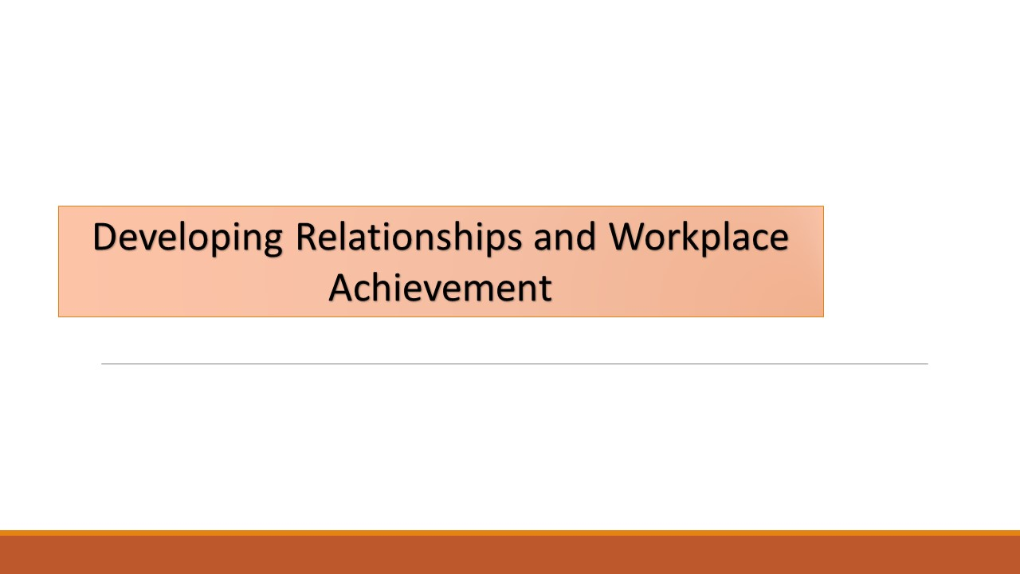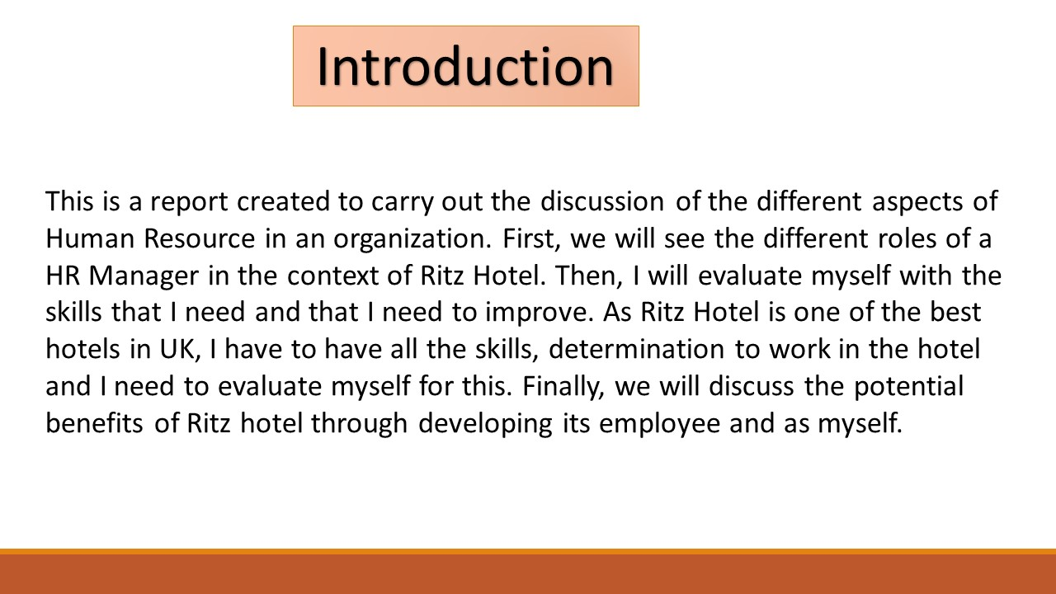

Introduction
This is a report created to carry out the discussion of the different aspects of Human Resource in an organization. First, we will see the different roles of a HR Manager in the context of Ritz Hotel. Then, I will evaluate myself with the skills that I need and that I need to improve. As Ritz Hotel is one of the best hotels in UK, I have to have all the skills, determination to work in the hotel and I need to evaluate myself for this. Finally, we will discuss the potential benefits of Ritz hotel through developing its employee and as myself.
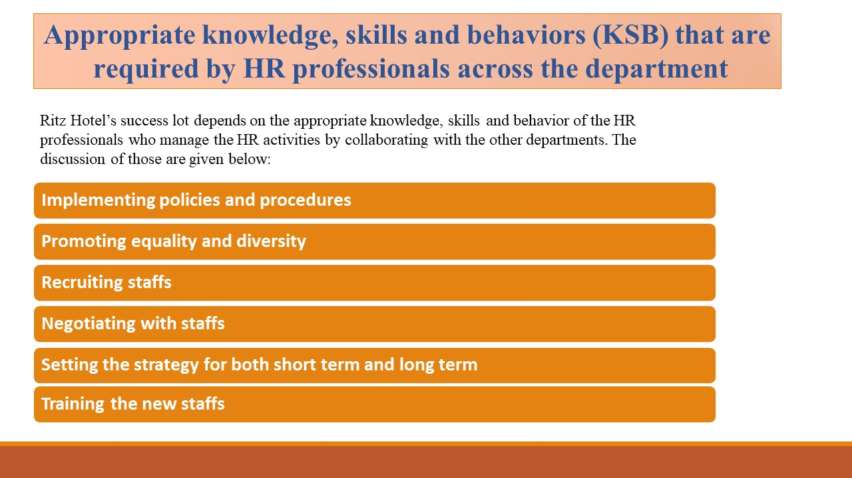

Appropriate knowledge, skills and behaviors (KSB) that are required by HR professionals across the department
Ritz Hotel’s success lot depends on the appropriate knowledge, skills and behavior of the HR professionals because they recruits the best potential candidates for the organization. The discussion of those are given below:
- Implementing policies and procedures: The HR department of Ritz Hotel at first sets the policies and procedures that are essential for maintain peace in the organization, brings clarity, clears responsibility and ensures equality among the members (Noe, 2017). But keeping in book doesn’t really implement it, so they make sure everyone in the organization knows it.
- Promoting equality and diversity: Ritz Hotel supports diversity in the organization as it helps to create more ideas and build better culture (Cascio, 2015). That is why the HR department ensures diversity when recruiting employees and create equality among them.
- Recruiting staffs: HR professionals in Ritz Hotel does various activities like giving job advertisement, choosing appropriate candidate from looking at CVs and also taking interviews (Noe, 2017). The professionals do this in a scientific way having adequate measures to choose the right employees for the organization.
- Negotiating with staffs: The HR professionals have extraordinary communication and case solving skill which makes them negotiate with persons even if the situation is complex. As they follow equity among members and creating clear policy, so justice also prevails and negotiation becomes effective.
- Setting the strategy for both short term and long term: The HR professionals of Ritz hotel sets short term and long-term goals for the organization where their critical thinking skills come into play (Noe, 2017). They also discuss with other departmental members for working in a collaborated way.
- Training the new staffs: The HR managers observes the employees and tries to bring out the best potential in them through effective training and also motivating them. The training services are provided to the individuals by hiring the training professionals.

Identifying the training and development skills in term of knowledge, skills and behavior for me to work in Ritz Hotel
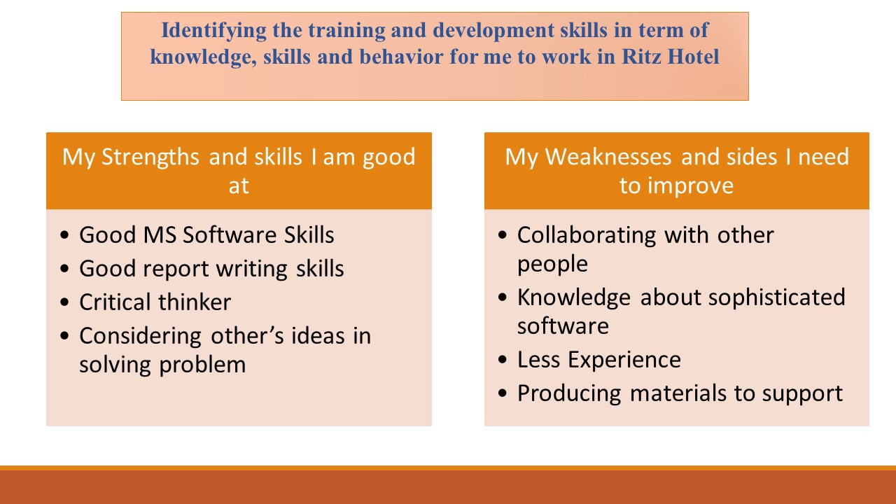
As I have shown in my personal skill audit, I have good skills in some cases and also some lacking in some cases too. First as it is seen that I have good command over using software like MS Word, Excel and PowerPoint but I lack the knowledge of using sophisticated HR software. I also have good expertise in using the internet efficiently and sending emails. As an introvert person, I lack the communication skills which needs to be improved. I need to learn how to take training sessions, how to take interviews and also write down the notes what I hear in a quick time. I like to think critically and that is why my problem solving skill is satisfactory on this level, but I also need to improve on this thing gradually as Ritz Hotel faces many complex situations every day, and needs people who can think critically of all the situations and problems that are been faced (Lee, 2019).

Potential benefits of Ritz Hotel in developing me through training and development
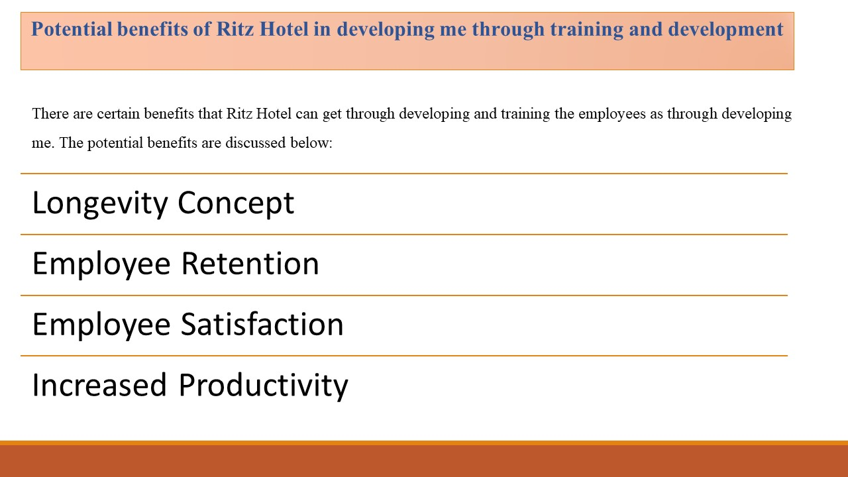
There are certain benefits that Ritz Hotel can get through developing and training the employees as through developing me. The potential benefits are discussed below:
- Longevity Concept: A company must have some loyal employees to survive in the long run. Ritz Hotel by providing training can develop me and bring out the best potential in me. This will help the company to get better results from me and also get the loyalty.
- Employee Retention: As Ritz hotel will be training me to learn how to work in the hotel and how to do collaboration plus teach me how to match with the company’s culture will make me comfortable working with the other members of Ritz hotel (Lee, 2019). This can give the opportunity for Ritz Hotel in the long run
- Employee satisfaction; When an employee gets a proper training makes him to feel a belongingness to the company, more confident and also create the eligibility for promotion. This satisfaction of mine can benefit Ritz Hotel in increased performance.
- Increased Productivity: By proper training I can do some extra tasks for Ritz Hotel, work with efficiency and work in a diversified workplace comfortably (Cascio, 2015). This can help the organization to boost up the performance.
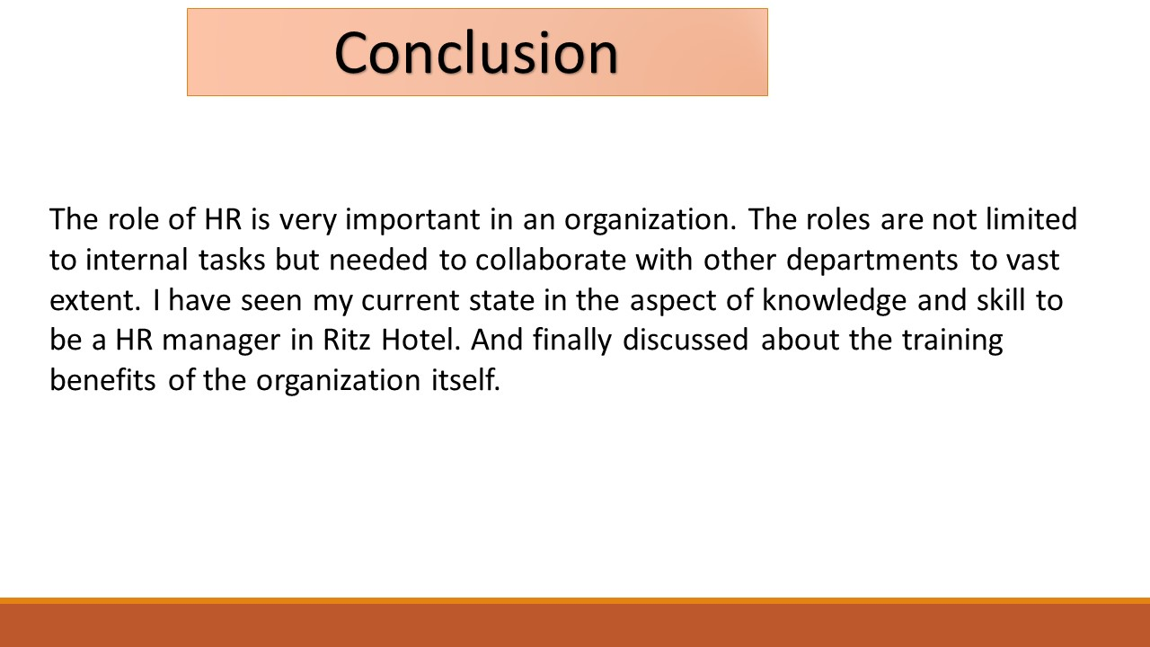

Conclusion
The role of HR is very important in an organization. The roles are not limited to internal tasks but needed to collaborate with other departments to vast extent. I have seen my current state in the aspect of knowledge and skill to be a HR manager in Ritz Hotel. And finally discussed about the training benefits of the organization itself.

References
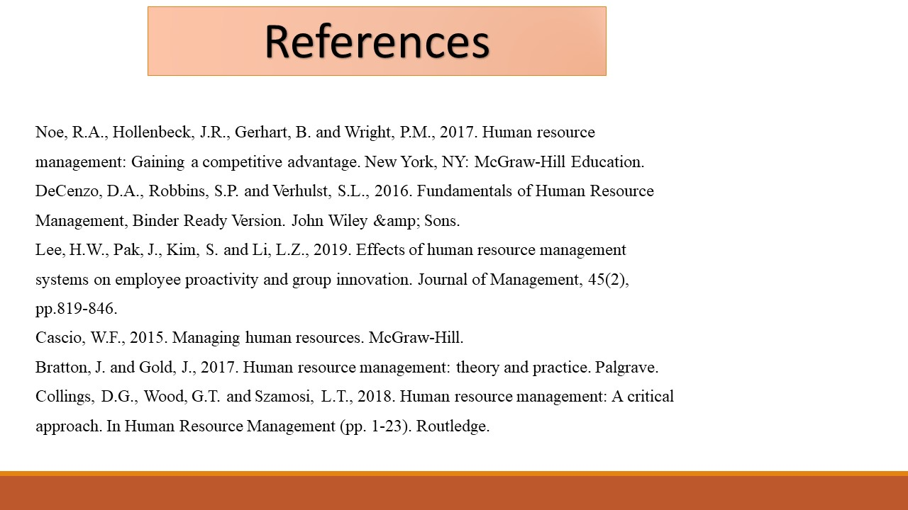
Noe, R.A., Hollenbeck, J.R., Gerhart, B. and Wright, P.M., 2017. Human resource
management: Gaining a competitive advantage. New York, NY: McGraw-Hill Education.
DeCenzo, D.A., Robbins, S.P. and Verhulst, S.L., 2016. Fundamentals of Human Resource
Management, Binder Ready Version. John Wiley &amp; Sons.
Lee, H.W., Pak, J., Kim, S. and Li, L.Z., 2019. Effects of human resource management
systems on employee proactivity and group innovation. Journal of Management, 45(2),
pp.819-846.
Cascio, W.F., 2015. Managing human resources. McGraw-Hill.
Bratton, J. and Gold, J., 2017. Human resource management: theory and practice. Palgrave.
Collings, D.G., Wood, G.T. and Szamosi, L.T., 2018. Human resource management: A critical
approach. In Human Resource Management (pp. 1-23). Routledge.

Appendix


