THE CONTINENTAL HOTEL & ZERO-BASED BUDGET PLAN REPORT

ANGUR MIAH
2021261

DALE CLARKE
FINANCIAL MANAGEMENT FOR THE HOTEL INDUSTRY

Table of Contents
THE CONTINENTAL HOTEL & ZERO-BASED BUDGET PLAN REPORT 1
TASK 1 2
TASK 2 4
Zero-Based Budgeting Technique 4
Introduction 4
Implementation of Zero-Based Budgeting: 6
Zero-Based Budget Implementation Example 9
Can budgeting control support sustainability? 10
References 10

TASK 1

 |  |  | THE CONTINENTAL HOTEL BUDGET PLAN
 |  |  | Jan | February | March | April | May | June | July | August | Sept | Oct | Nov | Dec | Total
 |  |  | £ | £ | £ | £ | £ | £ | £ | £ | £ | £ | £ | £ | £
Receipts :
Payment on business accounts |  |  | 85.000 | 66.000 | 85.000 | 40.000 | 42.000 | 49.000 | 56.500 | 66.900 | 74.000 | 49.000 | 50.900 | 50.800 | 715.100
Cash sales |  |  | 6.800 | 6.800 | 6.800 | 6.800 | 6.800 | 6.800 | 6.800 | 6.800 | 6.800 | 6.800 | 6.800 | 6.800 | 81.600
Interest Received |  |  | 180 | 2.555 | 4.424 | 6.926 | 8.053 | 9.323 | 10.829 | 12.616 | 14.751 | 17.167 | 18.961 | 20.869 | 126.654
Total Receipts |  |  | 91.980 | 75.355 | 96.224 | 53.726 | 56.853 | 65.123 | 74.129 | 86.316 | 95.551 | 72.967 | 76.661 | 78.469 | 923.354
Payments :
Complimentary Beverages |  |  |  |  |  | 350 |  | 350 |  | 350 |  | 350 |  | 350 | 1.750
Payments to suppliers
Wages |  |  | 6.000 | 6.000 | 6.000 | 6.000 | 6.000 | 6.000 | 6.000 | 6.000 | 6.000 | 6.000 | 6.000 | 6.000 | 72.000
Utility Bills |  |  | 700 | 700 | 700 | 700 | 700 | 700 | 700 | 700 | 700 | 700 | 700 | 700 | 8.400
Vehicles |  |  | 275 | 275 | 275 | 275 | 275 | 275 | 275 | 275 | 275 | 275 | 275 | 275 | 3.300
Vehicles Insurance |  |  |  |  |  |  |  |  |  |  |  |  |  | 4.000 | 4.000
Property insurance |  |  |  |  |  |  |  |  |  |  | 2.500 |  |  |  | 2.500
Wardrobes |  |  |  |  |  |  | 1.750 | 1.750 | 1.750 | 1.750 |  |  |  |  | 7.000
Petrol and diesel |  |  | 500 | 500 | 500 | 500 | 500 | 500 | 500 | 500 | 500 | 500 | 500 | 500 | 6.000
Rates |  |  | 300 | 300 | 300 | 300 |  | 300 | 300 | 300 |  | 300 | 300 | 300 | 3.000
Magazines Subscription |  |  |  | 250 |  |  | 250 |  |  | 250 |  |  | 250 |  | 1.000
Overdraft Interest
Vehicles Valleted |  |  | 140 | 140 | 140 | 140 | 140 | 140 | 140 | 140 | 140 | 140 | 140 | 140 | 1.680
Leisure Facilities |  |  | 1.500 | 1.500 | 1.500 | 1.500 | 1.500 | 1.500 | 1.500 | 1.500 | 1.500 | 1.500 | 1.500 | 1.500 | 18.000
SKY Subscription |  |  | 250 | 250 | 250 | 250 | 250 | 250 | 250 | 250 | 250 | 250 | 250 | 250 | 3.000
Premier League License |  |  |  |  |  | 3.000 |  |  |  |  |  |  |  |  | 3.000
Alcoholic Beverages (Minibar) |  |  | 3.000 | 3.000 | 3.000 | 3.000 | 3.000 | 3.000 | 3.000 | 3.000 | 3.000 | 3.000 | 3.000 | 3.000 | 36.000
Newspapers |  |  | 150 | 150 | 150 | 150 | 150 | 150 | 150 | 150 | 150 | 150 | 150 | 150 | 1.800
Total payments |  |  | 12.815 | 13.065 | 12.815 | 16.165 | 14.515 | 14.915 | 14.565 | 15.165 | 15.015 | 13.165 | 13.065 | 17.165 | 172.430
Balance b / f |  |  | 6.000 | 85.165 | 147.455 | 230.864 | 268.425 | 310.763 | 360.971 | 420.535 | 491.686 | 572.222 | 632.024 | 695.620 | 4.221.730
Net cashflow in month |  |  | 79.165 | 62.290 | 83.409 | 37.561 | 42.338 | 50.208 | 59.564 | 71.151 | 80.536 | 59.802 | 63.596 | 61.304 | 750.924
Balance c / f |  |  | 85.165 | 147.455 | 230.864 | 268.425 | 310.763 | 360.971 | 420.535 | 491.686 | 572.222 | 632.024 | 695.620 | 756.924 | 4.972.654

TASK 2

Zero-Based Budgeting Technique

Introduction
The prospect of reconstructing the corporate budget from the ground up can be terrifying for many firms. Scrubbing the financial slate clean and beginning over would be a last choice in the worst-case situation and would never be contemplated under normal conditions. However, beginning in about 2008, an increasing number of businesses elected to do just that. Faced with an economic downturn, both public and private organizations began to adopt an extreme budgeting strategy known as "Zero-Based Budgeting," or ZBB (Rodrigues G, Fien-Helfman J, Barber E, Peck A, 2015).

Zero-based budgeting (ZBB) is a method of planning an approach which emphasizes paying each new calendar's costs (A P Peter, 2012). The nil budgeting approach examines every internal commercial activity for its needs and costs from a "zero foundation" perspective. Then, irrespective of whether every budget is smaller or larger than that of the preceding one, the plans are constructed around what would be required for the following term(Kagan J, 2022).

The spending plan for the previous year is used as the starting point for traditional budgeting. The budgeting for the present year is created by modifying the budget from the former year and changing the costs in accordance with the inflation rates, consumer demand, economic conditions, etc. The new year's budget is heavily influenced by the earnings and expenses from the previous year. Only those budgetary elements in more conventional budgets that go well beyond the previous year's allocation must be substantiated(EFinance Management, 2022).

- The following list outlines the key distinctions between zero-based budgeting and conventional budgeting:
- The "conventional budgeting" approach to money management begins by utilizing last year's plan as a benchmark. Traditional budgeting relies on the preceding spending level, whereas zero-based budgeting is a financial technique where the activities are examined afresh and then started over each time the budget is established. Zero-based budgeting, on the other hand, emphasizes creating a brand-new economic strategy each time the budget is prepared (Dean, 1979).
- The traditional budget can be developed without the present project's rationale. The present and prospective initiatives must be evaluated in zero-based budgeting, however, compared to the costs and return.
- In traditional budgeting, top management decides why a certain amount is allocated on a certain judgment division. Managers choose to spend a certain amount on a decision unit as opposed to zero-based budgeting.
- Since it is founded on fundamental cost accounting concepts, traditional budgeting is accounting-centric. In contrast, the zero-based budgeting approach emphasizes decision-making. In traditional budgeting, historical expenditure levels serve as the primary benchmark, followed by the need to account for inflationary and new initiatives. In contrast, zero-based budgeting divides a decision unit into thorough decision unit setting goals and objectives, which are then ordered according to their importance, enabling top management to concentrate only on the decision elements that were given preferential treatment over all others.
- Traditional budgeting involves a disciplined approach, whereas zero-based budgeting is simple.
- Traditional budgeting performs better in terms of clarity and adaptability. (2021; OnAccounting)

Implementation of Zero-Based Budgeting:
Identifying the Decision Units

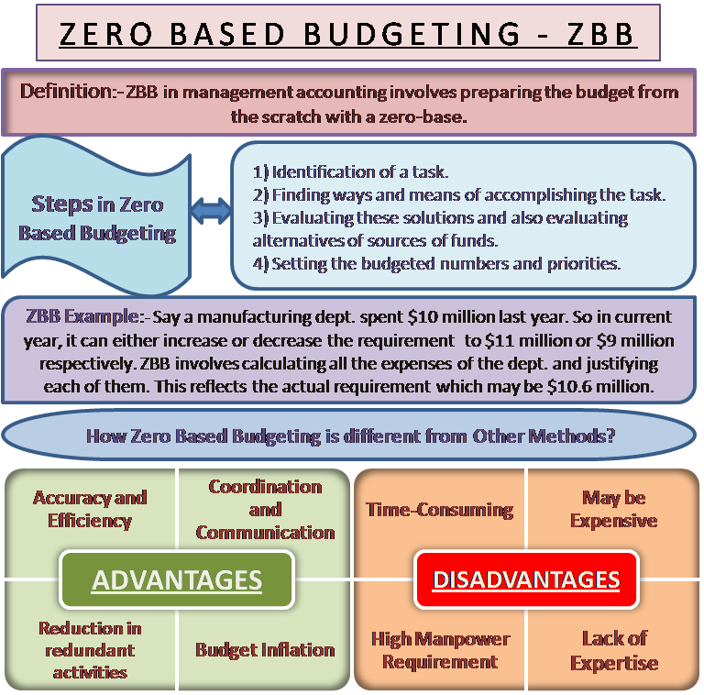
Finding the determination component is perhaps the most crucial step in the zero-based budgetary process. A decision element could be a unitary phenomenon or a collection of actions which can be effectively and individually recognized. We refer to an action which we carry out independently of other pursuits as being "autonomous."(Wetherbe JC & Montanari JR, 1981). Each decision unit will thus be unique in comparison to the others. A company has many decision-making divisions. Each cost center, including the advertising, production, human resource management, and R&D departments, among others, functions as a decision-making unit. This phase is essential for defending each line item in the budget. The supervisor of each decision unit must defend the costs and required budget allocation for his decision unit. The manager shouldn't base his or her decisions on the budget for the previous period or what his or her decision unit spent the previous year. Zero-based budgeting requires starting from zero, thus the justification for the required budget should likewise be brand-new.

Developing Decision Packages
In this stage, the decision units discovered in the initial phase are split into various decision elements. These decision packages must be in line with the objectives of the company. Every decision package serves as a separate proposal for allocating cash. Each decision package outlines the roles, operations, and procedures of the project as well as its need, the physical and intellectual benefits associated with its implementation, the opportunity wasted if funding is not granted for the plan, and other factors (Kreul,1978). A formal decision package must contain the following details:

- The function for which the decision package has been created.
- The objective and goals of the decision package.
- The goals and targets of the key decision unit with which it relates.
- Considering the task's necessity
- Assessment of the task's technical and functional feasibility.
- Assessing alternative courses of action.

Giving Decision Packages a Ranking
The third stage of the zero-based budgetary process is this one. During this point, the significance and importance of each decision package within a decision unit as well as among different decision units are evaluated. The goal of ranking decision packages is to distribute limited resources as efficiently as possible. Decision-making packages are rated using the cost-benefit approach. By doing so, all potential alternatives are examined to determine which are the best and perhaps most affordable. A decision package may be accepted or rejected by top management. Just those decision packages that are approved, enabling the business to achieve its outlined objectives. The pricing of each decision package is also guaranteed by management to be accurate and reasonable (Lei, 2019).
Distributing Available Resources
The previous stage is being continued with this zero-based budgeting step. In this stage, resources are distributed among the decision packages that were rated in the previous step. So we may claim that financing decisions are made at this stage. The rating of decision packages serves as the basis for allocating funding and other resources. Thus, the decision packages with the best prospects receive more financing. This guarantees the best possible use of limited resources.

Tracking and Assessing
The importance of forming a zero-based budget is now accomplished. During this phase, the effectiveness and output of the decision package are monitored and evaluated. By evaluating the decision package performance, management should try whether or not the allotment of resources is appropriate(senior,1990).

Since zero-based budgeting is a cost management strategy, it is crucial that the implementation procedures are carefully and correctly carried out. There must be a thorough explanation of how the money would be used by each department and how the company as a whole would profit from them. The zero-based budgeting process takes a lot of effort, but it offers the best organized way to allocate a company's cash.

Zero-Based Budget Implementation Example
Let's use ABC Industry's production line as an idea, which invested $ 10 million the year before last. Creating a budget for the current year's spending is difficult. There are various methods for doing this:
- The department's budget is increased or decreased by 10% by the company's board of directors. Consequently, the manufacturing company of ABC Ltd. will get either $ 9 million or $ 11 million, based on the senior management decision.
- The top management of the corporation can choose to give the dept the same funding as the year before without, for instance, boosting the department's headcount or production. As a consequence, the department got $10 million.
- Alternatively, to the conventional approach, management may employ zero-based budgeting, which does not base calculations on the $ 10 million from the prior year. Its implementation entails totaling and defending each of the department's costs. This indicates the potential $ 10.6 million demand for the manufacturing division of firm ABC.

Can budgeting control support sustainability?
A common feature in two recent financial crises, according to Seal et al. (2015), was the failure of companies that appeared to have believed that methods like budgeting were outmoded. Due to the time and effort required for the budgeting process, several managers have ignored it in the past. Businesses are institutions that place a premium on profitability. There is just not sufficient profit, they cannot survive. Predictions and forecasts are essential in decision-making. A scenario is built using these predictions and anticipations. In the event that a scenario contains financial data, a budgeting has been produced. A particular kind of company financial planner is a budget(Jones,2008). A crucial tool in financial planning for environmental sustainability is budgets. Budgeting also maintains the efficiency of the firm's investment capital. Every industry or company has a unique budget. Each industry has a different budgeting process, including production, transportation, aerospace, architecture, tourism, and many others(Downey,1982).
Here are some advantages of budgeting for sustainability:
- Budgets include organizational objectives that act as standards for monitoring and assessing performance moving forward.
- Budgets provide management a way to share their plans with the rest of the company.
- Managers are compelled by budgets to consider and make plans for the future.
- Budgets integrate the many segments' plans to synchronize the actions of the overall organization.

References
Dean, B.V. and Cowen, S.S., 1979. The use of zero-base budgeting in industry: some observations. Interfaces, 9(4), pp.55-60.

Zero Based Budgeting, A P Peter (2012)
(assessed on June, 26th, 2022)

https://efinancemanagement.com/budgeting/traditional-budgeting
(assessed on June, 26th, 2022)

https://www.insightsoftware.com/blog/zero-based-budgeting/
(assessed on July 6th, 2022)

https://www2.deloitte.com/us/en/misc/search.html?qr=zero%20based%20budgeting%20zero%20or%20hero(assessed on July 6th, 2022)

Kreul, L.M., 1978. Zero-base budgeting of hotel indirect expenses. Cornell Hotel and Restaurant Administration Quarterly, 19(3), pp.11-14.

Jones, T.A., 1998. UK hotel operators use of budgetary procedures. International Journal of Contemporary Hospitality Management.

How hoteliers do budgeting.(online)https://www.4hoteliers.com/features/article/14906

Senior, M. and Morphew, R., 1990. Competitive strategies in the budget hotel sector. International Journal of Contemporary Hospitality Management.

Lei, S.S.I., Nicolau, J.L. and Wang, D., 2019. The impact of distribution channels on budget hotel performance. International Journal of Hospitality Management, 81, pp.141-149.

Jones, T.A., 2008. Improving hotel budgetary practice—A positive theory model. International Journal of Hospitality Management, 27(4), pp.529-540.

https://onaccounting.co.za/difference-between-traditional-budgeting-and-zero-based-budgeting/#:~:text=Traditional%20Budgeting%20refers%20to%20the,and%20thus%20started%20from%20scratch
(assessed on July 3rh, 2022)

Downey, J.F. and O'Keefe, J., 1982. Zero-base budgeting: a management tool for evaluating hotel expenses. Practice of hospitality management.

