University of Wales Trinity Saint David

Wales Institute of Science & Art



Improving Yield, Throughput and Cost Performance on the Viloca Production Line Using Lean Six Sigma DMAIC
Independent Project (ACMA6013)

Joseph Carpanini
2211043
May 2026
Contents
1. Introduction 5
1.1 Project Background 5
1.2 Objective 5
1.3 Significance 6
2. Literature Review 7
2.1 Introduction 7
2.2 Lean manufacturing and process waste 7
2.3 Lean Six Sigma and DMAIC 9
2.4 First-time yield and manufacturing performance 10
2.5 Throughput and bottlenecks 10
2.6 Cost of Poor Quality 11
3. Define Phase 14
3.1 Project Charter 14
3.2 Voice of the Customer (VoC) & Critical to Quality (CTQ) 17
3.2.1 Voice of the Customer (VoC) 17
3.2.2 Critical to Quality Requirements 18
4. Measure 19
4.1 Purpose of the Measure Phase 19
4.2 Cost Per Unit Calculation Method 21
4.3 Baseline Cost Per Unit 21
4.4 Baseline Volume and Estimated Saving 22
4.5 Measure Phase Summary 22
5. Analyse Phase 24
5.1 Purpose of the Analyse Phase 24
5.2 Failure Mode Pareto Analysis 24
5.3 Scrap Cost Pareto Analysis 25
5.4 Failure Distribution by Test Machine 26
5.5 Five Whys Analysis 28
5.6 Analyse Phase Summary 29
6 Improve 30
6.1 Purpose of the Improvement Phase 30
6.2 Improvement Selection Methodology 30
6.3 Assembly Flow Change and Process Rebalancing 32
6.4 Test Code, Start-of-Shift Checks and Fixture Cleaning 34
6.5 End-of-Line Functional Check Improvement 35
6.6 Documentation, PFMEA and Training 35
6.7 Yield Improvement Validation 37
7. Control Phase 39
7.1 Purpose of the Control Phase 39
7.2 Key Performance Indicators 39
7.3 Performance Monitoring and Data Review 40
7.4 Standard Work, Training and PFMEA Control 42
8. Discussion 43
8.1 Comparison with Literature 43
9. Conclusions and Recommendations 46
9.1 Summary of Key Findings 46
9.2 Achievement of Aim and Objectives 46
9.3 Recommendations and Future Work 47
References 48

Figure 1 - Average hourly output for the Viloca line against target, based on internal production data. 19
Figure 2 - Pareto Graph of Viloca Test Failures 23
Figure 3 - Scrap cost Pareto by failure category, based on internal company cost and failure data. 25
Figure 4 - Pareto analysis of failures by Viloca test machine, based on internal company test data. 26
Figure 5 - Original Viloca process balance by timed work element before improvement. 30
Figure 6 - Original Process Map of Viloca Assembly Process 31
Figure 7 - Revised Viloca process balance by timed work element after improvement. 31
Figure 8 - Rebalanced Process Map of Viloca Assembly Process 32
Figure 9 - Weekly average hourly output following implementation compared with target. 34
Figure 10 - Hourly output performance during a recent production shift after implementation. 35
Figure 11 - Pareto of Post-Improvement Failures 36

1. Introduction

1.1 Project Background
The Viloca production line is used to assemble, test and release finished devices. Historically, the line had relatively low utilisation because demand was limited. As demand increased, the line began running more frequently and several performance issues became more visible. These included a high test reject rate, output below the required rate and an elevated cost per passed device.
Baseline data showed that the Viloca line had a test reject rate of approximately 26%, equivalent to 264.5 failures per 1,000 devices tested. Average output was approximately 33 units per hour against an original target of 48 units per hour. The cost per passed device was calculated at £3.37, made up of £2.75 labour cost per unit and £0.62 scrap cost per unit, compared with a target of £2.08.
These issues were important because test failures affect more than quality alone. Failed units require retesting, troubleshooting, repair or scrap decisions, all of which consume labour and test capacity. In Lean terms, defects can create further waste, including overprocessing, waiting and unnecessary movement (Ohno, 1988; Womack and Jones, 1996; Liker, 2004). The project was therefore structured using the Lean Six Sigma DMAIC methodology, which provides a systematic approach for defining, measuring, analysing, improving and controlling process performance (ASQ, n.d.c; George, 2002; Pande et al., 2000).

1.2 Objective
The aim of this project was to improve the performance of the Viloca production line by increasing first-pass yield, improving hourly output and reducing cost per passed device through the application of Lean Six Sigma DMAIC.
The project objectives were to:
- Define the current performance problem on the Viloca line.
- Measure baseline performance using production, test and cost data.
- Analyse the main contributors to reject rate, output loss and cost.
- Prioritise improvement actions based on impact, effort, risk and controllability.
- Implement practical improvements to the assembly flow, test process, fixture maintenance, start-of-shift checks, laser etch functional checks, documentation and training.
- Evaluate the early impact of the improvements on output, yield and process stability.
- Define KPIs and controls to sustain the improvements after implementation.
These objectives ensured that the project considered quality, throughput and cost together rather than treating them as separate issues.

1.3 Significance
The project was significant because the Viloca line was no longer performing at the level required to support increased demand. The baseline output of 33 units per hour showed a clear capacity gap, while the 26% reject rate indicated that a large proportion of test capacity was being lost to failed units, retests and repair activity.
From a financial perspective, the project also offered a clear cost reduction opportunity. The current cost per passed device was £3.37 compared with a target of £2.08, giving a potential saving of £1.29 per passed device. Based on approximately 30,000 passed devices per year, this equated to an estimated annual saving of around £38,700. This demonstrated a clear business case, particularly as future savings would increase if demand continued to rise.
The project was also important because it used lessons learnt from other production lines rather than starting from a completely new solution. This reduced implementation risk and helped multiple departments work together efficiently once project time and resource were available. This reflects the wider view that organisational learning and knowledge transfer are important contributors to sustained operational improvement (Garvin, 1993; Nonaka and Takeuchi, 1995). Overall, the project aimed to create a more stable and capable Viloca process by improving flow, reducing avoidable failures and strengthening process control.

2. Literature Review

2.1 Introduction
This literature review examines the main concepts relevant to improving performance on the Viloca production line. The review focuses on Lean manufacturing and process waste, Lean Six Sigma and the DMAIC methodology, first-time yield and throughput, bottlenecks in manufacturing systems, performance measurement, and the Cost of Poor Quality (COPQ). These themes were selected because the present project is concerned with high test failure rates, retest activity, output below target, and the associated operational and financial losses. Collectively, the literature provides the conceptual basis for understanding how defects, delays and process inefficiencies reduce both manufacturing performance and business value (Lean Enterprise Institute, n.da.; Radej et al., 2017; Shah and Ward, 2003).

2.2 Lean manufacturing and process waste
Lean manufacturing is fundamentally concerned with delivering customer value while eliminating activities that consume time, materials or labour without improving the final product. The Lean Enterprise Institute defines waste as any activity that absorbs resources but creates no value from the customer’s perspective, while also describing Lean more broadly as a management system focused on value, flow and continuous improvement (Lean Enterprise Institute, n.d.a; Lean Enterprise Institute, n.d.c). This is directly relevant to the Viloca line because repeated testing, waiting for decisions and processing defective units all consume resources without improving the customer’s experience of the final product. This interpretation is consistent with wider Lean literature, which links waste reduction, flow and standardised processes to improved operational performance (Bhamu and Sangwan, 2014; Liker, 2004; Womack and Jones, 1996).
A key strength of Lean is that it provides a practical framework for recognising different types of inefficiency within a process. The classical seven wastes are transportation, inventory, motion, waiting, overproduction, over-processing and defects. These categories remain widely used because they offer a simple but effective way to structure process analysis and identify where losses are occurring. Practitioner sources continue to emphasise the relevance of these wastes in manufacturing environments, especially where defects, waiting time and unnecessary handling are visible contributors to lost capacity and higher cost (Lean Enterprise Institute, n.d.a; Toyota Material Handling UK, 2022; Ohno, 1988).

The value of the seven-waste framework lies not only in classification, but in how it supports improvement prioritisation. In practical manufacturing terms, not every inefficiency has equal impact. Some wastes, particularly defects and waiting, often exert a disproportionate influence over output and cost because they interrupt flow and create secondary losses such as rework, retest or idle labour. For the Viloca line this is particularly important, because the project is not simply concerned with general tidiness or housekeeping; it is concerned with defects at test and the repeated loss of time and capacity that follows from those failures. In this sense, Lean provides a language for describing why test failures matter operationally, not just in quality terms. Lean research also suggests that improvement is more effective when practices such as quality management, maintenance and human involvement are treated as connected bundles rather than isolated tools (Shah and Ward, 2003; Liker, 2004).
However, later Lean interpretations suggest that the classical seven wastes do not fully capture the range of losses present in modern manufacturing systems. TXM Lean Solutions argues that office and administrative processes generate additional forms of waste, including what is described as the waste of knowledge, where organisations fail to use employees’ ideas, expertise or lessons learned effectively (TXM Lean Solutions, c.2024). This broader interpretation is particularly useful in environments where the main delays are not purely physical. On the Viloca line, process losses may arise not only from product defects, but also from unclear fault messages, duplicated checking, inconsistent responses between operators, or delays in deciding whether a unit should be retested, repaired or scrapped. These forms of waste do not change the physical product, but they still reduce effective throughput and increase cost.
This extension of Lean thinking is important because it moves the analysis beyond visible factory-floor inefficiency. In highly test-dependent processes, the flow of information can be just as important as the flow of materials. Where fault data are vague, responsibilities are unclear, or lessons from recurring failures are not embedded into standard practice, process inefficiency can persist even when the physical layout appears acceptable. Therefore, the broader waste perspective strengthens the justification for examining not only the test machines themselves, but also the information and decision-making processes surrounding test activity on the Viloca line (TXM Lean Solutions, c.2024).

2.3 Lean Six Sigma and DMAIC
Although Lean provides a strong basis for identifying non-value-adding activity, the Viloca problem is not solely a waste issue. The line is also affected by quality failures, performance variation and uncertainty over the causes of those failures. For this reason, Lean Six Sigma is particularly relevant. Radej et al. describe quality-improvement approaches as differing in emphasis, with some focusing on waste reduction and others on variation and defect control, while Lean Six Sigma is valuable because it brings these perspectives together within a more integrated improvement framework (Radej et al., 2017). This combined approach is appropriate for the present study because the line is affected by both process inefficiency and poor first-pass yield. Wider Lean Six Sigma literature also identifies manufacturing as a common application area for DMAIC projects that seek to improve quality, productivity and cost performance (Albliwi et al., 2015; Antony et al., 2017).
The DMAIC structure is central to most Lean Six Sigma projects. Bansal describes DMAIC as a systematic approach to problem solving in which the problem is first defined, then measured, analysed, improved and controlled to ensure sustainable gains (Bansal, 2017). Similarly, Shamsuzzaman et al. demonstrate that the DMAIC methodology can be used to improve productivity in manufacturing by identifying root causes of waste and focusing interventions on the most influential process losses (Shamsuzzaman et al., 2023). This is significant for the Viloca project because it supports a disciplined progression from baseline performance measurement through to root cause analysis and controlled implementation, rather than relying on unstructured trial-and-error changes. Established Six Sigma texts also emphasise the importance of data-led project selection, measurement discipline and control planning within DMAIC (Pande et al., 2000; Pyzdek and Keller, 2018; Montgomery, 2020).
The main advantage of DMAIC in a production setting is that it links operational observation to evidence-based decision making. Define and Measure provide a clear statement of the problem and its scale. Analyse then ensures that decisions are based on the causes of poor performance rather than on symptoms alone. Improve allows targeted changes to be tested, while Control is intended to prevent the process from drifting back to its previous condition. This structure is particularly relevant where failures appear to arise from several interacting causes, such as product issues, machine conditions, process variation and human factors. Therefore, the literature supports the use of DMAIC not only as a project management structure, but also as a method for building a robust argument for why particular improvements are necessary and how their impact should be evaluated (Bansal, 2017; Gijo et al., 2011; Shamsuzzaman et al., 2023).

2.4 First-time yield and manufacturing performance
A central concept in the Viloca project is first-time yield, also referred to as right first time or first-pass yield. Gregoire defines right first time as the proportion of work completed correctly without the need for rework or correction, while Sciemetric argues that first-time yield is one of the most important indicators of manufacturing health because it captures the extent to which defects and retests consume productive capacity (Gregoire, 2017; Sciemetric, 2011). This is particularly relevant to Viloca because the current issue is not simply that some units fail, but that each failure consumes additional test time, labour and decision-making effort. The wider quality literature similarly links right-first-time performance with prevention, process capability and reduced failure cost (Deming, 1986; Juran and Godfrey, 1999).
The literature indicates that first-time yield has implications that extend beyond quality performance alone. When units fail and re-enter the process through retest or repair loops, capacity that could have been used to process new units is diverted to handling previous failures. This means that poor yield reduces effective throughput even if nominal cycle times remain unchanged. Sciemetric explicitly frames first-time yield improvement as a return-on-investment opportunity because removing repeat processing increases usable capacity without necessarily requiring additional equipment or labour (Sciemetric, 2011). This aligns closely with the Viloca project, where low output appears to be linked not only to how quickly the line runs, but also to how often units fail and require additional handling. This also reflects the quality management principle that prevention and process control are more effective than relying on inspection or rework after defects occur (Feigenbaum, 1991; Shingo, 1986).
Gregoire further suggests that right-first-time performance is closely linked to process stability and standardisation. A process that produces frequent corrections or rework is typically one in which variation is poorly controlled or where the standard method is unclear or inconsistently applied (Gregoire, 2017). In the Viloca context this is highly relevant, because some failures may be genuine product faults, while others may be induced by inconsistent process conditions, incorrect preparation or unclear responses to fault indications. Improving first-time yield therefore requires not only defect reduction, but also clearer process definition and better consistency in execution.

2.5 Throughput and bottlenecks
The relationship between yield and output is closely connected to the concept of bottlenecks. Skoogh et al. define bottleneck detection as a critical part of manufacturing improvement because throughput losses are often concentrated around a limited number of constrained resources rather than spread evenly across the entire process (Skoogh et al., 2023). This is important because improvement effort is often diluted when all parts of the process are treated as equally problematic. In reality, system performance is usually governed by the stage where flow is most restricted. This is also consistent with operations management literature, which links system output to constrained resources, flow balance and the interaction between process capacity and demand (Goldratt and Cox, 2014; Slack et al., 2022).
For the Viloca line, the test stage is a likely bottleneck because failures and retests repeatedly consume capacity in a limited area of the process. Even if upstream assembly stages are capable of working more quickly, overall output will remain constrained if test resources are occupied by failures, fault resolution and retest loops. The bottleneck literature therefore supports the project’s emphasis on test yield rather than on general line speed alone. In practical terms, increasing output from 48 units per hour towards 53 units per hour is unlikely to be achieved simply by asking operators to work faster. The more credible route is to reduce the amount of capacity lost within the bottleneck itself through improved first-pass yield and more effective fault handling (Skoogh et al., 2023).
This perspective is particularly useful because it explains why poor quality and low throughput are not separate problems. On lines such as Viloca, they are closely linked. A failure at the bottleneck reduces quality performance immediately, but it also reduces capacity for all following units. Consequently, the literature supports treating yield improvement at test as both a quality objective and a productivity objective.

2.6 Cost of Poor Quality
The operational effects of defects and retests become more persuasive when translated into financial terms. The Cost of Poor Quality provides a framework for doing this. Hessing defines COPQ as the cost that would disappear if products and processes were right first time, including scrap, rework, repair, retest and other failure-related costs (Hessing, 2014). ASQ Quality Management Division et al. similarly present Lean Six Sigma implementation as financially important because many organisations fail to recognise the full economic impact of poor quality on labour, materials and business performance (ASQ Quality Management Division et al., 2007). This is directly relevant to Viloca, where the project has already identified a measurable cost per unit associated with current failure levels. The concept is also well established in quality management literature, where prevention, appraisal and failure costs are used to explain why poor quality has both visible and hidden financial consequences (Feigenbaum, 1991; Juran and Godfrey, 1999).
One of the main strengths of the COPQ concept is that it captures both visible and hidden losses. Visible losses include scrap and direct labour associated with failed units. Hidden losses include lost productive opportunity, reduced capacity, management time, delayed orders and the cumulative burden of repeated problem solving. This matters because operational problems are often tolerated when they are only described in technical or percentage terms. A 26% reject rate is clearly undesirable, but the improvement case becomes much stronger when that reject rate is translated into a cost per unit and a cost per thousand devices. COPQ therefore acts as an important bridge between quality analysis and managerial decision making (Hessing, 2014; ASQ Quality Management Division et al., 2007).
The literature also implies that COPQ should not be treated only as a reporting tool after failures have occurred. It should also inform where improvement activity is targeted. If a failure mode consumes a large share of labour time or creates significant retest burden, then it may warrant intervention even if its direct scrap cost is modest. This is relevant to Viloca because some recurring failures may be especially damaging not because they destroy the most material, but because they create the greatest disruption to throughput and test capacity. Consequently, the COPQ framework supports the broader aim of the project by showing that improving yield is not only about reducing rejects, but also about improving cost efficiency and unlocking capacity.

Overall, the literature shows that poor manufacturing performance is rarely caused by one factor alone. Instead, it tends to arise from the interaction of waste, variation, weak standardisation, bottleneck effects and poor information flow. Lean manufacturing provides a framework for identifying non-value-adding activity, while the broader interpretation of waste highlights that information handling and use of knowledge can also constrain performance. Lean Six Sigma and DMAIC then provide a structured approach for measuring, analysing and improving these losses in a disciplined way (Lean Enterprise Institute, n.d.d; Bansal, 2017; George, 2002; Shamsuzzaman et al., 2023).
The literature on first-time yield and bottlenecks is particularly important for the Viloca line because it demonstrates that quality failures at a constrained stage of the process have a disproportionate effect on throughput. This means that improving first-pass yield at test is likely to improve both output and cost performance simultaneously. Finally, COPQ provides a financial framework for quantifying the significance of these losses and justifying improvement activity to the business (Gregoire, 2017; Sciemetric, 2011; Hessing, 2014; Juran and Godfrey, 1999).
An important implication of the reviewed literature is that the Viloca project should not focus only on visible defects. It should also examine whether the current test process is weakened by unclear fault information, inconsistent responses, avoidable retests and insufficient standardisation. In this sense, the literature supports the overall project direction: improving yield and throughput on Viloca requires a combination of waste reduction, better data and traceability, clearer process control, and targeted intervention at the test bottleneck.

3. Define Phase

3.1 Project Charter
Project Details
Project Description | This project focuses on improving the performance of the Viloca production line which has recently seen an increase in demand after a period of relatively low utilisation. As the line has run more frequently, several process issues have become more apparent, including a high percentage of units failing at test and overall output falling short of the planned hourly target.  The work will focus on understanding how the current process operates, how well it performs, and where the main losses occur. Particular attention will be given to the test stages of the line, as these are a key point where defects and delays are introduced. Using a Lean Six Sigma Green Belt (DMAIC) approach, the project will examine existing data, map the process, and identify the principal factors that limit yield and throughput.  The overall intention is to develop and implement practical changes that improve first-pass yield at test and make the process more efficient, so that the line can run more reliably and closer to its intended output rate.
Business Case | Although the Viloca line has only recently begun to run more frequently, the current cost of poor quality and process inefficiency is already significant. Based on the revised cost calculation, the current cost per passed device is £3.37, made up of £2.75 labour cost per unit and £0.62 scrap cost per unit. The target cost per passed device is £2.08, giving a potential reduction of £1.29 per passed device, or approximately 38.3%.  The current performance also equates to approximately 264.5 failures per 1,000 devices tested. These failures consume labour, test capacity and support resource through retest, repair, investigation and scrap activity. Using approximately 30,000 passed devices as the annual baseline, the target cost reduction corresponds to an estimated annual saving of approximately £38,700. This provides a clear business justification for improving yield, output and cost performance on the Viloca line.
Problem Statement | The Viloca production line has recently experienced a step increase in demand following a period of relatively low utilisation, exposing underlying inefficiencies and quality issues that were previously less visible. Current performance data indicate that the line is operating at approximately 33 units per hour against an original target of 48 units per hour, while approximately 264.5 devices fail per 1,000 devices tested. This contributes to a current cost per passed device of £3.37 compared with a target of £2.08. Test-related defects, retests, repair activity and process delays are therefore constraining throughput as well as increasing the cost of poor quality. There is a clear need to identify and address the main controllable causes of test failures and process losses in order to improve first-pass yield, increase output and reduce cost per passed device.
Process & Owner | Test Process - Engineering / Overall Production Process - Production
Scope | Where does it Start? | Stage 1 Assembly
Scope | Where does it Stop? | Finished Goods at End of line
Scope | What is excluded? | All products other than Viloca  Non-production related faults (e.g. device software issues, inherent design issues)
Scope | What is Included? | Viloca test equipment, the product, Viloca test code, assembly process, all associated hardware
Project Goals | Measure | Current | Goal
Increasing yield from the test machines | Reject Rate | 26% | <15%
Increasing output from overall line | Finished goods at the end of line | 33/hr | Initial target 48/hr; revised post-balance target 55/hr
Expected Business Results | Repair cost saving, increased output, LCPU Saving
Expected Customer Benefits | Improved capacity, quality improvement, improved FTY
Team Members | Joe Carpanini, Jeff Jones, Production Team Leader, Repair Operators, Dean Davies, Louis Davies, Barry Jenkins
Support Required | Resource from Eng, Prod, QC & Dev, Line availability
Risks/Constraints | Altering test code, line availability, resource, lead time on critical parts

Although the Viloca line has only recently begun to run more frequently, the current cost of poor quality and inefficiency is already significant. Based on this year’s performance data, the current cost per passed device is estimated at £3.37. If the project achieves its target reduction in test failures and process losses, this is expected to reduce to £2.08 per passed device, a reduction of approximately 38.3% (£1.29 per device).
The current performance equates to approximately 264.5 failures per 1,000 devices tested, creating avoidable retest, repair, investigation and scrap activity. Under the improved scenario, the cost per 1,000 passed devices is expected to reduce from approximately £3,370 to £2,080, giving a saving of approximately £1,290 per 1,000 passed devices. Over the period analysed, scrap cost was approximately £19,102.55, showing that poor quality had a measurable financial impact.

Metric | Current | New (target) | Change
Labour cost per unit (LCPU) | £2.75 | £1.71 | £1.04 (37.8% reduction)
Scrap cost per unit (SCPU) | £0.62 | £0.37 | £0.25 (40.3% reduction)
Cost per unit (CPU) | £3.37 | £2.08 | −£1.29 (38.3% reduction)
Cost per 1,000 devices | £3,370.00 | £2,080.00 | −£1,290.00
Scrap cost over analysis period | £19,102.55 | £11,461.53 | −£7,641.02
Fails per 1,000 devices | 264.5 | 150 | 114.5
Lost opportunity cost per 1,000 devices | £9,257.40 | £5,250 | £4,007.40

Future annual savings have been estimated using this year’s Viloca volumes, as no confirmed forecast for next year is available. Using the 30,000 passed devices produced this year as a baseline, the reduction in cost per passed device (£1.29) corresponds to an annual saving of approximately £38,700. Actual savings will scale with demand; however, even under conservative assumptions the project offers a clear financial justification.

3.2 Voice of the Customer (VoC) & Critical to Quality (CTQ)

3.2.1 Voice of the Customer (VoC)
Production and Planning: (Done Quickly)
• Higher and more stable hourly output to support increased demand.
• Reduced test failures, retests and repair loops.
• Clear process flow and escalation route when repeat failures occur.
Quality Team: (High Quality)
• Improved first-pass yield and lower reject rate.
• Stronger failure categorisation for STS, Soak A, Soak B, fan and SCS-related failures.
• Evidence that inspection and functional checks can detect non-conforming units before release.
Engineering and Maintenance: (Reliable Process)
• Stable test equipment, clean fixtures and consistent start-of-shift checks.
• Better visibility of machine-level failure trends and repeat issues.
• Robust test code and clear reaction plans for recurring test failures.
Finance: (Low Cost)
• Reduced labour cost per passed device.
• Reduced scrap cost and Cost of Poor Quality.
• Improved line capacity without unnecessary additional labour.

3.2.2 Critical to Quality Requirements
The stakeholder requirements were translated into measurable Critical to Quality requirements. These CTQs link the customer and business needs to the project measures used during the Measure and Control phases. This is consistent with Six Sigma practice, where customer requirements are converted into measurable project outputs so that improvement can be judged objectively (George, 2002; Pande et al., 2000).
• Reduce the test reject rate from the baseline of approximately 26% towards the project target of less than 15%.
• Increase first-pass yield from the baseline of approximately 74%.
• Improve average hourly output from the baseline of approximately 33 units per hour towards the required production target.
• Reduce cost per passed device from £3.37 towards the target of £2.08.
• Maintain fan-related failures at zero or near-zero following the revised sub-assembly route and added checks.
• Improve failure categorisation and Pareto review so that high-volume and high-cost failure modes can be prioritised.
• Sustain start-of-shift checks, fixture cleaning, golden sample verification, PFMEA updates and operator training as routine process controls.
The Voice of the Customer and CTQ analysis shows that the Viloca line fundamentally requires higher first-pass yield, more stable throughput and lower cost per passed device. Production and planning are primarily concerned with output and capacity, quality and engineering are focused on failure reduction and process control, and finance is concerned with reducing the cost of poor quality. These requirements support the project focus on yield, output, cost and sustainable control.

4. Measure

4.1 Purpose of the Measure Phase
The purpose of the Measure phase was to establish a clear baseline for the current performance of the Viloca production line before detailed root cause analysis was carried out. Within DMAIC, the Measure phase is used to quantify the scale of the problem, confirm current process performance and provide a baseline against which later improvements can be assessed (ASQ, n.d.a; Montgomery, 2020).
For this project, the Measure phase focused on three key areas: quality performance, throughput performance and cost performance. These were selected because they directly reflect the main issues identified in the Define phase. The quality baseline was measured using reject rate, fails per 1,000 devices and estimated first-pass yield. Throughput was measured using average hourly output against the required target. Cost performance was measured using Labour Cost Per Unit, Scrap Cost Per Unit and total Cost Per Unit.
At this stage, the intention was not to determine the detailed causes of each failure mode. Instead, the Measure phase aimed to define how large the problem was, how far the line was from target and what financial impact was being created by the current level of poor quality and inefficient flow. Detailed Pareto analysis of failure categories, scrap cost drivers and test machine performance is therefore presented in the Analyse phase, where it is used to prioritise root cause investigation. This sequencing is consistent with DMAIC guidance, which separates baseline measurement from later cause verification and solution selection (Pyzdek and Keller, 2018; Montgomery, 2020).
The baseline test data showed that the Viloca line currently has a reject rate of approximately 26%. This means that around one in four devices entering the test process does not pass successfully at the first point of assessment. Expressed as a normalised measure, this equates to approximately 264.5 failures per 1,000 devices tested.
This level of yield loss creates a significant burden on the production process. Failed units do not simply disappear from the line; many require investigation, retesting, repair activity or a scrap decision. This means that operators, team leaders, repair personnel and test machines spend time dealing with failed or repeat units rather than processing new units towards finished goods. Therefore, the reject rate is directly linked to both the quality problem and the throughput problem identified in the Define phase.
First-pass yield is a useful measure because it shows the proportion of units that pass through the process without requiring rework, repair or retest. Poor first-pass yield creates operational waste because failed units consume additional labour, test capacity and material while reducing the number of good units produced from the same resources (Fogg, 2025). Based on the current reject rate, the Viloca line has an estimated first-pass yield of approximately 74%. First-pass yield is also widely used as a practical indicator of process capability because it links quality performance directly to usable output (Juran and Godfrey, 1999; Montgomery, 2020).
The Viloca line also showed a clear output gap against the required hourly target. The current average hourly output is approximately 33 units per hour, compared with a target of 48 units per hour. This represents a shortfall of 15 units per hour.
In percentage terms, the current output is approximately 69% of the required target rate, meaning that the line is operating around 31% below target. To reach the target of 48 units per hour from the current average of 33 units per hour, output would need to increase by approximately 45%. This confirms that the Viloca line has a significant capacity gap, particularly as demand for the product has increased.
The throughput issue should not be viewed separately from the reject rate. When units fail at test, capacity is consumed by retesting, troubleshooting and repair loops. This reduces the time available for processing new devices and contributes to lower finished goods output. Therefore, improving first-pass yield at test is expected to support both quality improvement and throughput improvement.
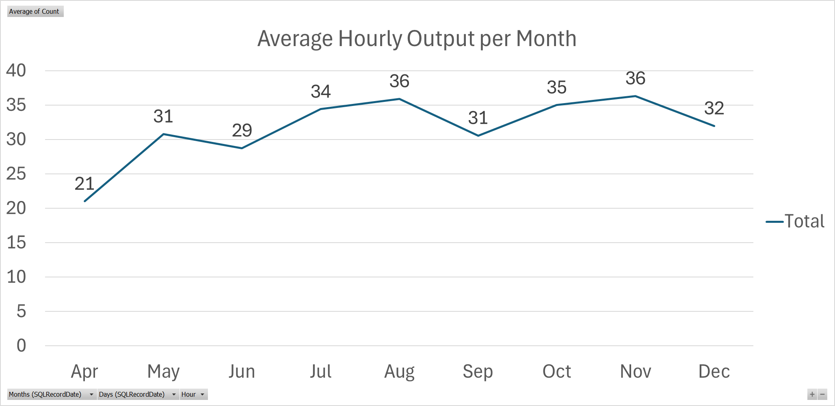
Figure 1 - Average hourly output for the Viloca line against target, based on internal production data.

4.2 Cost Per Unit Calculation Method
Cost per unit was calculated to provide a financial baseline for the Viloca line and to quantify the effect of poor yield and inefficient flow on production cost. For this project, Cost Per Unit (CPU) was calculated by combining Labour Cost Per Unit (LCPU) and Scrap Cost Per Unit (SCPU):
CPU = LCPU + SCPU
Labour Cost Per Unit was calculated by identifying the labour resource required to operate the Viloca line, including operators, team leaders and line feeders. This total labour resource was then multiplied by the standard flat labour rate used across the business. The resulting labour cost was divided by the number of passed devices produced during the selected period.
Scrap Cost Per Unit was calculated using the total scrap cost recorded over the same period. To keep the cost basis consistent with LCPU, the scrap cost was also divided by the number of passed devices produced during the period. This means that the final CPU represents the average labour and scrap cost associated with producing one accepted Viloca device. Using the same denominator for labour and scrap cost avoids combining values calculated on different unit bases and makes the financial comparison more robust.

4.3 Baseline Cost Per Unit
Using the calculation method described above, the baseline LCPU was calculated as £2.75, while the baseline SCPU was calculated as £0.62. This gives a current total CPU of:
£2.75 + £0.62 = £3.37 per passed device
The target cost per unit was calculated using the same method, with improved labour and scrap performance. The target LCPU was £1.71, while the target SCPU was £0.37. This gives a target CPU of:
£1.71 + £0.37 = £2.08 per passed device
The difference between the current and target cost per unit is therefore £1.29 per passed device, equivalent to an approximate 38.3% reduction. This demonstrates that the current Viloca process has a significant cost reduction opportunity.
Cost of Poor Quality is relevant to this analysis because it captures losses associated with processes not being right first time, including scrap, rework, repair and retest activity (Hessing, 2014). In the Viloca line, the high reject rate contributes to cost in two ways. Firstly, failed units increase labour demand because additional time is required for investigation, retest and repair activity. Secondly, units or components that cannot be recovered create direct scrap cost. The CPU baseline therefore shows that the problem is not only a quality issue, but also a measurable financial issue.
Cost metric | Current baseline | Target | Reduction
Labour Cost Per Unit | £2.75 | £1.71 | £1.04
Scrap Cost Per Unit | £0.62 | £0.37 | £0.25
Total Cost Per Unit | £3.37 | £2.08 | £1.29

4.4 Baseline Volume and Estimated Saving
The Viloca line produced approximately 30,000 passed devices during the year. This figure was used as the basis for estimating potential annual savings, as no confirmed future volume forecast was available at the time of analysis.
£1.29 × 30,000 = £38,700
This gives a conservative estimated annual saving of approximately £39,000, based on current passed volume. Actual savings would scale with future demand, meaning that a higher production volume would increase the financial benefit of reducing labour and scrap cost per unit. This supports the business case for the project, particularly as Viloca demand has increased and the line is expected to operate more frequently.

4.5 Measure Phase Summary
The Measure phase confirmed that the Viloca line is underperforming across three connected areas: quality, throughput and cost. The baseline reject rate is approximately 26%, equivalent to 264.5 failures per 1,000 devices and an estimated first-pass yield of 74%. Average hourly output is approximately 33 units per hour, which is 15 units per hour below the target of 48 units per hour.
The cost baseline also confirmed the financial impact of the current process. The current cost per passed device is £3.37, made up of £2.75 labour cost per unit and £0.62 scrap cost per unit. The target cost per passed device is £2.08, creating a potential saving of £1.29 per unit, or approximately £39,000 per year based on current passed volume.
Overall, the Measure phase established that the Viloca problem is not limited to a single metric. High rejects, reduced output and elevated cost per unit are linked through the same underlying losses: failed tests, retest activity, repair work, scrap and reduced effective capacity. The Analyse phase will therefore investigate which specific failure modes, cost drivers and process conditions are responsible for these losses, using Pareto analysis and root cause tools to prioritise improvement actions.

5. Analyse Phase

5.1 Purpose of the Analyse Phase
The purpose of the Analyse phase was to identify the main causes contributing to the Viloca line’s high reject rate, reduced hourly output and elevated cost per passed device. The Measure phase established that the line was operating with a reject rate of approximately 26%, an average output of 33 units per hour against a target of 48 units per hour, and a cost per passed device of £3.37 against a target of £2.08. The Analyse phase therefore focused on understanding which failure modes, cost drivers and process conditions were contributing most strongly to this performance gap.
Pareto analysis was used as the main prioritisation tool because it helps identify whether a small number of categories account for a large proportion of the problem. This supports Lean Six Sigma improvement work by focusing attention on the issues with the greatest potential benefit rather than spreading effort across all possible causes equally (ASQ, n.d.b; Alkiayat, 2021). In this project, Pareto analysis was applied to failure type, scrap cost by failure category and failures by test machine. These were then supported by cause-and-effect analysis and 5 Whys analysis.

5.2 Failure Mode Pareto Analysis
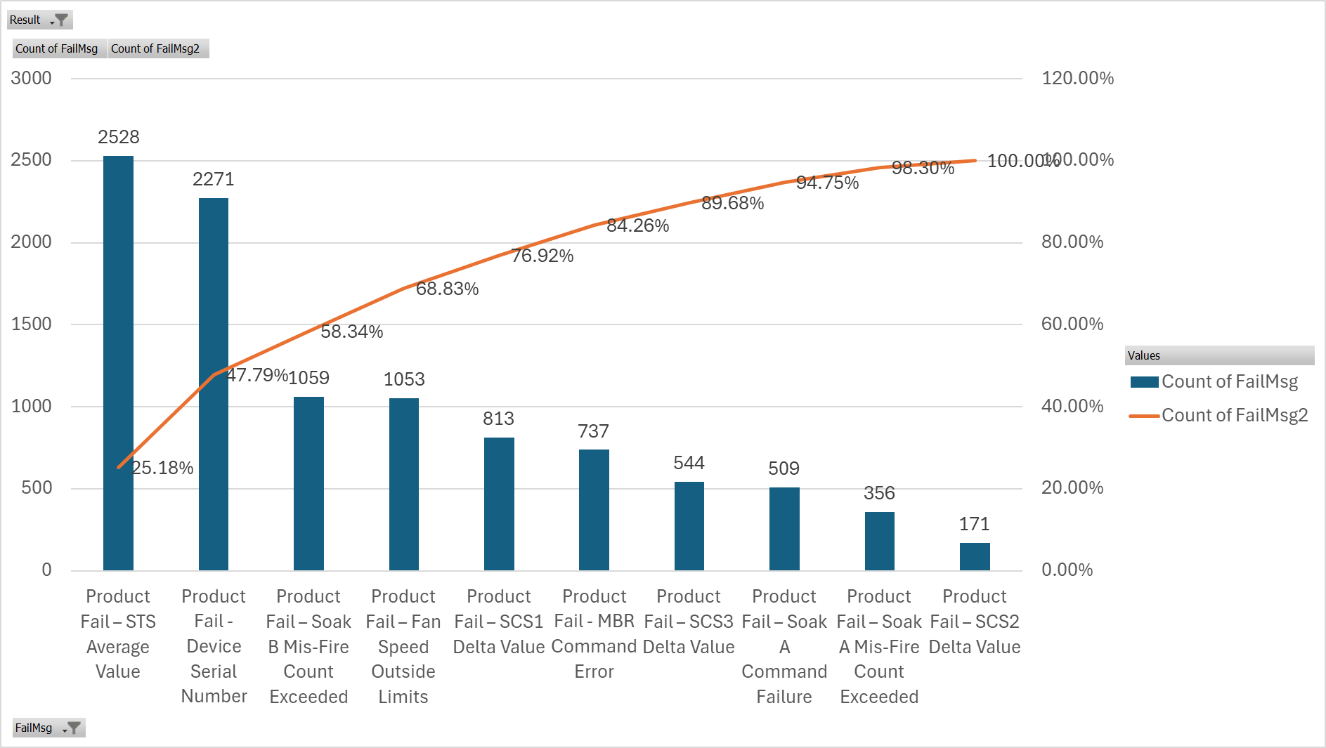
Figure 2 - Pareto Graph of Viloca Test Failures
Figure 2 shows the Pareto analysis of Viloca test failures across the selected project time range. The chart shows that failures are not evenly distributed across all categories. Instead, a small number of recurring failure modes account for most of the total reject volume.
The largest failure category was Product Fail – STS Average Value, with 2,528 recorded failures, representing 25.18% of the failure volume. The second largest category was Product Fail – Device Serial Number, with 2,271 failures. Together, these two categories accounted for 47.79% of all failures shown in the Pareto. The next largest categories were Product Fail – Soak B Mis-Fire Count Exceeded with 1,059 failures, Product Fail – Fan Speed Outside Limits with 1,053 failures, and Product Fail – SCS1 Delta Value with 813 failures. Combined, the top five failure categories accounted for 76.92% of the failure volume.
Although Device Serial Number failures were the second largest category, they were not selected as a main improvement focus. Local process knowledge confirmed that these failures are linked to an inherent limitation of the hardware used to communicate with the device. As this issue is outside the direct control and scope of the current production-focused improvement project, it was treated as a known constraint rather than a controllable root cause.
This means that improvement focus should not be based on Pareto ranking alone. Instead, the project should prioritise failures that are both significant and practically controllable, such as STS Average Value, Soak B Mis-Fire Count Exceeded, Fan Speed Outside Limits and selected SCS-related failures.

5.3 Scrap Cost Pareto Analysis
Failure count alone does not fully explain the business impact of poor quality. Some failures occur frequently but have lower cost, while others occur less often but create greater financial loss. For this reason, scrap cost by failure category was also analysed.
Figure 3 shows that the total scrap cost for the selected period was approximately £19,102.55. The largest contributor was Soak B excessive misfires, with a cost impact of approximately £6,443.71. This was followed by Soak A excessive misfires at approximately £4,717.54, and Cosmetic error – Assembly and Inspection at approximately £2,684.37.
Together, the top two cost categories accounted for approximately £11,161, or around 58% of the total scrap cost. When the top three categories are included, this increases to approximately £13,846, or around 72% of total scrap cost. This shows that financial loss is highly concentrated in a small number of categories.
A key finding is that the highest-cost categories are not the same as the highest-volume categories. STS Average Value was the largest failure type by count, but Soak B misfires, Soak A misfires and cosmetic errors were the largest contributors to scrap cost. Therefore, improvement selection must consider both frequency and financial impact. Reducing high-volume failures would improve yield and release test capacity, while reducing high-cost failures would lower Cost of Poor Quality and improve cost per unit.
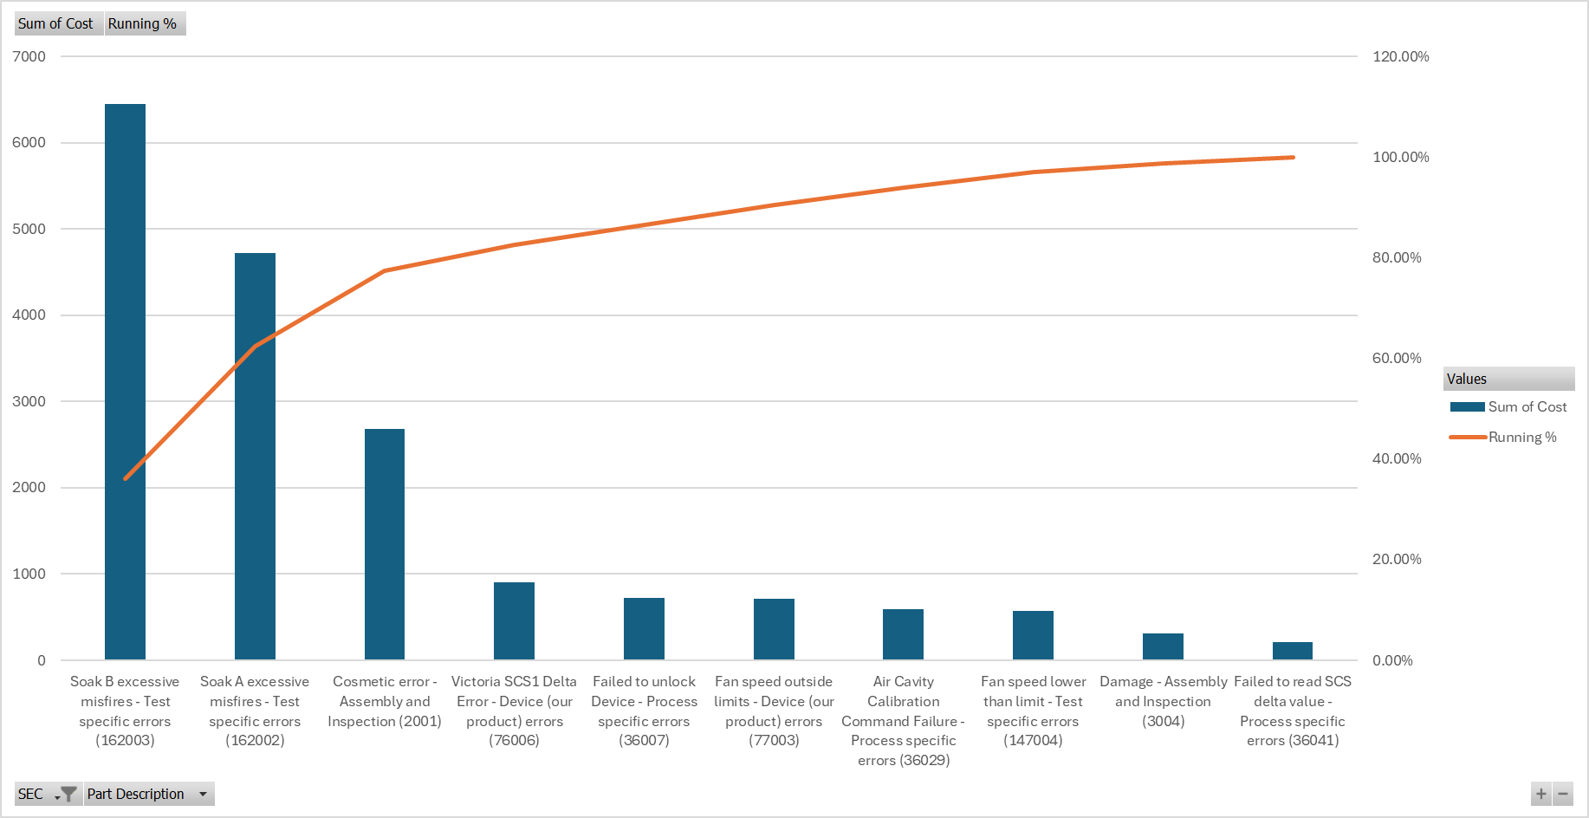
Figure 3 - Scrap cost Pareto by failure category, based on internal company cost and failure data.

5.4 Failure Distribution by Test Machine
Figure 4 shows the distribution of failures by test machine. The highest number of failures occurred on TM0802 / TRS-1326, followed closely by TM0803 / TRS-1327. TM0801 / TRS-1325 also contributed a high number of failures, while TM0804 / TRS-1328 recorded the lowest count of the four machines shown.
This indicates that failures were present across all test stations rather than being isolated to one individual machine. However, the chart shows total failure count rather than failure rate per machine. A station with more failures may simply have processed more devices during the selected time range. Therefore, this analysis identifies where further investigation should be focused but does not prove that TM0802 or TM0803 are performing worse. To confirm this, failures would need to be normalised against total devices tested or total test cycles per machine.

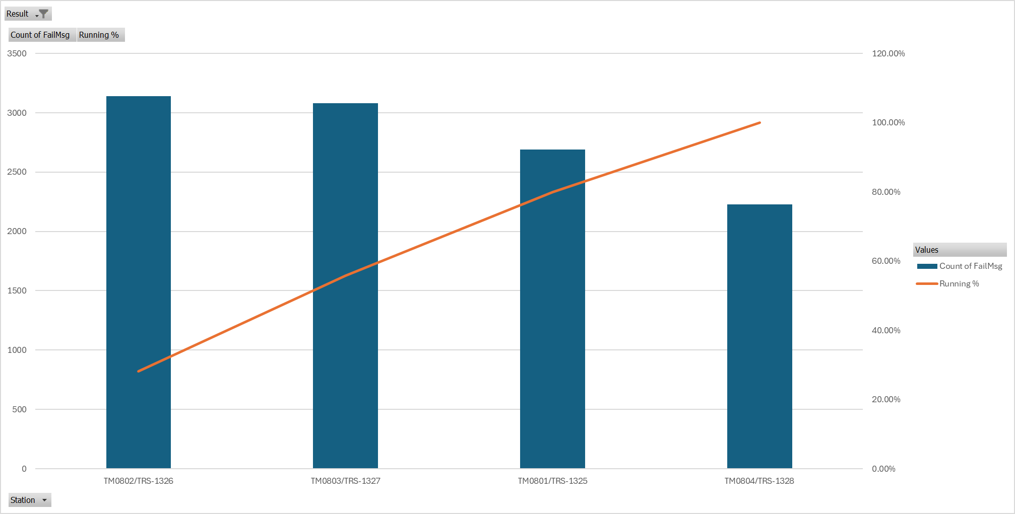
Figure 4 - Pareto analysis of failures by Viloca test machine, based on internal company test data.
Problem statement: High Viloca test reject rate, reduced hourly output and elevated cost per passed device.
Category | Potential contributing causes
Manpower | Variation in operator method; missed pre-test checks; reliance on memory; different experience levels; inconsistent escalation of repeat faults.
Machine | Fixture wear; connector condition; calibration; machine-to-machine variation; test station maintenance; Soak A / Soak B stability; fan test interface issues.
Method | No forced verification before test; unclear troubleshooting route; inconsistent retest decisions; limited reaction plan for repeat failures; insufficient poka-yoke.
Material | Subassembly variation; component variation; fan connection condition; cosmetic or handling damage; device-specific issues.
Measurement | Failure codes do not always identify physical cause; limited separation between product, process and equipment faults; machine data not normalised by usage.
Environment | Increased demand exposing weaknesses; production pressure; movement between test and repair; possible shift variation; layout constraints.
A cause-and-effect analysis was completed to identify potential contributors to the high reject rate, low output and high cost per passed device. The analysis used the 6M structure of Manpower, Machine, Method, Material, Measurement and Environment. Cause-and-effect diagrams are commonly used in quality improvement because they help teams organise possible causes before deciding which should be verified with data (Ishikawa, 1986).

5.5 Five Whys Analysis
5 Whys analysis was used to examine selected priority issues in more detail. Device Serial Number failures were excluded because their main cause was already known to be outside project scope.
Fan Speed Outside Limits
Why? | Explanation
Why are units failing Fan Speed Outside Limits? | The fan is not operating correctly during test.
Why is the fan not operating? | In many cases, the fan is not plugged in before test.
Why is it not plugged in? | The connection is not always confirmed before the unit reaches test.
Why is it not confirmed? | The process relies on operator memory.
Why does it rely on memory? | There is no forced verification or poka-yoke
The likely root cause is that the process relies too heavily on operator memory rather than a built-in prevention or detection method. This creates an opportunity for a simple improvement such as a visual check, pre-test checklist or physical/electrical confirmation before test.
Soak B Mis-Fire Count Exceeded
Why? | Explanation
Why are units failing Soak B Mis-Fire Count Exceeded? | The test records excessive misfires during Soak B.
Why are excessive misfires recorded? | The device, fixture or setup may be unstable during this test stage.
Why might the setup be unstable? | Possible causes include fixture condition, connection quality, product variation or test sensitivity.
Why is the cause not isolated quickly? | The failure data does not clearly separate product, process and equipment causes.
Why is this separation unclear? | The current failure categorisation does not identify the specific physical cause.
The likely root cause is not fully proven, but the analysis suggests that Soak B failures require further investigation into fixture condition, product condition and test data quality. This is important because Soak B misfires are both high volume and the largest scrap cost contributor.

5.6 Analyse Phase Summary
The Analyse phase showed that the Viloca performance gap is driven by a combination of high-volume failures, high-cost scrap drivers and wider process weaknesses. The failure Pareto identified STS Average Value and Device Serial Number as the two largest categories, but Device Serial Number was excluded from improvement scope due to its known hardware communication cause. The scrap cost Pareto showed that Soak B misfires, Soak A misfires and cosmetic errors accounted for approximately 72% of scrap cost. Machine analysis showed that failures were spread across all test stations, with TM0802 and TM0803 requiring further review once machine usage is normalised.
Overall, the analysis suggests that improvement activity should focus on controllable process issues, including fan connection verification, test fixture condition, failure categorisation, troubleshooting standards and reaction plans for repeat failures. These findings provide the basis for the Improve phase.

6 Improve

6.1 Purpose of the Improvement Phase
The purpose of the Improve phase was to select, implement and validate practical changes that addressed the main controllable issues identified during the Analyse phase. The Measure phase showed that the Viloca line was operating with a reject rate of approximately 26%, an average output of 33 units per hour and a cost per passed device of £3.37. The Analyse phase then identified that the main losses were linked to process imbalance, avoidable test failures, fixture condition, test efficiency and weaknesses in standard checks.
The improvement activity therefore focused on changes that could improve first-pass yield, increase effective output and reduce labour or scrap cost without requiring a major redesign of the product. Issues outside the direct project scope, such as the known serial number communication hardware limitation, were treated as constraints rather than improvement targets.

6.2 Improvement Selection Methodology
Selection criterion | Purpose
Failure frequency | Identifies whether the action targets a major contributor to rejects.
Cost impact | Checks whether the action could reduce scrap or labour cost per unit.
Controllability | Confirms whether the issue is within the project scope.
Implementation effort | Assesses time, resource, disruption and approval requirements.
Sustainability | Considers whether the improvement can be standardised and controlled.
The first stage of improvement selection used cross-functional brainstorming. Input was gathered from relevant production, engineering, quality, repair and test personnel so that potential solutions could be considered from different operational perspectives. This was important because the root causes identified in the Analyse phase were not limited to one area of the process. Some were linked to test equipment, some to operator method, some to communication and escalation, and others to product or hardware limitations. Structured brainstorming supports improvement projects by generating a wider range of possible solutions and reducing the risk that actions are selected from only one viewpoint (ASQ, n.d.c; Ishikawa, 1986).
The second stage used risk-based thinking based on the principles of Failure Mode and Effects Analysis. FMEA is commonly used to identify and prioritise risks by considering the seriousness of a failure, how often it occurs and how easily it can be detected before it affects the customer or process (Stamatis, 2003). In this project, a simplified FMEA approach was used to assess whether each potential improvement addressed a significant failure mode, whether the issue occurred frequently, and whether the current process had adequate controls to detect or prevent it. This helped separate issues that were visible in the data from issues that were genuinely controllable within the project. The current AIAG and VDA FMEA approach similarly emphasises structured analysis of failure modes, effects, prevention and detection controls (AIAG and VDA, 2019).
The third stage used an impact-effort assessment. Each potential improvement was reviewed against the expected operational benefit and the level of effort required to implement it. Expected impact considered whether the action could reduce failures, increase first-pass yield, release test capacity, reduce labour demand or lower scrap cost. Effort considered the likely resource required, implementation time, disruption to production, need for approval, training requirements and dependency on other departments. This allowed potential actions to be grouped into quick wins, major projects, lower-priority actions and actions that should be deferred. This approach is consistent with improvement project selection literature, which stresses the need to align solutions with business impact, feasibility and sustainability (Antony et al., 2017; Albliwi et al., 2014).

6.3 Assembly Flow Change and Process Rebalancing
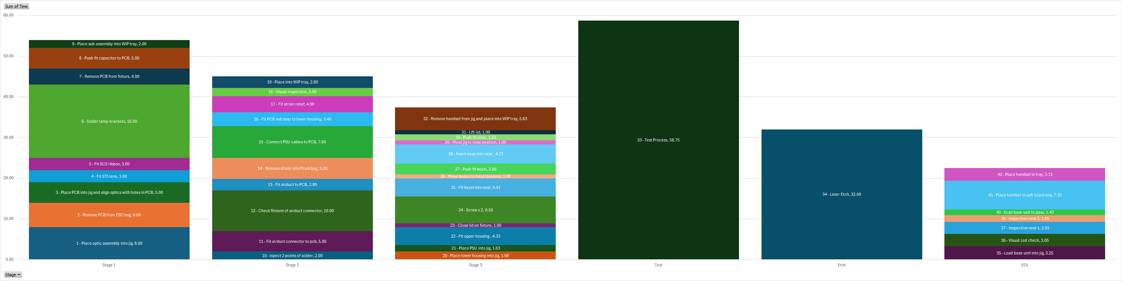
Figure 5 - Original Viloca process balance by timed work element before improvement.
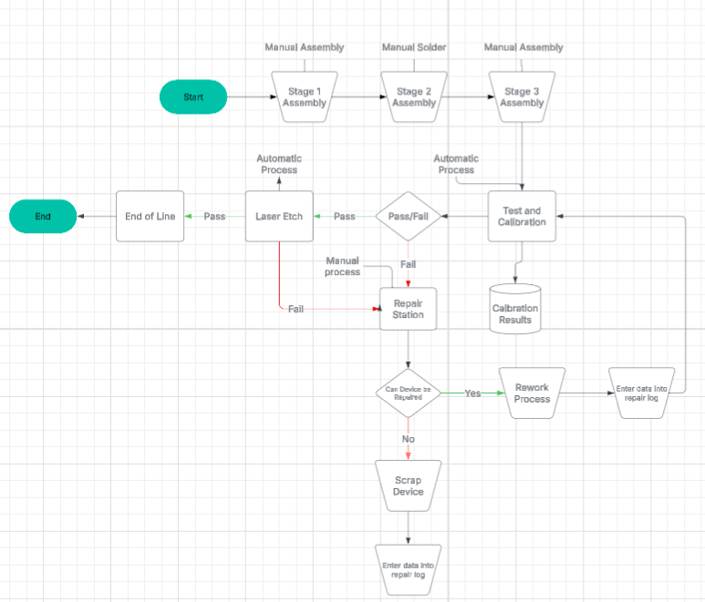
Figure 6 - Original Process Map of Viloca Assembly Process
Figures 5 and 6 show the original process balance, where the line operated with three assembly stages followed by test, laser etch and end-of-line inspection. Laser etch and EOL were performed by the same operator, so their combined workload was considered when assessing the overall line balance.
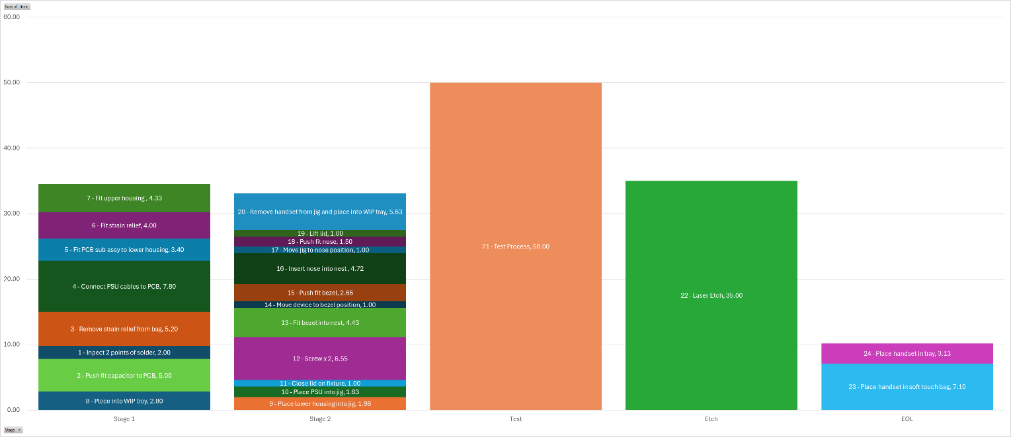
Figure 7 - Revised Viloca process balance by timed work element after improvement.
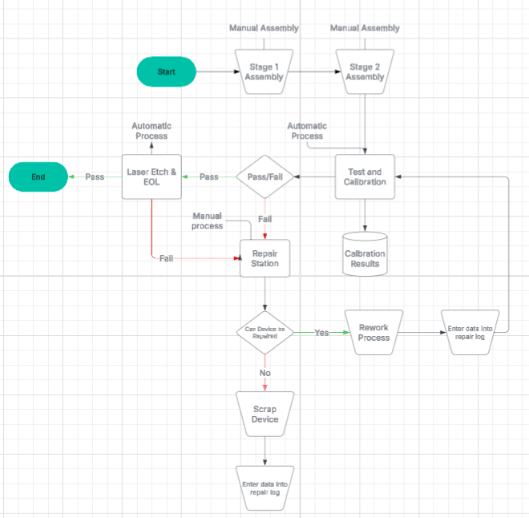
Figure 8 - Rebalanced Process Map of Viloca Assembly Process
Figures 7 and 8 show the revised balance after the first assembly stage was removed from the local process and the remaining work was redistributed across two assembly stations. The revised process reduced local assembly content, improved the balance between the two remaining assembly stages and confirmed that the test machines became the main bottleneck. This was an expected outcome because the improvement removed excess manual assembly workload while allowing the line to operate closer to the required output rate.
This allowed one operator to be removed from the local Viloca assembly line. The remaining local work was then rebalanced across two assembly stations so that the build stages were better aligned with each other and with the test machine bottleneck. Rather than describing every individual work element in detail, the process balance was demonstrated using stacked bar charts showing the timed activities at each stage. Visualising work content in this way is consistent with Lean process mapping practice, where work elements and flow are made visible to support waste reduction and line balancing decisions (Rother and Shook, 1999; Liker, 2004).
Although the assembly actions remained largely the same, the change introduced a potential risk that sub-assemblies could be damaged during transport from China. This risk was reviewed through the PFMEA. As the process steps themselves had not significantly changed, the PFMEA did not identify a large number of new process risks, but incoming part condition and transport damage were added as important considerations.
To validate the change, a 500-piece production trial was completed. All incoming sub-assemblies were inspected by the Quality Control team before being released to the line. Additional visual inspections and checks were also added to the work instructions at each stage so that transport damage, missing parts or obvious assembly issues could be identified before test.
This change also helped address fan-related failures. Fan Speed Outside Limits had been identified as a significant failure category during analysis, and local investigation suggested that many of these issues were linked to fan connection or inspection before test. The China process already had a more robust method for inspecting and confirming these parts. During the first production run using the revised sub-assembly route, no fan failures were recorded. This was a positive initial result, although continued monitoring is required to confirm that the improvement is sustained.

6.4 Test Code, Start-of-Shift Checks and Fixture Cleaning
The 500-piece trial also allowed the updated test machine code to be assessed under production conditions. The code changes were based on lessons learnt from other production lines and were introduced to improve test efficiency and consistency. Using learning from other lines reduced the need to develop a new solution from the beginning and allowed proven improvements to be transferred into the Viloca process.
The start-of-shift checks were also updated to strengthen control of test machine and fixture condition. These checks provided a clearer standard for confirming that key equipment and verification activities had been completed before production began. A defined cleaning process was introduced for the fixtures inside the test machines to reduce the risk of failures caused by contamination, poor contact or inconsistent fixture condition. The process defined what should be cleaned, when it should be cleaned and who was responsible. This moved fixture cleaning from an informal or reactive task into a standard process control.

6.5 End-of-Line Functional Check Improvement
A process change note was raised, the testing approach was agreed with Quality, and the results were recorded in the validation report. Multiple forced failures were run through the laser etch machine to confirm that the system could correctly detect non-conforming conditions. This was important because the change moved functional detection from a manual process into an automated machine process, meaning the detection capability had to be proven before release.

6.6 Documentation, PFMEA and Training
Supporting documentation was updated to ensure that the improvements were embedded into the normal production process. Work instructions were revised to include the new two-stage assembly flow, incoming sub-assembly checks, additional visual inspections, updated start-of-shift checks, fixture cleaning requirements and the revised EOL inspection method. Standardised work is important because it documents the agreed method and reduces variation between operators (Lean Enterprise Institute, n.d.b).
The PFMEA was also reviewed and updated to reflect the revised process and controls. This ensured that new or changed risks, including incoming part condition and transport damage, were considered and that appropriate controls were documented. Additional training was then provided to operators and relevant support staff so that the revised work instructions, checks, cleaning process and inspection responsibilities were understood.
Golden sample checks were also introduced for the camera systems inside the machine and added to the start-of-shift checks. Additional code was added so that the machine cannot be run each day unless the required checks have been completed. This created a stronger process control because the verification step is no longer dependent only on operator memory. This resembles poka-yoke thinking because the process was changed so that a critical verification step must be completed before production can proceed (Shingo, 1986).
Following implementation, output was monitored to confirm whether the revised process could achieve the required production rate. The target output was calculated from the bottleneck stage cycle time. Maximum theoretical output was calculated as:
Maximum theoretical output = 3600 ÷ bottleneck cycle time
Figure 9 - Weekly average hourly output following implementation compared with target.
Figure 9 shows that output increased progressively during the ramp-up period, rising from 48 units per hour in Week 1 to 56 units per hour by Week 5. The calculated target of 55 units per hour was achieved by Week 5, indicating that the revised process was capable of reaching the required output level once the new flow had stabilised. This was a significant improvement compared with the original baseline average of approximately 33 units per hour.
A recent production shift was also reviewed to assess whether the improved output level could be repeated during normal production. The shift data showed output remaining close to the target across most of the period, with the line achieving 94% of target output overall.
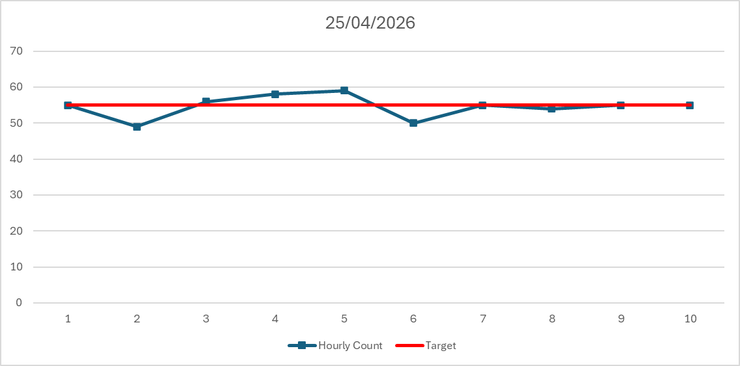
Figure 10 - Hourly output performance during a recent production shift after implementation.
This result provides further evidence that the revised process was not only capable during ramp-up, but could also operate close to target under normal production conditions. Although some hourly variation remained, the output was substantially improved compared with the baseline and supports the conclusion that the implemented changes improved effective line capacity.
This value was then multiplied by 0.85 to reflect a realistic operating assumption of 85% OEE, allowing for normal production losses such as minor stoppages, handling and short delays. OEE is widely used in manufacturing as a productivity measure because it links performance to availability, performance rate and quality losses (Nakajima, 1988; Slack et al., 2022).
Overall, the Improve phase changed the Viloca process from a three-stage local assembly route to a more streamlined two-stage process supported by incoming sub-assemblies from China, updated test code, improved fixture cleaning, stronger start-of-shift checks and automated functional inspection in the laser etch machine. The improvements were validated through trial builds, QC inspection, forced-failure testing, PFMEA review, updated work instructions and additional training. Early results showed that fan failures were eliminated in the first production run using the revised sub-assembly route and that output increased to the target level by Week 5. These results provide a strong basis for the Control phase, where the focus will be on sustaining the gains through monitoring, standard checks and ongoing process control.

6.7 Yield Improvement Validation
Post-implementation failure data was reviewed over a five-week period to assess whether the improvement actions had reduced the main controllable failure modes. Figure 11 shows the updated Pareto of test failures after implementation. The overall failure rate reduced to approximately 16%, compared with the original baseline reject rate of approximately 26%. This indicates a clear improvement in first-pass yield and shows that the implemented changes had a positive effect on quality performance as well as output.
The Pareto also shows a change in the failure profile. STS Average Value and Fan Speed Outside Limits, which were previously major contributors, no longer appeared among the highest failure categories. This supports the effectiveness of the revised sub-assembly route, additional checks and improved process controls. However, the largest remaining issue was now linked to Device Serial Number / communication-related failures. These failures were recognised during the Analyse phase as an inherent communication hardware issue and were therefore outside the scope of the current production-focused Green Belt project. As a result, the remaining failure profile suggests that the project successfully reduced several controllable process-related issues, while the next major opportunity would require a separate engineering-led investigation into communication hardware and test interface reliability.
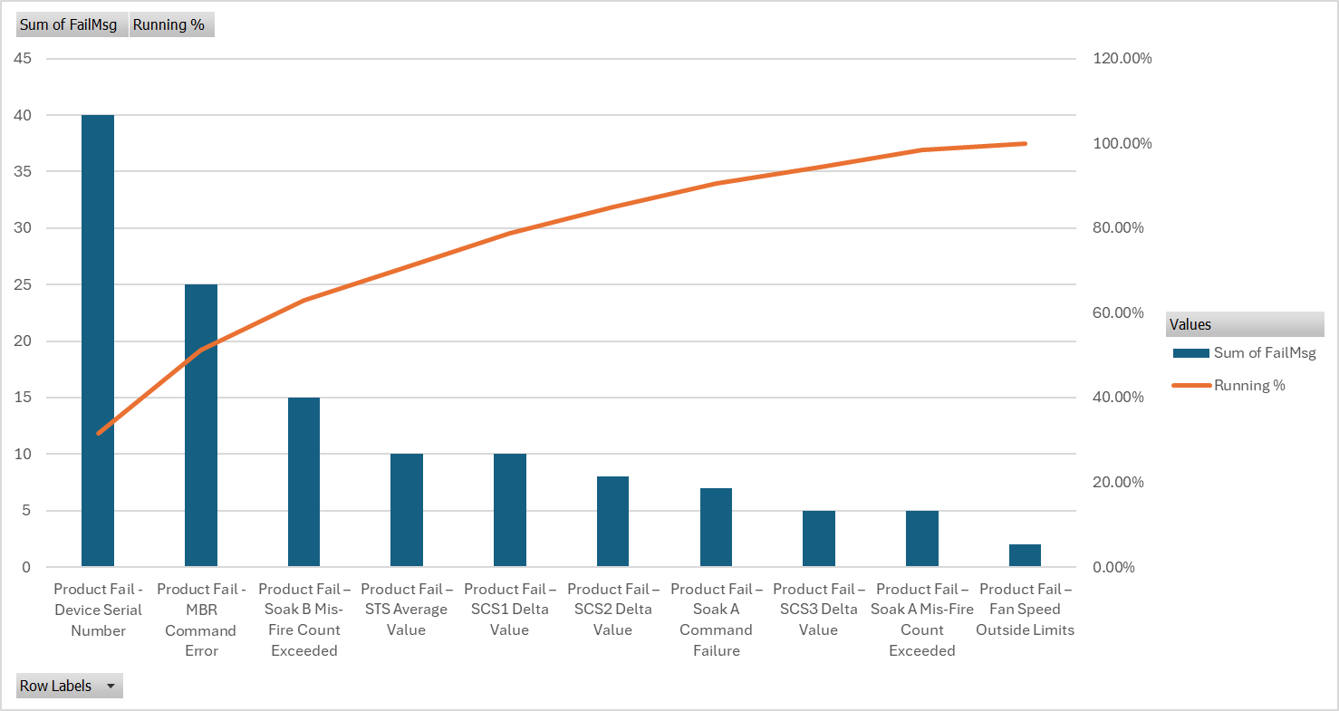
Figure 11 - Pareto of Post-Improvement Failures

7. Control Phase

7.1 Purpose of the Control Phase
The purpose of the Control phase was to ensure that the improvements made to the Viloca line were sustained after implementation. In DMAIC, the Control phase is used to monitor the improved process, maintain the gains achieved, and prevent the process from reverting to its previous condition (ASQ, n.d.c). For this project, the main control requirement was to ensure that the revised two-stage assembly process, updated test code, fixture cleaning process, start-of-shift checks and laser etch functional checks remained effective during normal production.
The Control phase therefore focused on three areas: tracking performance through key performance indicators, maintaining the updated process through standard work and training, and defining reaction plans for when performance falls below the expected level. This was important because the Improve phase introduced several changes across assembly, test, laser etch and end-of-line inspection. Without ongoing control, there would be a risk that operators return to previous working methods, checks are missed, fixtures are not maintained consistently, or output gains are not sustained.

7.2 Key Performance Indicators
A set of KPIs was defined to monitor whether the Viloca process continued to perform at the required level. The KPIs were selected to reflect the main objectives of the project: improved yield, higher output, reduced cost and stronger process control. Monitoring multiple KPIs was important because one measure alone would not fully show whether the process was stable. For example, output could improve while reject rate worsens, or yield could improve while start-of-shift discipline weakens.
KPI | Purpose | Target / expectation | Review frequency | Owner
Average hourly output | Confirms line capacity and flow | Meet or exceed agreed target | Daily / weekly | Production Team Leader
First-pass yield | Tracks how many units pass without retest or repair | Improve from baseline of approx. 74% | Weekly | Quality / Engineering
Reject rate | Monitors overall test failure level | Reduce from baseline of approx. 26% | Weekly | Quality
Failures per 1,000 devices | Normalised failure measure | Reduce from baseline of 264.5 | Weekly / monthly | Quality
Fan failures | Confirms whether fan issue remains controlled | Zero or near-zero occurrences | Daily during ramp-up, then weekly | Production / Quality
Top failure Pareto | Tracks whether dominant failure modes return | No adverse trend in top failures | Monthly | Engineering / Quality
Average cost per passed device | Confirms financial impact | Move towards £2.08 target | Monthly | Production / Finance
Start-of-shift check completion | Confirms process checks are being completed | 100% completion | Daily | Team Leader
Fixture cleaning compliance | Confirms test fixtures are maintained | 100% to agreed frequency | Daily / weekly | Production / Maintenance
Laser etch golden sample check | Confirms camera and detection system readiness | 100% completion before use | Daily | EOL / Team Leader
This KPI structure provides both outcome measures and process control measures. Output, yield, reject rate and cost per passed device show whether the improvement is delivering the required result. Start-of-shift checks, fixture cleaning and golden sample checks show whether the controls that support the improved process are being followed.

7.3 Performance Monitoring and Data Review
Failure data will also be reviewed regularly. A monthly Pareto of test failures should be produced to confirm whether the previous dominant failure modes have reduced and whether any new failure categories are emerging. Particular attention should be given to fan failures, Soak A and Soak B misfires, STS Average Value failures and SCS-related failures. This ensures that the project does not only confirm short-term output improvement, but also monitors whether the underlying failure profile remains controlled.
Weekly output data will be reviewed using a simple trend chart to identify whether performance remains stable over time. Control charts and trend-based monitoring are useful because they show process performance in time order and help distinguish normal variation from unusual changes that may require investigation (ASQ, n.d.a; NIST/SEMATECH, n.d.). If sufficient data are collected over time, statistical process control charts can be introduced for key measures such as hourly output, reject rate or failures per 1,000 devices. This would strengthen the Control phase by allowing abnormal variation to be detected before the process returns to its previous condition (Montgomery, 2020).
A control plan was created to define the checks, measures and responsibilities needed to maintain the improved process. The purpose of the control plan is to make the new process routine rather than relying on individuals remembering what changed. This is particularly important for start-of-shift checks, fixture cleaning, incoming sub-assembly inspection and laser etch golden sample verification.
Control point | Control method | Reaction if not achieved
Incoming sub-assemblies | QC inspection and visual checks at assembly stages | Quarantine suspect parts and escalate to Quality
Assembly process | Updated work instructions and operator training | Stop and retrain if incorrect method is observed
Fixture condition | Defined cleaning process and check sheet | Clean fixture before production continues
Start-of-shift checks | Daily check record | Escalate to Team Leader if missed
Laser etch camera system | Golden sample check before use | Machine cannot run until check is complete
Functional checks | Automated in laser etch machine | Investigate forced-failure or detection issue immediately
Test failure trend | Weekly review of reject rate and Pareto | Engineering review if failures exceed trigger level
Output performance | Daily / weekly output review | Review bottleneck, staffing, downtime and test issues
The strongest control introduced was the laser etch machine lockout. The machine code was changed so that it cannot be run each day unless the required golden sample checks have been completed. This is stronger than a manual reminder because the process physically prevents production from continuing without the verification step. This supports mistake-proofing by reducing reliance on operator memory.

7.4 Standard Work, Training and PFMEA Control
The updated work instructions form a key part of the Control phase. Standardised work helps document the current best method, reduce variation between operators and provide a stable baseline for future improvement (Lean Enterprise Institute, n.d.b; Liker, 2004). For Viloca, the work instructions were updated to include the two-stage assembly process, incoming part checks, visual inspection requirements, fixture cleaning, start-of-shift checks and the revised EOL inspection process.
Training was also used to sustain the improvement. Operators and support staff were trained on the revised process flow, updated work instructions, fixture cleaning requirements, laser etch checks and escalation routes. Training records should be maintained so that the business can confirm that all relevant personnel are competent to run the revised process. This links to change management literature, which stresses that new working methods must be embedded through ownership, communication and reinforcement rather than treated as one-off events (Kotter, 1996).
The PFMEA should remain a live document. If new failures occur, if incoming part quality changes, or if further changes are made to the test or laser etch process, the PFMEA should be reviewed and updated. This ensures that risks continue to be assessed and controlled after the project closes, rather than only during the initial implementation. This is consistent with FMEA practice, which treats risk analysis as an ongoing control activity rather than a static document (AIAG and VDA, 2019; Stamatis, 2003).

8. Discussion

8.1 Comparison with Literature
The findings from this project support the Lean Six Sigma principle that process improvement should be driven by measured evidence rather than assumption. The Measure phase showed that the Viloca line was affected by a combination of low first-pass yield, reduced hourly output and elevated cost per passed device. This aligns with DMAIC literature, which positions the Measure and Analyse phases as essential for defining the baseline condition and identifying the dominant causes of process loss before improvements are selected (ASQ, n.d.c; Shamsuzzaman et al., 2023; Pande et al., 2000). In this project, the use of reject rate, output rate, cost per unit and Pareto analysis provided a clear link between quality losses and operational performance.
The project also supports the Lean view that defects create wider process waste beyond the immediate failed unit. A 26% reject rate meant that a significant proportion of test capacity was being consumed by failures, retests, troubleshooting and repair activity rather than by new units progressing towards finished goods. This reflects the Lean principle that defects often generate further waste, including overprocessing, waiting, unnecessary movement and lost capacity (Ohno, 1988; Womack and Jones, 1996; Bhamu and Sangwan, 2014). The improvement work therefore did not only focus on reducing failures, but also on simplifying the local assembly flow and reducing non-value-adding manual activity.
The post-improvement output results also support literature on bottlenecks and throughput. Manufacturing systems are often constrained by the slowest or least available process step, meaning that improvements must be aligned with the true constraint rather than distributed equally across all stations (Goldratt and Cox, 2014; Skoogh et al., 2023). In the Viloca project, transferring the first-stage sub-assembly work to China reduced local assembly content and allowed the process to be rebalanced around the remaining assembly stations and test machines. This helped move the line from a baseline of approximately 33 units per hour to a ramp-up performance that achieved the revised target by Week 5. The results therefore support operations management theory that capacity improvement should be judged at system level rather than only by individual station cycle times (Slack et al., 2022).
The project also demonstrates the value of standardised work and process control. Improvements such as updated work instructions, defined fixture cleaning, start-of-shift checks, golden sample checks and PFMEA updates were used to make the new process repeatable. This is consistent with Lean literature, which argues that standardised work provides a baseline for stable performance and future improvement (Lean Enterprise Institute, n.d.b; Liker, 2004). The use of code to prevent the laser etch machine from running until daily checks had been completed also strengthened control by reducing reliance on operator memory, which is consistent with mistake-proofing and source-inspection principles (Shingo, 1986).
A key strength of the project was that improvement actions were based on a combination of data analysis and practical operational knowledge. The Pareto analysis identified high-volume and high-cost failure categories, while input from production, quality, engineering and test personnel helped determine which issues were realistically controllable. This was important because not every major failure mode could be addressed within the project scope. For example, Device Serial Number failures were significant by count, but were linked to an inherent hardware communication issue and therefore could not be solved through local process improvement.
One of the main constraints was the time taken to initialise the project. The early findings were identified during the Define phase, but competing business priorities meant that implementation and detailed analysis could not begin immediately. This created a delay between identifying the opportunity and carrying out the improvement work. However, once time and resource were allocated, the implementation phase ran smoothly. This was partly because several improvements were based on lessons learnt from other production lines and because similar sub-assembly strategies had already been introduced on other models. As a result, the business was not starting from a completely unknown position, and the relevant departments were already familiar with many of the required actions. This aligns with change management literature, which suggests that implementation is more effective when teams understand the need for change and have an existing basis of knowledge to work from (Kotter, 1996; Garvin, 1993).
This organisational familiarity was a major enabler. Production, quality, engineering, advanced engineering and support functions were able to work efficiently because the improvement approach was not entirely new to the business. This reflects the importance of organisational learning in continuous improvement, where knowledge from previous projects can reduce implementation risk and shorten the time needed to deliver change (Womack and Jones, 1996; Shamsuzzaman et al., 2023; Nonaka and Takeuchi, 1995).
There were also limitations in the available data. Some machine-level analysis was based on total failure count rather than failure rate normalised by machine usage, meaning that higher failure counts could partly reflect higher test volume rather than poorer machine performance. The early post-improvement results were also based on an initial production ramp-up and recent shift data, so longer-term monitoring is required before the gains can be considered fully sustained. Despite these constraints, the project produced clear evidence of improvement and established a stronger control plan for ongoing monitoring. This reinforces the need for ongoing statistical monitoring and longer-term data collection as part of the Control phase (Montgomery, 2020; NIST/SEMATECH, n.d.).

9. Conclusions and Recommendations

9.1 Summary of Key Findings
This dissertation investigated the use of a Lean Six Sigma DMAIC approach to improve the performance of the Viloca production line. The Measure phase showed that the line was operating below the required level, with a reject rate of approximately 26%, an estimated first-pass yield of 74%, average output of 33 units per hour and a cost per passed device of £3.37. These results confirmed that the issue was not only a quality problem, but also a throughput and cost problem.
The Analyse phase showed that failures and scrap cost were concentrated in a small number of categories. However, the project also showed that high Pareto ranking alone should not determine improvement priority, as some issues, such as Device Serial Number failures, were outside the direct scope of the project. Improvement activity therefore focused on controllable process changes.
The main improvements included changing from a three-stage to a two-stage local assembly process, transferring first-stage sub-assembly work to China, updating test code, introducing fixture cleaning, improving start-of-shift checks, automating functional checks within the laser etch machine, updating work instructions and providing additional training. Early results showed that output increased during ramp-up and achieved the revised target by Week 5, while fan failures were not seen during the first production run using the revised sub-assembly process.

9.2 Achievement of Aim and Objectives
The overall aim of the project was to improve Viloca line performance by increasing yield, improving throughput and reducing cost per passed device. This aim was substantially achieved. The line moved from a baseline average output of approximately 33 units per hour to a post-improvement ramp-up result of 56 units per hour by Week 5, exceeding the revised calculated target of 55 units per hour. Whilst the output objective was achieved, yield and cost improvements require longer-term monitoring to confirm full sustained achievement.
The first objective was to establish the baseline performance of the Viloca line. This was achieved through measurement of reject rate, first-pass yield, hourly output and cost per passed device. The second objective was to identify the main causes of poor performance. This was achieved using Pareto analysis, machine-level review, scrap cost analysis, cause-and-effect analysis and 5 Whys. The third objective was to select and implement practical improvements. This was achieved through process rebalancing, test code updates, fixture controls, EOL automation and improved standard work. The final objective was to define how the gains would be sustained. This was achieved through KPIs, updated start-of-shift checks, fixture cleaning requirements, golden sample checks, PFMEA updates, training and ongoing performance monitoring.

9.3 Recommendations and Future Work
Further work should focus on normalising failure data by test machine usage so that machine-level performance can be assessed more accurately. Additional DMAIC cycles could then target remaining high-cost issues such as Soak A and Soak B misfires, STS Average Value failures and SCS-related failures. The known serial number communication issue should also be considered as a separate engineering-led improvement project, as it remains a major contributor but was outside the scope of this dissertation.
Future research could build on this project by collecting a larger post-improvement dataset over several months. This would allow the long-term stability of the improvements to be assessed and would provide stronger evidence of sustained impact on yield, throughput and cost.
The main recommendation for the company is to continue monitoring the Viloca line using the KPIs defined in the Control phase, particularly hourly output, first-pass yield, reject rate, failures per 1,000 devices, fan failures and cost per passed device. Monthly Pareto reviews should also be used to confirm whether the dominant failure modes remain controlled or whether new issues are emerging. This would support continuous improvement by linking day-to-day performance measures to the wider operational objectives of quality, output and cost (Neely et al., 1995; Parmenter, 2015; Imai, 1986).

References
- AIAG and VDA (2019) Failure Mode and Effects Analysis: FMEA Handbook. 1st edn. Southfield, MI: Automotive Industry Action Group.
- Albliwi, S., Antony, J., Abdul Halim Lim, S. and van der Wiele, T. (2014) ‘Critical failure factors of Lean Six Sigma: a systematic literature review’, International Journal of Quality & Reliability Management, 31(9), pp. 1012–1030.
- Albliwi, S.A., Antony, J. and Lim, S.A.H. (2015) ‘A systematic review of Lean Six Sigma for the manufacturing industry’, Business Process Management Journal, 21(3), pp. 665–691.
- Alkiayat, M. (2021) ‘A practical guide to creating a Pareto chart as a quality improvement tool’, Global Journal on Quality and Safety in Healthcare, 4(2), pp. 83–84.
- Antony, J., Snee, R. and Hoerl, R. (2017) ‘Lean Six Sigma: yesterday, today and tomorrow’, International Journal of Quality & Reliability Management, 34(7), pp. 1073–1093.
- ASQ (n.d.a) Control Chart. American Society for Quality.
- ASQ (n.d.b) Cost of Quality (COQ). American Society for Quality.
- ASQ (n.d.c) DMAIC. American Society for Quality.
- ASQ Quality Management Division, Meisel, R.M., Babb, S.J., Marsh, S.F. and Schlichting, J.P. (2007) The Executive Guide to Understanding and Implementing Lean Six Sigma: The Financial Impact. Milwaukee, WI: ASQ Quality Press.
- Bansal, D. (2017) ‘DMAIC model: a practical guide to effective problem solving’, TQMI Blog, 11 April.
- Bhamu, J. and Sangwan, K.S. (2014) ‘Lean manufacturing: literature review and research issues’, International Journal of Operations & Production Management, 34(7), pp. 876–940.
- Deming, W.E. (1986) Out of the Crisis. Cambridge, MA: MIT Press.
- Feigenbaum, A.V. (1991) Total Quality Control. 3rd edn. New York: McGraw-Hill.
- Fogg, E. (2025) First Pass Yield: What is it, Formula, and How to Improve. MachineMetrics.
- Garvin, D.A. (1993) ‘Building a learning organization’, Harvard Business Review, 71(4), pp. 78–91.
- George, M.L. (2002) Lean Six Sigma: Combining Six Sigma Quality with Lean Production Speed. New York: McGraw-Hill.
- Gijo, E.V., Scaria, J. and Antony, J. (2011) ‘Application of Six Sigma methodology to reduce defects of a grinding process’, Quality and Reliability Engineering International, 27(8), pp. 1221–1234.
- Goldratt, E.M. and Cox, J. (2014) The Goal: A Process of Ongoing Improvement. 4th edn. Great Barrington, MA: North River Press.
- Gregoire, C. (2017) Understanding and Increasing Right First Time (RFT). Kansas State University.
- Hessing, T. (2014) ‘Cost of Poor Quality (COPQ)’, Six Sigma Study Guide.
- Imai, M. (1986) Kaizen: The Key to Japan’s Competitive Success. New York: McGraw-Hill.
- Ishikawa, K. (1986) Guide to Quality Control. 2nd edn. Tokyo: Asian Productivity Organization.
- ISO (2015) ISO 9001:2015 Quality Management Systems – Requirements. Geneva: International Organization for Standardization.
- Juran, J.M. and Godfrey, A.B. (1999) Juran’s Quality Handbook. 5th edn. New York: McGraw-Hill.
- Kaplan, R.S. and Norton, D.P. (1996) The Balanced Scorecard: Translating Strategy into Action. Boston, MA: Harvard Business School Press.
- Kotter, J.P. (1996) Leading Change. Boston, MA: Harvard Business School Press.
- Lean Enterprise Institute (n.d.a) Seven Wastes. Lean Enterprise Institute.
- Lean Enterprise Institute (n.d.b) Standardized Work. Lean Enterprise Institute.
- Lean Enterprise Institute (n.d.c) Waste. Lean Enterprise Institute.
- Lean Enterprise Institute (n.d.d) What is Lean? Lean Enterprise Institute.
- Liker, J.K. (2004) The Toyota Way: 14 Management Principles from the World’s Greatest Manufacturer. New York: McGraw-Hill.
- Montgomery, D.C. (2020) Introduction to Statistical Quality Control. 8th edn. Hoboken, NJ: Wiley.
- Nakajima, S. (1988) Introduction to TPM: Total Productive Maintenance. Cambridge, MA: Productivity Press.
- Neely, A., Gregory, M. and Platts, K. (1995) ‘Performance measurement system design: a literature review and research agenda’, International Journal of Operations & Production Management, 15(4), pp. 80–116.
- NIST/SEMATECH (n.d.) e-Handbook of Statistical Methods: Process or Product Monitoring and Control. National Institute of Standards and Technology.
- Nonaka, I. and Takeuchi, H. (1995) The Knowledge-Creating Company: How Japanese Companies Create the Dynamics of Innovation. Oxford: Oxford University Press.
- Ohno, T. (1988) Toyota Production System: Beyond Large-Scale Production. Cambridge, MA: Productivity Press.
- Pande, P.S., Neuman, R.P. and Cavanagh, R.R. (2000) The Six Sigma Way: How GE, Motorola, and Other Top Companies are Honing Their Performance. New York: McGraw-Hill.
- Parmenter, D. (2015) Key Performance Indicators: Developing, Implementing, and Using Winning KPIs. 3rd edn. Hoboken, NJ: Wiley.
- Pyzdek, T. and Keller, P.A. (2018) The Six Sigma Handbook. 5th edn. New York: McGraw-Hill Education.
- Radej, B., Drnovšek, J., Begič-Hajdarević, D. and Kramberger, J. (2017) ‘An overview and evaluation of quality-improvement methods from the manufacturing and supply-chain perspective’, Advances in Production Engineering & Management, 12(4), pp. 388–400.
- Rother, M. and Shook, J. (1999) Learning to See: Value Stream Mapping to Add Value and Eliminate Muda. Brookline, MA: Lean Enterprise Institute.
- Sciemetric (2011) The ROI of Improving First Time Yield. Manufacturing Whitepaper Series.
- Shah, R. and Ward, P.T. (2003) ‘Lean manufacturing: context, practice bundles, and performance’, Journal of Operations Management, 21(2), pp. 129–149.
- Shamsuzzaman, M., AlHerimi, N., Haridy, S., Shamsuzzoha, A.H.M., Abumadi, F., Al Jabban, R., Rami, H. and Asem, J. (2023) ‘Deployment of Lean Six Sigma DMAIC methodology to improve productivity of a can manufacturing industry’, International Journal of Productivity and Quality Management, 39(2), pp. 171–196.
- Shingo, S. (1986) Zero Quality Control: Source Inspection and the Poka-Yoke System. Cambridge, MA: Productivity Press.
- Skoogh, A., Thürer, M., Subramaniyan, M., Matta, A. and Roser, C. (2023) ‘Throughput bottleneck detection in manufacturing: a systematic review of the literature on methods and operationalization modes’, Production & Manufacturing Research, 11(1), 2283031.
- Slack, N., Brandon-Jones, A. and Burgess, N. (2022) Operations Management. 10th edn. Harlow: Pearson.
- Stamatis, D.H. (2003) Failure Mode and Effect Analysis: FMEA from Theory to Execution. 2nd edn. Milwaukee, WI: ASQ Quality Press.
- Toyota Material Handling UK (2022) ‘Identifying and eliminating the 7 wastes of Lean manufacturing’, Toyota Material Handling UK Blog.
- TXM Lean Solutions (c.2024) ‘The ninth waste in the lean office (and TIMWOOD)’, TXM Lean Solutions.
- Womack, J.P. and Jones, D.T. (1996) Lean Thinking: Banish Waste and Create Wealth in Your Corporation. New York: Simon & Schuster.

