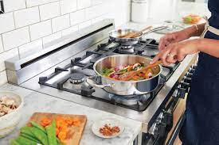  Cooking LESSONS  E-Portfolio | Jules Claes (2203522)  Changemakers: Creativity and Value Creation (ADPA5002)

In my time studying at university, I have been lucky enough to have the knowledge of being able to cook for myself, as I was taught back when living at home. However, many students are not as lucky and move out to live in accommodations not knowing how to cook for themselves. “Evidence shows there are many barriers which contribute to adopting unhealthful dietary behaviour at university, including limited budget, nutrition knowledge, and cooking skills” (Kelly et al, 2024). On top of this students can acquire unhealthy drinking habits, “drinking habits can also affect their diets; they're more likely to eat after drinking alcohol, and more likely to eat calorific foods high in salt and sugar, according to research” (Bradley, 2022). Bradley (2022) investigated on how students who go to university look after them self and, as just mentioned, that many students would sober themselves up with takeaways; this can evolve into unhealthy eating habits too.
To try and tackle this problem I wanted to propose cooking lessons that students would receive within their time in the university, this would teach students various techniques and recipes that they would be able to use in the kitchen to create delicious meals, as well as being cost-effective.
Due to the nature of the secondary research being current, it is primarily sourced online, as this format is becoming more commonplace. The research carried out within this academic portfolio will be taken from articles from the internet; this is because for my idea I needed to track problems that have been happening recently, especially from what happened after the COVID-19 worldwide pandemic, which effected a lot of our current society especially with students trying to study for their degrees.
I wanted to see on how people would go about cooking for themselves, as well as how much fast food they would buy. To gather information, I used the survey website LimeSurvey (LimeSurvey, 2020). From my data, it was mostly positive, the results are posted below (see Image 1). The first question was: “How often do you find yourself ordering takeaways?”
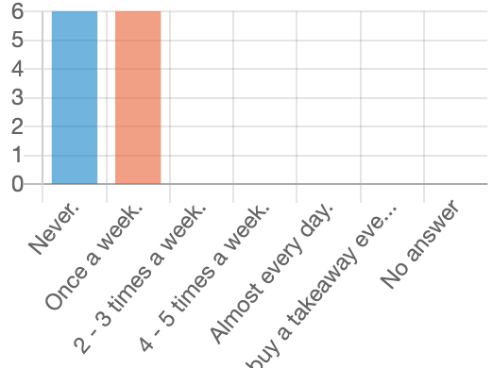
Image 1 - How often do you find yourself ordering takeaways?

As we can see from my primary research, 50% of people who completed the survey stated that they ordered takeaways at least once a week. The other 50% stated they ‘never’ ordered takeaways. This was a good sign from my university cohort in that people are actively making their own food. My hope is to give students more knowledge to take that number lower and not order takeaways in the first instance. This would add more benefits to my idea of teaching on how to prepare meals at the start of the week; all students would need to do is heat/reheat in the microwave or oven. Furthermore, this would help students’ budgets and save money which would be spent on takeaway food. There are many benefits such as saving money, which has been shown in the research from Blanton (2023), they state: “Having a plan allows you to figure out exactly what ingredients you will need for the week so you can use them”. Alongside saving money a lot of the recipes used with meal preparation can give a person the right nutrients they would need for their daily life, taking an example from a company that sells meal preparation kits, HelloFresh, they have got meals that tick many boxes of what different students need. These meals adhere to different cultures and dietary requirements (HelloFresh, 2024). HelloFresh’s rationale reflects what I am trying to achieve, by bringing efficient, quick and easy meal preparation to students. Within my proposal I also want to address the shopping students will have to do for each meal, such as creating a simple shopping list that is easy to find with the ingredients that you need. This sounds obvious, however, when looking for specific ingredients it can be challenge if they are not in your local store, so when showing the recipes, I want to make that known.
I also investigated how often students will cook for themselves in the kitchen, instead of buying takeaways to back up my points. The results below (see Image 2) are what I discovered.

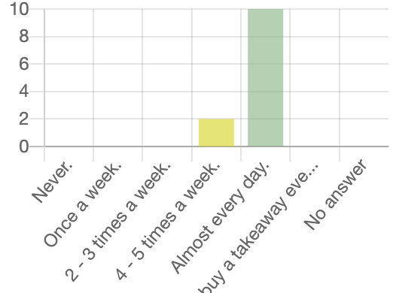
Image 2 – How often do you cook for yourself?

From my survey and the data, I have collected, I have found out from this primary research that most people would cook for themselves. Approximately 83% of participants cooked ‘Almost every day’, this will give me a solid basis when promoting my cooking lessons for I wouldn't have to appeal to people as much as they would already be engaged with cooking. This is another positive with students and will make the lessons more focused on expanding on those cooking techniques people already have, therefore helping them with their overall wellbeing while studying at university.
From all the potential participants, twelve participated in the survey, all individuals will have their data stored safely on LimeSurvey and a password protected laptop until this portfolio is submitted, all answers will be kept anonymous. Also, I made sure that the survey consisted of students from different courses ranging from Acting, Set Design and Production and Outdoor Education, where I sent them a link to the survey. Although I have had accurate and useful data through my primary research, looking back I could have had more effective questions supporting my idea. For example, I posed the question: ‘Do I cook for myself?’, which can be useful, however, I don’t specify in the question on the method of cooking - such as if it was done from scratch, getting the ingredients and making your own meal or if it was done by putting a pizza in the oven/curry in the microwave. So, because of that, it has impacted my data.
From my secondary research there is possibly more of a demand for people wanting more knowledge for cooking for themself, which is great because most students are on a budget while studying. On top of that product prices are rising, especially on more healthier foods such as fruit and vegetables, Linden (2020) comments:

“If you don't have a lot of money, you're stuck with that really toxic combination of having not much money combined with the unhealthy food environment that we already have, which is leading to some of those really worrying health outcomes”.

This can have a huge impact on students making it more limited on what to buy for their meals. An article from the Office for National Statistics (ONS) (2021) when interviewing different students across multiple universities goes into more detail on how the cost-of-living crisis is affecting students living situations, with some students commenting that: “Some days I really don’t eat at all”. So, in coming up with classes/lessons focusing on cooking it would help students in the university, focusing on making meals that would give the right nutrients needed as a student, as well as being cost-effective. I will be looking into meals that would be quick and easy, from my secondary research, Yun et al (2018) puts forward that students in general are ordering takeaways constantly, this is because of the limited time they have in between lectures, studying, and perhaps for some, working. This contradicts my primary research.
How I plan on forwarding this idea is trying to get to my target audience, which will be students across all years and courses. However, I will be mainly focusing on first year students because they will be the audience that could mostly benefit from these lessons; as they are new to university and in most cases just finished school/college and often moving out of their homes. Many may not have cooked for themselves and when moving to university accommodation realise that they have got to eat and may go for quick, easy and unhealthy foods, such as frozen foods and takeaways.
My main audience will be first years, who are often overwhelmed by university life and a new setting. They will be slowly getting used to this world and meeting other students, getting used to their location and getting to grips with how university works; so, I have got to be careful that I don’t overwhelm them further. I would hopefully be able to spread this information around during September in the Fresher's Fair, for it would be one of the first gatherings students will have within the university. An alternative way I would promote myself is through The Student’s Union (including the website) and using Y Lloft as a focal point (UWTSD Student Union, 2020). In these locations I would promote different recipes offered through the different lessons, using different recipes that I have adapted from ones that are already out there. Recipes will be developed from the British Dietetic Association (2014), which have many recipes that support my idea and how I want to help students out. For example, it uses recipes that help students in various ways such as meals that require 5 or less ingredients therefore helping students out with their budgets and saving money. It also uses recipes that can be cooked quickly in under thirty minutes or less, as well as meals that can be stored and cooked in the microwave. This is great as it would be useful for students not having to make those tough choices on if they should eat or to study, they can create these dishes and get back to work. I will also be using different ingredients from different medias to have more of a range of recipes that I will be able to teach to people, such as cookbooks which get overlooked, but support a great range of different recipes such as “North African Lamb” (Doncaster, 2011, p.150), which can be adapted for the student cohort. I am hoping with all the recipes that I learn from different pieces of media that I can provide an engaging experience for students and bring an overall great first impression, so they can learn from what I have to give them in their own kitchens.
I think overall, if successful, if these classes work, they could provide a healthier overall wellbeing within the university for students who would not have to worry about food, or how much they have got to spend, or how long it would take. Through these lessons, it will teach them the most effective techniques that that will benefit them through their studies, as well as if it attracts the first-year audience, they will learn these skills early into their studies which they can use throughout their time at university and beyond.

I have also considered liaising with the Merlin/Myrddin canteen at UWTSD, Carmarthen, who have experience within marketing and how I could potentially attract more people. Furthermore, asking them to recommend recipes that I could use within these lessons, ones that students have taken a liking to, and this could help develop my idea going-forward.
With my idea I think it has great potential to work with the right marketing and preparation. My feelings and thought towards this project would require a great deal of preparation in finding the recipes and audiences, as well as establishing the right connections. This said, I hope this new venture will benefit students and impact positively on their wellbeing, health and give them skills for the future.

Bibliography

Bradley. J. (2022) ‘University students are often derided for eating poorly. But is the stereotype of a bad diet stuck in the past?’, BBC, 29TH November. Available at https://www.bbc.com/future/article/20221128-do-students-really-eat-that-badly (Accessed: 13 January 2024)
Office for National Statistics. (2023) Student Voices: Experiences of the Rising Cost of Living. Available: at: https://www.ons.gov.uk/peoplepopulationandcommunity/educationandchildcare/articles/studentvoicesexperiencesoftherisingcostofliving/2023-09-06 (Accessed: 15 January 2024)
E. Kelly, M. Weech, R. Fallaize, R. Zenun Franco, F. Hwang and J. A. Lovegrove (2024) ’Importance, motivation and confidence of eating healthily whilst at university and barriers UK students face to eating well at university’, Cambridge University Press, 8th January 2024 (Accessed: 17 January 2024)
Linden. J. K, (2020) ’ Eating a healthy diet is too expensive for many Britons, research finds, The Telegraph, 21st September. Available at: https://www.telegraph.co.uk/global-health/climate-and-people/eating-healthy-diet-expensive-many-britons-research-finds/ (Accessed: 17 January 2024)
Blanton. K (2023) ’8 Scientific Benefits of Meal Prepping’, Everyday Health, 13th December 2023. Available at: https://www.everydayhealth.com/diet-nutrition/scientific-benefits-of-meal-prepping/ (Accessed: 18 January 2024)
UWTSD Student Union (2020) UWTSD Student Union, Available at: https://www.uwtsdunion.co.uk/ (Accessed: 18 January 2024)
British Dietetic Association (2014) British Dietetic Association, Available at: https://www.bda.uk.com/ (Accessed: 18 January 2024)
Hello Fresh (2011) Hello Fresh, Available at: https://www.hellofresh.co.uk/recipes (Accessed: 18 January 2024)
Doncaster, L. (2011) The Student Budget Cookbook. Leicestershire: Anness Publishing Ltd
LimeSurvey (2020), LimeSurvey, Available at: https://www.hellofresh.co.uk/recipes (Accessed: 17 January 2024)
Yun. T. C, Ahamad. S. R, Quee. D. K. S. (2018) ’Dietary Habits and Lifestyle Practices among University Students in Universiti Brunei Darussalam’, National Library of Medicine, 28 June

