
Applied Computing
Wales Institute of Science and Art (WISA)

Network Programmability (ACCB5029)

Lab 3: Software Version Control with GIT


ICONS Used in this document:
Do research and complete the task. Need referencing/ in-text citations. Shall be included as a part of your coursework.

Record your Reflection

Find out the outcome/ Answers/ Solution


Task 1:
Objectives
- Initializing Git
- Staging and Committing a File in the Git Repository
- Managing the File and Tracking Changes
- Branches and Merging
- Handling Merge Conflicts
- Integrating Git with GitHub
Task 2:
In-class Activity
Required Resources
Host computer with DEVASC VM.
Instructions
Launch the DEVASC VM
- Initializing Git
  - Open a terminal in the DEVASC-LABVM. Double-click the Terminal Emulator icon on the desktop.
  - Initialise a Git Repository.
    - Use the ls command to display a listing of the current directory. Remember that commands are case-sensitive.
devasc@labvm:~$ ls
    - Configure user information to be used for this local repository.
(This will associate your information with the work that you contribute to a local repository. Use your name in place of "Sample User" for the name in quotes " ". Use @example.com for your email address.)
Note: These settings can be anything you want at this point. However, when you reset these global values later while integrating Git with GitHub, you will use the username for your GitHub account. If you wish, you can use your GitHub username now.
devasc@labvm:~$ git config --global user.name "SampleUser"
devasc@labvm:~$ git config --global user.email sample@example.com
    - At any time, you can review these setting with the git config --list command.
devasc@labvm:~$ git config --list
user.name=SampleUser
user.email=sample@example.com
    - Use the cd command to navigate to the devnet-src folder:
devasc@labvm:~$ cd labs/devnet-src/
    - Make a directory git-first and change directory into it:
devasc@labvm:~/labs/devnet-src$ mkdir git-first
What is the command to change into git-first directory?
Cd git-first

    - Use the git init command to initialize the current directory (git-first) as a Git repository.
Note: The message displayed indicates that you have created a local repository within your project contained in the hidden directory .git. This is where all your change history is located. You can see it with the ls -a command.
devasc@labvm:~/labs/devnet-src/ git-first$ git init
Initialized empty Git repository in /home/devasc/labs/devnet-src/ git-first/.git/
devasc@labvm:~/labs/devnet-src/ git-first$ ls -a
. .. .git
For your Understanding
As you work on your project, you will want to check to see which files have changed. This is helpful when you are committing files to the repo, and you don't want to commit all of them.
The git status command displays modified files in working directory that are staged for your next commit.
This message tells you:
That you are on branch master. (Refer to our discussion on Branches during the lecture)
The commit message is Initial commit.
There is nothing changed to commit.
You will see that the status of your repo will change once you add files and start making changes.
Try this command
devasc@labvm:~/labs/devnet-src/ git-first$ git status
On branch master
No commits yet
nothing to commit (create/copy files and use "git add" to track)
- Staging and Committing a File in the Repository
After initializing the Git, we will create a file, stage that file, and commit that file to the Git repository.
  - Create a file
The git-first repository is created but empty. Using the echo command, create the file NETPRGTY.txt with the information contained in quotes.
devasc@labvm:~/labs/devnet-src/git-first$ echo "I am currently enjoying my group work in Network Programmability Module" > NETPRGTY.txt
    - Use the ls -la command to verify the file, as well as the .git directory, are in the git intro directory. Then use cat to display the contents of NETPRGTY.txt.
devasc@labvm:~/labs/devnet-src/git-first$ ls -la
total 16
-rw-rw-r-- 1 devasc devasc 48 Feb 12 05:38 NETPRGTY.txt
Note: Refer to previous labs (Review Linux Commands) to understand the commands using here
devasc@labvm:~/src/git-first$ cat NETPRGTY.txt
I am currently enjoying my group work in Network Programmability module
  - Examine the Repository Status.
Examine the repository status using git status. Notice that Git found the new file in the directory and knows that it's not tracked.
devasc@labvm:~/labs/devnet-src/git-first$ git status
On branch master
No commits yet
Untracked files:
(use "git add <file>..." to include in what will be committed)
NETPRGTY.txt
nothing added to commit but untracked files present (use "git add" to track)
  - Staging the File.
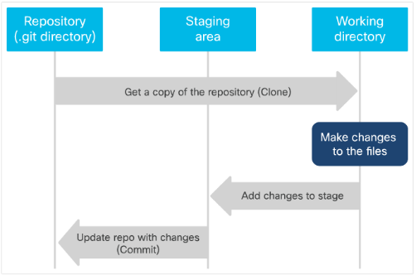
    - Use the git add command to "stage" the NETPRGTY.txt file.
Staging is an intermediate phase prior to committing a file to the repository with the git commit command. This command creates a snapshot of the contents of the file at the time this command is entered. Any changes to the file require another git add command prior to committing the file.
devasc@labvm:~/labs/devnet-src/git-first$ git add NETPRGTY.txt
    - Using the git status command again, notice the staged changes displayed as "new file: NETPRGTY.txt".
devasc@labvm:~/labs/devnet-src/git-first$ git status
On branch master
No commits yet
Changes to be committed:
(use "git rm --cached <file>..." to unstage)
new file: NETPRGTY.txt
  - Committing a File.
Now that you have staged your changes, you will need to commit them to let Git know you want to start tracking those changes.
Commit your staged content as a new commit snapshot by using the git commit command.
The -m message switch enables you to add a message explaining the changes you've made.
Note the number and letter combination highlighted in the output. This is the commit ID. Every commit is identified by a unique SHA1 hash. The commit ID is the first 7 characters of the full commit hash. Your commit ID will be different than the one displayed.
devasc@labvm:~/labs/devnet-src/git-first$ git commit -m "Committing NETPRGTY.txt to begin tracking changes"
[master (root-commit) b510f8e] Committing NETPRGTY.txt to begin tracking changes
1 file changed, 1 insertion(+)
create mode 100644 NETPRGTY.txt
  - Viewing the Commit History.
Use the git log command to show all commits in the current branch's history. By default, all commits are made to the master branch. (Branches will be discussed later.)
The first line is the commit hash with the commit ID as first 7 characters. The file is committed to the master branch. This is followed by your name and email address, the date of the commit and the message you included with the commit.
devasc@labvm:~/labs/devnet-src/git-first$ git log
commit b510f8e5f9f63c97432d108a0413567552c07356 (HEAD -> master)
Author: Sample User <sample@example.com>
Date: Sun Feb 12 05:43:18 2023 +0000
Committing NETPRGTY.txt to begin tracking changes
- Modifying the File and Tracking the Changes
In this part, you will modify a file, stage the file, commit the file, and verify changes in the repository.
  - Modify the file.
Make a change to NETPRGTY.txt using the echo command. Be sure to use ">>" to append the existing file. The ">" will overwrite the existing file. Use the cat command to view the modified file.
devasc@labvm:~/labs/devnet-src/git-first$ echo "I am slowly getting to understand Git!" >> NETPRGTY.txt
    - Use the cat command to view the modified file.
devasc@labvm:~/labs/devnet-src/git-first$ cat NETPRGTY.txt
I am currently enjoying my group work in Network Programmability Module
I am slowly getting to understand Git!
  - Verify the change to the repository using the git status command.
devasc@labvm:~/labs/devnet-src/git-first$ git status
On branch master
Changes not staged for commit:
(use "git add <file>..." to update what will be committed)
(use "git restore <file>..." to discard changes in working directory)
modified: NETPRGTY.txt
no changes added to commit (use "git add" and/or "git commit -a")
  - Stage the modified file.
The modified file will need to be staged again before it can be committed using the git add command again.
devasc@labvm:~/labs/devnet-src/git-first$ git add NETPRGTY.txt
  - Commit the staged file.
Commit the staged file using the git commit command. Notice the new commit ID.
devasc@labvm:~/labs/devnet-src/git-first$ git commit -m "Added additional line to file"
[master 9f5c4c5] Added additional line to file
1 file changed, 1 insertion(+)
  - Verify the changes in the repository.
Use the git log command again to show all commits. Notice that the log contains the original commit entry along with the entry for the commit you just performed. The latest commit is shown first. The output highlights the commit ID (first 7 characters of the SHA1 hash), the date/time of the commit, and the message of the commit for each entry.
devasc@labvm:~/labs/devnet-src/git-first$ git log
commit 9f5c4c5d630e88abe2a873fe48144e25ebe7bd6a (HEAD -> master)
Author: Sample User <sample@example.com>
Date: Sun Feb 12 05:54:18 2023 +0000
Added additional line to file
commit b510f8e5f9f63c97432d108a0413567552c07356
Author: Sample User <sample@example.com>
Date: Sun Feb 12 05:59:26 2023 +0000
Committing NETPRGTY.txt to begin tracking changes
    - When you have multiple entries in the log, you can compare the two commits using the git diff command adding original commit ID first and the latest commit second: git diff <commit ID original> <commit ID latest>. You will need to use your commit IDs. The "+" sign at the end, followed by the text indicates the content that was appended to the file.
devasc@labvm:~/labs/devnet-src/git-first$ git diff b510f8e 9f5c4c5
diff --git a/NETPRGTY.txt b/NETPRGTY.txt
index 93cd3fb..085273f 100644
--- a/NETPRGTY.txt
+++ b/NETPRGTY.txt
@@ -1 +1,2 @@
I am currently enjoying my group work in Network Programmability Module
+I am slowly getting to understand Git!
- Branches and Merging
When a repository is created, the files are automatically put in a branch called master. Whenever possible it is recommended to use branches rather than directly updating the master branch. Branching is used so that you can make changes in another area without affecting the master branch. This is done to help prevent accidental updates that might overwrite existing code.
Now, we will create a new branch, checkout the branch, make changes in the branch, stage and commit the branch, merge the branch changes to the master branch, and then delete the branch.
  - Create a new branch
Create a new branch called feature using the git branch <branch-name> command.
devasc@labvm:~/labs/devnet-src/git-first$ git branch feature
  - Verify current branch
Use the git branch command without a branch-name to display all the branches for this repository. The "*" next to the master branch indicates that this is the current branch – the branch that is currently "checked out".
devasc@labvm:~/labs/devnet-src/git-first$ git branch
feature
* master
  - Checkout the new branch
Use the git checkout <branch-name> command to switch to the feature branch.
devasc@labvm:~/labs/devnet-src/git-first$ git checkout feature
  - Verify current branch
Verify you have switched to the feature branch using the git branch command. Note the "*" next to the feature branch.
What is the command to verify that you have switched to the feature branch?
Are you getting the below output after the command issued?
* feature
Master
  - Append a new line of text "This text was added originally while in the feature branch" to the NETPRGTY.txt file, again using the echo command and verify the appended line.
Command to Append
echo "This text was added originally while in the feature branch" >> NETPRGTY.txt
Command to verify
cat NETPRGTY.txt
Output expected:
I am currently enjoying my group work in Network Programmability Module
I am beginning to understand Git!
This text was added originally while in the feature branch
  - Stage the modified file in the feature branch. Stage the updated file to the current feature branch and confirm the file is staged.
Command to Stage:
git add NETPRGTY.txt

Command to confirm the file is staged:
git status
Output expected:
On branch feature
Changes to be committed:
(use "git restore --staged <file>..." to unstage)
modified: NETPRGTY.txt
  - Commit the staged file in the feature branch. Commit the staged file using the git commit command with a note “Added a third line in feature branch". Notice the new commit ID and your message.
Command to commit the staged file:
git commit -m "Added a third line in feature branch"
Output expected:
[feature cd828a7] Added a third line in feature branch
1 file changed, 1 insertion(+)
  - Confirm and show all commits including the commit you just did to the feature branch. The prior commit was done within the master branch.
Command to commit the staged file:
git log --oneline --all
Output expected:
commit cd828a73102cf308981d6290113c358cbd387620 (HEAD -> feature)
Author: Sample User <sample@example.com>
Date: Sat Apr 18 22:59:48 2020 +0000
Added a third line in feature branch
commit 9f5c4c5d630e88abe2a873fe48144e25ebe7bd6a (master)
Author: Sample User <sample@example.com>
Date: Sat Apr 18 19:17:50 2020 +0000
Added additional line to file
commit b510f8e5f9f63c97432d108a0413567552c07356
Author: Sample User sample@example.com
Date: Sat Apr 18 18:03:28 2020 +0000
Committing NETPRGTY.txt to begin tracking changes
  - Switch to the master branch using the appropriate command and verify the current working branch using the git branch command.
Command to switch:
git checkout master
Command to verify:
git branch
Expected Output:
feature
* master
  - Merge file contents from feature to master branch.
Branches are often used when implementing new features or fixes. They can be submitted for review by team members, and then once verified, can be pulled into the main codebase – the master branch.
Merge the contents (known as the history) from the feature branch into the master branch using the git merge <branch-name> command. The branch-name is the branch that histories are pulled from into the current branch. The output displays that one file was changed with one line inserted.
devasc@labvm:~/labs/devnet-src/git-first$ git merge feature
Updating 9f5c4c5..cd828a7
Fast-forward
NETPRGTY.txt | 1 +
1 file changed, 1 insertion(+)
  - Verify the appended content to the NETPRGTY.txt file in the master branch using the cat command.
devasc@labvm:~/labs/devnet-src/git-first$ cat NETPRGTY.txt
I am currently enjoying my group work in Network Programmability Module
I am slowly getting to understand Git!
This text was added originally while in the feature branch
Hope, you are now clear to create a file, work on a file, create branches, stage the changes, and commit them to the repository. Let us delete the branch and do a new task.

  - Verify the feature branch is still available.
Command to verify:
git branch
Expected Output:
feature
* master
  - Delete the feature branch using the git branch -d <branch-name> command. .
devasc@labvm:~/labs/devnet-src/git-first$ git branch -d feature
Deleted branch feature (was cd828a7).
  - Again, verify the feature branch is no longer available command.
Command to verify:
git branch
Expected Output:
* master
- Handling Merge Conflicts
At times, you may experience a merge conflict. This is when you may have made overlapping changes to a file, and Git cannot automatically merge the changes.
Now, let us create a test branch, modify its content, stage and commit the test branch, switch to the master branch, modify the content again, stage and commit the master branch, attempt to merge branches, locate and resolve the conflict, stage and commit the master branch again, and verify your commit.
  - Create a new branch test.
Command: git branch test

  - Switch to the branch test.
Command: git checkout test
  - Verify the working branch is the test branch.
Command: git branch
Expected Outcome:
master
* test
  - Verify the current contents of NETPRGTY.txt. Notice the first line includes the word "Module".
Command: cat NETPRGTY.txt
Expected Outcome:
I am currently enjoying my group work in Network Programmability Module
I am slowly getting to understand Git!
This text was added originally while in the feature branch
  - Modify the contents of NETPRGTY.txt in the test branch.
Use the sed command to change the word "Module" to "Concepts" in the NETPRGTY.txt file.
devasc@labvm:~/labs/devnet-src/git-first$ sed -i 's/Cisco/Concepts/' NETPRGTY.txt
Discuss about similar commands that can do the same action?
sed -i 's/Module/Concepts/g' NETPRGTY.txt

  - Verify the contents of the modified NETPRGTY.txt in the test branch.
Command: cat NETPRGTY.txt
Expected Outcome:
I am currently enjoying my group work in Network Programmability Concepts
I am slowly getting to understand Git!
This text was added originally while in the feature branch

  - Stage and commit the test branch.
Stage and commit the file with a single git commit -a command. The -a option only affects files that have been modified and deleted. It does not affect new files.
devasc@labvm:~/labs/devnet-src/git-first$ git commit -a -m "Change Module to Concepts"
[test b6130a6] Change Module to Concepts
1 file changed, 1 insertion(+), 1 deletion(-)
  - Checkout the master branch. Switch to the master branch.
Command: git checkout master
Expected Outcome:
Switched to branch 'master'
  - Verify that the master branch is your current working branch.
Command: git branch
Expected Outcome:
* master
test
  - Modify the contents of NETPRGTY.txt in the master branch using the sed command. Change the word "Module" to "ACCB5029" in the NETPRGTY.txt file.
Command: sed -i 's/Module/ACCB5029/g' NETPRGTY.txt

  - Verify the contents of the modified NETPRGTY.txt in the master branch.
Command: cat NETPRGTY.txt

Expected Outcome:
I am currently enjoying my group work in Network Programmability ACCB5029
I am slowly getting to understand Git!
This text was added originally while in the feature branch
  - Stage and commit the master branch using the git commit -a command with comments "Changed Module to ACCB5029".
Command: git commit -a -m "Changed Module to ACCB5029"
Expected Outcome:
[master 72996c0] Changed Module to ACCB5029
1 file changed, 1 insertion(+), 1 deletion(-)
  - Attempt to merge the test branch history into the master branch.
devasc@labvm:~/labs/devnet-src/git-first$ git merge test
Auto-merging NETPRGTY.txt
CONFLICT (content): Merge conflict in NETPRGTY.txt
Automatic merge failed; fix conflicts and then commit the result.
devasc@labvm:~/labs/devnet-src/git-first$
  - Working with conflicts.
    - Use the git log command to view the commits. Notice that the HEAD version is the master branch. This will be helpful in the next step.
devasc@labvm:~/labs/devnet-src/git-first$ git log
commit 72996c09fa0ac5dd0b8ab9ec9f8530ae2c5c4eb6 (HEAD -> master)
Author: Sample User <sample@example.com>
Date: Sun Feb 12 06:25:07 2023 +0000
Changed Module to ACCB6019
<output omitted>
    - Use the cat command to view the contents of the NETPRGTY.txt file. The file now contains information to help you find the conflict. The HEAD version (master branch) containing the word "DevNet" is conflicting with the test branch version and the word "NetAcad".
devasc@labvm:~/labs/devnet-src/git-first$ cat NETPRGTY.txt
<<<<<<< HEAD
I am currently enjoying my group work in Network Programmability accb6019
=======
I am currently enjoying my group work in Network Programmability concepts
>>>>>>> test
I am beginning to understand Git!
This text was added originally while in the feature branch
    - Manually edit the NETPRGTY.txt file to remove the conflicting text.
Use the vim command to edit the file.
devasc@labvm:~/labs/devnet-src/git-first$ vim NETPRGTY.txt
Use the up and down arrow to select the proper line of text. Press dd (delete) on the following lines that are highlighted. dd will delete the line the cursor is on.
<<<<<<< HEAD
I am currently enjoying my group work in Network Programmability accb6019
=======
I am currently enjoying my group work in Network Programmability Module
>>>>>>> test
I am beginning to understand Git!
This text was added originally while in the feature branch
Save your changes in vim by pressing ESC (the escape key) and then typing : (colon) followed by wq and press enter.
  - Verify your edits of NETPRGTY.txt in the master branch.
Command: cat NETPRGTY.txt

Expected Outcome:
I am currently enjoying my group work in Network Programmability accb6019
I am beginning to understand Git!
This text was added originally while in the feature branch
  - Stage and commit the master branch.
Stage and commit NETPRGTY.txt to the master branch using the git commit -a command with a comment "Manually merged from test branch". Note: You must add before committing.
Command: git add NETPRGTY.txt
git commit -a -m "Manually merged from test branch"
Expected Outcome:
[master 22d3da4] Manually merged from test branch
  - Verify the commit. Use the git log command to verify the commit. If necessary, you can use q to quit out of the git log display.
Command: git log
Expected Outcome
commit 22d3da41e00549ce69dc145a84884af6a1697734 (HEAD -> master)
Merge: 729496c0 b6130a6
Author: Sample User <sample@example.com>
manually merged from branch test
<output omitted>
- Integrating Git with GitHub
So far, all the changes you have made to your file have been stored on your local machine. Git runs locally and does not require any central file server or cloud-based hosting service. Git allows a user to locally store and manage files.
Although Git is useful for a single user, integrating the local Git repository with a cloud-based server like GitHub is helpful when working within a team. Each team member keeps a copy on the repository on their local machine and updates the central cloud-based repository to share any changes.
There are quite a few popular Git services, including GitHub, Stash from Atlassian, and GitLab. Because it is readily accessible, you will use GitHub in these examples.
  - Create a GitHub Account/ Log into your GitHub Account Create a Repository.
  - Create a Repository.
Select the "New repository" button or click on the "+" icon in the upper right corner and select "New repository".
    - Create a repository using the following information:
Repository name: np-study-team
Description: Trail to work together for Group Work Task
Public/Private: Private
Select: Create repository
  - Create a new directory np-study-team.
If you are not already in the git-first directory, change to it now.
devasc@labvm:~$ cd ~/labs/devnet-src/git-first
    - Make a new directory called np-study-team. The directory does not have to match the name as the repository.
devasc@labvm:~/labs/devnet-src/git-first$ mkdir np-study-team
    - Change directory to np-study-team. Use the cd command to change directories to np-study-team.
Command: cd np-study-team
Expected Outcome
devasc@labvm:~/labs/devnet-src/git-first/np-study-team $

  - Copy and verify the file.
    - Use the cp command to copy the NETPRGTY.txt from git-first parent directory to the np-study-team sub-directory.
Command: cp ../NETPRGTY.txt NETPRGTY.txt
Expected Outcome
devasc@labvm:~/labs/devnet-src/myGit-first/np-study-team$ ls
NETPRGTY.txt
    - Verify the file contents.
Command: cat NETPRGTY.txt
Expected Outcome
I am currently enjoying my group work in Network Programmability concepts
I am slowly getting to understand GIT
  - Initialize a new Git repository.
Use the git init command to initialize the current directory (np-study-team) as a Git repository. The message displayed indicates that you have created a local repository within your project contained in the hidden directory .git. This is where all your change history is located.
devasc@labvm:~/labs/devnet-src/git-first/np-study-team $ git init
Initialized empty Git repository in /home/devasc/src/git-first/np-study-team /.git/
  - Next, check your global git variables.
Command: git config --global --list
Expected Outcome
user.name=SampleUser
user.email=sample@example.com
core.repositoryformatversion=0
core.filemode=true
core.bare=false
core.logallrefupdates=true
  - If the user.name and user.email variables do not match your GitHub credentials, change them now.
devasc@labvm:~$ git config --global user.name "GitHub username"
devasc@labvm:~$ git config --global user.email GitHub-email-address
  - Point Git repository to GitHub repository.
Use the git remote add command to add a Git URL as a remote alias. The value "origin" points to the newly created repository on GitHub. Use your GitHub username in the URL path for github-username. Note: Your username is case-sensitive.
devasc@labvm:~/labs/devnet-src/git-first/np-study-team $ git remote add origin https://github.com/github-username/np-study-team .git
  - Verify the remote is running on github.com.
devasc@labvm:~/labs/devnet-src/git-first/np-study-team $ git remote --verbose
origin https://github.com/username/np-study-team .git (fetch)
origin https://github.com/username/np-study-team .git (push)
  - View the git log. The error indicates that there are no commits.
devasc@labvm:~/labs/devnet-src/git-first/np-study-team $ git log
fatal: your current branch 'master' does not have any commits yet
  - Stage and commit the NETPRGTY.txt file. Use the git add command to stage the NETPRGTY.txt file.
devasc@labvm:~/labs/devnet-src/git-first/np-study-team $ git add NETPRGTY.txt
  - Use git commit command to commit the NETPRGTY.txt file.
devasc@labvm:~/labs/devnet-src/git-first/np-study-team $ git commit -m "Add NETPRGTY.txt file to np-study-team "
[master (root-commit) c60635f] Add NETPRGTY.txt file to np-study-team
1 file changed, 3 insertions(+)
create mode 100644 NETPRGTY.txt
  - Verify the commit.
Command: git log
Expected Outcome
commit c60635fe4a1f85667641afb9373e7f49a287bdd6 (HEAD -> master)
Author: username <user@example.com>
Add NETPRGTY.txt file to np-study-team
  - Use the git status command to view status information. The phrase "working tree clean" means that Git has compared your file listing to what you've told Git, and it's a clean slate with nothing new to report.
devasc@labvm:~/labs/devnet-src/git-first/np-study-team $ git status
On branch master
nothing to commit, working tree clean
  - Upload the file by logging in to your.GitHub page.
    - Click on Code, Add files via Upload. Check if the files are uploaded.

TASK – 2
Attached as In-Class Activity – Lecture 3.

Pre Work
Which methodology so you think is the best in today's Software Development
DevOps is a methodology that focuses on collaboration between developers and operations teams, with a focus on automation, continuous integration, and continuous delivery. Its great for projects requiring frequent releases and updates.
What is the best Software Development approach you think will be efficient to work as a Team? Why? Discuss with your team and record valuable arguments
An Agile approach would be the best software development approach for a team to work efficiently together. Here are some reasons why:

- Flexibility and adaptability: Agile allows for flexibility and adaptability, which is essential for a team to work together effectively. With Agile, the team can respond to changes in requirements or priorities quickly, and make adjustments as needed.

- Collaboration: Agile emphasises collaboration, which helps the team work together more effectively. By working together on each iteration and communicating openly, team members can stay aligned and focused on shared goals.

What is the Software Development approach you think will be efficient to work on today's challenge? Why? Discuss with your team and plan accordingly.

Planning

What files are you going to create?
.png and a Word document
How to work on those files
By using the command prompt or using the Github desktop app and or the Git app
Do all the team members have a Github account?
Yes, all the team members have a Github account of their own
How to collaborate?
By chatting and discussing ideas with other people in our team

What is the timeline for each task
The team worked on different sections of task 1 at the same time
Who is responsible for what?
The team worked on different parts of task 1 at the same time

Rhys Davies Screenshots
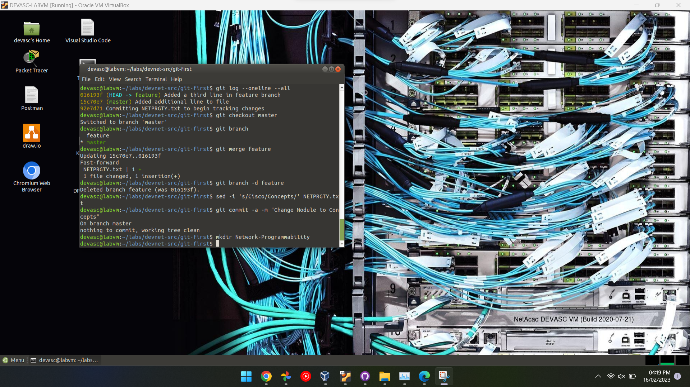
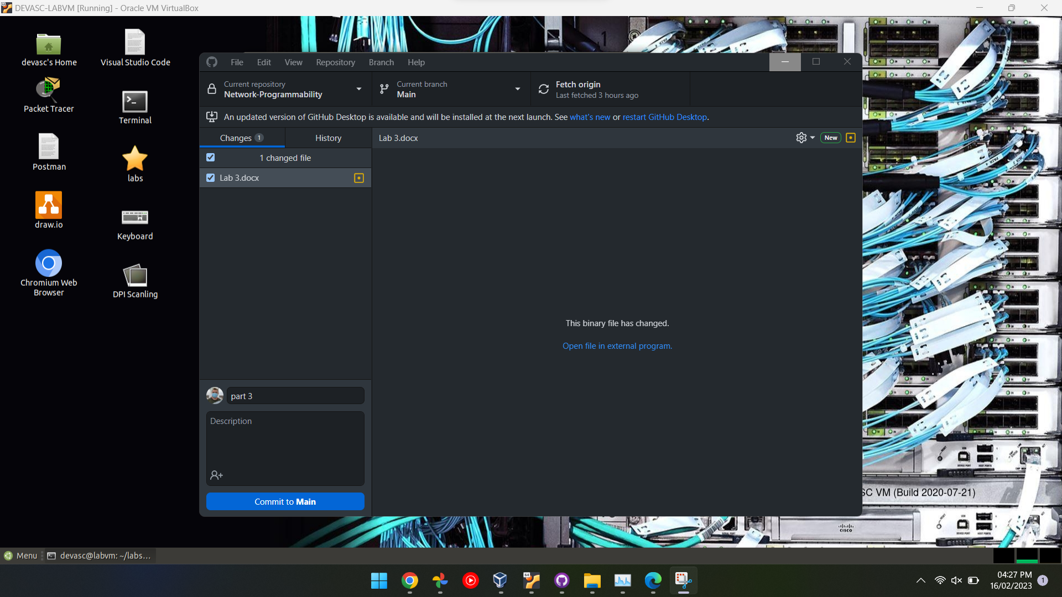

Reflection
How your team designed this task
By creating a repository on Github and using the command line on the virtual machines to then send and receive files from the Github server
What did the team learn from this task
Different commands in Linux and commands for Git in the command line
What was really challenging?
Yes this was a very challenging task that challenged us academically
Did the task work as planned?
Yes the planned worked as expected

