
Work Based projects
What probable reasons cause a delay in a construction project?



KAMRAN DAVIES
2014508
2014508@student.uwtsd.ac.uk

Name of student – Kamran Davies
Student ID – 2014508
Student Email – 2014508@student.uwtsd.ac.uk
Table of Contents
1. Proposed Research Title (Chapter 1) 1
1.1 Abstract 2
1.2 Overview – What will the work be about? 2
1.3 Aims and objectives 2
1.4 Research 2
2. Introduction 2
3. Classification of delay in construction projects 3
4. Literature Review (Chapter 2) 3
4.1. What is the definition of a probable delay in construction? 3
4.2. Types of delays 4
4.3. Delays resulting from neutral causes. 4
4.4. Delays that are the fault of the client. 4
4.5. Delays that are the fault of the contractor, sometimes referred to as culpable delay or contractor delay. 4
4.6. Impacts of delays in terms of time, cost, and quality 5
4.7. Extension of time in construction (EOT) 5
5.Research Methodology (Chapter 3) 5
4. Limitations and Ethics 6
5. Research questions (Chapter 4) 6
6. Results (Chapter 5) 7
7. Conclusion and Reflection 15
8. References 16

Proposed Research Title (Chapter 1)
What probable reasons cause a delay in a construction project?

1.1 Abstract
This research will help me seek more of an understanding in what the probable cause(s) and reason(s) on why delays in a construction project occur.

1.2 Overview – What will the work be about?
Throughout my research I will be looking further into my chosen proposed research title and to see and find out what, who, why and how the probable causes have an affect on construction. I will be researching deeper into what type of delays arise. There being a delay from human error, weather, contracts or natural and unavoidable circumstances along with several others. The research will assess all kinds of probable cause in what could delay a construction project and comparing on how they are dealt with and managed on their occurrence.

1.3 Aims and objectives
The aim from my research is to achieve and comprehend the effects of having delays on a construction project. Also knowing and widening my knowledge on types of delays, how to manage when encountered and what other implications you have to face with that being with the costing, time frame or contract in issue.

1.4 Research
Information will be sourced using online reading, websites, books, and news articles. I will also take upon myself to gain information from site managers and contract managers in my field of work to obtain useful research in previous and ongoing possible delays which have been faced.

Introduction
During a construction project, a team of individuals, being from one or more companies comes together to produce a development on a particular location. In a construction project it requires the co-ordination of permissions, contracts, plant, material, labour, designs, planning etc. Upon commencing a construction project, a project team will have to take into consideration of many ‘unknown factors’ that could arise if delaying the process. (buildings, 2021)
In the construction industry, there is a wide span of options in what organisation you decide to go in. That being part of a building everyday team or task specific work such as energy and water. From the management role, carrying out tasks of planning, deadlines, monitoring, development of the project, a time and date will be set to have this complete. If the project duration has exceeded the given finishing end date detailed in a contract document, this is classified as a delay. This will now require in additional costs and extra time for the construction to meet the completion. (Technology, 2018)
For contractors, a delay is a loss of finance. The reason that the work takes long time duration to be progressed, higher cost of construction material due to inflation, increasing of workers cost. Usually delay in the construction industry by many factors linked with the performance of time, quality, and cost. This could result in termination of a construction project and their contract. (Technology, 2018)

Classification of delay in construction projects
Delays in construction project are caused by several factors. However, the type of delay will fall under either or of the two delay categories.
- Internal causes
- External causes
Internal causes are arisen by the companies of the contract such as the client, contractor and consultant on the other hand external causes are arise from the event which cannot be controlled by the individuals of the contract. (UKDISS, 2019)

4. Literature Review (Chapter 2)

4.1. What is the definition of a probable delay in construction?
The explanation of a delay is a period of a set time in a contract settlement that the date goes greater that what was formerly scheduled for close of a project. (Gate, 2018)
Construction projects, is an organised process of creating, or an improvement of a building, structure or infrastructure. The project process typically starts with an certain requirement which is developed through the creation of a brief. They can be very difficult, requiring the co-ordination of consents and agreements with everyone involved. However, when the construction project begins, there can be many unknown factors to consider which could have a probable cause of for delay. Varying from late order and delivery for plant and material, labour shortage, uncertain site conditions, weather etc. A result of all this is that delays are very widespread on a construction project. (Buildings, 2021)
List below of several examples on probable delyas:
- Decisions not being accurate or not in time.
- Inadequate or improbable scheduling.
- Weak communication.
- Labour output.
- Availability of sources.
- Confrontational relationships.
- Third party dependencies.
- Site restrictions.
- Climate.
(Buildings, 2021)
All of the above can be minimised by the following:
- Cautious and proactive when monitoring and frequent site discussions.
- Efficient and successful site management.
- Collective working and effective coordination.
- Careful planning and preparation.
- Full commitment.
- Being able to be bold and show leadership skills.
- Having a good, strong, healthy relationship with those working closely around you.
- Being able to meet deadlines and have an excellent time management credentials.
(Buildings, 2021)

4.2. Types of delays
There are two types of delay.
- Delays in activities for which there is programme put forward available (i.e. they can be delayed without impacting on the completion date).
- Delays that will impact on the completion date, sometimes referred to as critical delays.

4.3. Delays resulting from neutral causes.
- Exceptionally adverse weather.
- Civil commotion or terrorism.
- Force majeure (such as a war or an epidemic).
- A specified peril such as flood.
- National strikes.

4.4. Delays that are the fault of the client.
- The client instructing modifications in the planned works.
- Failure by the client to supply the correct materials or equipment.
- Prolong in giving the contractor possession of the site.
(Buildings, 2021)

4.5. Delays that are the fault of the contractor, sometimes referred to as culpable delay or contractor delay.
- Where a delay which forces on the close date is caused by the contractor, the contractor will be liable to pay settled damages.
- Concurrent delay refers to the development situation where more than one event impacts on the completion date at the same time, but where not all of those events would entitle the contractor to claim an extension of time or loss and expense.
(Buildings, 2021)

4.6. Impacts of delays in terms of time, cost, and quality
The impacts of delays in construction can be measured in terms of the domestic impacts which unfavourably affect the industry as a whole. Where delays affect production and value and at a project scale where delays result in dissatisfied clients, profit margins decrease. Arguing that delays often lead to cost overrun, disputes and litigation. This could then turn to influence the production of the project and can lead to disagreement and differences. (Diss, 2022)
While the delays reviewed above present some key factors, project managers need a way to prioritise delay causes and deal with them accordingly. Understanding this is therefore important for identifying and managing delay causes in complex projects. (Livrepository, n.d.)

4.7. Extension of time in construction (EOT)
Construction contracts generally allow the construction period to be extended where there is a delay that is not the contractor's fault. This is described as an extension of time (EOT).
When it becomes reasonably obvious that there is, or that there is likely to be, a delay that could merit an extension of time, the contractor gives written notice to the contract administrator identifying the relevant event that has caused the delay. If the contract administrator accepts that the delay was caused by a relevant event, then they may grant an extension of time and the completion date is adjusted. (Buildings, 2021)

5.Research Methodology (Chapter 3)
My proposed research title seeks to add to the research on delays in construction and is aimed at businesses and workers working within the industry.
My research methodology adopts a variety of questionnaire survey techniques and face to face interviewing along with speaking with clients, sub-contractors, and other resources to assess and see why these delays in construction occur and the reasoning behind it along with the affect and consequences it causes.
For my research questionnaire I wanted to get information from all different professionals within the industry and compare and evaluate their responses. With a variety of job roles, this then gives me a wider scope of my chosen research proposal and it gives me an idea on what each professional encounters daily and gives me a better understanding from an outsider and getting to learn. These professionals are people I worked with on a daily basis.
In order to completely obtain first-hand information from the individuals or groups, a structured questionnaire was used to gather the primary data in this research survey through self-administration. The questionnaires were given to the respondents to get their opinions and find out their knowledge concerning the delays in a construction project. This evidence is based on the experience and judgement. I aimed my questionnaire mainly at the people with a vast amount of experience as I feel these parties would have a better understanding of how and why this was caused and how they overcome the delay process.
The questionnaire survey was designed based on the most common delay factors on how and why they occur. I found that there are a number of reasons why a delay in construction could and does happen. They are broken down into seven categorise or groups. The groups are owner related, contractor related, consultant related, labour related, materials related, equipment or plant machinery related, and external factor delays. All of the categories have significant impact on delays in construction.

Further research shows that construction delays are often mismanaged and is one of the main reasons why delays arise. The contractor is generally required to try to prevent or mitigate delay, even where the fault is not their own or cannot be helped. If there is on the other hand a delay, the client may wish to direct speeding up the project to keep within the time frame. An agreement between both the client and contractor can be agreed as a for all outstanding claims to extend the time, loss and expense.

Measures below that are considered it quickening up the construction project that would be considered are:
- Additional resources of manpower, plant and materials directly employed or subcontracted.
- Revised methodologies including off site prep.
- Requests for phased completion.
- Increasing working hours on and off site, including weekends, holidays, night working and shift working.
- Extra supervision and teams.
- Changes to the design or specification.
- Reduction in scope.

Limitations and Ethics
There are potential limitations linked with the above methodology, including the need to find a delegate sample of professionals to contribute to the study. This is an important point as the sample needs to be representative of a wider opinion in the population that is the construction industry. As such the sample will be chosen using my own personal contacts in the industry (Management and to those a similar level to myself) and the questions will be used to confirm that each participant has adequate information and in addition more important the experience.

Research questions (Chapter 4)
To gather my findings on delays in the construction industry, I have now assembled questions relating and sent over for why and how it affects the industry. The questions asked were all open questions, however I then want to know the reason or solution behind their answers. The questions asked are as follows:
- What probable reasons cause a delay in a construction project?
- When a major or slight delay occurs, who is at fault?
- How do delays affect the cost of a project?
- How is a delay managed?
- Are delays claimable?
- What contractual affects may a delay bring?
The above questions were sent over to the senior management (Contracts managers, site managers, quantity surveyors, designers) in the company I work for. Also, as for growing close relationships with clients and sub-contracting teams throughout my time as a site supervisor in the railway sector, I felt it was necessary to get a wider scope from not only my company, but for others also and have their opinion on the questions. These questions were sent to 20 people, all having to answer the questions stated above.
The fact that it is a case study, this allows me to ask the questions, it gives the person answering the questions the opportunity to reply with an honest answer with reason. It gives them the chance to explain their views and tell me about their experiences. I decided against a closed survey for my research. Furthermore, by doing an open survey, it gives them an option to answer the question. With this strategy, it helps in obtaining different knowledge relating to the topic.
I feel that the targeted personal will give me a much greater understanding as for them having a wealth of experience. Not just that, but as for having different job descriptions, it will also give me more of an idea of what challenges are faced. Therefore, they should have the knowledge working on a project that was faced with delays.

Results (Chapter 5)
Following on from my previous chapter in relation to gathering a questionnaire in seeking more of an understanding in the probable cause of delays in construction. This chapter, I will be gathering all the information obtained from the survey and compare on how they were responded by the selected individuals.
Out of the 20 people asked, all have replied in a face-to-face interview kind like questionnaire. All of the 20 individuals were asked the same 6 questions in an open survey.

The graph below shows the persons elected and their job title role.

Figure 1
As shown in figure 1, I have opted to use a variety of different job roles as I felt this would benefit me having different opinions from numerous avenues and experiences faced in the industry. furthermore, I will be expanding on the answers given in a graph like structure and using the information gained to help me with my case study.
The graph below shows time served within the construction industry. I aimed my survey towards the higher end of experience or time worked as I felt these individuals would have a far better understanding on why a delay happens and rectifying these problems.

Figure 2
Figure 2 indicates the work history by those asked. As seen, the majority of my questionnaire survey were from people with a wealth of experience within the industry. I wanted to have a diverse age and history range as I wanted feedback from all different parties, however, purposely aimed higher at the individuals with more understanding.
Moving on from the job roles of the people asked and years’ experience, I know want to concentrate on the questions that I previously set out and asked and compare the responses provided.

Figure 3
Before setting out this certain question, I was expecting the above graph to look similar to what it does now as this is what they would face each day given the job title. For example, I would expect a quantity surveyor to speak about budget inaccuracies as this is what they do day in day out. As for site managers for example, I was fully expecting a wide range of different probable delays as they have more involvement and could encounter different delays.
A lot of the above answers given I feel could be non-accurate as it could have been a slight bad experience that has happened previously and not fully recovered from that moment. Also, looking at the sub-contractors’ answers given, as for these certain individuals/companies not having much of a say or not being lead or principal contractor, I felt their answers given was an obvious choice. I feel that they would look for an obvious ‘blame’ as for them possibly not having a greater understanding from behind the scenes.
Furthermore, it was nice to see a broad range of different probable causes as this is something has helped me with my understanding and definitely given me a better insight.

Figure 4
As seen in the graph on where a delay impacts on the completion date is caused the contractor will be liable for this. 3 of the 20 people asked were unsure as for them having little to no experience in the industry.
All identified in the contracts, it will generally allow for the contractors where it is out of their control to have an extension of time (EOT). This now means that there will be no claim for an increase for any time, loss and amount paid. As a result of this the principle contractor would need to pay liquidated and ascertained damages (LADs) to the client. (Wiki, 2020)

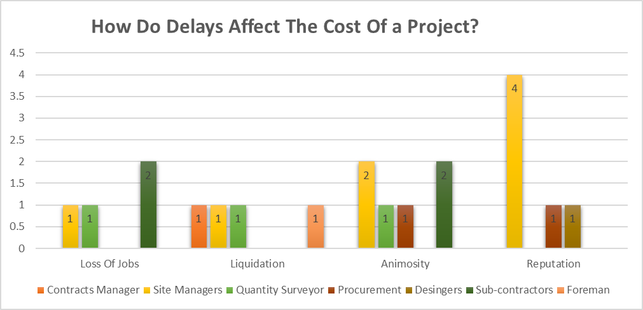
Figure 5
Results show having a delay occur in a construction project will not only have affect the project itself, but people’s livelihoods. The potential is there for loss of earning, redundancies and having the company go into liquidation. A lesser serious situation could result in company or individual reputation. This can have a serious knock-on effect in possible further tenders and the company’s progression to grow. If a delay would ever occur this could also lead to severe stress and animosity towards others. This could potentially lead to communication break ups and hostile workplace environment. All personnel will have different temperaments and personalities as this will play a massive part in these kinds of situations.

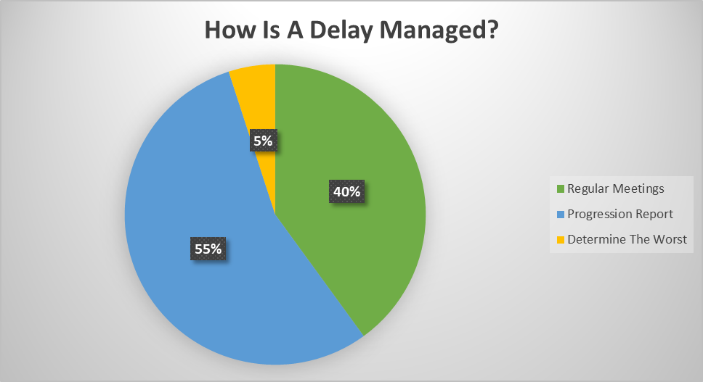
Figure 6
As figure 6 shows, planning and regular interaction is vital in leading a construction project and managing a delay ever happening. 19 of the 20 asked shows that regular meetings and progression reports are almost equally important. By completing this, it will have significant benefits in where the construction project is at in regards time and development. If there was a possible or probable delay in the arisen that has possibility to cause an impact, then having these meeting and progression reports will rectify them future issues from taking place. 1 of the 20 has stated determine the worst. This way then you are covering all angles, however, does have that possibility of missing the minor issues.

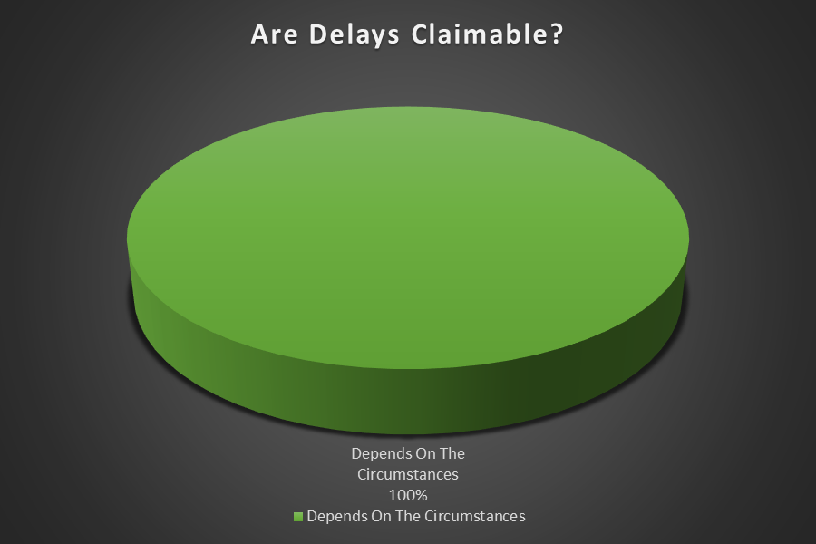
Figure 7
As seen from the results on whether or not are delays claimable really does depend on the circumstances. There are several delays which can arise, and they are as follow:
- Critical vs non-critical
A Critical delay is one that will affect the project completion date and take extra time. A non-critical delay will affect certain completions of work activity, however not the end date. (Levelset, 2022)

- Excusable vs Inexcusable
An excusable delay is one that allows the contractor added time, additional payment, or in some cases both as certain delays can be out of the contractor’s control. Whether or not this is the case will be defined in the agreement. The most common excusable delay is when it falls under a ‘force majeure clause’. This will be incidents such as terrorist attacks and natural disasters for instance floods and earthquakes. Inexcusable delays are those where the contractor was solely accountable for increasing the project’s duration. If found this is the reason, the contractor will be laid responsible for any fees or damages caused by the delay. (Levelset, 2022)
- Compensable vs non-compensable
All excusable delays are compensable. This means that any time a delay is considered as excusable then the contractor will usually have a claim for any additional. That being time and cost. If the contractor is solely at fault, this will result in the delay to be non-compensable. (Levelset, 2022)
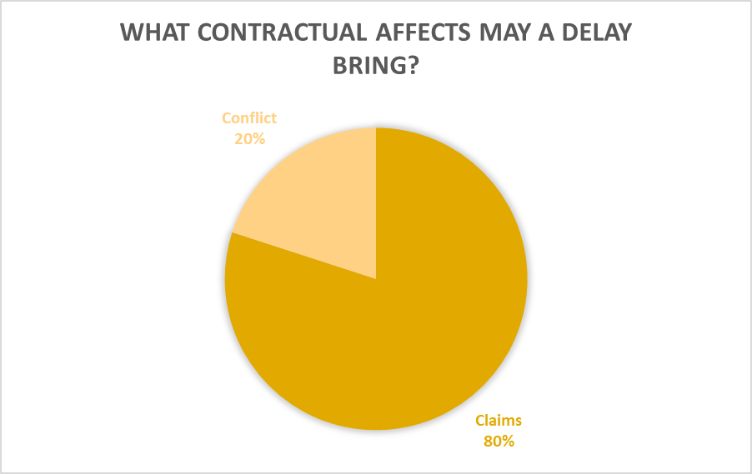
Figure 8
As seen from percentages shown in figure 8, majority of people asked said claims. A claims normally arise between the parties to construction contracts. A claim can be the result of issues as delays, alterations, unforeseen circumstances, insufficient information and conflicts. Loss of expenses, additional time and damages are something than can be claimable. (Wiki, 2022)

Conclusion and Reflection
The purpose of this study was to look into the probable causes of delays in construction projects. The study's aims were to reflect the magnitude of delay as a problem in the construction industry and to investigate the underlying factors for delay from the view of the main contractor. The research also took to assess the impact of these delays in terms of time, cost, and quality, as well as to identify the process that could be used to minimise delays.
There are numerous reasons of construction delays, many of which are beyond the contractor's control. These involve adjustments during the construction phase and failures due to natural disasters and so on. There are also delays caused by designers, such as poor communication, failure to provide good quality and accurate data to the contractor, and changes during the construction stage due to errors or a lack of experience with construction procedures. However, the contractor is also to blame for delays caused by poor site management and organisation, poor quality, and inexperience.
From the questionnaires that I set out previously it was interesting to see a diverse range of answers. From being in the industry a number of years myself and slowly progressing myself into the management team, there were answers on there that I wasn’t expecting. That was my main aim and objective. I wanted to learn and understand more on why and how delays occur and effect projects and jobs as this is something most definitely, I will encounter at a later date in my career. I believe having such problem defines you as a manager. Having a wider scope of what can happen has certainly aided me to prevent this ever happen. There are things I wish I done differently. For example, the questions asked, maybe I could have been in more depth and given myself more time in explored different companies with other type of works so this then would give me a much greater understanding of other construction sectors.
In conclusion, from the information gained from the survey shows it is fairly even on the graphs shown in chapter 5. There is no clear or obvious reason on delays. This was nice to see as this prepares me for future challenges. having one stand out delay I would of felt this would not of really helped me with my research proposal, however having a variety has assisted me greatly.

References
buildings, D., 2021. The Construction Wiki. [Online]
Available at: https://www.designingbuildings.co.uk/wiki/Delays_on_construction_projects
[Accessed 06 12 2021].
Technology, I. R. J. o. E. a., 2018. International Research Journal of Engineering and Technology. [Online]
Available at: https://www.irjet.net/archives/V5/i1/IRJET-V5I1132.pdf
[Accessed 08 12 2021].
UKDISS, 2019. UKDISS. [Online]
Available at: https://ukdiss.com/litreview/assessing-the-issue-of-delay-in-construction.php
[Accessed 09 12 2021].
UKESSAYS, 2021. UKESSAYS. [Online]
Available at: https://www.ukessays.com/essays/construction/payment-and-delay-issues-construction-essay.php
[Accessed 10 12 2021].
Available at: https://www.designingbuildings.co.uk/wiki/Construction_project
[Accessed 30 01 2022].
Buildings, D., 2021. Designing Buildings. [Online]
Available at: https://www.designingbuildings.co.uk/wiki/Extension_of_time_EOT_in_construction_contracts
[Accessed 01 02 2022].
Diss, U., 2022. UK Diss. [Online]
Available at: https://ukdiss.com/services/samples/2-1-construction-literature-review.php
[Accessed 01 02 2022].
Gate, R., 2018. Research Gate. [Online]
Available at: https://www.researchgate.net/publication/354289034_A_CRITICAL_LITERATURE_REVIEW_ON_MAIN_CAUSE_OF_DELAY_IN_CONSTRUCTION_PROJECTS
[Accessed 30 01 2022].
Livrepository, n.d. Livrepository. [Online]
Available at: https://livrepository.liverpool.ac.uk/3009230/1/PPC-SNA&Project%20delay-Accepted%20version.pdf
[Accessed 01 02 2022].
Levelset, 2022. Levelset. [Online]
Available at: https://www.levelset.com/blog/construction-delay-claim-defenses/#:~:text=All%20excusable%20delays%20are%20compensable.%20This%20means%20that,fault%2C%20the%20delay%20will%20very%20likely%20be%20non-compensable.
[Accessed 11 04 2022].
Wiki, D. B. T. C., 2020. Designing Buildings. [Online]
Available at: https://www.designingbuildings.co.uk/wiki/Culpable_delay_in_construction_contracts
[Accessed 08 04 2022].
Wiki, D. B. T. C., 2022. Designing Buildings. [Online]
Available at: https://www.designingbuildings.co.uk/wiki/Contract_claims_in_construction
[Accessed 14 04 2022].

