Assignment 2
Advanced Web Development (ACCB6006)
April 20, 2020
Matthew Lewington
BSc Software engineering
UWTSD School of Applied Computing
Contents
Table of Tables iii
1 Introduction 1
2 Testing 2
2.1 Black Box Testing 2
2.1.1 Equivalence Class Partitioning 3
2.2 White Box Testing 4
2.2.1 White Box Testing Example 4
3 Behaviour Driven Development 7
3.1 Scenarios 7
3.2 Tools and Frameworks 8
3.3 Advantages and Disadvantages 9
4 Test Frameworks 10
4.1 Shared Methods 10
4.2 Test Doubles 11
4.3 Advantages and Disadvantages 12
5 Conclusion 13
6 References 14

Table of Figures
Figure 2-1 ECP age example 3
Figure 2-2 Pseudocode for example 3
Figure 2-3 Example flowchart 5
Figure 2-4 Pseudocode for example flowchart 5
Figure 2-5 Flowchart path 1 – A, D, G 6
Figure 2-6 Flowchart path 2 – A, B, C, E, F, G 7
Figure 3-1 BDD cycle [14] 8
Figure 4-1 Example describe, it and expect [27] 11
Figure 4-2 Example code comparison of two functions in Jasmine and Mocha 12
Figure 4-3 Pseudocode of the Jasmine spyOn() function 13

Table of Tables
Table 1 – Example Scenario 9
Table 2 – BDD tools and supported languages 10

Introduction
This report has been produced to provide an overview of various testing types such as black box and white box testing, with relevant examples of how some tests are carried out. How behaviour driven development works along with advantages and disadvantages, and a brief outline of the characteristics of testing frameworks, showing similarities between multiple frameworks and examples of tests that are written.

Testing
Software testing is a major activity required throughout the lifetime of software development and maintenance. As software development can potentially be prone to errors, which is sometimes not helped by software complexity, the quality assurance and validation of the software being developed needs to be of a considerably high standard to ensure the system being tested is built to the specifications and expectations of the customers [1], [2]. Software testing comprises of three categories: Unit testing, Integration testing and System testing [3]. This report will be concentrating on the sub-categories of unit testing of which are black box and white box testing.

Black Box Testing
In general, black box testing, also known as closed-box, data driven or functional testing [4], means that the software tester has no information about the internal structure and architecture of the software system being tested [5]. Black box testing is split into three categories; functional testing (testing the functional requirements of a software system), non-functional testing (testing non-functional requirements – performance, response time and usability [6, p. 47]), and regression testing (ensuring code updates have not affected the pre-existing, or legacy code [6, p. 246]). The behaviour of the system must be observed entirely by input and output only without the tester knowing what is happening within the system [2], [6, p. 254], [7].
Black box testing is efficient for testing larger code segments, and the test cases can also be developed quicker. However on the contrary, without clear specification guidelines, it can sometimes prove difficult for the test cases to be designed effectively [8].
Some examples of box testing techniques are [8], [9]:
- Equivalence class partitioning,
- Boundary value analysis,
- Fuzzing,
- Decision tables,
- State transition testing,
- Orthogonal array testing,
- All pair testing

Equivalence Class Partitioning
Equivalence Class Partitioning (ECP) is a black box testing technique that divides the input data into separate partitions of data (which are expected to exhibit similar behaviours) from this, a finite number of classes are then produced to test the input or output domains [8], [9]. ECP can help eradicate the need for exhaustive testing, and it can help cover a large amount of both input and output domains. A basic example would be similar to checking the value the user enters for their age as shown in Figure 2-1. There are only three test classes required; less than or equal to 17, between 18-28, or greater than or equal to 26.

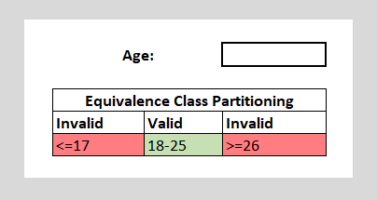
Figure 2-1 ECP age example

The pseudocode for such a test would be as outlined in Figure 2-2. (Please note this is not optimal and merely poses as an example.)
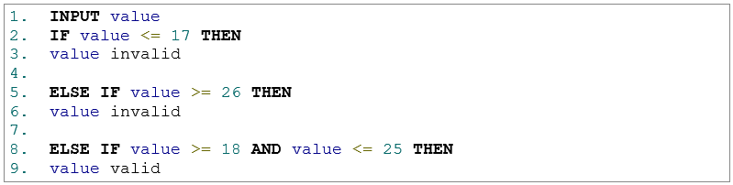
Figure 2-2 Pseudocode for example

Two invalid test classes will be if the input is equal to 17, or if the input is greater than or equal to 26. As a result of this, the output displayed could just be a prompt to the user to re-check or an “invalid” message be shown.
A valid class would be if the input is between 18 and 25. This then could be further developed to include alpha or special characters as additional test classes, depending on the input validation.

White Box Testing
White box testing, also known as structural or glass box testing [9], provides access to data, such as how methods are written, how data is laid out, method return types, etc… [6, p. 253] and permission to capture or inject some data [7]. With the provided data and information, test cases can be derived and specific code paths can be targeted to achieve the required level of code coverage [5].
An advantage of white box testing is that it achieves maximum coverage during test scenario writing, however it can be very time consuming or resource consuming as a skilled tester will be required to perform it. There is unfortunately the chance of some code areas being overlooked as it can sometimes be difficult to test every small detail in a software system [8], however it is hoped that potential bugs may be found by the quality assurance testers, user acceptance, or further down the line if necessary.
Some examples of white box testing techniques are [8], [9]:
- Code coverage,
- Statement coverage,
- Branch testing,
- Basis path testing,
- Loop testing,
- Data flow testing

Statement Coverage
Statement coverage is a white box testing technique used that is aimed at traversing every node, or statement (condition), at least once, which should result in every line of code being tested [9]. For example, as per Figure 2-3, there are three statements to check; A, B and E. Pseudocode provided in Figure 2-4 would be run with different input values, and this would test each statement.
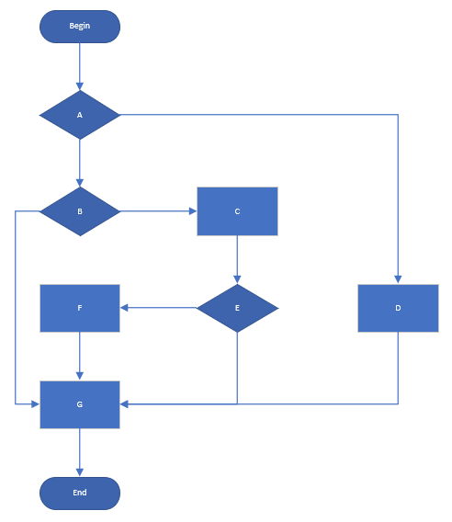
Figure 2-3 Example flowchart

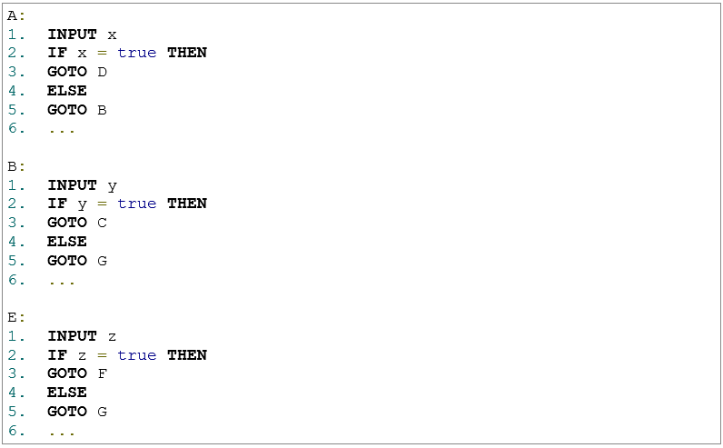
Figure 2-4 Pseudocode for example flowchart

As outlined in the flowcharts provided in Figure 2-5 and Figure 2-6, each statement is traversed at least once, which then allows for each statement to be tested.
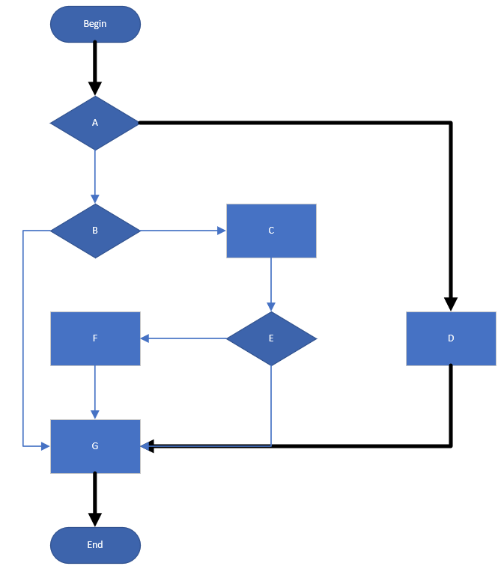
Figure 2-5 Flowchart path 1 – A, D, G

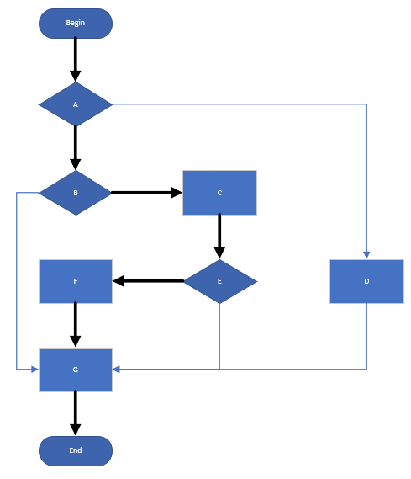
Figure 2-6 Flowchart path 2 – A, B, C, E, F, G

Behaviour Driven Development
Behaviour Driven Development (BDD) is a methodology originally developed by North [10], that has been derived from Test Driven Development (TDD) (and generally regarded as the evolution of TDD and ATDD) and follows the TDD methodology of a “test-first approach” by the creation of test cases (or scenarios) before coding [11, p. 46], [12]. BDD testing methods concern themselves with testing the behavioural aspects of the implemented code, rather than the implementation of the code itself and follows a process of discovery (collaboration effort on product requirements), formulation (scenarios), and automation (utilising tools to run the relevant tests), until a working software is developed from a user story as shown in Figure 3-1 [13].

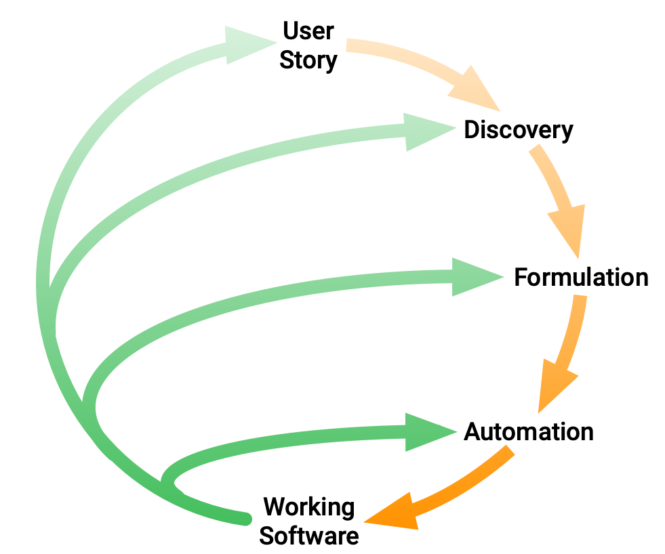
Figure 3-1 BDD cycle [14]

Scenarios
Correct scenarios should be relevant to the product, repeatable (it should always offer the same result if there has not been a change in the source code), fast, for quick feedback, and the scenarios should be isolated; a test should only fail on the condition that the feature being tested has a defect [15, pp. 23–24].
BDD tools often use a syntax called “Gherkin”, which follows the pattern of “Given, When, Then” (GWT) as key words, then the rest is common language [11, p. 389], [16], [17]:
- Given – initial context of the system,
- When – an event or action occurs,
- Then – expected outcome or result,
- And – additional parameters to continue the meaning of the previous sentence
The pre-defined syntax allows development of concrete examples for a scenario, and an example of which would be as shown in Table 1.

Table 1 – Example Scenario
Feature | Show my account page
Scenario | Get account page
Given | I am logged in
When | I send a ‘GET’ request to ‘{base}/myacct’
Then | I should receive a HTML response code of 200
And | I should receive the relevant HTML response header corresponding with the requested page

Tools and Frameworks
There exist several different tools and test frameworks available, some of which are named Behave [18], Cucumber [19], Jasmine [20] and Mocha [21], each of which support either single or multiple languages as shown in table 2 (tools may support more languages than those shown), and have a varied level of popularity amongst development teams [12]. Tools such as Cucumber and the like have been purposely written to ensure scenarios can be easily read and written by anyone on the team, which can encourage interaction from stakeholders and the like, not just developers input [22, p. 5].

Table 2 – BDD tools and supported languages
Tool | Programming Language(s) Supported
Behave | Python
JBehave | Java
Cucumber | Ruby, Java, JavaScript, …
Jasmine | JavaScript
Mocha | JavaScript

Advantages and Disadvantages
Some advantages of BDD are the ease of organising test functions, it proves precise and effective for providing up-to-date documentation, no changes need to be implemented for test functions, and it can be easier to detect potential conflicting user stories [11, p. 386], [12], [13]. These advantages can translate into [23, pp. 28–29]:
- Reduced waste and costs by not wasting effort producing features which aren’t aligned with business goals and by having the requirements communicated effectively, allows defects to be discovered early into development.
- Easier and safer changes as the documentation is generated from the specifications using language and terms that stakeholders and customers alike will be able to understand.
- Faster release cycles as automated acceptance tests can be used instead of manual testing sessions.
However, on the opposite side there are also challenges faced when utilising the BDD framework. It can be difficult to manage and maintain scenarios once they grow beyond a small amount of features or once multiple development teams all collaborate on said features [16], and along with this there is also the potential for a slower overall feature run [22, p. 103].

Test Frameworks
A test framework is a tool that assists the BDD process by improving test automation. As previously described in section 3.2, they follow the GWT syntax
and there are multiple frameworks available which all share common characteristics such as assertions, test doubles and mocks either built into them or available via 3rd party libraries or plugins. This section will describe the shared features and functionality.

Shared Methods
There are several shared methods amongst frameworks such as hooks, which are executed before a scenario, or after a scenario [15, p. 174], [22, p. 147], [23, p. 137], [24]–[27]. Some of these main hook methods are:
- beforeAll – called once before all of the specs (code block that contains the expectations within a describe),
- afterAll – called after the specs have completed,
- beforeEach – similar to above but is called before each spec,
- afterEach – called after each spec is completed,

The main code blocks and methods (which develop the test suites) are as shown in Figure 4-1 and are comprised of the following:

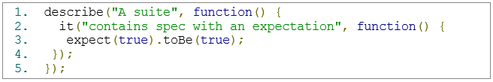
Figure 4-1 Example describe, it and expect [27]

- describe - also known as a spec suite, or container, is a function that houses the spec and it code blocks. These take two parameters; a string, for the suite title, and a function that implements the block of code.
- it - this contains the code block that defines a spec. Similar to the describe, it takes a string and a function as a parameter. An it function is independent of others, so everything within it is self-contained. It is within this code block that the state is set up, the function is executed, the return value is checked, and all expectations are ensured to have been met. If these expectations are not met, then the test will have failed.
- expect - expectations, or assertions, are statements within test methods which desired specifications are checked against actual program behaviour, particularly checking whether a Boolean predicate is true at a certain point, and are the core of all test methods [11, p. 46], [28], [29]. An assertion would look similar to the given code in Figure 4-2, albeit the syntax for the expectation is slightly different between the two framework examples (Jasmine and Mocha). If the first function to add two numbers produces something other than 11, then the add method of the calculator would need to be investigated, and the same for the multiply method if the expectation was incorrect.

There is no built-in assertion framework for Mocha, so there is the requirement of a 3rd party library such as Chai [30], should.js [31] or expect.js [32].

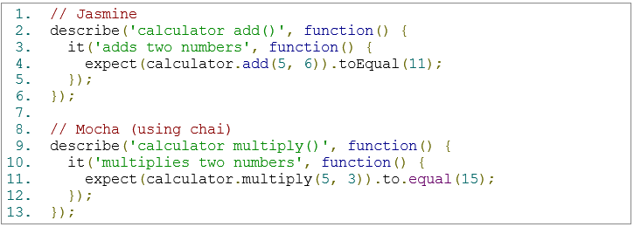
Figure 4-2 Example code comparison of two functions in Jasmine and Mocha

Test Doubles
Test doubles, which can also be known as spies, are shared functions between frameworks and essentially are copies of objects with their functions “stubbed” that allow the object to “hook” into certain functions and check things such as whether they were called, how many times they were called, what arguments they were called with, etc... [33, p. 113]. A spy only exists in the “describe” or “it” block where it is instantiated.
For example, as show in Figure 4-3, a new Student object is created and a spyOn function is called with the relevant object (student1) and method (getName). The expectation is then for the getName method of the Student object to have been called.

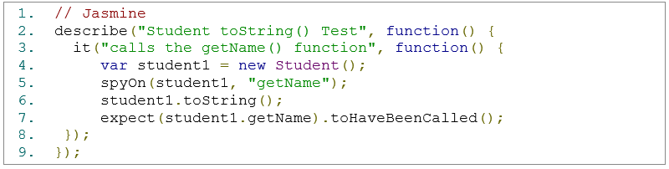
Figure 4-3 Pseudocode of the Jasmine spyOn() function

Advantages and Disadvantages
Some key advantages of testing frameworks are that a testing framework can provide the developer with an easy method to perform their individual tests (typically it can be defined which tests are run) and to see their results [11, p. 45]. As the tests have their own “describe” and “it” blocks, everything within these is self-contained, such as the student1 variable in the above Figure 4-3, and allows the tests to run without interfering with each other.
Test frameworks can help increase test efficiency and lower maintenance costs as if test cases are developed first, the code to come after will be designed around the test cases. However on that point with software systems that have been developed with a large amount of classes and methods with multiple interdependencies, it can be difficult to write test harnesses for them as some dependencies may be 3rd party libraries and it would also depend on the quality of code produced by the developer(s) and whether it adheres to testability requirements [11, p. 413].

Conclusion
Testing is an important part of development throughout the software development life cycle. There are an abundance of tools and frameworks available to assist developers with their test cases and test suites, each offering similar functionality but best suited to different languages. BDD, though with some slight drawbacks, has many advantages that would prove beneficial within a development team working on smaller scale projects, and can perhaps be manageable with larger scale projects depending on the requirement and feature management.

References
[1] M. Dadkhah, S. Araban, and S. Paydar, “A systematic literature review on semantic web enabled software testing,” J. Syst. Softw., vol. 162, p. 110485, Apr. 2020.
[2] S. Ul Haq and U. Qamar, “Ontology based test case generation for black box testing,” in ACM International Conference Proceeding Series, 2019, vol. Part F148151, pp. 236–241.
[3] P. M. Jacob and M. Prasanna, “A Comparative analysis on Black box testing strategies,” in Proceedings - 2016 International Conference on Information Science, ICIS 2016, 2017, pp. 1–6.
[4] M. Hayek, P. Farhat, Y. Yamout, C. Ghorra, and R. A. Haraty, “Web 2.0 Testing Tools: A Compendium,” in 2019 International Conference on Innovation and Intelligence for Informatics, Computing, and Technologies, 3ICT 2019, 2019, pp. 1–6.
[5] K. K. Mohan, A. K. Verma, and A. Srividya, “Software reliability estimation through black box and white box testing at prototype level,” in 2010 2nd International Conference on Reliability, Safety and Hazard, ICRESH-2010: Risk-Based Technology and Physics-of-Failure Methods, 2010, pp. 517–522.
[6] J. F. Dooley, Software Development, Design and Coding: With Patterns, Debugging, Unit Testing, and Refactoring, 2nd ed. Apress, 2019.
[7] A. Cabana, C. Charrier, and A. Louis, “Mono and multi-modal biometric systems assessment by a common black box testing framework,” Futur. Gener. Comput. Syst., vol. 101, pp. 293–303, Dec. 2019.
[8] M. Ehmer and F. Khan, “A Comparative Study of White Box, Black Box and Grey Box Testing Techniques,” Int. J. Adv. Comput. Sci. Appl., vol. 3, no. 6, 2012.
[9] S. Nidhra, “Black Box and White Box Testing Techniques - A Literature Review,” Int. J. Embed. Syst. Appl., vol. 2, no. 2, pp. 29–50, Jun. 2012.
[10] C. Solís and X. Wang, “A study of the characteristics of behaviour driven development,” in Proceedings - 37th EUROMICRO Conference on Software Engineering and Advanced Applications, SEAA 2011, 2011, pp. 383–387.
[11] A. Axelrod, Complete Guide to Test Automation. Apress, 2018.
[12] F. Zampetti et al., “Demystifying the Adoption of Behavior-Driven Development in Open Source Projects,” Inf. Softw. Technol., p. 106311, Mar. 2020.
[13] I. B. K. Manuaba, “Combination of test-driven development and behavior-driven development for improving backend testing performance,” in Procedia Computer Science, 2019, vol. 157, pp. 79–86.
[14] “Become a BDD Expert | Cucumber Blog.” [Online]. Available: https://cucumber.io/blog/bdd/bdd-is-not-test-automation/. [Accessed: 19-Apr-2020].
[15] E. Amodeo, Learning Behavior-driven Development with JavaScript. Packt, 2015.
[16] L. P. Binamungu, S. M. Embury, and N. Konstantinou, Maintaining Behaviour Driven Development Specifications: Challenges and Opportunities. .
[17] I. Lazǎr, S. Motogna, and B. Pârv, “Behaviour-driven development of foundational UML components,” in Electronic Notes in Theoretical Computer Science, 2010, vol. 264, no. 1, pp. 91–105.
[18] “Welcome to behave! — behave 1.2.7.dev1 documentation.” [Online]. Available: https://behave.readthedocs.io/en/latest/. [Accessed: 05-Apr-2020].
[19] “BDD Testing & Collaboration Tools for Teams | Cucumber.” [Online]. Available: https://cucumber.io/. [Accessed: 05-Apr-2020].
[20] “Jasmine Documentation.” [Online]. Available: https://jasmine.github.io/. [Accessed: 05-Apr-2020].
[21] “Mocha - the fun, simple, flexible JavaScript test framework.” [Online]. Available: https://mochajs.org/. [Accessed: 05-Apr-2020].
[22] M. Wynne and A. Hellesoy, The Cucumber Book, 1st ed. Pragmatic Bookshelf, 2012.
[23] J. Ferguson, BDD In Action, 1st ed. Manning, 2015.
[24] “Mocha Hooks.” [Online]. Available: https://mochajs.org/#hooks. [Accessed: 19-Apr-2020].
[25] “Cucumber Hooks.” [Online]. Available: https://cucumber.netlify.app/docs/cucumber/api/. [Accessed: 19-Apr-2020].
[26] “Behave API Reference — behave 1.2.7.dev1 documentation.” [Online]. Available: https://behave.readthedocs.io/en/latest/api.html. [Accessed: 19-Apr-2020].
[27] “introduction.js.” [Online]. Available: https://jasmine.github.io/2.1/introduction. [Accessed: 19-Apr-2020].
[28] Y. Zhang and A. Mesbah, “Assertions are strongly correlated with test suite effectiveness,” in Proceedings of the 2015 10th Joint Meeting on Foundations of Software Engineering - ESEC/FSE 2015, 2015, pp. 214–224.
[29] J. Chen, Y. Bai, D. Hao, L. Zhang, L. Zhang, and B. Xie, “How Do Assertions Impact Coverage-Based Test-Suite Reduction?,” in Proceedings - 10th IEEE International Conference on Software Testing, Verification and Validation, ICST 2017, 2017, pp. 418–423.
[30] “Chai.” [Online]. Available: https://www.chaijs.com/. [Accessed: 10-Apr-2020].
[31] “GitHub - shouldjs/should.js: BDD style assertions for node.js -- test framework agnostic.” [Online]. Available: https://github.com/shouldjs/should.js. [Accessed: 10-Apr-2020].
[32] “GitHub - Automattic/expect.js: Minimalistic BDD-style assertions for Node.JS and the browser.” [Online]. Available: https://github.com/Automattic/expect.js. [Accessed: 10-Apr-2020].
[33] S. Seshadri and B. Green, AngularJS: Up and Running: Enhanced Productivity with Structured Web Apps, 1st ed. O’Reilly, 2014.

