University of Wales Trinity Saint David
Wales Institute of Science and Art


Research proposal and presentation

Research methods
ACHA 7027

Word count: 3562
Ewan Evans
2200899
Date submitted: 18/4/2026
Contents
1. Title 1
2. Introduction 1
3. Literature review 2
a. Aerodynamic principles and devices used in motorsport 2
b. CFD methods in aerodynamic research 6
c. Previous studies and research gap 7
d. Conceptual framework / research direction and overall summary 8
4. Methods 9
5. Results 10
6. Evaluation 11
7. References 12

Figure 1 – Sports 100 vehicle (race car direct 2025) 1
Figure 2 - boundary layer interaction near the surface of the vehicle (Altair 2026) 2
Figure 3 - Different types of separation on aerofoils for changes in attack angle (Embry Riddle aeronautical university, date unknown) 3
Figure 4 – Vortex generators used in aerodynamics (Aleks Udris, 9/1/2015) 4
Figure 5 - Laminar, transitional and turbulent airflow representations (CREST Foundation Studies, date unknown) 4
Figure 6 - Venturi tunnel diagram (Rich Opong, date unknown) 5
Figure 7 - K-Epsilon and K-Omega uses (Sim Scale 2025) 6
Figure 8 - Drag, Cl front and rear in relation to a change in ride heights on a Corvette (A.Nastov, D.Caples, 2019) 7
Figure 9 - Downforce distribution on the baseline vehicle (left) and final design (right) on Subaru WRX (M.Cross M.Jackson, 2026) 8
Figure 10 - Example of compiled project document 11
Figure 11 – Example of an aero map (Race car engineering, 2019) 11

Title
Aerodynamic development and ride height sensitivity analysis of a sports 1000 race car using CFD

Introduction
The Sports 1000 race vehicles have a unique set of regulations resulting in a compromise in competitive racing, yet still giving a high performance feel to the vehicle. With other forms of aerodynamic development projects, there is often an overlook/neglect of the drag aspect of motorsport vehicles in comparison to the downforce and as a result interests me. Furthermore, the Sports 1000 vehicles have had little development from aerodynamic testing methods, with none using CFD (computational fluid dynamics).

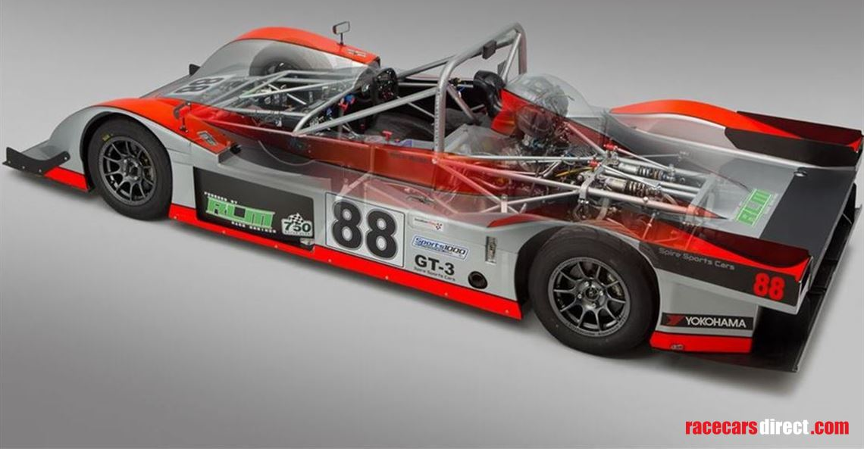
Figure 1 – Sports 100 vehicle (race car direct 2025)

Various testing methods can be used for aerodynamic development, but in this case the other methods can be used as reinforcement for the CFD validation, acting as a controlled variable. This creates a robust method, which confirms accuracy of the results, especially when no previous CFD work has been completed on this specific vehicle. Also, it is important that the CAD acts as a watertight geometry. As mentioned, controlling the drag is an area of importance, however controlling the balance of the vehicle and how sensitive the balance is in relation to a change in ride heights (pitch sensitivity) allows for better control as gives a more predictable response back to the driver. These dependant variables (Cd, Cl, and balance) are dictated by the CFD methodology setup, but just importantly the ride heights and vehicle bodywork changes.
Sports 1000 vehicles have had little to no aerodynamic testing and development and therefore research can help to understand the current performance of the vehicle as well as provide suggestions for improvements. Furthermore, the use of this project can combine multiple testing methods (if applicable), with the aim to increase the understanding of the CFD methods, resulting in an increase in accuracy of the results. This leads to the study having a CFD methodology, baseline analysis and the implementation of various aerodynamic devices implemented through CFD.

Literature review

Aerodynamic principles and devices used in motorsport

Aerodynamic is a key fundamental in all forms of engineering, especially in relation to motorsport. Teams are always looking for improvement in performance and the understanding of aerodynamic devices and principles being utilised for downforce came from F1 around 1970 and has spiralled from there. A strong place to start, and why certain aspects are implemented in motorsport is understanding aerodynamic principles and therefore why and how these principles are implemented as aerodynamic devices.
Drag was a concept that was understood before downforce producing devices and has been critical in motorsport for gaining increased straight line speed. Drag comes from different types of airflow, surface interaction, pressure buildup and skin friction. Pressure build up occurs when an air molecule hits the surface of an object and then gets slowed down/stopped (stagnation point). The next air molecule hits the previous molecule near the surface, leading to a pressure buildup occurring as the airflow can not move cleanly around the object, resulting in drag.
Furthermore, the interaction of the air molecules near the surface of the vehicle loose energy by the skin friction interaction. This is where an object applies frictional forces to the molecule slowing down the speed of the airflow, this happens within the boundary layer. Within the boundary layer this frictional loss with the molecule slows down the molecule in the free stream, which results in viscous shear stress losses on the nearby molecules, this happens to additional nearby molecules and so on. The boundary layer is where the molecule near the surface is slowed down due to the viscous shear stresses of the surface and then has a knock on effect to the nearby molecules. This increases the drag as well as reducing the velocity and energy of the airflow in the boundary layer. The molecular interaction does not only happen at the surface of the object but with airflow moving away from the surface in alternate directions also increasing the drag of the vehicle.

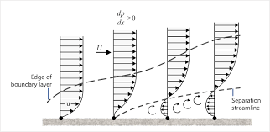
Figure 2 - boundary layer interaction near the surface of the vehicle (Altair 2026)

This is why motorsport teams look for clean airflow and make the frontal area of the car as small as possible for straight line speed. It could be suggested that having a smaller leading edge, would reduce the stagnation point, however it is more effective to have a larger radius leading edge instead. This is because sharp leading edge aerofoils cause separation as the airflow cannot turn sharp corners (National air and space museum, date unknown) and is why aerofoils rarely generally have a rounded leading edge.
Separation of the airflow not only influences the drag of the vehicle, but also the lift or in the case of motorsport the downforce of the vehicle. Separation occurs when the airflow can not remain within the boundary layer. When the airflow moves away from the surface the pressure drops on the surface, reducing the downforce. Flow separation is often seen on surfaces when the angle is too extreme and is why wings often loose performance at high angle of attacks.

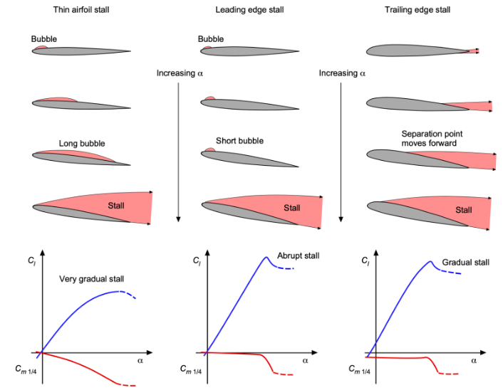
Figure 3 - Different types of separation on aerofoils for changes in attack angle (Embry Riddle aeronautical university, date unknown)

Aerodynamic devices such as vortex generators can be used to allow for higher angle of attacks to be utilised. Vortex generators work by placing a tooth like object on the surface near where the separation occurs, the trailing edge of the ‘tooth’ then sets off a vortex pulling in more airflow at an alternate angle allowing for some airflow to remain attached for a longer period. Another method used in aerofoils is multi element wings as they break up the original aerofoil and reestablish airflow tangentially to the surface of the aerofoil where separation occurs.

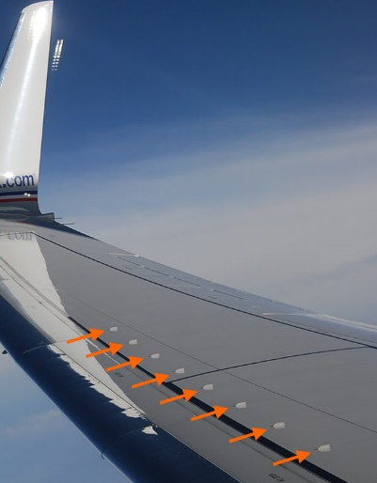 | 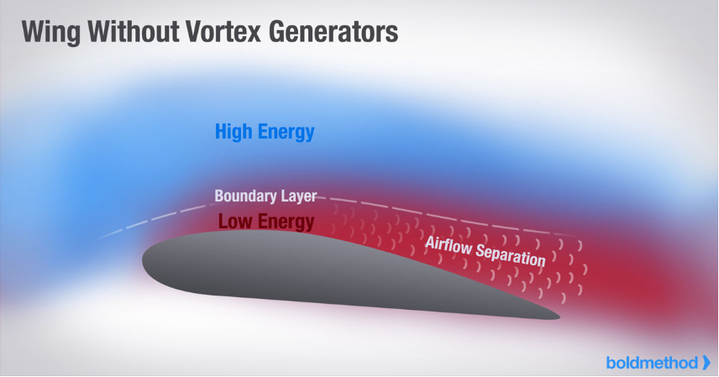
 | 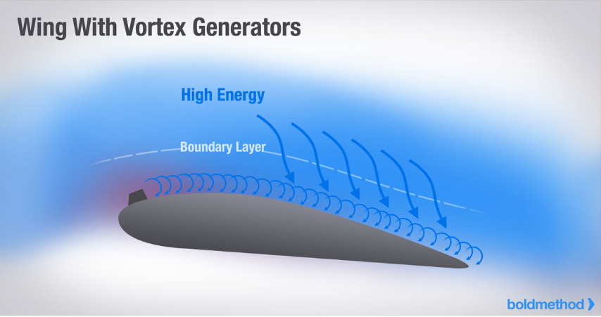
Figure 4 – Vortex generators used in aerodynamics (Aleks Udris, 9/1/2015)

The more energy near the surface of the vehicle the higher the downforce is applicable, therefore maintaining laminar flow is key. Laminar flow is generally when the Reynolds number is below 2000 and in an ideal scenario all airflow on the surface of the vehicle is laminar (CREST Foundation Studies, date unknown). Once Reynolds number reaches above 2000 the flow goes through a transitional period, then the airflow starts to become turbulent (Reynolds number above 4000). When turbulent airflow occurs, airflow acts in a less predictable manner. This often results in a loss of energy and therefore overall performance begins to drop off as a result.

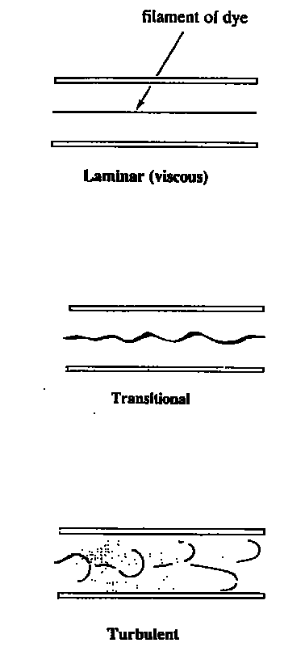
Figure 5 - Laminar, transitional and turbulent airflow representations (CREST Foundation Studies, date unknown)

Varying aerodynamic devices have been developed over the years, and with this, a better understanding of how to increase performance of the vehicle. One of the most commonly used devices is the use of aerofoils, predominantly front and rear wings. They work by creating a large pressure difference between the upper and lower surfaces of the aerofoil, in the case of motorsport application high pressure on the top surface, low pressure on the underside of the wing. The high pressure wants to push the wing to the floor, whilst the low pressure wants to pull it to the ground.
The mounting of these aerofoils often plays an important role as they need to have structural support yet from an aerodynamic point of view, they want to disrupt as little airflow as possible. There are a few methods that are applicable, with end plate or swan neck mounting being the most preferred. The low pressure underside of the wing is the most important side of the wing and therefore by putting the mount on the upper side keeps the mounts out the way. The end plate mount solves both the purpose of an end plate and mounting simultaneously. Without the end plates wings create vortices (wing tip vortices), where high pressure airflow wants to spill from the top to the lower surfaces, reducing the performance of the wing. With these sports 1000 series a rear wing is not applicable due to regulations, however the principles still apply for many other aspects of the vehicle.

With the series allowing front end splitters the use of a simplified rear diffuser is allowed to add some additional downforce at the rear of the vehicle to create an evenly aero balanced car. The aim is to act as an exit for a venturi tunnel where the air is allowed to expand, returning the low pressure air to return to atmospheric pressure, giving an overall increase in downforce. Without it the airflow would change from laminar flow in the low pressure to a more disruptive/turbulent airflow (BCST 2025).

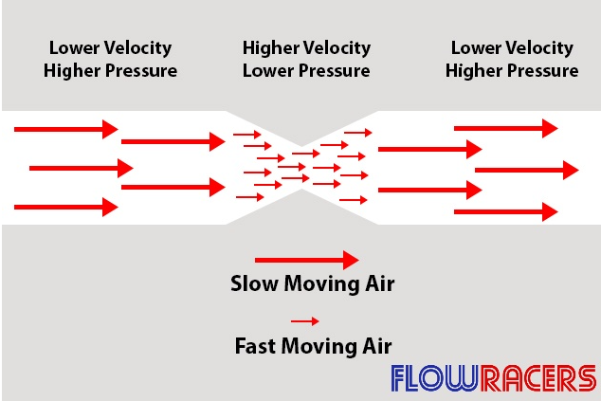
Figure 6 - Venturi tunnel diagram (Rich Opong, date unknown)

Other aerodynamic devices such as canards/ dive planes, vortex generators and more have their own specific use of application, often involving sealing/ bleeding pressure or dictating airflow into other directions for increased performance.

CFD methods in aerodynamic research

Many aerodynamic testing methods are applicable, however due to the cost, time and university resources, the use of CFD (computational fluid dynamics) is the most applicable to this investigation. Other methods such as wind tunnel, pressure tap/ aero rake and flow vis testing can be used to reinforce CFD correlation if applicable.
One of the key aspects of CFD is the use of the Navier Stokes equations, which act as fundamentals in the CFD world and have allowed CFD to become more accurate. They are a set of differential mathematical equations for calculating the momentum in the X, Y and Z direction, the continuity and the energy of the airflow. However, in CFD the use of turbulent models is implemented to reduce the time taken to solve these equations and therefore different turbulence models are applicable depending upon the level of accuracy / time taken to solve these equations. The two most common uses of turbulence models are the K-Epsilon (preferred for free stream air) and K-Omega (preferred for near wall air) (Riqy Rizqyandra,2025). They have a strong ratio in levels of accuracy / time taken to solve equations in vehicle CFD.

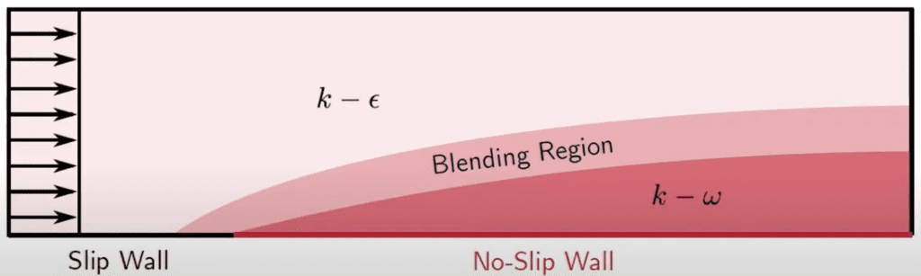
Figure 7 - K-Epsilon and K-Omega uses (Sim Scale 2025)

Other aspects of the CFD setup are vitally important as well such as domain size, mesh size and boundary layer replication. All of these have had studies completed in great detail and generally follow a similar trend to the turbulence models where the more detail desired, the more time consuming the simulation is. Often due to the universities resources lower mesh sizes need to be used due to the processing time being too extreme. Especially in the case of mesh sizing, it is frequent to use body of influence to add additional detail in areas of key significance. Papers such as Marco Lanfritz gives a strong starting point as to how to improve the accuracy of the model (Marco Lanfrit 2005).

With the controlling of the boundary layer the use of controlling the Y+ value is important to accurately replicate the airflow. The Y+ is the dimensionless distance of the wall in relation to the velocity and viscosity of the fluid. Depending upon the area of focus, the y+ value should vary depending upon region of investigation (viscous sublayer = <1, buffer layer = 5 to 30, logarithmic area = >30) (Jousefm, 2025 and Fidelis, 2026). Furthermore, due to the importance being more significant when the airflow is closer to the surface of the vehicle it would be suggested to focus more time and computational resources within the viscous sublayer and buffer layer.

Equation 1 - y+ formula
$$Y^{+}=\frac{YU_{τ}}{V}$$

Previous studies and research gap

As mentioned previously the Sports 1000 vehicle has had little to no aerodynamic work done, especially none through the use of CFD, predominantly due to costs. Furthermore, the application of the CFD is perfect for this scenario allowing for quick design and analysis setting. In addition, CFD is commonly used within motorsport and the use of this method for testing is highly applicable. Creating the reliable CFD methodology is important and as mentioned previously is why papers such as Marco Lanfritz paper is commonly used as a starting point for CFD simulations. However, it is often that these settings differ depending upon the model and scenario of the simulation. Therefore, the use of other papers on vehicles with similar applications can be utilised alongside Marco Lanfritz paper. For example a paper on a Ford Ka is more up to date and uses simulation settings that are more applicable for this situation, such as body of influences aligning with decisions that are likely to be the outcome of the CFD validation (Patil, Patil 2021) (S.Rijns, et al, 2024).

Aerodynamic change in performance based upon varying ride height performance is an area that has been investigated in the past but not specifically for Sports 1000 vehicles. However, the general trends should be similar to other investigations, such as the paper by Alexander Nastov and David Caples on the aerodynamic development of the Chevrolet Corvette, with a significant portion of the investigation focused on the influence on the ride heights on aerodynamic characteristics (A.Nastov, D.Caples, 2019). The experiment follows general trends that would be expected. It must be stated that the paper follows smooth trends, which within motorsport is limited. Also the change in performance in relation to the change in ride heights is not as extreme as what would be expected within motorsport The reasoning behind this comes from the previous experience and understanding of studies carried out on the university’s sports 2000 race vehicle.

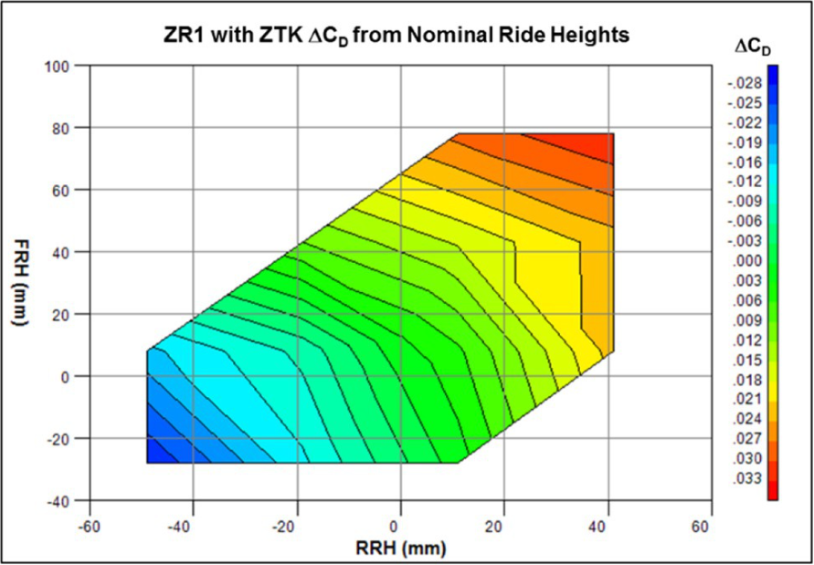 | 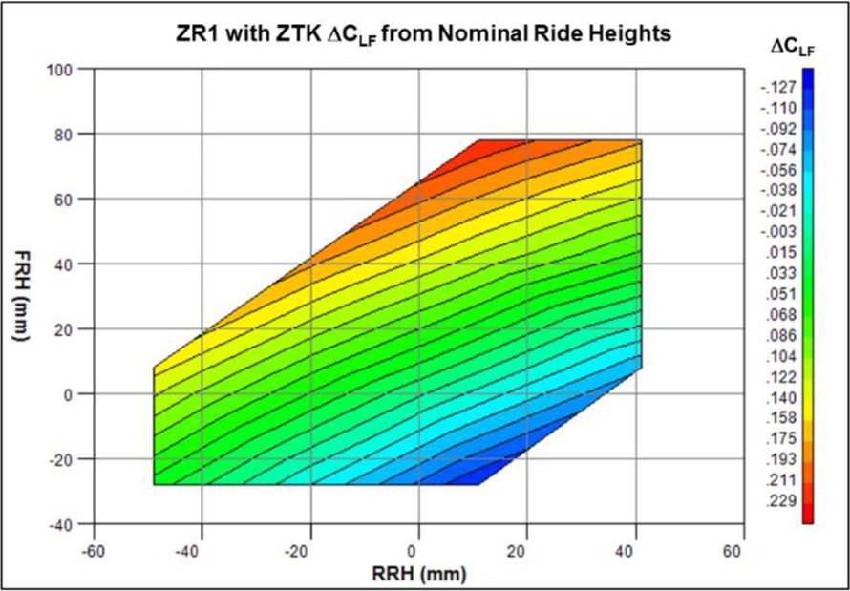 | 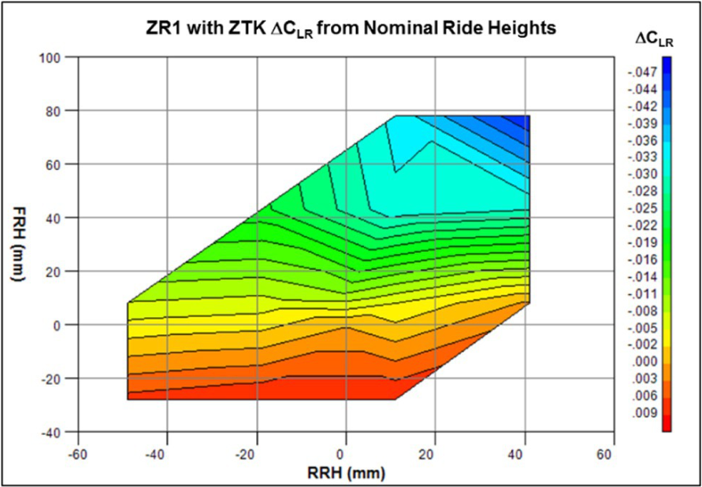
Figure 8 - Drag, Cl front and rear in relation to a change in ride heights on a Corvette (A.Nastov, D.Caples, 2019)

As stated in the principles of aerodynamics, the use of aerodynamic devices such as splitters, diffusers, rear wings and more, are commonly used due to the simple implementations onto vehicles for high levels of downforce. A strong example of the implementation of these is in a paper by M.Cross and M.Jackson, where various aerodynamic devices were implemented to improve the downforce of the vehicle without excessively increasing drag (M.Cross M.Jackson, 2026). The rear wing for an example would not be applicable for the sports 1000 series however, several other devices commonly used such as a splitter could be applicable. Furthermore, the study reinforces the point that often papers focus on downforce rather than drag and therefore is more focused on drag.

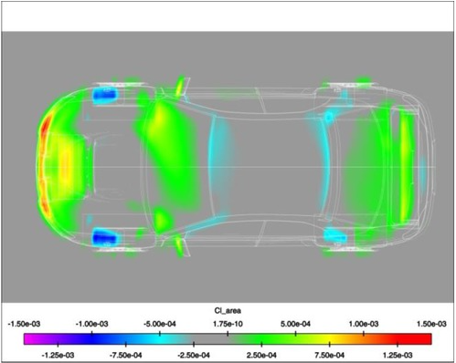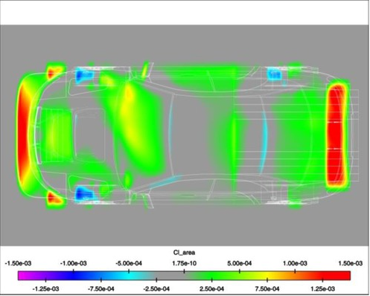
Figure 9 - Downforce distribution on the baseline vehicle (left) and final design (right) on Subaru WRX (M.Cross M.Jackson, 2026)

Conceptual framework / research direction and overall summary

Having a model that accurately represents the airflow significantly impacts the comparison in the results between real world and computational comparison. However, controlling the balance between accuracy and the computation time is important and this is the common reason why certain sections such as radiators and pipe airflow is often blanked out to simplify the simulation.
The CFD process will start of with a so called ‘baseline’/ starting point on the CFD validation. These CFD settings will be a combination of various CFD technical papers, however it will generally be a more simplified CFD method. If the method is too detailed to begin with it can be difficult to reverse the settings back to original point/ diagnosing where an issue or inaccuracy comes from. With this finalised, the development of the Sports 1000 vehicle can take place, with the initial baseline run from CFD settings giving indications of the areas to investigation.
Aerodynamic devices have been implemented in all kinds of different circumstances. The inspiration for these designs in certain scenarios depends predominantly on the regulations. Furthermore, the general aerodynamic devices are already in place on the vehicle, however the aerodynamic design of these can be significantly improved due to the current simplicity of the devices.
Understanding the pitch sensitivity is key when relating it back to on track performance as being able to dictate the position of the vehicle when in high speed straights to low speed corners is key for slower lap times. Therefore, understanding how the vehicle aerodynamic balance changes depending upon the ride heights of the vehicle is key. There are often trends that are common, however each vehicle has characteristics that make them unique and why aero maps are utilised to tune the set up into the best performing region around a desired circuit.

Methods

Before any form of analysis can take place, having a model that is watertight in CFD is critical. If this is not watertight making changes that allow for this to take place needs to happen. Assuming this is complete, the creation of the CFD methodology can take place. With this having a methodology that has reliability in the results, allows for progress to be made throughout the investigation due to the results giving confidence in accuracy of numerical and visual responses. The accuracy of these results comes from creating boundary conditions (CFD settings) that are repeatable for a change in design of the vehicle or ride heights, these often involve settings such as turbulence models, mesh size, domain size and much more. Each setting is changed to understand its influence on Cd, Cl, balance and flow structures and whether these values correlate with other testing methods. The other methods give a range in results, with wind tunnel data focused more on numerical representation, flow vis gives a flow structure representation and pressure tap data giving both a numerical and visual flow structure representation. A combination of these being used in comparison to the CFD gives a stronger reliability in these results. It must be stated that there are differences between CFD and other testing procedures and can explain why these results are not 100% accurate. A strong example of this is that the wind tunnel data is gathered using MIRA wind tunnel which has a kick wall, which trips the airflow to re-establish a boundary layer with the floor, which is not replicated in CFD, predominantly due to the wall trying to make the wind tunnel more comparable to track results.

Wind tunnel (Ed Hardy, 2024) | Pressure tap/ Aero Rake (Rob Smedley, 2019)
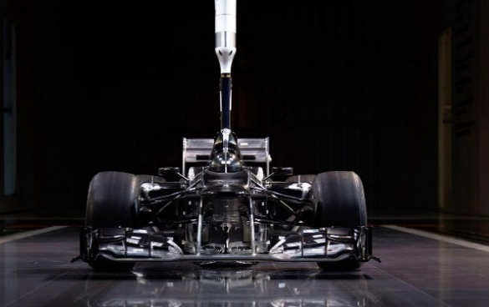 | 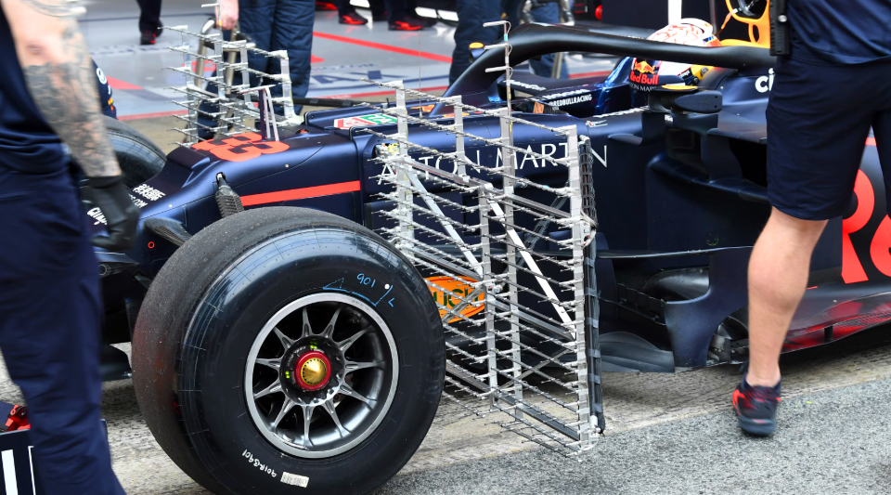
Flow vis (Rosario Guliana, 2024) | CFD (Willem Toet, 2019)
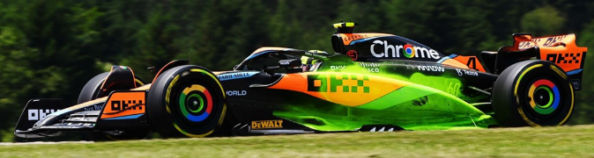 | 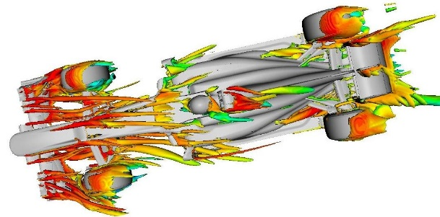
After finalising the CFD methodology a baseline run needs to be completed and deeply analysed to understand areas of importance as well as the dynamic ride height influence. This often involves Cd, Cl and balance being the quick numerical analysis and then pressure, velocity contours and more being used to understand why these numerical values are what they are. With this a baseline ride height study would be beneficial to understand as to how sensitive the vehicle is to changes in ride height. This can then be compared to a ride height study completed towards the end of the investigation to get a comparison to how the vehicle has changed dynamically with the aerodynamic bodywork changes.
Looking at the baseline results, will lead to development on certain aspects of the vehicle. This will be done through an iterative process. A design change will be made in CAD, which is then run through CFD and analysed numerically and visually. Other areas of improvements can be changed, and this process will be repeated, until a final design is confirmed. Using this final design a ride height study will be completed to conclude the overall project.
It could be suggested that doing a ride height study throughout the project could be beneficial. However, due to the time constraints involved this won’t be carried forwards as it would require multiple CFD runs for every individual change in design.
Alternative testing methods other than CFD would be applicable and are used throughout industry. Yet the costs involved with wind tunnel testing in comparison to CFD is significantly different. Even though the cost of flow visualisation is a cheap form of testing, the cost of manufacturing the components is a significant issue, as well as the possibility that the time and money gone into production with no improvement is a significant waste of resources. Within industry, often large changes are completed in CFD, whilst final designs or small changes are tested in the wind tunnel. This is then followed up with flow vis and pressure tap for correlation of the CFD and wind tunnel data.

Results

Within CFD there is 2 main categories for the results, visual and numerical. Cd, Cl and balance being the more common results, whilst Coefficient of pressure, Y+ and others are useful within specific analysis. Visual results often involve a form of contours, streamlines or vectors on the physical vehicle or around the surrounding section of investigation. This can give an indication of how the airflow is moving in terms of direction and magnitude.
The data is often compiled into large spreadsheets, where progress on various sections is collected into an individual table and then a more focused table on the finalised versions of each section is also applicable. These tables will be similar to figure 3, where they have Cd, Cl, balance and efficiency all for the individual test as well as then being compared back to the baseline. It is common to include post processing visual images where a specific region is being investigated as that can further reinforce the progress made.

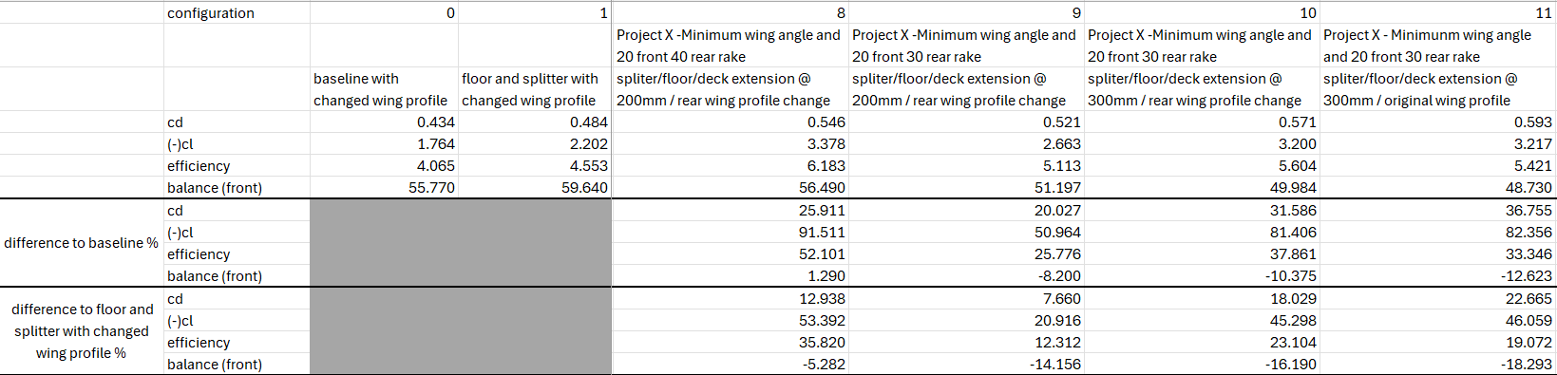
Figure 10 - Example of compiled project document

Ride height studies often include the use of aero maps as they indicate how the vehicles numerical data changes dependant upon the location of the front and rear ride heights. They give strong trends and are useful for identifying where to place the front and rear ride heights for track performance.

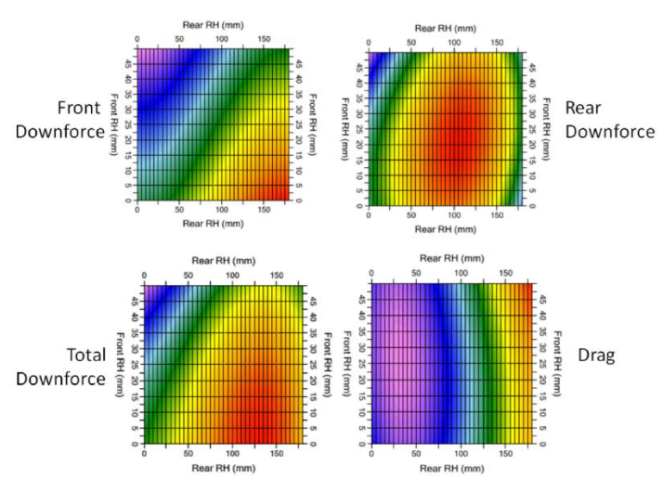
Figure 11 – Example of an aero map (Race car engineering, 2019)

Evaluation

The project will aim to give an increased performance in terms of Cl but with more of a predominant focus on drag and balance of the vehicle. The balance importance is mainly through the ride height sensitivity of the vehicle, whilst the drag is through aerodynamic design changes. Due to the specific nature of the project being on the sports 1000 race car it is then unique to the individual vehicle as well as a focus away from downforce and more on improving the drag of the vehicle. One area of weakness is that even though effort will be put into CFD to ensure accurate results there can be no guarantee on the performance value if they were to be implemented into the real world. If they were to be manufactured it could give further resolution to the project, however the time and cost involved with this process is not applicable.
When looking at the timings involved with the project it needs to be understood that the Gantt chart shown below gives a good structure to the project.

Table 1 - Gantt chart of the project overview
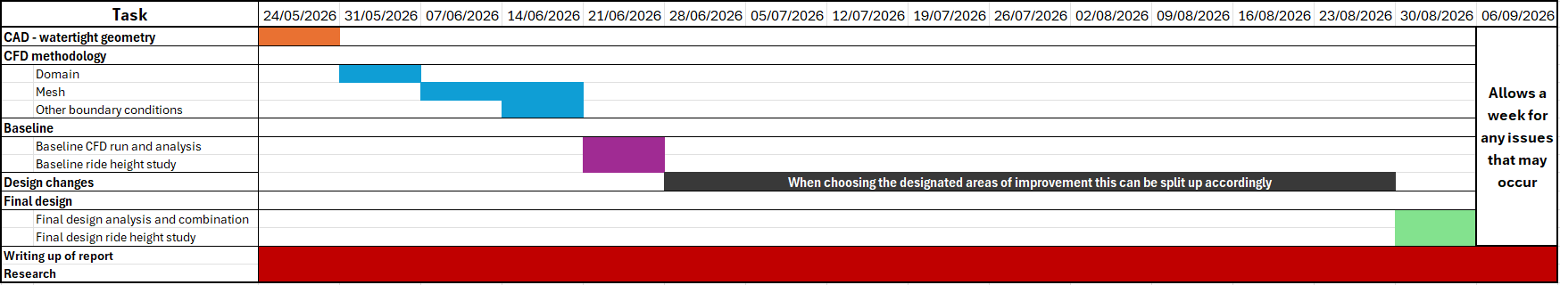

References

- NASTOV D.CAPLES, 2019. Aerodynamic Development of the 2019 Chevrolet Corvette C7 ZR1. (date retrieved 2026)
- ALEKS UDRIS, 2015. Vortex Generators: Preventing Stalls At High And Low Speeds. (date retrieved 2026)
- ALTAIR, 2026. Basic Boundary Layer Theory. (date retrieved 2026)
- ANSYS, What is Computational Fluid Dynamics (CFD)? . (date retrieved 2026)
- ATUL PATHAK, 2020. Studying the airflow over a car using an ahmed model. (date retrieved 2026)
- BCST, 2025. How does a venturi flow meter work. (date retrieved 2026)
- CREST FOUNDATION STUDIES, 7. Laminar and turbulent flow. (date retrieved 2026)
- ED HARDY, 2024. Why do F1 cars run flow-vis paint and aero rakes in testing? . (date retrieved 2026)
- EMBRY RIDDLE AERONAUTICAL UNIVERSITY, Aerodynamics of Airfoil Sections. (date retrieved 2026)
- FIDELIS, 2026. What Is y+ In CFD? – And Why Does It Matter? . (date retrieved 2026)
- FLORIAN MENTER, 2025. Laminar vs. Turbulent Flow: Difference, Examples, and Why It Matters. (date retrieved 2026)
- JOUSEFM, 2025. What is y+ (yplus)? . (date retrieved 2026)
- KSANDER N. DE WINKEL, TUGRUL IRMAK, RIENDER HAPPEE, BARYS SHYROKAU, 2023. Standards for passenger comfort in automated vehicles (acceleration and jerk). Science direct. (date retrieved 2026)
- M.CROSS M.JACKSON, 2026. Methodology for Optimizing the Aerodynamic Performance of the Time Attack Series Cobb Tuning Subaru WRX 2006 Using Mesh Deformation Techniques. (date retrieved 2026)
- MARCO LANFRIT, 2005. Best practice guidelines for handling Automotive External Aerodynamics with FLUENT. (date retrieved 2026)
- NANCY HALL, 2021. Navier-Stokes equations. (date retrieved 2026)
- NASA, 2026. Naiver -stokes equations. (date retrieved 2026)
- NATIONAL AIR AND SPACE MUSEUM, Factors Affecting Lift. (date retrieved 2026)
- PATIL, T. and PATIL, V., 2021. Aerodynamic Performance Prediction of a Car using GEKO Turbulence Model and Application of Gradient Based Optimisation for Improving Aerodynamic Drag. SAE International. (date retrieved 2026)
- RACE CAR DIRECT, 2025a. 2022 Sports 1000 Championship - 750MC. (date retrieved 2026)
- RACE CAR DIRECT, 2025b. Spire Sports 1000 cars for sale or hire. (date retrieved 2026)
- RACE CAR DIRECT, 2019. What is an Aero Map? . (date retrieved 2026)
- RICH OPONG, What Are Venturi Tunnels In F1? (Venturi Effect Explained). (date retrieved 2026)
- RIQY RIZQYANDRA, 2025. CHOOSING BETWEEN K-EPSILON AND K-OMEGA FOR YOUR CFD SIMULATION: A PRACTICAL GUIDE. (date retrieved 2026)
- ROB SMEDLEY, 2019. Testing explained: Rob Smedley on aero rakes. (date retrieved 2026)
- ROSARIO GULIANA, 2024. How do windtunnels work - and how are they regulated in Formula 1? . (date retrieved 2026)
- S., RIJNS T. and TESCHNER K.BLACKBURN J.BRIGHTON, 2024. Integrated Numerical and Experimental Workflow for High-Performance Vehicle Aerodynamics. (date retrieved 2026)
- SIMSCALE, 2025. K-Omega Turbulence Models. (date retrieved 2026)
- SIMSCALE, 2023. Validation Case: DrivAer Model. SimScale. (date retrieved 2026)
- VW OWNERS CLUB GREAT BRITAIN, 2018. More Downforce Than Weight. (date retrieved 2026)
- WILLEM TOET, 2019. Willem Toet explains…CFD Post Processing. (date retrieved 2026)

