Operating Systems
Computer Architecture and Operating Systems BSc (Hons) Computing Data and Information Systems
Anonymous

Abstract
This document explains the general functions of a Computing Operating System and demonstrates how the user can interact with the operating system using Windows and UNIX CLI and Batch and Bash scripts
Contents
1 Introduction 3
2 Functions of an Operating System(OS) 3
3 Command Line Interface (CLI) for Windows 5
3.1 CLI whoami 5
3.2 CLI help 5
3.3 CLI help color 5
3.4 CLI color 7D 6
3.5 CLI prompt 6
3.6 CLI tasklist 7
3.7 CLI driverquery 7
3.8 CLI ipconfig 8
3.9 CLI ipconfig | clip 8
3.10 CLI /? 9
3.11 CLI assoc 9
3.12 CLI ping 10
3.13 CLI tracert 10
3.14 CLI cls 11
3.15 CLI echo 11
3.16 CLI notepad 11
3.17 CLI dir 11
3.18 CLI cd 12
3.19 CLI mkdir 12
3.20 CLI rmdir 13
4 Linux CLI 14
4.1 CLI pwd 14
4.2 CLI clear 14
4.3 CLI echo 14
4.4 CLI mkdir 14
4.5 CLI ls 15
4.6 CLI cd 16
4.7 CLI cd.. 16
4.8 CLI cd – 16
4.9 CLI touch 17
4.10 CLI echo > or echo >> 17
4.11 CLI cat 17
4.12 CLI head & tail 17
4.13 CLI stat 18
4.14 CLI du 18
4.15 CLI cp 19
5 Bat/Batch Scripts 19
5.1 Getting started 19
5.2 Variables 19
5.3 User input 20
5.4 If and Else 21
5.5 If and Goto 21
5.6 For Loops 22
5.7 Arrays 23
5.8 Call and Functions 24
6 Bash Scripts 27
6.1 #!/bin/bash 27
6.2 Echo command 27
6.3 Variables 27
6.4 If/elif/else command 28
6.5 Case Statement 29
6.6 Function command 30
6.7 Arrays 30
6.8 Loop commands 31
6.8.1 For loops 31
6.8.2 While loops 31
6.8.3 Until loops 31
7 Conclusion 32
8 References 33
9 Appendix 35
9.1 Types of Operating Systems(OS) 35
9.2 NDG Linus Unhatched 35
9.2.1 Arguments 35
9.2.2 File Permissions 38
9.2.3 Viewing Files 38
9.3 Bat files 38
9.4 Bash files 38

Introduction

This report describes the common types of operating systems and their functions.
The report also demonstrates how the user can interact with a Microsoft Windows or Unix operating systems using command line interface (CLI), Batch scrips and Bash scripts.
Screenshots are available within the appendix of the CISCO Unix Unhatched online learning course, which demonstrates evidence of engagement with the course.

Functions of an Operating System(OS)

The Operating system is the most important piece of software held on your device. Tanenbaum states its purpose being:
To provide user programs with a better, simpler, cleaner, model of the computer and to manage managing all the resources.(some main memory, disks, printers, a keyboard, a mouse, a display, network interfaces and various other input/output(I/O) devices. [1]
The main functions that the OS performs to create this environment are:
- Memory Management – Ritchie [2] explains that the memory manager’s main functions are to provide sufficient memory for several functions to simultaneously, to share memory space between processes and to provide these functions as transparently as possible for the user. It allocates and manages Virtual Memory, which is a segment of volatile memory created when several processes are running an RAM(random access memory) is running low. It does this either using demand paging. Which as Stallings [3]explains is just a method that allows each page of the process to be brought into RAM only when it is needed. Another method is Segmentation but majority of modern OS’s use Paging.

- Process Management – involves several main tasks:
  - Process scheduling
  - Termination of processes
  - Dead lock avoidance – deadlock is when two processes sharing the same resource, effectively prevent each other for accessing the resource. Previously this would lead to system crash.
The OS uses two techniques to prevent dead lock and to schedule processes one is Multithreading which allows several processes to seemly run simultaneously. Another is the Bankers Algorithm which controls the allocation of resources.
Figure 2 Preplnsta [4] Figure 3 A Singhal [5]
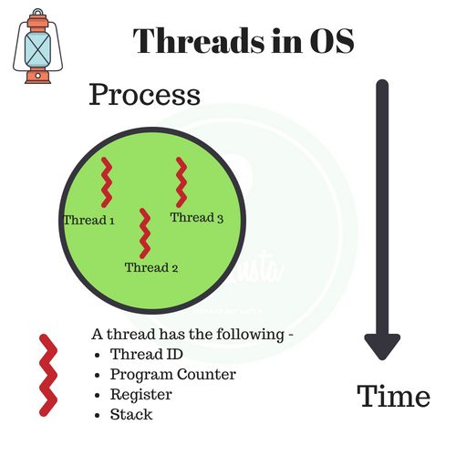 | 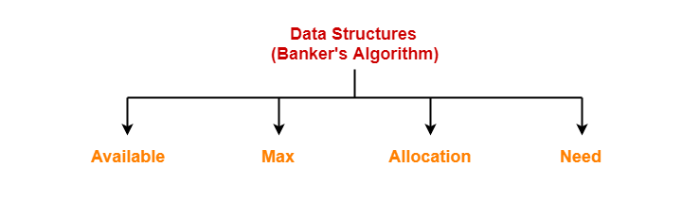

- Device management within an operating system is a function to control the Input/Output devices:
- Disk
- Microphone
- Keyboard
- Printer
- USB ports
- Network devices
One process running on the computer might need several different resources, if they become available, they are allocated, otherwise the process will be postponed until required resource becomes available.

- Security – modern OS’s have several built-in security tools to protect both the hardware and software of the device:
Figure 4 Wikipedia [6]
- Firewalls  - Antivirus scanning  - File and disk encryption  - Authentication of the user, with user ids and passwords  - Backup and restore, in the event of corrupted files and system crashes  - Intrusion detection and prevention  - Protection rings, which grant hierarchical permission to which protect the Kernel(core of the OS) and give each resource only the permission it needs | 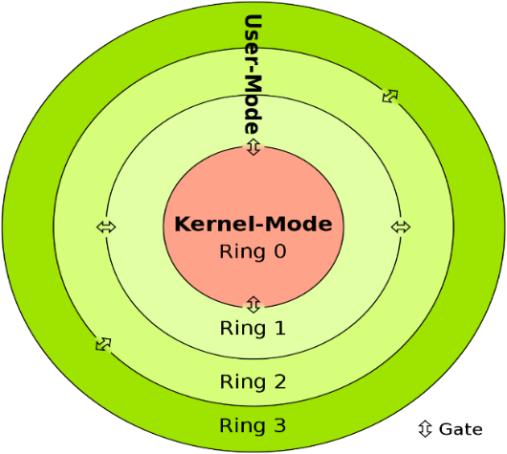

- File Management – Yernagula [7] asserts is the base and one of the most prominent features of the OS and its tasks include:

- Creation of files
- Accessing of files
- Sharing of files
- Storage of files in directories and keeping a track of their location
- Amendment of files
- Moving of files
- Displaying old files
- Sorting files according to gauges
There a several different File Management Systems
Operating System | File Management System | Abbreviation
Windows | New Technology File System | NTFS
Unix | Unix File System | UFS
Linux | Extended File System | EXT
Macs | Apple File System | APFS

Command Line Interface (CLI) for Windows

CLI whoami
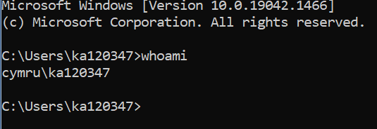
‘whoami’ displays the user’s id (username/login details) and the group they belong to.

CLI help
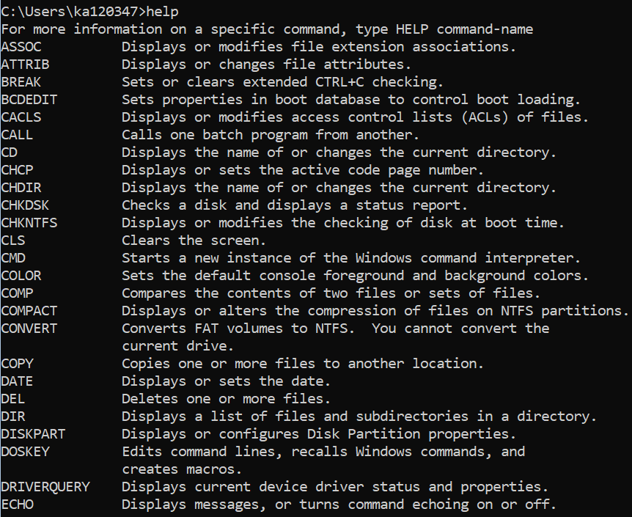
‘help’ displays a list of CLI’s and their description.

CLI help color
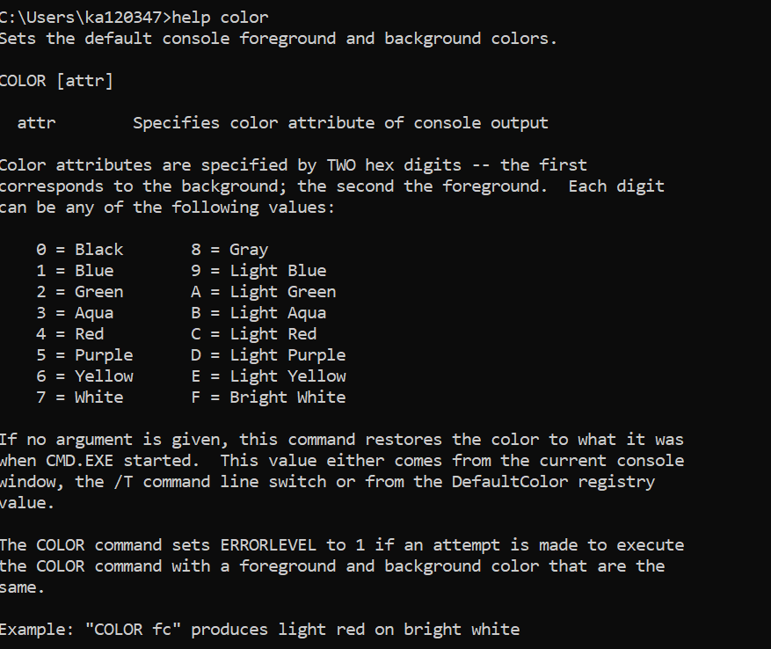
Gangwar [8] states that the default background and text colours can be boring.
And suggests using ‘help color’ which displays instructions and suggestions to jazz up your background colour and text.

CLI color 7D
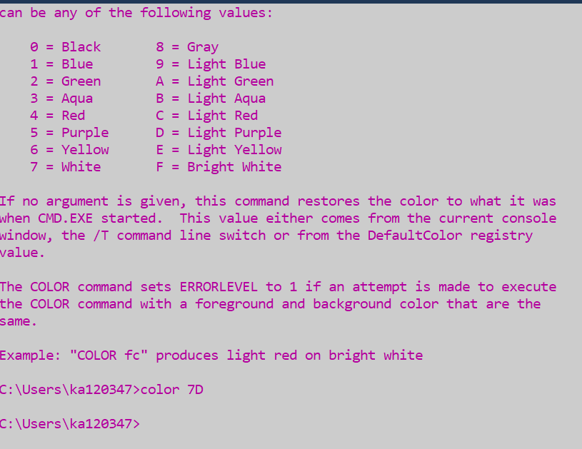
‘color 7D’ changes the background color to white (looks grey) and the text to purple

CLI prompt

The prompt’s text can be changed using ‘prompt’ followed by the desired text then ‘$G.’
Entering ‘prompt’ followed by enter, returns the user to default prompt.

CLI tasklist
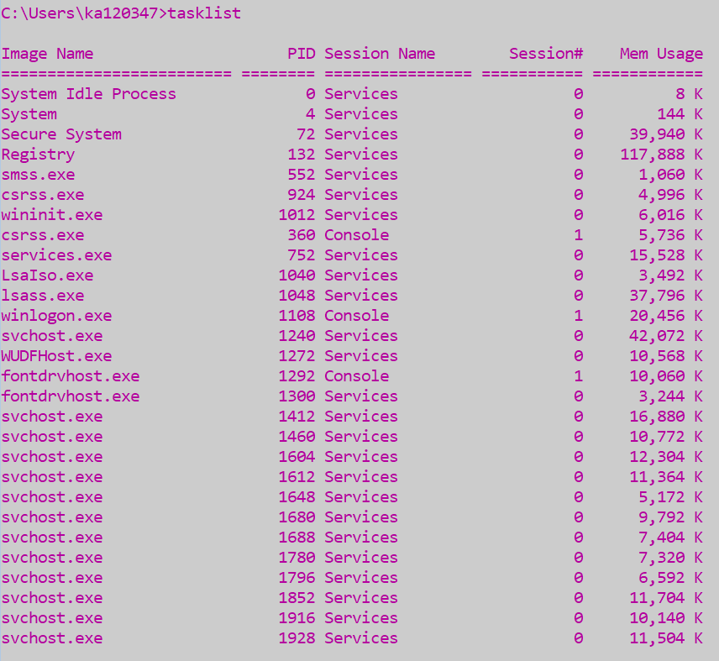
Turner and Franco [9] describes how the ‘tasklist’ displays all the processes running on the computer.

CLI driverquery
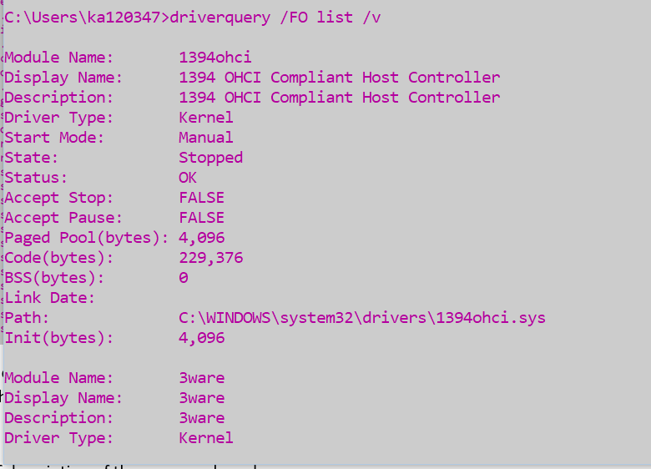
‘drivequery’ displays a list of all the drivers and the status of the device.

CLI ipconfig
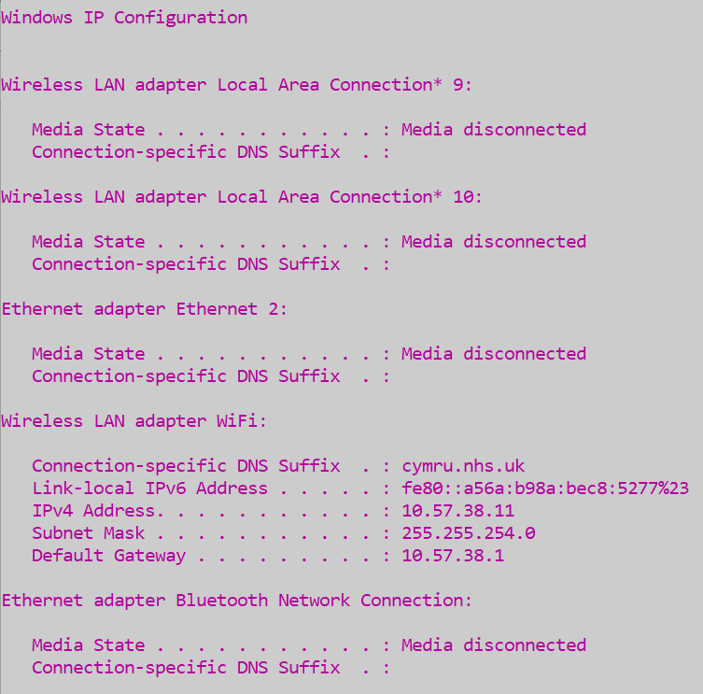
Meridianoutpost [10] states that one of the most popular CLI command is ‘ipconfig’. It is used to display the TCP/IP network configuration of the computer. It is often used for troubleshooting network connectivity issues.

CLI ipconfig | clip
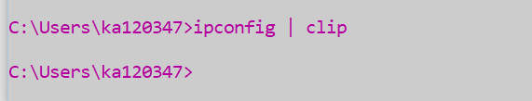
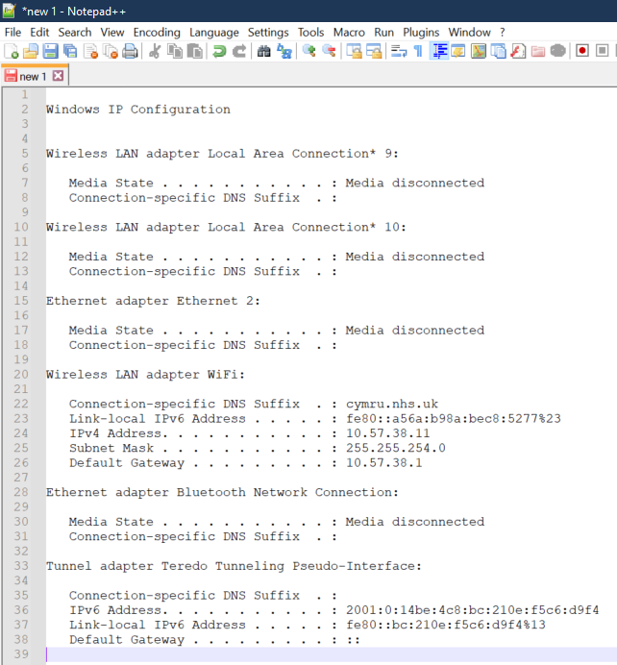
Following any command with ‘| clip’ will stop any output, but it will copy the output into a text editor using the ‘Control + V’ to paste the output.

CLI /?
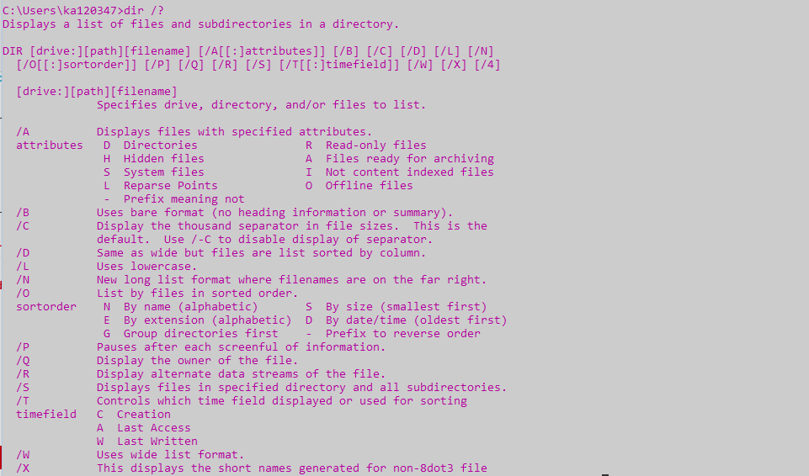
Adding ‘/?’ at the end of any command also displays information about the command.

CLI assoc
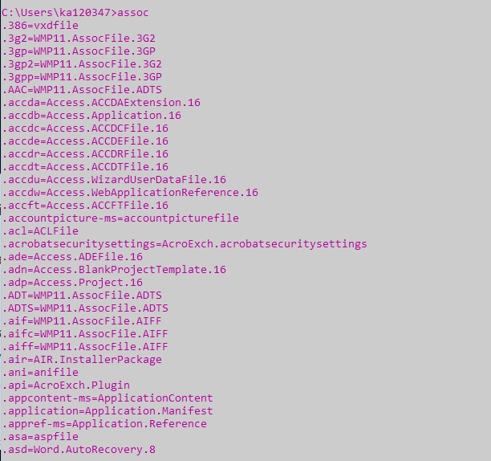
Sieber [11] suggests the ‘assoc’ command is a useful one to know, as it displays a full list of filenames with extensions and program associations.

CLI ping
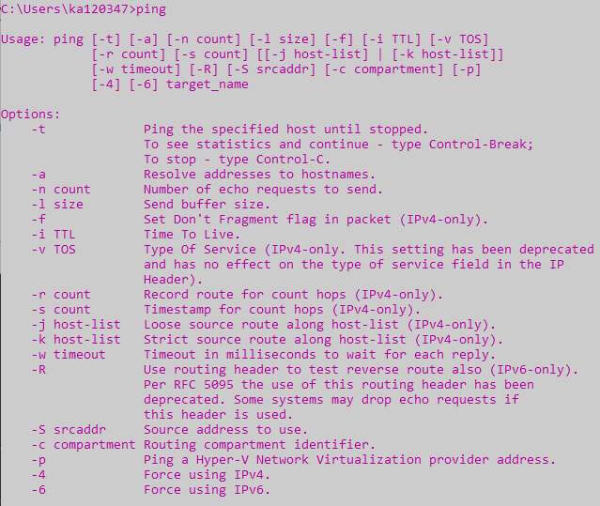
‘ping’ sends a packet of data to a specific IP address on the network. ‘ping’ can be followed with an IP address or website domain.
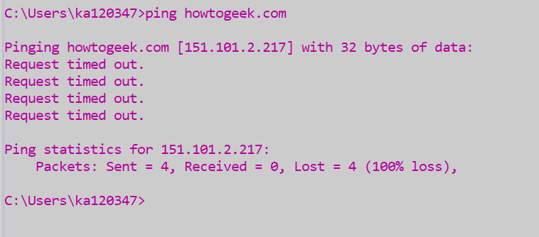

CLI tracert
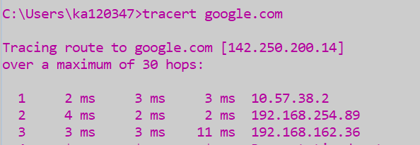
‘tracert’ displays information about each step in the route between the user’s PC and the target domain.

CLI cls

‘cls’ is short for clear screen and clear the screen apart from screen prompt.

CLI echo
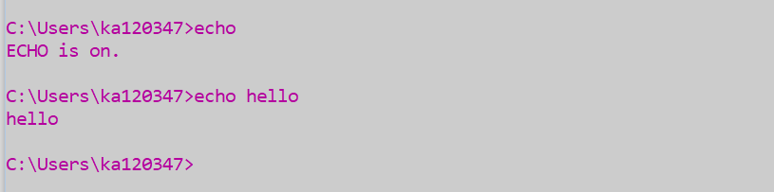
‘echo’ outputs the text which is entered after the command.

CLI notepad
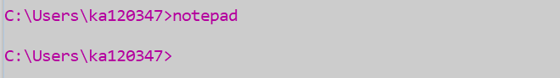
‘notepad’ opens the notepad application in a separate window

CLI dir
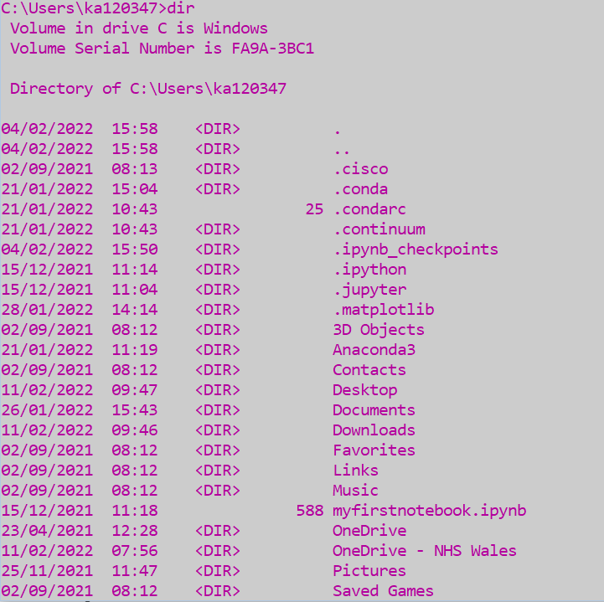
‘dir’ is short for directory and will list the content of the current directory/folder.

CLI cd

‘cd’ is short for change directory. The above command moves the user from the default user folder to their desktop

‘cd..’ moves the user up one folder

CLI mkdir
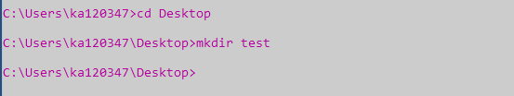
‘mkdir’ creates a new directory. The above example changes directory to desktop and creates a new folder called ‘test.’
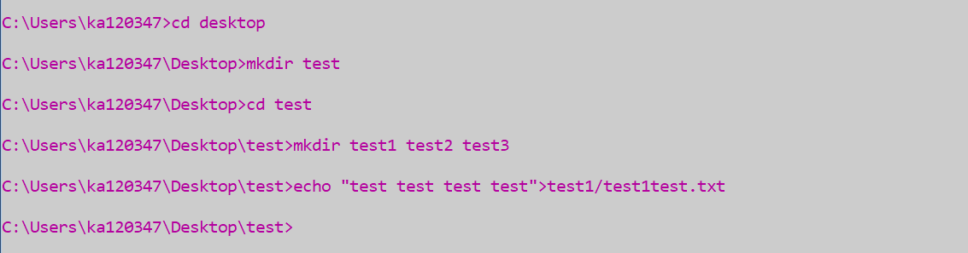
‘mkdir’ can create nested folders.
Used with ‘echo’ and the ‘>’ operator it can create a new file including text.
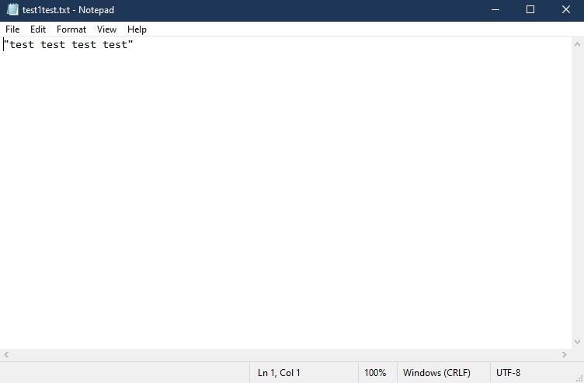

CLI rmdir
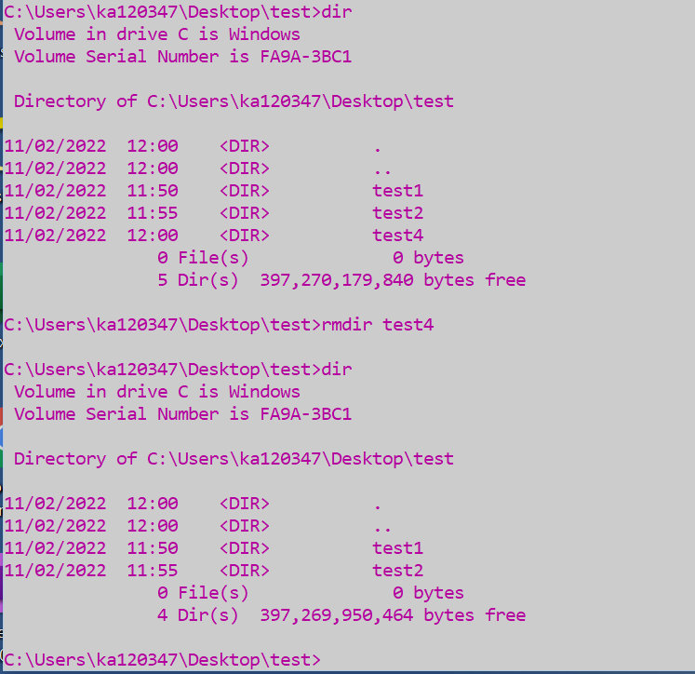
‘rmdir’ deletes a directory/folder.
The above example creates new directory, lists the directory, deletes the folder using ‘rmdir’.

Linux CLI

CLI pwd
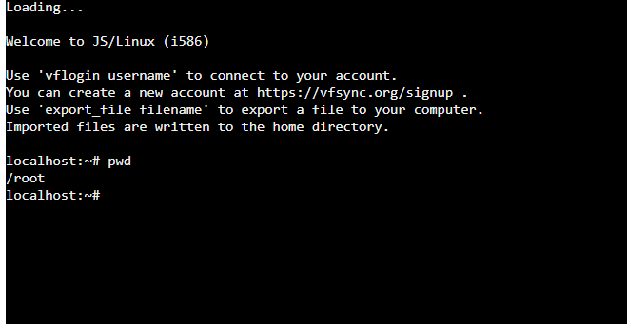
‘pwd’ displays the current working directory.

CLI clear
‘clear’ clears the screen, leaving just the command prompt top left


CLI echo
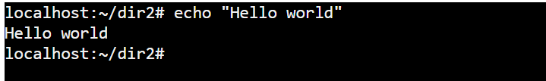
‘echo’ outputs a message contained with quotes to the display screen

CLI mkdir
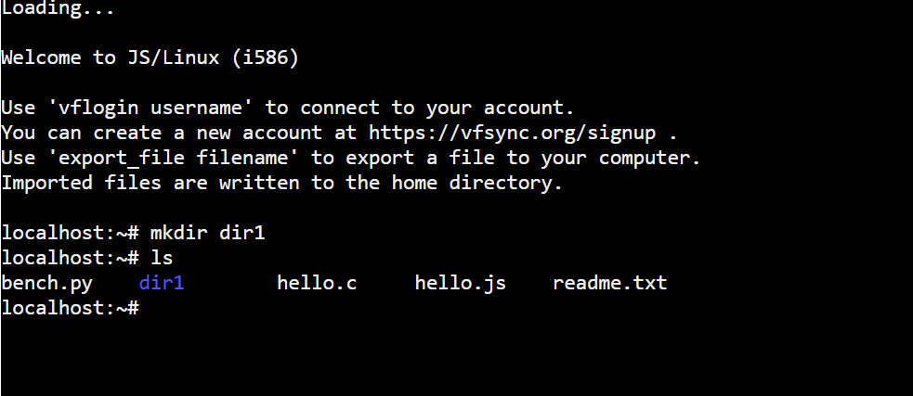
‘mkdir’ allows you to create a new directory, in the above example we have created a new directory dir1.
Multiple directories can be created in one command , the below code creates dir2, dir3 and dir4.
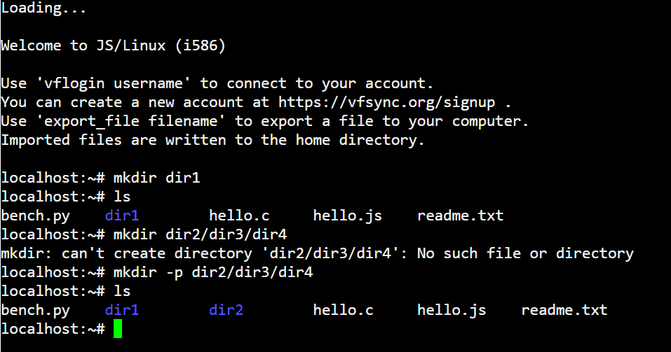
GeeksforGeeks [12] suggests using ‘mkdir -p’ which allows the user to create nested or parent child directories.
‘mkdir -v’ (the -v is verbose) displays a message for every directory the user has created
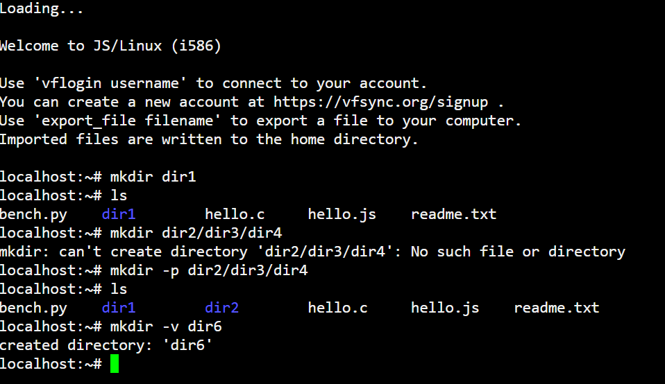

CLI ls
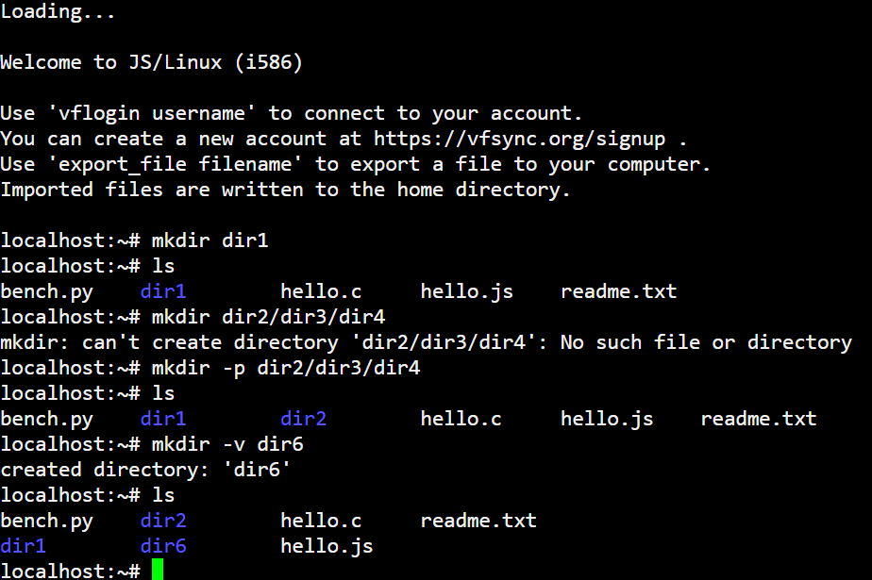
Ayodeji [13] explains that the ‘ls’ command allows the user to list the files in their current directory.
In the example above only three of the six directories the user has created are displayed. To be able to display the sub/child directories the user will need to change directories.

CLI cd
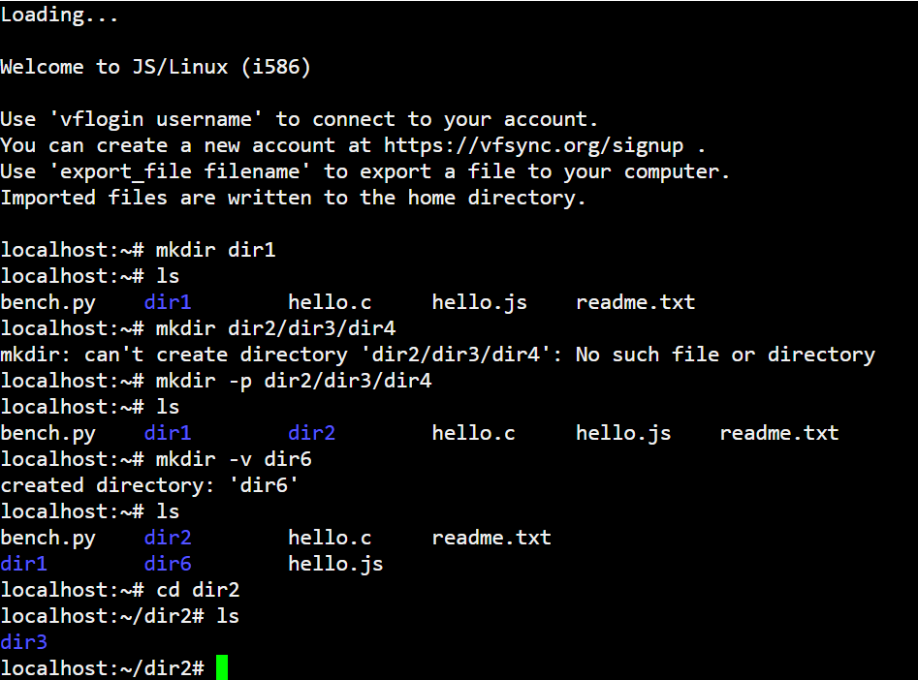
‘cd’ allows the user to change to the stated directory, in the above the user has changed to ‘dir2’ and when the ‘ls’ command is entered it displays ‘dir3’

CLI cd..
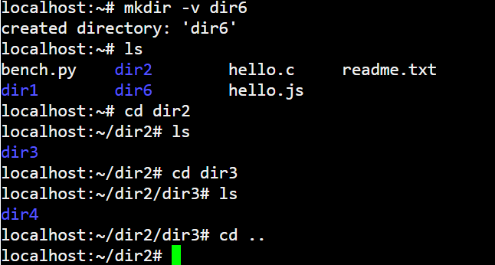
‘cd ..’ allows the user to move back one directory

CLI cd –
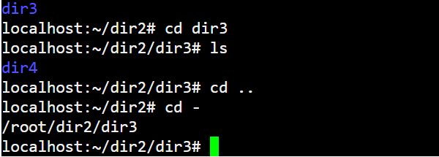
‘cd -’ moves the user to the last worked directory

CLI touch
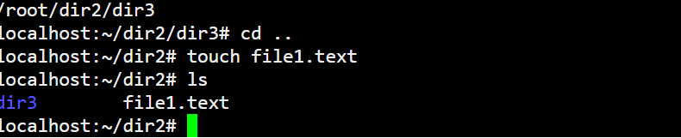
Zachariah [14] writes that ‘touch’ is used to create an empty file but cannot be used to open or close a file.

CLI echo > or echo >>
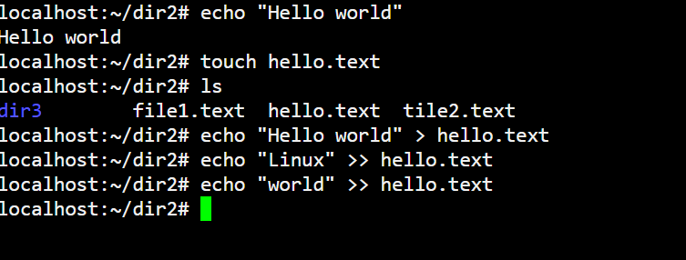
To add text to a file you need to use the command ‘echo “ *** “ > filename.text’ and to append text to a file ‘echo “****” >> filename.text’

CLI cat
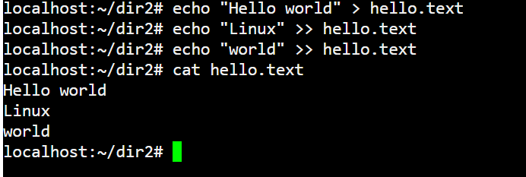
Simic [15] explains that ‘cat’ is concatenate and allows the user to display the content of a file without opening it.

CLI head & tail
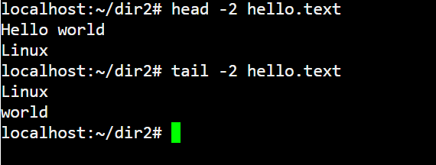
‘head’ displays first ten lines of a file and ‘tail’ will display the last ten. The above example shows the first and last two lines of the file hello.text.

CLI stat
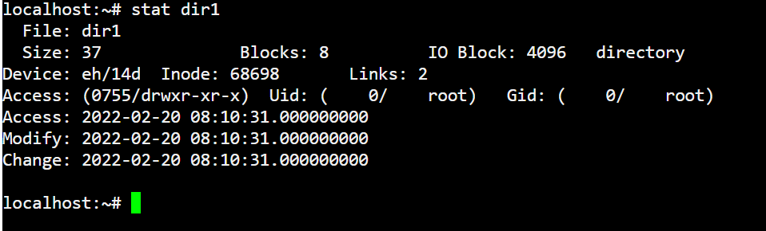
On his website McKay [16] explains how ‘Stat’ provides detailed information on the directory or file including:
- Name
- Size
- Owner
- Time and type of access

CLI du
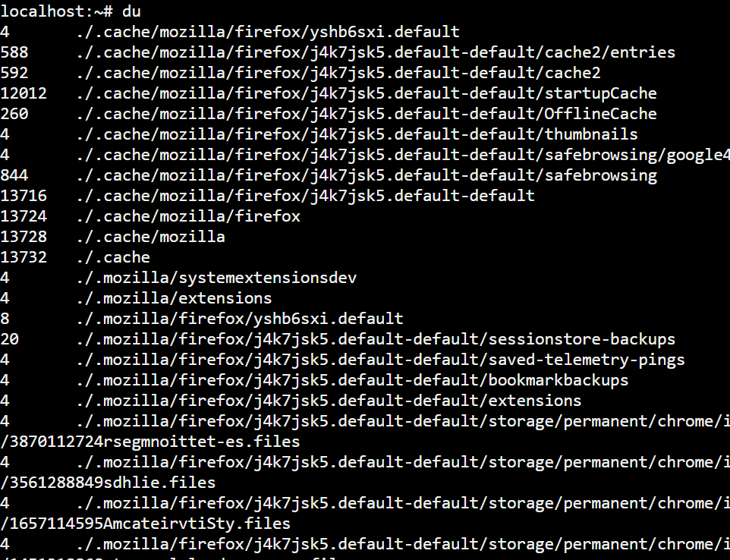
‘du’ displays the disk usage within current directory. Using ‘du -xh ~ ‘(x excludes other file systems , h readable format, ~ home) makes information more readable.
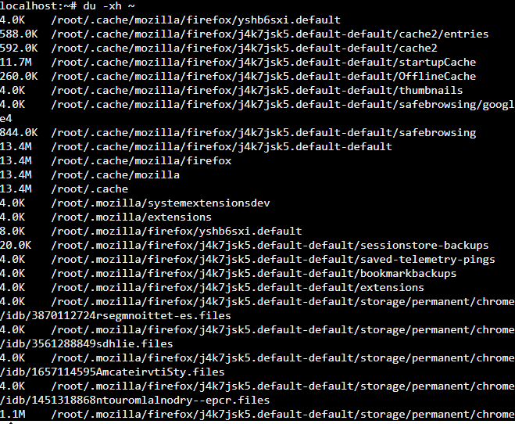

CLI cp
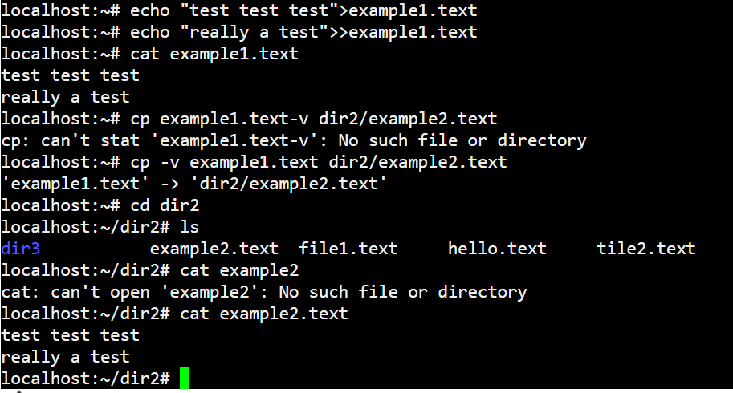
‘cp’ copies the contents of a file into another file and directory. The above example creates example1.text in dir1 and copies the contents of the file into a new file example2.text within dir2.

Bat/Batch Scripts

Getting started
Heath [17] explains that ‘@echo off’ should be the first command assigned as this prevents the contents of the bat file being displayed ( only allowing the output of the script to be displayed). So that the output of the script can be viewed Woude [18] advises that the ‘pause’ command is used so that ‘Press any key to continue …. ‘ will be displayed before the screen is cleared.

Variables
In batch variables can be pre-set or the data can be input by the user and can be alphanumeric or numeric.
Numeric variables can be used to perform calculations.
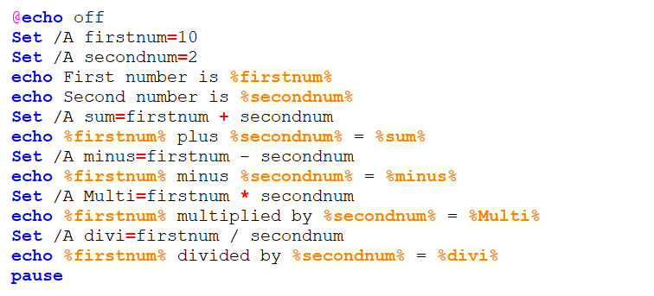 | 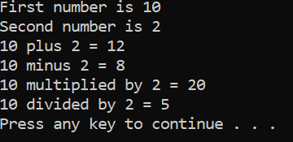

Increments and modulus
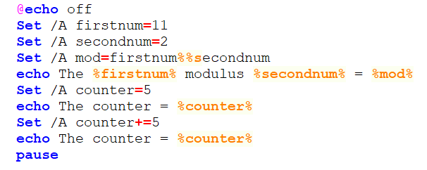 | 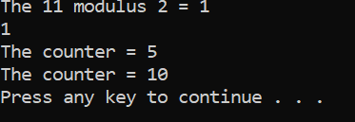

To create a numeric variable the ‘Set /A’ command must be assigned. Alpha numeric variables just need the ‘Set’ command
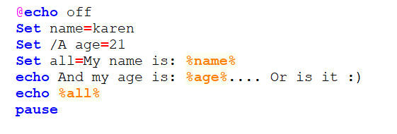 | 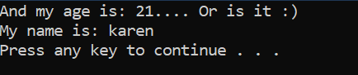

User input
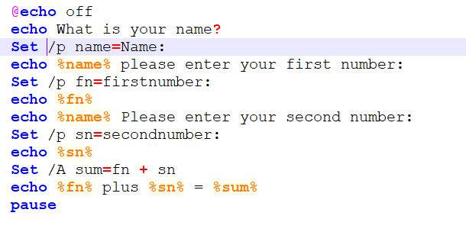 | 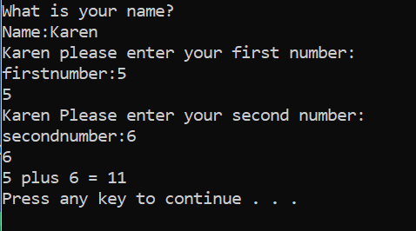

This script allows the user to enter their name and two number of their choice, which are then added together.

If and Else
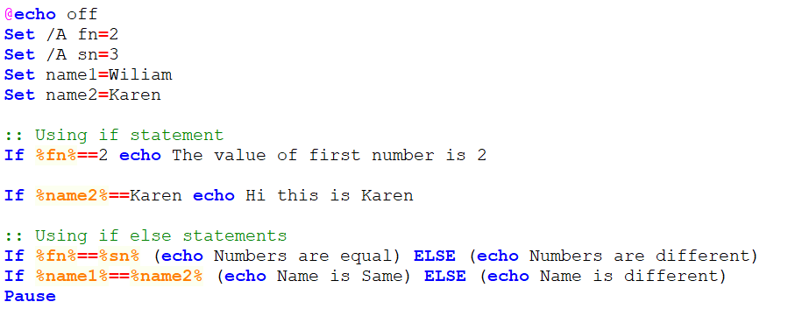 | 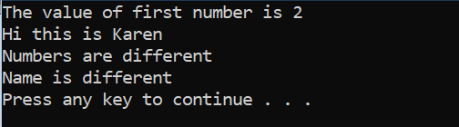

The above script compares two number and two names and produces different outputs depending on whether the values are equal or not.

If and Goto
If statements are as Dube [19] explains are method of comparing two values, but can save time, effort and make your script more flexible. The Listek [20] describes the goto command as a method of controlling the flow of the script, instead of the script running from each line sequentially from top to bottom.
The below script checks the user’s names, prompts for numbers, and finally checks if they wish to perform the action of entering the numbers again.

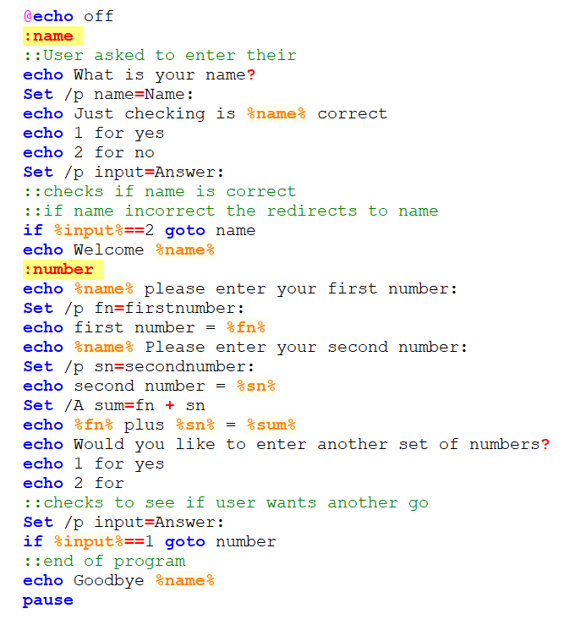 | 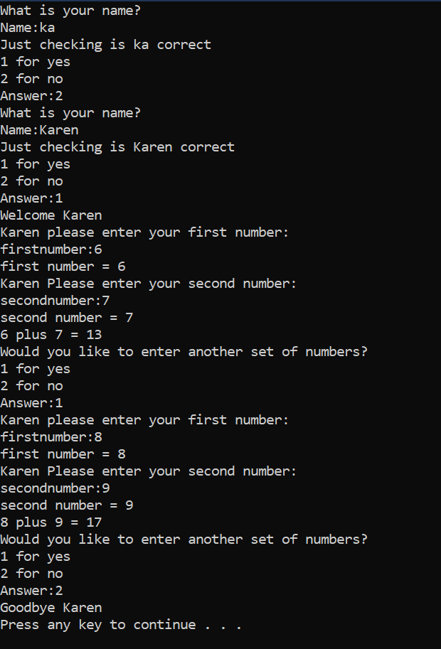

For Loops
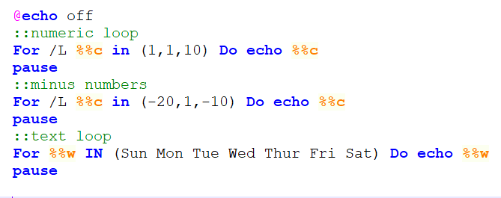 | 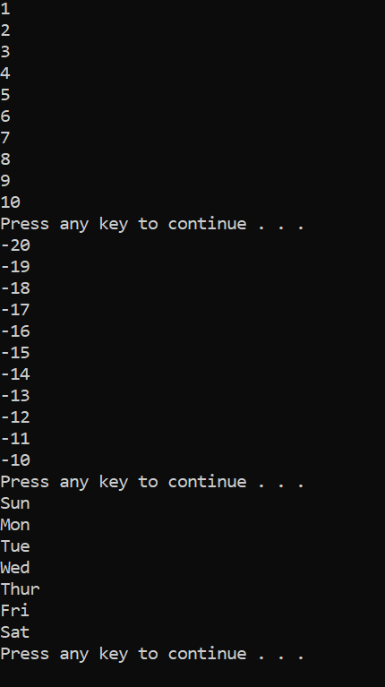

The above script show 3 different ways that a ‘For loop’ can be created, however in their website trytoprogram [21] show that you can use the ‘For’ command to loop through directories and files as well.

Arrays
Arrays in batch script are lists of either numeric or text. In the array each element needs to be define and a ‘For’ loop to iterate through the elements within the array
The output colours have been changed using the ‘color’ command.
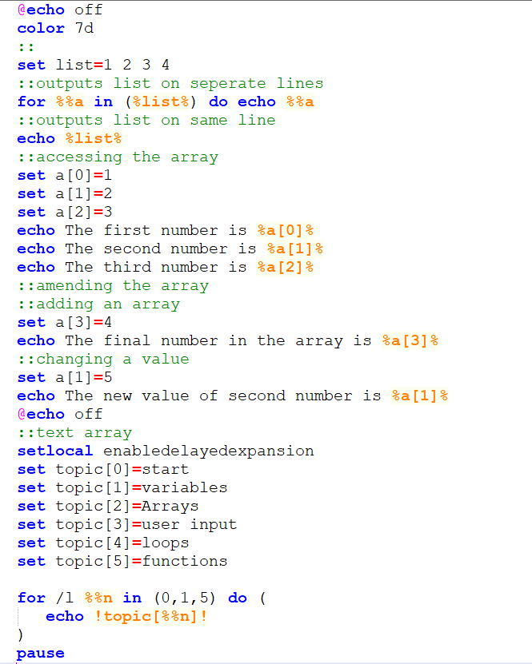 | 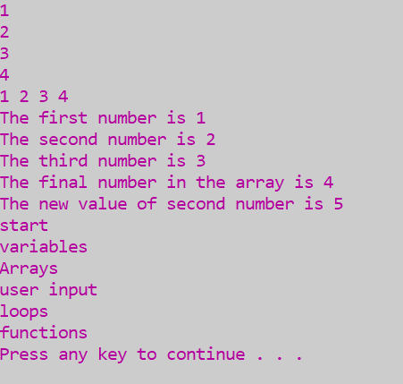

The ‘Setlocal EnableDelayedExpansion’ command was demonstrated on the SS64 [22] website and allows the text included with in the variables to be output to the display at the time of execution.

Call and Functions
Creating functions that you can call allows the user to execute specific parts of a batch script
This script asks the user to:
- Enter two number
- Displays menu
- Choose type of calculation, ensuring it is a valid choice and calls function
- Gives user option of choosing another calculation
- Exits
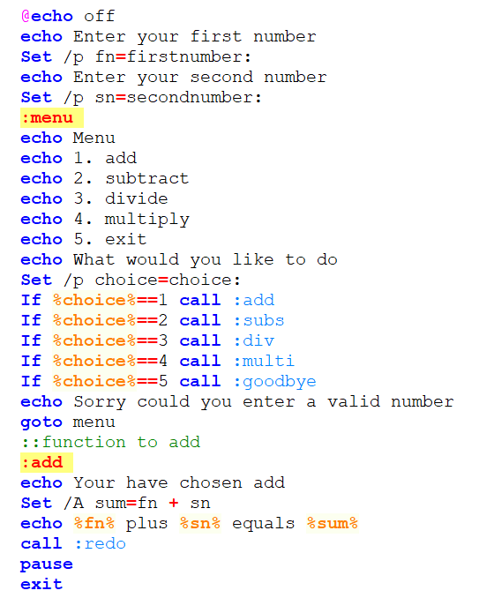
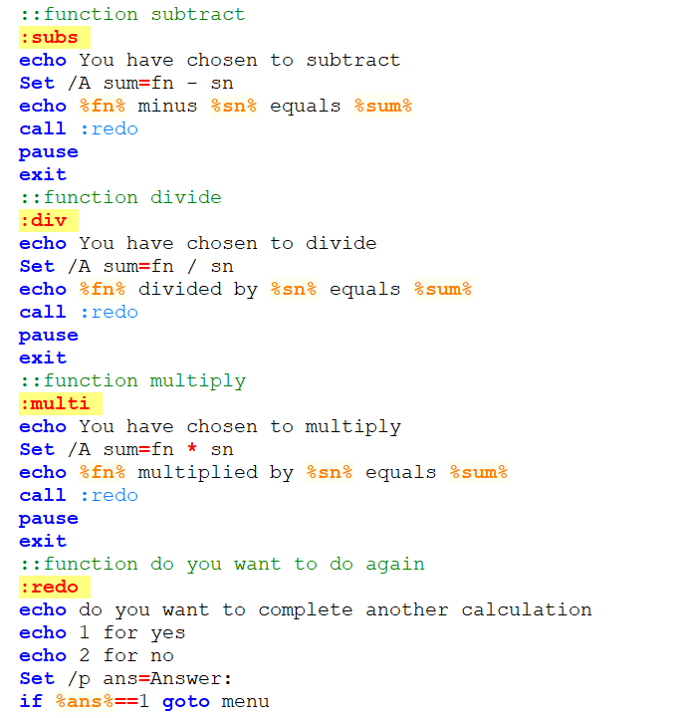
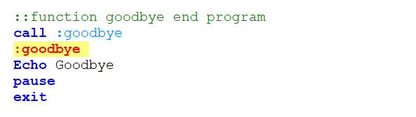

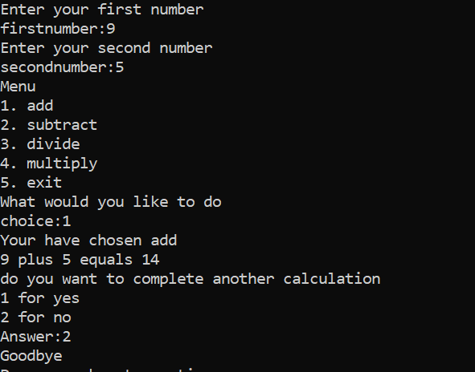 | 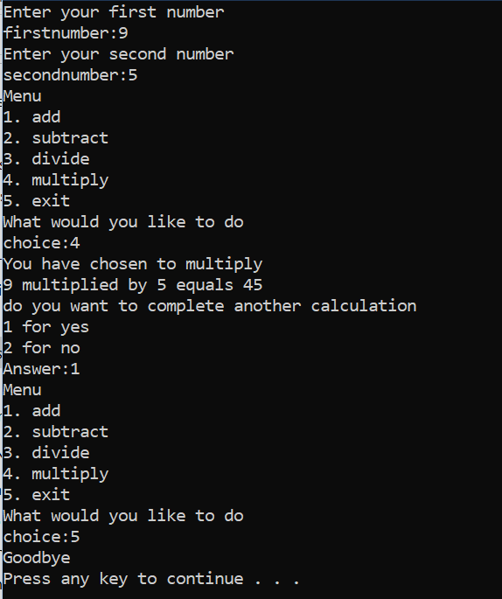

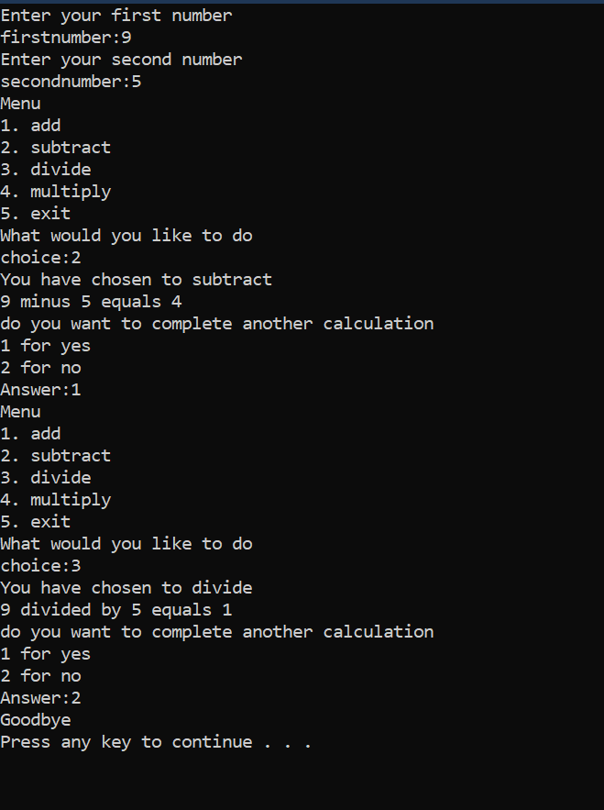

Bash Scripts

#!/bin/bash
According to the geeksforgeeks [23] website ‘#!/bin/bash’ should be the first command, as this instructs the operating system to use bash as a command interpreter.

Echo command
‘echo’ allows the user to output text/numeric/variables to the display screen. Though a simple command you can add interesting options to the basis ‘echo’ command.
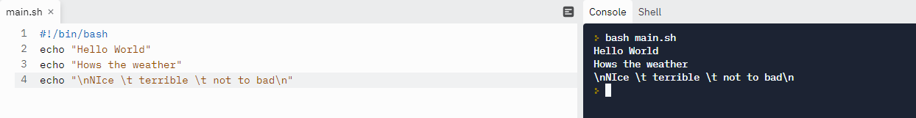
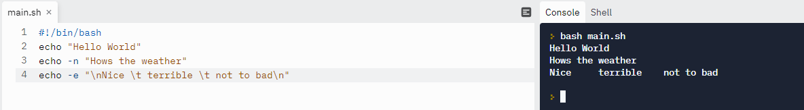
The ‘-e’ removes any backslash characters from the output.

Variables
Variables can be used to hold set values alphanumeric/numeric and then use ‘echo’ to output variables to screen.
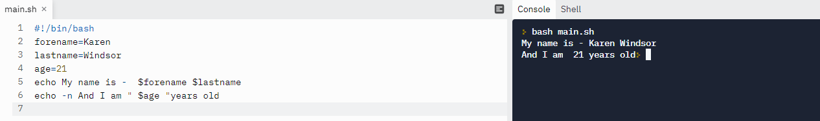
Variables can hold values input by the user.
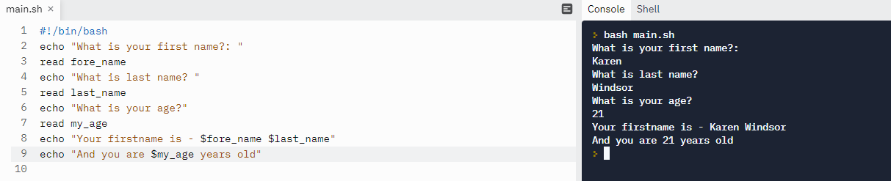
Read allows users to enter data and interact with the script.
Variables can be used to perform arithmetic calculations. Tecnstuff [24] states that it is best practice to include comment lines within scripts (start line with #), as this allows the script to be understandable for the original coder and colleagues who might need to update the original script.
The below script shows calculations using numbers entered by the user and echoed to the display
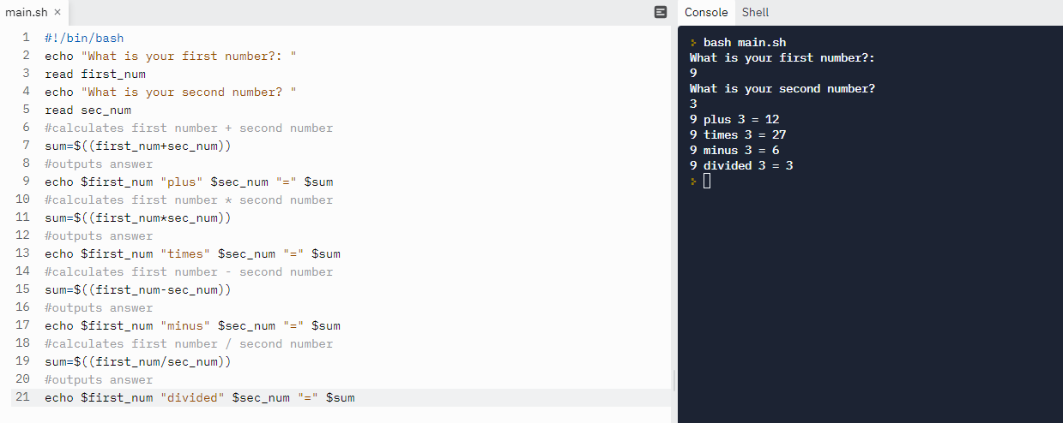

If/elif/else command
As demonstrated by Yesmin [25] if/else is different in bash as the user will need to use ‘elif’ to define an else if condition and the ‘fi’ command is required to signify the end of the ‘if’ block.
This script outputs a menu asking the user to input their choice of calculation.
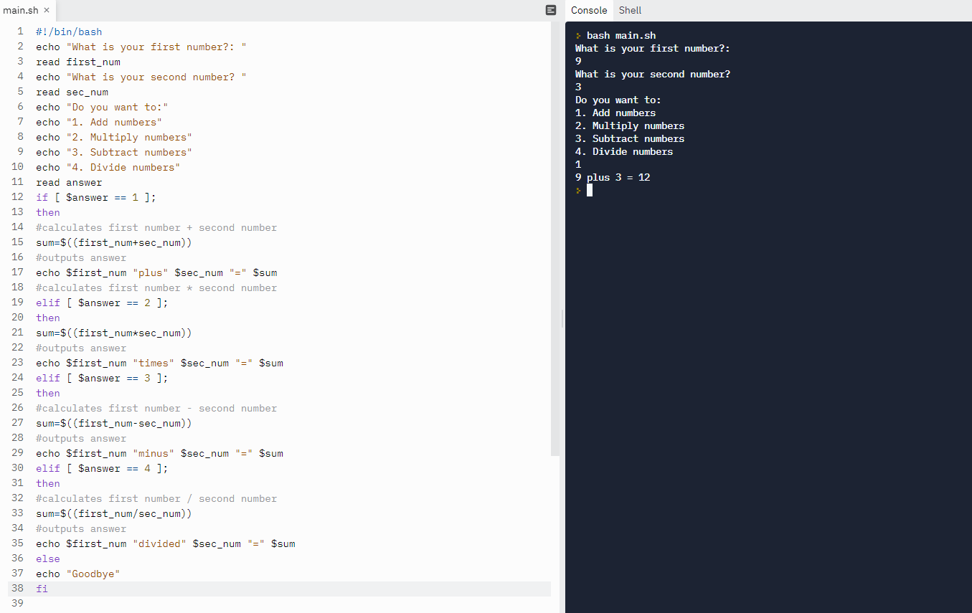

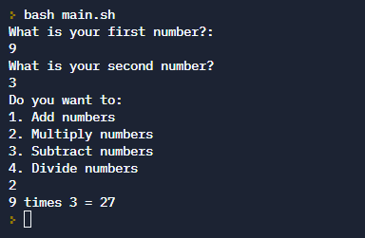 | 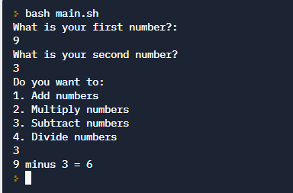 | 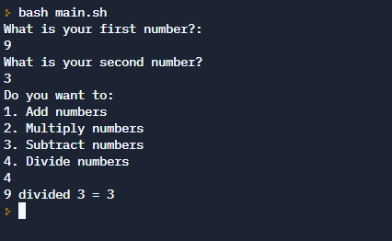

Case Statement
Case is an alternative to if-elif-else statement, and should start with ‘case’ and end with ‘esac’ (case backwards).
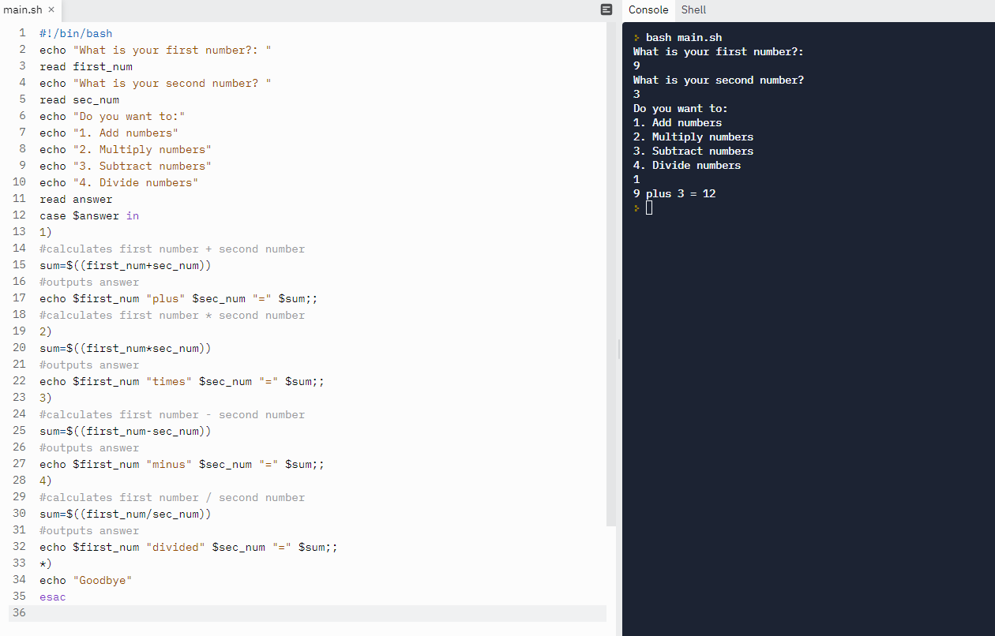
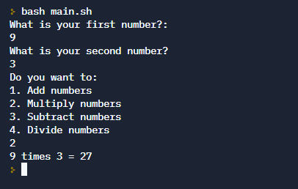 | 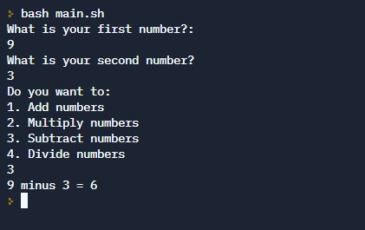 | 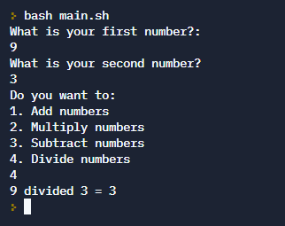

Function command
Functions are blocks of commands that can be called many times. The bash function commands are useful commands to make scripts more readable and prevent duplication of code.
This script calls functions to perform calculations.
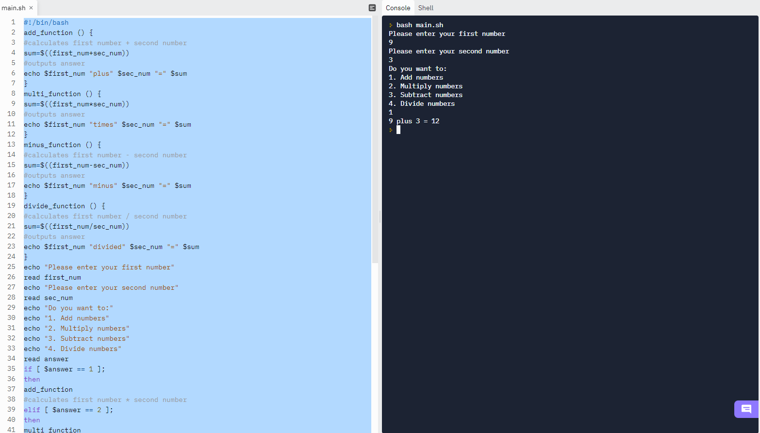
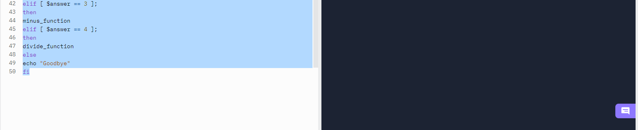
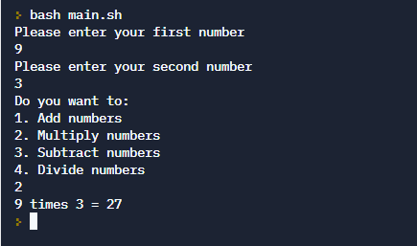 | 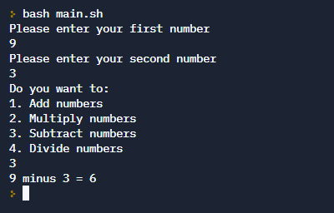 | 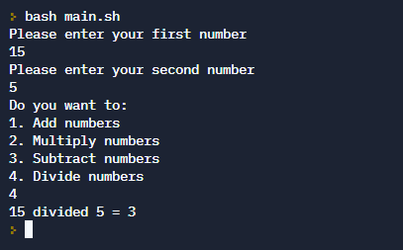

Arrays
An array is a variable that can hold many data items whose positions are indexed with the array.
The below script declares an array “element” to hold data items.
Data items can be output individually using their index within the array or ‘@’ to output all data items within the array.
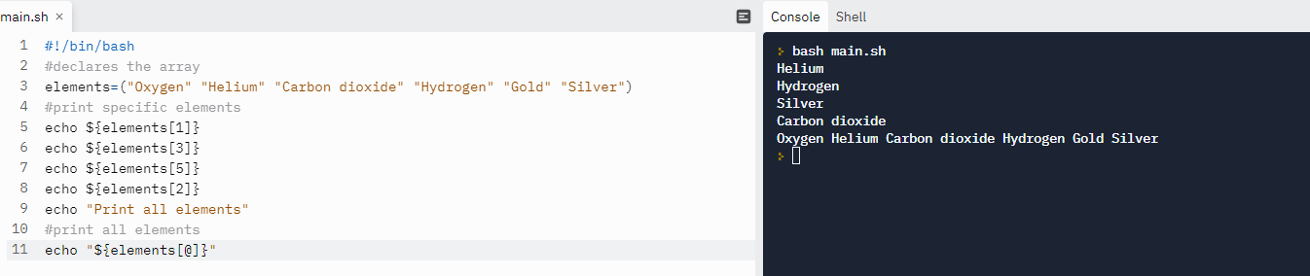

Loop commands
Loops are a set of commands that repeat until a condition is reached. There are 3 basic loops in Bash:
- for
- while
- until

For loops
This loop repeats over a list of items and performs a block of commands within the loop until the ‘done’ command line is reached – array is output
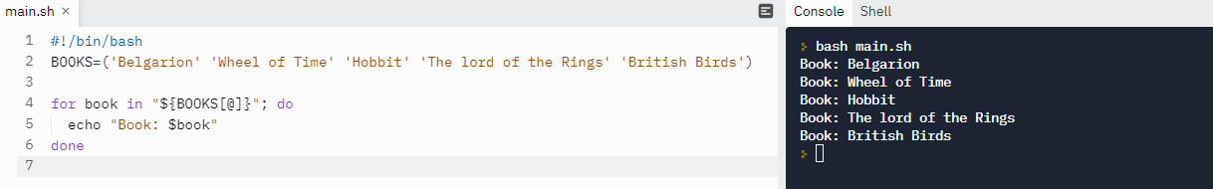

While loops
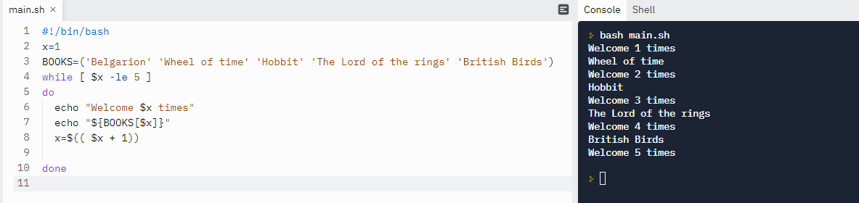

Until loops
The until loop runs until a condition is reached – counter greater than 5
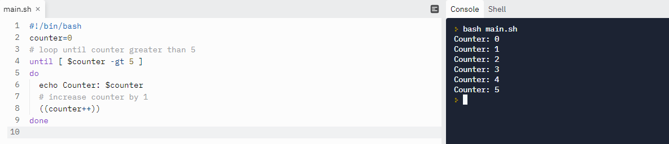

Conclusion
The main finding of this report are that operating systems are found in various devices, and they all have their own individual functions.
The user can interact with the operating system using CLI, Batch (MS) or Bash(UNIX) to create files, perform calculations, loops, functions and allow user input.
Although Batch and Bash are run on separate systems the commands are very similar, allowing the user to move confidently from one operating system to another.
One thing that became apparent is that, both Batch and Bash are very powerful, and it would be very easy for an unwary novice to cause damage to their files and the operating system itself. Taking this into account the only commands and scripts demonstrated within this report are ones that are considered safe.

References

[1] | A. S. Tanenbaum, Modern Operating Systems, 4th Edition ed., London: Pearson, 2008, p. 1.
[2] | C. Ritchie, Operating Systems, 4th Edition ed., London: Thomson Learning, 2004, p. 79.
[3] | W. Stallings, Computer Organization & Architecture, 7th ed., London: Pearson Education Ltd, 2006, p. 267.
[4] | PrepInsta, “Threads in Operating System (OS),” PrepInsta.com, 21st August 2019. [Online]. Available: https://prepinsta.com/operating-systems/threads/. [Accessed 6th February 2022].
[5] | A. Singhal, “Banker's Algortihm Deadlock Avoidance,” GateVidyalay.com, 2020. [Online]. Available: https://www.gatevidyalay.com/bankers-algorithm-deadlock-avoidance-2/. [Accessed 3rd February 2022].
[6] | Wikipedia, “Rootkit,” 2nd January 2022. [Online]. Available: https://en.wikipedia.org/wiki/Rootkit. [Accessed 6th February 2022].
[7] | A. Yernagula, “Understanding File Management System in Operating System,” Medium.com, 28th February 2020. [Online]. Available: https://princeabhishek410.medium.com/understanding-file-management-system-in-operating-system-4c7fbfc306f2. [Accessed 6th February 2022].
[8] | A. Gangwar, “20 command Prompt Tricks that You Should Know,” beebom.com, 20th December 2021. [Online]. Available: https://beebom.com/command-prompt-tricks-to-know/. [Accessed 11th February 20222].
[9] | M. Turner and J. Franco, “A Compilation of Command Prompt Tips, Tricks and Cool Things You Can Do,” TECHSPOT, 2nd December 2021. [Online]. Available: https://www.techspot.com/guides/1724-command-prompt-what-you-can-do/. [Accessed 11th February 2022].
[10] | Meridianoutpost, “How to Use IPConfig Command with Examples,” MeridianOutpost.com, 202. [Online]. Available: https://www.meridianoutpost.com/resources/articles/command-line/ipconfig.php. [Accessed 11th February 2022].
[11] | T. Sieber, “15 Windows Command Prompt (CMD) Commands You Must Know,” Makeuseof.com, 22nd July 2021. [Online]. Available: https://www.makeuseof.com/tag/15-cmd-commands-every-windows-user-know/. [Accessed 11th February 2022].
[12] | GeeksforGeeks, “mkdir command in Linux with Examples,” GeeksforGeeks, 8th September 2021. [Online]. Available: https://www.geeksforgeeks.org/mkdir-command-in-linux-with-examples/. [Accessed 20th February 2022].
[13] | B. Ayodeji, “The Linux LS Command - How to List Files in a Directory + Option Flags,” freeCodeCamp, 3rd September 2020. [Online]. Available: https://www.freecodecamp.org/news/the-linux-ls-command-how-to-list-files-in-a-directory-with-options/. [Accessed 16th February 2022].
[14] | B. Zachariah, “Touch Command in Linux (5 examples),” LinOxide, 29th September 2021. [Online]. Available: https://linoxide.com/touch-command-in-linux/. [Accessed 20th February 2022].
[15] | S. Simic, “How to Use Linux Cat Command (with Examples),” PhoenixNAP, 13th July 2020. [Online]. Available: https://phoenixnap.com/kb/linux-cat-command. [Accessed 20th February 2022].
[16] | D. McKay, “How to Use the stat Command on Linux,” How-to-Geek, 2nd January 2020. [Online]. Available: https://www.howtogeek.com/451022/how-to-use-the-stat-command-on-linux/. [Accessed 20th February 2022].
[17] | A. Heath, “What is @echo off in BAT file?,” Easierwithpractice, 26th July 2019. [Online]. Available: https://easierwithpractice.com/what-is-echo-off-in-bat-file/. [Accessed 23rd February 2022].
[18] | R. v. d. Woude, “Rob van der Woude's Scripting Pages,” robvanderwoude.com, 17th September 2020. [Online]. Available: https://www.robvanderwoude.com/wait.php. [Accessed 23rd February 2022].
[19] | R. Dube, “5 If Statements to Use for Smarter Windows Batch Scripts,” Makeuseof.com, 12th December 2019. [Online]. Available: https://www.makeuseof.com/tag/windows-batch-if-statements/. [Accessed 23rd February 2022].
[20] | A. Listek, “Learning Batch: The Goto Command,” Talearning, 17th June 2021. [Online]. Available: https://adamtheautomator.com/goto-batch/. [Accessed 23rd February 2022].
[21] | trytoprogram, “Batch file for loop,” Trytoprogram, [Online]. Available: http://www.trytoprogram.com/batch-file-for-loop/#example. [Accessed 24th February 2022].
[22] | SS64, “SS64.com,” 2016, [Online]. Available: http://www.nms-rennweg.ksn.at/allmann/allgemeines/1/scripts%20kommandozeile/Windows%20CMD%20Shell%20Command%20Line%20Syntax/EnableDelayedExpansion%20_%20Windows%20CMD%20_%. [Accessed 24th February 2022].
[23] | geeksforgeeks, “Shell Scripting - Deinfe #!/bin/bash,” GeeksforGeeks.org, 4th January 2022. [Online]. Available: https://www.geeksforgeeks.org/shell-scripting-define-bin-bash/#:~:text=The%20shebang%2C%20%23!%2Fbin%2Fbash,time%20it%20will%20be%20bash).. [Accessed 10th March 2022].
[24] | Admin, “Writing Comments in Bash Scripts,” Tecnstuff, 21st November 2020. [Online]. Available: https://tecnstuff.net/bash-comments/. [Accessed 10th March 2022].
[25] | F. Yesmin, “30 Bash Script Examples,” linuxhint, 2018. [Online]. Available: https://linuxhint.com/30_bash_script_examples/#t11. [Accessed 10th March 2022].
[26] | H. B. Andrew S Tanenbaum, Modern Operating Systems, 4th Edition ed., London: Pearson plc, 2008, pp. 35- 39.
[27] | I. Englander, The architecture of computer hardware, systems software & networking, 5th Edition ed., Hoboken: Wiley, 2014, p. 502.
[28] | “What is a mobile Operating System,” Study.com, 2022. [Online]. Available: https://study.com/academy/lesson/what-is-a-mobile-operating-system-features-types.html. [Accessed 26th January 2022].

Appendix

Types of Operating Systems(OS)

Tanenbaum and Bos [26] state that there are nine distinct types of operating systems:
- Mainframe OS is as explained by Englander [27] specifically designed to manage largescale computer systems, which require the capacity to run enormous amounts of transactions. These differ from smaller OS in the number of differing ways they can be configured, their power and capacity and the control they offer to the system administrators. The main type of mainframe OS are the UNIX variants like LINUX.
- Server OS area as the name suggests servers which are specifically designed to run on servers, to run the request of client computers within their network.
- Multiprocessor OS contain 2 or more CPUs to control the computer’s functions and can run multiple tasks.
- Personal OS found on our laptops are Microsoft windows, macOs or Linux based.
- Handheld or mobile OS have been developed according to Study.com [28] are something most people do not even consider when choosing their phone. But it is the basis of how our mobile phones run our favourite applications and programs. It controls the settings, internet connection, how we send messages and even our calendar appointments. The two main types of OS used on mobiles are Android and IOS.
- Embedded OS we see everywhere but never recognised them, they are commonly used in cash machines, dishwashers, cars, and traffic lights.
- Senor-node OS used in small battery systems used in building alarms and systems that detect changes in environmental temperatures
- Real-time OS’s (RTOS) are used in robotics, cars and for airline and military systems and by their very name are systems that are required to guarantee task can be completed within a specified time range.
- Smart Card OSs are used in small credit card sized systems usually using JAVA and are used in banking to provide additional security applications.

NDG Linus Unhatched

Arguments
- ls Documents – lists the contents of the Documents directory (case sensitive)
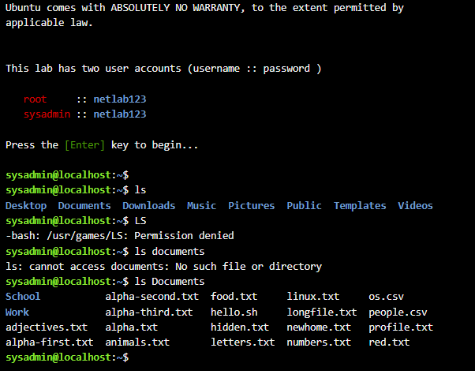
- aptitude moo
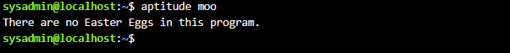
- ls -l – long display
ls -r – reverse order
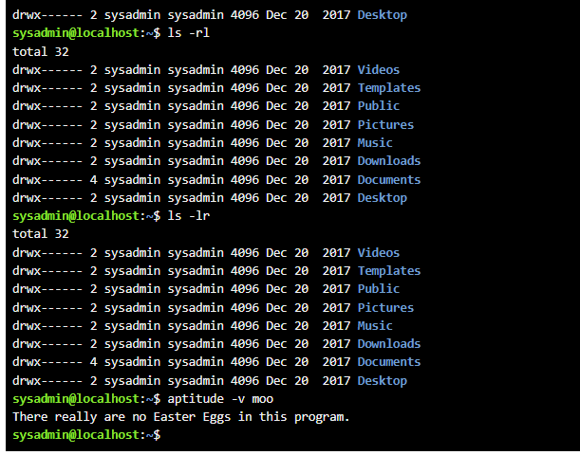
- cd – change directory
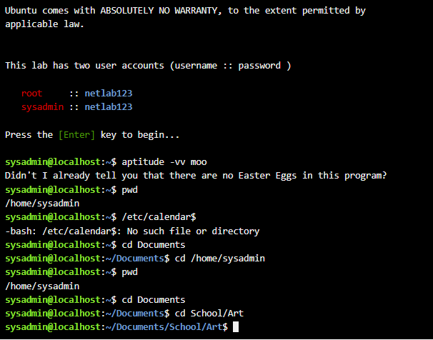

- ls -lSr /var/log – sort files by size in reverse order
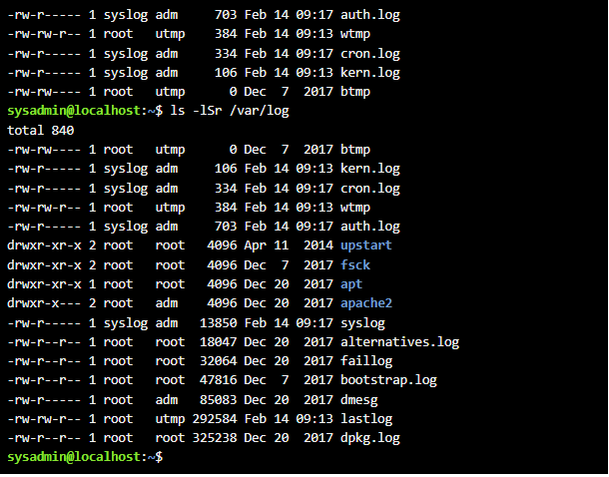
- su and sudo commands
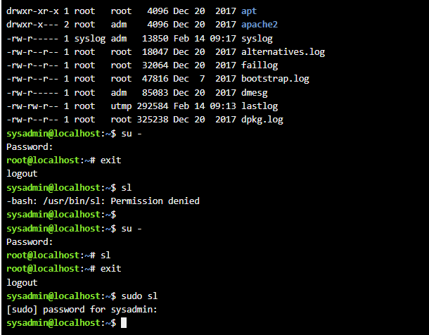
Hidden animation
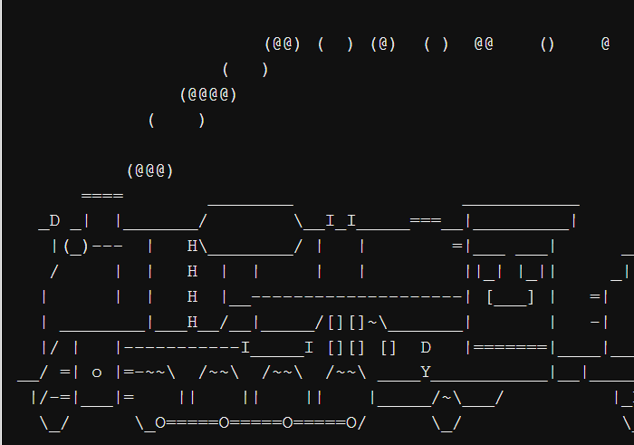

File Permissions
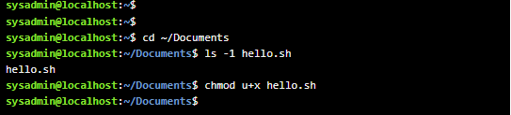
‘chmod’ is used to set and change file permissions
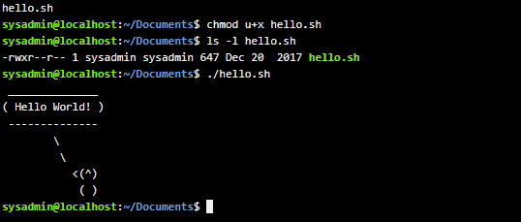

Viewing Files
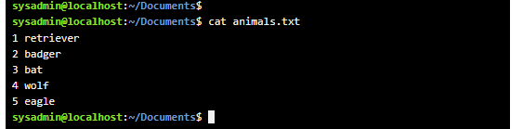
Displays what is in file ‘animals’

Bat files

Bash files

